Capstone Project Proposal
Natural-Language Playlist-Builder Agent
Student name | Ephraim (ephraimtjofficial@gmail.com)
Project title | Natural-Language Playlist-Builder Agent
Repository / notebook link | Local repo: C:\AdrenoX\Work\University\Semester 3\Agentic AI\Capstone (entry point: run_baseline.py). Not yet pushed to GitHub.
Configuration location | examples/readme.md

1. Problem Definition
Task. Given a plain-English description of a desired playlist (a mood, activity, era, or genre), the agent selects real tracks from a Spotify dataset by filtering on audio features and returns a playlist that matches the request — it never invents songs.
Intended user & situation. A listener who wants a playlist for a specific vibe or activity (“high-energy pop for a workout”) but does not want to hand-pick tracks or translate their taste into audio-feature filters.
Input. (1) a natural-language playlist request (a text file), and (2) the Spotify tracks dataset (CSV, ~33k tracks).
Output. A playlist: a one-line summary of the filters applied, followed by a numbered list of tracks with title, artist, genre, release year, and key audio features.
Success. Every returned track satisfies the constraints stated or implied by the request (genre, era, energy/mood, …), the number of tracks matches the request, there are no duplicates, and every track exists in the dataset.
Failure. A track violates a stated constraint, the wrong number of songs is returned, duplicates appear, or a track is hallucinated (not in the dataset).

2. Motivation and Project Scope
Why it matters. Playlist curation is a core music-listening task. Describing what you want in words is natural, but mapping that description onto concrete audio-feature filters (tempo, energy, valence…) is not something end-users do — an agent can bridge that gap.
Why an agentic approach. The task requires interpreting fuzzy language, exploring the catalog, and composing and executing filters iteratively — tool use over a dataset rather than a single model call. Grounding every pick in the real catalog is what prevents hallucinated songs.
In scope this semester:
- A single ~33k-track dataset; constraints on genre, release era, and audio features (energy, danceability, valence/mood, acousticness, tempo, popularity).
- A tool-use loop that filters the catalog, de-duplicates, and honours a requested track count.
- At least two concrete test requests and a constraint-satisfaction check.
Intentionally out of scope:
- Creating/playing playlists via the real Spotify API (a planned later extension), and raw audio-signal analysis.
- Personalization from listening history, multi-dataset catalogs, and requests needing knowledge outside the provided features (e.g. lyrical themes).

3. Runnable Baseline
Type. A tool-use / agentic-loop baseline.
Model, tools, libraries. Python 3.13, pandas, and the openai SDK pointed at an OpenAI-compatible endpoint. The reference run uses Groq’s free tier with model openai/gpt-oss-120b. Dataset: the TidyTuesday spotify_songs.csv (~33k tracks), hosted on GitHub and auto-downloaded on first run.
What it does, step by step:
- Ensures the dataset is present (downloads it from GitHub if missing) and loads it into a DataFrame df.
- Builds a system prompt describing the schema, the meaning of each audio feature, and a de-duplication rule.
- Sends the user’s request to the model with a single tool, run_pandas(code).
- When the model calls the tool, the code runs against df and its printed output is returned to the model.
- The loop repeats (bounded to 12 steps) until the model returns a filter summary and a numbered playlist, which is printed and saved to outputs/.
Why this is a reasonable start. It is minimal yet genuinely agentic (real iterative tool use), grounds every selection in the real catalog, produces a measurable output (constraint satisfaction), and extends naturally to the live Spotify API.
Files. run_baseline.py (agent, loop, tool), examples/spotify_songs.csv (data), examples/test1.txt / examples/test2.txt (requests), examples/readme.md (config), requirements.txt, and outputs/.

4. Test Case and Baseline Output
Test 1 — request: “Build me a 10-song playlist of high-energy pop songs from the 2010s for a workout.”
Expected behaviour: 10 distinct pop tracks released 2010–2019 with high energy (the dataset holds 2,548 candidate pop / 2010s / high-energy tracks). Actual: the agent filtered to pop + 2010–2019 + energy ≥ 0.75, de-duplicated on track + artist, and returned the 10 most popular matches (e.g. “Blinding Lights – The Weeknd”, “Don’t Start Now – Dua Lipa”). ✓
Test 2 — request: “I want a chill 8-song playlist of calm, low-energy acoustic songs for studying.”
Expected behaviour: 8 distinct low-energy, high-acousticness tracks. Actual: the agent filtered to low energy + high acousticness + low danceability (≈ energy ≤ 0.35, acousticness ≥ 0.85), de-duplicated, and returned 8 tracks (e.g. “lovely – Billie Eilish”, “Mad World – Gary Jules”). ✓
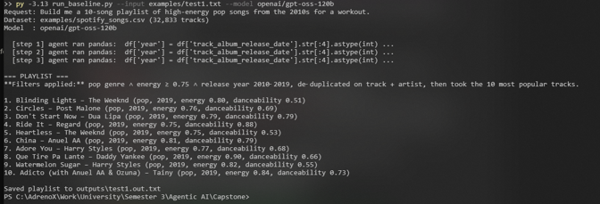
Test 1 — high-energy 2010s pop workout playlist (your terminal).
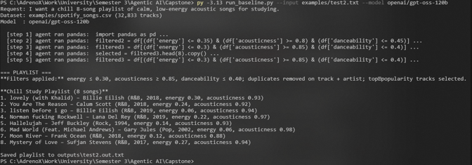
Test 2 — calm low-energy acoustic study playlist (your terminal).
What worked. The agent reliably turns fuzzy language (“high-energy”, “chill”) into concrete feature thresholds, grounds every pick in the catalog, and de-duplicates. What did not. The thresholds are the model’s own ad-hoc choices and vary from run to run; genre labels are playlist-derived and noisy (some “pop” rows lean reggaeton); there is no guarantee of exactly N tracks if filters are too strict; and the baseline does not verify after the fact that each returned track actually satisfies the stated filters.

5. Reproducibility and Run Instructions
- Install: py -3.13 -m pip install -r requirements.txt
- Configure (Groq free tier): set OPENAI_API_KEY to a key from console.groq.com/keys and OPENAI_BASE_URL=https://api.groq.com/openai/v1. (For OpenAI instead: set only OPENAI_API_KEY and use --model gpt-4o-mini.)
- Dataset: committed at examples/spotify_songs.csv; auto-downloaded from GitHub on first run if missing (no Kaggle account needed).
- Run: py -3.13 run_baseline.py --input examples/test1.txt --model openai/gpt-oss-120b
- Input location: examples/*.txt. Output: printed to console and saved to outputs/<input-name>.out.txt.
- Known limitations: the model must support tool calling; free tiers are rate-limited (retry on HTTP 429).

6. Initial Evaluation Plan
The improved system will be compared to this baseline on a set of playlist requests, each paired with a machine-checkable set of intended constraints:
- Constraint-satisfaction rate — fraction of returned tracks that meet every stated constraint (the primary metric).
- Count correctness — returned track count equals the requested count.
- Duplicate & hallucination rate — duplicate tracks, and tracks not present in the dataset.
- Diversity — number of unique artists in the playlist.
- Latency, cost, tool-failure rate — wall-clock time, tokens / tool-steps used, and unrecovered code errors.
- Optional human / LLM-as-judge — rating of how well the playlist fits the requested vibe.
Evidence of improvement: higher constraint-satisfaction and lower duplicate / hallucination rates than the baseline, reliably correct counts, better vibe-fit ratings, and fewer wasted tool steps.

7. Limitations and Next Steps
Known weaknesses. Feature thresholds are chosen ad-hoc and are inconsistent between runs; genre labels are noisy; there is no post-hoc validation that returned tracks satisfy the request; model-written code is executed without a real sandbox; only one dataset is supported; there is no personalization.
Expected failure cases. Over-strict filters returning fewer than N tracks; ambiguous requests (“sad but not too sad”); non-English or regional requests; and requests that depend on information not in the audio features (e.g. “songs about summer”). One such case was observed during testing: on the test-2 request the agent looped on near-identical queries and exhausted its step budget without finalizing, which prompted raising the bound from 8 to 12 steps and adding a “be decisive” instruction — a mitigation, not a full fix.
Next phase. Add a validation-and-repair step that checks each track against parsed constraints; standardize the language-to-threshold mapping; guarantee exactly-N with graceful constraint relaxation; connect to the real Spotify API/MCP to create the playlist in the user’s account; and grow the evaluation into a labeled request suite.
Risks & help needed. Model availability / rate limits and unsafe code execution are the main risks; defining ground-truth constraints for fuzzy requests takes care. The project would benefit from stable API access and a small labeled request→constraint benchmark.

