Ephraim Lebese
211062642

Assignment 1

i Initilaise git repository

student@student-virtual-machine:~/Downloads/ActivityOne$ git init
Initialized empty Git repository in /home/student/Downloads/ActivityOne/.git/

ii. Create a file in your repository and check the status and give the explanation of the status

student@student-virtual-machine:~/Downloads/ActivityOne$ touch file1.txt
student@student-virtual-machine:~/Downloads/ActivityOne$ git status
On branch master

Initial commit

Untracked files:
(use "git add <file>..." to include in what will be committed)

.idea/
ActivityOne.iml
file1.txt
pom.xml
src/

nothing added to commit but untracked files present (use "git add" to track)

All files are not tracked by git

iii. Track he file that you just created and check status

student@student-virtual-machine:~/Downloads/ActivityOne$ git add ActivityOne.iml file1.txt pom.xml
student@student-virtual-machine:~/Downloads/ActivityOne$ git status
On branch master

Initial commit

Changes to be committed:
(use "git rm --cached <file>..." to unstage)

new file: .idea/.name
new file: .idea/compiler.xml
new file: .idea/copyright/profiles_settings.xml
new file: .idea/encodings.xml
new file: .idea/libraries/Maven__junit_junit_3_8_1.xml
new file: .idea/misc.xml
new file: .idea/modules.xml
new file: .idea/scopes/scope_settings.xml
new file: .idea/vcs.xml
new file: .idea/workspace.xml
new file: ActivityOne.iml
new file: file1.txt
new file: pom.xml
new file: src/main/java/ActivityOne/App.java
new file: src/test/java/ActivityOne/AppTest.java

iv. Committ the file to your repository , check the status and give an explanation

student@student-virtual-machine:~/Downloads/ActivityOne$ git commit -m 'Initial commit'
[master (root-commit) 44bd7c8] Initial commit
15 files changed, 642 insertions(+)
create mode 100644 .idea/.name
create mode 100644 .idea/compiler.xml
create mode 100644 .idea/copyright/profiles_settings.xml
create mode 100644 .idea/encodings.xml
create mode 100644 .idea/libraries/Maven__junit_junit_3_8_1.xml
create mode 100644 .idea/misc.xml
create mode 100644 .idea/modules.xml
create mode 100644 .idea/scopes/scope_settings.xml
create mode 100644 .idea/vcs.xml
create mode 100644 .idea/workspace.xml
create mode 100644 ActivityOne.iml
create mode 100644 file1.txt
create mode 100644 pom.xml
create mode 100644 src/main/java/ActivityOne/App.java
create mode 100644 src/test/java/ActivityOne/AppTest.java
student@student-virtual-machine:~/Downloads/ActivityOne$ git status
On branch master
Changes not staged for commit:
(use "git add <file>..." to update what will be committed)
(use "git checkout -- <file>..." to discard changes in working directory)

modified: .idea/workspace.xml

no changes added to commit (use "git add" and/or "git commit -a")

v. Create three more files and check the status and explain why the files are in the states they are in

student@student-virtual-machine:~/Downloads/ActivityOne$ touch file2.txt file3.txt
student@student-virtual-machine:~/Downloads/ActivityOne$ git status
On branch master
Changes not staged for commit:
(use "git add <file>..." to update what will be committed)
(use "git checkout -- <file>..." to discard changes in working directory)

modified: .idea/workspace.xml

Untracked files:
(use "git add <file>..." to include in what will be committed)

file2.txt
file3.txt

no changes added to commit (use "git add" and/or "git commit -a")

file2 and file3 are untracked because they are not added yet

vi. Make Changes to the file you committed and check the status

student@student-virtual-machine:~/Downloads/ActivityOne$ git status
On branch master
Changes not staged for commit:
(use "git add <file>..." to update what will be committed)
(use "git checkout -- <file>..." to discard changes in working directory)

modified: .idea/workspace.xml
modified: file1.txt

Untracked files:
(use "git add <file>..." to include in what will be committed)

.idea/uiDesigner.xml
file2.txt
file3.txt

no changes added to commit (use "git add" and/or "git commit -a")

vii. Now track the two files that you added above and give the explanation of your status output

student@student-virtual-machine:~/Downloads/ActivityOne$ git add .idea/ file2.txt file3.txt
student@student-virtual-machine:~/Downloads/ActivityOne$ git status
On branch master
Changes to be committed:
(use "git reset HEAD <file>..." to unstage)

new file: .idea/uiDesigner.xml
modified: .idea/workspace.xml
new file: file2.txt
new file: file3.txt

Changes not staged for commit:
(use "git add <file>..." to update what will be committed)
(use "git checkout -- <file>..." to discard changes in working directory)

modified: file1.txt

the two files are added and ready to be committed and file1 is not tracked

viii. Commit the modified file ad check the status

student@student-virtual-machine:~/Downloads/ActivityOne$ git add file1.txt
student@student-virtual-machine:~/Downloads/ActivityOne$ git commit -m 'Initial commit'
[master 83f358d] Initial commit
5 files changed, 318 insertions(+), 25 deletions(-)
create mode 100644 .idea/uiDesigner.xml
create mode 100644 file2.txt
create mode 100644 file3.txt
student@student-virtual-machine:~/Downloads/ActivityOne$ git status
On branch master
Changes not staged for commit:
(use "git add <file>..." to update what will be committed)
(use "git checkout -- <file>..." to discard changes in working directory)

modified: .idea/workspace.xml

no changes added to commit (use "git add" and/or "git commit -a")

file1 was added and committed along with all the other files which are tracked

ix. Get the output of the Short Status of your repo

student@student-virtual-machine:~/Downloads/ActivityOne$ git status -s
M .idea/workspace.xml

x. Ensure that Git ignores one of the three files that you have created above

student@student-virtual-machine:~/Downloads/ActivityOne$ touch .gitignore

file to be ignored is included in the .gitignore file

xi. Get the status of the changes that you made to your repository

student@student-virtual-machine:~/Downloads/ActivityOne$ git status
On branch master
Changes not staged for commit:
(use "git add <file>..." to update what will be committed)
(use "git checkout -- <file>..." to discard changes in working directory)

modified: .idea/workspace.xml

Untracked files:
(use "git add <file>..." to include in what will be committed)

.gitignore

no changes added to commit (use "git add" and/or "git commit -a")

xii. Remove one of the three files that you had created and are tracking. Get the status and give an explanation

student@student-virtual-machine:~/Downloads/ActivityOne$ git rm file3.txt
rm 'file3.txt'
student@student-virtual-machine:~/Downloads/ActivityOne$ git status
On branch master
Changes to be committed:
(use "git reset HEAD <file>..." to unstage)

deleted: file3.txt

Changes not staged for commit:
(use "git add <file>..." to update what will be committed)
(use "git checkout -- <file>..." to discard changes in working directory)

modified: .idea/workspace.xml

Untracked files:
(use "git add <file>..." to include in what will be committed)

.gitignore

file3 has been removed from the staging area so it wont be committed to the repo

xiii. Get the output of your committ History

student@student-virtual-machine:~/Downloads/ActivityOne$ git log
commit 83f358d07bd6ed00cbc319b5024eda1f2f575d54
Author: Ephraim <lebesee@gmail.com>
Date: Thu Feb 25 16:05:58 2016 +0200

Initial commit

commit 44bd7c8980952e1180c6c7e8f3ee0fc319807e46
Author: Ephraim <lebesee@gmail.com>
Date: Thu Feb 25 15:50:39 2016 +0200

Initial commit
:

Section 3

i. In your GitHub account, creaete a respository and clone it onto you PC and ensure that you put it in a different directory

student@student-virtual-machine:~/Downloads/ActivityOne$ git clone https://github.com/Ephraimlebese/Chaper1Execises.git myproject
Cloning into 'myproject'...
warning: You appear to have cloned an empty repository.
Checking connectivity... done.

ii. Show your full remotes on your local machine using a git command and take asnapshort

student@student-virtual-machine:~/Downloads/ActivityOne/myproject$ git remote
origin

ii. Add a file to your repo and push he file to GitHub

student@student-virtual-machine:~/Downloads/ActivityOne/myproject$ touch file1.txt
student@student-virtual-machine:~/Downloads/ActivityOne/myproject$ git add file1.txt
student@student-virtual-machine:~/Downloads/ActivityOne/myproject$ git commit -m 'Initial Commit'
[master (root-commit) b599450] Initial Commit
1 file changed, 0 insertions(+), 0 deletions(-)
create mode 100644 file1.txt
student@student-virtual-machine:~/Downloads/ActivityOne/myproject$ git remote add firstProject https://github.com/Ephraimlebese/Chaper1Execises
student@student-virtual-machine:~/Downloads/ActivityOne/myproject$ git push firstProject master
Username for 'https://github.com': lebesee@gmail.com
Password for 'https://lebesee@gmail.com@github.com':
Counting objects: 3, done.
Writing objects: 100% (3/3), 221 bytes | 0 bytes/s, done.
Total 3 (delta 0), reused 0 (delta 0)
To https://github.com/Ephraimlebese/Chaper1Execises
* [new branch] master -> master

iii. Create Another Git Repo and add any other file to the remote repository and again show full remotes for yourrepository

student@student-virtual-machine:~/Desktop/Chapter1$ git init
Initialized empty Git repository in /home/student/Desktop/Chapter1/.git/
student@student-virtual-machine:~/Desktop/Chapter1$ git add New.txt
student@student-virtual-machine:~/Desktop/Chapter1$ git commit -m 'Initial commit'
[master (root-commit) bbcc4a9] Initial commit
1 file changed, 1 insertion(+)
create mode 100644 New.txt
student@student-virtual-machine:~/Desktop/Chapter1$ git remote add projectTwo https://github.com/Ephraimlebese/Chapter1SecondRepo.git
student@student-virtual-machine:~/Desktop/Chapter1$ git push projectTwo master
Username for 'https://github.com': lebesee@gmail.com
Password for 'https://lebesee@gmail.com@github.com':
Counting objects: 3, done.
Writing objects: 100% (3/3), 220 bytes | 0 bytes/s, done.
Total 3 (delta 0), reused 0 (delta 0)
To https://github.com/Ephraimlebese/Chapter1SecondRepo.git
* [new branch] master -> master
student@student-virtual-machine:~/Desktop/Chapter1$ cd
student@student-virtual-machine:~$ git remote
fatal: Not a git repository (or any of the parent directories): .git
student@student-virtual-machine:~$ cd Desktop/Chapter1/
student@student-virtual-machine:~/Desktop/Chapter1$ git remote
projectTwo

iv. Get the contents of the remote repository in and merge it into your local repo

student@student-virtual-machine:~/Desktop/Chapter1$ git fetch projectTwo

v. Create another git repository and add another repo repository.

student@student-virtual-machine:~/Desktop/THird$ git commit -u
On branch master

Initial commit

Untracked files:
Assignment1 Ephraim Lebese .abw

nothing added to commit but untracked files present
student@student-virtual-machine:~/Desktop/THird$ git add Assignment1\ Ephraim\ Lebese\ .abw
student@student-virtual-machine:~/Desktop/THird$ git commit -u
[master (root-commit) d2ee7dc] Initial commi
1 file changed, 342 insertions(+)
create mode 100644 Assignment1 Ephraim Lebese .abw
student@student-virtual-machine:~/Desktop/THird$ git remote add third https://github.com/Ephraimlebese/Chapter1ThirdRepo.git
student@student-virtual-machine:~/Desktop/THird$ git push third master
Username for 'https://github.com': lebesee@gmail.com
Password for 'https://lebesee@gmail.com@github.com':
Counting objects: 3, done.
Delta compression using up to 2 threads.
Compressing objects: 100% (3/3), done.
Writing objects: 100% (3/3), 5.13 KiB | 0 bytes/s, done.
Total 3 (delta 0), reused 0 (delta 0)
To https://github.com/Ephraimlebese/Chapter1ThirdRepo.git
* [new branch] master -> master

vii. Remove the remote from your repostory

student@student-virtual-machine:~/Desktop/THird$ git remote -v
third https://github.com/Ephraimlebese/Chapter1ThirdRepo.git (fetch)
third https://github.com/Ephraimlebese/Chapter1ThirdRepo.git (push)
student@student-virtual-machine:~/Desktop/THird$ git remote rm third

4. Demostrate the ability to tag your repo with version numbers and commit these them to gitHub

student@student-virtual-machine:~/Downloads/ActivityOne$ git tag
student@student-virtual-machine:~/Downloads/ActivityOne$

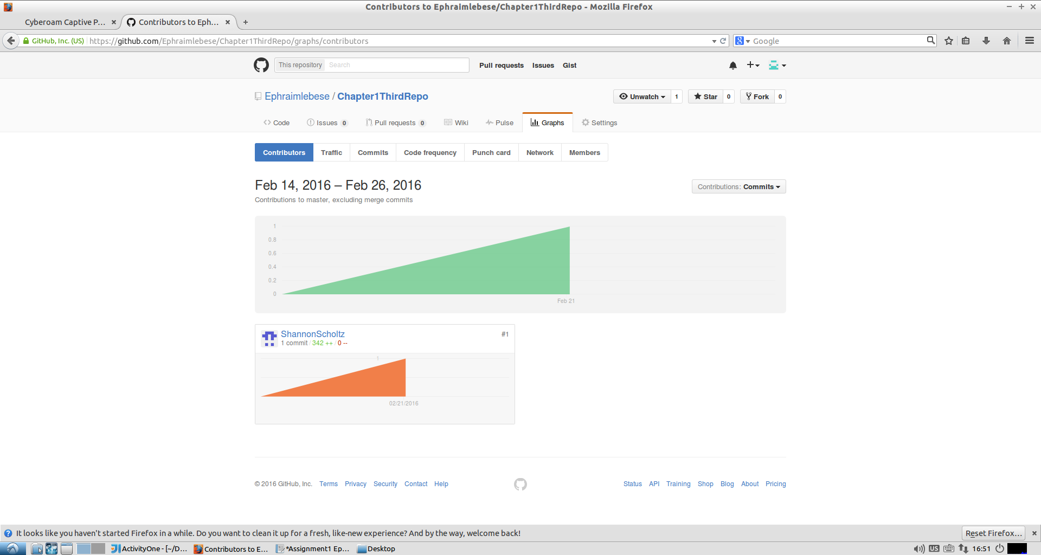

6. Demostrate Rebasing on another repo that you create on GitHub

student@student-virtual-machine:~/Desktop/Chapter1$ git remote
projectTwo
student@student-virtual-machine:~/Desktop/Chapter1$ git fetch projectTwo
student@student-virtual-machine:~/Desktop/Chapter1$ git branch --track firstProject
Branch firstProject set up to track local branch master.
student@student-virtual-machine:~/Desktop/Chapter1$ git checkout firstProject
Switched to branch 'firstProject'
Your branch is up-to-date with 'master'.

