2.2. Business function diagram
2.2.1. Novel management (Author)
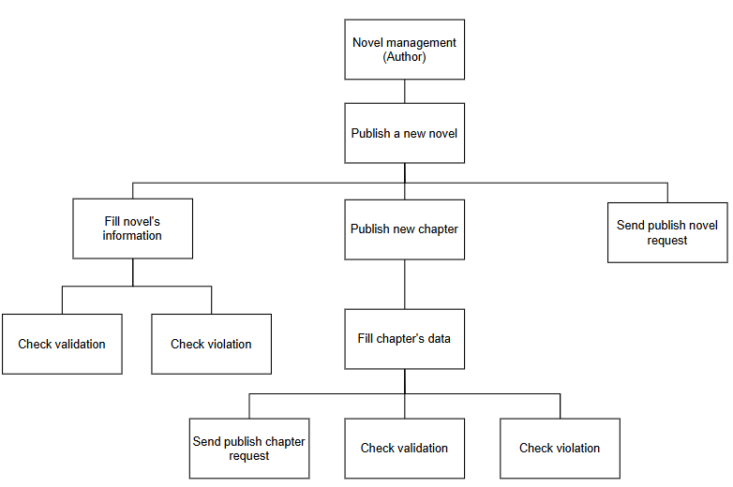

3.2. Business process
3.2.2. Process of publish new novels
a. Publish a new novel
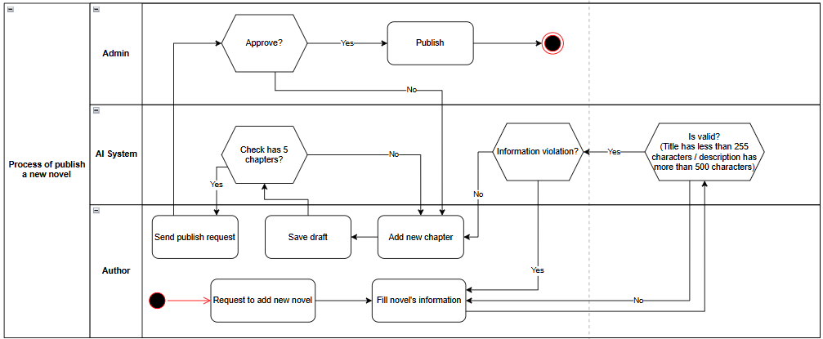
Figure : Process of author request to publish a new novel

b. Publish new chapter
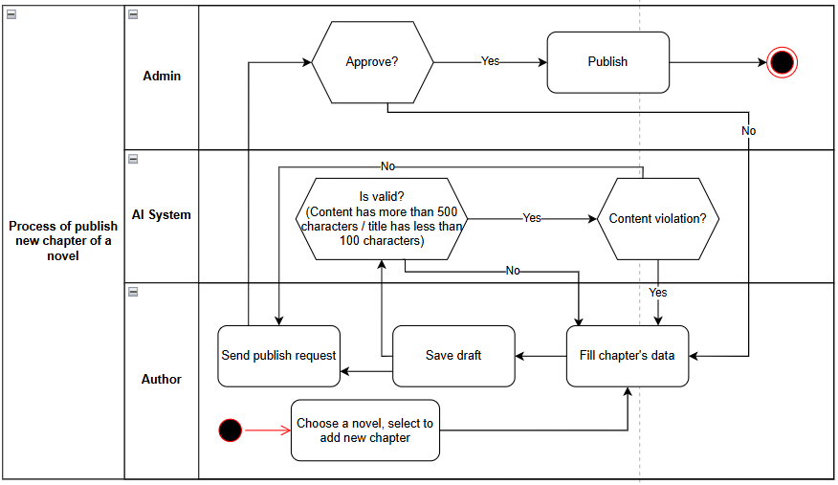
Figure : Process of author request to publish a new chapter

4. Use Case Specifications
4.2. Novel management
4.2.1. UC: Publish a new novel
a. Activity diagram
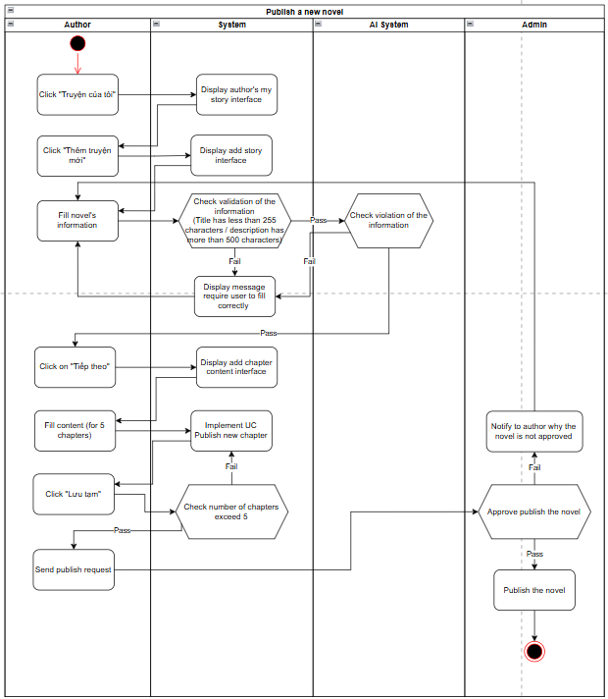
b. Use case description
Objective | This function allows authors to publish a new novel on the platform
Actor | Author, System, AI System, Admin
Trigger | Author wants to publish a new novel
Pre-condition | Author has an account in the system and logged in successfully
Post-condition | - Novel is published on the platform

Step | Basic Flow | Exception Flow | Alternative Flow
1 | Author clicks "Truyện của tôi" – System displays author's my story interface. Author clicks "Thêm truyện mới" – System displays add story interface
2 | Author fills novel's information (title, description, genre, etc.) | 2a. System detects validation errors (Title ≥ 255 characters OR Description < 500 characters)  2a1. System displays message requiring user to fill correctly  2a2. Author re-fills the information
3 | System validates information and passes to AI System to check for content violations | 3a. AI System detects violation of information  3a1. System notifies author of the violation  3a2. Author edits and re-submits the information
4 | Author clicks "Tiếp theo" – System displays add chapter content interface
5 | Author fills content for chapters – System implements UC Publish new chapter for each chapter | 5a. Chapter content fails UC Publish new chapter validation  5a1. Author re-edits the chapter content
6 | Author clicks "Lưu tạm" – System checks if number of chapters meets requirement (≥ 5) | 6a. Number of chapters does not exceed 5  6a1. System notifies author to add more chapters  6a2. Author continues filling remaining chapters
7 | Author sends publish request to Admin
8 | Admin reviews and approves the novel – System publishes the novel | 8a. Admin does not approve the novel  8a1. System notifies author with the reason for rejection  8a2. Author edits novel and re-submits publish request

4.2.2. UC: Publish new chapter
a. Activity diagram
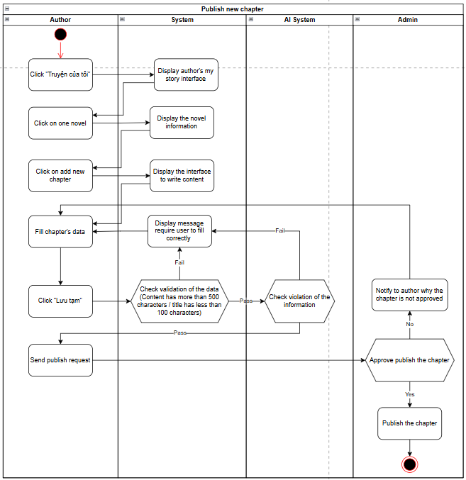

b. Use case description
Objective | This function allows authors to publish a new chapter for an existing novel on the platform
Actor | Author, System, AI System, Admin
Trigger | Author wants to add and publish a new chapter to their novel
Pre-condition | Author has an account in the system, logged in successfully, and has at least one novel created in the system
Post-condition | - The new chapter is published on the platform  - System records the successful chapter publication activity to database

Step | Basic Flow | Exception Flow | Alternative Flow
1 | Author clicks "Truyện của tôi" – System displays author's my story interface
2 | Author clicks on one novel – System displays the novel information
3 | Author clicks on "Add new chapter" – System displays the interface to write content
4 | Author fills chapter's data (title, content)
5 | Author clicks "Lưu tạm" – System checks validation of the data (Content > 500 characters AND Title < 100 characters) | 5a. System detects validation errors  5a1. System displays message requiring user to fill correctly  5a2. Author re-fills chapter's data
6 | System passes chapter to AI System to check for content violations | 6a. AI System detects violation of the information  6a1. System displays message requiring user to correct the content  6a2. Author edits and re-submits chapter's data
7 | Author sends publish request to Admin
8 | Admin reviews and approves the chapter – System publishes the chapter | 8a. Admin does not approve the chapter  8a1. System notifies author with the reason why the chapter is not approved  8a2. Author edits the chapter and re-sends the publish request

5. Design UI/UX
5.2. Mockups Web UI (Author)
- Author “Truyện của tôi” page:
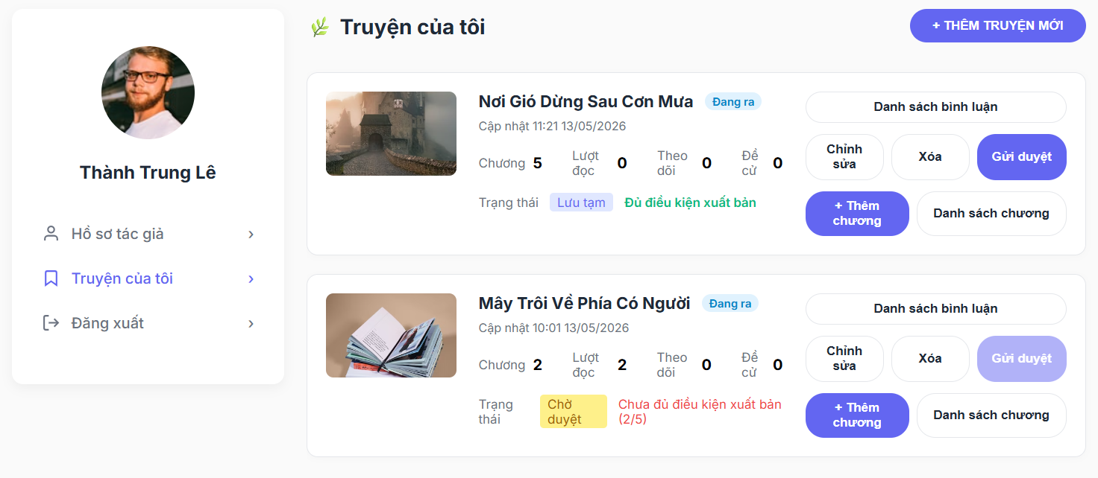

- Filling novel information page:
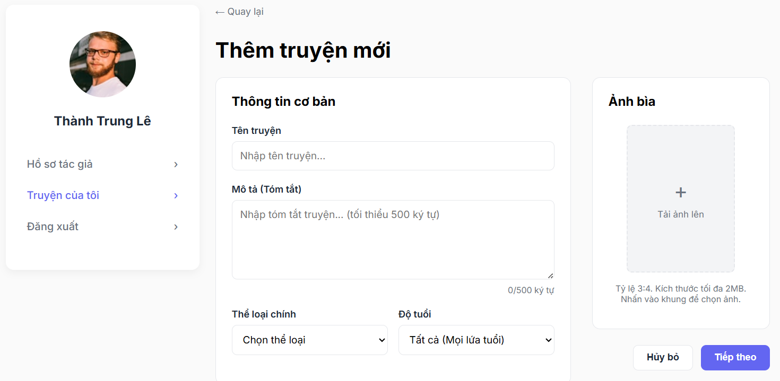

- Add new chapter page:
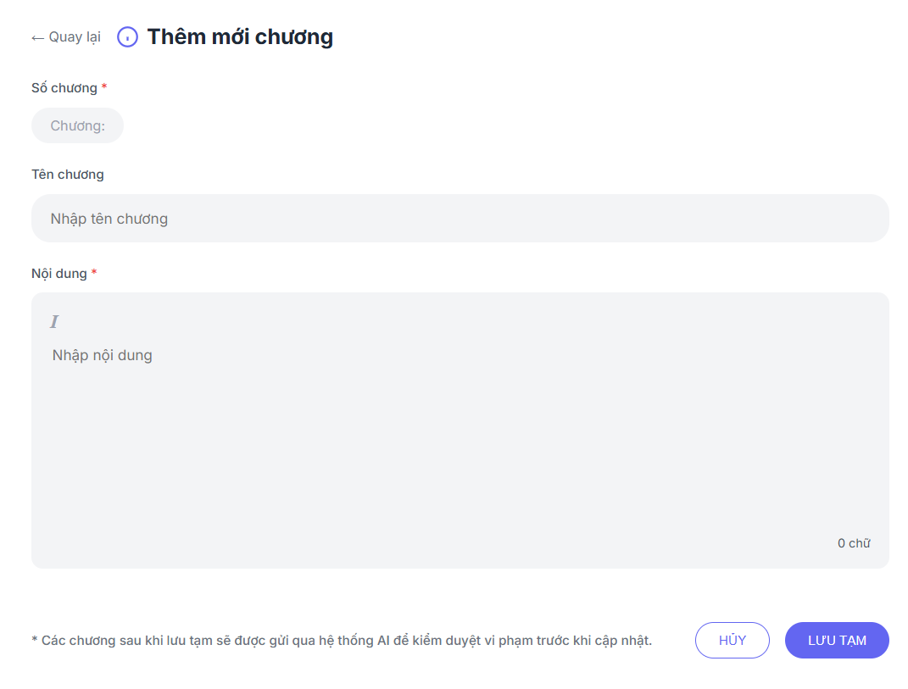

- Check information and send request page:
