EpiData Entry Client
Preliminary Help and Documentation file
v1.02
J.Lauritsen/T.Christiansen

The EpiData EntryClient is used for direct data entry into files from a given project and to browse through the data once these are entered (or imported).

Installation
Currently only test versions are available. Get the most recent version from http://www.epidata.dk/testing.php. When full releases for production are available this will be announced in the EpiData list and shown on the website.

Download and install the EntryClient for your operating system (Linux, Machintosh or Windows).

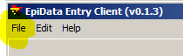
Preparation of data
Before you can work with data in the EntryClient preparation must be done with the EpiData Manager. Once this is done in the EntryClient all you do is to open the project file containing the data. (menu file, or Ctrl+O). Files are of two types – the .epx file and the .epz file. Contents are the same except that the epz file is a zip file version of the epx file. If you have a .epz file, then try to rename it to .zip. Any unzip program can then unzip the file and you will notice that the content is a .epx file.
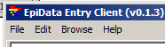
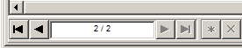
After you open the file, the menu changes, such that a ”browse” part is also found. This part indicates how you can move between records, including showing the short-cut keys.
You may also use the indicator at the bottom of the screen. To go to a specific record write the number.

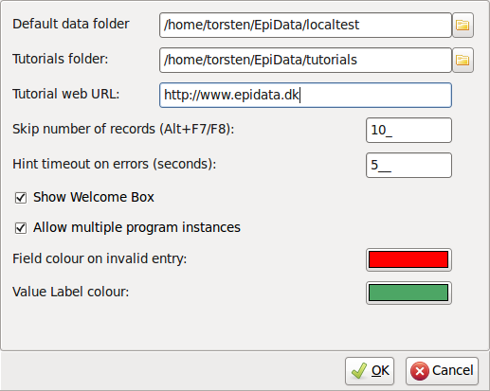
Settings
The EntryClient has a number of settings:

- Default Data folder: This is the starting folder for then ”open file” dialog.
- Tutorials folder: The program searches this folder for .pdf files and places found files in the help menu.
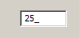
- Tutorial web URL: A user customized link to a website. This link opens when cliking on ”Tutorials on Web” in the help menu.
- Skip number of records: The number of records to skip forward or backwards if the user presses F5 / F8.
- Show Welcom Box: Show a small welcome box in the upper left corner of the screen.
- Allow multiple program instances: If NOT ticked, the program can only have one instance running at a time.
- Field colour...: If an illigal entry is made, the field is focused and given this colour.
- Value Label colour: If the field is showing the label part of a value label right of the field, the label will be given this colour. (Option to show value label is set in EpiData Manager.)
Notes on data entry:
With the introduction new attributes for fields a new aspect of data entry has risen – flow of entry. On a normal entry of fields, the flow is defined as moving from field to field in a left-to-righ, then down, manner – but with respect to sections.

The flow of entry is respected whenever a field is left either because the entire length of the field is filled* or by using one of the following keys: ”Arrow down”, ”Enter” or ”Tab”.

It is however possible to break the flow of entry (although this is normally not recommended) by using the mouse to click on a new field or pressing the “Arrow up” key. It is not recommended because a field could have some attributes set the defines another flow of entry (see jumps below).

The new attributes are:
- A field can have the ”Must Enter” attribute set. This mean that during entry, the field cannot be left without the user entering some data. If the user tries to leave the field, but without entering data, an error notification is given and the field regains focus.
As above it is possible to break the flow of entry, but it is not recommended.
Before a record is saved all fields are validated and if a field marked with ”Must Enter” exists and have no data, an error notification is given, focus is set to the field and the record is NOT saved.
- A field may have one or more jumps defined. A jump is meant a control instance for the flow of entry, where the normal flow is broken for a user defined flow.
- A field may have the “Confirm entry” attribute set. During normal data entry, a field is automatically left if the entire length of the field is left. If this attribute is set the user must actively press any of the flow keys (see above) before the field is left.
- A field may have the “No Enter” attribute set (mutually exclusive with “Must Enter”). This will leave the field in a disabled state during entry and cannot be focused. At the moment this attribute has no sensible meaning but in the future where scripting is possible, it will be possible to create a script the writes data to a no-entry field.

Timed recovery and backup after file closing
It is very important to recognise, that while you are entering data these are ONLY in memory and not saved to a disk. When setting up the project the Manager indicates two aspects for securing the data:
- Timed recovery backup. This means that for every – e.g. 10 minutes a copy of the current data in memory is saved. If for some reason the Client brakes down you can then recover the data and will be asked when you open the files next time whether you wish to recover the data.
- Backup after closing. A zipped copy of the file (epz) will be created with the date of today added to the name. If you open the project more than once per day, the file will be overwritten until you reach a new date.

