Short Introduction to EpiData manager
J.Lauritsen v1.0

The EpiData Project and Data Manager - in short EpiData Manager - is used for defining new data structures, modifying existing data structures (without loss of data) and documentation or export of data.

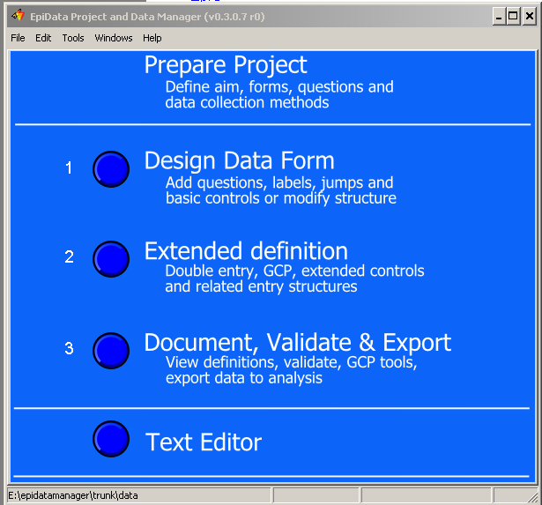
The Manager will gradually replace the existing EpiData Entry software as development goes on.

When starting the application You will see a blue front with white text and four buttons. By clicking on the buttons as indicated in the figure the different parts will be activated. An alternative is to use the menus.

The workflow is a graphical visualisation of a project. Preparing the project is not in the scope of the software, but obviously a necessary part of getting sound and valid data.

Most users will only need part 1 and 3 in the figure, whereas the ”Text Editor” and the ”Extended definition” is relevant for advanced users.

Functionality will increase with the implementation of features in the software. Information on development will be given in the EpiData-list, which you can find on the front page of http://www.epidata.dk

Why change to EpiData Manager ?
Since release of first EpiData software in 1999 many aspects have changed. The main
reasons for development of the new strategy are:
- New users are increasingly ”graphicly” oriented and focused on mouse usage.
  - not understanding the well known qes-chk-rec principle
- There is a need for multiplatform development (Linux, Mac, Windows, PDA …..)
- Font management is changing to UTF-8 to avoid nationalisation problems
- We wish to implement GCP (Good Clinical Practice) required for many medical data projects. This demands encryption and logging of editing at a very detailed level.
- There should be a common ”engine” for all EpiData software, such that handling of data and metadata (labels etc.) are based on the same internal routines.
- When doing data entry it should not be immediately easy to change rules or structure for data entry personnel. Therefore a dedicated EpiData EntryClient will be developed – serving only data entry.

How will a project manager see the new strategy ?
The work process is more clearly divided into what the manager does and what the data
entry persons do. The EpiData Manager is a tool for the project person, which:
- Defines data structures, adds metadata (labels and definitions), documents data and exports for analysis.
- Updates data with new fields, changed formats for fields (e.g. More decimals) and is used for control of data.
- There is a choice of using computers with either Linux, Mac or Windows depending on the choice of the person. Files created are independent of operating system.

Basic ways of using the new software are explained on the next page. Please comment on
functionality and possible discrepancies with your expectations on the EpiData List.
(http://lists.umanitoba.ca/pipermail/epidata-list/)

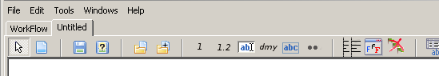
How to create data forms ?
When you select ”Design Data Form” on the Workflow screen a new empty Data Form is shown. The toolbar contains buttons for adding a file or the structure from a file, a group of buttons for single fields as seen at ”Add Integer” and to the right of this a group of buttons allowing for aligning, erasing or showing the structure of a data form.

When you save the form a file will be created in the format called ”RecXml”, which
contains as well the visual design as any data within file from before the structure.

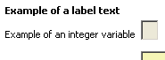
There are two types of elements on a data form. Data entry fields of different types (integer, float, date, string etc.) and label texts, which are just used for ”guidance” or as headings.

A field is where the user enters data. When all observations have been recorded the data is read into analysis software. Fields on the data form are then used as variables in the analysis.

How to create data forms ?

Experiment with the following strategies when defining new data structutes:
:
Point and click:
- Point on the toolbar for a given type of field and click - this indicates type of field.
- Place the mouse curser on the dataform and click on the left button. The field open box will be shown, where you can indicate field name, field label and length.
- Move the entry box around or change.

Quick addition of fields
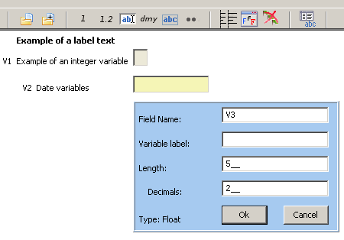
Press F2, F3, F4, F5, F6, which will add fields at the bottom of current data form and give you the opportunity to add labels, length and variable name for each.

Right click on the "dmy" button to change default date type.

Even quicker is to use the Shift+F2 .... F5 keys to add fields without opening the field edit box.

Editor usage - QES principle
- Open the editor from the workflow or menu.
- To work with QES structure, write such a structure in the editor.
e.g. This is my question ##
Happened on <dd/mm/yyyy>
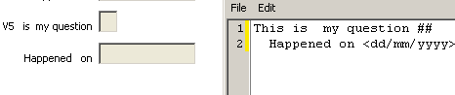
- Mark the text as block
- Press F8 - and you will see the fields on the data form.
- Experiment also with the other "paste special" options shown in the main menu.

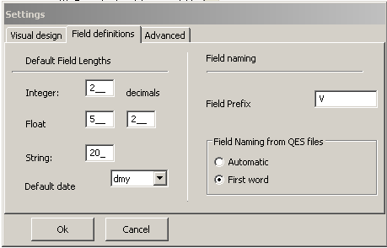
Default settings.
Also experiment with settings, which are shown with ”Alt+S” or in the "Edit" part of the main menu. There are three aspects in this as shown on the ”Visual design” ”Field definitions” or ”Advanced” tab pages, as shown in the figure.

Align on data form
Do some experimentation with alignment. (F11)

