EpiData EntryClient

Short Introduction, Documentation and help file. v2.01
J.Lauritsen/T.Christiansen

The EpiData EntryClient - in short EntryClient - is used to enter or edit data already defined and contained in a project created with the EpiData Manager.

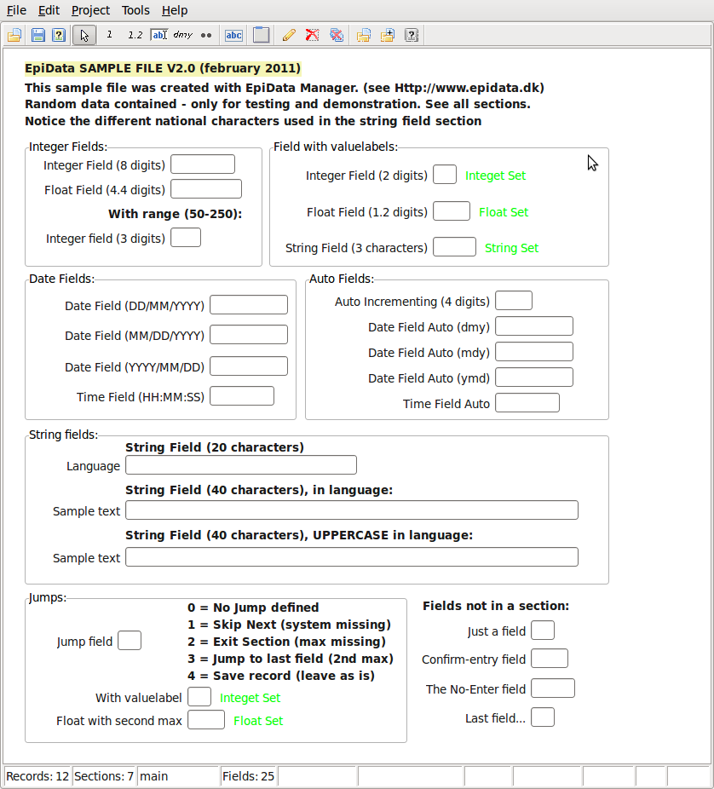
The EntryClient is now the main tool for entering data replacing the EpiData Entry software developed from 1999-2008.

The EpiData EntryClient is used for direct data entry into files from a given project and to browse through or search the data once these are entered (or imported). The EntryClient was developed in a way, where the user cannot change the structure or definition of a given file.

Changes are made with the Epidata Project Manager

Installation
Get the most recent public release from http://www.epidata.dk/download.php for "real projects".

Whereas the development versions from http://www.epidata.dk/testing.php should only be used for testing to provide feedback and discussions on the EpiData-List.

Download the EntryClient for your particular operating system (Linux, Machintosh or Windows). Depending on your situation you can either download the install or the "packed" version. Both are in function the same, but the setup and time to get to work should be easier with the install version. Sometimes local restrictions do not allow "install versions" - in such a situation get the packed file version and unpack it to a folder of your decision. The files do not need an installatiion as such. Just click on the downloaded or unpacked EpiDataEntryClient "exe" file and this will run.

Preparation of data
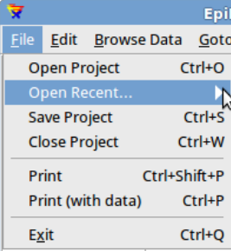
Before you can work with data in the EntryClient you must prepare data in the EpiData Manager.

Once this is done in the EntryClient all you do is to open the project file containing the data. (menu file, or Ctrl+O).

Files are of two types – the .epx file and the .epz file. Be careful in choosing the correct one. Contents are the same except that the epz file is a zip file version of the epx file.

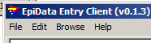
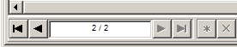
After you open the file, the menu changes, such that a ”browse” part is also found. This part indicates how you can move between records, including showing the short-cut keys.
You may also use the indicator at the bottom of the screen. To go to a specific record write the number.

Settings
The EntryClient has a number of settings:

- General Page:
  - Show Welcom Box: Show a small welcome box in the upper left corner of the screen.
  - Allow multiple program instances: If NOT ticked, the program can only have one instance running at a time.
  - Skip number of records: The number of records to skip forward or backwards if the user presses F5 / F8.
  - Hint timeout: The number of seconds a hint is shown on wrong entry.
- Path page:
  - Default Data folder: This is the starting folder for then ”open file” dialog.
  - Tutorials folder: The program searches this folder for .pdf files and places found files in the help menu.
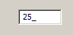
  - Tutorial web URL: A user customized link to a website. This link opens when cliking on ”Tutorials on Web” in the help menu.
- Colours Page:
  - Field colour...: If an illigal entry is made, the field is focused and given this colour.
  - Value Label colour: If the field is showing the label part of a value label right of the field, the label will be given this colour. (Option to show value label is set in EpiData Manager.)
  - Active Field: Colour shown for the active field in focus, where data is currently entered.
  - Inactive field: All other fields not having focus.

Notes on data entry:
With the introduction new attributes for fields a new aspect of data entry has risen – flow of entry. On a normal entry of fields, the flow is defined as moving from field to field in a left-to-righ, then down, manner – but with respect to sections.

The flow of entry is respected whenever a field is left either because the entire length of the field is filled* or by using one of the following keys: ”Arrow down”, ”Enter” or ”Tab”.

It is however possible to break the flow of entry (although this is normally not recommended) by using the mouse to click on a new field or pressing the “Arrow up” key. It is not recommended because a field could have some attributes set the defines another flow of entry (see jumps below).

The new attributes are:
- A field can have the ”Must Enter” attribute set. This mean that during entry, the field cannot be left without the user entering some data. If the user tries to leave the field, but without entering data, an error notification is given and the field regains focus.
As above it is possible to break the flow of entry, but it is not recommended.
Before a record is saved all fields are validated and if a field marked with ”Must Enter” exists and have no data, an error notification is given, focus is set to the field and the record is NOT saved.
- A field may have one or more jumps defined. A jump is meant a control instance for the flow of entry, where the normal flow is broken for a user defined flow.
- A field may have the “Confirm entry” attribute set. During normal data entry, a field is automatically left if the entire length of the field is left. If this attribute is set the user must actively press any of the flow keys (see above) before the field is left.
- A field may have the “No Enter” attribute set (mutually exclusive with “Must Enter”). This will leave the field in a disabled state during entry and cannot be focused. At the moment this attribute has no sensible meaning but in the future where scripting is possible, it will be possible to create a script the writes data to a no-entry field.

Timed recovery and backup after file closing
It is very important to recognise, that while you are entering data these are ONLY in memory and not saved to a disk. When setting up the project the Manager indicates two aspects for securing the data:
- Timed recovery backup. This means that for every – e.g. 10 minutes a copy of the current data in memory is saved. If for some reason the Client brakes down you can then recover the data and will be asked when you open the files next time whether you wish to recover the data.
- Backup after closing. A zipped copy of the file (epz) will be created with the date of today added to the name. If you open the project more than once per day, the file will be overwritten until you reach a new date.

Setup / flow relational systems
For relational systems, notice further settings of what happens after entering data at a given level.
