EpiData Entry Client
Preliminary Help and Documentation file
v0.01
J.Lauritsen/T.Christiansen

The EpiData EntryClient is used for direct data entry into files from a given project and to browse through the data once these are entered (or imported).

Installation
Currently only test versions are available. Get the most recent version from http://www.epidata.dk/testing.php. When full releases for production are available this will be announced in the EpiData list and shown on the website.

Download and install the EntryClient for your operating system (Linux, Machintosh or Windows).

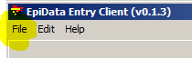
Preparation of data
Before you can work with data in the EntryClient preparation must be done with the EpiData Manager. Once this is done in the EntryClient all you do is to open the project file containing the data. (menu file, or Ctrl+O). Files are of two types – the ..epx file and the ...epz file. Contents are the same except that the epz file is a zip file version of the epx file. If you have a ...epz file, then try to rename it to ...zip. Any unzip program can then unzip the file and you will notice that the content is a ...epx file.
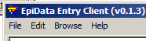
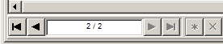
After you open the file, the menu changes, such that a ”browse” part is also found. This part indicates how you can move between records, including showing the short-cut keys.
You may also use the indicator at the bottom of the screen. To go to a specific record write the number.

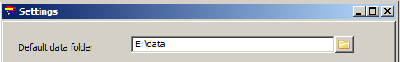
Settings
The EntryClient has two settings:
Default Data folder

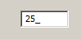
The number of records to skip forward or backwards if the user presses alt+F8 or alt+F7.

Timed recovery and backup after file closing
It is very important to recognise, that while you are entering data these are ONLY in memory and not saved to a disk. When setting up the project the Manager indicates two aspects for securing the data:
- Timed recovery backup. This means that for every – e.g. 10 minutes a copy of the current data in memory is saved. If for some reason the Client brakes down you can then recover the data and will be asked when you open the files next time whether you wish to recover the data.
- Backup after closing. A zipped copy of the file (epz) will be created with the date of today added to the name. If you open the project more than once per day, the file will be overwritten until you reach a new date.

