Short Introduction to EpiData manager (test versions)
v1.06
J. Lauritsen & T. Christiansen

The EpiData Project and Data Manager - in short EpiData Manager - is used for defining new data structures, modifying existing data structures (without loss of data) and documentation or export of data.
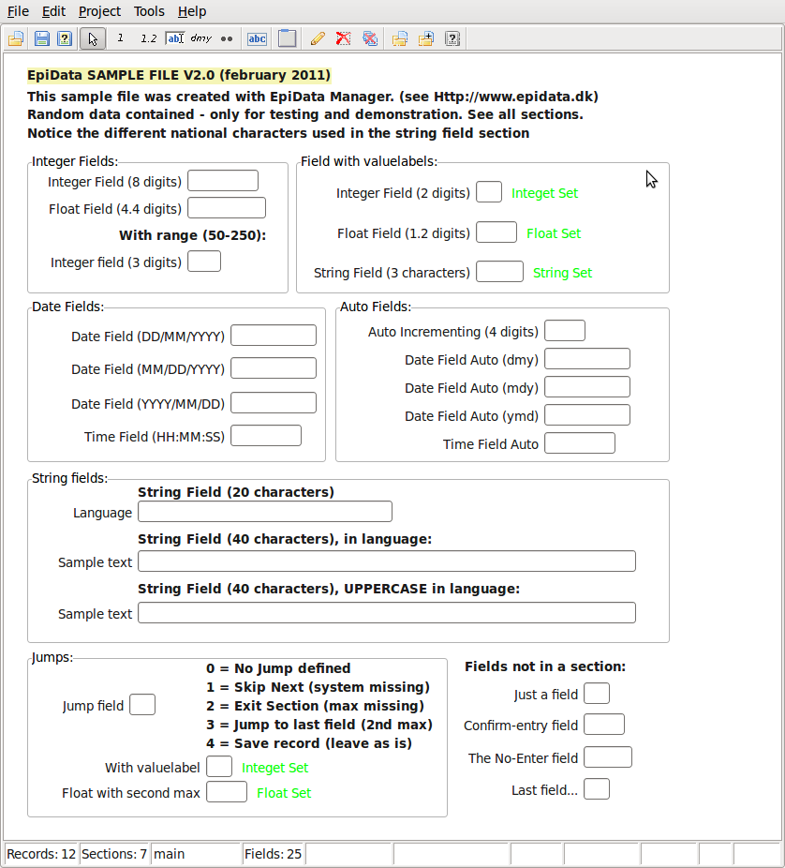
The Manager will gradually replace the existing EpiData Entry software as development continues.

The application will be shipped with a sample file which contain a number of field, section and records with sample data. You can use this sample file as you like and will be available from the testing site also.
The sample file will have a wide variety texts (in native languages) and try to use the latest features implemented in the program to show how a project file may be used.

Functionality will increase with the implementation of features in the software. Information on development will be given in the EpiData-list, which you can find on the front page of http://www.epidata.dk

Why change to EpiData Manager ?
Since release of first EpiData software in 1999 many aspects have changed. The main
reasons for development of the new strategy are:
- New users are increasingly ”graphically” oriented and focused on mouse usage.
  - not understanding the well known qes-chk-rec principle
- There is a need for multi-platform development (Linux, Mac, Windows, PDA …..)
- Use of Unicode (UTF-8) to support non-latin characters uniformly across multiple platforms.
- We wish to implement GCP (Good Clinical Practice) required for many medical data projects. This demands encryption and logging of editing at a very detailed level. I also demands control of user access to data.
- There should be a common ”engine” for all EpiData software, such that handling of data and meta-data (labels etc.) are based on the same internal routines.
- When doing data entry it should not be immediately easy to change rules or structure for data entry personnel. Therefore a dedicated EpiData EntryClient has been developed – serving only data entry.
Help in EpiData Manager
Some features of the help menu will come later in development. The intention is to have a link to introduction notes (this file), a link to keyboard short cuts (on internet), and a local short introduction (pdf). Therefore save this introduction file in the same folder as your exe file for manager. Just see in a given test version how far we are with this development.

How will a project manager see the new strategy ?
The work process will be more clearly divided into what the manager does and what the data entry persons do.

The EpiData Manager is a tool for the project manager person:
- Defines data structures, adds metadata (labels and definitions), documents data and exports for analysis.
- Updates data with new fields, changed formats for fields (e.g. more decimals) and is used for control of data.
- There is a choice of using computers with either Linux, Mac or Windows depending on the choice of the person. Files created are independent of operating system.

Basic ways of using the new software are explained on the next page. Please comment on
functionality and possible discrepancies with your expectations on the EpiData List.
(http://lists.umanitoba.ca/pipermail/epidata-list/)

How to create and modify data structures ?
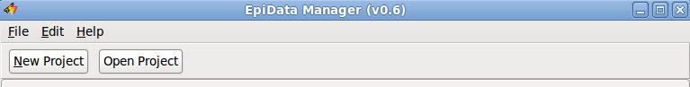
When you start the program, an empty form is shown with a work toolbar in the top. Click “New Project” to start creating a new project or “Open Project” to open a previously created project, eg. the sample file.

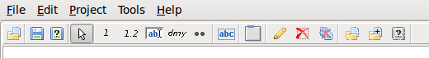
In either case a toolbar is shown in the top. This toolbar contains buttons placed into logical groups of similar functionality.

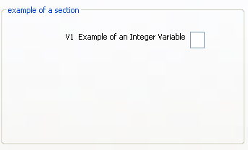
The "arrow" is the default tool and is used to interact with the components placed on the data form. Next is the group with fields that allows for creating the supported types of fields (e.g. Integer, Float, string, etc. - note this list differs slightly from previous versions of Manager and Entry). Next to the fields are two independent tools, the Heading tool which is used to create new headings (previously know as labels) and to the right is the new "Section" tool.

This gives three types of elements on a data form. Data entry fields of different types (integer, float, date, string etc.), text headings, which are just used for ”guidance” and section, for grouping common fields and heading into logical units.

A field is where the user enters data. When all observations have been recorded the data can be read by analysis software, such as EpiData Analysis (currently only Windows®). Fields on the data form are then used as variables in the analysis. The sections will be the level for control of user access, e.g. some entry persons could have read only access to main data, and edit rights to a section with supplementary data.

How to create data forms in practice ?
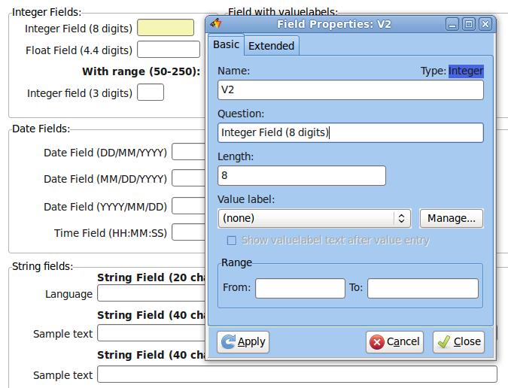
Experiment with the following strategies when defining new data structutes:

Point and click:

- Point on the toolbar for a given type of field and click - this indicates type of field.
- Place the mouse cursor on the dataform and click on the left button. The field open box will be shown, where you can indicate name, question and length.
- Move the entry box around or change.

Quick addition of fields

Press F2, F3, F4, F5, F6, which will add fields and headings at the bottom of the current data form and give you the opportunity to add question, length and name for each.

Right click on the "dmy" button to change default date type.

Even quicker is to use the Shift+F2 .... F5 keys to add fields without opening the field edit box.

Paste text and create data fields and headers
Open any editor or other software (text processor) etc. and create text lines. Mark these lines in a block and copy to the clipboard.

e.g. simple text:
Sex
age
date of birth
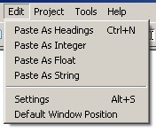
Then switch to the EpiData Manager and paste the text as fields or heading lines. For pasting the same type of field several times you might wish to change the default paste type in settings.

The fields are named Vx....Vx+n where the "V" is the prefix specified in settings and the x is the number of fields on the dataform. This style is what is known as "First Word" in EpiData Entry.

Default settings.
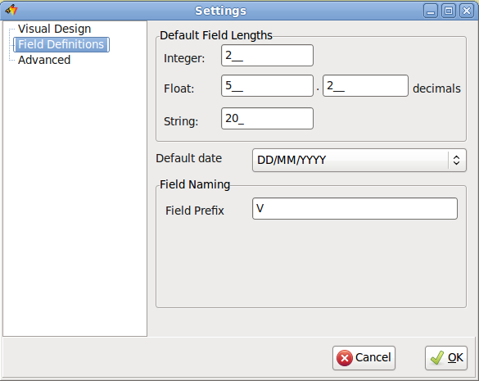
Also experiment with settings, which are shown with ”Alt+S” or in the "Edit" part of the main menu.

There are three aspects in this as shown on the ”Visual design” ”Field definitions” or ”Advanced” tab pages.

On the visual design tab snapping is defined. When this is "on", the software tries to autoalign components on the same x or y co-ordinate during a move (dragging a component around).

Keyboard Short cuts.
Please see the latest changes to keyboard shortcuts on the EpiData wiki page:
http://www.epidata.org/dokuwiki/doku.php/documentation:program_keys

