Short Introduction to EpiData Manager
v2.01
J. Lauritsen & T. Christiansen

The EpiData Project and Data Manager - in short EpiData Manager - is used to define new data structures, modify existing data structures (without loss of data) and documentation or export of data.
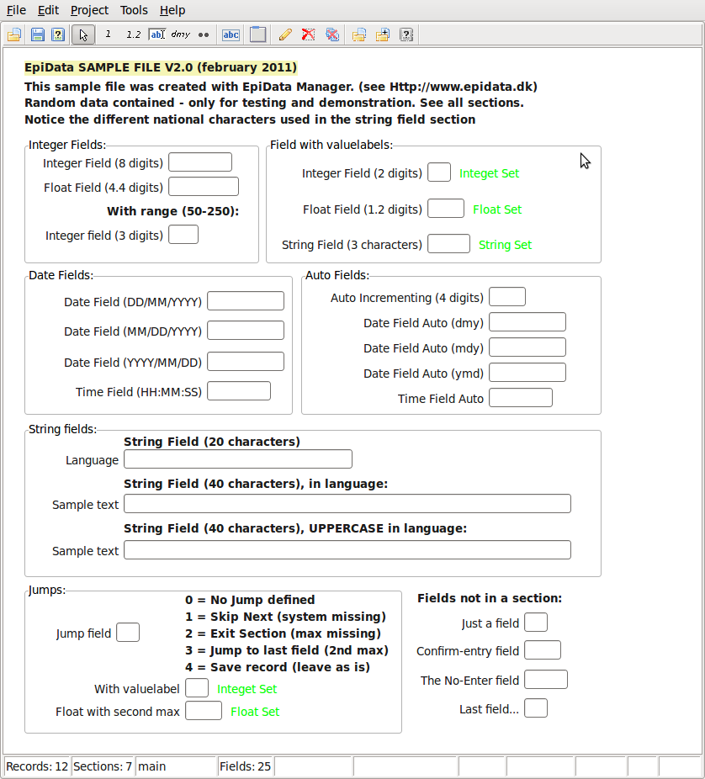
The Manager is now the main tool for project Managers replacing the EpiData Entry software developed from 1999-2008.

The application will be shipped with a sample file which contain a number of field, section and records with sample data.

The sample file contains a wide variety of texts in native languages to show that now we store all data in an extended and modernised format.

Functionality will continue to expand when we develop and implement new features in the software. Information on development will be given in the EpiData List, which you can find on the front page of http://www.epidata.dk.

Key features of EpiData Manager ?
Since release of first EpiData software in 1999 many aspects have changed.

The main reasons for development of the new strategy now represented with the EpiData Manager and EpiData EntryClient are:
- New users are increasingly
  - ”graphically” oriented and focused on mouse usage.
  - not understanding the well known qes-chk-rec principle
- There is a need for multi-platform development (Linux, Mac, Windows, PDA …..)
- Use of Unicode (UTF-8) to support non-Latin characters uniformly.
- We wish to implement GCP (Good Clinical Practice) required for many medical data projects. This demands encryption and logging of editing at a very detailed level. It also demands control of user access to data.
- There should be a common ”engine” for all EpiData software, such that handling of data and meta-data (labels etc.) is based on the same internal routines.
- When doing data entry it should not be immediately easy for the data entry personnel to change rules or structure. Therefore a dedicated EpiData EntryClient has been developed – serving only data entry.

How will a project manager see the new strategy ?
The work process will be more clearly divided into what the manager does and what the data entry persons do.

The EpiData Manager is a tool for the project manager person:
- Defines data structures, adds metadata (labels and definitions), documents data and exports for analysis.
- Updates data with new fields, changed formats for fields (e.g. more decimals) and is used for control of data.
- There is a choice of using computers with either Linux, Mac or Windows depending on the choice of the person. Files created are independent of operating system.

Basic ways of using the new software are explained on the next page. Please comment on
functionality and possible discrepancies with your expectations on the EpiData List.
(http://lists.umanitoba.ca/pipermail/epidata-list/)

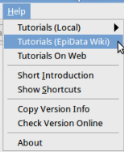
Help in EpiData Manager
The help structure is visible from the help menu. Help files are partially installed locally contained in pdf files. Other aspects will require internet access. In the preference settings found under "Edit" menu, you may indicate precise plaments.
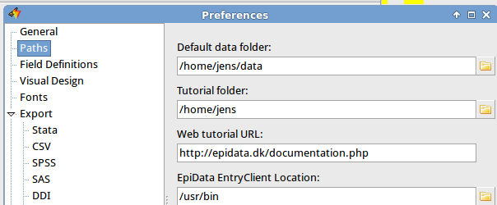

Users are encouraged to assist in developing manuals and instructions, which can be placed on your own web system with links from EpiData.dk, or in the wiki.

How to create and modify data structures?
When you start the program, an empty form is shown with a work toolbar in the top.

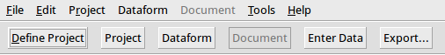
From version 2.0 several dataforms can be part of the same project in a relational structure. Therefore a new button is added with "Dataform". Some aspects will then be part of the dataform settings and others for the whole project. In a relational structure one to many data forms are contained within a project. E.g. one for person information, one for visits and one for family level or household.
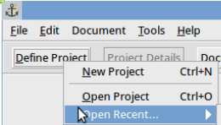
Click “Define Project” and choose either
- "New Project": To create a project from scratch.
- “Open Project” to open a previously created project, e.g. the sample file.
- "Recent files" : To open again a project that you worked on.

Focus on study information.
Formal requirements to document projects and data structures are increasing in many countries. Therefore from version 2.0 you will see "Study Information" as part of the opening.

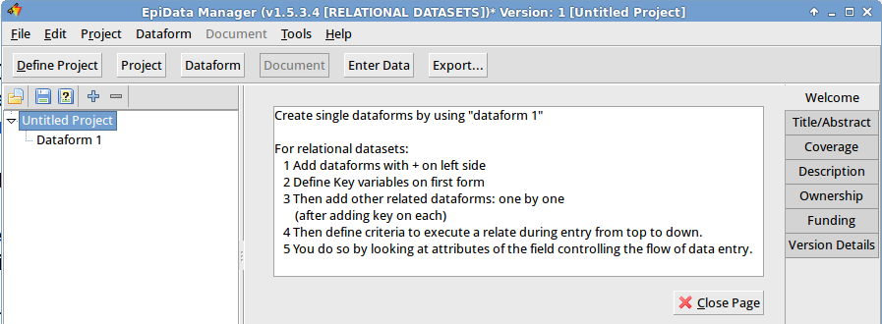

In the "Untitled Project" you can edit the title of the project and on the right you see the various parts of the study information, which are needed to know what is this project about. The details of this (Coverage, Description etc) follows standard study descriptions and is part of the intention to further document studies. The full set of study information is known as the Dublin Core collection.

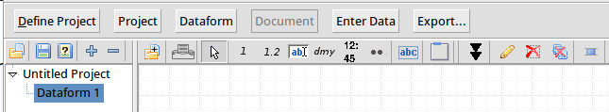
If you click on the "Dataform 1" on the left you will see a working toolbar, as shown here:

The toolbar is now divided into two parts:
1 On the left you manage the number of data forms in the project.
2 On the right side of the divider you have a single data form.

Hold the mouse over a given icon to see the function of that one. The toolbar contains buttons placed into logical groups of similar functionality.

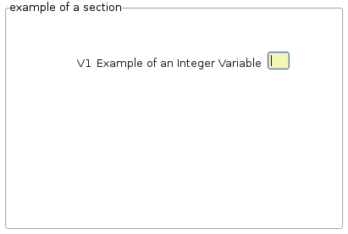
The "arrow" is the default tool and is used to interact with the components placed on the data form. Next is the group with fields that allows creating the supported types of fields (e.g. integer, float, string, etc). Next to the fields are two independent tools, the Heading tool which is used to create new headings. To the right is the new "Section" tool. Extend page etc.

This gives three types of elements on a data form. Data entry fields of different types (integer, float, date, string etc.), text headings, which are just used for ”guidance” and sections, for grouping common fields and heading into logical units.

A field is where the user enters data. When all observations have been recorded the data can be read by analysis software, such as EpiData Analysis (currently only Windows®). Fields on the data form are then used as variables in the analysis. The sections will be the level for control of user access, e.g. some entry persons could have read only access to main data, and edit rights to a section with supplementary data.

How to create data forms in practice ?

Experiment with the following strategies when defining new data structures:
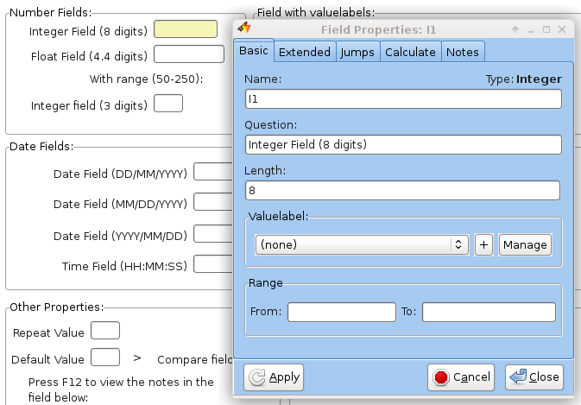
Point and click:
- Point on the toolbar for a given type of field and click - this indicates type of field.
- Place the mouse cursor on the data form and click on the left button. The field open box will be shown, where you can indicate name, question and length.
- Move the entry box around or change.
- Extend the data form in length by clicking on the icon with two down arrows (number 4 from the right)
- Align fields on the page by selecting them with drawing a square around them with the mouse and use the align tool (right most icon).
- Move some fields by clicking and holding the mouse down and move it to some other place.

Quick addition of fields

Press 1, 2, 3, 4, 5, which will add fields and headings at the bottom of the current data form and give you the opportunity to add question, length and name for each.
Right click on the "dmy" button to change default date type.
Even quicker is to use the Shift+1....5 keys to add fields without opening the field edit box.

Paste text and create data fields and headers
Open other software (text processor) etc. and create some text lines. Mark these lines in the other software as a block and copy to the clipboard.
e.g. simple text:
Sex
age
or some dates :
date of birth
date of visit

Then in the "edit menu" find the appropriate part and paste as you desire, see next page.
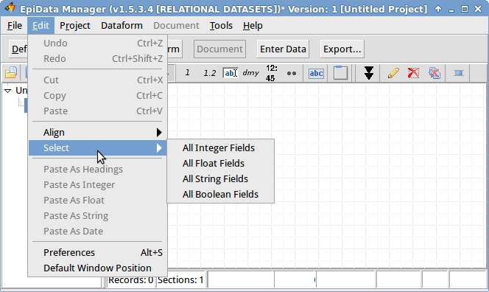

Then switch to the EpiData Manager and paste the text as fields or heading lines. For pasting the same type of field several times you might wish to change the default paste type in settings.

The fields are named Vx....Vx+n where the "V" is the prefix specified in settings and the x is the number of fields on the data form.

This style is what is known as "First Word" in EpiData Entry.

Default settings.

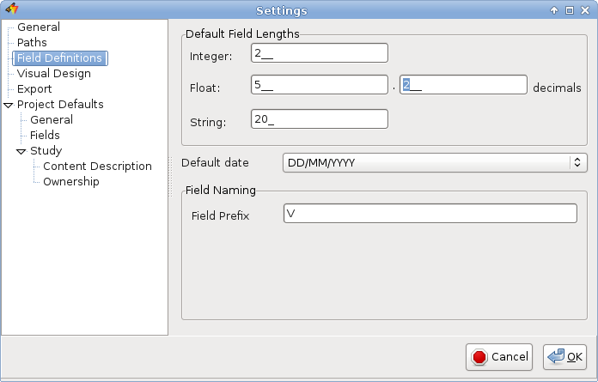
Also experiment with settings, which are shown with ”Alt+S” or in the "Edit" part of the main menu.

There are three aspects in this as shown on the ”Visual design” ”Field definitions” or ”Advanced” tab pages.

On the visual design tab snapping is defined. When this is "on", the software tries to autoalign components on the same x or y coordinate during a move (dragging a component around).

Keyboard shortcuts.
Please see the latest changes to keyboard shortcuts on the EpiData wiki page:
http://www.epidata.org/dokuwiki/doku.php/documentation:program_keys
or in the help menu.

Relational data structures

You build these with the left part of the above.

For more information try out the sample file "Clinical_example" provided with the software under examples.

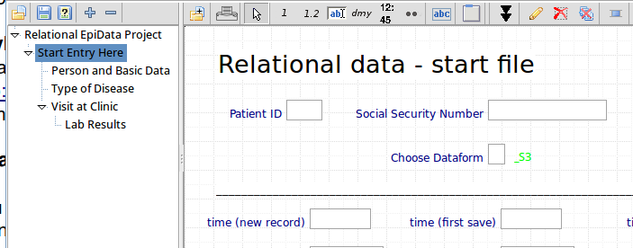
It is important to follow the suggested mode of creating such structures as is indicated when you create a new project:

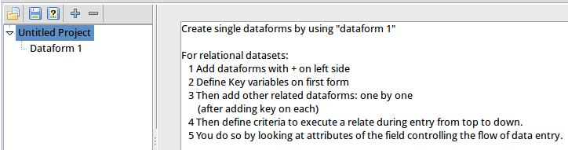
Consider when you need 1:1 relate and when you need 1:many

For a given field you may define the "flow criteria" under that field as shown here:
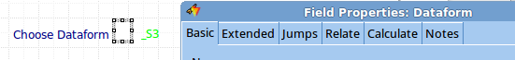

Always remember that in Manager as well as in EntryClient you define default behaviour related to a given project in "Project Details" - experiment with the various settings.

More information will be given on the list and future versions of this document.

