User Manual: ForeSITE Alerting Report

1. Introduction
ForeSITE Alerting Report is an open-source C# WPF application designed specifically for time-series epidemiological data analysis and automated alerting. It allows public health professionals and analysts to transform raw surveillance data into actionable insights through automated PDF reports and visualizations. The system integrates a C# frontend with a Python Flask backend to process data using the epySurv module.

2. System Requirements
To ensure the application runs correctly, your system should meet the following requirements:
- Operating System: Windows 10 or later.
- .NET Frameworks: .NET 8.0 or higher.
- Python: Version 3.7 or later (required for the Flask server and epySurv package).
- Privileges: Administrative privileges are required to create and manage scheduled tasks.

3. Installation and Setup

Option A: Release Version (Recommended)
- Download and extract the latest release archive on GitHub.
- Download Python epySurv dev environment from https://github.com/EpiForeSITE/ForeSITE_Alerting_Report/releases/download/V0.6/epysurv-dev.tar.gz
- Setup the configuration file on your folder ForeSITETestApp/Server/config.json
In this file, we need to indicate the python epySurv folder, as this example:

{
"pythonPath": "C:\\Users\\taohe\\miniconda3\\envs\\epysurv-dev\\python.exe",
"RPath": "C:\\Users\\taohe\\miniconda3\\envs\\epysurv-dev\\Lib\\R",
"serverPath": "epyflaServer.py",
"logPath": "",
"activateCommand": "C:\\Users\\taohe\\miniconda3\\envs\\epysurv-dev\\Scripts\\activate.bat",
"envName": "epysurv-dev",
"host": "smtp.gmail.com",
"port": 587,
"enableSsl": true,
"username": "<your gmail address>",
"password": "<ypur google app password>",
"from": "<your gmail address>",
"fromDisplay": "ForeSITE Alerting Report"
}

Change the Yellow-marked paths to indicate your environment, and also setup your gmail address and your google app password

Seach “Google app password”, you can see the link in google account help document:
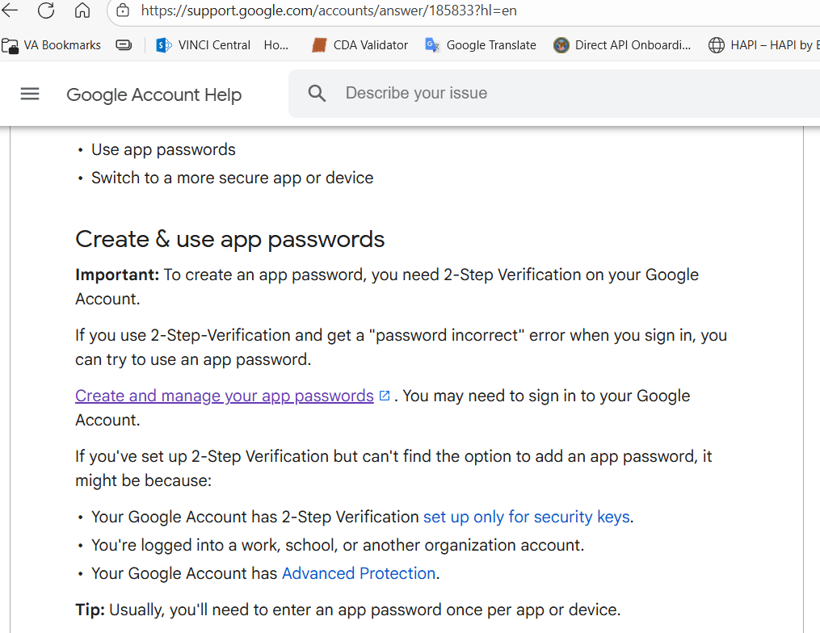

Click to create a google app password for your own google email address by login and then you can create it:

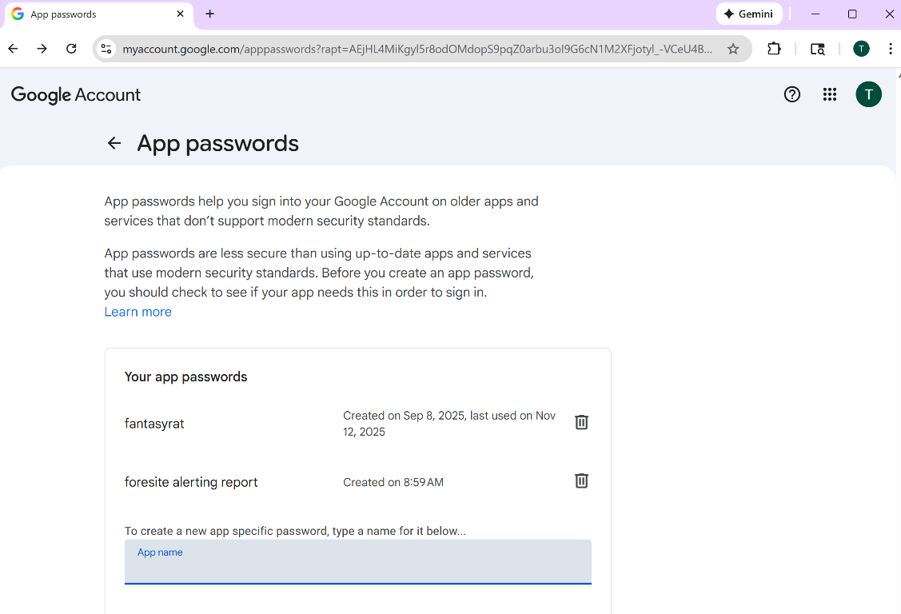
- Run ForeSITEAlertingReport.exe from the extracted folder.
- The application includes a bundled .NET 8 runtime and a pre-configured Python environment (epysurv-env).

Option B: From Source Code
- Clone the Repository: Use git clone to download the source from GitHub.
- WPF Setup: Open ForeSITETestApp.sln in Visual Studio 2022 and restore NuGet packages.
- Flask Server: Install dependencies (pip install flask pandas matplotlib) and run python app.py. Note: While the application can call the Flask server automatically in the background, manual starts can be used for testing.

4. Core Features and Usage

4.1 Creating a Report
- Add a Title: Navigate to the 'Reporter' tab and use the rich text editor to create a customized, formatted title.
- Configure Plots: Click 'Add Plot' to define your data source (CDC public data or custom files), select an analysis model (e.g., Farrington, Bayes, or EARS-C1), and set the time range and thresholds.
- Generate PDF: Click 'Save' to export the finalized report as a PDF using the QuestPDF engine.

4.2 Data Source Management
Users can import custom datasets in CSV or JSON formats. To ensure compatibility, custom data must include a date column (labeled 'date', 'dates', or 'start_date') and a count column (labeled 'cases', 'n_cases', 'deaths', etc.). You can add, edit, or delete these sources in the 'Data Source Manager' tab.

4.3 Automated Scheduling and Emailing
- Navigate to the 'Scheduler' tab.
- Set the frequency (daily, weekly, or monthly) and start date.
- Input recipient email addresses (supports Gmail and Outlook).
- Enable the 'Abnormal Report Only' setting if you wish to receive notifications only when data exceeds set thresholds within the last three units of time.

5. Advanced Analysis: Interactive Notebook
For advanced users, the application features a Jupyter-like notebook window. This allows for runtime analysis using Python and R code cells. Users can dynamically add, execute, and save analysis cells to perform exploratory data analysis directly on surveillance datasets.

6. Troubleshooting
- Flask Server Connectivity: Ensure the backend is running at http://127.0.0.1:5001 before attempting to generate plots.
- Missing Plots: If plots do not appear, verify the 'Year Back' parameter; if your dataset has less than five years of history, set this value to three.
- File Locations: Logs and generated reports are saved by default to C:\Users\<YourUsername>\Documents\ForeSITEAlertingReportFiles.

