Mortality in Korean Chronic Kidney Disease patients

A Korean National Cohort Study

Kyeong Min Kim, Hyung Jung Oh, Hyungyun Choi, Hajeong Lee, Dong-Ryeol Ryu

ESRD Registry Committee, Korean Society of Nephrology, Seoul, Korea

Kyeong Min Kim

Department of Internal Medicine, Eulji University Hospital,

College of Medicine, Eulji University

95, Dunsanseo-ro, Seo-gu, Daejeon, Korea

e-mail: [km1209@eulji.ac.kr](mailto:km1209@eulji.ac.kr)

Tel: 82-42-611-3366, Fax: 82-42-611-3853

Corresponding author

Dong-Ryeol Ryu

Department of Internal Medicine, Ewha Womans University Mokdong Hospital,

College of Medicine, Ewha Womans University

Anyangcheon-ro, Yangcheon-gu, Seoul, Korea

e-mail: drryu@ewha.ac.kr

Tel: 82-2-2650-2507, Fax: 82-2-2650-2501

Running title: Mortality in Korean CKD patients

## Abstract

### Purpose

It is known that mortality is higher in patients with chronic kidney disease (CKD) than in the general population, but there is a lack of data on CKD-related mortality that is representative of the Korean population. Our objective was to investigate the mortality risk in Korean CKD patients.

### Methods

We extracted data of CKD patients without dialysis between January 1, 2003 and December 31, 2007 in Korea using the database of the Korean National Health Insurance Review and Assessment Service and monitored for all-cause mortality during the study follow-up period until December 2013.

### Results

A total of 1,473 incident CKD patients between 2003 and 2007 were included in the analysis. The cumulative incidence of CKD at 5 years is approximately 1.4%. During follow-up period, 941 patients with CKD died (133 deaths/1,000 person-years) compared with 966 deaths in non-CKD patients (24 deaths/1,000 person-years). Therefore, the rate ratio for mortality rate was 5.5.Against matched general population controls, the mortality Hazard Ratio was 7.22 (95% CI, 6.56-7.95, P < 0.0001) for CKD patients.

### Conclusion

In this nationally representative sample cohort study, excess mortality observed for Korean patients with incident CKD. The present findings provide meaningful epidemiological data and remind us of the importance of recognizing CKD as a significant risk factor for mortality.

### Keywords

Chronic Kidney Disease, Cohort studies, Korea, Mortality,

## Introduction

Chronic kidney disease (CKD) is an increasingly global public health problem, and its prevalence is increasing dramatically due to an aging population and increased chronic diseases. A recent study reported that the global prevalence of CKD was increased by 87% and the death from CKD was increased by 98% from 1990 to 2016 [1].

The reported prevalence of CKD is heterogeneous amongst the studies and ranges from 5.8% to 13.1% by countries [2]. Although there is a difference in prevalence rates among countries, according to the National Health and Nutrition Examination Survey reported in the United States, the prevalence of chronic kidney disease in the United States has increased from 10% between 1994 and 1998 to 13.1% between 1999 and 2004, 16% of Australian adults, and 19.1% of Japanese adults were reported to have CKD stage 3 or higher chronic kidney disease [3]. According to the report of the Korean Society of Nephrology, 5% of all subjects had a glomerular filtration rate of less than 60m/min/1.73m² and it is reported that the prevalence of chronic kidney disease in the population aged 60 ~ 69 is 23% and the prevalence of elderly people over 70 years old is more than 35% [4]. In a recent Korean population-based study, including the albuminuria group with albumin-to-creatinine ratio > 30 mg/g regardless kidney function, the prevalence of CKD is known to be approximately 8.2% in patients over 20 years of age and 22% in elderly patients over 60 years [5].

It is known that mortality is higher in patients with CKD than in the general population. Although focused on reducing the risk of progression to dialysis of patients with CKD, these individuals are much more likely to die from any cause than progress to end-stage renal disease (ESRD) requiring dialysis [6]. Because of the absence of symptoms in patients in the early stages of CKD, much of those with early-stage kidney disease don’t even know they have CKD. However, even relatively mild decreases in renal function are associated with significantly increased risk of mortality [7,8]. Therefore, it is important to identify incident CKD patients and provide timely and proper management.

The purpose of this study was to determine the mortality risk in CKD patients than non-CKD counterpart from this national representative sample of Korea from 2002 to 2013 using data from the Korean National Health Insurance Service-National Sample Cohort (NHIS-NSC).

**Subjects and Methods**

**Data resource**

The investigation was performed using data from the National Health Insurance Service-National Sample Cohort in the Republic of Korea. The cohort was composed of 2.2% of the total eligible Korean population (baseline population = 1,025,340 people), which was selected as a representative sample in 2002 using systematic stratified random sampling. The data contained information for demographics such as age groups (<1 years, 1-4 years, 5-84 years, and ≥85 years), sex, income levels, healthcare utilization, prescriptions, and diagnostic codes based on the international classification of disease-10th (ICD-10). Information related to deaths was also provided from the Korea National Statistical Office, with follow-up data from 2002 to 2013 available. Detailed information about the NHIS-NSC can be found in a previously published paper [9]. This study was approved by the Institutional Review Board of the Ewha Womans University Mokdong Hospital (IRB No: 2018-09-007 ). The need for informed consent from patients was waived due to the retrospective design of the study.

**Study sample**

We defined pre-dialytic CKD as follows: those who had new insurance claims with the diagnostic codes of 'N18.x' (chronic kidney disease; N18, N18.1, N18.2, N18.3, N18.4, N18.5, and N18.9) from 1 January 2003 to 31 Dec**e**mber 2007. However, those who were diagnosed with CKD in 2002 were not included in the current study, because the information about their disease history was inaccurate. Of those patients, anyone diagnosed with ESRD was excluded from the study, and ESRD was identified when subjects had insurance claims with a regular dialysis treatment code (O7010, O7020, and O7070). Additionally, subjects who underwent kidney transplantation previously were also excluded. Finally, a total of 1,473 patients were included in the present study as a CKD group.

To construct the control group, among the participants with “0” point of Charlson Comorbidity Index (CCI) [10], three control subjects per one CKD patient were selected through individual matching according to age and sex (n=4,451).

**Study outcomes**

All study participants were monitored for all-cause mortality during the study follow-up duration.

**Statistical analysis**

We presented these subjects after being stratified based on the 65-year old age (less than 65 years old vs 65 years old or more) and sex. Moreover, we also described the yearly incidence rate of CKD in Table 1.

The crude incidence rates were calculated by dividing the number of subjects with a given event by the person-years of follow-up, which were expressed as cases per 1,000 person-years. In addition, Kaplan-Meier curve was conducted to compare the mortality rate between CKD group and control group with log-rank test. Cox proportional hazards analysis was also performed to examine time-to-event association with all-cause mortality. We adjusted age and sex using a multivariate model. This analysis was conducted using SAS version 9.4 (SAS Institute Inc, Cary, NC), and a P-value less than 0.05 was considered statistically significant.

### **Results**

Of a total of 1,025,340 randomly selected individuals from the NHIS-NSC (comprising 2.2 % of the total eligible Korean population in 2002), a total of 1,473 patients (864 men and 609 women) who developed CKD between January 1, 2003, and December 31, 2007, were included in this study. The cumulative incidence of CKD at five-years was approximately 1.4%. The patient characteristics of the participants stratified by the presence of CKD are summarized in Table 1. About 58% of patients with CKD were more than 65 years old, and the proportion of males in all groups was high (59% vs 41%). The number of patients who developed CKD in each year showed an increasing trend. Regarding selected register-identified comorbidities, more than 90% of patients had hypertension with about 80% having had cardiovascular disease, 80% of patients had diabetes mellitus (DM) and 37% of patients had cancer at inclusion.

Among the 1473 participants with CKD, 941 (64%) and among the 7365 participants without CKD, 966 (22%) died until the end of the study period. The death rate was higher in the CKD group than in the non-CKD group (Table 2; Figure 1). The crude death rates among individuals with CKD was 133 per 1000 person-years compared with 24 per 1000 person-years among those without CKD; the rate ratio for mortality was 5.5 (Table 2). When stratified by age group, the crude mortality rate was considerably higher in patients older than 65 years compared with patients younger than 65 years (223 vs 62 in CKD group, 39 vs 5 in the non-CKD group). When stratified by presence of DM, patients with DM exhibited a lower risk of mortality than the non-DM patients (121 vs 199 in CKD group, 24 vs 25 in non-CKD group) (Table 2; Figure 2).

Survival analysis using the Kaplan-Meier survival curves with log-rank test revealed that the survival rate in CKD patients was significantly lower compared to the control group and the gap between the two curves widened over time (Figure 1; P < 0.0001). The mortality by age group and the presence of DM were shown in Figure 2. In non-DM group compared to DM group, the highest mortality risk was in the first 2-years after CKD development, then the risk became stable after 5 years (Figure 2-A, 2-B). In both age groups, the CKD group showed a decrease in cumulative survival over time compared to the non-CKD group, and the cumulative survival was considerably lower in the age group of ≥65 years old ( Figure 2-C,2-D).

For the analysis of independent risk factors associated with all-cause mortality, the Cox proportional hazards analysis was performed. Against matched general population controls, the mortality hazard ratio (HR) was 7.22 times higher for CKD group (95% CI, 6.56-7.95, P < 0.0001) compared to the control group. (Table 3-A). Thereafter we divided the study population into subgroups by age. Compared with patients with non-CKD group, CKD group aged ≥ 65 had a 6.57(95% CI, 5.90-7.32; P < 0.0001), and CKD group aged < 65 years a 13.28(95% CI, 10.3-17.2; P < 0.0001) times greater mortality hazard.

## Discussion

CKD is well-known to be a major risk factor for the development of all-cause mortality. A large number of epidemiologic studies demonstrated that mild elevations in serum creatinine levels are associated with increased rates of death from any cause [9-12].A large observational study showed that the risk of death increased dramatically as the GFR decreased below 60 ml/min per 1.73m² and the adjusted hazard ratio for death was 3.2 [13]. One systematic review of the association between non–dialysis-dependent CKD and the risk for all-cause mortality showed the unadjusted relative risk for mortality in participants with reduced kidney function compared with those without ranged from 0.94 to 5.0 [13]. In another population-based study, the mortality rate was a 120 (deaths/1,000 person-years) against matched general population controls, the mortality HR was 3.6 (95% CI 3.2 to 4.0) for CKD [14]. These results demonstrate that chronic kidney disease is a significant risk factor for death.

Some studies have revealed that racial and ethnic difference exists in mortality outcome among individuals with CKD [16-18]. Asians appear to have faster CKD progression and lower mortality rates compared to Caucasian populations [18]. Because these differences exist, it is important to build and manage the country's data for CKD in each country, which is a global trend. In a recent observational cohort study, the overall age- and sex-adjusted SMR among Korean ESRD patients were 10.3 [95% confidence interval (CI), 10.0-10.6] in 2009 and 10.9 (95% CI, 10.7-11.2) in 2010, respectively [19]. however, there is a lack of representative data on mortality in non-dialysis CKD patients.

In this population-based cohort study, we examined the mortality among Korean incident CKD patients in 2003 and 2007 using the NHIS-NSC database. Development of CKD was associated with significantly elevated risk for all-cause mortality in the Korean population; the mortality rate was 133 per 1000 person-years, the rate ratio for mortality to control group was 5.5 and the mortality HR was 7.2 (95% CI, 6.56-7.95, P < 0.0001). The mortality rate of incident CKD patients in Korea was relatively higher than that of other studies.

There are two interesting points in this study. First, the non-DM group had a higher mortality rate than the DM group and the cumulative survival rate of the non-DM group was rather steeply decreased, especially in the first 2 years of observation [Table 2, Figure 2-A]. It may be interpreted that a decrease in renal functions due to non-diabetic causes a greater impact on mortality than diabetes. Previous studies on the effect of diabetes on the survival of CKD patients are heterogeneous. According to data from Korean end-stage renal disease registry, five-year survival of diabetic dialysis patients was 62.3%, chronic glomerulonephritis patients 84.6%, hypertensive nephrosclerosis patients 73.8%, respectively. However, no systematic assessment has been made of the effects of a non-diabetic cause (hypertension, glomerulonephritis, et. al.) on the mortality and incidence rates of Korean CKD population.

Second, the effect of CKD on mortality at age 65 and younger was greater than at 65 years and over (Table 3). Other underlying diseases or factors that can cause CKD at a younger age appear to have had a stronger effect on the mortality. Kumar et al explained that younger patients with CKD had a cardiac death rate of more than 100 times and that the largest relative excess was observed [20]. Further research is needed to determine whether there is a difference in the mortality rate and the cause of death in Korean patients with CKD according to age or presence of diabetes.

Our data had some limitations and necessary precautions in interpreting the results. As in other registry-based observational studies, this study also has some inherent limitations. First, KDIGO guideline is defined as CKD if there is an evidence of chronic kidney damage that lasts more than three months even if the GFR is 60 or higher. Albuminuria is the earliest marker of glomerular damage and independently associated with increased mortality, even in the presence of normal GFR [17]. Therefore, subjects with albuminuria or other early markers of kidney damage and with normal or mildly decreased GFR (CKD stage 1 to 2), as well as subjects with GFR < 60 ml/min per 1.73 m2 (CKD stages 3 to 5) should be included to reflect its attributable mortality. However, since the CKD patients enrolled in this study were assessed by reviewing the diagnosis codes claimed, it is likely that mild CKD patients were not included. Therefore, the number of CKD populations may have been underestimated than that in the real world. In addition, considering the tendency of physicians not to enter codes used to define CKD in patients with mild severity, it was likely that more serious patients were included. Therefore, it is possible that the mortality rate has been overexpressed.

Second, the proportion of CKD stage in each group was not determined. Therefore, the impact of CKD stage could not be reflected in a comparative analysis of mortality differences between DM or non-DM and between aged ≥ 65 or aged < 65.

In spite of these limitations, the major strength of our present study is that this is the first study on incident CKD patient in Korean population using a large and representative national sample of Korean CKD patients that allowed for a comprehensive understanding and ascertainment of information on mortality. A future investigation using large-scale cohort studies or complete enumeration involving more clearly separated groups of patients at all stages and age using NHIS database is needed.

.

**References**

[1] Xie, Yan, Benjamin Bowe, Ali H Mokdad, et al (2018). Analysis of the Global Burden of Disease study highlights the global, regional, and national trends of chronic kidney disease epidemiology from 1990 to 2016. Kidney Int. 94, 567-581.

[2] Abd ElHafeez S, Bolignano D, D’Arrigo G, et al (2018). Prevalence and burden of chronic kidney disease among the general population and high-risk groups in Africa: a systematic review. BMJ Open. 10; 8(1): e015069.

[3] HJ Chin, JM Ahn, KY Na, et al (2010). The effect of the World Kidney Day campaign on the awareness of chronic kidney disease and the status of risk factors for cardiovascular disease and renal progression. Nephrol Dial Transplant. 25, 413–419.

[4] Kim S, Lim CS, Han DC, et al (2009). The prevalence of chronic kidney disease (CKD) and the associated factors to CKD in urban Korea: a population-based cross-sectional epidemiologic study. J Korean Med Sci. 24(Suppl), S11–21.

[5] Park J.I., Baek H., Jung H.H (2016). Prevalence of chronic kidney disease in korea: The korean national health and nutritional examination survey 2011–2013. J. Korean Med. Sci. 31, 915–923.

[6] Lorien S. Dalrymple, Ronit Katz (2011). Chronic Kidney Disease and the Risk of End-Stage Renal Disease versus Death J Gen Intern Med. 26(4), 379–385.

[7] C.M. Gullion, D.S. Keith, G.A. Nichols et al (2006). Impact of comorbidities on mortality in managed care patients with CKD. Am J Kidney Dis. 48, 212-220

[8] E.S. Johnson, M.L. Thorp, X. Yang, et al (2007). Predicting renal replacement therapy and mortality in CKD. Am J Kidney Dis. 50, 559-565

[9] Lee J, Lee JS, Park SH, Shin SA, Kim K (2017). Cohort Profile: The National Health Insurance Service-National Sample Cohort (NHIS-NSC), South Korea. Int J Epidemiol. 46, e15.

[10] Roffman CE, Buchanan J, Allison GT. (2016) Charlson Comorbidities Index. J Physiother. 62(3), 171.

[11] Shlipak MG, Heidenreich PA, Noguchi H, et al (2002). Association of renal insufficiency with treatment and outcomes after myocardial infarction in elderly patients. Ann Intern Med. 137, 555-562.

[12] Muntner P, He J, Hamm L, et al (2002). Renal insufficiency and subsequent death resulting from cardiovascular disease in the United States. J Am Soc Nephrol. 13, 745-753.

[13] Garg AX, Clark WF, Haynes RB, et al (2002). Moderate renal insufficiency and the risk of cardiovascular mortality: results from the NHANES I. Kidney Int. 61, 1486-1494.

[14] [Go AS](https://www.ncbi.nlm.nih.gov/pubmed/?term=Go%20AS%5BAuthor%5D&cauthor=true&cauthor_uid=15385656), [Chertow GM](https://www.ncbi.nlm.nih.gov/pubmed/?term=Chertow%20GM%5BAuthor%5D&cauthor=true&cauthor_uid=15385656), [Fan D](https://www.ncbi.nlm.nih.gov/pubmed/?term=Fan%20D%5BAuthor%5D&cauthor=true&cauthor_uid=15385656), et al (2004). Chronic kidney disease and the risks of death, cardiovascular events, and hospitalization.  [J Am Nephrol.](https://www.ncbi.nlm.nih.gov/pubmed/15385656) 23;351(13), 1296-305.

[15] Tonelli M, Wiebe N, Culleton B, et al (2006). Chronic Kidney Disease and Mortality Risk: A Systematic Review. J Am Nephrol. 17(7), 2034-2047.

[16] [Martin Neovius](https://www.ncbi.nlm.nih.gov/pubmed/?term=Neovius%20M%5BAuthor%5D&cauthor=true&cauthor_uid=24549162), [Stefan H Jacobson](https://www.ncbi.nlm.nih.gov/pubmed/?term=Jacobson%20SH%5BAuthor%5D&cauthor=true&cauthor_uid=24549162), [Jonas K Eriksson](https://www.ncbi.nlm.nih.gov/pubmed/?term=Eriksson%20JK%5BAuthor%5D&cauthor=true&cauthor_uid=24549162) (2014). Mortality in chronic kidney disease and renal replacement therapy: a population-based cohort study. BMJ Open. 4(2), e004251.

[17] E Kang, M Han, H Kim, et al (2017). Baseline General Characteristics of the Korean Chronic Kidney Disease: Report from the KoreaN Cohort Study for Outcomes in Patients With Chronic Kidney Disease (KNOW-CKD). J Korean Med Sci. 32, 221-230

[18] Mehrotra R, Kermah D, Fried L, et al (2008). Racial differences in mortality among those with CKD. J Am Soc Nephrol. 19(7), 1403–1410.

[19] Muntner P, Newsome B, Kramer H, et all (2012). Racial differences in the incidence of chronic kidney disease. Clin J Am Soc Nephrol. 7(1), 101–107.

[20] Sean J. Barbour, Lee Er, Ognjenka Djurdjev, et al (2010). Differences in progression of CKD and mortality amongst Caucasian, Oriental Asian and South Asian CKD patients. Nephrol Dial Transplant. 25, 3663–3672.

[21] H Choi, M Kim 2, H Kim, et al (2014). Excess mortality among patients on dialysis: Comparison with the general population in Korea Kidney Res Clin Pract. 33, 89–94

[22] Kumar S, Bogle R, Banerjee D (2014). Why do young people with chronic kidney disease die early? World Journal of Nephrology. 3(4), 143-155.

**Table 1: Patient characteristics between the CKD group and the non-CKD group**

|  |  |  |  |  |  |
| --- | --- | --- | --- | --- | --- |
|  |  |  |  |  |  |
|  |  |  | **CKD** | **Non CKD group** |  |
|  |  |  | No.(%) | No.(%) |  |
|  |  |  |  |  |  |
|  | N |  | 1473 (24.9) | 4451 (75.1) |  |
|  | Age (years) |  |  |  |  |
|  | ≥65 | M | 472 (32.0) | 1408 (31.6) |  |
|  |  | F | 375 (25.5) | 1180 (26.5) |  |
|  | <65 | M | 392 (26.6) | 1176 (26.4) |  |
|  |  | F | 234 (15.8) | 687 (15.4) |  |
|  | Year of incidence |  |  |  |  |
|  | 2003 |  | 251 (17.0) | 753 (16.9) |  |
|  | 2004 |  | 247 (16.8) | 741 (16.6) |  |
|  | 2005 |  | 298 (20.2) | 894 (20.0) |  |
|  | 2006 |  | 320 (21.7) | 960 (21.6) |  |
|  | 2007 |  | 357 (24.2) | 1103 (24.8) |  |
|  | Comobidity |  |  |  |  |
|  | Hypertension |  | 1415 (96.0) | NC |  |
|  | Diabetes |  | 1180 (80.1) | NC |  |
|  | Cardiovascular disease |  | 774 (52.5) | NC |  |
|  | Malignancy |  | 553 (37.5) | NC |  |
|  |  |  |  |  |  |

(NC = not checked)

**Table 2. Crude Death Rates between the CKD and matched control groups**

|  |  |  |  |  |  |  |  |  |  |
| --- | --- | --- | --- | --- | --- | --- | --- | --- | --- |
|  |  | CKD group | | Non CKD group | | Mortality rate | | Rate Ratio |  |
|  |  |  |
|  |  | Observed  deaths | Person-  Years | Observed  deaths | Person-  Years | CKD group | NON- CKD group |  |  |
|  |  |  |  |
|  |  |  |  |  |  |  |  |  |  |
|  | Total | 941 | 7095 | 966 | 39720 | 133 | 24 | 5.5 |  |
|  |  |  |  |  |  |  |  |  |  |
|  | >65 | 693 | 3114 | 885 | 22442 | 223 | 39 | 5.6 |  |
|  |  |  |  |  |  |  |  |  |  |
|  | <65 | 248 | 3981 | 81 | 17277 | 62 | 5 | 13.3 |  |
|  |  |  |  |  |  |  |  |  |  |
|  | DM | 733 | 6048 | 410 | 17285 | 121 | 24 | 5.1 |  |
|  |  |  |  |  |  |  |  |  |  |
|  | Non DM | 208 | 1048 | 556 | 22435 | 199 | 25 | 8 |  |
|  |  |  |  |  |  |  |  |  |  |

|  |  |  |  |  |  |  |  |  |
| --- | --- | --- | --- | --- | --- | --- | --- | --- |
|  |  | | Total | ≥ 65 | < 65 | DM | Non-DM |  |
|  |  |
|  |  |  |  |  |  |  |  |  |
|  | CKD group | Observed deaths | 941 | 693 | 248 | 733 | 208 |  |
|  | Person-Years | 7095 | 3114 | 3981 | 6048 | 1048 |  |
|  |  |  |  |  |  |  |  |  |
|  | NON CKD group | Observed deaths | 966 | 885 | 81 | 410 | 556 |  |
|  | Person-Years | 39720 | 22442 | 17277 | 17285 | 22435 |  |
|  |  |  |  |  |  |  |  |  |
|  |  |  |  |  |  |  |  |  |
|  | Mortality rate | CKD group | 133 | 223 | 62 | 121 | 199 |  |
|  | NON CKD group | 24 | 39 | 5 | 24 | 25 |  |
|  |  |  |  |  |  |  |  |  |
|  | Rate ratio |  | 5.5 | 5.6 | 13.3 | 5.1 | 8.0 |  |
|  |  |  |  |  |  |  |  |  |

위의 두 표 (같은 내용)중 어느 것이 나을지?

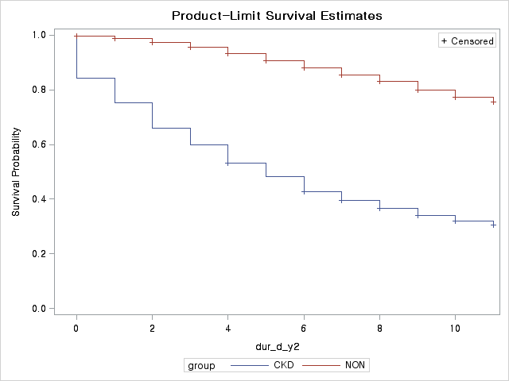

**Figure 1. Kaplan-Meier survival curve for survival according to the presence of CKD**

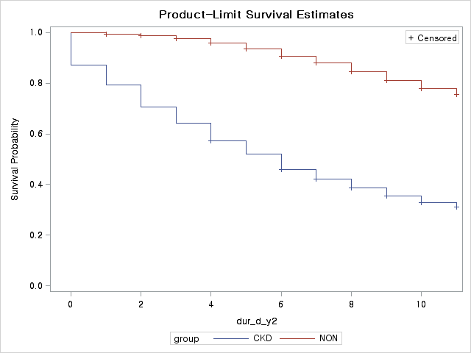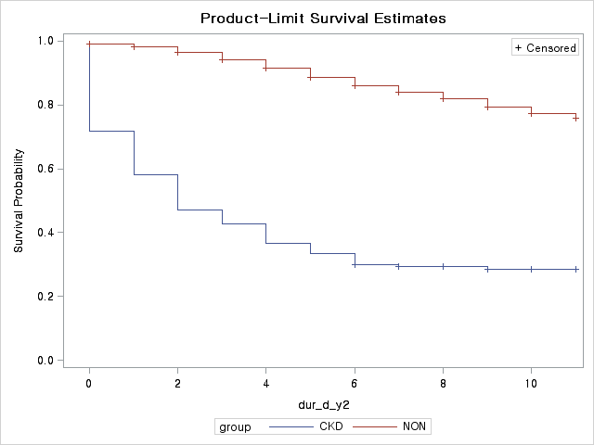

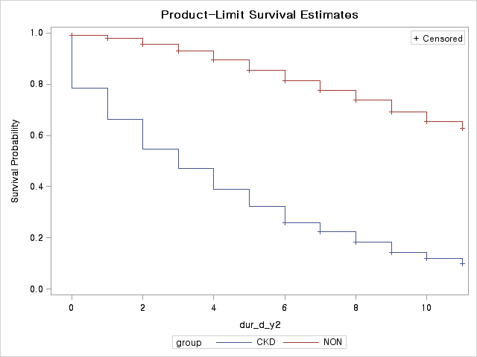A B

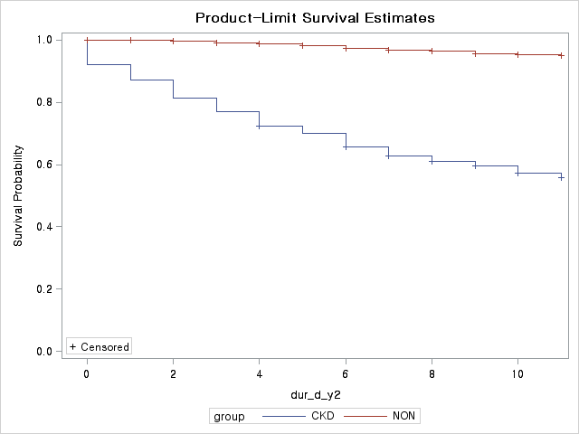

## C D

**Figure 2: Kaplan-Meier survival curves and comparisons of survival rates by log-rank test**

(A) Kaplan–Meier curves for the CKD patients (blue line) and non-CKD patients (red line) for with DM (P < 0.0001). (B) Kaplan–Meier curves for the CKD patients (blue line) and non-CKD patients (red line) without DM (P < 0.0001). (C) Kaplan–Meier curves for the CKD patients (blue line) and non-CKD patients (red line) for older than 65 years (P < 0.0001). (D) Kaplan–Meier curves for the CKD patients (blue line) and non-CKD patients (red line) for patients with younger than 65 years (P < 0.0001).

|  |  |  |  |  |  |  |  |  |  |  |  |
| --- | --- | --- | --- | --- | --- | --- | --- | --- | --- | --- | --- |
|  | **Table 3. Results of the Cox proportional hazards analysis for all-cause mortality.** | | | | | | | | |  |  |
|  |  |  |  |  |  |  |  | | |  |  |
|  |  |  |  |  |  |  |  | | |  |  |
|  | All patiets |  |  |  |  |  |  | | |  |  |
|  |  | Univariate | | | | Multivariate | | | | | |
|  |  | HR | 95% CI | | p value | HR | 95% CI | | p value | | |
|  |  |
|  | CKD (vs. non CKD) | 5.84 | 5.32 | 6.42 | <.0001 | 7.22 | 6.56 | 7.95 | <.0001 | | |
|  | Age caterogy (>65) | 3.96 | 3.52 | 4.46 | <.0001 | 5.03 | 4.46 | 5.67 | <.0001 | | |
|  | Male (vs. female) | 1.16 | 1.05 | 1.27 | 0.002 | 1.25 | 1.14 | 1.37 | <.0001 | | |
|  |  |  |  |  |  |  |  |  |  | | |
|  |  |  |  |  |  |  |  |  |  | | |
|  | < 65 years group |  |  |  |  |  |  |  |  | | |
|  |  | Univariate | | | | Multivariate | | | | | |
|  |  | HR | 95% CI | | p value | HR | 95% CI | | p value | | |
|  |  |
|  | CKD (vs. non CKD) | 13.20 | 10.21 | 17.08 | <.0001 | 13.28 | 10.26 | 17.17 | <.0001 | | |
|  | Male (vs. female) | 1.60 | 1.26 | 2.04 | 0.000 | 1.65 | 1.30 | 2.10 | <.0001 | | |
|  |  |  |  |  |  |  |  |  |  | | |
|  |  |  |  |  |  |  |  |  |  | | |
|  | ≥ 65 years group |  |  |  |  |  |  |  |  | | |
|  |  | Univariate | | | | Multivariate | | | | | |
|  |  | HR | 95% CI | | p value | HR | 95% CI | | p value | | |
|  |  |
|  | CKD (vs. non CKD) | 6.59 | 5.92 | 7.33 | <.0001 | 6.57 | 5.906 | 7.32 | <.0001 | | |
|  | Male (vs. female) | 1.21 | 1.09 | 1.33 | 0.000 | 1.19 | 1.07 | 1.31 | 0.001 | | |
|  |  |  |  |  |  |  |  |  |  | | |