Arūnas Butkus EKSfmu-16

**Practical Task 1**

Opening notes: I wrote this for fun, this is by no means an official paper, but is shows my though processes without obscuring in polite speak. Also the overall structure is intended for printing out text the text part and reading that while scrolling through images on PC.

What I did:

**Part 1:** “Choose open source virtual machine and install it (for example VirtualBox,QEMU. In case you get into trouble running virtual machine, you can try using commercial one: VMware Workstation Player)”

Even though it is paid program this corporate licensing and “protection”, I’m picking VMware Player, because I do have some experience using it from before; so onwards to Google! One of the first results is VMware workstation 10 official page, but it asks for registration at the least. Then Google search again: “vmware tpb”. This time I find: “VMware Workstation 12 Pro + Serials [danhuk]”, but no one’s seeding right now, so look again. By the time VMware 10 torrent is half downloaded some seeds appear for the version 12. In hindsight maybe I shouldn’t have done this in the evening when internet is unusually unstable… So while those downloads get sorted out I’ll look for x64 bit Fedora as Ubuntu was quite slow when I tried to VM it years ago. Both choices are free legally just that Ubuntu before download asks to donate and shames you if you don’t. But internet keeps NOPE’ing out so that is it for today. Will work on checking for solutions to the internet instability problem.

Day 2, attempt 2: downloading Fedora (“Fedora-Workstation-Live-x86\_64-26-1.5.iso”) from official sources (https://getfedora.org/en/workstation/download/). 1.5 GB – will take few minutes. On another hand both VMware versions are downloaded by now. So for own conscience Avast virus scan 12th version. Apparently no viruses then installing Windows x64 version (this contained Linux version too…).

VMware installation: agree with license without reading any of it; leave default install path (maybe will be faster on SSD); skip “Enhanced Keyboard Driver”, because don’t want to reboot PC; disable updates and “anonymous” usage statistics; this time ill experiment with leaving start menu shortcut on, because sometimes when I disable that windows quick search doesn’t find it; remove desktop shortcut because desktop is for game shortcuts. Installing. And while I documented it all, now Fedora is downloaded. VMware installer now wants serial. Go to “software.nfo” and copy first serial from the provided ones. Success.

**Part 2:** “Choose and install open source operating system inside virtual machine (for example Linux, BSD, Solaris, or any similar. I do recommend Ubuntu, Mint, Fedora, Arch linux…)”

Good news – Windows quick search finds VMware Workstation 12 Pro. Let’s see what’s inside (Fig. 1.). So try out “Create a New Virtual Machine”. I’m a professional so let’s go custom (Fig. 2). Sure this seems nice (Fig.3). This will be Fedora Linux from .iso, thus set it all up appropriately (Fig. 4). Give VM some more generic and redundant name than the original due to lack of creativity and give it precious SSD space in more easily accessible path than somewhere in “users” (Fig. 5). Technically this PC has 1 processor (it is a PC and not a server…) having 4 cores (Intel i5 4460), but just because, give it two cores (Fig. 6). Then the RAM settings: I have 16-ish GB on this PC so give VM 7000 MB because it is difficult to get such number of RAM and by hardware means, not to mention it is not 7168 MB (Fig. 7). Remember that I had tea made before all this and expecting it to be cold by now, almost burn my tongue – I dislike hot drinks. Don’t really know how much of a difference network settings will give so I leave default (Fig. 8). Have no clue what the next field wants so default it is (Fig. 9)! Similarly for the disk type – it is VIRTUAL so not like the HARDWARE connection should make a difference (Fig. 10)? Now it asks maybe I want it to be hardware disk after all… Nope. Make it a new virtual disk (Fig. 11). I can’t spare the “recommended” 20 GB on my puny 111 GB SSD for this VM, and I do want it all allocated from the start (had bad experiences with not pre-allocated space) and might as well make it a single file since it will not be moving (Fig. 12). At this point I’m sad about the disk space so I don’t care how the .vmdk file is called. And thus the final setup (Fig. 13). And my space is gone (Fig 14).

Cleanup break. Let’s see where my space in SSD disappeared – Space Sniffer to the rescue (Fig. 15)! For some unknown reason Guild Wars 2 decided to take up residence in default path (I knew it was trouble when installer/launcher did not ask where to install it) – delete it; didn’t like it anyway. Uninstall was odd – faster than shift+delete. Then Grid 2 – leave it because it is fun to occasionally go around Yas Marina at 300 kph. Then there’s RunesScape of all things with 3.6 GB? Played it for few hours for nostalgia sake – delete it. Now I might as well have given the requested 20 GB for the VM (Fig. 16). And VMware player allowed it.

Back on topic. Now VMware window shows the existence of a VM (Fig. 17). Figure 18: Suuure, OK… Lots of things show “OK”, which I guess is ok (Fig. 19). So now it says it has booted as “live media”, directly from .iso I take it, thus install it to “hard drive” (Fig. 20). Of course English I have enough issues with Lithuanian windows where I know where things are, I’m not going to decipher things in Linux (Fig. 21). Localization settings it found by itself just fine. Indicate that I want it installed in the one and only “hard drive” (Fig. 22). Network should be fine – doesn’t show errors here; so begin installation. Now it politely asks to set password and create user, and I don’t want either (Fig. 23). Well I made unprotected administrator user with best name: “admin”. But it doesn’t like the best root password (Fig. 24), “admin” is apparently too short. But even if it is hard to press “Done” twice, I shall. I know I shouldn’t have set a user - stuck for a few minutes now (Fig. 25). But it’s done now (Fig. 26)! Time for some personalization.

Two hours later: Fedora has nice colors, but I hate the name (only hipsters wear fedoras) and more importantly I messed up with permissions and base user can’t use sudo; root user can’t launch programs. Issues all around. So using same principles as with Fedora, I’ve installed Ubuntu instead. So far it works better. Git server install is now left for another evening.

**Part 3:** “Inside open source operating system install git server.”

Day 3. Back to Google we go! This webpage shows promise (https://www.linux.com/LEARN/HOW-RUN-YOUR-OWN-GIT-SERVER) let’s give it a try. Considered skipping straight to GitLab, but it might be more fun to do it with terminal (Fig. 27). So step by step:

1. In terminal: sudo apt-get install git-core
2. sudo useradd git and passwd git – not sure if useradd did anything as there was no confirmation, and passwd git threw error saying I can’t change that. Revisiting during editing: sudo useradd git added new system user… already trashing up the place…
3. Next is creating for convenience SSH keys. Used the suggested command, did not use any passphrase because I don’t care about security at this point and presumably operation succeeded (Fig. 28).
4. So here’s a step I intend to skip – making a “local-server” for git. Right now as the task asks I’ll just worry about “remote-server”.
5. With great difficulty made a folder for git project (Fig. 29).
6. Meh it’s getting confusing. Time for a YouTube tutorial

Well long story (13 minutes) short time to make mishmash. So I should set user name and email in config (totally made if first try) (Fig. 30). Testing git status and file ignoring (Fig. 31). Aaaand some more basic commands in between. I’m just learning but they’re the basic stuff. git add, git commit, git clone, git remote -v, git branch –a.

Hmm. I kind of veered off to trying to install appearance themes, but any way; I guess that is it? Technically git is running in VM.

Day 6. About licensing: VMware virtualization tools is a licensed and paid programs – good thing we’re in Lithuania where all software is free without consequences; both Linux OS’s that I considered are free for official download and fall under GNU General Public License as does all the Linux distributions (I guess?..); git is also free – the core program at least, and is protected by the same GNU GPL license as Linux.

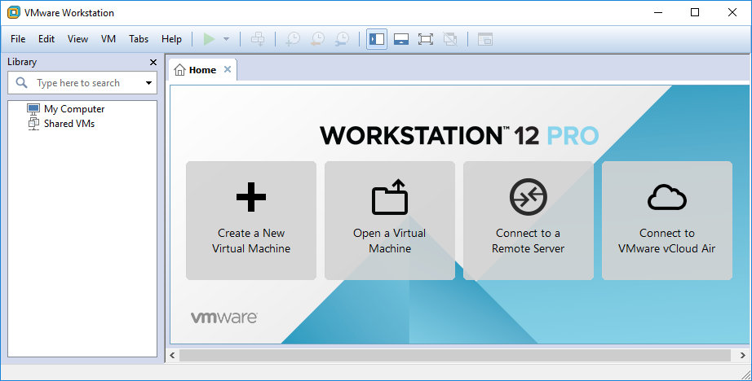

Fig. 1

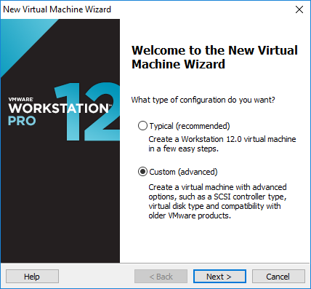

Fig. 2

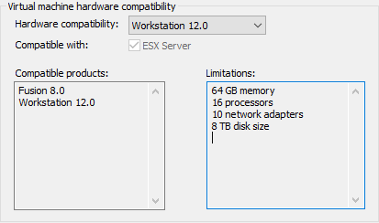

Fig. 3

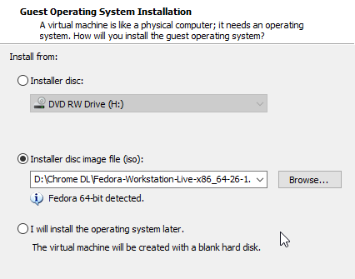

Fig 4

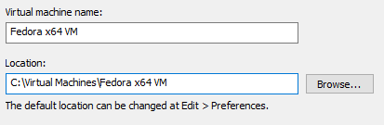

Fig 5

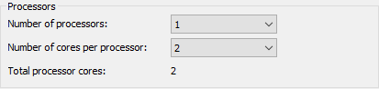

Fig 6

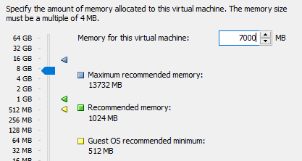

Fig 7

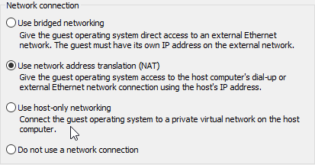

Fig 8

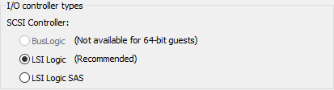

Fig 9

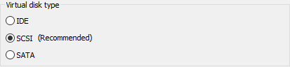

Fig 10

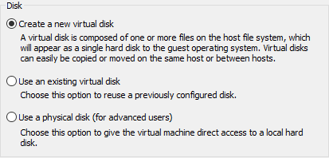

Fig 11

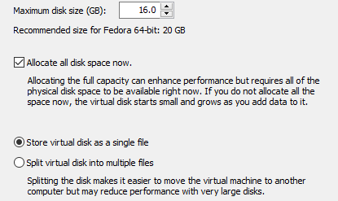

Fig12

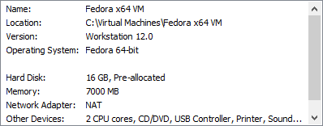

Fig 13

C:\Users\Iridium MK2\Documents\ShareX\Screenshots\2017-09\explorer_2017-09-05_19-53-58.pngC:\Users\Iridium MK2\Documents\ShareX\Screenshots\2017-09\explorer_2017-09-05_19-54-01.pngC:\Users\Iridium MK2\Documents\ShareX\Screenshots\2017-09\explorer_2017-09-05_19-54-08.pngC:\Users\Iridium MK2\Documents\ShareX\Screenshots\2017-09\explorer_2017-09-05_19-54-13.pngC:\Users\Iridium MK2\Documents\ShareX\Screenshots\2017-09\explorer_2017-09-05_19-54-16.pngC:\Users\Iridium MK2\Documents\ShareX\Screenshots\2017-09\explorer_2017-09-05_19-54-21.pngC:\Users\Iridium MK2\Documents\ShareX\Screenshots\2017-09\explorer_2017-09-05_19-54-25.pngC:\Users\Iridium MK2\Documents\ShareX\Screenshots\2017-09\explorer_2017-09-05_19-54-32.pngC:\Users\Iridium MK2\Documents\ShareX\Screenshots\2017-09\explorer_2017-09-05_19-54-37.png

Fig. 14

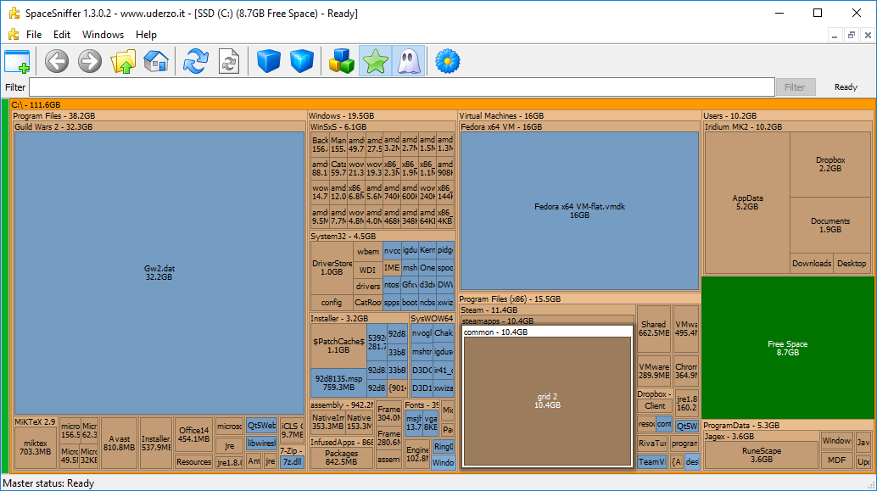Fig 15

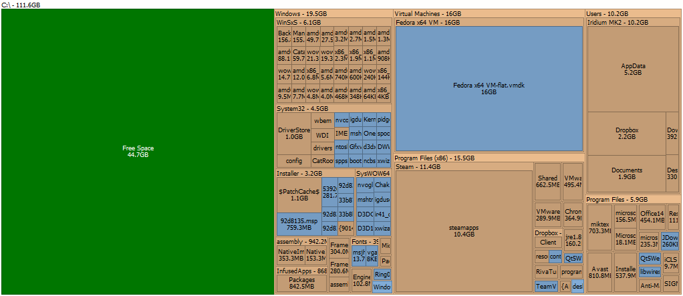Fig 16

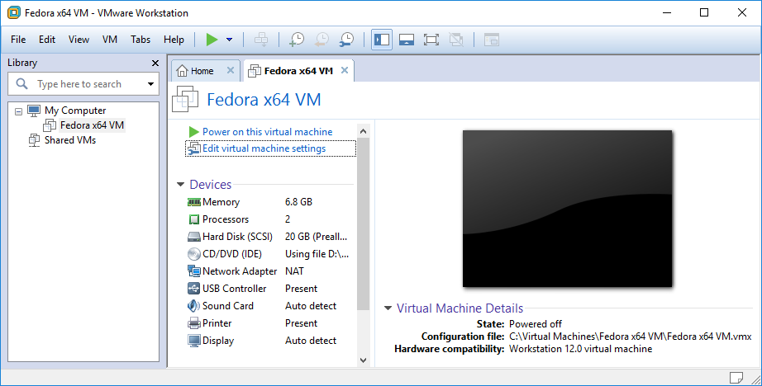Fig 17

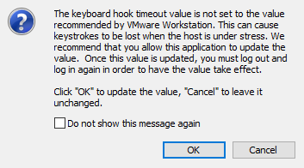

Fig 18

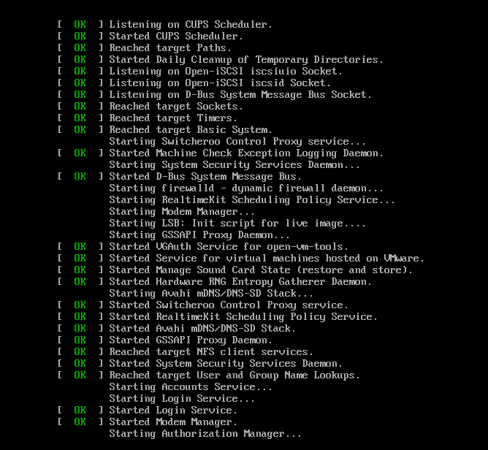

Fig 19

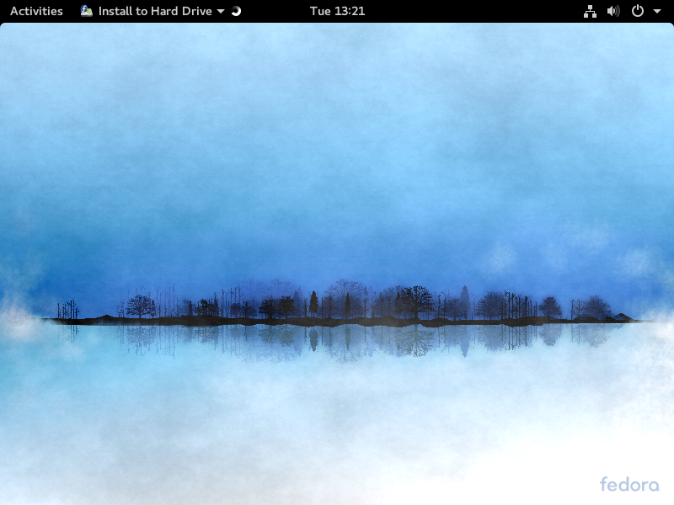

Fig 20

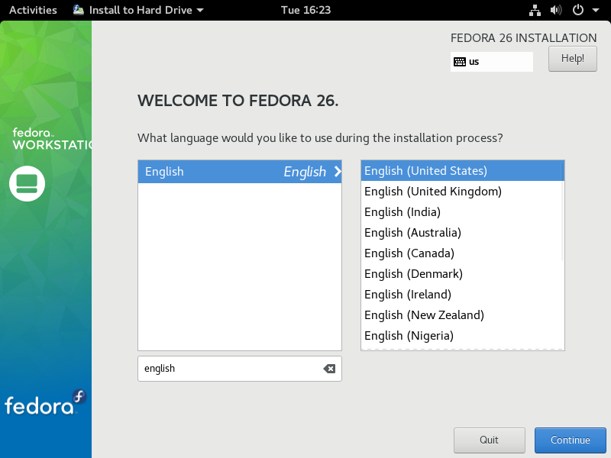 Fig 21

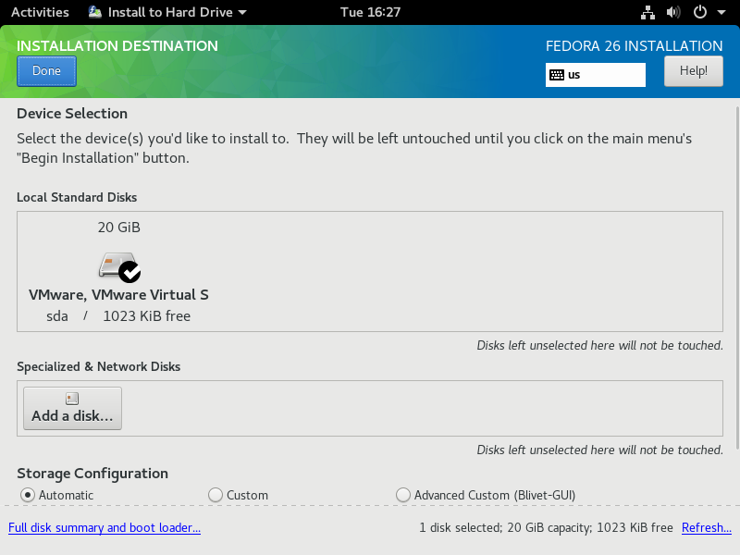Fig 22

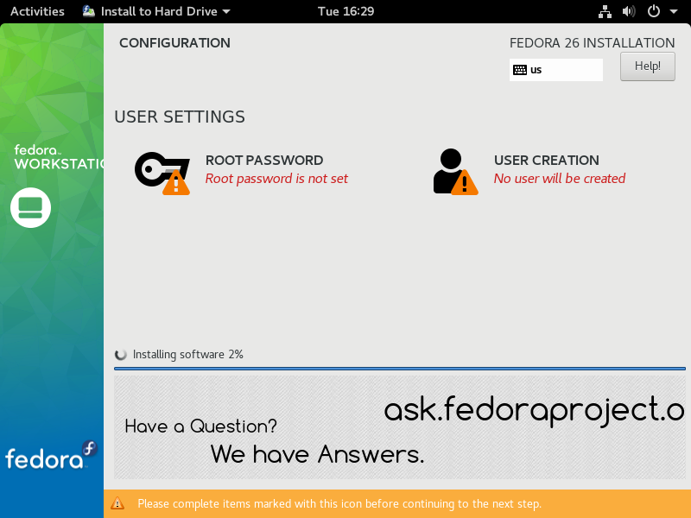Fig 23

C:\Users\Iridium MK2\Documents\ShareX\Screenshots\2017-09\vmware_2017-09-05_20-34-31.pngFig 24

C:\Users\Iridium MK2\Documents\ShareX\Screenshots\2017-09\vmware_2017-09-05_20-43-22.png

Fig 25

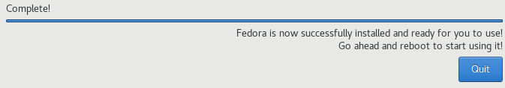

Fig 26

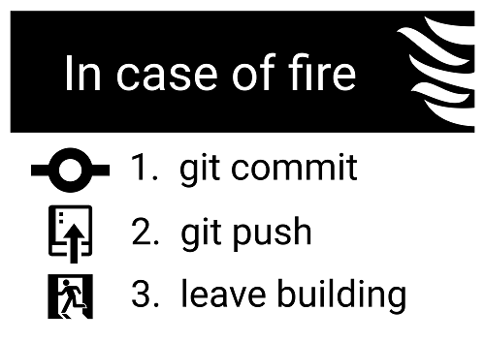

Fig 27

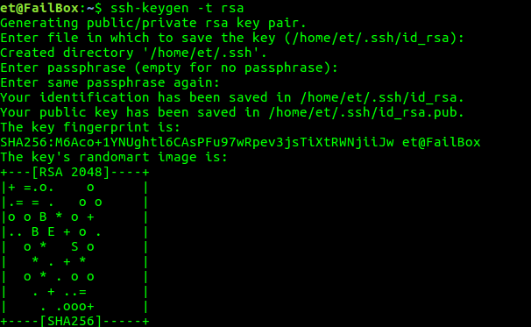

Fig 28

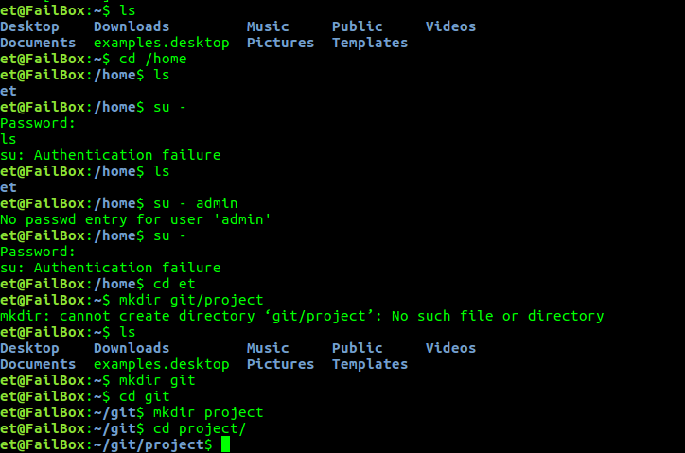

Fig 29

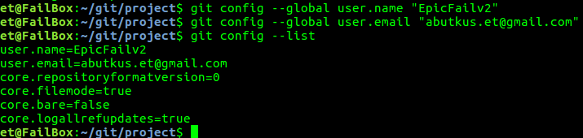Fig 30

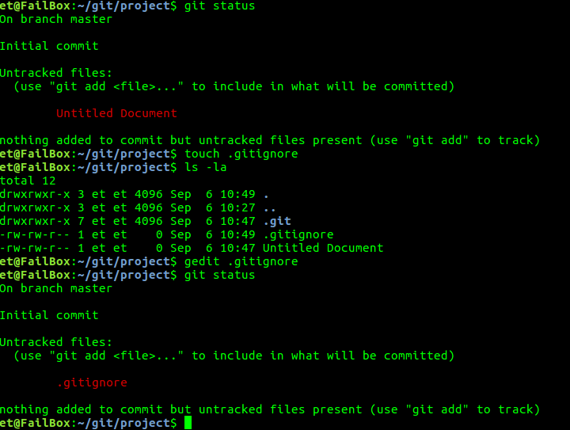Fig 31