Arūnas Butkus EKSfmu-16

**Laboratory work 3**

What I did:

**Part 1:** “Choice of online git service, account creation”

First is choosing free online git repo. From the beginning I thought I’ll go with GitHub. As I looked though the list of options provided by git-tower (https://www.git-tower.com/blog/git-hosting-services-compared/), going through all the unknown services I settled on GitHub. Main reasons being that when you look for code snippets you see links to GitHub and not to “Beanstalk”. Also how can I not pick it with such recommendation: “The undisputed number one in the Open Source world with projects like Ruby on Rails or jQuery being hosted at GitHub”.

Registration is fairly painless: just username, email, and password (no need to even repeat it) (Fig. 1). Followed by plan selection, where, of course, I take the free option and make sure no subscriptions are checked. And last registration window I just a questionnaire and I like questionnaires.

**Part 2:** “New repository creation, adding collaborators”

Initiating new repo is simple: give a path, description and a few more optional picks if needed (Fig. 2. – was already created, and screenshot is after pressing back). For simplicity, because I’m finding lack of motivation to do things the hard way, I’ll manage the repo with GitHub Desktop (GHD).

In the app go to clone a repo (Fig. 3.). Pick GitHub.com (Fig. 4.). This asks for a login (Fig. 5). It goes back to main view. I go to clone a repo again. This time I get to pick a repo and where to place it (Fig. 6.), so I place it among my other git attempts and press “clone”.

Following the task I add some random text file in the repo folder (Fig. 7.). This shows up in GHD (Fig. 8.). Adding required comment and an optional description I commit it to master (Fig. 9.). Pushing throws an error, that is a GHD and after quick Google search and deleting .git/hooks/pre-push pushing now works – file is not in GitHub (Fig. 10.).

The issue with adding colleagues to the project is that one is barely attending and is contemplating leaving, another is gone, and one more is already done; none of them reply to messages fast or are reliable. So my colleague will be myself on my laptop with a different account. So the issue becomes: how to add collaborator. Answer is: when in github.com/username/reponame go “settings” and then “collaborators” (or straight to github.com/username/reponame/settings/collaboration (Fig. 11.). Inviting is easy enough (Fig. 12.). Next is figuring out how to accept. OK – you get an email and follow links therein. And as such now I have a collaborator (Fig. 13.).

There is big emphasis on pushing/pulling on both sides so do some of that and then attempt to create a conflict. I change text file on both ends to have an extra line of text, commit it on both ends (Fig. 14.) and attempt to push. And GHD seems to have a safety measure (Fig. 15.). Thus I now pull, which throws another error (Fig. 16.). Conflict appears in Changes list (Fig. 17.) the change being that the new file now contains. Long story short, since I am getting seriously hungry: I reedit the text file, re-commit and re-push. There’s also more commits to clean up the mess.

TortoiseSVN is so far significantly better, and I like that it has a dedicated conflict resolution window. Git command line version is cumbersome, GHD is better but still far from great, especially when it comes to conflicts. Still for sharing files among my PCs I prefer Dropbox and at work we use SVN.

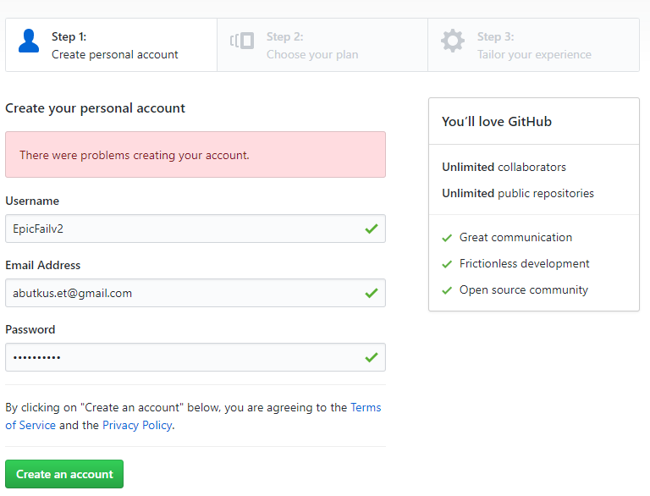

Fig. 1.

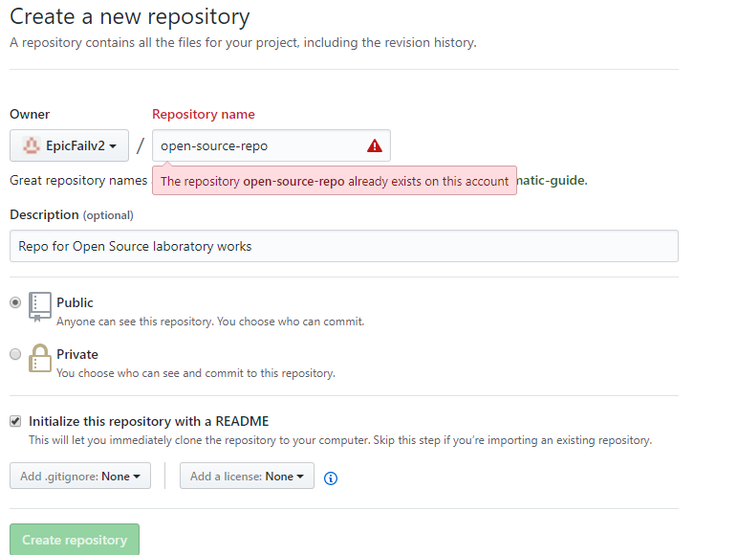

Fig. 2.

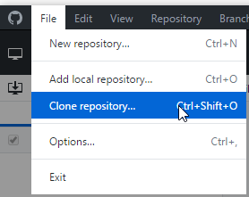

Fig. 3.

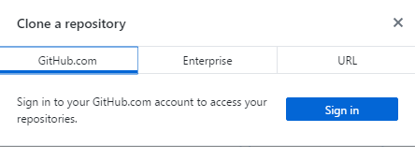

Fig.4.

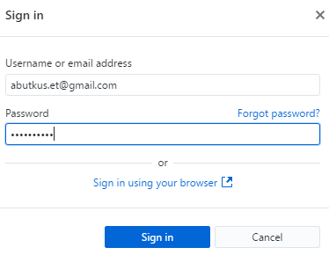

Fig. 5.

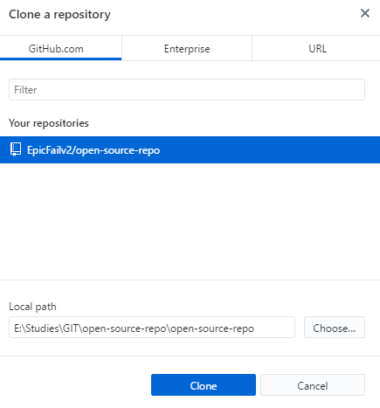

Fig. 6.

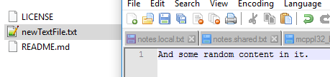

Fig. 7.

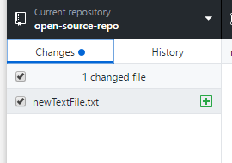

Fig. 8.

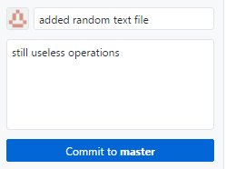

Fig. 9.

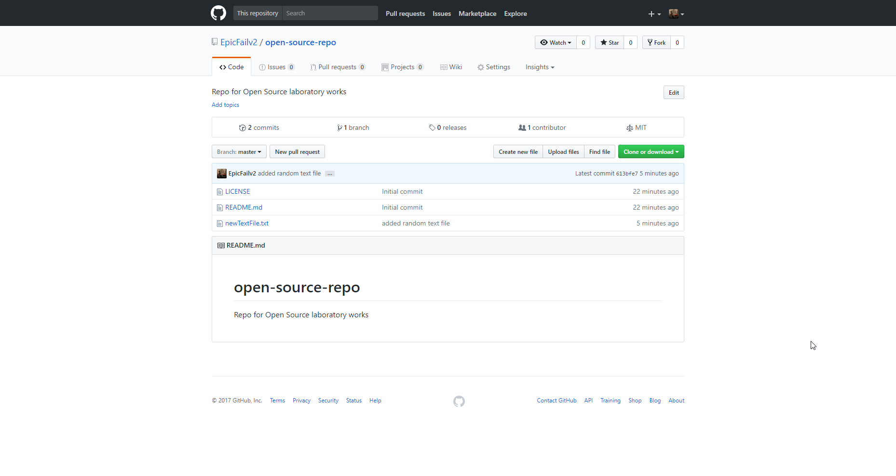

Fig. 10.

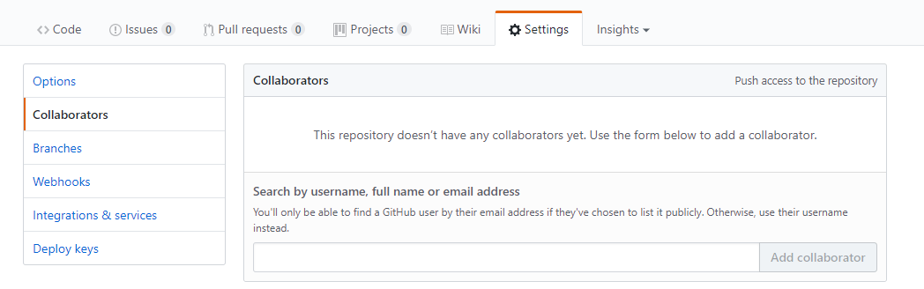

Fig. 11.

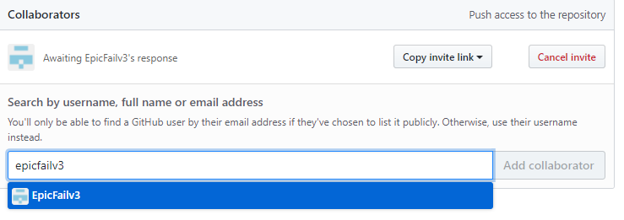

Fig. 12.

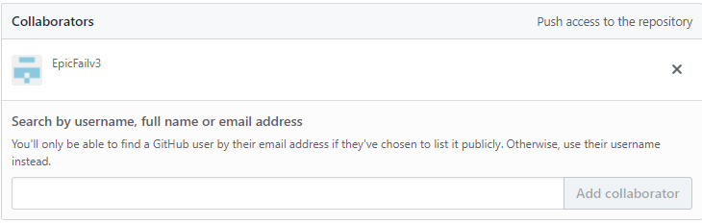

Fig. 13.

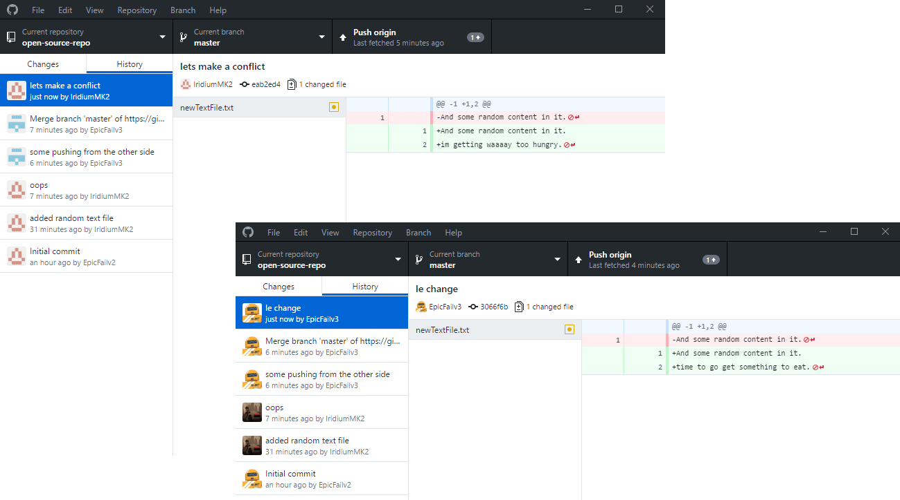

Fig. 14.

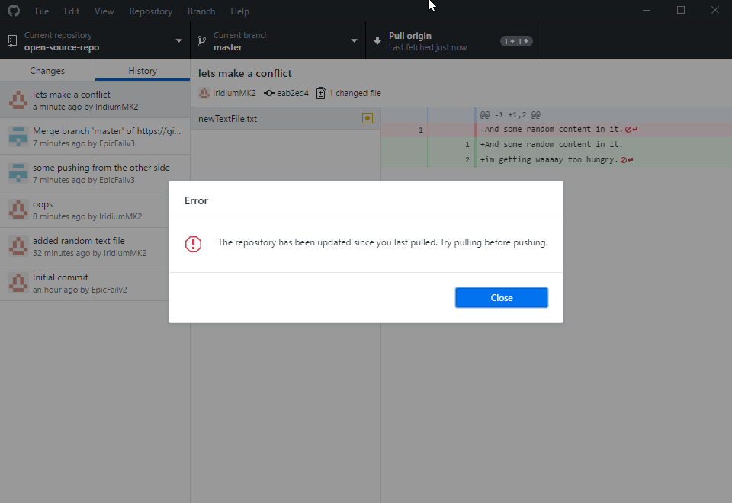

Fig. 15.

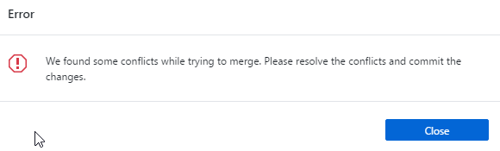

Fig. 16.

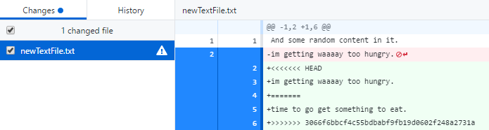

Fig. 17.