Arūnas Butkus EKSfmu-16

**Laboratory work 5**

What I did:

**Part 1:** “Do some research, choose and install open source web server (apache, nginx, lighttpd…)”

First of I google the options. Obviously apache is most popular so I check out the other two suggestions. From what I’ve read nginx is bit better and has better support than lighttpd. Both nginx and lighttpd fall under BSD license. Apache has its own license. And since I’m not in the mood to bother with difficult nonsense nowadays, I just go for first Ubuntu web server installation tutorial. In this case it is apache.

It is a five step process as described by “Digital Ocean”. To get the apache webserver on Ubuntu it is as simple as using a single command (Fig. 1). Next step is configuring firewall, but in the end I figured since this OS is running on a VM then firewall is not even enabled. Well at least that what the terminal states (Fig. 2). Step 3 is to check if the server is running; and both the terminal (Fig. 3) and practical test, by way of server IP (Fig. 4), shows that the server is running. Step 4 shows some basic commands for use in server control – obvious, self-explanatory and not needed at the moment. Step 5 notes some important directories of the server – also not yet needed.

**Part 2:** the rest of it

To change the default webpage I need to change the html at /var/www/html and that is it. To edit the content of the directory had to stop the apache server with sudo systemctl stop apache2 command. Then made a backup of index, just because, removed comments, styles and body content from the index.html, saved and started the server up again (same command just start instead of stop). And the result is even more basic webpage (Fig. 5).

C:\Users\Iridium MK2\Documents\ShareX\Screenshots\2017-10\chrome_2017-10-15_11-42-36.png

Fig. 1

C:\Users\Iridium MK2\Documents\ShareX\Screenshots\2017-10\vmware_2017-10-15_11-49-12.png

Fig. 2

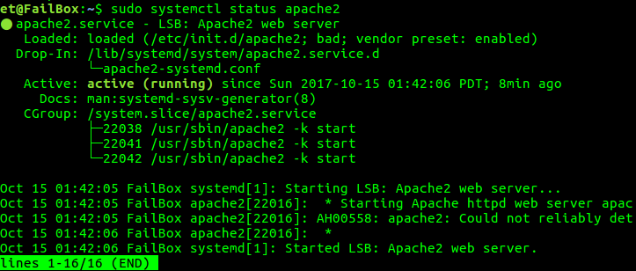

Fig. 3

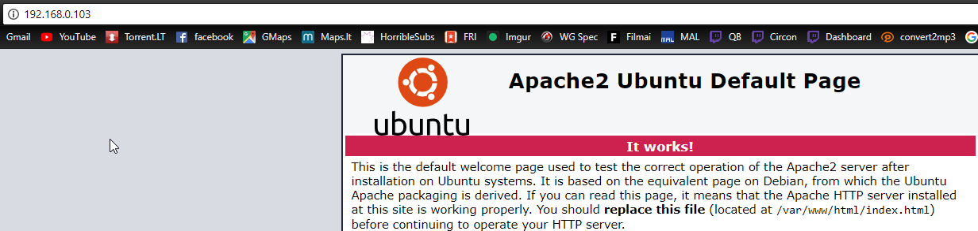

Fig. 4

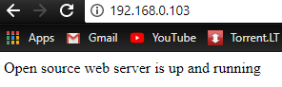

Fig. 5