Arūnas Butkus EKSfmu-16

**Laboratory work 6**

What I did:

**Part 1:** “Do some research, choose and locally install open source database (postgresql, mariadb, mysql…)”

Idea is to get some open source database management system installed on the VM OS. Reason for using one or the other option is same as ever – first that popped up with a decent installation tutorial. This time it is MySQL – another “Digital Ocean” tutorial. MySQL is part of Oracle corporation. If distributing your software as open source then it can fall under GPL license, but for commercial use the license from Oracle must be bought.

To get the MySQL server it is again a simple install command: sudo apt-get install mysql-server. First time ever I’ve seen that a special input is required while installing a package – it asked to set a password for a root user and of course I used “admin”. Next I run the suggested automatic configuration script: sudo mysql\_secure\_installation (Fig. 1). I left mostly default/testing values as this is by no means a production thing. Using systemctl status mysql.service I test if MySQL is running and it is (Fig. 2).

**Part 2:** “Configure the database user (create initial user and set password)”

To start off I connect to MySQL DBMS using root account (Fig. 3). And there is two things to do to make a user: one creates the user and another gives him privileges (Fig. 4). In my case I basically made the main OS user have near same rights as the root user when connecting from localhost with the second best password ever: “password”.

**Part 3:** “Create first database with the name “mydb” and connect to it”

Single SQL command to achieve this (Fig. 5).

**Part 4:** Working with the database

First a table is required for storing stuff in it. Will make the example one (Fig. 6). This creates an empty table (Fig. 7). An then there is the simple insert statement specifying into which column what data to insert (Fig. 8). And that concludes basic functionality of working with a database.

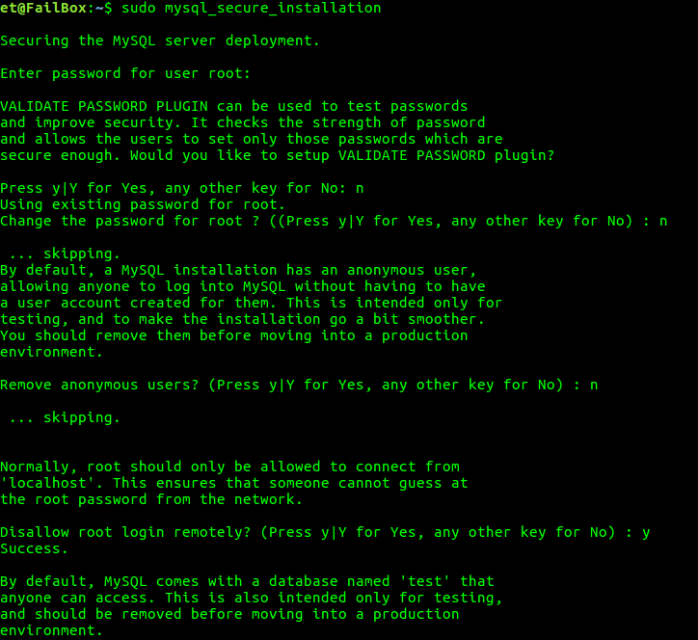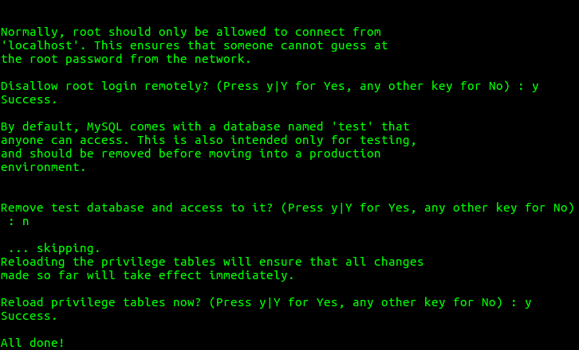

Fig. 1.

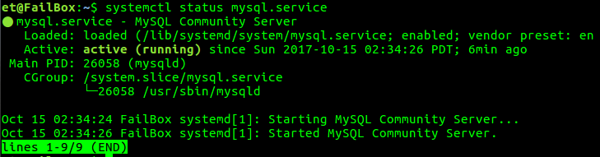

Fig. 2.

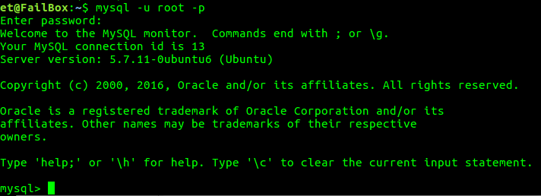

Fig. 3.

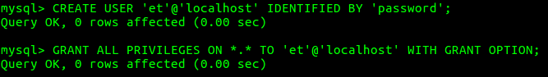

Fig. 4.

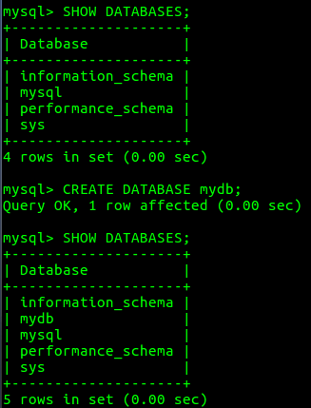

Fig. 5

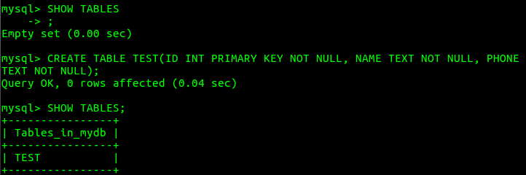

Fig .6.

C:\Users\Iridium MK2\Documents\ShareX\Screenshots\2017-10\vmware_2017-10-15_13-29-47.png

Fig. 7.

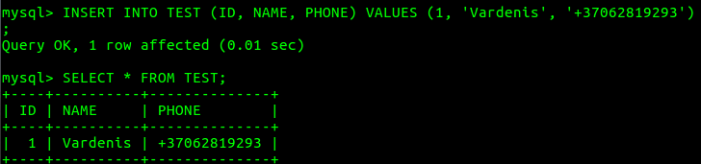

Fig. 8