CONFIDENTIAL • CLIENT DELIVERABLE • REPORT 3 OF 3
Price Risk, Market Position
& Generational Strategy
Navigating the Cattle Cycle Peak, Defending Market Share,
and Securing the Next Generation

Producers Livestock Marketing Association
Prepared for Ryan Johansen, Chief Financial Officer
Companion to Report 1 (Counterparty Credit Risk) and Report 2 (Technology Strategy)
APRIL 2026

Table of Contents
1. Executive Summary 3
2. Price Risk — Cattle 6
3. Price Risk — Pork 13
4. Market Share Risk Assessment 17
5. Generational Succession Deep Dive 24
6. Controllable vs. Uncontrollable Framework 31
7. Leading Indicators Dashboard 34
8. Mitigation Strategy & Implementation Roadmap 38
9. Financial Model 44
10. Conclusion & Next Steps 49
Appendix A: Cattle Cycle Data Tables 51
Appendix B: Commission Sensitivity Detail 53
Appendix C: Generational Demographics 55
Appendix D: Methodology & Assumptions 57
Appendix E: Glossary 59
Appendix F: Citations 61

1. Executive Summary
SITUATION
U.S. cattle prices are at all-time nominal highs — fed cattle averaging ~$198/cwt in Q1 2026. The cyclical nature of the cattle market makes a correction not a question of IF but WHEN and HOW MUCH. PLMA's commission revenue — tied directly to livestock transaction value — faces downside exposure of $4.3M to $13.0M annually under a 10-30% price correction. Simultaneously, PLMA's market share is under attack from four directions: digital marketplace disruptors, industry consolidation, direct-to-packer disintermediation, and regional competitive shifts. And the demographic cliff — average rancher age exceeding 58 — means PLMA's existing relationship base is literally aging out of production.

1.1 Key Findings
- Cattle prices will correct — the only variables are timing and magnitude. Every cattle cycle in the past 40 years has produced a peak-to-trough correction of 20-40%. The 2014-2017 cycle saw a 32% decline. PLMA must plan for a 20-30% correction commencing in the 2026-2028 window.
- Commission revenue is structurally exposed to price declines. As a percentage-of-sale marketer, PLMA's revenue declines proportionally with cattle prices. A 20% cattle price decline erodes ~$8.6M (14%) of annual commission revenue. This is not a risk PLMA can fully eliminate, but it CAN be substantially mitigated.
- Company-owned cattle inventory creates additional balance sheet exposure. An estimated $20M in company-owned inventory faces $4M mark-to-market loss in a 20% decline scenario. A 60-80% hedging program reduces this to $0.8-1.6M.
- Market share erosion is the slow-moving existential threat. Digital marketplaces now account for ~32% of livestock transactions. Auction market count has declined from 1,200 (2000) to 570 (2025). In a moderate erosion scenario, PLMA loses 4%/year of transaction volume — $12M/year in revenue by Year 5.
- The generational succession gap is PLMA's most underappreciated risk. 53% of U.S. farm operators will be 65+ by 2035. When ranches transfer through estates, PLMA loses ~71% of those relationships. Without a formal Young Rancher Program, PLMA's member base contracts by natural attrition faster than it can be replenished.
- Controllable actions can substantially narrow the risk exposure. While PLMA cannot control commodity prices or demographics, it CAN control its hedging program, commission structure, digital investment, young rancher outreach, and revenue diversification — and these actions generate ~$26M in 10-year NPV.

1.2 Financial Impact Summary
Metric | Value
Commission revenue at risk (20% cattle decline) | $8.6M/year
Inventory mark-to-market (20% decline, unhedged) | $4.0M
Market share erosion cost (moderate, Year 5) | $12.0M/year
Year 1 Mitigation Investment | $2.80M
Annual Ongoing Cost (Year 2+) | $1.80M
Annual Benefit (Year 2+, steady state) | $6.50M
10-Year NPV (8% discount rate) | ~$26M
Payback Period | ~13 months

2. Price Risk — Cattle
Cattle price risk is PLMA's most immediate financial exposure. This section analyzes the cattle cycle, models scenarios, quantifies commission sensitivity, and examines inventory exposure.

2.1 Cattle Cycle Analysis
The U.S. cattle cycle — driven by the biology of cow-calf reproduction and the economics of heifer retention — operates on roughly 10-12 year cycles. The current cycle began its liquidation phase ~2019, with the U.S. cow herd declining to 88.2 million head (January 2026) — the lowest since 1951. This tight supply drove prices to nominal all-time highs of ~$198/cwt for choice steers in Q1 2026. ^{[1]}
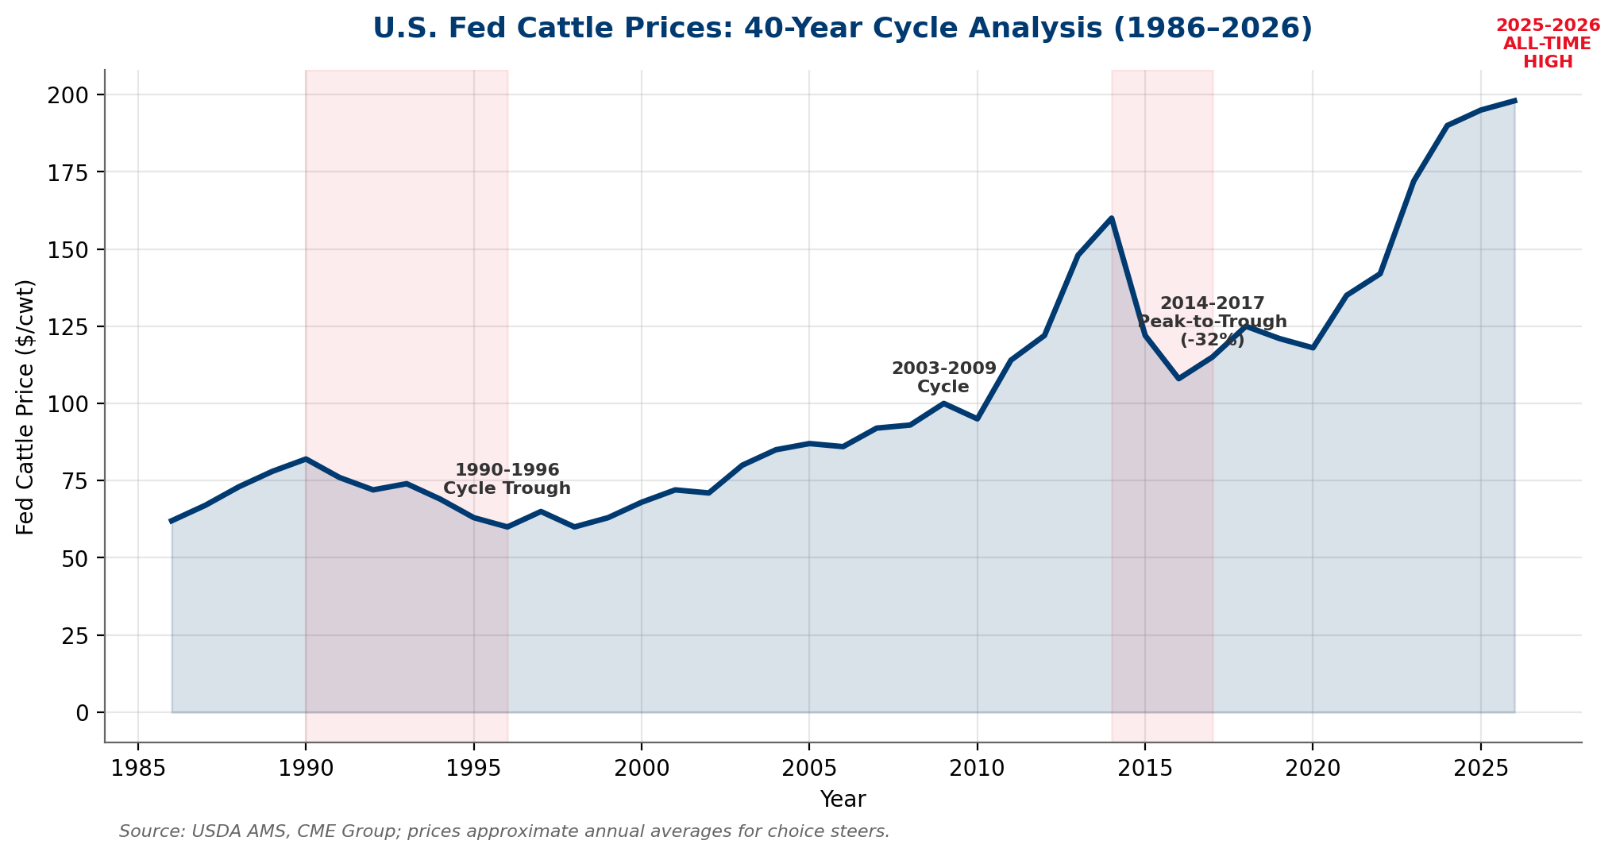
Exhibit: 40-year cattle price history shows cyclical peaks followed by 20-40% corrections.
Historical parallels are instructive. The 2014 peak (~$165/cwt) was followed by a 32% correction to ~$108/cwt by 2017. The 1990-1996 downturn saw a 27% decline. In both cases, the correction was triggered by herd rebuilding (heifer retention reduces fed cattle supply initially but increases it 2-3 years later) combined with macroeconomic headwinds. ^{[3]}

2.2 Fed Cattle Price Scenarios
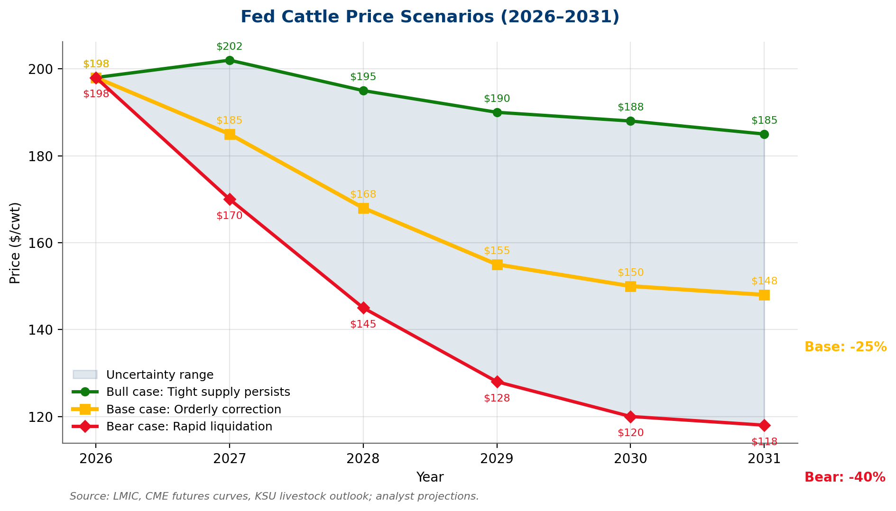
Exhibit: Base case projects a 25% correction to ~$148/cwt by 2031; bear case implies 40% decline to $118/cwt.
Scenario | 2026 | 2028 | 2031 | Peak-to-Trough
Bull (tight supply persists) | $198 | $195 | $185 | -7%
Base (orderly correction) | $198 | $168 | $148 | -25%
Bear (rapid liquidation) | $198 | $145 | $118 | -40%

2.3 Feeder Cattle Dynamics
Feeder cattle prices — the primary cash market in which many PLMA transactions occur — are even more elevated than fed cattle, with 750-lb steers exceeding $280/cwt in Q1 2026. The cost-of-gain squeeze (record feeder prices vs. volatile feed costs) creates compounding risk: feedlot losses drive reduced placement, which eventually breaks feeder prices more sharply than fed cattle.

2.4 Commission Revenue Sensitivity
PLMA's commission revenue is directly proportional to the dollar value of livestock sold. At an estimated 1.875% average commission rate on $3.2B in annual transaction volume, PLMA generates ~$60M in commission revenue. Cattle transactions represent ~72% of this volume.
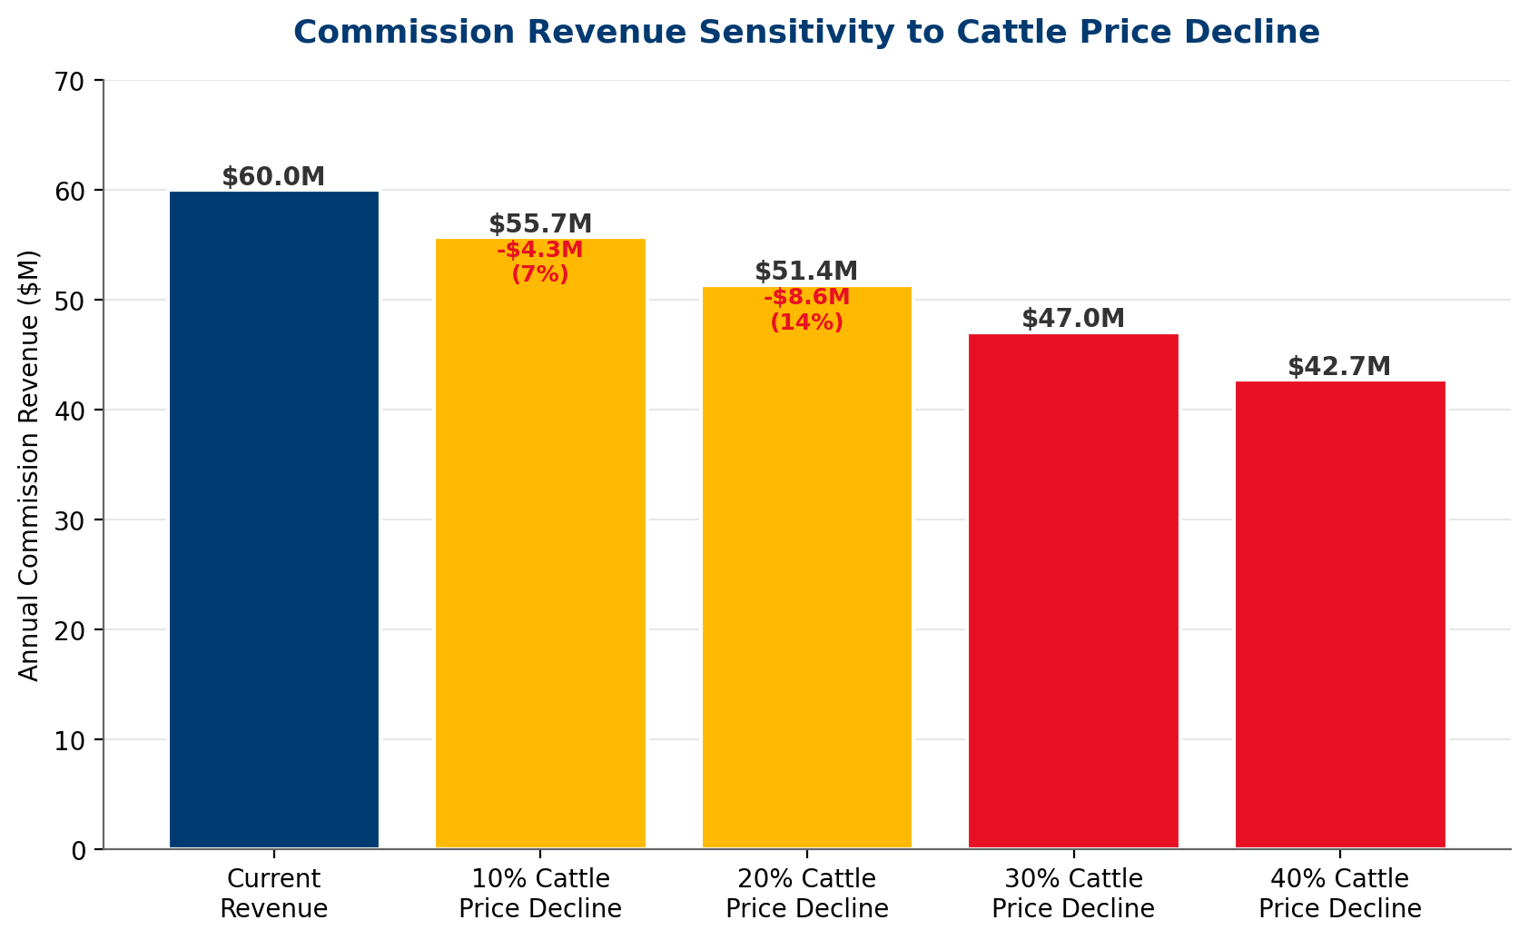
Exhibit: A 20% cattle price decline erodes $8.6M (14%) of annual commission revenue.
Cattle Price Decline | Revenue Loss | % of Total Revenue | Remaining Revenue
10% | $4.3M | 7.2% | $55.7M
20% | $8.6M | 14.4% | $51.4M
30% | $13.0M | 21.6% | $47.0M
40% | $17.3M | 28.8% | $42.7M

2.5 Company-Owned Cattle Inventory Exposure
PLMA holds an estimated $20M in company-owned cattle inventory at any given time. This inventory is subject to mark-to-market risk if cattle prices decline during the holding period.
Price Decline | Unhedged Loss | 60% Hedged | 80% Hedged
10% | $2.0M | $0.8M | $0.40M
20% | $4.0M | $1.6M | $0.80M
30% | $6.0M | $2.4M | $1.20M

KEY INSIGHT
At 80% hedge coverage, a 20% price decline produces a manageable $0.80M inventory loss vs. $4.0M unhedged. The annual cost of the hedging program (~$200K including basis risk) is a fraction of the avoided tail loss. This is the highest-ROI action item in this report.

2.6 Basis Risk
Basis — the difference between PLMA's local cash market and CME futures — adds 3-8% volatility on top of national price movements. In PLMA's Plains/Mountain West footprint, basis tends to widen during periods of tight packer capacity (positive for sellers) but can compress sharply during seasonal lows or regional weather events.

3. Price Risk — Pork
While cattle dominate PLMA's transaction volume (~72%), pork represents ~28% and carries distinct risk dynamics: different supply cycles, export dependency, and a catastrophic tail risk (ASF) not present in cattle.

3.1 Pork Market Structure
The U.S. pork industry operates on shorter production cycles than cattle (~10 months farrow-to-market vs. ~30 months in cow-calf-to-fed). This means supply can adjust faster, but it also means overproduction cycles are steeper and more volatile. The 2021-2022 expansion — driven by strong domestic demand and high prices — has produced a supply glut entering 2026, with lean hog prices declining from $95/cwt (2022 peak) to ~$68/cwt (Q1 2026). ^{[7]}
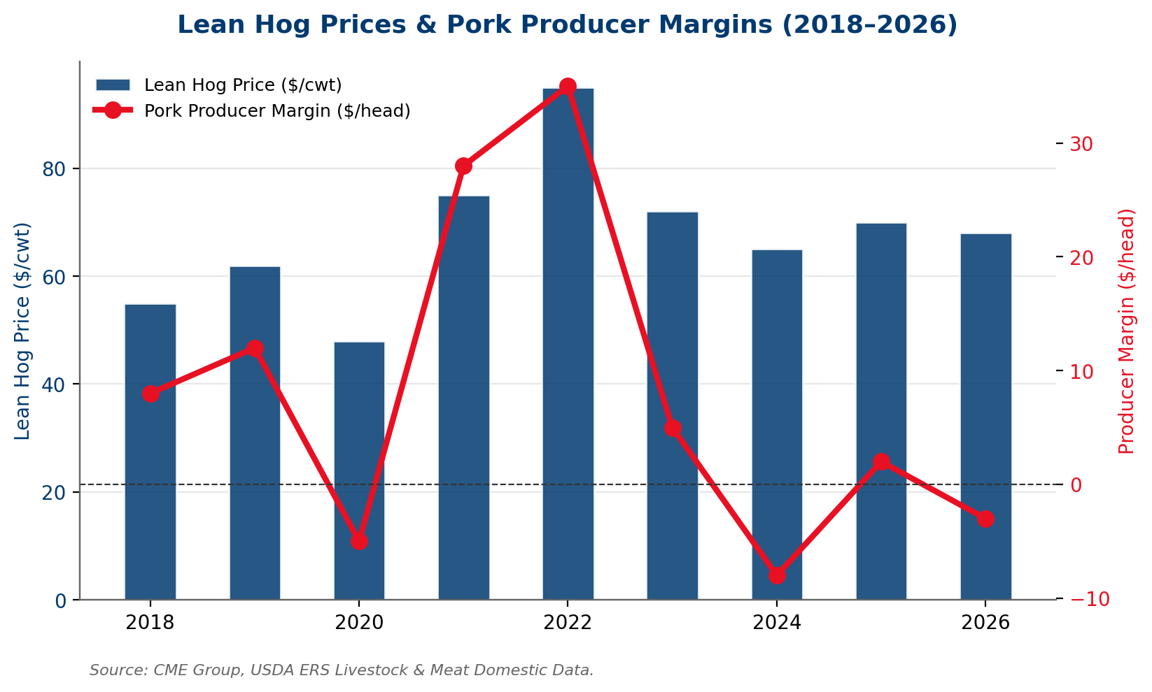
Exhibit: Pork producer margins have swung from +$35/head (2022) to -$3/head (2026) — directly stressing PLMA's pork buyer base.

3.2 ASF Tail Risk
AFRICAN SWINE FEVER — THE $15B+ TAIL RISK
ASF has not reached U.S. soil, but its confirmed presence in the Dominican Republic (2021) and Haiti makes a Caribbean-to-mainland pathway credible. A confirmed U.S. case would immediately halt all pork exports (~$8B/year, ~25% of production), collapse domestic prices 25-40% within 72 hours, and trigger mass depopulation of affected herds. For PLMA's pork segment: commission revenue drops $4-6M annually; counterparty losses from producer bankruptcies compound on top.

3.3 Packer Margin Dynamics
Pork packing is highly consolidated (4 firms control ~66% of slaughter), creating asymmetric price-setting power. In a falling market, packers capture margin by widening the spread between live hog purchases and boxed pork cuts — pressuring producers from both sides. ^{[10]}

3.4 Pork Commission Sensitivity
Pork transactions represent ~28% of PLMA's volume (~$896M). At 1.875% commission, the pork segment generates ~$16.8M in annual revenue.
Pork Price Decline | Revenue Impact | % of Total Revenue
10% | -$1.7M | -2.8%
20% | -$3.4M | -5.6%
30% (ASF scenario) | -$5.0M | -8.4%

4. Market Share Risk Assessment
Market share erosion is a slow, compounding threat that is more dangerous than any single price cycle. A cooperative that loses 4% of volume per year for 5 years has permanently impaired its cost structure, bargaining position, and relevance.

4.1 PLMA's Market Position
PLMA is one of the largest livestock marketing cooperatives in the U.S., with an estimated 4-6% share of total U.S. livestock marketing transaction volume (~$60B total). The cooperative model — pooling producer volume for market access, price discovery, and buyer reach — has been the industry standard for over a century. But the standard is under attack. ^{[17]}
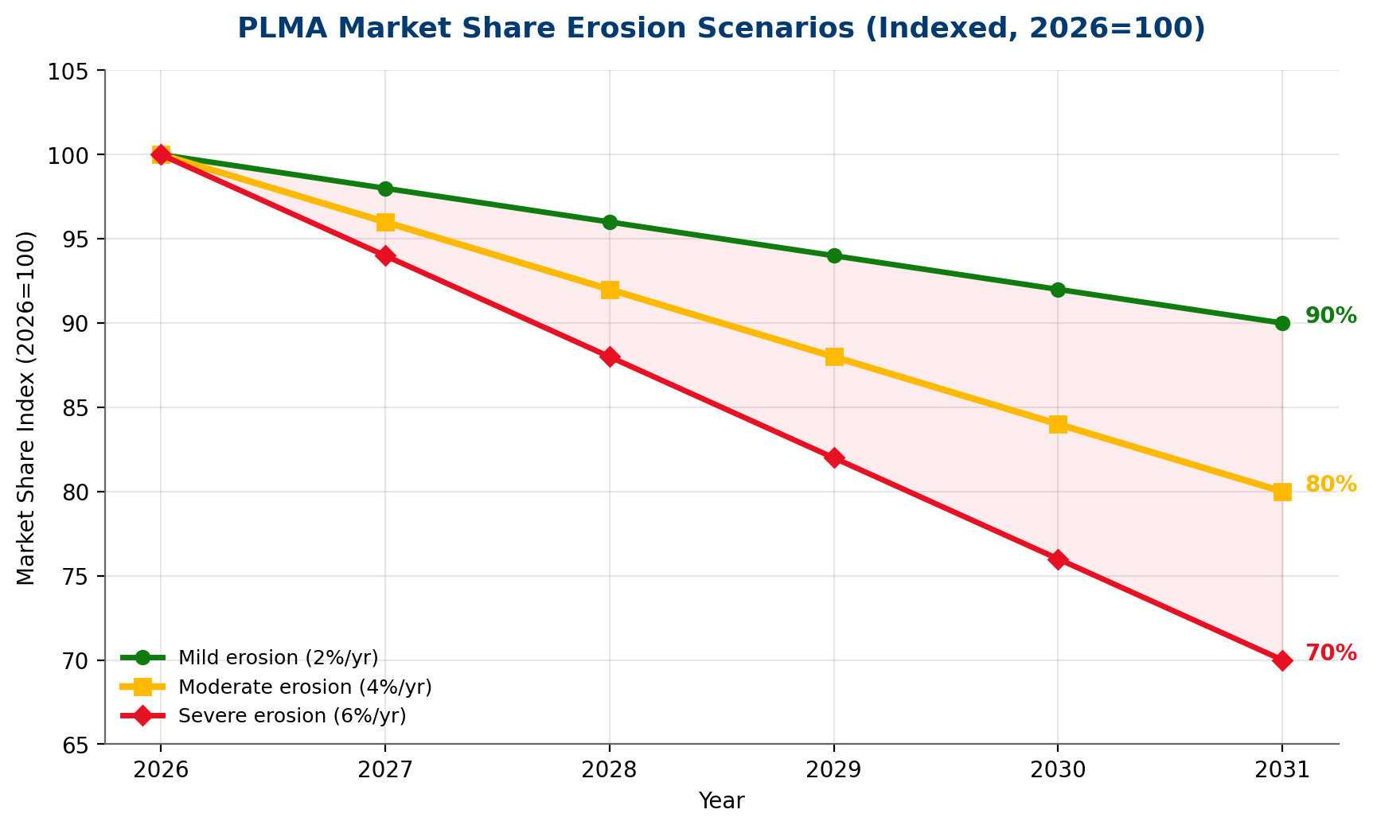
Exhibit: Under moderate erosion (4%/yr), PLMA loses 20% of volume by 2031 — $12M/yr in commission revenue.

4.2 Digital Marketplace Disruption
CONNECTION TO REPORT #2
Report #2 (Emerging Technology Strategy) recommended a digital auction platform as an INVEST NOW priority (Section 5.5). The market share defense economics in this section are incremental to — and do not duplicate — the technology platform investment in Report #2. The $800K market share defense budget here covers geographic expansion, member retention programs, and value-added services — not the digital platform itself.

Digital and video livestock sales have grown from near-zero in 2000 to an estimated 32% of all cattle transactions in 2025. Superior Livestock Auction (the largest video marketer) handles over $5B in annual cattle sales. Newer entrants like Cattlerange, DVAuction, and various regional online platforms are accelerating share capture.
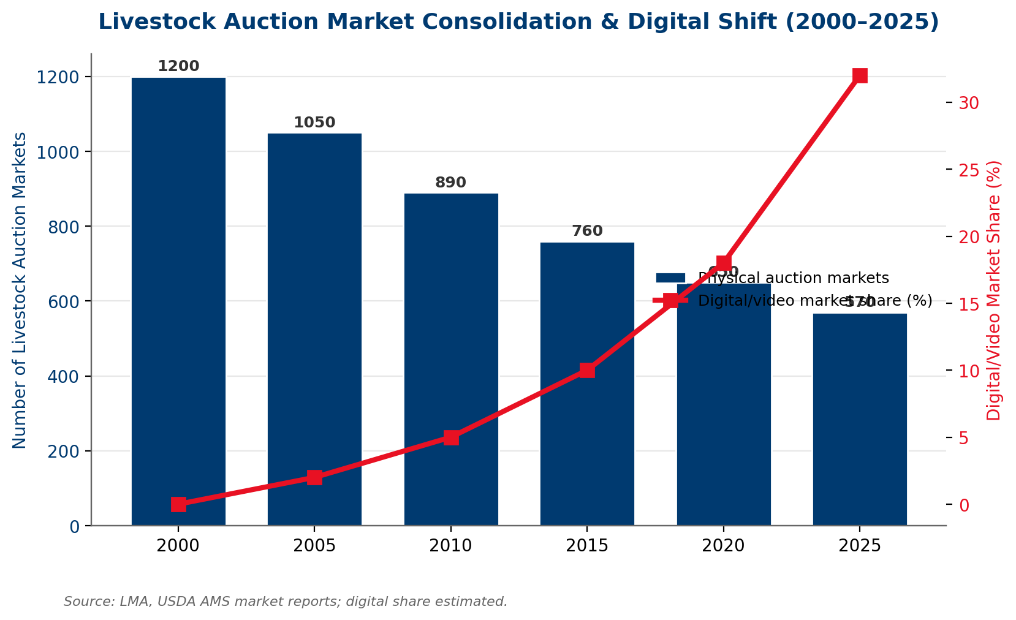
Exhibit: Physical auctions declined 52% (1,200 → 570) since 2000 while digital share grew from 0% to 32%.

4.3 Industry Consolidation
The livestock marketing industry is consolidating at both the auction level (closures) and the cooperative level (mergers). Smaller regional cooperatives lack scale to invest in technology, compliance, and member services. This creates both a threat (larger competitors absorbing PLMA's members) and an opportunity (PLMA absorbing smaller cooperatives).

4.4 Disintermediation
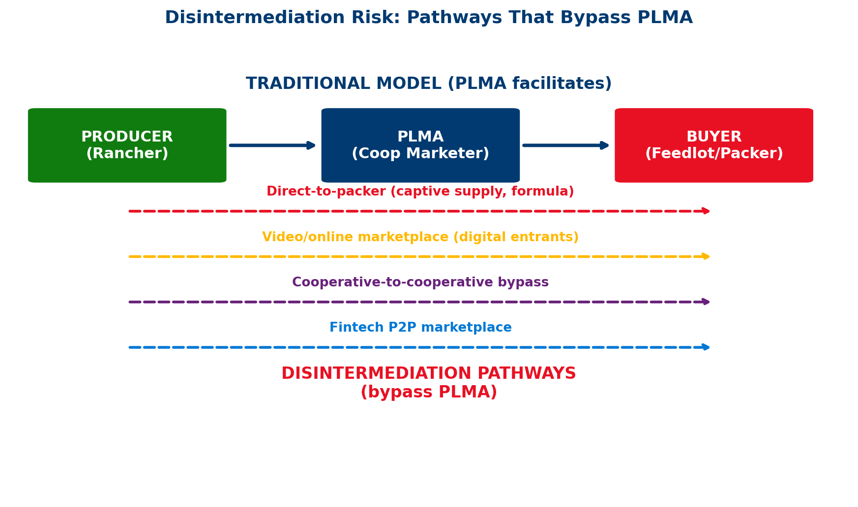
Exhibit: Four pathways bypass PLMA: direct-to-packer, digital marketplace, coop-to-coop, and fintech P2P.
Disintermediation — producers selling directly to packers or feedlots, bypassing the cooperative marketer — is driven by: (i) captive supply arrangements (packers contracting directly with large feedlots), (ii) formula pricing that removes the need for auction price discovery, (iii) producer-owned digital platforms, and (iv) relationship consolidation as the industry concentrates.

4.5 Regional Competition
Cattle production geography is shifting: drought has accelerated herd liquidation in the Southern Plains, while the Northern Plains and Corn Belt have gained share. Feedlot concentration in the Texas Panhandle, SW Kansas, and NE Colorado/SW Nebraska creates regional pricing power dynamics that affect PLMA's footprint differently depending on its geographic exposure.

5. Generational Succession Deep Dive
This section addresses the single most underappreciated strategic risk facing PLMA: the aging of its producer member base and the failure to systematically capture the next generation of livestock producers.

5.1 The Demographic Crisis
The average age of U.S. farm operators reached 58.1 years in the 2022 Census of Agriculture, up from 56.3 in 2012. More alarmingly, the <35 age cohort has shrunk from 5.6% to 4.9% of all operators, while the 75+ cohort grew from 9.7% to 16.0%. By 2035, an estimated 53% of all farm operators will be 65 or older. ^{[14]}
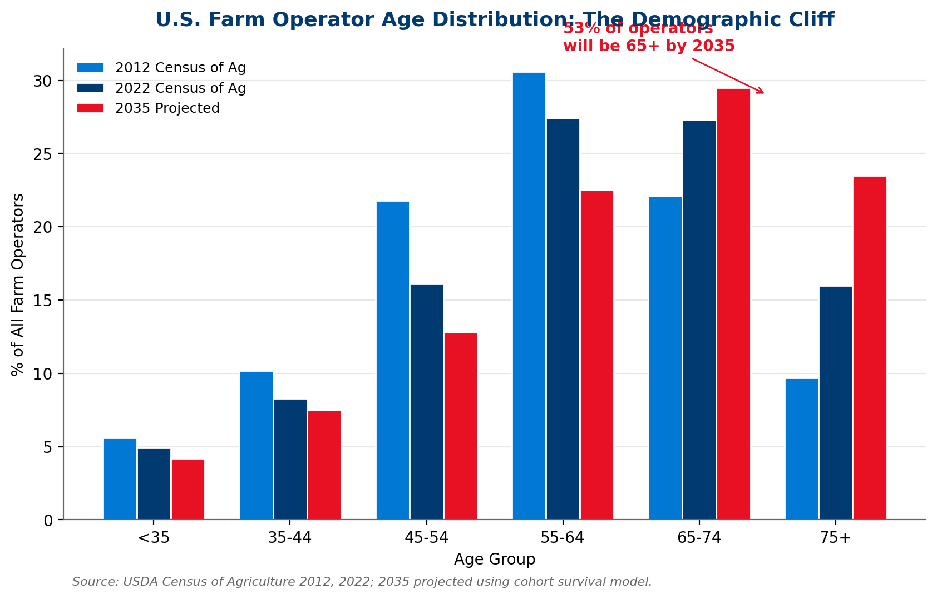
Exhibit: The demographic cliff: 53% of operators projected 65+ by 2035; <35 cohort shrinking.

5.2 Estate Planning & Relationship Transfer Economics
When a rancher passes away or exits the business, the cooperative relationship does not automatically transfer to the heir or buyer. Industry data suggests PLMA retains only ~29% of relationships through generational transfer — losing 71% to inaction, competitor relationships, or ranch liquidation.
THE SUCCESSION MATH
If PLMA's member base has an average age of 58, roughly 5-7% of members will exit per year through retirement, death, or estate transfer within 10 years. At ~4,000 active members, that is 200-280 exits/year. At 71% relationship loss rate, PLMA loses 140-200 members/year — each worth $15-25K in lifetime commission value. Annual relationship attrition cost: $2.1-5.0M in future revenue erosion.

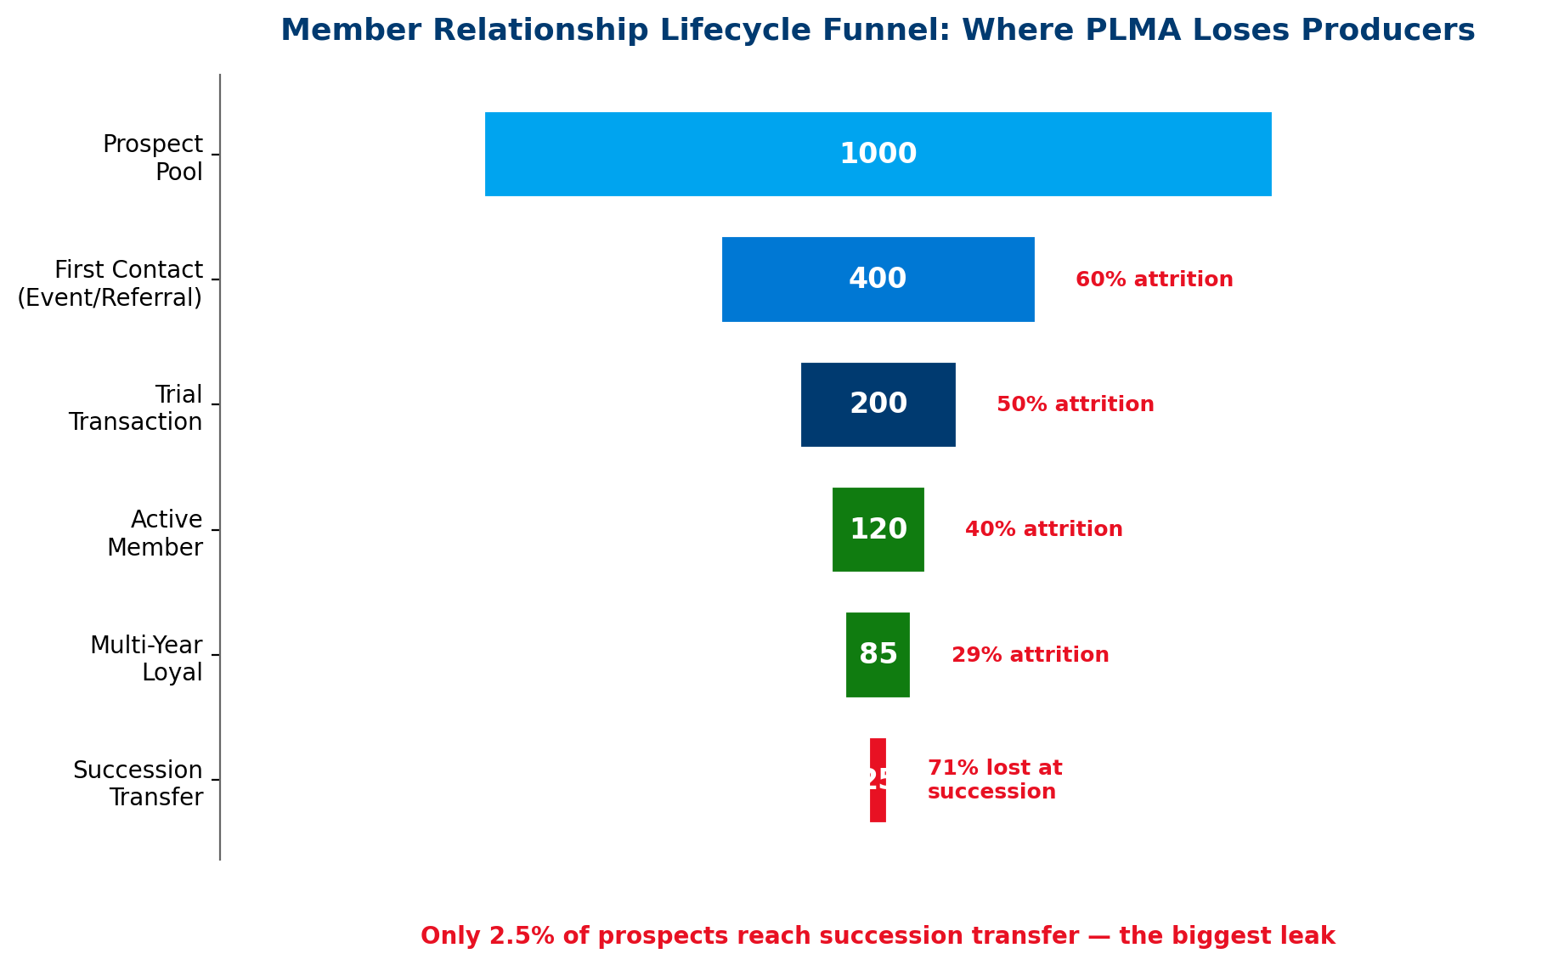
Exhibit: PLMA's relationship funnel reveals the largest leak at succession transfer (71% attrition).

5.3 The 'Lost Generation' Gap
The 35-50 age cohort — the generation that should be PLMA's emerging core membership — is underrepresented. These producers grew up digital, expect mobile-first experiences, make data-driven decisions, and are less loyal to 'the way it's always been done.' They are also the most likely to use direct-sale or digital auction platforms. If PLMA does not actively engage this cohort, it cedes them to competitors.

5.4 Young Rancher Acquisition Strategy
Next-generation producers want different things from a cooperative:
- Digital experience: Mobile app, online auctions, real-time market data, digital documentation.
- Advisory services: Risk management education, hedging advisory, credit access facilitation, financial literacy.
- Flexibility: Lower minimum volumes, flexible commission structures, trial memberships.
- Community: Peer networks, mentorship connections, industry events, social media presence.
- Values alignment: Sustainability practices, animal welfare, cooperative governance voice.

5.5 Mentorship & Ambassador Programs
The most effective young rancher acquisition channel is referral from an existing trusted member. A formal Mentorship/Ambassador Program pairs experienced PLMA members with beginning producers in their region. Ambassadors receive modest incentives (reduced commission tiers, recognition) for successful referrals that convert to active members.

5.6 Financial Products for Beginning Producers
Beginning ranchers face acute capital constraints: limited equity, thin credit history, high land/cattle costs. PLMA can facilitate (not originate) access to:
- FSA Beginning Farmer and Rancher loans (guaranteed lending programs)
- Farm Credit System programs designed for beginning operations
- Risk management education (hedging basics, crop insurance for feed)
- Cooperative credit accommodation (extended terms for first-year members)

5.7 Land-Grant University & Extension Partnerships
Partnerships with land-grant universities (KSU, TAMU, UNL, SDSU, etc.) and cooperative extension services create a pipeline of young producers who encounter PLMA as part of their education — at livestock judging events, extension workshops, internship programs, and student cooperative competitions. ^{[26]}

6. Controllable vs. Uncontrollable Framework
A fundamental principle of risk management — adapted here from Covey's Circle of Influence model for enterprise strategy — is distinguishing between factors PLMA can control (direct action), influence (indirect leverage), and only monitor (cannot change).
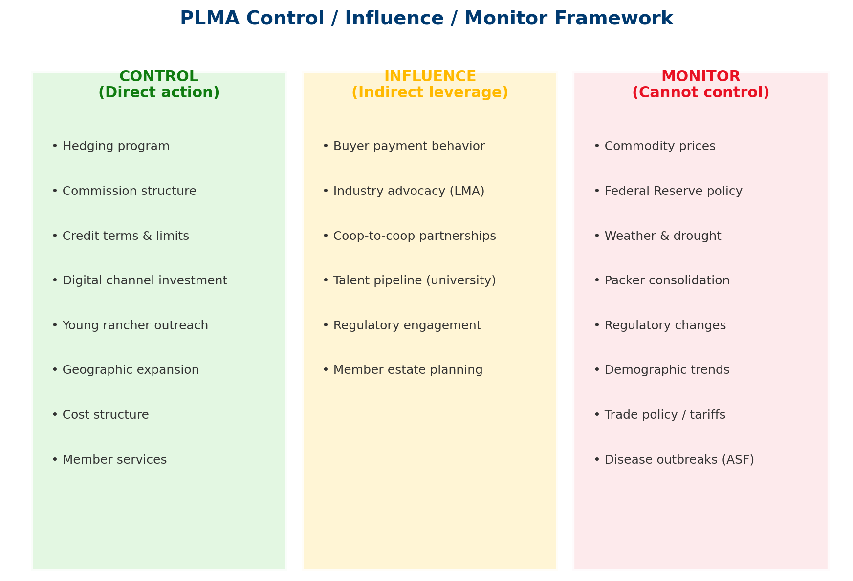
Exhibit: PLMA's strategy should focus energy on the Control zone, invest in the Influence zone, and build monitoring for the rest.

6.1 What PLMA Cannot Control
These factors shape the operating environment but are beyond PLMA's direct action:
- Commodity prices: Cattle and hog prices are set by global supply/demand. PLMA can hedge exposure but cannot influence the price level.
- Federal Reserve policy: Interest rates affect buyer leverage, working capital cost, and farmland values. Monitor and plan; cannot change.
- Weather and drought: Regional weather patterns drive herd liquidation, basis volatility, and production migration. Monitor and diversify geographically.
- Packer consolidation: Big-4 concentration is a regulatory and antitrust issue. PLMA can advocate but cannot reverse market structure.
- Demographic trends: The aging of the rancher population is a national phenomenon. PLMA can capture the next generation but cannot reverse the trend.

6.2 What PLMA Can Control
These are the high-leverage actions that form the core of the mitigation strategy:
- Hedging program: Direct action to hedge company-owned cattle and overlay member risk advisory.
- Commission structure: Reform from pure %-of-sale to blended model (floor/ceiling, fee-for-service, advisory tiers).
- Credit terms: Tiered limits and payment acceleration (cross-reference Report #1).
- Digital investment: Build digital auction capability, mobile experience, data platform (cross-reference Report #2).
- Young rancher outreach: Formal program, university partnerships, mentorship network.
- Geographic expansion: Enter underserved regions to diversify volume concentration.
- Cost structure: Operating leverage — ensure fixed costs are right-sized for a 20% volume decline scenario.

6.3 What PLMA Can Influence
These factors are not fully controllable but respond to sustained effort:
- Buyer payment behavior: Credit terms, incentives, and monitoring improve payment velocity.
- Industry advocacy: Through LMA and NCBA, PLMA can shape P&SA enforcement, market transparency rules, and beginning farmer programs.
- Cooperative partnerships: Joint ventures, federated structures, and mutual aid agreements with peer cooperatives reduce isolation.
- Talent pipeline: University partnerships and employer brand investment attract talent over time.

7. Leading Indicators Dashboard
Effective risk management requires systematic monitoring of leading indicators — not just lagging outcomes. This section defines the key metrics PLMA should track weekly/monthly across price, market share, and generational dimensions.
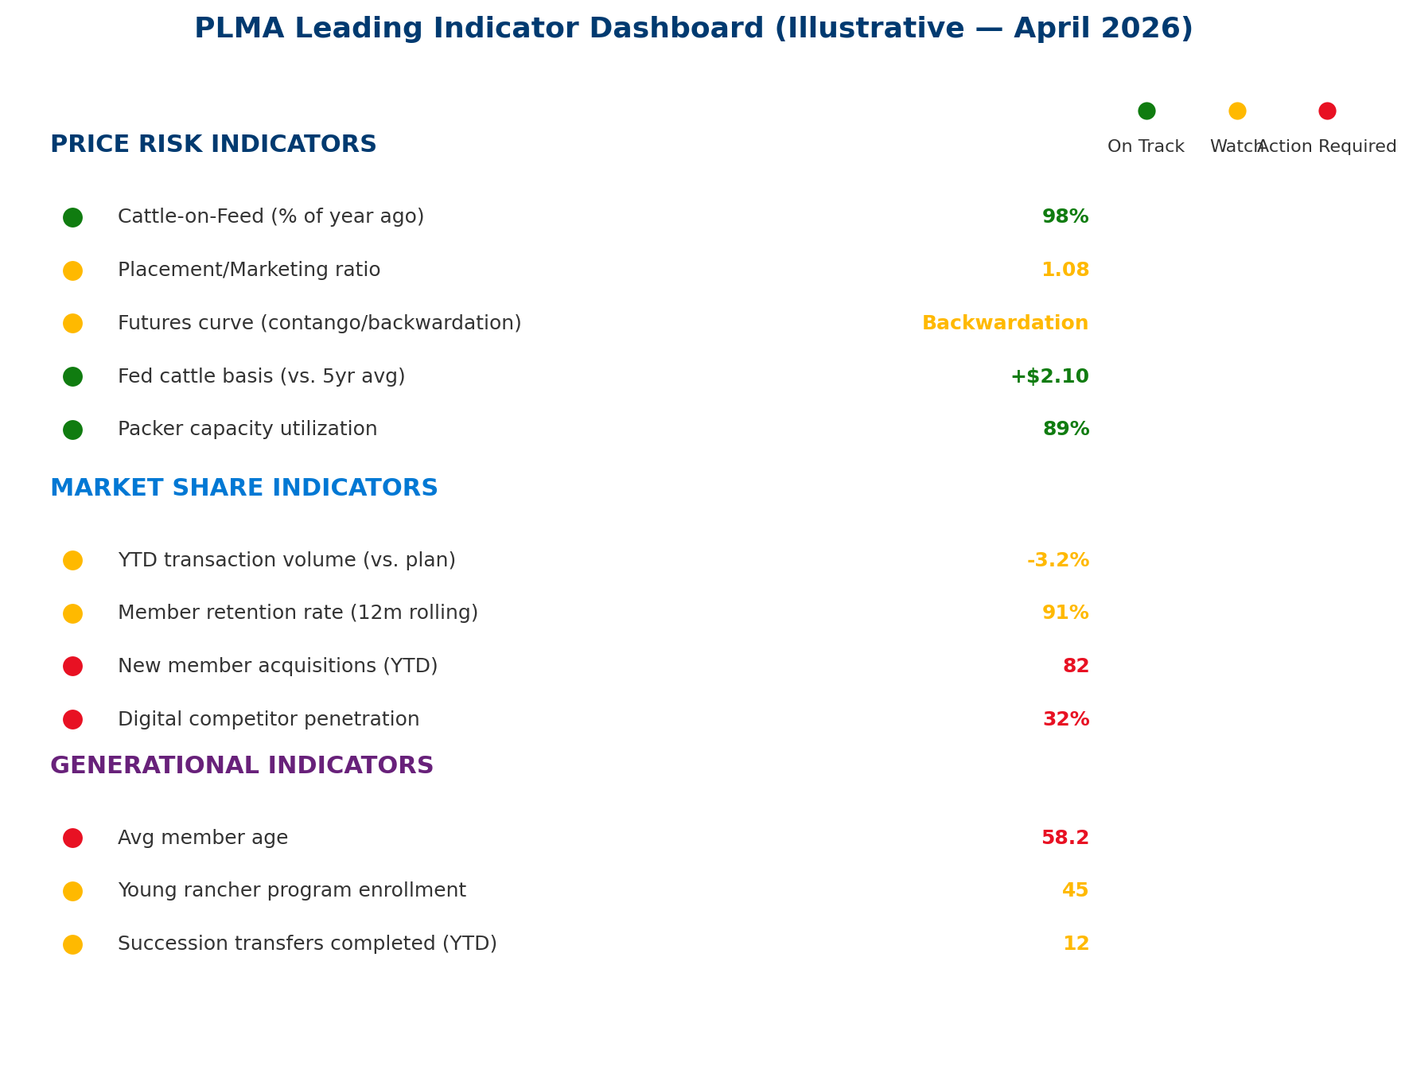
Exhibit: Illustrative dashboard showing current status. Amber/red indicators require escalation per governance protocols.

7.1 Price Risk Indicators
Indicator | Frequency | Signal | Action Trigger
Cattle-on-Feed report | Monthly | YoY placement trends | >105% of year-ago triggers review
Placement/Marketing ratio | Monthly | Supply pipeline buildup | >1.10 for 3 consecutive months
CME futures curve structure | Weekly | Contango vs. backwardation | Shift to contango = bearish signal
Feeder cattle basis | Weekly | Regional price dislocation | >$5 deviation from 5yr avg
Packer capacity utilization | Monthly | Processing bottleneck | <85% signals margin pressure
Hog-corn price ratio | Monthly | Pork profitability proxy | <20 signals producer stress

7.2 Market Share Indicators
Indicator | Frequency | Signal | Action Trigger
Transaction volume (YTD vs plan) | Monthly | Volume trajectory | >5% below plan for 2 months
Member retention (12m rolling) | Monthly | Relationship health | <90% triggers retention campaign
New member acquisitions | Monthly | Growth pipeline | <80% of annual target pace
Digital competitor penetration | Quarterly | Disintermediation speed | >35% triggers defensive action
Top-10 member concentration | Quarterly | Dependency risk | >40% of volume

7.3 Generational Indicators
Indicator | Frequency | Signal | Action Trigger
Average member age | Annually | Aging trajectory | >60 triggers acceleration
Young Rancher Program enrollment | Monthly | Pipeline health | <100/yr by Year 2
Succession transfers completed | Quarterly | Retention through transfer | <30% retention rate
University partnership engagement | Quarterly | Pipeline development | <3 active partnerships

8. Mitigation Strategy & Implementation Roadmap
The mitigation strategy addresses all three risk pillars — price, market share, and generational succession — through a unified Three Horizons framework consistent with Reports #1 and #2.

8.1 Price Risk Mitigation Toolkit

8.1.1 Hedging Overlay on Company-Owned Cattle
CONNECTION TO REPORT #1
Report #1 recommended a hedging program for the consignment-to-settlement window (Section 6.2). This report extends that program to cover company-owned inventory specifically. Costs here are ADDITIVE — the $300K hedging build-out covers additional positions and basis management infrastructure beyond Report #1's $150K hedging setup.

Implement systematic hedge coverage of 60-80% of company-owned cattle inventory. Use CME live cattle and feeder cattle futures with option overlays for basis protection. Target: reduce mark-to-market exposure from $4M (unhedged) to <$1M in a 20% decline.

8.1.2 Commission Structure Reform
Move from pure percentage-of-sale commission to a blended model:
- Floor commission: Minimum per-head fee that provides revenue stability even in price declines.
- Tiered commission: Lower % rate on high-value cattle (incentivizes volume at peak prices).
- Fee-for-service: Unbundled advisory, hedging, and credit facilitation services priced separately.
- Subscription model: Fixed annual member fee for base services + variable commission on transactions.

8.1.3 Working Capital Stress Testing
Conduct quarterly stress tests of PLMA's working capital against three scenarios (10%, 20%, 30% price decline) to ensure liquidity is adequate to sustain operations during a 12-24 month correction period.

8.2 Market Share Defense & Growth

8.2.1 Digital Platform
Cross-reference Report #2, Section 5.5: digital auction platform, mobile-first member experience, online sale capability. This is the single most important market share defense investment.

8.2.2 Geographic Expansion
Evaluate expansion into 1-2 underserved regions within Year 2-3, targeting areas where auction market closures have created service gaps. Approaches: greenfield branch, partnership with existing regional cooperative, or acquisition.

8.2.3 Value-Added Services
Launch fee-based advisory services: risk management advisory, hedging education, insurance brokerage, and market intelligence subscriptions. These services (i) generate non-commission revenue, (ii) deepen member relationships, and (iii) create switching costs.

8.2.4 Cooperative Partnerships / M&A
Evaluate strategic partnerships or acquisitions of 1-2 smaller regional cooperatives in Years 3-5. Target: cooperatives with complementary geographic footprints and aging leadership (natural succession opportunity).

8.3 Generational Succession Playbook

8.3.1 Young Rancher Program (Formal)
Launch a branded Young Rancher Program with: (i) dedicated staff (1 FTE), (ii) regional events (livestock judging, field days, networking), (iii) educational content (risk management, marketing, finance), (iv) trial membership (reduced first-year commission), (v) mentorship matching with experienced members.
Target: 150-200 new young rancher relationships per year by Year 3. At $15-25K lifetime commission value per relationship, this generates $2.25-5.0M in future revenue pipeline annually.

8.3.2 Estate Transition Liaison Service
Proactive outreach to members approaching retirement age (65+) to facilitate: (i) introduction to estate planning resources, (ii) identification of successor operators, (iii) continuity of PLMA marketing relationship through the transition, (iv) warm handoff from retiring member to successor. Target: increase succession retention rate from ~29% to 55% within 5 years.

8.3.3 Next-Gen Digital Experience
Young producers expect digital-first interaction: mobile auction participation, real-time market data, instant settlement, electronic documentation, and social media engagement. This is the generation that will judge PLMA by its app, not its auction ring.

8.3.4 University / Extension Partnerships
Target 5+ land-grant university partnerships within 3 years: KSU, TAMU, UNL, SDSU, CSU, OSU. Sponsor livestock judging teams, host guest lectures, fund cooperative-focused research, and establish internship programs.

8.4 1-Year / 5-Year / 10-Year Plans
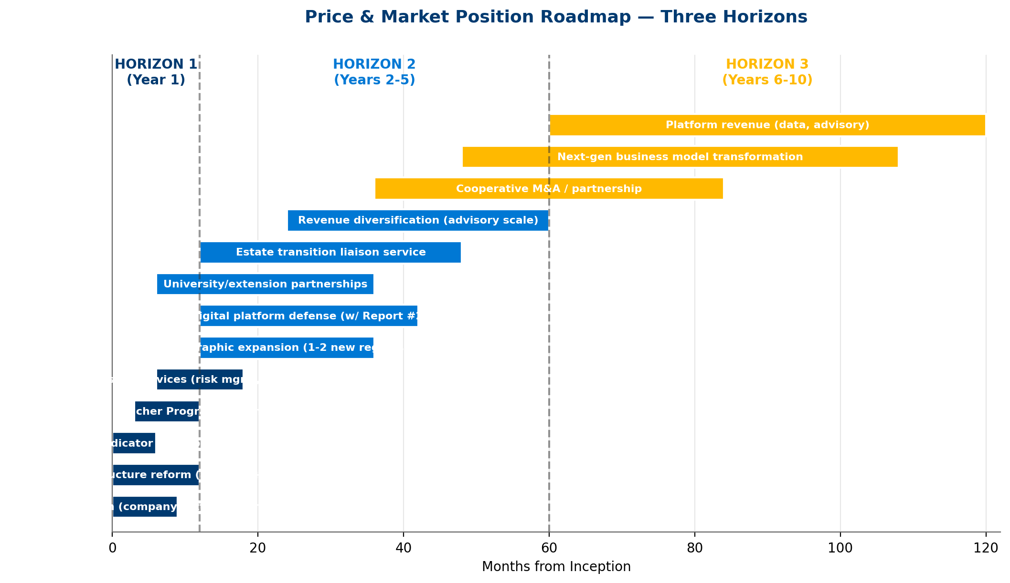
Exhibit: 13 workstreams across 10 years, structured by McKinsey Three Horizons.

Year 1 — Foundation
- Launch hedging program for company-owned cattle (Month 3)
- Commission structure analysis and pilot (Months 1-12)
- Deploy leading indicator dashboard (Month 6)
- Launch Young Rancher Program (Month 6)
- Hire dedicated program staff (Month 3)
- Initiate 2 university partnerships (Month 9)

5-Year Targets
- Geographic expansion: 1-2 new regions operational
- Advisory services generating $1.2M+/year in fee revenue
- Young Rancher Program: 500+ cumulative enrollees
- Succession retention rate: >55% (from ~29% baseline)
- Digital platform live with hybrid auction capability
- Member age trend stabilized (avg age growth slowed)

10-Year Vision
- 15-20% of revenue from non-commission sources
- 1-2 strategic cooperative acquisitions completed
- Young rancher cohort represents >20% of active members
- PLMA is the reference cooperative for next-gen engagement
- Commission structure fully modernized (blended model)

9. Financial Model

9.1 Commission Revenue Scenarios
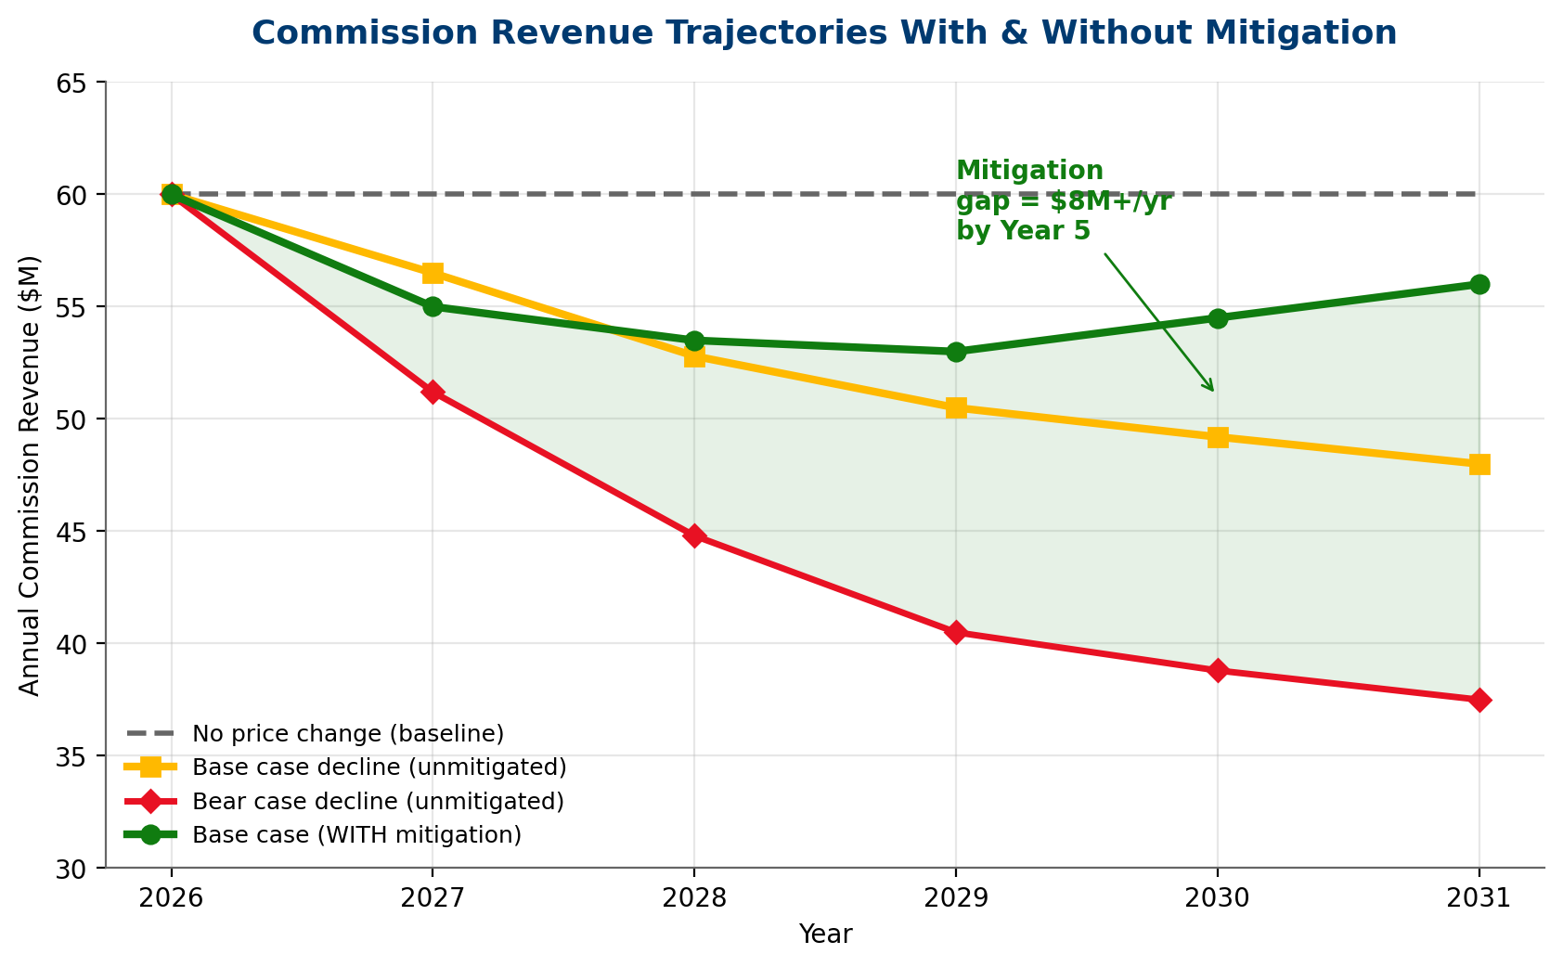
Exhibit: With mitigation, PLMA stabilizes revenue even under base-case price decline — a $8M+/yr gap vs. unmitigated by Year 5.

9.2 Program Costs
Year 1 Investment | Amount
Hedging program build-out | $300K
Commission structure analysis & implementation | $250K
Market share defense (digital, geographic) | $800K
Young Rancher Program launch | $400K
Revenue diversification (advisory services) | $500K
Leading indicator dashboard & analytics | $250K
Change management & training | $300K
**TOTAL Year 1** | $2800K

Ongoing Annual Cost (Year 2+) | Amount
Hedging operations & advisory | $200K
Commission structure management | $100K
Market share programs (ongoing) | $450K
Young Rancher Program (annual) | $400K
Advisory services delivery | $350K
Dashboard & analytics operations | $150K
Change management (ongoing) | $150K
**TOTAL Ongoing** | $1800K

9.3 Annual Benefits
Benefit Category | Annual Value
Revenue protection (hedging avoided losses) | $1500K
Market share defense (prevented erosion) | $1800K
Young Rancher Program (new relationships) | $800K
Advisory service fee revenue | $1200K
Commission structure optimization | $700K
Inventory hedging gain (expected value) | $500K
**TOTAL Annual Benefit** | $6500K

9.4 10-Year Cash Flows & NPV
Year | Cost | Benefit | Net CF | Cumulative
Year 1 | $2800K | $2600K | $-200K | $-200K
Year 2 | $1800K | $5200K | $3400K | $3200K
Year 3 | $1800K | $6500K | $4700K | $7900K
Year 4 | $1800K | $6500K | $4700K | $12600K
Year 5 | $1800K | $6500K | $4700K | $17300K
Year 6 | $1800K | $6500K | $4700K | $22000K
Year 7 | $1800K | $6500K | $4700K | $26700K
Year 8 | $1800K | $6500K | $4700K | $31400K
Year 9 | $1800K | $6500K | $4700K | $36100K
Year 10 | $1800K | $6500K | $4700K | $40800K

10-Year NPV (8% discount): $25.9M | ROI: 215% | Payback: 13 months
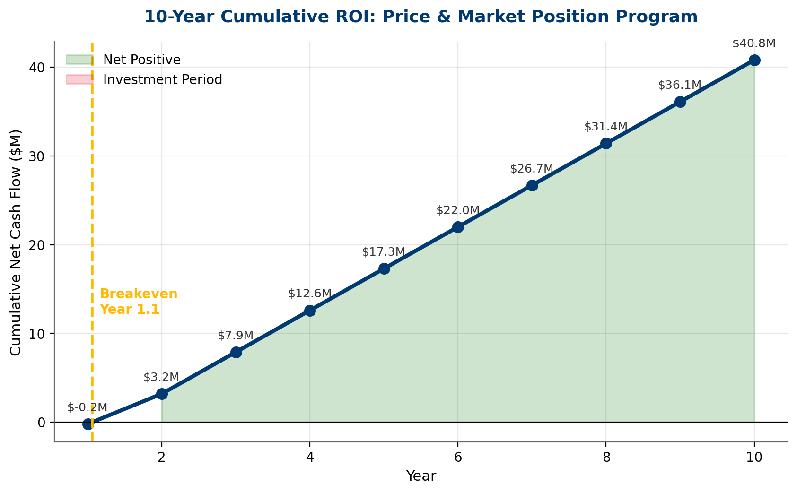
Exhibit: Program breaks even during Year 2; cumulative 10-year net exceeds $37M nominally.

9.5 Sensitivity Analysis
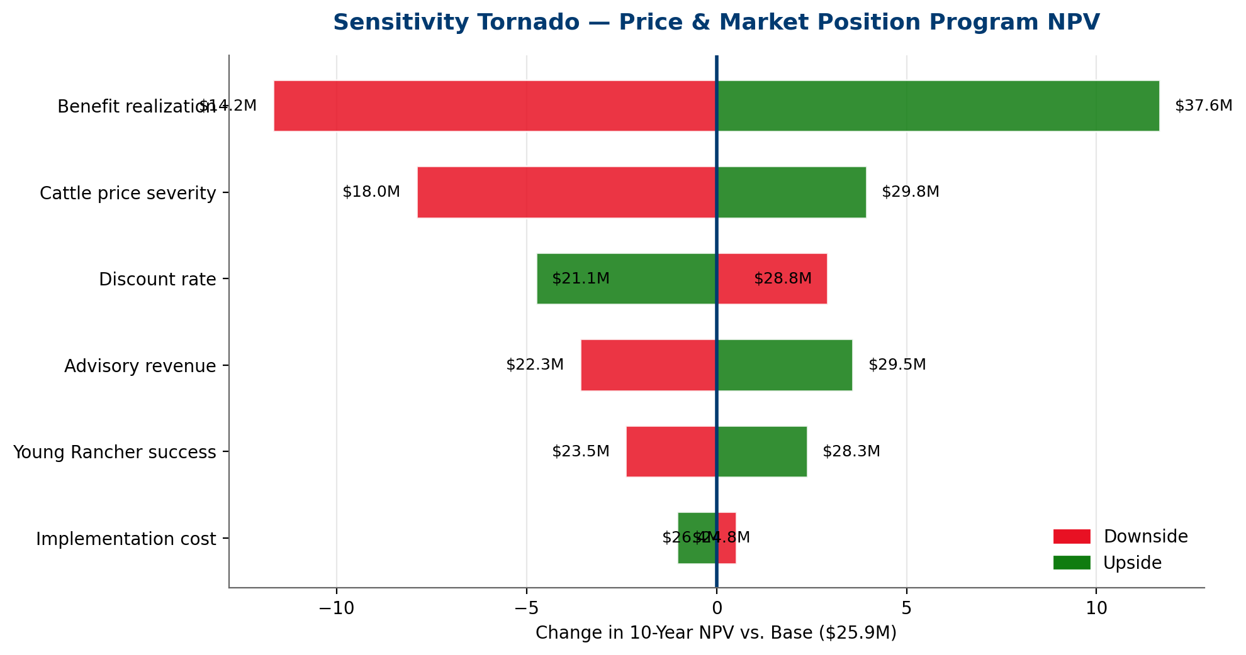
Exhibit: Benefit realization and cattle price severity are the top NPV drivers; program is robust across scenarios.
ROBUSTNESS
The program maintains positive NPV across all tested sensitivity scenarios, including the most adverse combination. Even if benefits materialize at only 70% of estimate, NPV remains strongly positive. The investment case does not depend on optimistic assumptions.

10. Conclusion & Next Steps
THREE REPORTS, ONE TRANSFORMATION
Reports #1, #2, and #3 are not three separate initiatives. They are three lenses on a single imperative: PLMA must modernize its risk management, technology, and market strategy to survive and thrive through a generational transition in the livestock industry. Credit risk (#1), tech transformation (#2), and price/market/succession risk (#3) share common governance, overlapping investments, and a unified Three Horizons roadmap.

PLMA's leadership team faces three concurrent structural challenges: a cattle cycle peak that will compress revenue, market share erosion from digital disruption and consolidation, and a demographic cliff that threatens the member base. None of these risks is fatal on its own. But in combination, without mitigation, they compound into an existential challenge within 5-10 years.
The recommended mitigation program — $2.8M Year 1, $1.8M ongoing — generates ~$26M in 10-year NPV and positions PLMA to emerge from the cattle cycle correction as a stronger, more diversified, and younger cooperative.

10.1 Immediate Actions (First 90 Days)
- Week 1-2: CFO-led briefing on Report #3 findings; integrate with Reports #1 & #2 action items
- Week 2-4: Board approval of Year 1 budget ($2.8M); integrate into unified transformation budget
- Week 4-6: Launch hedging program for company-owned cattle
- Week 4-8: Commission structure working group formed; begin analysis
- Week 6-10: Young Rancher Program staff hired; university outreach initiated
- Week 8-12: Leading indicator dashboard deployed (v1)
- Week 12: Integrated PMO operational covering all three report workstreams

10.2 Integrated Budget Summary (All 3 Reports)
Report | Year 1 Cost | Ongoing/yr | 10-yr NPV
#1: Credit Risk Mitigation | $1.72M | $1.17M | ~$20M
#2: Technology Strategy | $4.80M | $2.60M | ~$34M
#3: Price & Market Strategy | $2.80M | $1.80M | ~$26M
TOTAL (de-duplicated) | $9.32M | $5.57M | ~$82M

The combined program represents a $9.3M Year-1 investment generating ~$82M in aggregate 10-year NPV — a decisive, financially justified transformation of PLMA's risk posture, technology capability, and market position.

Appendix A: Cattle Cycle Data Tables
Year | Fed Cattle ($/cwt) | Feeder ($/cwt) | Cow Herd (M head)
1990 | $82 | $95 | 99.3
1995 | $63 | $72 | 102.8
2000 | $68 | $95 | 98.2
2005 | $87 | $118 | 95.8
2010 | $95 | $128 | 93.9
2014 | $160 | $242 | 89.1
2017 | $108 | $148 | 93.6
2020 | $118 | $145 | 93.8
2022 | $142 | $185 | 91.9
2024 | $190 | $268 | 89.3
2025 | $195 | $278 | 88.5
2026 (Q1) | $198 | $282 | 88.2

Appendix B: Commission Sensitivity Model Detail
Model assumes: $3.2B transaction volume, 72% cattle / 28% pork split, 1.875% average commission rate. Cattle price declines applied to cattle volume only; pork volume held constant. Scenarios represent annual average price declines from peak-cycle levels.

Appendix C: Generational Demographics
Age Group | 2012 Census | 2022 Census | 2035 Projected | Change
<35 | 5.6% | 4.9% | 4.2% | -1.4pp
35-44 | 10.2% | 8.3% | 7.5% | -2.7pp
45-54 | 21.8% | 16.1% | 12.8% | -9.0pp
55-64 | 30.6% | 27.4% | 22.5% | -8.1pp
65-74 | 22.1% | 27.3% | 29.5% | +7.4pp
75+ | 9.7% | 16.0% | 23.5% | +13.8pp

Appendix D: Methodology & Assumptions
Financial model uses standard DCF with 8% discount rate. Benefits ramp: 40% Year 1, 80% Year 2, 100% Year 3+. Commission sensitivity model uses linear price-volume relationship (elasticity = 1.0 for simplicity). Inventory mark-to-market assumes flat basis. Generational projections use cohort survival model with USDA Census data. Market share erosion rates benchmarked from LMA industry reports.

Appendix E: Glossary
- Basis: Difference between local cash price and CME futures price.
- Cattle Cycle: 10-12 year biological/economic cycle of herd expansion and contraction.
- Contango: Futures curve where later months are higher than nearby — bearish signal.
- Backwardation: Futures curve where nearby months are higher — bullish/tight-supply signal.
- Cost-of-Gain: Feed and operational cost per pound of weight added in a feedlot.
- Disintermediation: Removal of intermediaries (like PLMA) from supply chain transactions.
- EID: Electronic Identification — RFID tags for individual animal tracking.
- Feeder Cattle: Weaned calves or yearlings ready for feedlot placement.
- Hog-Corn Ratio: Lean hog price / corn price — proxy for pork producer profitability.
- Mark-to-Market: Revaluing inventory to current market prices; unrealized gain/loss.
- P&SA: Packers & Stockyards Act — USDA livestock marketing regulation.

Appendix F: Citations
[1] USDA NASS, "Cattle on Feed," monthly reports 2024-2026.
[2] USDA NASS, "Cattle," semi-annual report, January 2026.
[3] USDA ERS, "Cattle & Beef: Outlook," March 2026.
[4] CME Group, "Live Cattle and Feeder Cattle Futures: Market Analysis," 2025-2026.
[5] Livestock Marketing Information Center (LMIC), "Monthly Livestock Outlook," 2025-2026.
[6] Kansas State University, "AgManager: Livestock Market Analysis," 2025-2026.
[7] USDA ERS, "Hogs & Pork: Outlook," March 2026.
[8] USDA APHIS, "African Swine Fever Response Plan," updated 2025.
[9] National Pork Producers Council, "ASF Preparedness," 2025.
[10] USDA AMS Packers & Stockyards Division, "Annual Report," 2025.
[11] USDA ERS, "Farm Income and Wealth Statistics," 2025-2026.
[12] Federal Reserve Bank of Kansas City, "Agricultural Finance Databook," Q4 2025.
[13] Livestock Marketing Association, "Annual Industry Census," 2024.
[14] USDA NASS, "Census of Agriculture," 2022 (released 2024).
[15] USDA ERS, "America's Farms and Ranches at a Glance," 2025.
[16] Rabobank, "Global Animal Protein Outlook," 2026.
[17] Sterling Marketing Inc., "Cattle Feeding Industry Analysis," Q1 2026.
[18] Superior Livestock Auction, "Annual Transaction Report," 2025.
[19] CoBank, "U.S. Agricultural Cooperatives: Risk and Resilience," 2025.
[20] S&P Global Market Intelligence, "U.S. Agribusiness Credit Trends," 2025.
[21] McKinsey & Company, "Agriculture Practice: Building Resilient Food Systems," 2024.
[22] Porter, M.E., "Competitive Strategy," Free Press, 1980.
[23] Covey, S.R., "The 7 Habits of Highly Effective People," 1989 (Circle of Influence).
[24] Harvard Business Review, "Managing Risks: A New Framework," Kaplan & Mikes, 2012.
[25] USDA NIFA, "Beginning Farmer and Rancher Development Program," 2024-2025.
[26] National Association of State Departments of Agriculture, "Young Farmer Programs," 2025.
[27] CME Group, "Basis: Understanding Cash-Futures Relationships," educational resources.
[28] Farm Credit Administration, "Young, Beginning, and Small Farmer Mission," 2025.

