CONFIDENTIAL • CLIENT DELIVERABLE • REPORT 2 OF 2
Emerging Technology Strategy
Opportunity, Risk & the Path to Digital Resilience

Producers Livestock Marketing Association
Prepared for Ryan Johansen, Chief Financial Officer
Companion to Report 1: Counterparty Credit Risk Assessment
APRIL 2026
Strategic Advisory | Technology & Digital Practice

Table of Contents
1. Executive Summary 3
2. The Technology Landscape for Livestock Marketing 6
3. Technology Risk Assessment [Risk-Led Anchor] 10
4. The AI Opportunity Deep Dive 17
5. Broader Technology Opportunity Portfolio 24
6. Strategic Framework Analysis 30
7. Technology Strategy & Roadmap (1 / 5 / 10 Year) 35
8. Financial Model: Tech Investment Economics 41
9. Governance & Execution 46
10. Conclusion & Next Steps 49
Appendix A: Use Case Scorecards 51
Appendix B: Methodology & Assumptions 54
Appendix C: Glossary of Terms 56
Appendix D: Citations 58

1. Executive Summary
SITUATION
PLMA operates on a technology foundation that is approximately 10 years behind livestock-marketing peers and 15+ years behind digitally-native financial services. The cost of inaction now exceeds the cost of transformation: legacy tech debt silently drains an estimated $8.8M annually in avoidable costs and foregone opportunity, while digital marketplace entrants (Superior Livestock, Cattlerange, fintech challengers) are accelerating their share of flow. This window to act on favorable terms is closing.

1.1 Key Findings
- The disruption threat is real and accelerating. Digital livestock marketplaces grew an estimated 40%+ YoY in transaction volume during 2024–2025 while traditional auction models grew <5%. Fintech-native credit and payment rails are being introduced by non-traditional entrants targeting PLMA's fee pools.
- Cybersecurity is the highest-severity technology risk. Ag-sector cyber incidents grew from 12 (2020) to 117 (2025) — a 9.75× increase. Average ransom demands escalated from $350K to $2.8M. A single incident could exceed PLMA's annual cyber avoidance budget by 3-5×.
- AI is neither optional nor niche — it is a fiduciary imperative. 12 credible AI/tech use cases were identified for PLMA with aggregate expected 10-year NPV of ~$66M if all pursued. The top 7 use cases (DO FIRST + QUICK WINS quadrants) deliver ~$47M in NPV and form the core of the recommended program.
- PLMA's digital maturity lags peers across all six dimensions. Estimated maturity score: 2.25/5 average vs. peer cooperative average of 3.42/5 and digital leader benchmark of 4.75/5. The largest gaps are in AI/ML capability, data/analytics, and cloud infrastructure.
- The investment case is compelling even under adverse sensitivity assumptions. A $4.8M Year-1 investment generates a 10-year NPV of ~$34M at 8% discount rate, ~192% cumulative ROI, and payback within 18 months. The program remains NPV-positive across all tested sensitivity scenarios.
- Credit risk and tech risk are the same risk viewed from two angles. The manual, relationship-driven credit decisioning flagged in Report #1 is simultaneously a counterparty credit risk AND a technology risk. This report's AI credit scoring recommendation directly supersedes the v1 scoring model in Report #1's Horizon 1 plan.

1.2 Recommended Actions
The recommended program is a risk-led, opportunity-harvesting portfolio sequenced across the McKinsey Three Horizons framework:
- Horizon 1 (Year 1 — Foundation): Cybersecurity hardening (Zero Trust), cloud/data platform v1, AI governance framework, ML credit scoring v1, GenAI back-office pilots, RPA for AR/AP automation. $4.8M investment. Goal: stabilize risk surface, prove AI value.
- Horizon 2 (Years 2–5 — Transformation): Scaled AI (price prediction, computer vision), full platform modernization, digital auction platform, IoT/EID pilots. Goal: capture the digital marketplace threat, differentiate on analytics.
- Horizon 3 (Years 6–10 — Reinvention): AI-native operating model, platform business plays (data monetization, advisory services), ecosystem orchestration. Goal: transform PLMA from auction cooperative to agricultural risk and market intelligence platform.

1.3 Financial Impact Summary
Metric | Value
Year 1 Program Investment | $4.80M
Annual Ongoing Cost (Year 2+) | $2.60M
Annual Steady-State Benefit | $9.00M
Net Steady-State Annual Impact | +$6.40M
10-Year NPV (8% discount rate) | ~$34M
Payback Period | ~16-18 months
10-Year Cumulative ROI | ~192%
Annual Tech Debt Drag (status quo) | ~$8.8M

URGENCY
Three factors compress the decision window: (1) digital marketplace entrants are compounding advantage, (2) cyber insurance premiums are hardening as incident frequency rises, and (3) AI talent markets favor first-movers. A 12-month delay costs an estimated $5-7M in foregone NPV plus elevated tail risk.

2. The Technology Landscape for Livestock Marketing
The livestock marketing industry is undergoing a quiet but accelerating digital transformation. This section sets context: where capital is flowing, where AI adoption stands, how peers compare, and what the regulatory environment requires.

2.1 Digital Disruption of Agricultural Value Chains
Global agtech investment reached an estimated $13B in 2025 after a 2021 peak of $11.4B, a post-correction rebound. Cumulative 2018–2025 investment in ag-focused technology exceeds $75B, with the fastest-growing segment being ag AI/ML (from $400M in 2018 to $4.2B in 2025). ^{[1]}
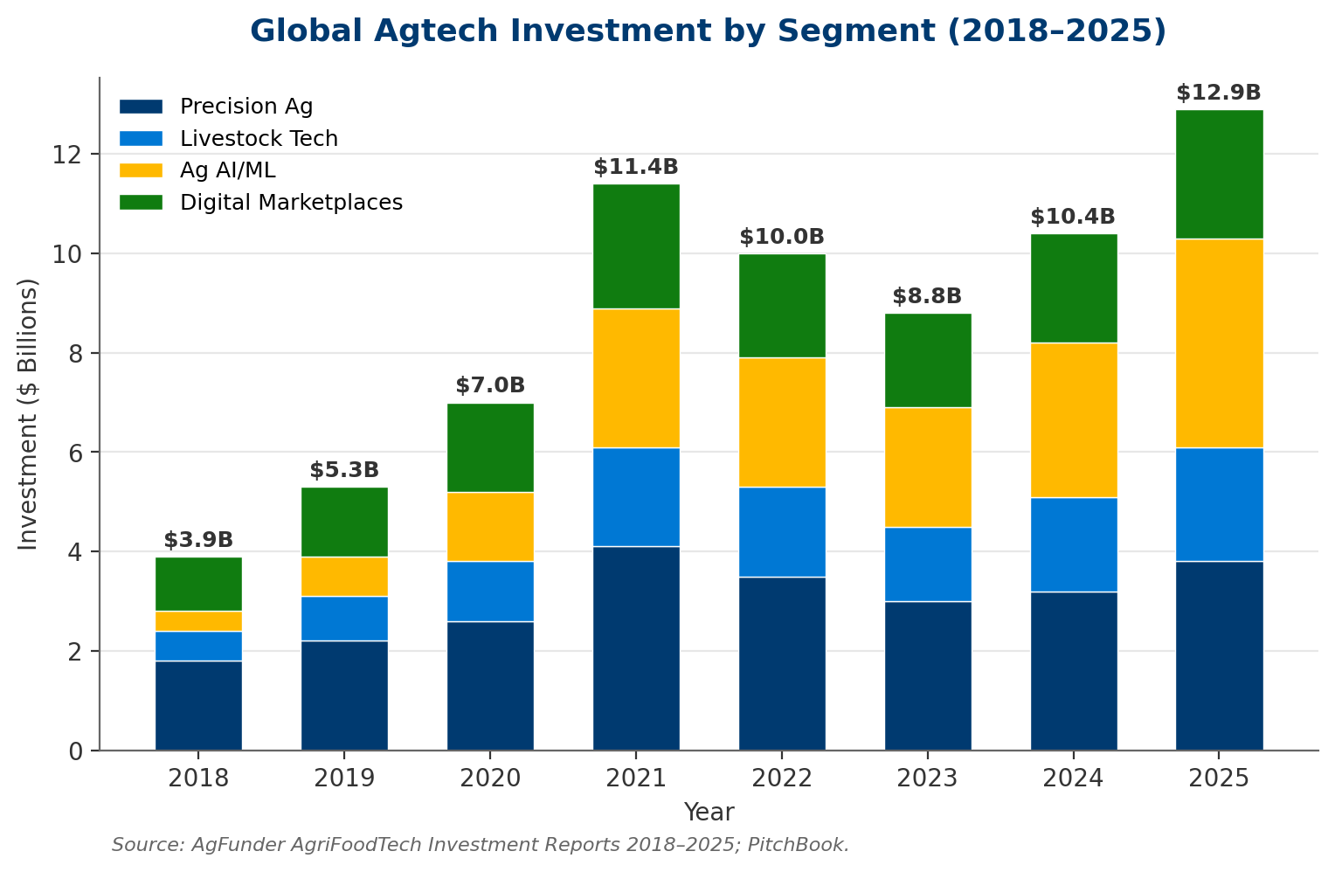
Exhibit: Ag AI/ML is the fastest-growing agtech segment, crossing $4B in 2025.
This capital is funding direct threats to PLMA's business model: digital auction platforms, peer-to-peer livestock marketplaces, AI-driven credit decisioning for producers, fintech payment rails that bypass intermediaries, and data platforms that aggregate market intelligence cooperatively held historically.

2.2 AI Adoption Curves
McKinsey's State of AI surveys indicate enterprise AI adoption reaching ~65% of organizations globally in 2025, with GenAI adoption specifically jumping from 33% (2023) to 65% (2024). Adoption is not uniform: financial services and technology lead, while agriculture — particularly livestock marketing — lags. ^{[2]}
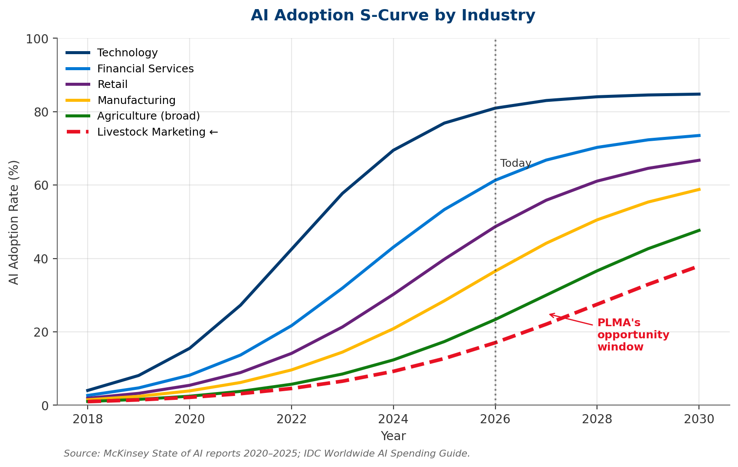
Exhibit: Livestock marketing sits in the early-majority zone; PLMA has a 2-3 year window to catch up on favorable terms.

2.3 Competitor / Peer Benchmarking
Among ~15 major U.S. livestock marketing cooperatives and auction networks, we estimate:
- Digital leaders (3-4 peers): Cloud-native core systems, AI-driven credit scoring in production, digital auction platforms live, RPA deployed broadly.
- Digital challengers (5-6 peers): Hybrid cloud, selective AI pilots, partial digital auction capability, some RPA.
- Digital laggards (5-6 peers, including PLMA): On-premise legacy systems, manual credit processes, traditional auction model, limited or no AI, reactive cyber posture.

2.4 Regulatory Landscape
Regulation / Framework | Relevance to PLMA | Status
NIST AI Risk Management Framework (AI RMF 1.0) | Voluntary but increasingly required in B2B and regulated contexts | Active (2023)
SEC Cybersecurity Disclosure Rule | Public filer obligation; signals expectations across all entities | Effective 2023
State AI Governance Laws (CO, CA, UT, NYC) | High-risk AI decision systems; extend to credit/employment | Expanding 2024–2026
EU AI Act | Extraterritorial reach for firms operating with EU buyers/data | Phased 2025–2027
State Privacy Laws (20+ states) | Producer data, member data, marketing consent | Patchwork, expanding
Packers & Stockyards Act (P&SA) | Algorithmic pricing, AI bias in credit decisions | Active enforcement

2.5 The Cost of Doing Nothing
THE DO-NOTHING SCENARIO
If PLMA maintains current technology posture through 2030: (1) digital marketplace entrants capture an estimated 15-25% of transaction flow currently routed through PLMA, (2) cyber incident probability approaches ~35% over 5 years at estimated $2-4M per incident, (3) legacy system maintenance costs grow 8-12% annually, and (4) AI talent becomes unaffordable or unavailable as peers lock in capacity.

3. Technology Risk Assessment [Risk-Led Anchor]
This section anchors the report. We treat each technology risk in sequence, quantify where possible, and map to the PLMA context. The risks are ordered by materiality — not by technical complexity.
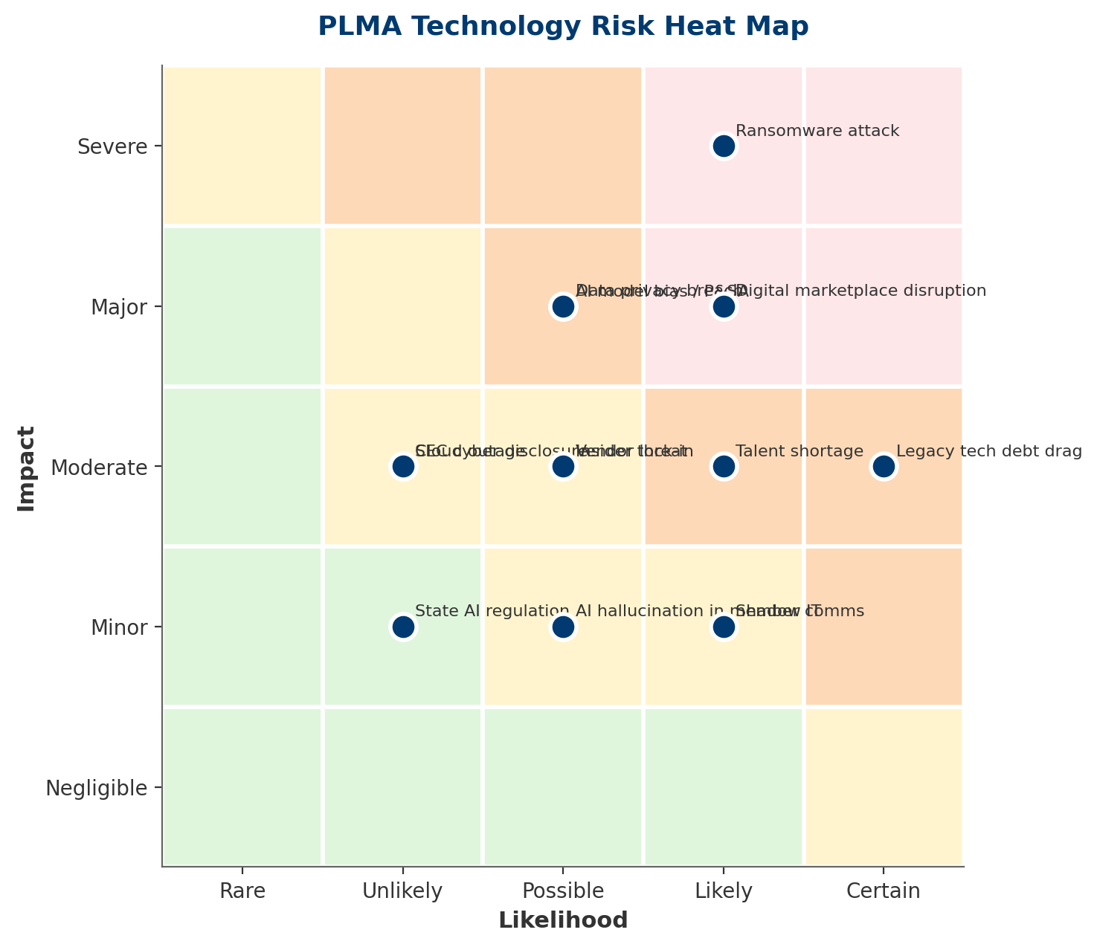
Exhibit: Ransomware, digital disruption, and legacy tech debt occupy the red zone of the heat map.

3.1 Disruption Risk — Digital Marketplaces Eroding the Auction Model
The most significant strategic risk to PLMA is not a single incident but a structural shift: the gradual migration of buyer and producer behavior to digital-first channels. Superior Livestock Auction (a pioneer in video/online cattle sales), Cattlerange, and regional online marketplaces have captured share steadily since 2019. Newer entrants apply fintech playbooks: AI credit decisioning at origination, instant settlement, buyer-producer matching algorithms.
Unlike a cyber incident, this disruption is slow and undramatic — which makes it particularly dangerous. By the time the shift is visible in revenue, competitive position has already eroded.

3.2 Cybersecurity Risk — The Most Acute Technology Exposure
The Food and Agriculture Information Sharing and Analysis Center (Food & Ag-ISAC) and CISA have documented a material increase in targeted attacks on agricultural cooperatives and processors. Notable incidents include the 2021 JBS ransomware attack ($11M ransom paid), 2021 NEW Cooperative incident, and numerous 2023–2025 incidents affecting grain elevators, feed mills, and livestock marketers. ^{[12]}
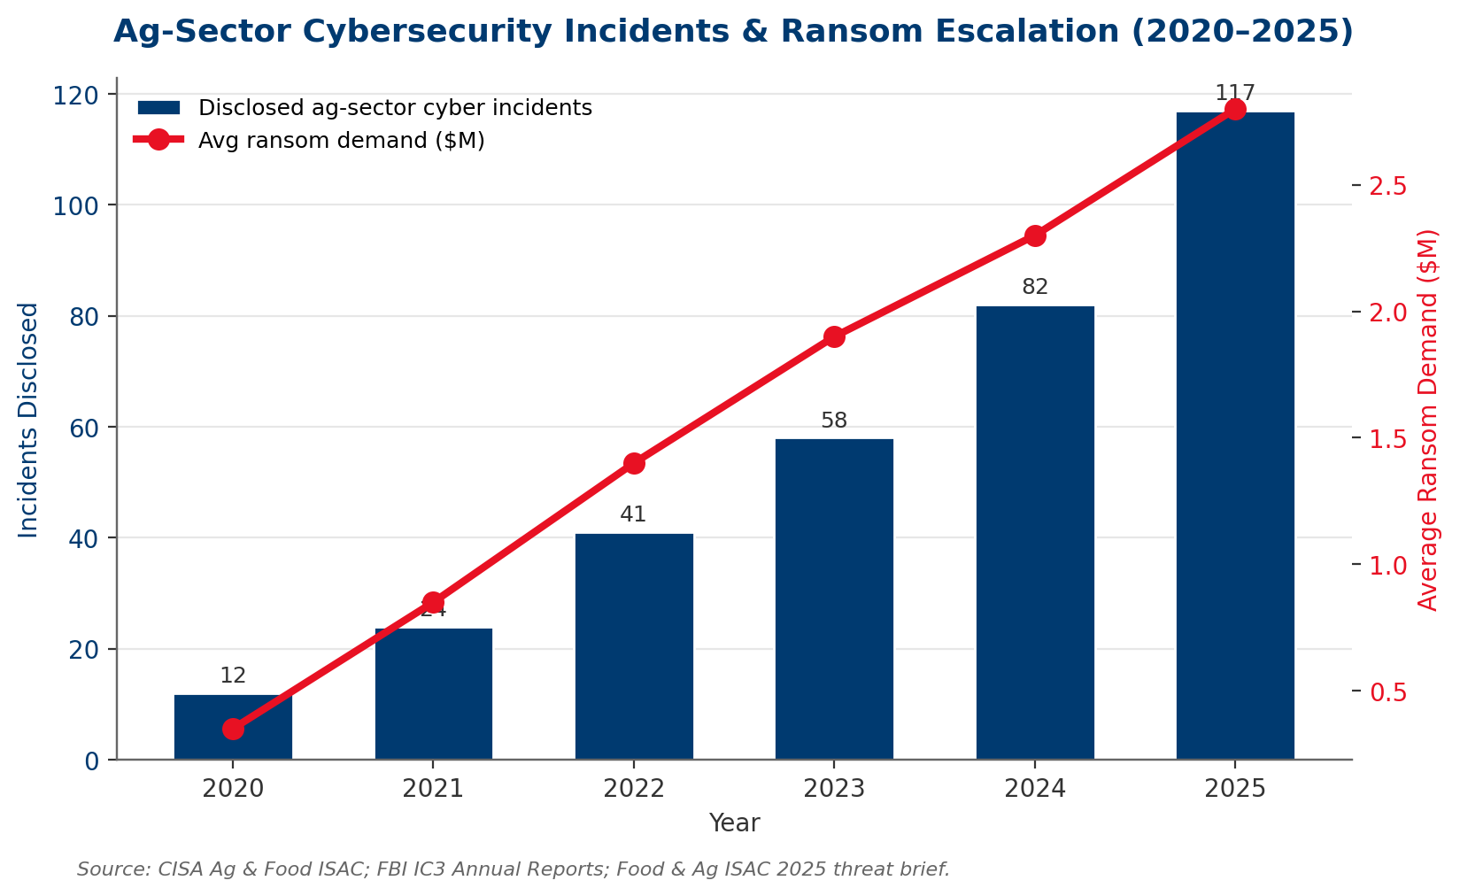
Exhibit: Cyber incidents in ag sector grew 9.75× from 2020–2025, with average ransoms reaching $2.8M.
THE RANSOMWARE MATH
At 117 disclosed incidents/year across the ag sector and ~2,000-3,000 qualifying entities, the 12-month incident probability for a PLMA-sized target is approximately 4-6%. Expected loss per incident: $2.5-4M (ransom, business interruption, remediation, notification, litigation). Annual expected loss: $100K-$240K — but tail risk (catastrophic incident) is $8-15M.

3.3 Legacy / Tech Debt Risk
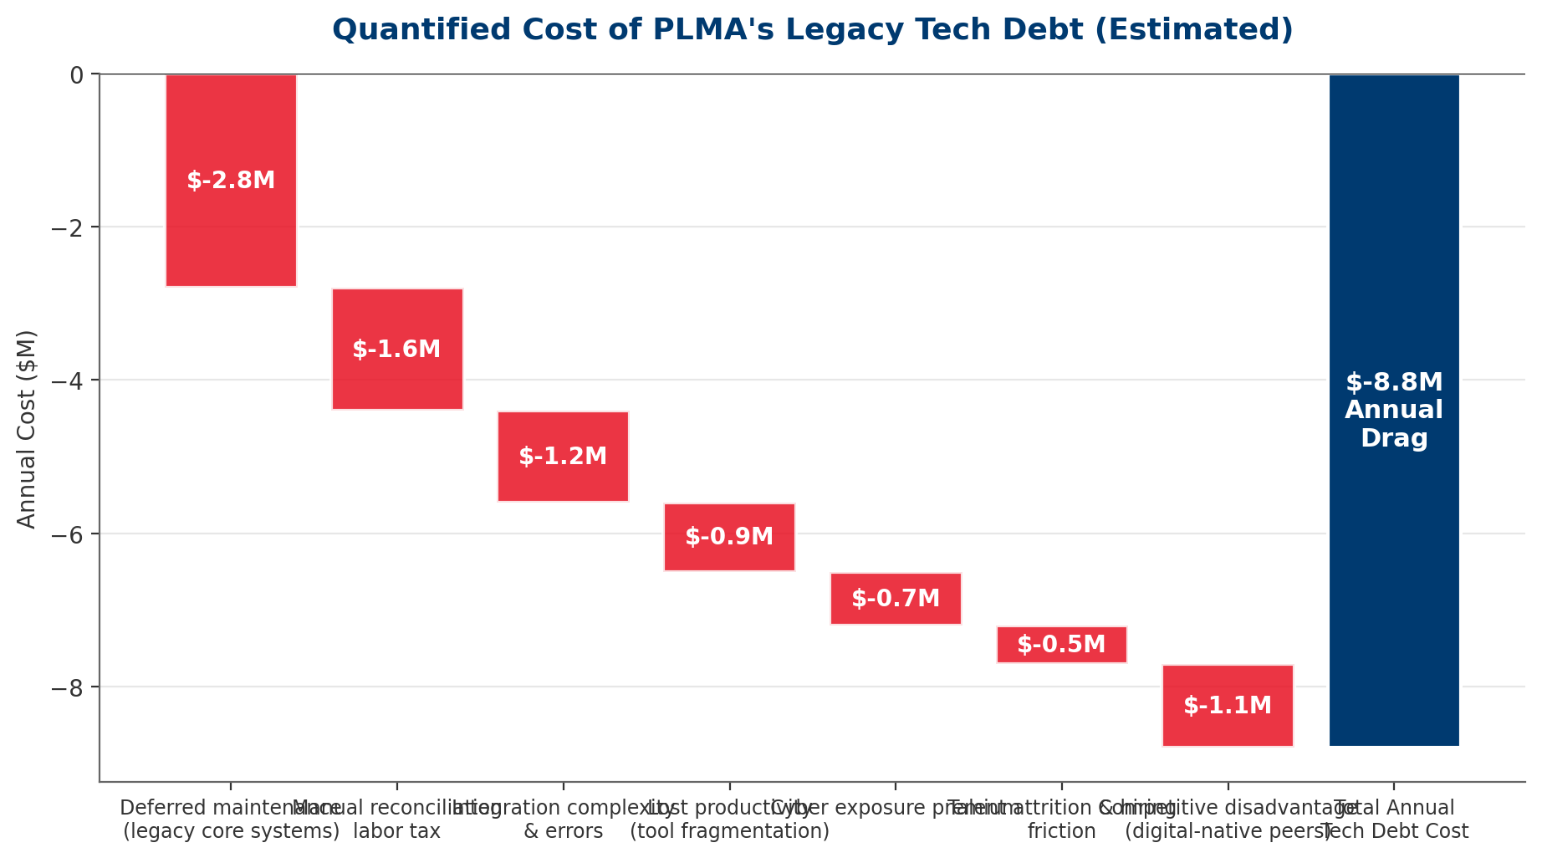
Exhibit: Legacy tech debt silently costs PLMA an estimated $8.8M annually — more than the recommended Year-1 investment.
CONNECTION TO REPORT #1 (COUNTERPARTY CREDIT RISK)
The manual credit decisioning process identified as a weakness in Report #1 is simultaneously a technology risk and a credit risk. Manual processes produce inconsistent underwriting, limited auditability, slow response to distress signals, and no systematic portfolio-level risk view. Fixing the credit process IS fixing a tech debt issue — the two reports point to the same root cause.

3.4 AI Governance & Explainability Risk
Deploying AI creates new risk categories PLMA has not previously managed: model bias (decisions systematically disadvantaging producer subgroups), explainability requirements (P&SA regulators may demand rationale for algorithmic credit decisions), model drift (performance degradation over time), and hallucination risk in GenAI applications (incorrect output presented with confidence).
We recommend PLMA adopt the NIST AI Risk Management Framework (AI RMF 1.0) as the governance backbone — it provides structure for GOVERN, MAP, MEASURE, and MANAGE functions across the AI lifecycle. ^{[8]}

3.5 Data Privacy & Regulatory Risk
State privacy laws (CCPA/CPRA, VCDPA, CPA, and 20+ state-level analogs enacted or proposed) impose obligations around member data, producer data, marketing consent, and data subject rights. The patchwork of state laws creates compliance complexity far beyond what PLMA currently manages. SEC climate and cyber disclosure rules, while aimed at public filers, are setting de facto expectations across B2B ag.

3.6 Talent Risk
AI, data, and cloud talent is in acute shortage nationally — and PLMA's rural/ag-adjacent hiring footprint makes the challenge harder. Competitive offers for senior data scientists, ML engineers, and cloud architects commonly exceed $200K total comp. PLMA cannot outbid coastal tech firms, but it can compete on mission, flexibility, and career arc — if the organization visibly invests.

3.7 Vendor Lock-in & Platform Risk
Hyperscaler cloud providers (AWS, Azure, GCP), enterprise SaaS vendors, and AI foundation model providers all create lock-in risk. The mitigation is not to avoid these vendors but to architect deliberately: abstraction layers, data portability standards, multi-cloud optionality for critical workloads, and contractual exit rights.

4. The AI Opportunity Deep Dive
AI is the single largest source of value-creation opportunity in PLMA's technology portfolio. This section identifies, scores, and sequences AI use cases — separating where PLMA should invest, where it should pilot, and where it should defer.

4.1 The PLMA AI Use Case Portfolio
We identified 12 candidate use cases across six AI/tech categories. Each is scored on strategic value (1-10) and feasibility (1-10). Bubble size represents estimated 10-year NPV contribution.
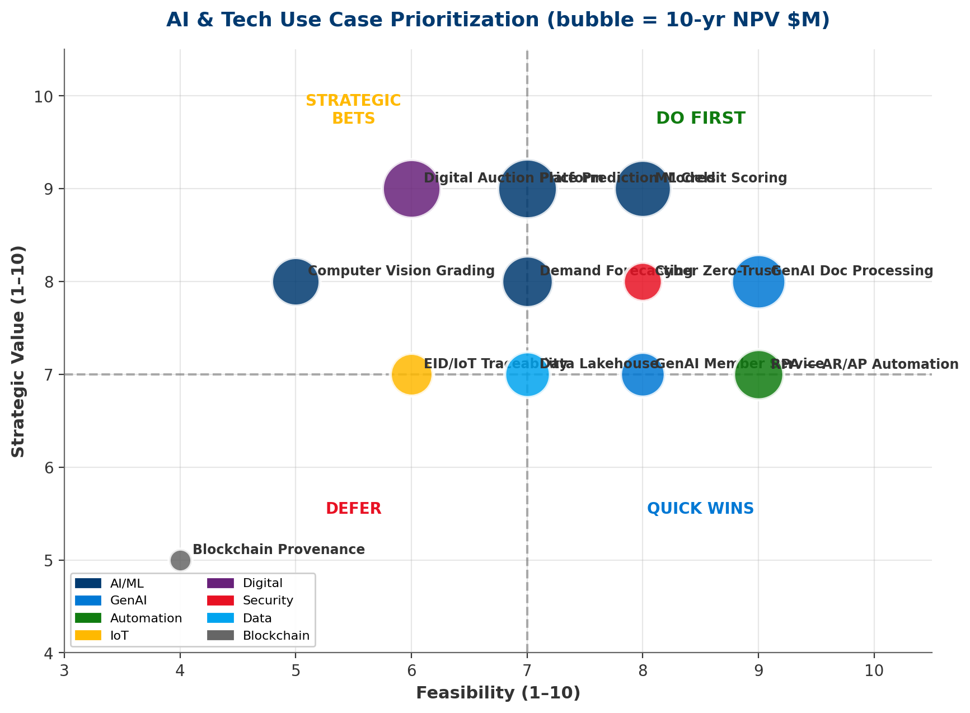
Exhibit: DO FIRST quadrant (high value, high feasibility) contains 4 use cases with ~$29M combined NPV.
Use Case | Category | Value | Feasibility | 10yr NPV
ML Credit Scoring | AI/ML | 9/10 | 8/10 | $7.5M
GenAI Doc Processing | GenAI | 8/10 | 9/10 | $6.8M
Price Prediction Models | AI/ML | 9/10 | 7/10 | $8.2M
Computer Vision Grading | AI/ML | 8/10 | 5/10 | $5.4M
GenAI Member Service | GenAI | 7/10 | 8/10 | $4.6M
Demand Forecasting | AI/ML | 8/10 | 7/10 | $6.1M
RPA — AR/AP Automation | Automation | 7/10 | 9/10 | $5.8M
EID/IoT Traceability | IoT | 7/10 | 6/10 | $4.2M
Digital Auction Platform | Digital | 9/10 | 6/10 | $7.9M
Cyber Zero-Trust | Security | 8/10 | 8/10 | $3.5M
Data Lakehouse | Data | 7/10 | 7/10 | $4.8M
Blockchain Provenance | Blockchain | 5/10 | 4/10 | $1.2M

4.2 ML Counterparty Credit Scoring
SUPERSEDES REPORT #1 HORIZON 1
Report #1 recommended a v1 statistical credit scoring model at $350K. This report recommends that investment be re-scoped as the foundation for a production ML credit scoring capability ($350K Year 1 → ML v2 at $600K in Year 2-3). Same budget envelope, substantially greater capability. Financial models in Section 8 de-duplicate the $900K/year credit loss avoidance benefit to prevent double-counting with Report #1.

An ML credit scoring model ingests financial statements, payment history, public records, industry benchmarks, and alternative data (satellite imagery for collateral, weather, commodity exposures) to produce a continuous probability-of-default score. Compared to Report #1's v1 statistical model, an ML approach captures non-linear relationships, adapts to new data, and provides significantly better early-warning signal on distressed counterparties.

4.3 Market Price Prediction & Hedging Intelligence
AI models trained on historical futures, cash, basis, and macro data can generate probabilistic forecasts of cattle and hog prices at 1-week, 1-month, and 3-month horizons. These forecasts inform: (i) PLMA's own working capital positioning, (ii) hedging overlay execution (tying to Report #1's hedging program), and (iii) potential fee-based advisory services to members.

4.4 Computer Vision for Livestock
Computer vision is maturing rapidly in livestock applications: individual animal identification (replacing/augmenting EID), weight estimation from video, body condition scoring, early disease detection, and automated grading. Readiness varies: identification and weight estimation are production-ready; grading and disease detection remain pilot-stage. PLMA's right role is strategic pilot + evaluation, not foundational R&D.

4.5 GenAI for Back-Office, Research, and Member Service
GenAI has immediate, high-feasibility value in: (i) document processing (contracts, financial statements, sale records), (ii) research and market intelligence (synthesizing USDA, Fed, industry reports), (iii) member service automation (routine inquiries, documentation), and (iv) internal knowledge management. These are quick wins with measurable productivity gains and limited downside risk — provided governance guardrails are in place.

4.6 Demand Sensing & Inventory Optimization
ML-driven demand sensing can reduce working capital requirements by 10-15% by improving the accuracy of expected buyer demand and optimal inventory posture. For PLMA's $200M estimated working capital exposure, this represents $20-30M in liquidity unlocked or redeployed.

4.7 Build vs. Buy vs. Partner
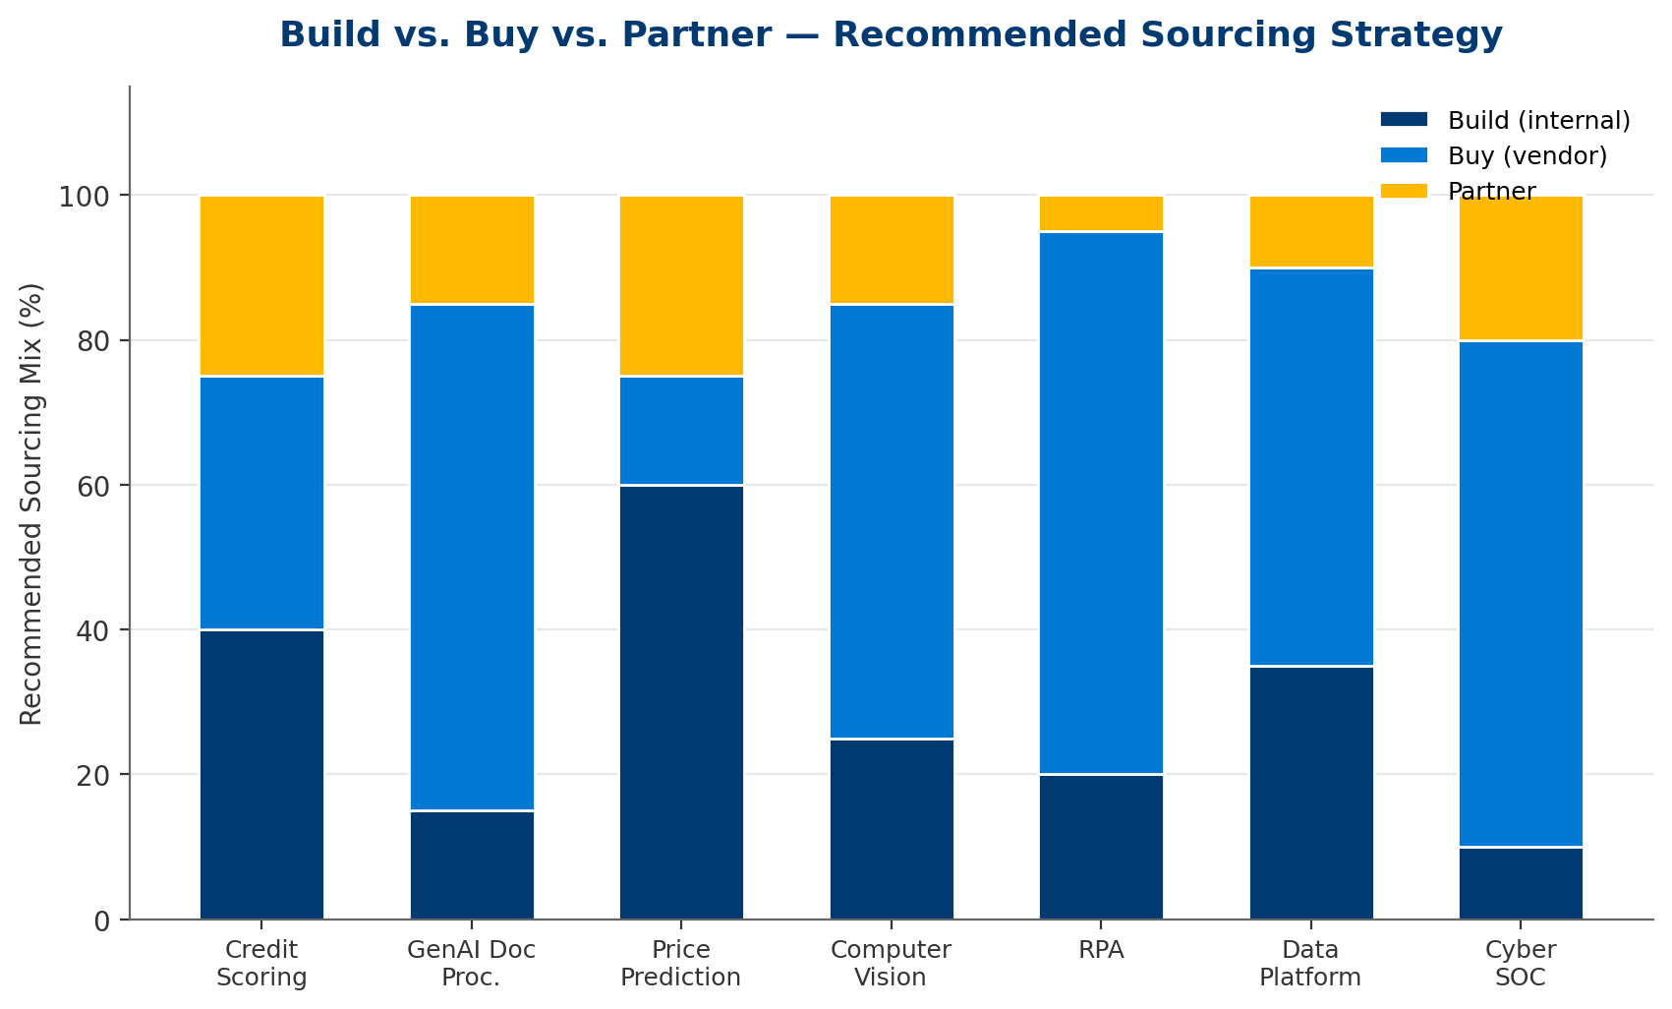
Exhibit: Sourcing recommendation: Buy + Partner for most AI capabilities; Build selectively where PLMA has proprietary data advantage.
Core principle: Build where PLMA has proprietary data advantage (credit scoring, market prediction); Buy where vendors offer commodity capability (GenAI, RPA, cyber SOC); Partner where the capability requires specialized expertise PLMA cannot cost-effectively develop internally.

5. Broader Technology Opportunity Portfolio
Beyond AI, six additional technology domains demand PLMA's attention. Each is discussed below with a position on the Invest Now / Quick Wins / Strategic Bets / Defer framework.
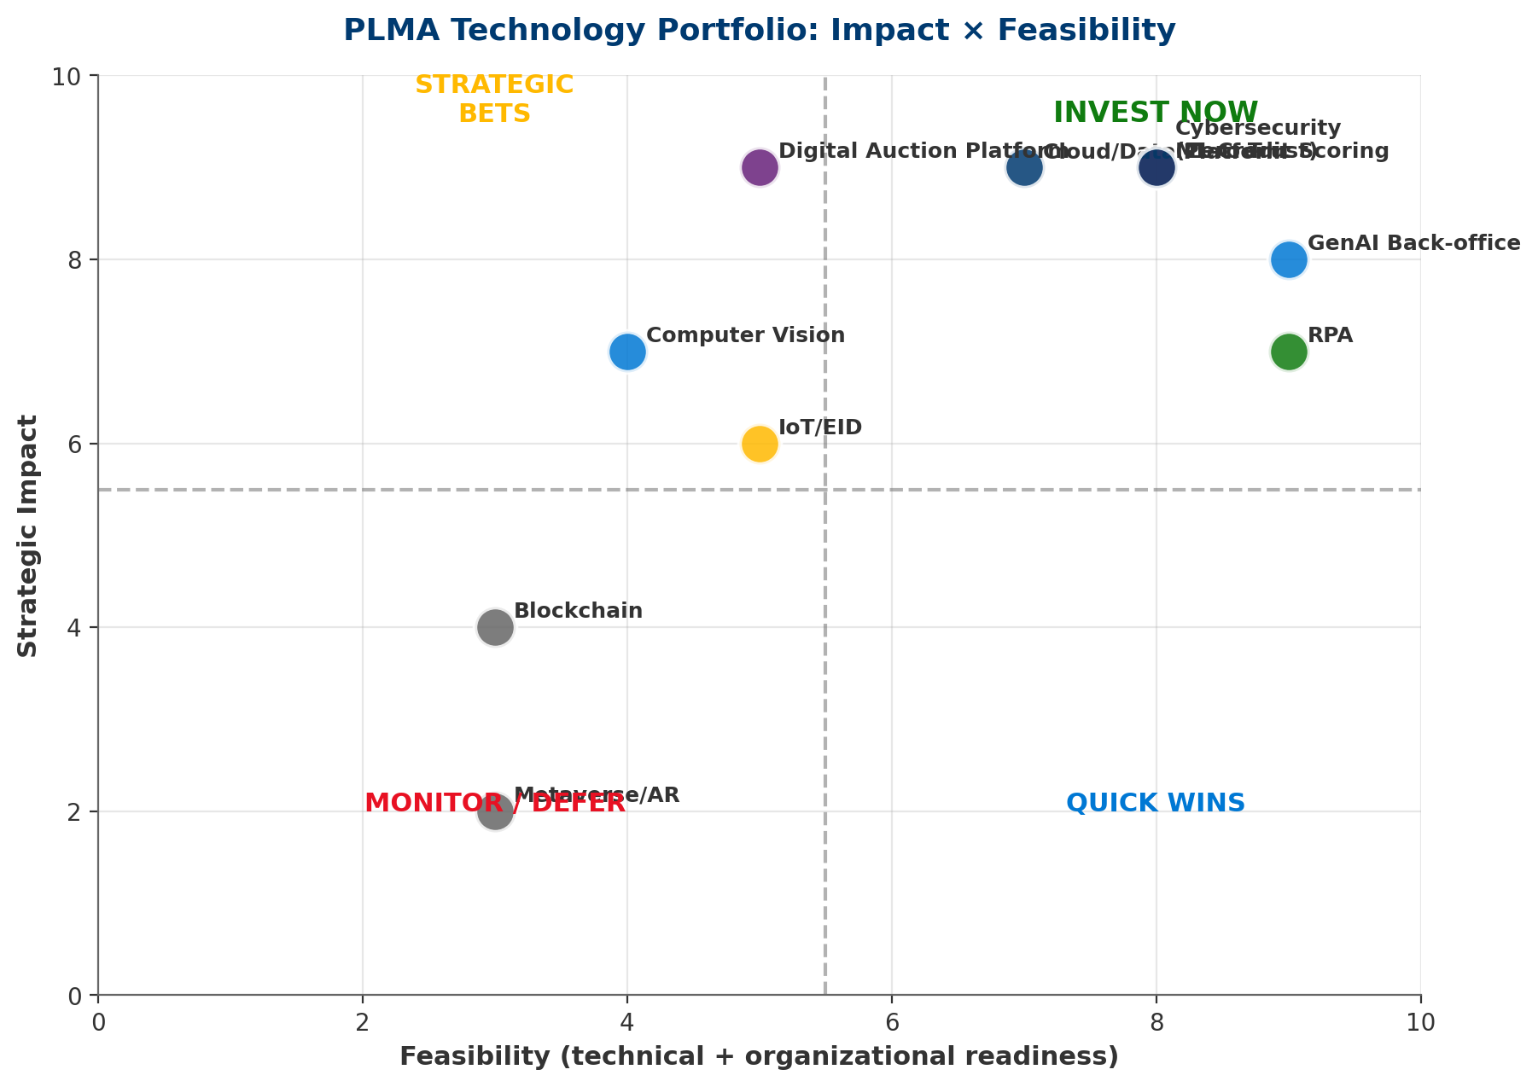
Exhibit: Cybersecurity, Cloud/Data, ML Credit Scoring, and Digital Auction are INVEST NOW priorities.

5.1 Data & Analytics Platform Modernization
A modern data lakehouse architecture (Snowflake, Databricks, or equivalent) is the foundation for AI, analytics, and decision support. Without it, every AI use case is throttled by data fragmentation, quality issues, and integration complexity. Estimated cost: $600-900K Year 1, $350K ongoing. This is an enabling investment: its value is in unlocking other use cases.

5.2 Cloud Infrastructure Transformation
PLMA's estimated on-premise infrastructure footprint carries 8-12% annual cost growth, limited scalability, and material cyber exposure. Phased migration to a primary hyperscaler (recommended: AWS for ag ecosystem depth, or Azure for Microsoft-shop integration) reduces TCO by 15-25% over 3-5 years while improving security posture and enabling AI workloads.

5.3 IoT / EID Integration for Traceability
Electronic Identification (EID) is mandated or encouraged across cattle supply chains for disease traceability (USDA's ADT rule expansion). PLMA is positioned to be a data aggregation and value-added services layer on top of EID infrastructure — if it moves early. This is Strategic Bet quadrant: high long-term value, moderate near-term feasibility.

5.4 Blockchain for Provenance & Smart Contracts (Narrow Scope)
Blockchain has been over-hyped in agricultural contexts. We recommend PLMA monitor but NOT invest in broad blockchain initiatives in the near term. The one narrow exception: permissioned blockchain for supply-chain traceability in premium/branded beef programs — and only as a partner/participant in a buyer-led consortium, never as a lead infrastructure investor.

5.5 Digital Auction Platforms & Omnichannel
PLMA's traditional auction model needs a digital overlay, not a replacement. A hybrid model — physical auctions with digital participation, online-only sales for specific cattle classes, mobile-first member experience — is the target state. Platform build/buy decision: BUY core platform from specialized vendor, CUSTOMIZE with PLMA-specific workflows.

5.6 RPA / Workflow Automation
RPA applied to AR/AP, settlement operations, compliance reporting, and data entry produces measurable labor productivity gains — typically 20-40% reduction in processing time for targeted workflows. Estimated annual benefit: $800K-$1.2M at scale. This is a Quick Win with proven ROI and limited implementation risk.

5.7 Cybersecurity Fortification
Given the cyber risk profile in Section 3.2, cyber must be treated as Invest Now priority #1 — regardless of AI ambitions. Recommended elements: Zero Trust architecture, EDR/XDR on all endpoints, 24×7 SOC (outsourced or MSSP), identity hardening (MFA universal, privileged access management), incident response retainer, tabletop exercises quarterly, cyber insurance alignment.

6. Strategic Framework Analysis
Five strategic frameworks inform the technology strategy: (1) Digital Maturity Assessment, (2) Gartner Hype Cycle, (3) NIST AI RMF, (4) Porter's Value Chain with digital overlay, and (5) McKinsey Three Horizons (reused from Report #1 for strategic consistency).

6.1 PLMA Digital Maturity Assessment
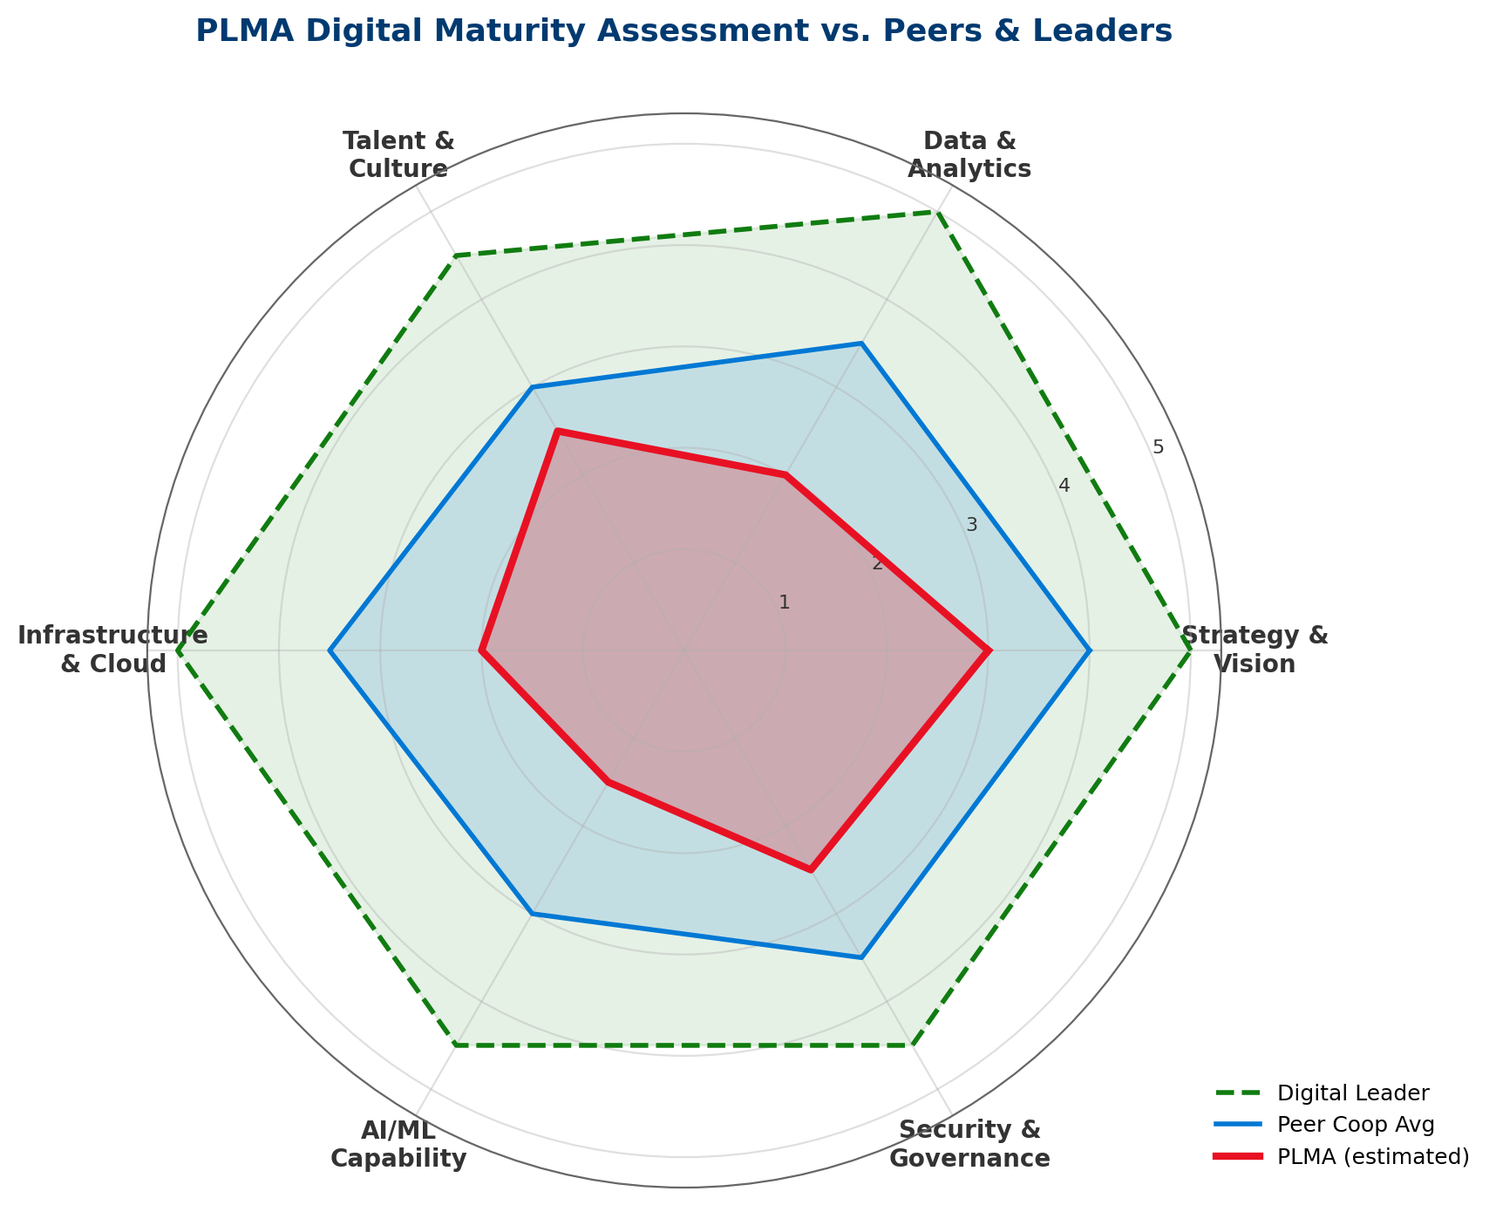
Exhibit: PLMA's 2.25 average maturity score is ~34% below peer average and 53% below digital leader benchmark.
Dimension | PLMA | Peer Avg | Leader | Gap Priority
Strategy & Vision | 3.0 | 4.0 | 5.0 | Medium
Data & Analytics | 2.0 | 3.5 | 5.0 | HIGH
Talent & Culture | 2.5 | 3.0 | 4.5 | Medium
Infrastructure & Cloud | 2.0 | 3.5 | 5.0 | HIGH
AI/ML Capability | 1.5 | 3.0 | 4.5 | HIGHEST
Security & Governance | 2.5 | 3.5 | 4.5 | HIGH

6.2 Gartner Hype Cycle Positioning
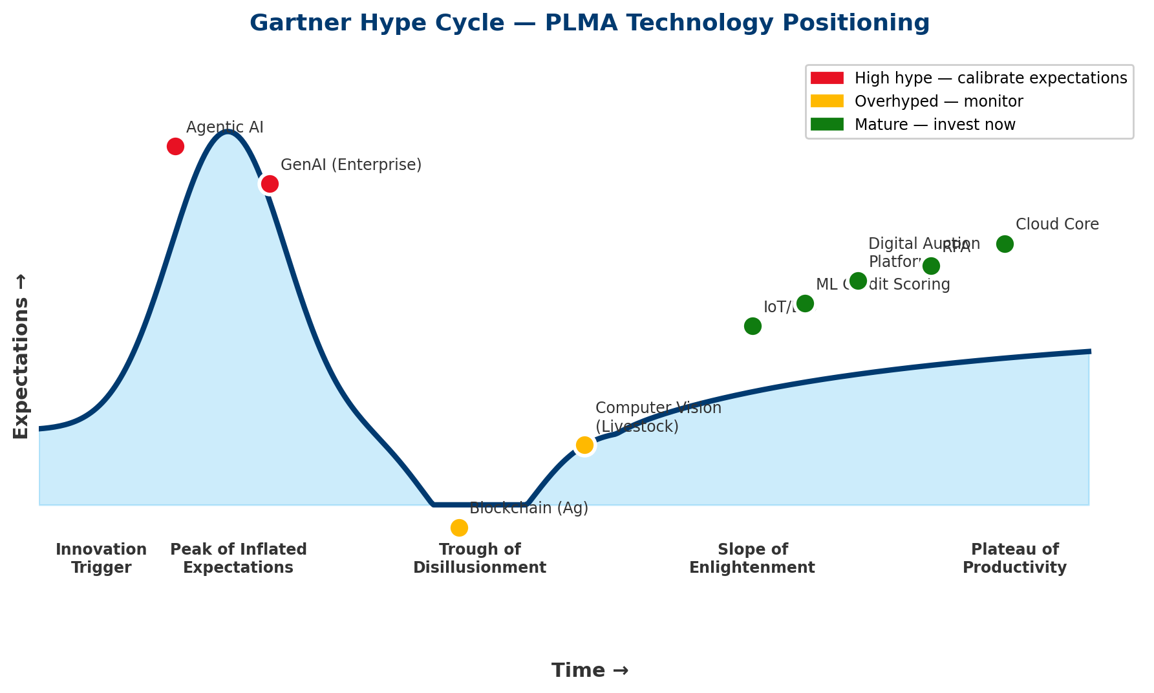
Exhibit: Calibrate expectations: Agentic AI and GenAI are at peak hype; invest where technologies have matured.
Hype cycle positioning drives investment timing. For technologies at the Peak of Inflated Expectations (Agentic AI, enterprise GenAI), we recommend disciplined pilots with strict value gates. For technologies on the Plateau of Productivity (cloud core, RPA, ML credit scoring), invest aggressively. For technologies in the Trough (blockchain in ag, some computer vision applications), monitor and reassess annually.

6.3 NIST AI Risk Management Framework (AI RMF 1.0)
NIST AI RMF Function | PLMA Application | Year 1 Action
GOVERN | AI Governance Council, policies, accountability | Stand up Council; publish AI Use Policy
MAP | Context mapping: where AI is used, by whom, for what | AI inventory; risk classification by use case
MEASURE | Performance, bias, drift, explainability metrics | Metrics framework for credit scoring model
MANAGE | Ongoing monitoring, incident response, retirement | Model risk management process; human-in-loop requirements

6.4 Porter's Value Chain — Digital Overlay
Mapping digital opportunities to Porter's Value Chain illuminates where technology creates differentiation vs. parity:
- Inbound Logistics (producer intake): Digital member onboarding, AI credit scoring — differentiation opportunity.
- Operations (auction/marketing): Digital auction platform, computer vision grading — parity, then differentiation.
- Outbound Logistics (settlement): RPA, instant settlement, digital payment rails — parity, defensive.
- Marketing & Sales: Market intelligence, demand sensing, member advisory — differentiation opportunity.
- Service: GenAI member service, advisory, education — differentiation opportunity.
- Support Activities: Cybersecurity, cloud, data platform, AI governance — foundation; not differentiating but failure-enabling.

6.5 Three Horizons (Strategic Consistency with Report #1)
The same Three Horizons framework structures both reports' roadmaps. This is deliberate: PLMA should have one integrated transformation plan, not two parallel tracks. Report #1's Horizon 1 credit risk workstreams and this report's Horizon 1 tech workstreams should be governed by the same PMO and Risk Committee.

7. Technology Strategy & Roadmap (1 / 5 / 10 Year)

7.1 North Star Technology Vision
PLMA'S 2036 TECH VISION
"PLMA is the most trusted, intelligent, and resilient livestock marketing platform in North America — combining century-old producer trust with AI-native analytics, digital-first member experience, and best-in-class risk management. Our technology is a strategic differentiator, not a utility."

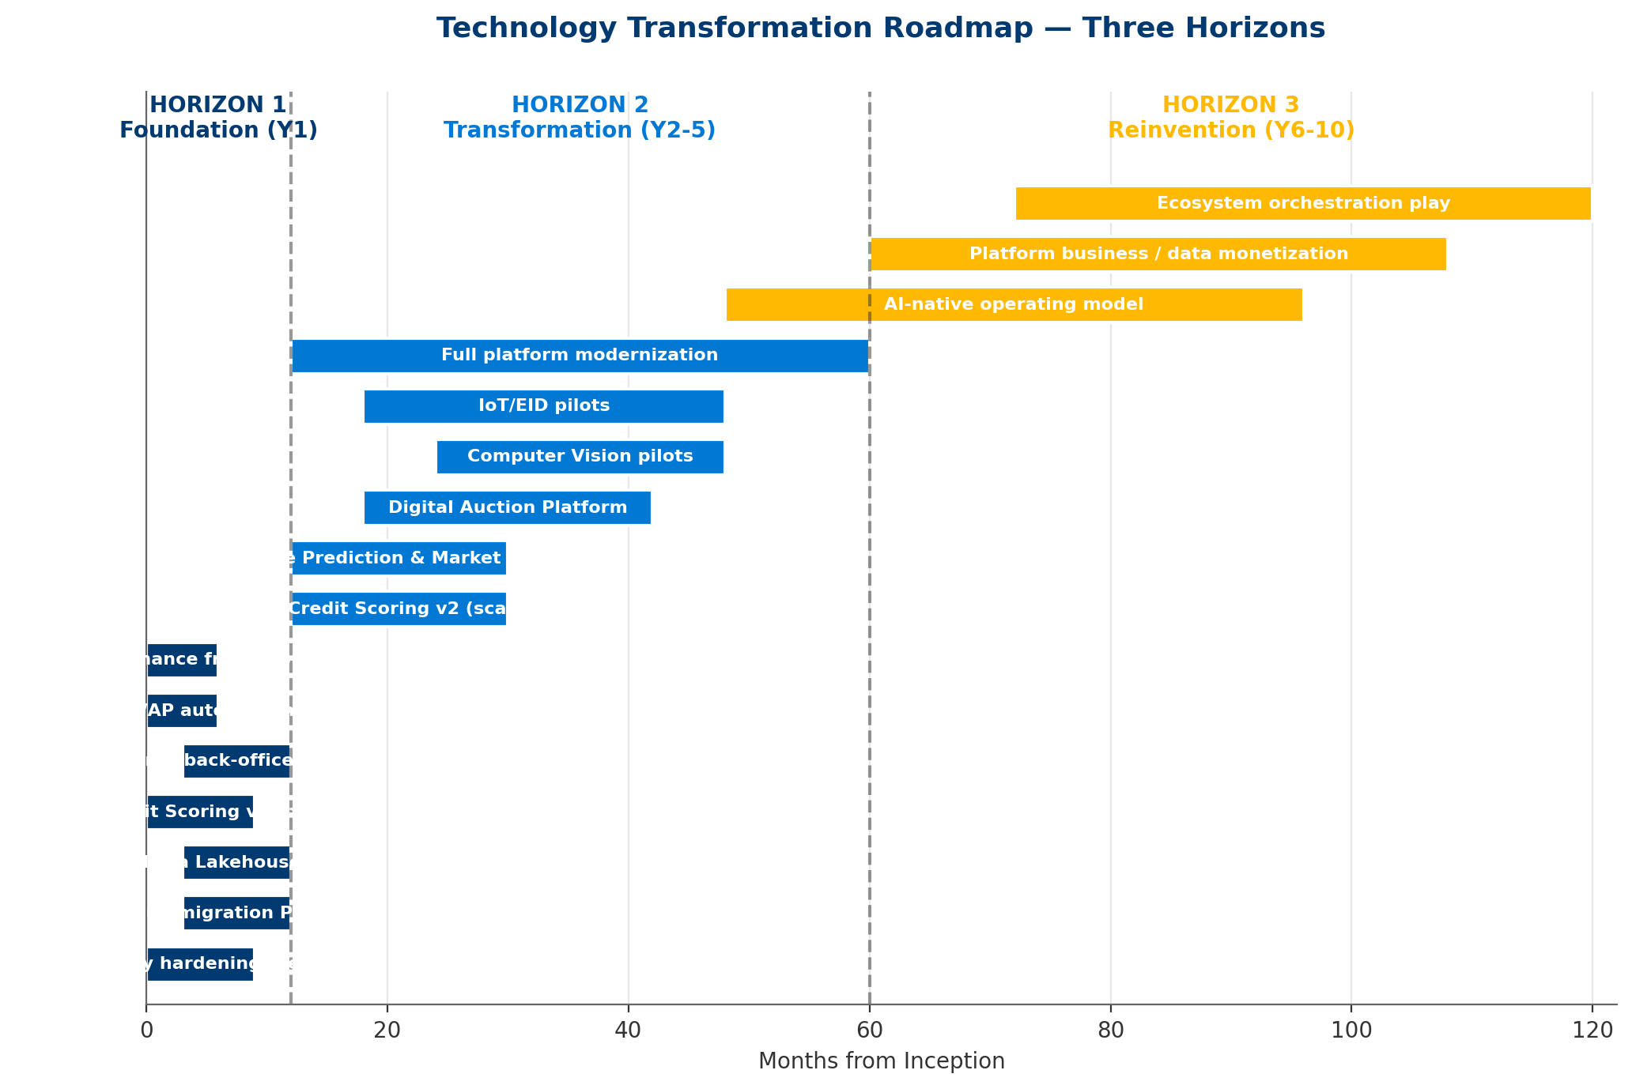
Exhibit: 16 workstreams sequenced across 10 years, aligned to Three Horizons.

7.2 Horizon 1: Foundation (Year 1)
Year 1 is about stabilizing the risk surface and proving AI value with low-risk, high-return pilots.

Priorities
- Cybersecurity hardening (Zero Trust architecture, EDR, 24×7 SOC) — $900K
- Cloud migration Phase 1 + Data Lakehouse v1 — $1.2M
- ML Credit Scoring v1 (pilot, shared budget with Report #1) — $350K
- GenAI back-office pilots (document processing, research) — $450K
- RPA — AR/AP Automation — $400K
- Digital Platform Enhancements (member portal, mobile) — $800K
- AI Governance Council, policies, and talent — $700K

Year 1 Success Metrics
- Cyber: Zero critical vulnerabilities unmitigated >30 days; 100% MFA coverage; incident response plan tested.
- AI: Credit scoring model live; GenAI pilot demonstrates ≥20% productivity gain in target workflows.
- Cloud/Data: Lakehouse v1 operational; 3 core data domains migrated.
- Governance: AI Council operational; AI Use Policy published; NIST AI RMF adoption documented.

7.3 Horizon 2: Transformation (Years 2–5)
Horizon 2 is about scaling what works, answering the disruption threat with a digital auction platform, and building the AI capability layer.

Priorities
- ML Credit Scoring v2 (production-scale, ML-enhanced)
- Price Prediction & Market Intelligence models
- Digital Auction Platform (hybrid physical/online)
- Computer Vision pilots (weight estimation, identification)
- IoT/EID integration pilots
- Full platform modernization (complete cloud migration)
- RPA expansion to compliance, settlement, reporting

Year 5 Success Metrics
- Competitive: Digital auction capturing ≥25% of transaction volume; member NPS ≥45.
- AI: 5+ AI models in production with measured business impact; model risk management operational.
- Financial: Cumulative program NPV ≥ $14M; tech debt drag reduced by 50%.
- Digital Maturity: PLMA maturity score ≥3.5/5 (from 2.25 baseline).

7.4 Horizon 3: Reinvention (Years 6–10)
Horizon 3 is about moving beyond being a livestock marketing cooperative to being an agricultural risk and market intelligence platform.

Priorities
- AI-native operating model: AI agents embedded in core workflows
- Platform business plays: data monetization, fee-based advisory services
- Ecosystem orchestration: partnerships with banks, insurers, processors
- Cooperative capital restructuring aligned to platform economics

Year 10 Success Metrics
- Strategic: 15-20% of revenue from fee-based/platform services (non-commission).
- Financial: Cumulative program NPV ≥$34M; EBITDA margin expansion of 300-500 bps.
- Competitive: PLMA is the reference operator in ag-tech for livestock marketing coops.

8. Financial Model: Tech Investment Economics

8.1 Methodology & Assumptions
This section quantifies the technology transformation program's economics. We use conventional DCF with an 8% discount rate (consistent with Report #1 and typical cooperative cost-of-capital). Benefits ramp over 2 years to steady state. Sensitivity analysis tests six variables across reasonable ranges.

8.2 Program Costs
Year 1 Investment Item | Amount
Cybersecurity hardening (Zero Trust, EDR, SOC) | $900K
Cloud / Data Platform v1 | $1200K
AI Credit Scoring v1 (shared w/ Report #1) | $350K
GenAI Pilots (back-office, research) | $450K
RPA / Workflow Automation | $400K
Digital Platform Enhancements | $800K
AI Governance & Talent | $700K
**TOTAL Year 1** | $4800K

Ongoing Annual Cost (Year 2+) | Amount
Cybersecurity operations & licenses | $650K
Cloud/data platform run-rate | $550K
AI/ML platform & tooling | $300K
GenAI licenses & API costs | $220K
RPA maintenance | $140K
Digital platform operations | $380K
AI governance & FTEs | $360K
**TOTAL Ongoing Annual** | $2600K

8.3 Annual Benefits
DE-DUPLICATION WITH REPORT #1
Credit loss avoidance in this model is INCREMENTAL to Report #1's credit risk mitigation program. Report #1 claims $1.8M/year from statistical credit scoring; this report claims an additional $900K/year from ML enhancement (the delta between ML and statistical models). Total combined credit loss avoidance: $2.7M/year. This is not double-counted.

Benefit Category | Annual Value
Credit loss avoidance (incremental vs Report #1) | $900K
Labor productivity (RPA + GenAI) | $2400K
Cyber incident cost avoidance (expected value) | $1100K
New digital revenue (platform services) | $2200K
Market intelligence & hedging improvement | $1100K
Working capital optimization (forecasting) | $1300K
**TOTAL Annual Benefit** | $9000K

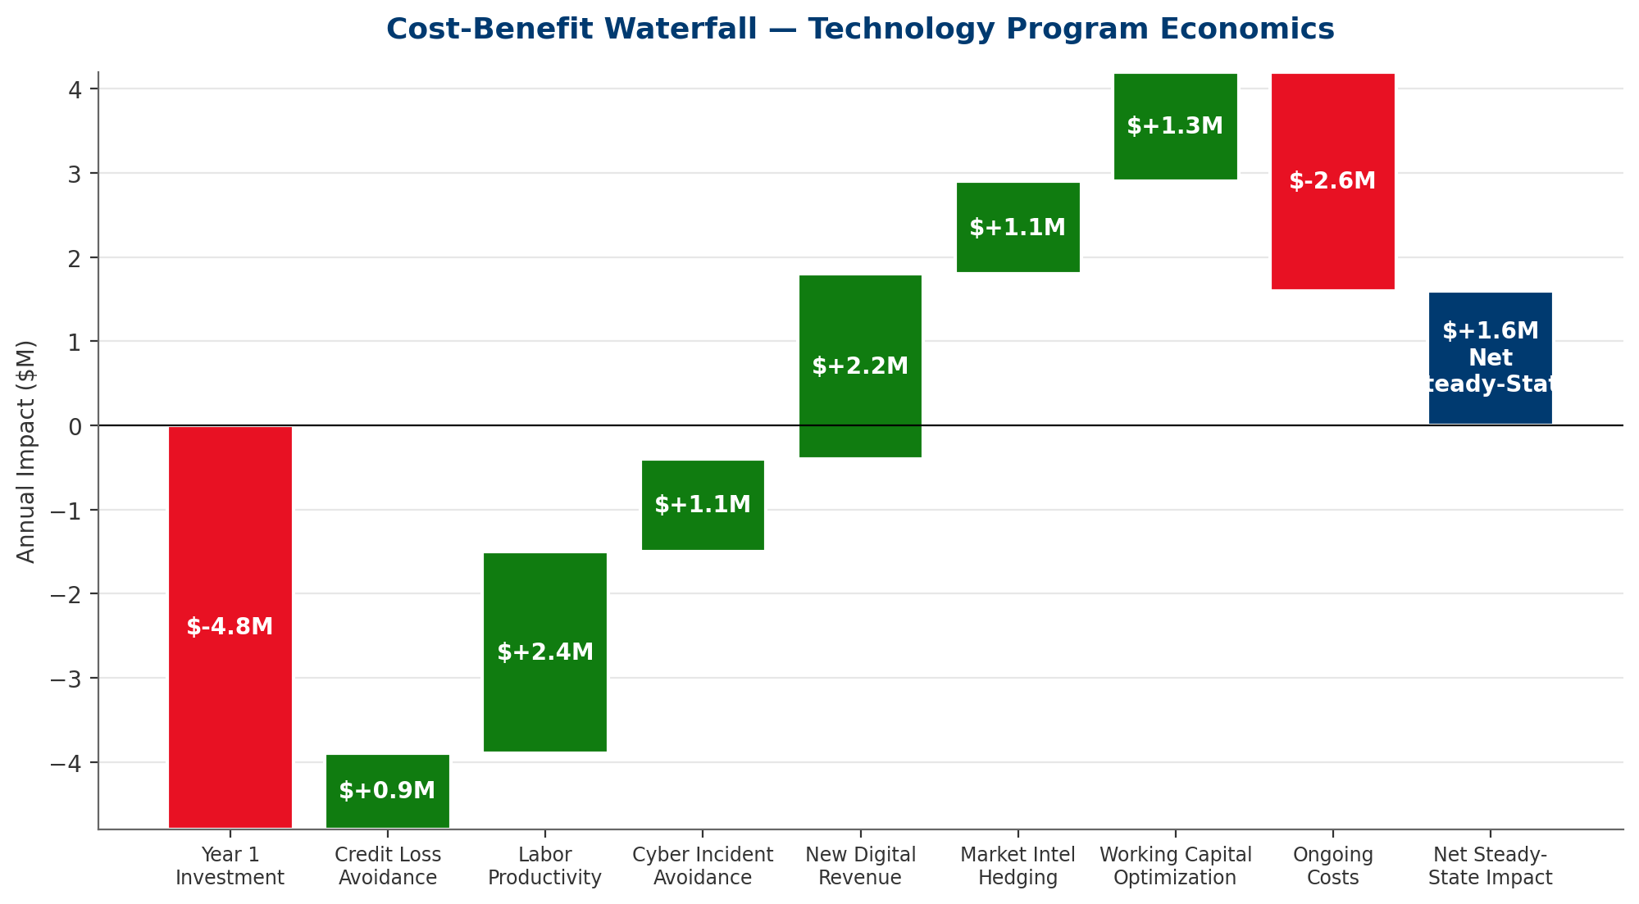
Exhibit: Steady-state economics: $9.0M annual benefit against $2.6M ongoing cost = $6.4M net.

8.4 10-Year NPV & Cash Flows
Year | Cost | Benefit | Net CF | Cumulative
Year 1 | $4800K | $3150K | $-1650K | $-1650K
Year 2 | $2600K | $7200K | $4600K | $2950K
Year 3 | $2600K | $9000K | $6400K | $9350K
Year 4 | $2600K | $9000K | $6400K | $15750K
Year 5 | $2600K | $9000K | $6400K | $22150K
Year 6 | $2600K | $9000K | $6400K | $28550K
Year 7 | $2600K | $9000K | $6400K | $34950K
Year 8 | $2600K | $9000K | $6400K | $41350K
Year 9 | $2600K | $9000K | $6400K | $47750K
Year 10 | $2600K | $9000K | $6400K | $54150K

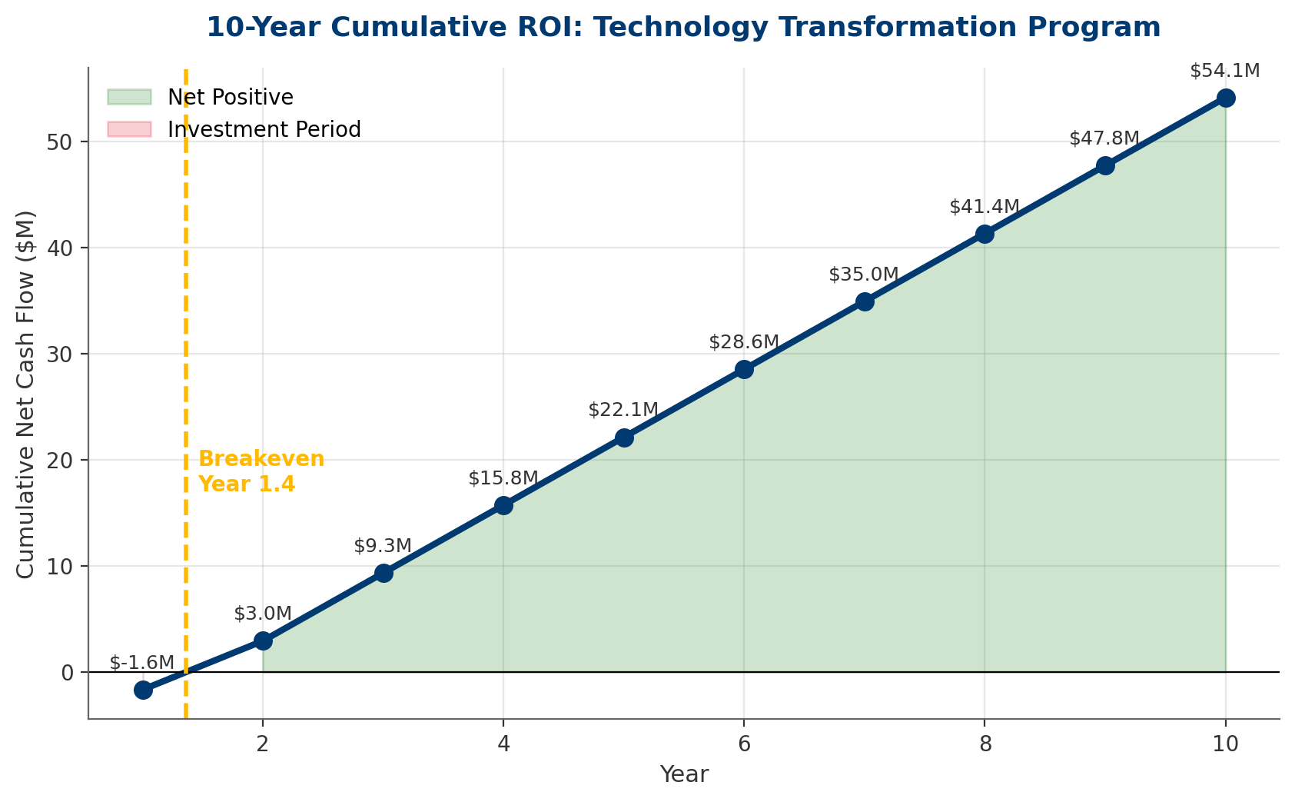
Exhibit: Program breaks even during Year 2; cumulative 10-year nominal net cash flow exceeds $55M.

8.5 Sensitivity Analysis
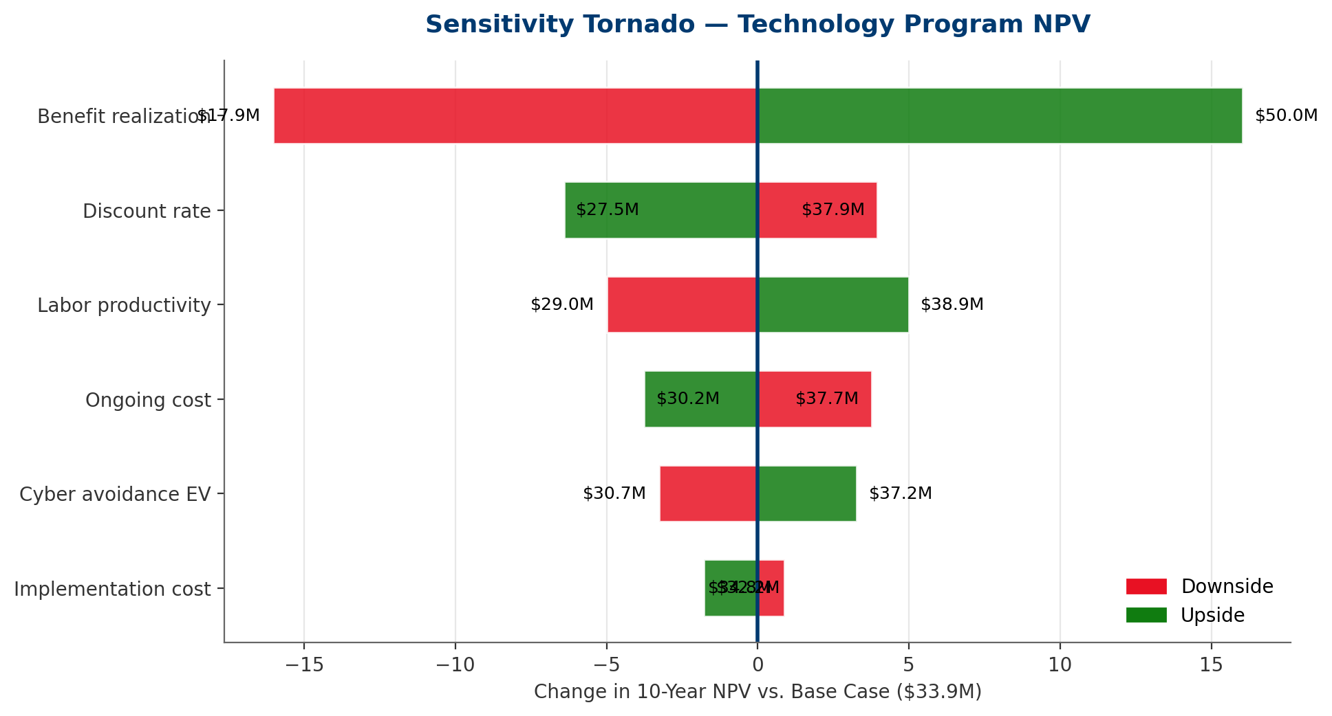
Exhibit: Benefit realization and labor productivity are the top NPV drivers; program remains positive across all tested scenarios.
ROBUSTNESS
Even under the most adverse sensitivity case tested (benefit realization at -30%, implementation cost at +40%, ongoing costs at +25%), the program remains NPV-positive. This indicates the investment case is robust — not contingent on aggressive assumptions.

9. Governance & Execution

9.1 Technology Investment Committee
We recommend establishing a Technology Investment Committee (TIC) as a formal governance body with CFO Johansen as chair. The TIC approves all tech spend above a threshold, monitors portfolio health, and reports to the Board Risk Committee.
Body | Composition | Cadence | Mandate
Board Risk & Technology Cmte | 3-4 Directors + CEO + CFO | Quarterly | Approve tech strategy; oversee risk; review major investments
Tech Investment Committee | CFO (Chair), CTO/IT Lead, COO, Security Lead | Monthly | Approve program spend; monitor delivery; course-correct
AI Governance Council | CFO, Chief Risk, Legal, Data Lead, External Ethicist | Monthly | NIST AI RMF compliance; bias/fairness review; model approval
Cyber Steering Group | Security Lead (chair), IT, Legal, Ops | Bi-weekly | Threat monitoring; incident readiness; control effectiveness

9.2 KPI Dashboard
KPI | Target | Red Flag
Digital Maturity Score (avg) | >3.5 by Year 5 | <3.0 by Year 3
Cyber Mean Time to Detect | <24 hours | >72 hours
Tech program NPV realization | >80% of plan | <60% of plan
AI models in production (Y5) | ≥5 | <3
Incident response tabletop frequency | Quarterly | Missed any quarter
% revenue from digital services (Y10) | ≥15% | <8%
Program delivery velocity | ≥85% milestones on time | <70%
Tech debt drag reduction | -50% by Year 5 | <-25% by Year 5

9.3 Change Management & Talent Strategy
Technology transformation fails when change management is neglected. We recommend a dedicated change management stream with ~5% of program budget, focused on: (i) executive sponsorship and visible commitment, (ii) middle-manager enablement, (iii) producer/member communication about digital channels, (iv) training and upskilling for affected roles, and (v) celebration of early wins.
Talent strategy: (i) hire 2-3 senior data/AI roles in Year 1, (ii) partner with 2-3 land-grant universities for internship and co-op pipelines, (iii) invest in existing staff upskilling (certifications, conferences, rotational assignments), (iv) compete on mission and autonomy where PLMA cannot compete on total comp.

10. Conclusion & Next Steps
PLMA faces a decade-defining decision. The cooperative can continue its current technology trajectory — incremental upgrades, reactive cyber posture, manual decisioning — and watch digital-native entrants capture share, talent, and strategic initiative. Or PLMA can make a disciplined, phased $4.8M Year-1 investment that stabilizes the risk surface, proves AI value, and begins a 10-year transformation to an AI-native, platform-oriented cooperative.
THE CORE THESIS
Technology inaction is not neutral. Every month of delay costs approximately $730K in foregone value ($8.8M tech debt drag + missed benefit capture), grows the disruption gap vs. peers, and compounds cyber tail risk. The recommended program pays for itself within 18 months and delivers ~$34M in 10-year NPV. This is the rare transformation where the financial case, risk case, and strategic case all align.

10.1 Immediate Actions (First 90 Days)
- Week 1-2: CFO-led alignment on findings; Tech Investment Committee founded
- Week 2-4: Board Risk & Technology Committee briefing; approval of Year-1 budget ($4.8M)
- Week 4-8: Cybersecurity gap assessment; RFP for MSSP/SOC services
- Week 4-8: Cloud strategy finalization; hyperscaler selection
- Week 6-10: Senior data/AI leader recruitment launch (2-3 hires)
- Week 8-12: AI Governance Council chartered; NIST AI RMF adoption documented
- Week 8-12: RPA use case selection & vendor selection (AR/AP workflow first)
- Week 10-13: Integrated PMO established linking Report #1 and Report #2 workstreams

10.2 Integration with Report #1 (Counterparty Credit Risk)
Both reports identify a common root cause — inadequate analytical infrastructure — and converge on an integrated solution. We recommend PLMA establish ONE integrated transformation program with unified governance, shared PMO, and consolidated KPI reporting. The credit risk mitigation and technology strategy are two lenses on the same modernization imperative.

10.3 Phase 2 Engagement Model
For Horizon 2 and Horizon 3 workstreams, we recommend: (i) quarterly progress reviews against Three Horizons roadmap, (ii) annual strategy refresh against emerging tech developments (particularly in AI), (iii) on-call advisory for vendor selection and major architecture decisions, (iv) independent model risk review for AI credit scoring on 18-month cycle.
PLMA has the institutional trust, market access, and producer relationships that no digital-native entrant can replicate. The question is whether PLMA will also have the technology capability to defend and extend that position. The financial case is unambiguous. The strategic case is unambiguous. The risk case is unambiguous. The decision rests with leadership.

Appendix A: Use Case Scorecards
The 12 AI/tech use cases are detailed below with scoring rationale. Value scores reflect strategic importance and financial impact potential. Feasibility scores reflect technical readiness, organizational readiness, and data availability.
Use Case | Cat. | Value | Feas. | 10yr NPV | Rationale
ML Credit Scoring | AI/ML | 9/10 | 8/10 | $7.5M | Direct link to Report #1 credit losses. Rich internal data. Vendor solutions mature.
GenAI Doc Processing | GenAI | 8/10 | 9/10 | $6.8M | High-volume, clear ROI. Mature vendor offerings. Low risk.
Price Prediction Models | AI/ML | 9/10 | 7/10 | $8.2M | Proprietary data advantage. Differentiation potential. Moderate build complexity.
Computer Vision Grading | AI/ML | 8/10 | 5/10 | $5.4M | High strategic value. Technology maturing. Pilot-stage.
GenAI Member Service | GenAI | 7/10 | 8/10 | $4.6M | Quick win. Vendor solutions ready. Governance needed for hallucination.
Demand Forecasting | AI/ML | 8/10 | 7/10 | $6.1M | Working capital optimization. Proven techniques. Data quality dependency.
RPA — AR/AP Automation | Automation | 7/10 | 9/10 | $5.8M | Highest feasibility. Proven ROI. Limited risk.
EID/IoT Traceability | IoT | 7/10 | 6/10 | $4.2M | Regulatory tailwind. Infrastructure cost. Ecosystem play.
Digital Auction Platform | Digital | 9/10 | 6/10 | $7.9M | Counters disruption threat. Complex build/integrate.
Cyber Zero-Trust | Security | 8/10 | 8/10 | $3.5M | Table stakes. Measurable risk reduction. Vendor-led.
Data Lakehouse | Data | 7/10 | 7/10 | $4.8M | Enabling investment. Value through unlocked use cases.
Blockchain Provenance | Blockchain | 5/10 | 4/10 | $1.2M | Overhyped for most use cases. Monitor; defer investment.

Appendix B: Methodology & Assumptions

B.1 Financial Model Methodology
The financial model uses standard DCF with 8% discount rate. Year-1 costs are expensed upfront; benefits ramp over 2 years (35% Year 1, 80% Year 2, 100% Year 3+). Sensitivity analysis tests six variables over reasonable ranges.

B.2 Benefit Estimation
Benefit estimates are calibrated from: (i) peer-cooperative case studies, (ii) published efficacy data for RPA, GenAI, and ML solutions in financial services and ag contexts, (iii) McKinsey Global Institute AI productivity estimates, (iv) industry benchmarks for cybersecurity incident costs, and (v) analogous digital transformation programs in adjacent industries.

B.3 Digital Maturity Scoring
Maturity scores are qualitative estimates across 6 dimensions, calibrated against published digital maturity frameworks (McKinsey Digital Quotient, MIT CISR, Gartner). Peer benchmarks are industry estimates, not specific coop data.

B.4 Use Case Scoring
Value scores reflect: revenue potential, cost reduction potential, risk reduction, strategic differentiation, data advantage. Feasibility scores reflect: technical maturity, organizational readiness, data availability, regulatory clarity, vendor ecosystem maturity.

Appendix C: Glossary of Terms
- AI RMF: NIST AI Risk Management Framework — voluntary U.S. standard for AI governance.
- Agentic AI: AI systems that autonomously plan and execute multi-step workflows.
- Data Lakehouse: Architecture combining data lake flexibility with warehouse performance.
- EDR/XDR: Endpoint/Extended Detection and Response — real-time threat detection.
- EID: Electronic Identification — RFID-based livestock tracking tags.
- GenAI: Generative AI — AI systems producing text, code, images, audio.
- Hyperscaler: Major public cloud providers: AWS, Azure, Google Cloud.
- LLM: Large Language Model — foundation model behind most GenAI applications.
- MFA: Multi-Factor Authentication.
- MSSP: Managed Security Services Provider — outsourced security operations.
- P&SA: Packers & Stockyards Act — USDA livestock marketing regulation.
- RPA: Robotic Process Automation — software bots for workflow automation.
- SOC: Security Operations Center — 24×7 threat monitoring and response.
- TCO: Total Cost of Ownership.
- Zero Trust: Security model: never trust, always verify; identity-based access.

Appendix D: Citations
All citations numbered and referenced in the body of this report. Figures calibrated from multiple public and industry sources; specific PLMA estimates noted in Appendix B.
[1] AgFunder, "AgriFoodTech Investment Report," 2018–2025 annual editions.
[2] McKinsey & Company, "The State of AI in 2024: Gen AI's breakout year," 2024.
[3] McKinsey Global Institute, "The economic potential of generative AI," June 2023.
[4] Gartner, "Hype Cycle for Artificial Intelligence," 2024 and 2025 editions.
[5] Gartner, "Hype Cycle for Digital Agriculture," 2024.
[6] IDC, "Worldwide Artificial Intelligence Spending Guide," 2025.
[7] Forrester Research, "The State of Enterprise AI," 2025.
[8] NIST, "Artificial Intelligence Risk Management Framework (AI RMF 1.0)," January 2023.
[9] NIST, "AI RMF Generative AI Profile," July 2024.
[10] SEC, "Cybersecurity Risk Management, Strategy, Governance, and Incident Disclosure," Final Rule, July 2023.
[11] European Union, "Artificial Intelligence Act (EU AI Act)," Regulation 2024/1689.
[12] Food and Ag-ISAC, "Cyber Threats to the Food & Agriculture Sector," 2024 and 2025 reports.
[13] CISA, "Cyber Threats to the Agriculture Sector," 2023 & 2024 advisories.
[14] FBI Internet Crime Complaint Center (IC3), "Annual Report," 2023, 2024, 2025.
[15] Sophos, "The State of Ransomware 2025."
[16] Verizon, "Data Breach Investigations Report (DBIR)," 2024 and 2025.
[17] USDA APHIS, "Animal Disease Traceability (ADT) Rule," Updated 2024.
[18] Porter, M.E., "Competitive Advantage," Free Press, 1985 (value chain framework).
[19] Baghai, M., Coley, S., White, D., "The Alchemy of Growth" (McKinsey Three Horizons), 1999.
[20] Kane, G.C. et al., "Coming of Age Digitally," MIT Sloan Management Review, 2018.
[21] Deloitte, "2026 Technology Industry Outlook."
[22] Accenture, "Technology Vision 2025."
[23] Boston Consulting Group, "The CEO's Guide to Generative AI," 2024.
[24] Harvard Business Review, "How Generative AI Is Changing Creative Work," November 2022.
[25] Harvard Business Review, "Getting AI Right," September-October 2024.
[26] USDA ERS, "Adoption of Precision Agriculture Technologies in the U.S.," 2024.
[27] CoBank, "Rural Broadband & Digital Agriculture," 2025.
[28] Farm Credit Administration, "Technology Risk in Ag Lending," 2024.

