Lorann-Ex

Mercredi 23 Juin 2016

# Planning

At the beginning of the project we had to organize all the project to give differents tasks to the members of the team.

## Team

The team is composed of four persons each have a specific task in the project.

Baptiste Saclier

*Project leader* : In charge of the organisation of the project and the controller of the software

Marie Chiaverini

In charge of the model of the game

Clément Chabrier

In charge of the view of the project

Maxime Zupka

In charge of the design of the level, the documentation and the administration of the database.

## Planning diagram

### Estimated planning

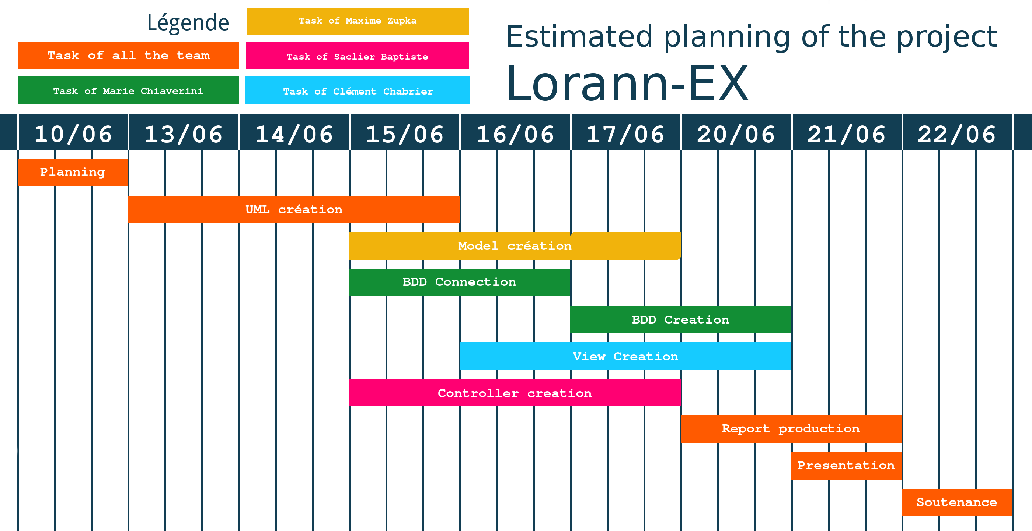

### Efficient planning

