**Vanier College**

**Computer Science Department**

**420-426-VA Systems Development Section 1**

***6th Deliverable: Second Prototype and UI design***

**Submitted By**

I, Manirath, Julie, student ID# \_\_\_\_\_\_\_\_\_\_\_\_\_\_\_\_\_\_\_\_, certify that I have contributed to this

Deliverable in the amount of 20 %, \_\_\_\_\_\_\_\_\_\_\_\_\_\_\_\_\_\_\_\_\_\_\_\_\_\_\_\_\_.

I, Doan-Duong, Tung, student ID# \_\_\_\_\_\_\_\_\_\_\_\_\_\_\_\_\_\_\_\_, certify that I have contributed to this

Deliverable in the amount of 20 %, \_\_\_\_\_\_\_\_\_\_\_\_\_\_\_\_\_\_\_\_\_\_\_\_\_\_\_\_\_.

I, Del Corpo, Jonathan, student ID# \_\_\_\_\_\_\_\_\_\_\_\_\_\_\_\_\_\_\_\_, certify that I have contributed to this

Deliverable in the amount of 20 %, \_\_\_\_\_\_\_\_\_\_\_\_\_\_\_\_\_\_\_\_\_\_\_\_\_\_\_\_\_.

I, Mendez, David, student ID#\_\_\_\_\_\_\_\_\_\_\_\_\_\_\_\_\_\_\_\_, certify that I have contributed to this

Deliverable in the amount of 20 %, \_\_\_\_\_\_\_\_\_\_\_\_\_\_\_\_\_\_\_\_\_\_\_\_\_\_\_\_\_.

I, Sinnadurai, Gowriekaran, student ID# \_\_\_\_\_\_\_\_\_\_\_\_\_\_\_\_\_\_\_\_, certify that I have contributed to this

Deliverable in the amount of 20 %, \_\_\_\_\_\_\_\_\_\_\_\_\_\_\_\_\_\_\_\_\_\_\_\_\_\_\_\_\_.

**Client contact:** Back of House Catering

**E-mail:** backofhousecatering@gmail.com

**Contact Name:** Jackie Biber

**14th April 2015**

No work or ideas previously developed will be used for this project.

**Table of Contents**

[**Executive Overview** 5](#_Toc416767116)

[**Narrative Summary** 6](#_Toc416767117)

[**Prototype** 8](#_Toc416767118)

[**Client Comments** 14](#_Toc416767119)

[**Appendix 1** 15](#_Toc416767120)

[**Bibliography** 15](#_Toc416767121)

# **Executive Overview**

Expanding upon the previous deliverable, this one further deals with the user interface of our prototype for Back of House Catering, our client. Having made pencil sketches of the user interface with the input of our sole liaison of the company, the manager, Jackie Biber, this deliverable will display the digitally rendered version of said interface. The digitally rendered user interfaces were made possible through the implementation of a software named Pencil Project.

Jackie's comments on the somewhat more elaborate user interface can also be observed within the contents of this deliverable. Furthermore, our revisions and addition of user stories as well as their corresponding tests are enclosed.

# **Narrative Summary**

The prototype we're working on for our client, Back of House Catering, will be produced via code written in Java and MySQL. Its purpose will be to increase company efficiency and organization through the vast improvement of dealing with data.

Via the use of an inventory management system, the user will be capable of adding, removing, finding, and updating an item's information. Furthermore, the user (most likely the manager, Jackie) will be able to manage and observe their contacts with great ease and efficiency. Like with the inventory, the user will have the ability to add, remove, update, and even filter the company's clients' information.

In the meeting for our previous deliverable, Jackie had expressed the desire to be able to categorize the company's contacts by client and by business with the purpose of making things neater for her when using the system. Concluding our most recent meeting, her thoughts on the matter had not changed. That being said, we did not make any unnecessary changes to the UI in regards to that aspect. Our prototype will possess the capability to print inventory lists and invoices.

In addition, the system will notify of late payments, as Jackie requested in our meeting. Not only that, but it will also support viewing, managing, storing, and updating event information.

We implemented a useful program named Pencil Project in order to digitally render the user interface designs we had sketched with the help of Jackie's input. In the most recent meeting with our liaison, we displayed the printed displays. Her reaction was overall a positive one, noting that it was much more visually appealing than the pencil sketches and she equally appreciated the simplicity of the design. It didn't come as a surprise when she declined to discuss any possible changes to it.

Lastly, we added a brand new user story while revisiting a previously established one and further perfecting it. In our meeting, after going over the user stories, Jackie suggested that she'd want to be able to view all the employee emails so that she could send the work schedule to them simultaneously instead of one-by-one. After much thoughtful deliberation, we collectively came up with the user story involving the manager, Jackie, viewing past events. A "history" page of sorts that would allow her and the company to provide a more personalized service to returning clients, catering to their specific needs. We determined that testing the user story would be as simple as adding an event and viewing the associated client's information page. On said page should be displayed the event name.

# **Prototype**

|  |
| --- |
| **Login Screen** |
| C:\Users\Tung\Documents\TeamBlueVanier\TeamBlueVanier\Deliverables\6th_Deliverable\UI\Login.png  + |

|  |
| --- |
| **Home Screen** |
| C:\Users\Tung\Documents\TeamBlueVanier\TeamBlueVanier\Deliverables\6th_Deliverable\UI\Home Screen.png |

|  |
| --- |
| **Inventory (1)** |
| C:\Users\Tung\Documents\TeamBlueVanier\TeamBlueVanier\Deliverables\6th_Deliverable\UI\Inventory (1).png |

|  |
| --- |
| **Inventory (3)** |
| C:\Users\Tung\Documents\TeamBlueVanier\TeamBlueVanier\Deliverables\6th_Deliverable\UI\Inventory (3).png |

|  |
| --- |
| **Events (3)** |
| C:\Users\Tung\Documents\TeamBlueVanier\TeamBlueVanier\Deliverables\6th_Deliverable\UI\Events (3).png |

|  |
| --- |
| **Events (1)** |
| C:\Users\Tung\Documents\TeamBlueVanier\TeamBlueVanier\Deliverables\6th_Deliverable\UI\Events (1).png |

|  |
| --- |
| **Employee (3)** |
| C:\Users\Tung\Documents\TeamBlueVanier\TeamBlueVanier\Deliverables\6th_Deliverable\UI\Employees (3).png |

|  |
| --- |
| **Employee (2)** |
| C:\Users\Tung\Documents\TeamBlueVanier\TeamBlueVanier\Deliverables\6th_Deliverable\Jon\Employees(2) table view.png |

|  |
| --- |
| **Employee (1)** |
| C:\Users\Tung\Documents\TeamBlueVanier\TeamBlueVanier\Deliverables\6th_Deliverable\UI\Employees (1).png |

|  |
| --- |
| **Contacts (3)** |
| C:\Users\Tung\Documents\TeamBlueVanier\TeamBlueVanier\Deliverables\6th_Deliverable\UI\Contacts (3).png |

|  |
| --- |
| **Contacts (2)** |
| C:\Users\Tung\Documents\TeamBlueVanier\TeamBlueVanier\Deliverables\6th_Deliverable\Jon\Contacts(2) Copy Emails.png |

|  |
| --- |
| **Contacts (1)** |
| C:\Users\Tung\Documents\TeamBlueVanier\TeamBlueVanier\Deliverables\6th_Deliverable\UI\Contacts (1).png |

|  |
| --- |
| **Billing** |
| C:\Users\Tung\Documents\TeamBlueVanier\TeamBlueVanier\Deliverables\6th_Deliverable\Jon\Billing.png |

# **Client Comments**

“Looks way better on the computer!”

“Love how it looks simple”

“I don’t mind about esthetic, I just want functionality”  
“Excited to see the working prototype!”

“Like the billing design, way better than the one on excel”

# **Appendix 1**

**Revised user Stories/Tests: One Change**

|  |  |
| --- | --- |
| Before | After |
| Send Employees Shifts Calendar.png | C:\Users\Tung\Documents\TeamBlueVanier\TeamBlueVanier\Deliverables\6th_Deliverable\User stories\Changed user stories\Changed user story 1.png |
| TEST - Sending updated employees schedule.png | C:\Users\Tung\Documents\TeamBlueVanier\TeamBlueVanier\Deliverables\6th_Deliverable\User stories\Changed user stories\changed test 1.png |

**New Stories:**

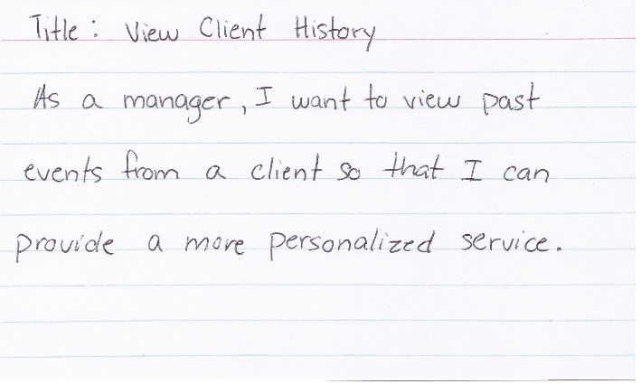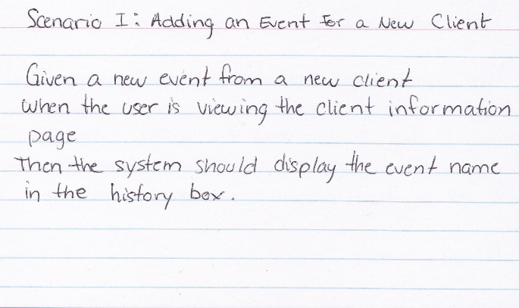

# **Bibliography**

n/a