**Vanier College**

**Computer Science Department**

**420-426-VA Systems Development Section 1**

***7th Deliverable: Database Design***

**Submitted By**

I, Manirath, Julie, student ID# \_\_\_\_\_\_\_\_\_\_\_\_\_\_\_\_\_\_\_\_, certify that I have contributed to this

Deliverable in the amount of 20 %, \_\_\_\_\_\_\_\_\_\_\_\_\_\_\_\_\_\_\_\_\_\_\_\_\_\_\_\_\_.

I, Doan-Duong, Tung, student ID# \_\_\_\_\_\_\_\_\_\_\_\_\_\_\_\_\_\_\_\_, certify that I have contributed to this

Deliverable in the amount of 20 %, \_\_\_\_\_\_\_\_\_\_\_\_\_\_\_\_\_\_\_\_\_\_\_\_\_\_\_\_\_.

I, Del Corpo, Jonathan, student ID# \_\_\_\_\_\_\_\_\_\_\_\_\_\_\_\_\_\_\_\_, certify that I have contributed to this

Deliverable in the amount of 20 %, \_\_\_\_\_\_\_\_\_\_\_\_\_\_\_\_\_\_\_\_\_\_\_\_\_\_\_\_\_.

I, Mendez, David, student ID#\_\_\_\_\_\_\_\_\_\_\_\_\_\_\_\_\_\_\_\_, certify that I have contributed to this

Deliverable in the amount of 20 %, \_\_\_\_\_\_\_\_\_\_\_\_\_\_\_\_\_\_\_\_\_\_\_\_\_\_\_\_\_.

I, Sinnadurai, Gowriekaran, student ID# \_\_\_\_\_\_\_\_\_\_\_\_\_\_\_\_\_\_\_\_, certify that I have contributed to this

Deliverable in the amount of 20 %, \_\_\_\_\_\_\_\_\_\_\_\_\_\_\_\_\_\_\_\_\_\_\_\_\_\_\_\_\_.

**Client contact:** Back of House Catering

**E-mail:** backofhousecatering@gmail.com

**Contact Name:** Jackie Biber

**21st April 2015**

No work or ideas previously developed will be used for this project.

Table of Contents

[**Executive Overview** 3](#_Toc417361359)

[**Narrative description** 3](#_Toc417361360)

[**Appendix 1: ER Diagram** 6](#_Toc417361361)

[**Appendix 2: DB description** 7](#_Toc417361362)

[*Attributes Data Types:* 7](#_Toc417361363)

[Index & database architecture: 8](#_Toc417361364)

[Query Optimization: 8](#_Toc417361365)

[**Appendix 3: DB Analysis** 9](#_Toc417361366)

[**Appendix 4: UI Designs** 10](#_Toc417361367)

[Print Reports: 16](#_Toc417361368)

[**Bibliography** 18](#_Toc417361369)

# **Executive Overview**

This deliverable further expands upon our prototype for the catering company, Back of House Catering. It kicks off with a narrative-style description of our databases simple, yet highly efficient and user-friendly implementation. Accompanying the description is a block diagram serving as an illustration to help readers visualize the various processes and operations of our prototype. Immediately following the aforementioned information are the four appendixes.

Within the first, an ER diagram, complete with cardinalities. The second appendix holds descriptions and explanations of the attribute data types, indexes and database architectures, and query optimization. Appendix number three features an in-depth analysis of the size of the database (now and for the next three to five years), as well as an explanation of the access speed required, and how our design will permit this. Last but most definitely not least, appendix four will show our updated user interface designs.

# **Narrative description**

The user can interact with the database management system through a user interface which will allow him or her to easily manage data. In order to do so, the user must first log in to the database for authentication reasons in order to make sure unauthorized users cannot access it. After login to the database, the user will be greeted with a home page which includes a calendar with notifications about upcoming events. From there, if the user wants more details about a particular upcoming event, he or she simply has to click on the “View Details” button which will direct him or her to the event UI screen to interact with the event table from the database. Furthermore, there are tabs in the user interface representing the different tables within the database in which the user can click and interact with in order to add, delete, and modify data depending on which category needs to be touched on.

Let's say the user wants to manage data involving employees, he or she simply has to click on the “Employees” tab within the UI. This will allow him or her to interact with the employee table within the database. The user has the option to add, delete, and edit employee information. To do so the user has to click on the corresponding buttons. Furthermore, the user can specifically search for an employee within the database by simply clicking on the “Find” button. If the user wants to view detailed information about an employee as a simple view, he or she simply has to click on the “View” button to display detailed information about the selected employee. Within this view, the user can print out the employee information if desired. On the other hand, if the user wants to view the employees’ information in a table form, he or she has to click on the “Table view” button.

If the user would like to manage data concerning their customers and suppliers, he or she has to click on the “Contacts” tab within the UI. This will enable the user to interact with the supplier and consequentially the customer table within the database. The operations available for the user to manage data for their contacts are the same as when he or she manages data for employees. Therefore the user can add, delete, and edit suppliers or customer’s information. The user can as well search for a specific contact within the database, and he or she has viewing options for their data. In order to accomplish that, the user has to click on the corresponding buttons for these operations. Of course, if desired, the user can print out their customers/suppliers information by clicking on the “print” button.

When the user wants to manage data for their events, he or she has to click on the “Events” tab within the UI, which will allow them to interact with the event and its related tables within the database. All the operations described for the data management of the employees and the contacts are the exact same operations applied for the data management of events; adding, deleting, editing, searching, viewing options of data, and printing. Clicking on the corresponding buttons will enable the user to perform these operations.

Whenever the user wants to manage data for the inventory, he or she has to click on the “Inventory” tab within the UI. They will be able to manipulate the inventory and its related tables within the database. All operations mentioned previously for the data management of other tables also applies for the data management of the inventory.

The user may want to view invoices, in order to do so, he or she has to click on the “Billing” tabs within the UI to view all of their invoices in a table view. The user will be interacting with the invoice and invoiceDetails tables within the database. To view more detailed information about the invoice, the user can click on the “View Bill” button.

If the user wants to print something from the database, he or she has the options to either print it directly from the database or to save the wanted information to print within a file for convenience.

When the user wants to exit the database management system, he or she can accomplish it by simply clicking on the “x” of the user interface window.

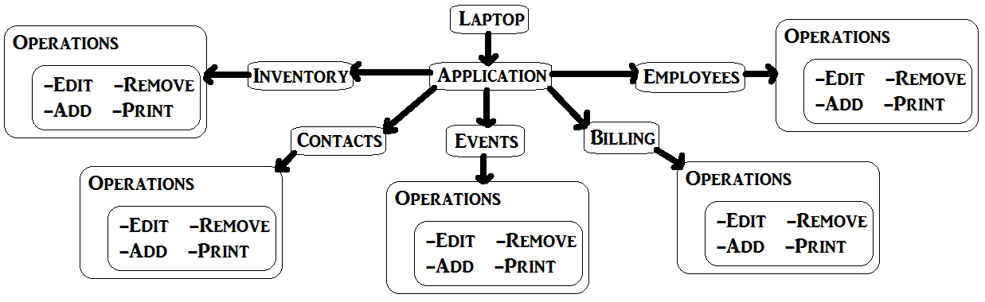

# **Appendix 1: ER Diagram**

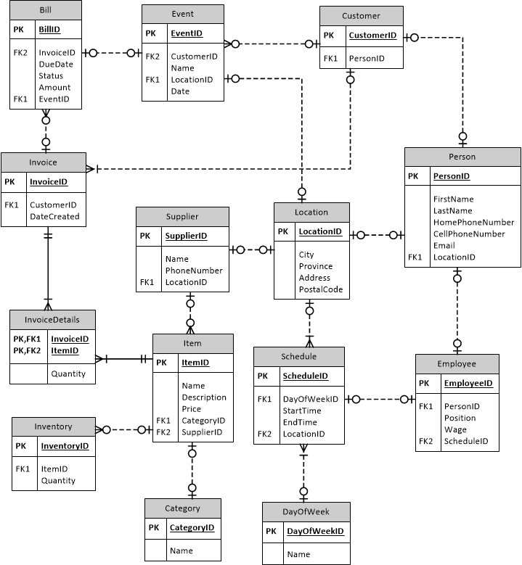

# **Appendix 2: DB description**

## Attributes Data Types:

Choosing the right data types is important because it will determine the size of the database and with the size we could estimate the cost of using the database in the future. In our case, here is our data types of our database:

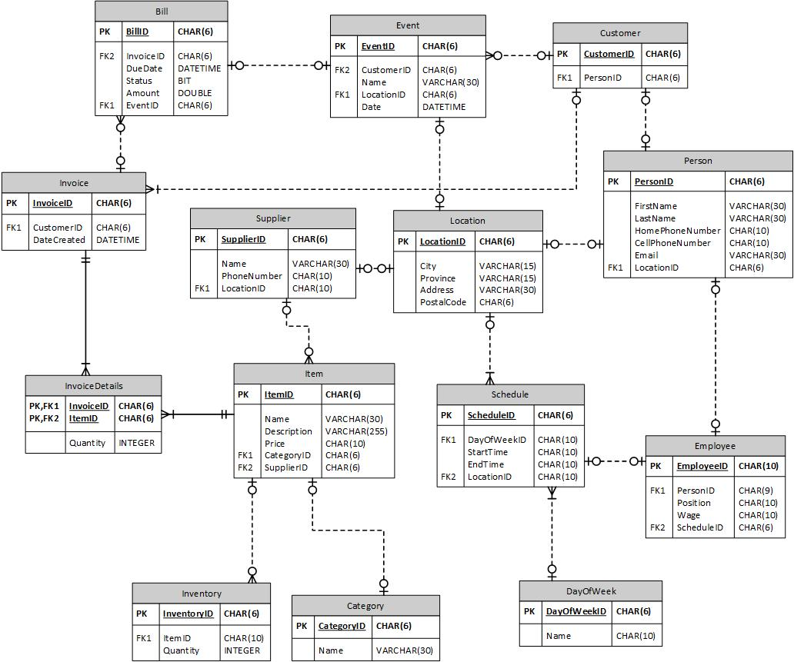

## Index & database architecture:

Indexes is the method used to find a specific row with specific columns values. One common index is the primary key which is a must have attribute. Without index, the database would have to start form the first row until it finds the wanted data. Which is a lot slower than using indexes since MySQL know where is the position of that index.

## Query Optimization:

Query optimization goal is to find the most efficient way to execute a query. In MySQL, there is multiples queries, some have the same function, however one will be always better than another depending on how we write the query. Here is a simple example:

|  |  |
| --- | --- |
| **Before optimization** | **After optimization** |
| SELECT \*  FROM Person | SELECT FirstName  From Person  Where LocationID = 1 |

Basically, we filter has much as possible, we select only the field we need (ServerWatch, 2001).

# **Appendix 3: DB Analysis**

For the current database, we have calculated that the size would be somewhere around 42.53KB (42527 Bytes). Because of the rather small amount of data that is used, a host offering 25MB of data should be more than enough to suite the company’s needs. At a growth rate of 1 customer a day excluding weekends and holidays (around 235 working days a year), In 5 years from now the size of the database would be around 445.83KB (445832 Bytes). Seeing how the database and its data are quite small in terms of size, the minimum required access speed should be 1MB/second which is more than enough for a fast experience.

# **Appendix 4: UI Designs**

Only the part that we updated and new one from the previous deliverable

|  |
| --- |
| **Home Screen** |
| C:\Users\Tung\Documents\TeamBlueVanier\TeamBlueVanier\Deliverables\7th_Deliverable\UI - Prototype 3\Home Screen.png |

|  |
| --- |
| **Inventory (1)** |
| C:\Users\Tung\Documents\TeamBlueVanier\TeamBlueVanier\Deliverables\7th_Deliverable\UI - Prototype 3\Inventory (1).png |

|  |
| --- |
| **Inventory (3)** |
| C:\Users\Tung\Documents\TeamBlueVanier\TeamBlueVanier\Deliverables\7th_Deliverable\UI - Prototype 3\Inventory (3).png |

|  |
| --- |
| **Events (3)** |
| C:\Users\Tung\Documents\TeamBlueVanier\TeamBlueVanier\Deliverables\7th_Deliverable\UI - Prototype 3\Events (3).png |

|  |
| --- |
| **Events (1)** |
| C:\Users\Tung\Documents\TeamBlueVanier\TeamBlueVanier\Deliverables\7th_Deliverable\UI - Prototype 3\Events (1).png |

|  |
| --- |
| **Employee (3)** |
| C:\Users\Tung\Documents\TeamBlueVanier\TeamBlueVanier\Deliverables\7th_Deliverable\UI - Prototype 3\Employees (3).png |

|  |
| --- |
| **Employee (2)** |
| C:\Users\Tung\Documents\TeamBlueVanier\TeamBlueVanier\Deliverables\6th_Deliverable\Jon\Employees(2) table view.png |

|  |
| --- |
| **Employee (1)** |
| C:\Users\Tung\Documents\TeamBlueVanier\TeamBlueVanier\Deliverables\7th_Deliverable\UI - Prototype 3\Employees (1).png |

|  |
| --- |
| **Contacts (3)** |
| C:\Users\Tung\Documents\TeamBlueVanier\TeamBlueVanier\Deliverables\6th_Deliverable\UI\Contacts (3).png |

|  |
| --- |
| **Contacts (2)** |
| C:\Users\Tung\Documents\TeamBlueVanier\TeamBlueVanier\Deliverables\6th_Deliverable\Jon\Contacts(2) Copy Emails.png |

|  |
| --- |
| **Contacts (1)** |
| C:\Users\Tung\Documents\TeamBlueVanier\TeamBlueVanier\Deliverables\6th_Deliverable\UI\Contacts (1).png |

|  |
| --- |
| **Contacts (4)** |
| C:\Users\Tung\Documents\TeamBlueVanier\TeamBlueVanier\Deliverables\7th_Deliverable\UI - Prototype 3\Contacts (4).png |

## Print Reports:

**Inventory** Item ID: 0000001

Item Name: Apple Quantity: 100

Item Description: Round, Red and Fresh Category: Fruits

Selling Price: 4.99$ Purchasing Cost: 1.99$

Supplier: Jane Doe Supplier ID: 00000001

**Event**  Event ID: 0000001

Customer ID: 00000001

Event Name: Joe Birthday Event Location: 225 D’eglise, Saint Laurent, Quebec H3K289

Event Date: 12/12/15 Event Time: 3:00pm

Items

> Item Name: Apple Item ID: 00000001

> Item Name: Orange Item ID: 00000025

> Item Name: Banana Item ID: 00000324

**Employee** Employee ID: 0000001

First Name: John Last Name: Doe

Apt. #: 225 Street Name: D’eglise

Province: Quebec City: Saint Laurent

Postal Code: H3K289 Email : Jone@Doe.com

Home Phone: 514-012-3456 Cellphone: 514-012-3456

Position: Waiter Pay: 14$/hour

SIN: 111 111 111

Availabilities:

> Mondays: 3-11pm

> Fridays: 7-3pm

Contact Type: **Supplier**  Supplier ID: 0000001

First Name: John Last Name: Doe

Apt. #: 225 Street Name: D’eglise

Province: Quebec City: Saint Laurent

Postal Code: H3K289 Cellphone: 514-012-3456

Associated Items

> Item Name: Apple Item ID: 00000001

> Item Name: Orange Item ID: 00000025

> Item Name: Banana Item ID: 00000324

Contact Type: **Customer** Customer ID: 0000001

First Name: John Last Name: Doe

Apt. #: 225 Street Name: D’eglise

Province: Quebec City: Saint Laurent

Postal Code: H3K289 Email: John@Doe.com

Home Phone: 514-123-4567 Cellphone: 514-012-3456

Associated Events

> Event Name: Jane Birthday Event ID: 00000001

> Event Name: Joni Birthday Event ID: 00000025

> Event Name: John Birthday Event ID: 00000324

# **Bibliography**

*Optimizing SELECT statements*. (n.d.). Retrieved from MySQL: https://dev.mysql.com/doc/refman/5.5/en/select-optimization.html

ServerWatch. (2001, August 7). *Optimize Queries*. Retrieved from ServerWatch: http://www.serverwatch.com/tutorials/article.php/2175621/How-to-Optimize-Queries-Theory-an-Practice.htm