

**SuRVEILLANCE** report

Annual Epidemiological Report for YEAR

**-** **DISEASE -**

|  |
| --- |
| Key facts |

Methods

This report is based on data for 2016 retrieved from The European Surveillance System (TESSy) on 07 February 2018. TESSy is a system for the collection, analysis and dissemination of data on communicable diseases.

Epidemiology

Table 1. Distribution of pertussis cases and rates per 100 000 population by country and year, EU/EEA, 2012–2016

| **Country** | **2012** | | **2013** | | **2014** | | **2015** | | **2016** | | |
| --- | --- | --- | --- | --- | --- | --- | --- | --- | --- | --- | --- |
| **Number** | **Rate** | **Number** | **Rate** | **Number** | **Rate** | **Number** | **Rate** | **Number** | **Rate** | **ASR** |
| Austria | 571 | 6.8 | 580 | 6.9 | 370 | 4.3 | 579 | 6.8 | 1291 | 14.9 | 15.7 |
| Belgium | 500 | 4.5 | 799 | 7.2 | 1395 | 12.5 | 1118 | 9.9 | 1325 | 11.7 | 11.7 |
| Bulgaria | 102 | 1.4 | 89 | 1.2 | 52 | 0.7 | 35 | 0.5 | 98 | 1.4 | 1.5 |
| Croatia | 0 | 0.0 | 109 | 2.6 | 131 | 3.1 | 49 | 1.2 | 122 | 2.9 | 3.1 |
| Cyprus | 16 | 1.9 | 9 | 1.0 | 7 | 0.8 | 3 | 0.4 | 2 | 0.2 | 0.2 |
| Czechia | 737 | 7.0 | 1233 | 11.7 | 2521 | 24.0 | 585 | 5.6 | 627 | 5.9 | 6.2 |
| Denmark | 980 | 17.6 | 484 | 8.6 | 762 | 13.5 | 945 | 16.7 | 2096 | 36.7 | 36.8 |
| Estonia | 149 | 11.2 | 55 | 4.2 | 43 | 3.3 | 77 | 5.9 | 74 | 5.6 | 5.5 |
| Finland | 541 | 10.0 | 192 | 3.5 | 206 | 3.8 | 165 | 3.0 | 432 | 7.9 | 8.1 |
| France | 196 | - | 166 | - | 83 | - | - | - | 60 | - | - |
| Germany | - | - | - | - | 12339 | 15.3 | 9000 | 11.1 | 13437 | 16.4 | 17.6 |
| Greece | 56 | 0.5 | 40 | 0.4 | 15 | 0.1 | 17 | 0.2 | 87 | 0.8 | 0.9 |
| Hungary | 5 | 0.1 | 20 | 0.2 | 20 | 0.2 | 5 | 0.1 | 5 | 0.1 | 0.1 |
| Iceland | 36 | 11.3 | 31 | 9.6 | - | - | 4 | 1.2 | 15 | 4.5 | 4.3 |
| Ireland | 458 | 10.0 | 174 | 3.8 | 73 | 1.6 | 118 | 2.5 | 213 | 4.5 | 3.7 |
| Italy | 489 | 0.8 | 523 | 0.9 | 670 | 1.1 | 503 | 0.8 | 965 | 1.6 | 1.7 |
| Latvia | 257 | 12.6 | 201 | 9.9 | 81 | 4.0 | 210 | 10.6 | 256 | 13.0 | 13.8 |
| Liechtenstein | . | . | . | . | . | . | . | . | . | . | . |
| Lithuania | 154 | 5.1 | 65 | 2.2 | 143 | 4.9 | 60 | 2.1 | 36 | 1.2 | 1.3 |
| Luxembourg | 11 | 2.1 | 29 | 5.4 | 6 | 1.1 | 0 | 0.0 | 7 | 1.2 | 1.2 |
| Malta | 3 | 0.7 | 3 | 0.7 | 1 | 0.2 | 0 | 0.0 | 0 | 0.0 | 0.0 |
| Netherlands | 12853 | 76.8 | 2982 | 17.8 | 8067 | 47.9 | 6178 | 36.6 | 5080 | 29.9 | 30.1 |
| Norway | 4247 | 85.2 | 2608 | 51.6 | 3032 | 59.4 | 1902 | 36.8 | 2205 | 42.3 | 42.2 |
| Poland | 4684 | 12.3 | 2182 | 5.7 | 2100 | 5.5 | 4956 | 13.0 | 6828 | 18.0 | 18.7 |
| Portugal | 237 | 2.2 | 106 | 1.0 | 74 | 0.7 | 238 | 2.3 | 563 | 5.4 | 6.2 |
| Romania | 83 | 0.4 | 57 | 0.3 | 87 | 0.4 | 98 | 0.5 | 72 | 0.4 | 0.4 |
| Slovakia | 950 | 17.6 | 907 | 16.8 | 1123 | 20.7 | 334 | 6.2 | 289 | 5.3 | 5.3 |
| Slovenia | 178 | 8.7 | 169 | 8.2 | 399 | 19.4 | 68 | 3.3 | 127 | 6.2 | 7.1 |
| Spain | 1804 | 3.9 | 1678 | 3.6 | 2607 | 5.6 | 6863 | 14.8 | 4095 | 8.8 | 9.3 |
| Sweden | 289 | 3.0 | 237 | 2.5 | 703 | 7.3 | 603 | 6.2 | 679 | 6.9 | 7.0 |
| United Kingdom | 11986 | 18.9 | 6077 | 9.5 | 4043 | 6.3 | 5482 | 8.5 | 7360 | 11.3 | 11.5 |
| **EU-EEA** | **42572** | **11.7** | **21805** | **5.9** | **41153** | **9.2** | **40195** | **9.0** | **48446** | **10.8** | **11.2** |

Source: Country reports.  
ASR: age-standardised rate.  
.: no data reported.   
-: no rate calculated.

Figure 1. Distribution of pertussis cases by country, EU/EEA, 2016

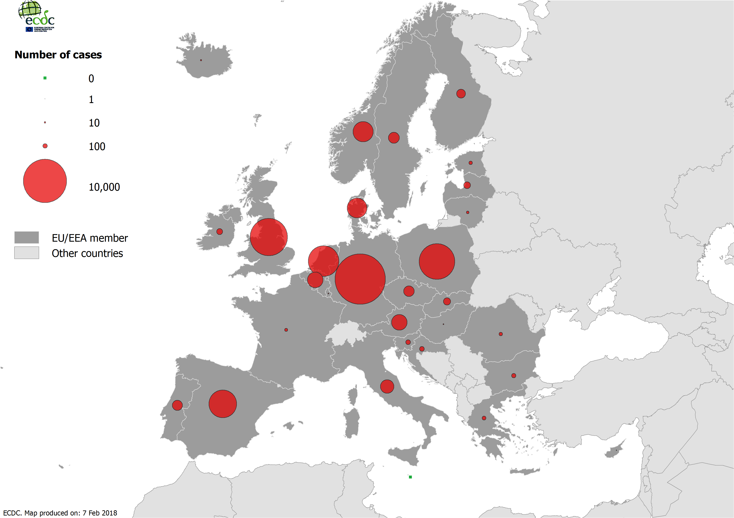

Figure 2. Distribution of pertussis cases per 100 000 population by country, EU/EEA, 2016

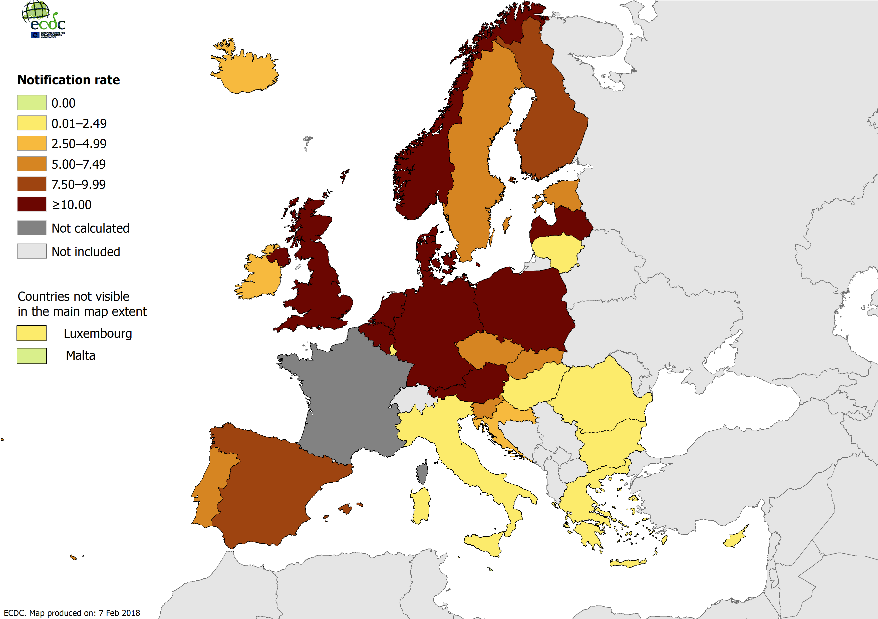

MAP_ASR_CAPTION

MAP_ASR

Figure 3. Distribution of pertussis cases by month, EU/EEA, 2012–2016

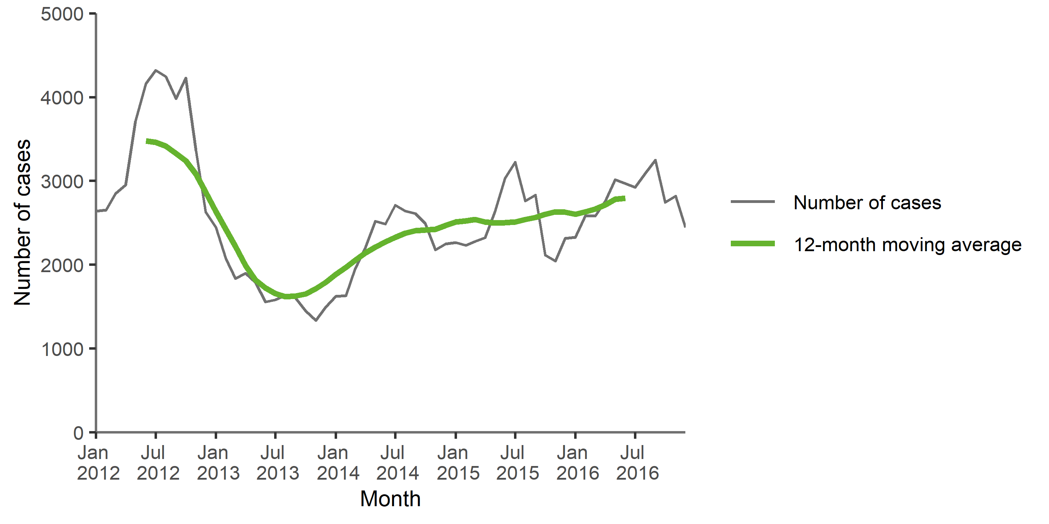

Source: Country reports from Austria, Croatia, Cyprus, Czechia, Denmark, Estonia, Finland, Greece, Hungary, Ireland, Italy, Latvia, Lithuania, Malta, the Netherlands, Norway, Poland, Portugal, Romania, Slovakia, Slovenia, Spain, Sweden, the United Kingdom.

Figure 4. Distribution of pertussis cases by month, EU/EEA, 2016 and 2012–2015

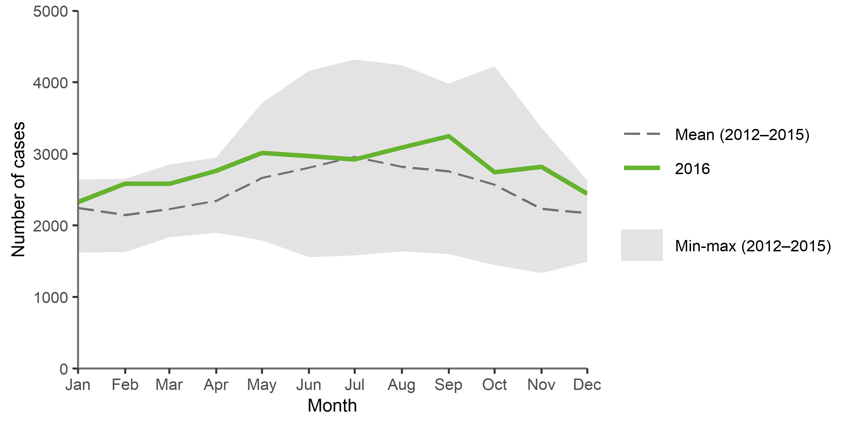

Source: Country reports from Austria, Croatia, Cyprus, Czechia, Denmark, Estonia, Finland, Greece, Hungary, Ireland, Italy, Latvia, Lithuania, Malta, the Netherlands, Norway, Poland, Portugal, Romania, Slovakia, Slovenia, Spain, Sweden, the United Kingdom.

TS_SPECIFIC_CAPTION

TS_SPECIFIC

Figure 5. Distribution of pertussis cases per 100 000 population, by age and gender, EU/EEA, 2016

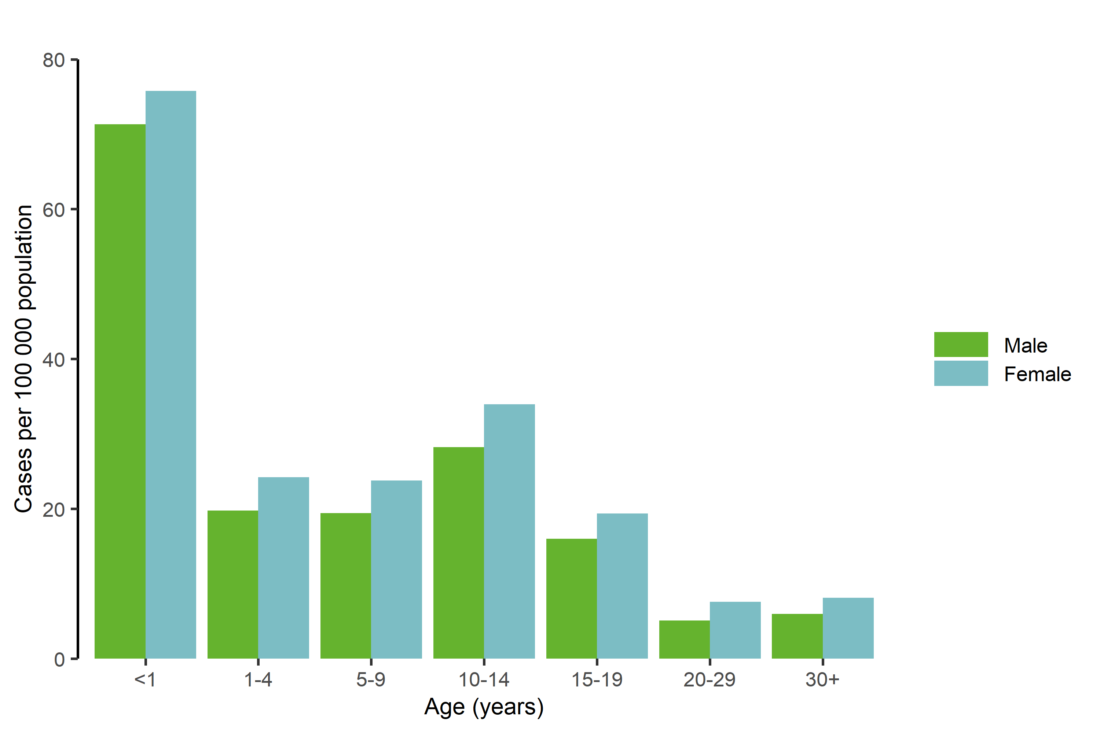

BARGPH_AGE_CAPTION

BARGPH_AGE

Outbreaks and other threats

Discussion

Public health implications

References