Indicator | Pooled |  | Belgium |  | Denmark |  | Italy |  | Navarra |  | Norway |  | Portugal |  | Sweden
COVID-19-related hospitalisation
65-79 years old
Events observed | 25,242 |  | 1,127 |  | 1,396 |  | 14,426 |  | 145 |  | 4,058 |  | 927 |  | 3,163
 | 25,275 |  | 1,160 (correction after Toon comments)
Events expected without vaccination programme | 27,903  (27,845 - 27,980) |  | 1,254  (1,250 - 1,259) |  | 2,107  (2,092 - 2,126) |  | 14,696  (14,691 - 14,703) |  | 175  (173 - 176) |  | 4,851  (4,835 - 4,872) |  | 1,062  (1,057 - 1,069) |  | 3,759  (3,744 - 3,777)
 | 27,834  (27,417 - 28,247) |  | 1,298  (1,265 - 1,332) |  | 2,083  (1,976 - 2,203) |  | 14,681  (14,638 - 14,721) |  | 172  (164 - 182) |  | 4,816  (4,703 - 4,931) |  | 1,051  (1,011 - 1,097) |  | 3,733  (3,634 - 3,843)
NAE | 2,662  (2,603 - 2,738) |  | 127  (123 - 132) |  | 711  (696 - 730) |  | 270  (265 - 277) |  | 30  (28 - 31) |  | 793  (777 - 814) |  | 135  (130 - 142) |  | 596  (581 - 614)
 | 2,559  (2,142 - 2,972) |  | 138  (105 - 173) |  | 687  (580 - 807) |  | 255  (212 - 295) |  | 27  (19 - 37) |  | 758  (645 - 873) |  | 124  (84 - 170) |  | 570  (471 - 680)
NAE / pop. size (per 100,000) | 18  (18-19) |  | 8  (8 - 8) |  | 102  (100 - 104) |  | 3  (3 - 3) |  | 35  (33 - 36) |  | 113  (111 - 116) |  | 9  (8 - 9) |  | 43  (42 - 44)
 | 18  (15 - 21) |  | 10  (7 - 12) |  | 98  (83 - 115) |  | 3  (2 - 3) |  | 32  (22 - 43) |  | 108  (92 - 125) |  | 8  (5 - 11) |  | 41  (34 - 49)
PAE (%) | 10  (9 - 10) |  | 10  (10 - 10) |  | 34  (33 - 34) |  | 2  (2 - 2) |  | 17  (16 - 18) |  | 16  (16 - 17) |  | 13  (12 - 13) |  | 16  (16 - 16)
 | 9  (8 - 11) |  | 11  (8 - 13) |  | 33  (29 - 37) |  | 2  (1 - 2) |  | 16  (11 - 20) |  | 16  (14 - 18) |  | 12  (8 - 16) |  | 15  (13 - 18)
Average NNV | - |  | 4,613  (4,454 - 4,762) |  | 795  (775 - 812) |  | 3,167  (3,086 - 3,234) |  | 1,805  (1,721 - 1,883) |  | 485  (473 - 495) |  | 6,195  (5,908 - 6,449) |  | 1,680  (1,631 - 1,722)
 |  |  | 4,260  (3,402 - 5,604) |  | 823  (701 - 976) |  | 3,360  (2,903 - 4,042) |  | 1,980  (1,447 - 2,859) |  | 508  (441 - 597) |  | 6,771  (4,909 - 9,947) |  | 1,756  (1,473 - 2,127)
≥80 years old
Events observed | 36,631 |  | 997 |  | 1,678 |  | 22,730 |  | 234 |  | 3,671 |  | 2,216 |  | 5,105
 | 36,656 |  | 1,022
Events expected without vaccination programme | 40,714  (40,033 - 41,736) |  | 1,134  (1,106 - 1,173) |  | 2,484  (2,363 - 2,660) |  | 23,323  (23,233 - 23,439) |  | 309  (292 - 333) |  | 4,451  (4,339 - 4,616) |  | 2,629  (2,527 - 2,787) |  | 6,376  (6,152 - 6,709)
 | 40,292  (39,775 - 41,058) |  | 1,170  (1,141 - 1,212) |  | 2,402  (2,303 - 2,539) |  | 23,256  (23,183 - 23,347) |  | 298  (285 - 318) |  | 4,369  (4,275 - 4,492) |  | 2,569  (2,485 - 2,690) |  | 6,228  (6,055 - 6,482)
NAE | 4,083  (3,402 - 5,105) |  | 137  (109 - 176) |  | 806  (685 - 982) |  | 593  (503 - 709) |  | 75  (58 - 99) |  | 780  (668 - 945) |  | 413  (311 - 571) |  | 1,271  (1,047 - 1,604)
 | 3,637  (3,119 - 4,402) |  | 148  (120 - 190) |  | 724  (625 - 861) |  | 526  (453 - 617) |  | 64  (51 - 84) |  | 698  (604 - 821) |  | 353  (269 - 474) |  | 1,123  (950 - 1,377)
NAE / pop. size (per 100,000) | 64  (53 – 80) |  | 23  (19 - 30) |  | 308  (262 - 375) |  | 15  (12 - 17) |  | 217  (169 - 288) |  | 345  (296 - 418) |  | 62  (47 - 86) |  | 239  (197 - 302)
 | 58  (49 - 70) |  | 30  (24 - 38) |  | 277  (239 - 329) |  | 13  (11 - 15) |  | 186  (149 - 244) |  | 309  (267 - 364) |  | 53  (40 - 71) |  | 211  (179 - 259)
PAE (%) |  | 10  (8 – 12) |  | 12  (10 - 15) |  | 32  (29 - 37) |  | 3  (2 - 3) |  | 24  (20 - 30) |  | 18  (15 - 20) |  | 16  (12 - 20) |  | 20  (17 - 24)
 |  | 9  (8 - 11) |  | 13  (10 - 16) |  | 30  (27 - 34) |  | 2  (2 - 3) |  | 22  (18 - 26) |  | 16  (14 - 18) |  | 14  (11 - 18) |  | 18  (16 - 21)
Average NNV | - |  | 1,723  (1,336 - 2,154) |  | 267  (219 - 314) |  | 952  (796 - 1,121) |  | 349  (264 - 449) |  | 165  (137 - 193) |  | 990  (715 - 1,313) |  | 354  (281 - 430)
 |  |  | 1,589  (1,240 - 1,969) |  | 297  (250 - 344) |  | 1,072  (914 - 1,247) |  | 407  (311 - 510) |  | 185  (157 - 214) |  | 1,159  (861 - 1,520) |  | 401  (327 - 474)
COVID-19-related death
≥80 years old
Events observed | 5,993 |  | - |  | 325 |  | 3,071 |  | 11 |  | 455 |  | 1,561 |  | 570
Events expected without vaccination programme | 6,724  (6,616 - 6,861) |  | - |  | 497  (471 - 528) |  | 3,137  (3,129 - 3,146) |  | 17  (16 - 19) |  | 588  (571 - 610) |  | 1,746  (1,718 - 1,782) |  | 740  (712 - 775)
 | 6,809  (6,571 - 7,020) |  |  |  | 517  (458 - 571) |  | 3,141  (3,116 - 3,156) |  | 18  (14 - 22) |  | 601  (563 - 632) |  | 1,770  (1,684 - 1,859) |  | 765  (706 - 819)
NAE | 731  (623 - 868) |  | - |  | 172  (146 - 203) |  | 66  (58 - 75) |  | 6  (5 - 8) |  | 133  (116 - 155) |  | 185  (157 - 221) |  | 170  (142 - 205)
 | 816  (578 - 1,027) |  |  |  | 192  (133 - 246) |  | 70  (45 - 85) |  | 7  (3 - 11) |  | 146  (108 - 177) |  | 209  (123 - 298) |  | 195  (136 - 249)
NAE / pop. size (per 100,000) | 13  (11 - 15) |  | - |  | 66  (56 - 78) |  | 2  (1 - 2) |  | 18  (15 - 23) |  | 59  (51 - 68) |  | 28  (24 - 33) |  | 32  (27 - 39)
 | 14 (10 -18) |  |  |  | 73  (51 - 94) |  | 2  (1 - 2) |  | 22  (10 - 33) |  | 65  (48 - 78) |  | 31  (18 - 45) |  | 37  (26 - 47)
PAE (%) | 11  (9 - 13) |  | - |  | 35  (31 - 38) |  | 2  (2 - 2) |  | 37  (32 - 42) |  | 23  (20 - 25) |  | 11  (9 - 12) |  | 23  (20 - 26)
 | 12  (9 - 15) |  |  |  | 37  (29 - 43) |  | 2  (1 - 3) |  | 40  (24 - 50) |  | 24  (19 - 28) |  | 12  (7 - 16) |  | 26  (19 - 30)
Average NNV | - |  | - |  | 1,251  (1,058 - 1,470) |  | 8,578  (7,484 - 9,797) |  | 4,114  (3,308 - 5,102) |  | 967  (835 - 1,115) |  | 2,214  (1,848 - 2,605) |  | 2,649  (2,193 - 3,170)
 |  |  |  |  | 1,122  (875 - 1,614) |  | 8,100  (6,646 - 12,595) |  | 3,520  (2,333 - 7,487) |  | 883  (730 - 1,199) |  | 1,958  (1,370 - 3,335) |  | 2,307  (1,811 - 3,311)

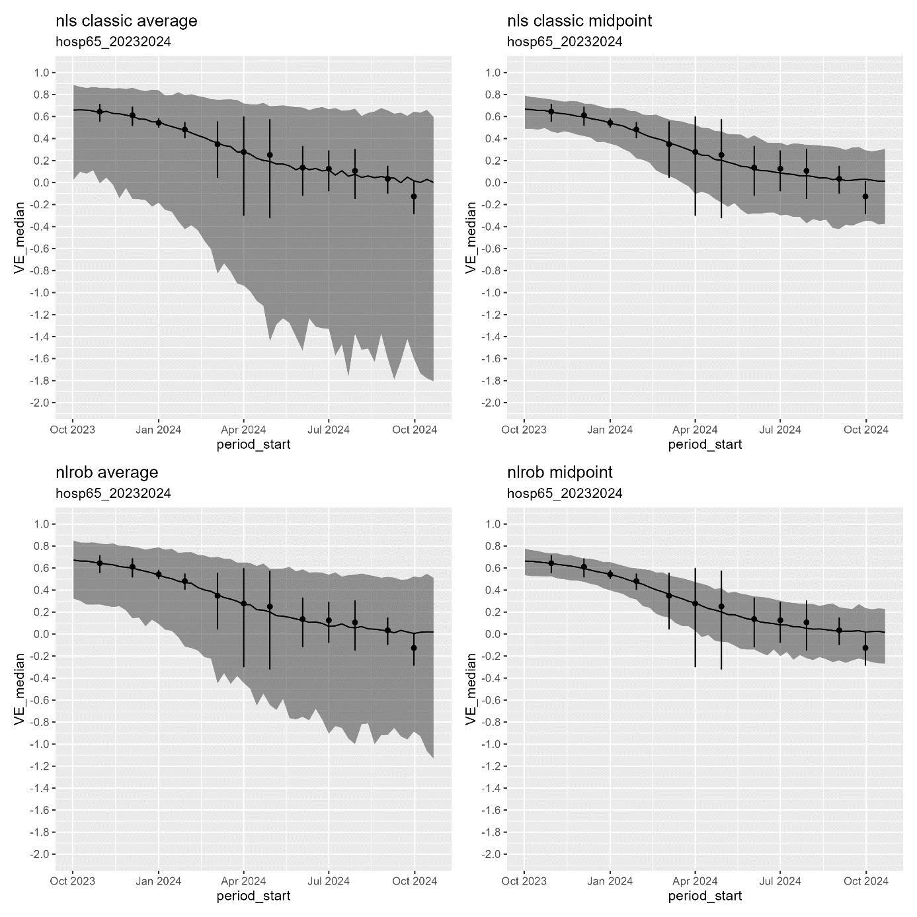

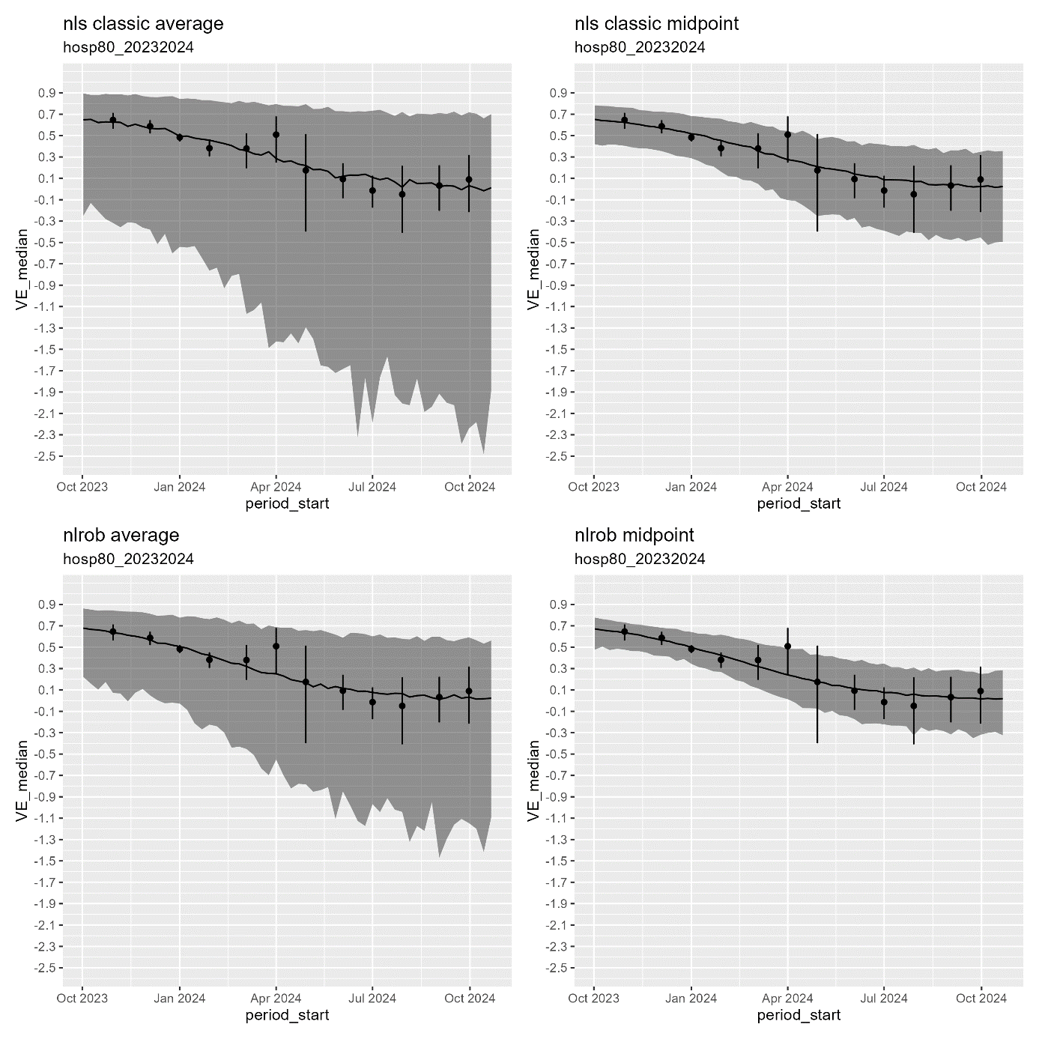
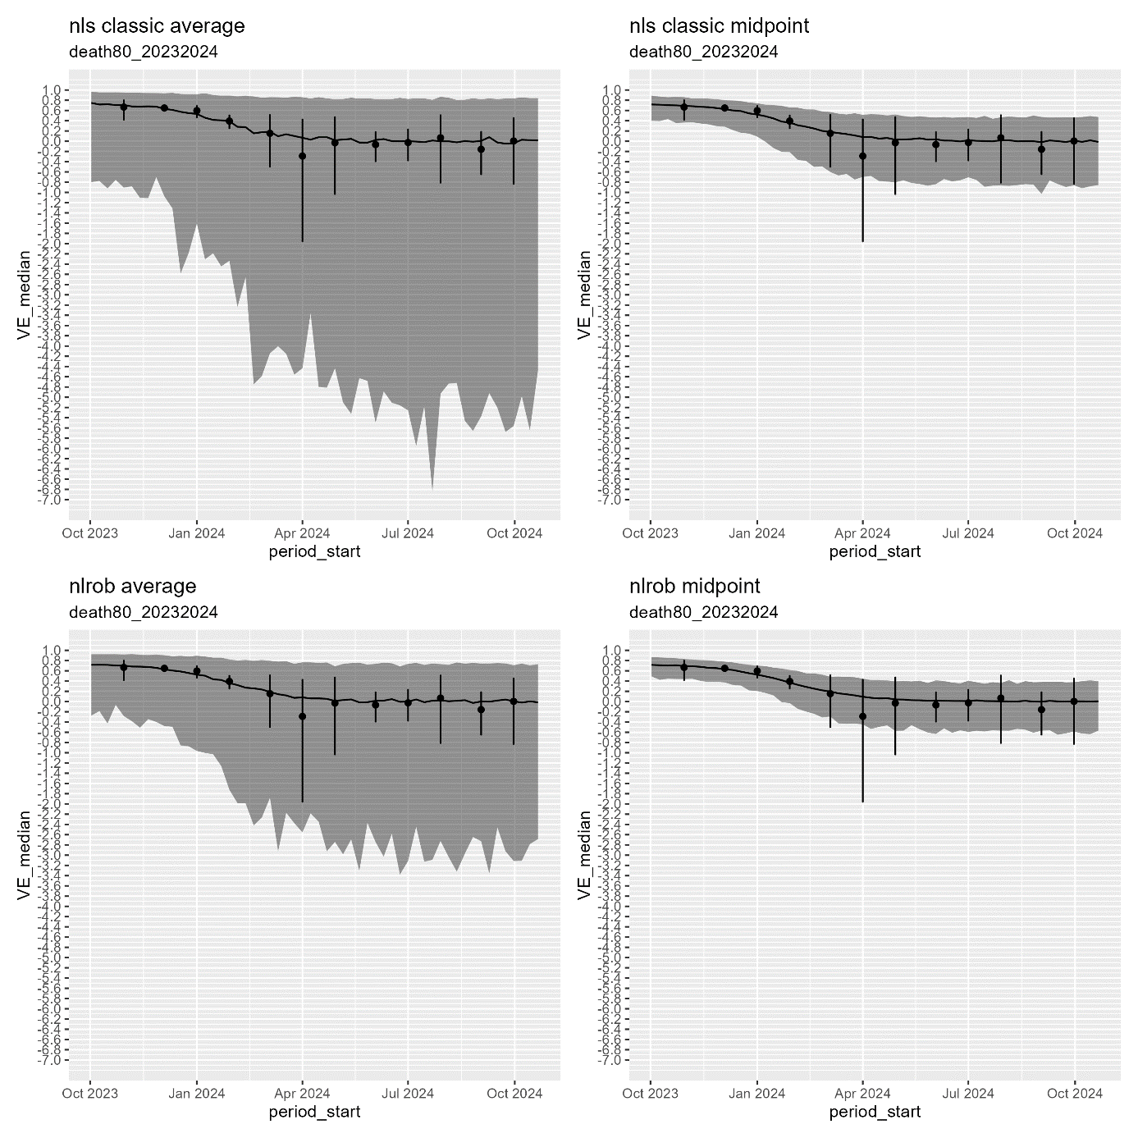

2024-2025
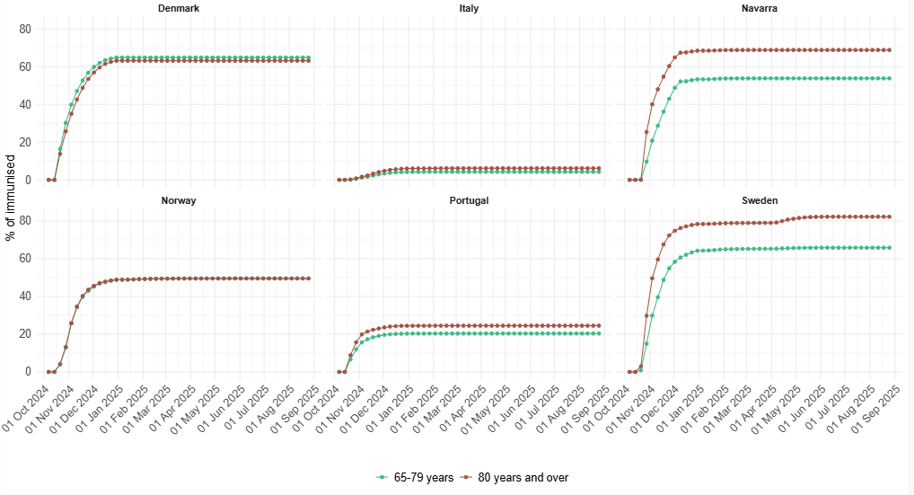

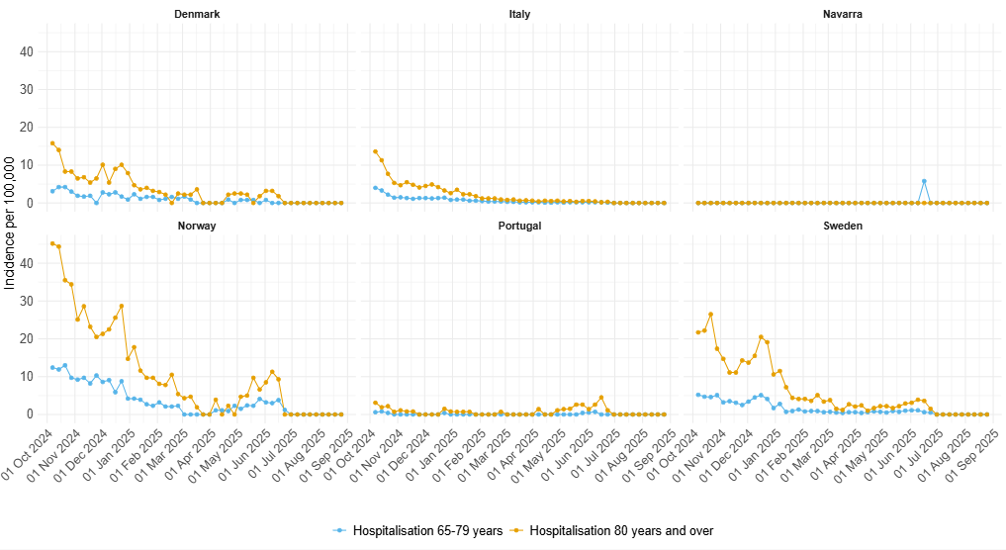

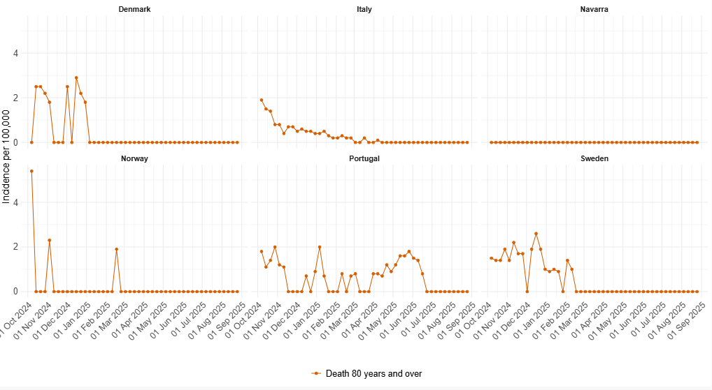

Indicator | Pooled |  |  |  | Denmark |  | Italy |  | Navarra |  | Norway |  | Portugal |  | Sweden
COVID-19-related hospitalisation
65-79 years old
Events observed | 5,090 |  |  |  | 310 |  | 2,583 |  | 5 |  | 1,128 |  | 62 |  | 1,002
Events expected without vaccination programme | 5,797  (5,671 - 5,914) |  |  |  | 419  (400 - 440) |  | 2,613  (2,609 - 2,617) |  | 6  (4 - 7) |  | 1,371  (1,330 - 1,411) |  | 64  (63 - 66) |  | 1,324  (1,263 - 1,378)
NAE | 707  (581 - 824) |  |  |  | 109  (90 - 130) |  | 30  (26 - 34) |  | 1  (-1 - 2) |  | 243  (202 - 283) |  | 2  (1 - 4) |  | 322  (261 - 376)
NAE / pop. size (per 100,000) | 5 (4, 6) |  |  |  | 17  (14 - 20) |  | 0  (0 - 0) |  | 1  (-1 - 2) |  | 37  (30 - 43) |  | 0  (0 - 0) |  | 23  (19 - 27)
PAE (%) | 12  (10 - 14) |  |  |  | 26  (23 - 30) |  | 1  (1 - 1) |  | 10  (-16 - 27) |  | 18  (15 - 20) |  | 4  (1 - 6) |  | 24  (21 - 27)
Average NNV | - |  |  |  | 3,811  (3,206 - 4,619) |  | 12,174  (10,862 - 14,248) |  | 57,534  (-710,277 - 1,062,180) |  | 1,348  (1,160 - 1,625) |  | 141,423  (89,315 - 481,782) |  | 2,863  (2,452 - 3,535)
≥80 years old
Events observed | 7,954 |  |  |  | 457 |  | 4,119 |  | 0 |  | 1,350 |  | 262 |  | 1,766
Events expected without vaccination programme | 9,123  (8,864 - 9,366) |  |  |  | 583  (556 - 608) |  | 4,179  (4,168 - 4,188) |  | 0  (0 - 0) |  | 1,603  (1,551 - 1,648) |  | 276  (271 - 282) |  | 2,482  (2,312 - 2,648)
NAE | 1,169  (910 - 1,412) |  |  |  | 126  (99 - 151) |  | 60  (49 - 69) |  | 0  (0 - 0) |  | 253  (201 - 298) |  | 14  (9 - 20) |  | 716  (546 - 882)
NAE / pop. size (per 100,000) | 19 (15 - 23) |  |  |  | 45  (35 - 54) |  | 1  (1 - 2) |  | 0  (0 - 0) |  | 98  (77 - 115) |  | 2  (1 - 3) |  | 122  (93 - 150)
PAE (%) |  | 13  (10 - 15) |  |  |  | 22  (18 - 25) |  | 1  (1 - 2) |  | NA  (NA - NA) |  | 16  (13 - 18) |  | 5  (3 - 7) |  | 29  (24 - 33)
Average NNV | - |  |  |  | 1,394  (1,161 - 1,781) |  | 4,242  (3,694 - 5,218) |  | NA  (NA - NA) |  | 507  (430 - 639) |  | 12,595  (8,931 - 21,281) |  | 673  (547 - 883)
COVID-19-related death
≥80 years old
Events observed | 980 |  |  |  | 51 |  | 536 |  | 0 |  | 25 |  | 218 |  | 150
Events expected without vaccination programme | 1,105  (1,063 - 1,148) |  |  |  | 67  (60 - 74) |  | 544  (542 - 546) |  | 0  (0 - 0) |  | 28  (26 - 29) |  | 237  (228 - 244) |  | 230  (201 - 262)
NAE | 125  (83 - 168) |  |  |  | 16  (9 - 23) |  | 8  (6 - 10) |  | 0  (0 - 0) |  | 3  (1 - 4) |  | 19  (10 - 26) |  | 80  (51 - 112)
NAE / pop. size (per 100,000) | 2 (1 – 3) |  |  |  | 6  (3 - 8) |  | 0  (0 - 0) |  | 0  (0 - 0) |  | 1  (0 - 2) |  | 3  (1 - 3) |  | 14  (9 - 19)
PAE (%) | 11  (8 - 15) |  |  |  | 24  (15 - 31) |  | 1  (1 - 2) |  | NA  (NA - NA) |  | 9  (3 - 14) |  | 8  (4 - 10) |  | 35  (25 - 43)
Average NNV | - |  |  |  | 10,886  (7,765 - 18,772) |  | 31,654  (25,961 - 45,554) |  | NA  (NA - NA) |  | 50,126  (32,218 - 132,189) |  | 9,708  (7,077 - 17,471) |  | 6,025  (4,306 - 9,501)

