**User Manual**

**EasySave 3.0**

*Group 8 : GRILLY Paolo, MARTORELL Antoine, PICCINI Mattéo, SAVALLE Florian*

When you start EasySave, you will arrive on this graphic interface which let you choose between multiple sub-menus corresponding to the different features of EasySave.

In the bottom-left corner, you will be able to change the language of the application between English and French. By default, at the first start of EasySave, the language will be English, but if you change it, your choice will be remembered for the next time.

* **Menu [Classics]**

In EasySave, you will be able to create and save multiple pre-made backup configurations, but you will also be able to quickly launch a save without saving it as a backup work, that is a Classic Backup.

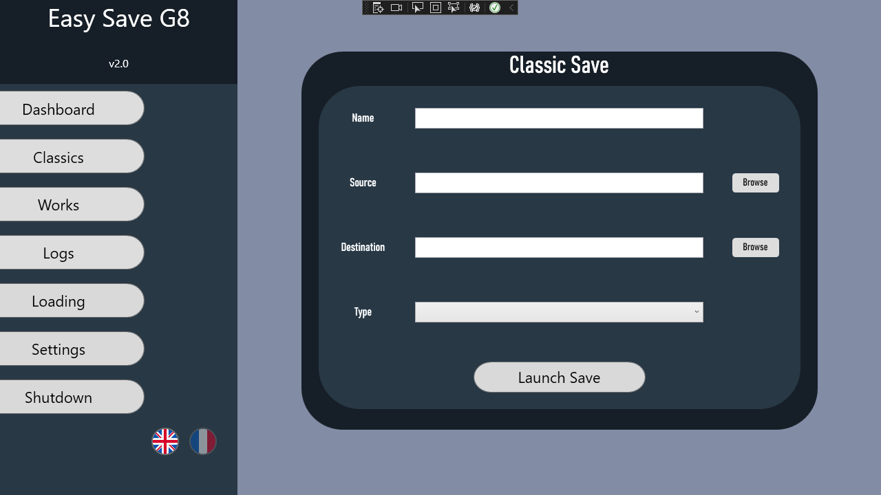

When you choose to launch a Classic Backup, you will have to enter some information :

* A name for your backup. Even if it won’t be saved as a backup work, that will be useful for the logs.
* A source path. It will be the path to the file or the folder that contains what you want to save.
* A destination path. It will be the path where you want the files to be saved.
* The save type that you want. You have two choices : Full and Differential
  + Full : Simple copy of your files from the source to the destination.
  + Differential : A save that will only save files that have been edited since the last full save. Therefore, you will need to do a full save on your directory or your files before doing a differential save.

Then, you will be able to follow the progress of your save from the **[Loading]** menu.

* **Menu [Works]**

It’s the part where you can save pre-made configurations : the backup works. By heading to this menu, you will have multiple choices :

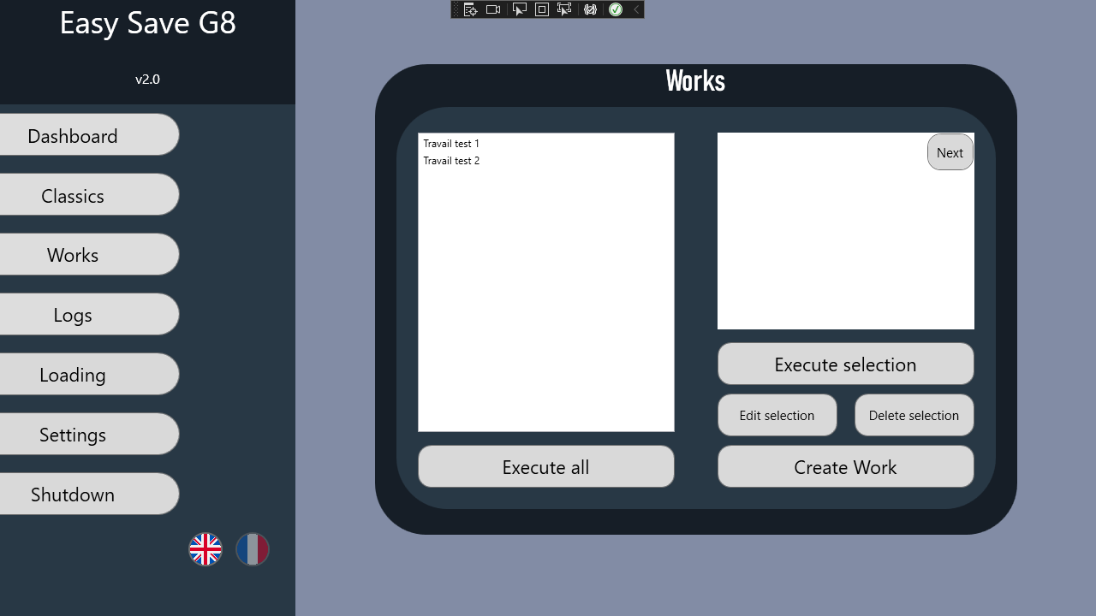

Firstly, the left white box displays all the backup works that you have created. The right one display all the details of the selected backup work. Then, you have different options :

* Execute All : Launch simultaneously all the backup works that you have created.
* Execute selection : Launch simultaneously the selected backup work or works.
* Edit selection : You can edit all the parameters of the selected backup work.
* Delete selection : Delete the selected backup work or works.
* Create work : Create a new backup work. You will have to enter the same information as for the Classic backup, but you can also choose to launch the backup work right after its creation.
* **Menu [Logs]**

Visualize the logs of EasySave. There are two types of logs :

* Daily logs : Allows you to see all the backup works that have been lauch in a specified day.
* State logs : Allows you to directly see the progress of your active and finished backup works.
* **Menu [Loading]**

Displays all the progress bars from the current active saves. For the saves that are finished, the progress bars will stay a few seconds and then will be cleared. Furthermore, you can pause an active save (the pause will be effective after the end of the current file) or completely stop a save (immediately effective).

* **Menu [Settings]**

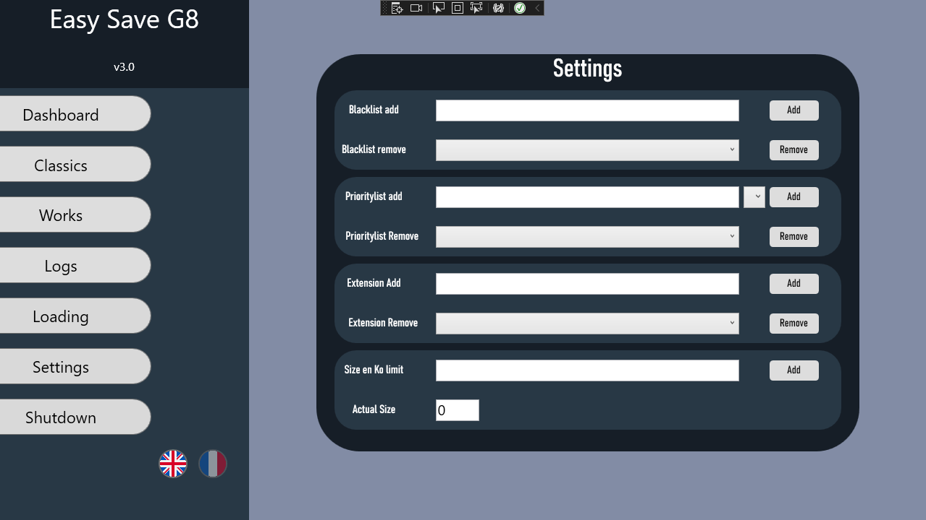

In this menu, you will be able to select various settings for EasySave :

* Blacklist : Allows you to choose software that will completely block the progress of backup works until they’re closed.
* Priority files : Allows you to choose files that will completely block the progress of other backup works until they’re finished.
* Extensions : EasySave works with the application CryptoSoft to encrypt you files once saved. You can select files extensions that will be ignored by CryptoSoft, so the files won’t be encrypted.
* Size limit : Allows you to choose to block the save of the files that exceed a certain size. You can set this size in this menu.
* **Menu [Shutdown]**

Simply closes the application.