Wazuh ICT Environment Diagram

This document will explain the technical artefact Wazuh ICT Environment Diagram.

The artefact is a high-level logical network diagram visualising our ICT environment on which we are running our Wazuh platform and agents. The purpose of the diagram is to assist IT staff in understanding how the nodes connect to each other.

The diagram provides the hostname, public IP address, private IP address, operating system, and purpose of each Wazuh node. The solid boxes surrounding the nodes represent logical network isolation. Nodes wazuh01 and wazuh02 are on the same subnet and virtual network as each other. They are also in the same region as the other Wazuh agents. As they are on the same subnet, they can communicate with each other using the internal network.

Nodes wazuh03 and wazuh04 are on different virtual networks and subnets from each other. Therefore, they must communicate over the Internet. Likewise, all four group members access the nodes via an Internet connection.

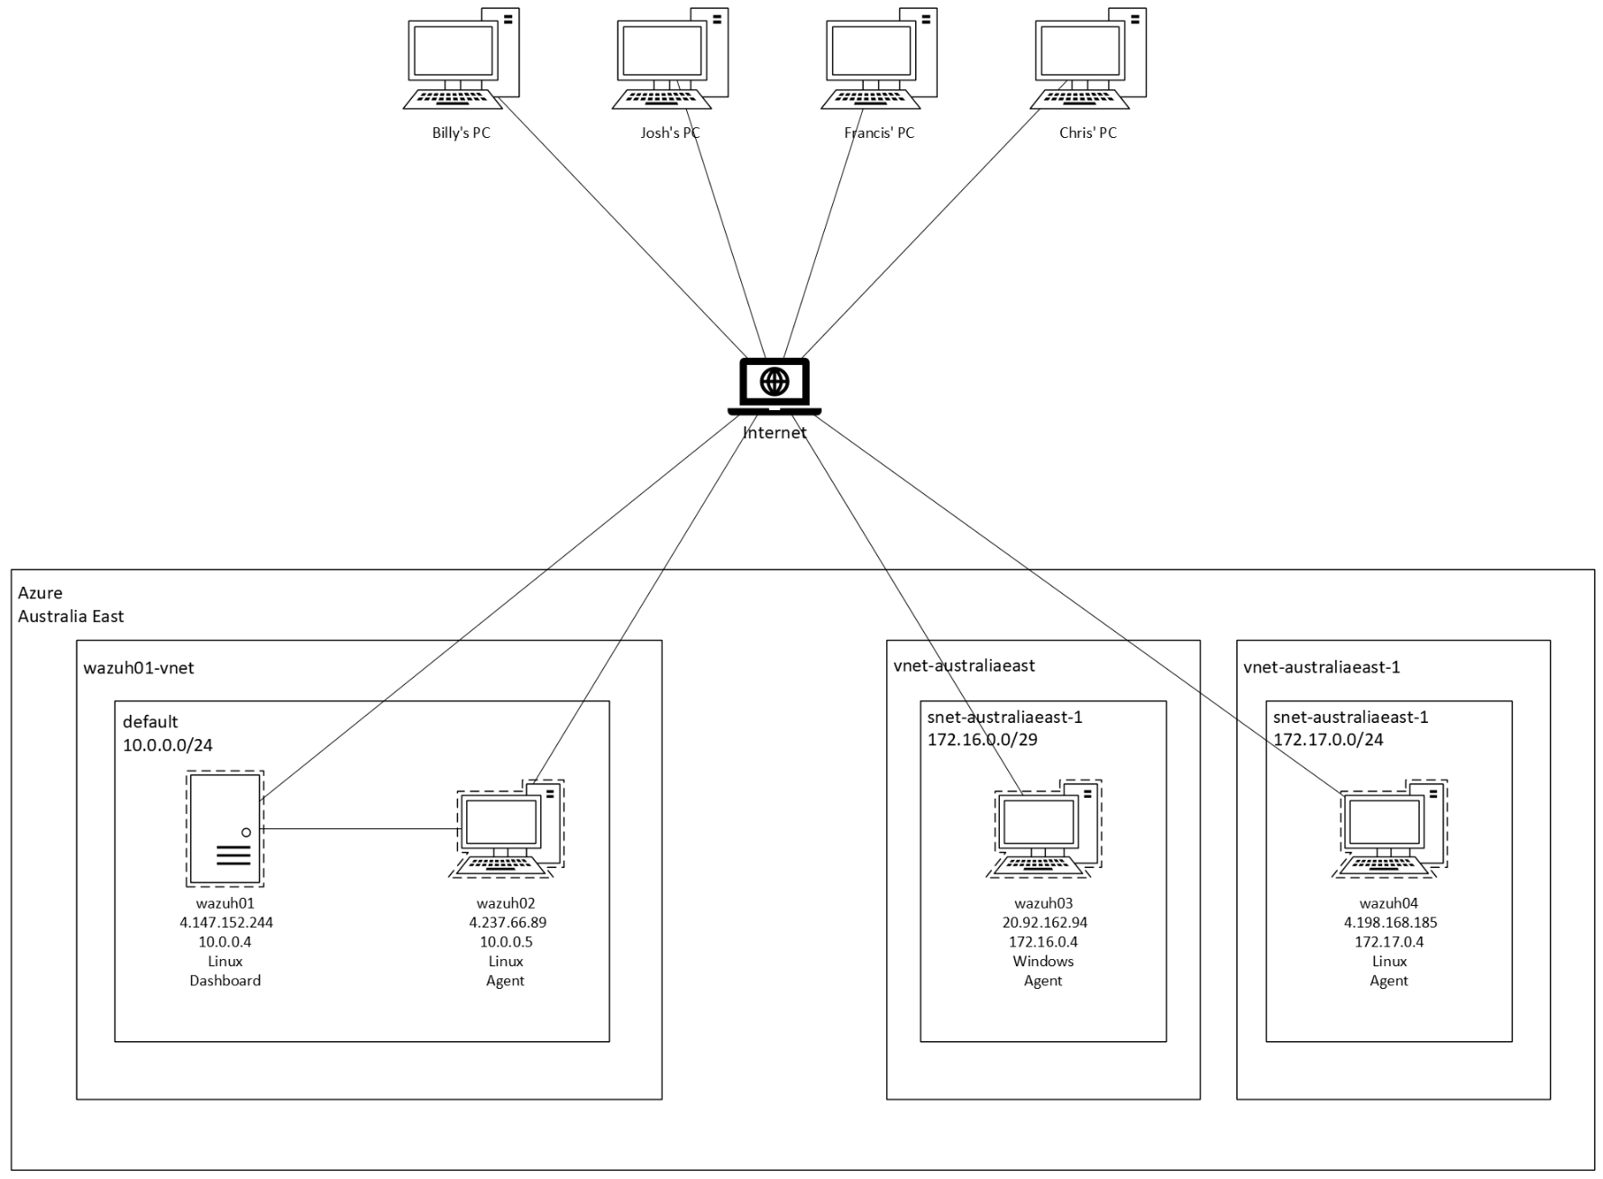

Figure : Wazuh ICT Environment