Exercise 1
Dataset:
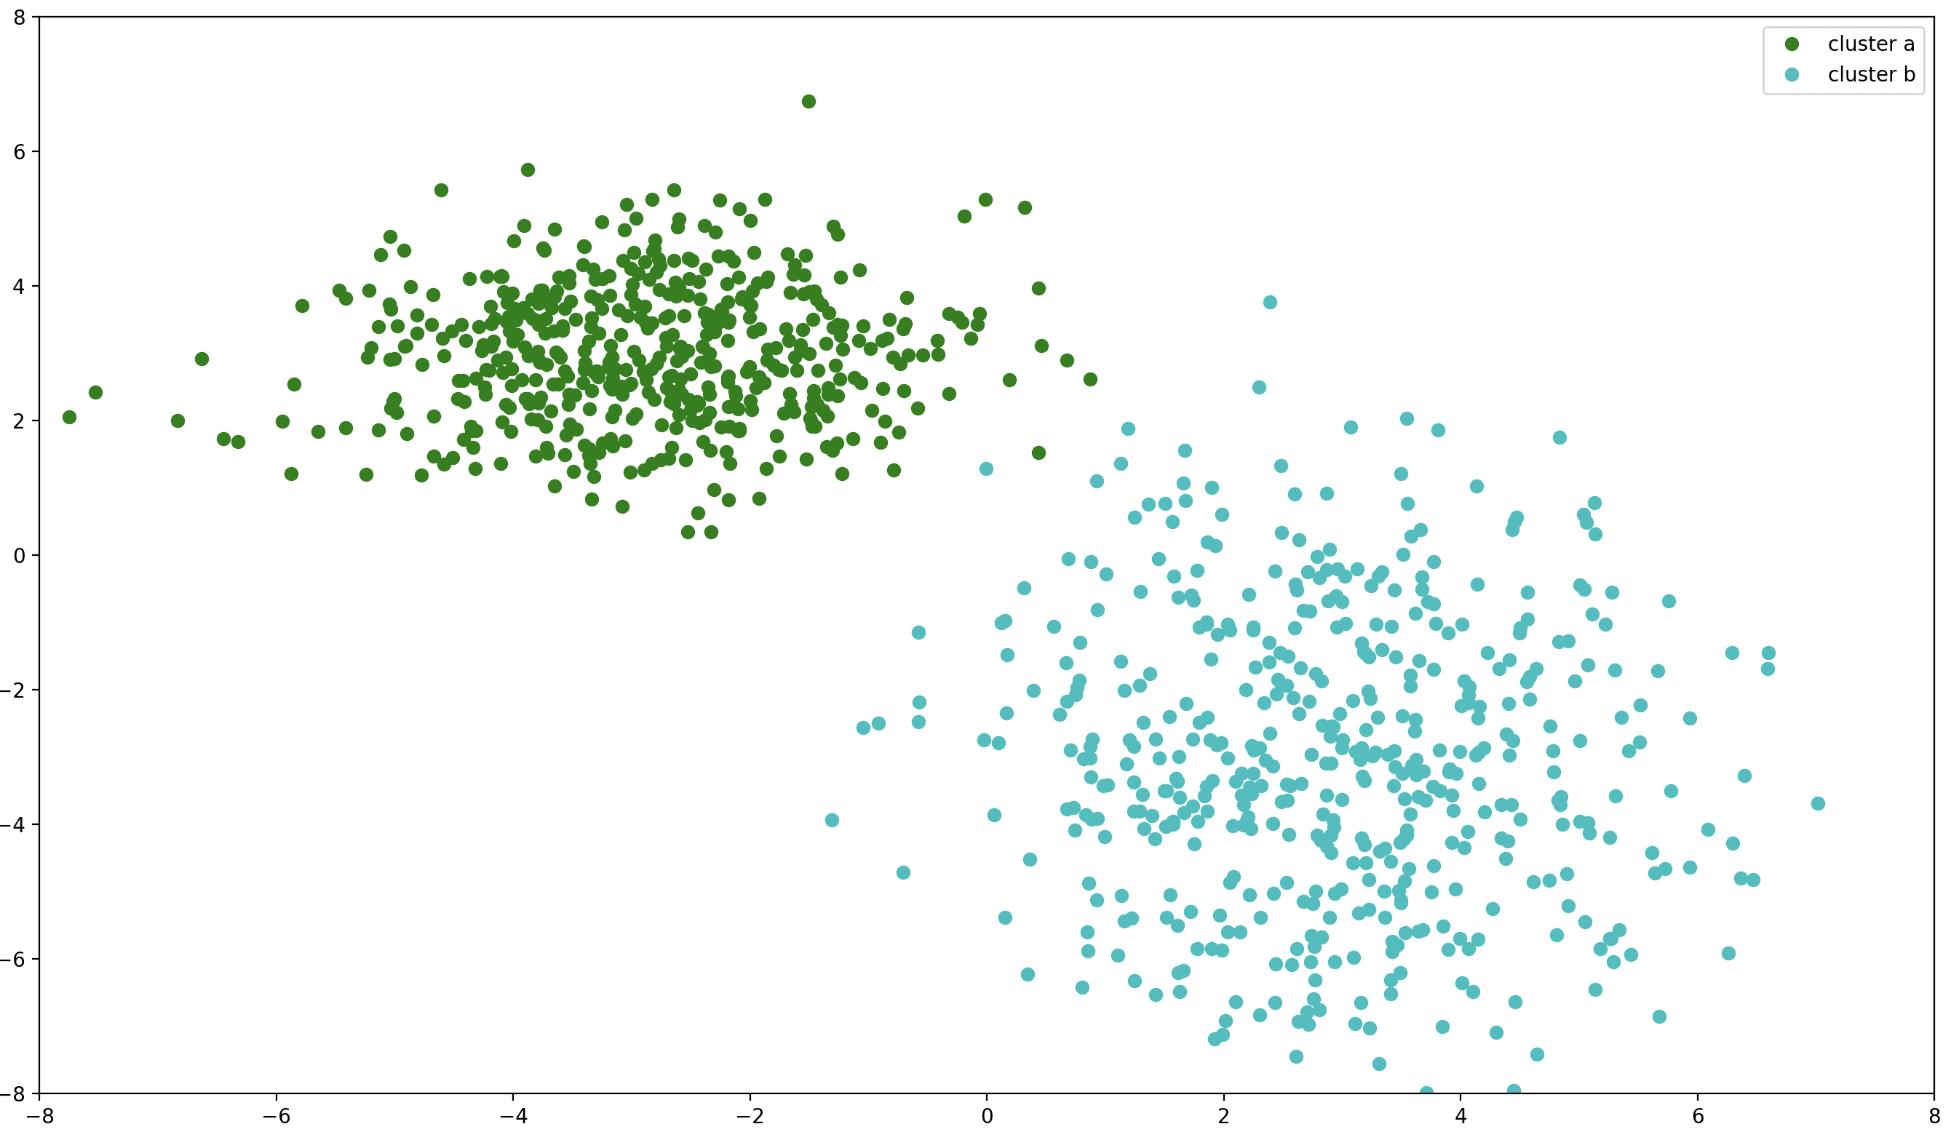Figure 1: Data that will be used for exercise 1

1. Start by choosing two random points in the dataset r1 and r2 and apply the following adaptation rule.
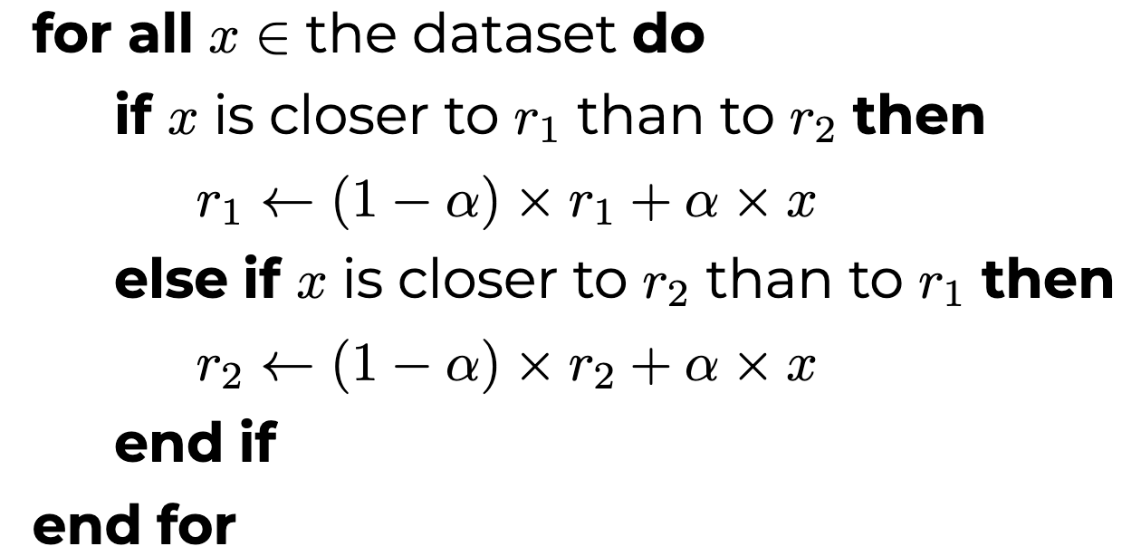
2. Repeat for 10 times a passage through all the elements of the dataset (i.e. 10 epochs) with α = 10E − 5 and save.
3. Plot (i) and (ii) upon the dataset plot in different graphs. Change the value of α and the number of epochs to see the evolution of the representatives clearly. What do you conclude about the evolution of the two points in the different situations? Is there any relation between the final values of the representatives (r1 and r2) and the parameters
used to generate the dataset?
(I) the consecutive values of r1 and r2 for the first passage;
(II) the values of r1 and r2 at the end of each passage.

(I) Changes during the first epoch
For a = 10E-5 and 10 epochs:
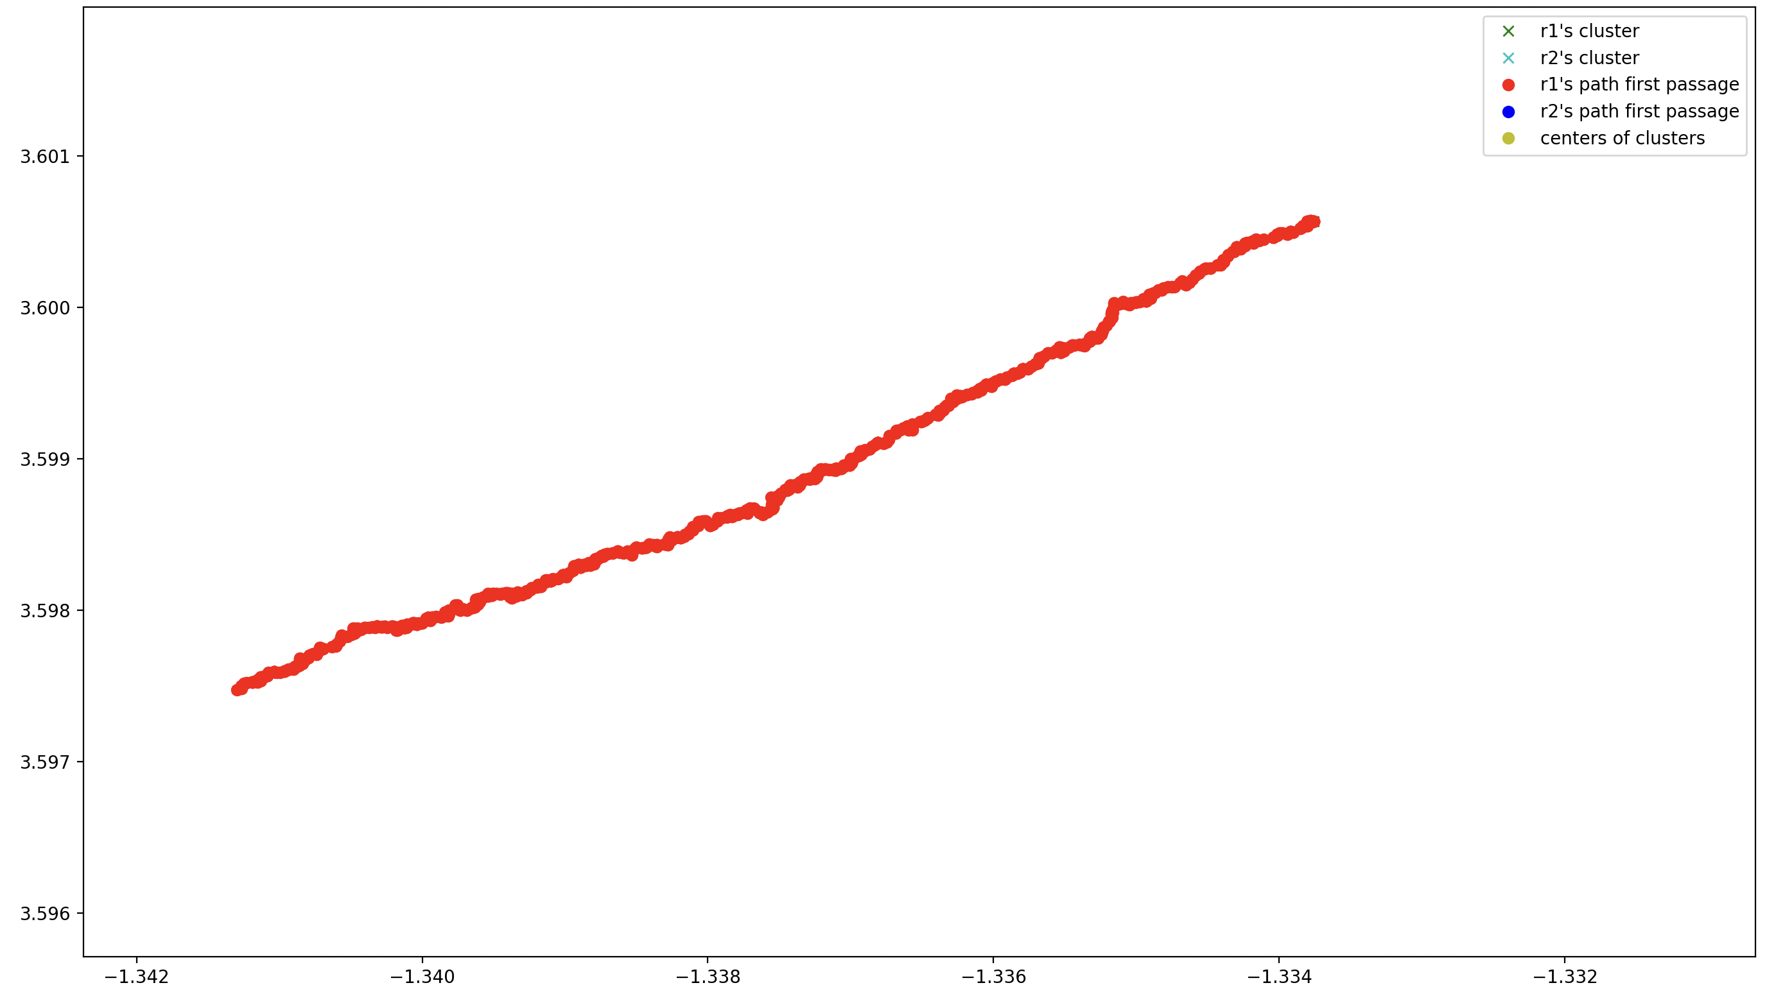Figure 2: zoomed in changes of r1's position during the first passage for a = 10E-5
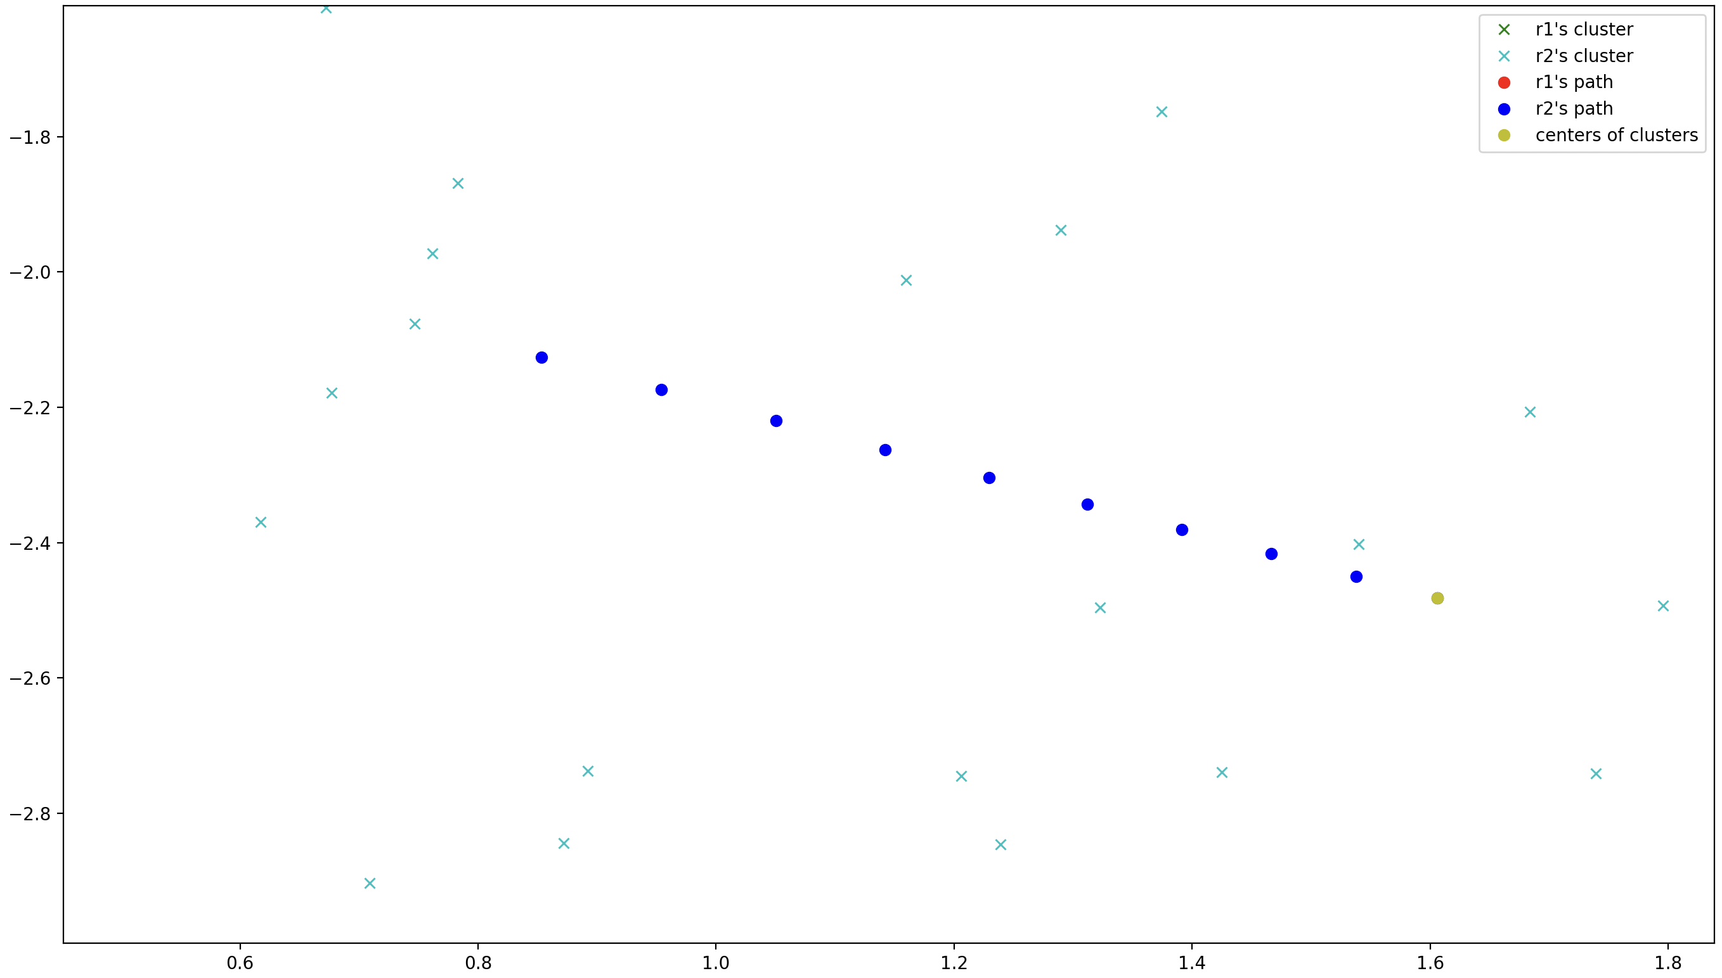Figure 3: zoomed in changes of r2's position during the first passage for a = 10E-5

For a = 10E-2 and 10 epochs:
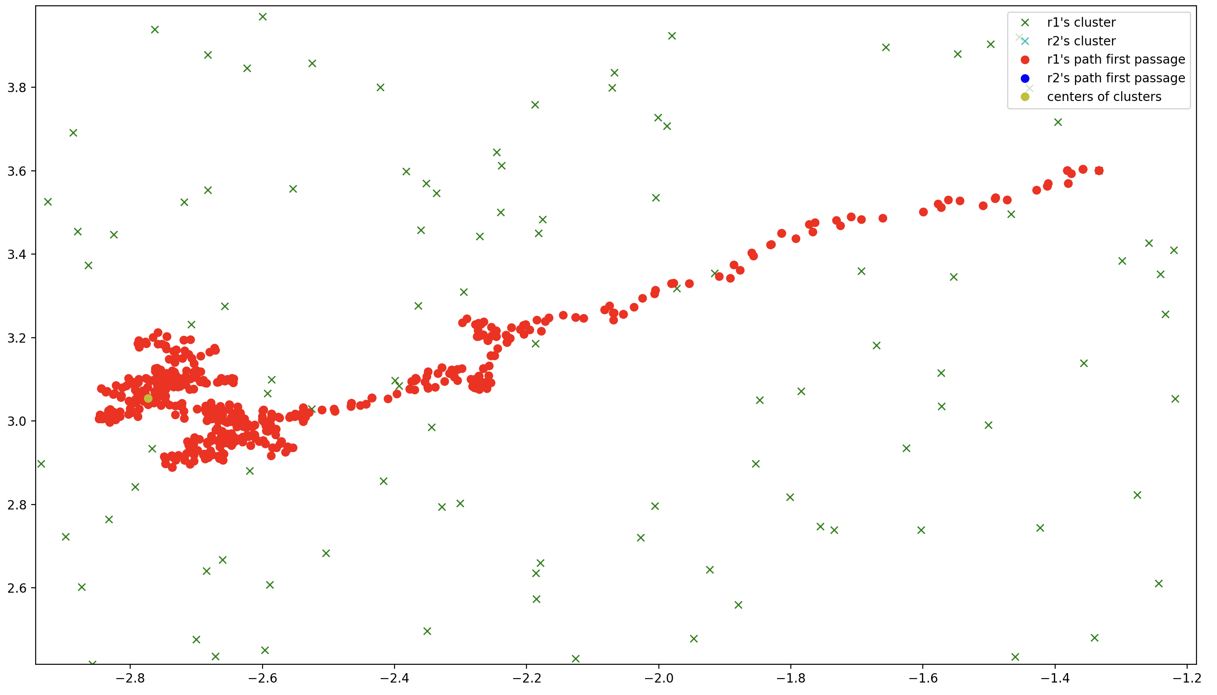Figure 4: zoomed in changes of r1's position during the first passage for a = 10E-2

For a = 5 * 10E-5 and 100 epochs:
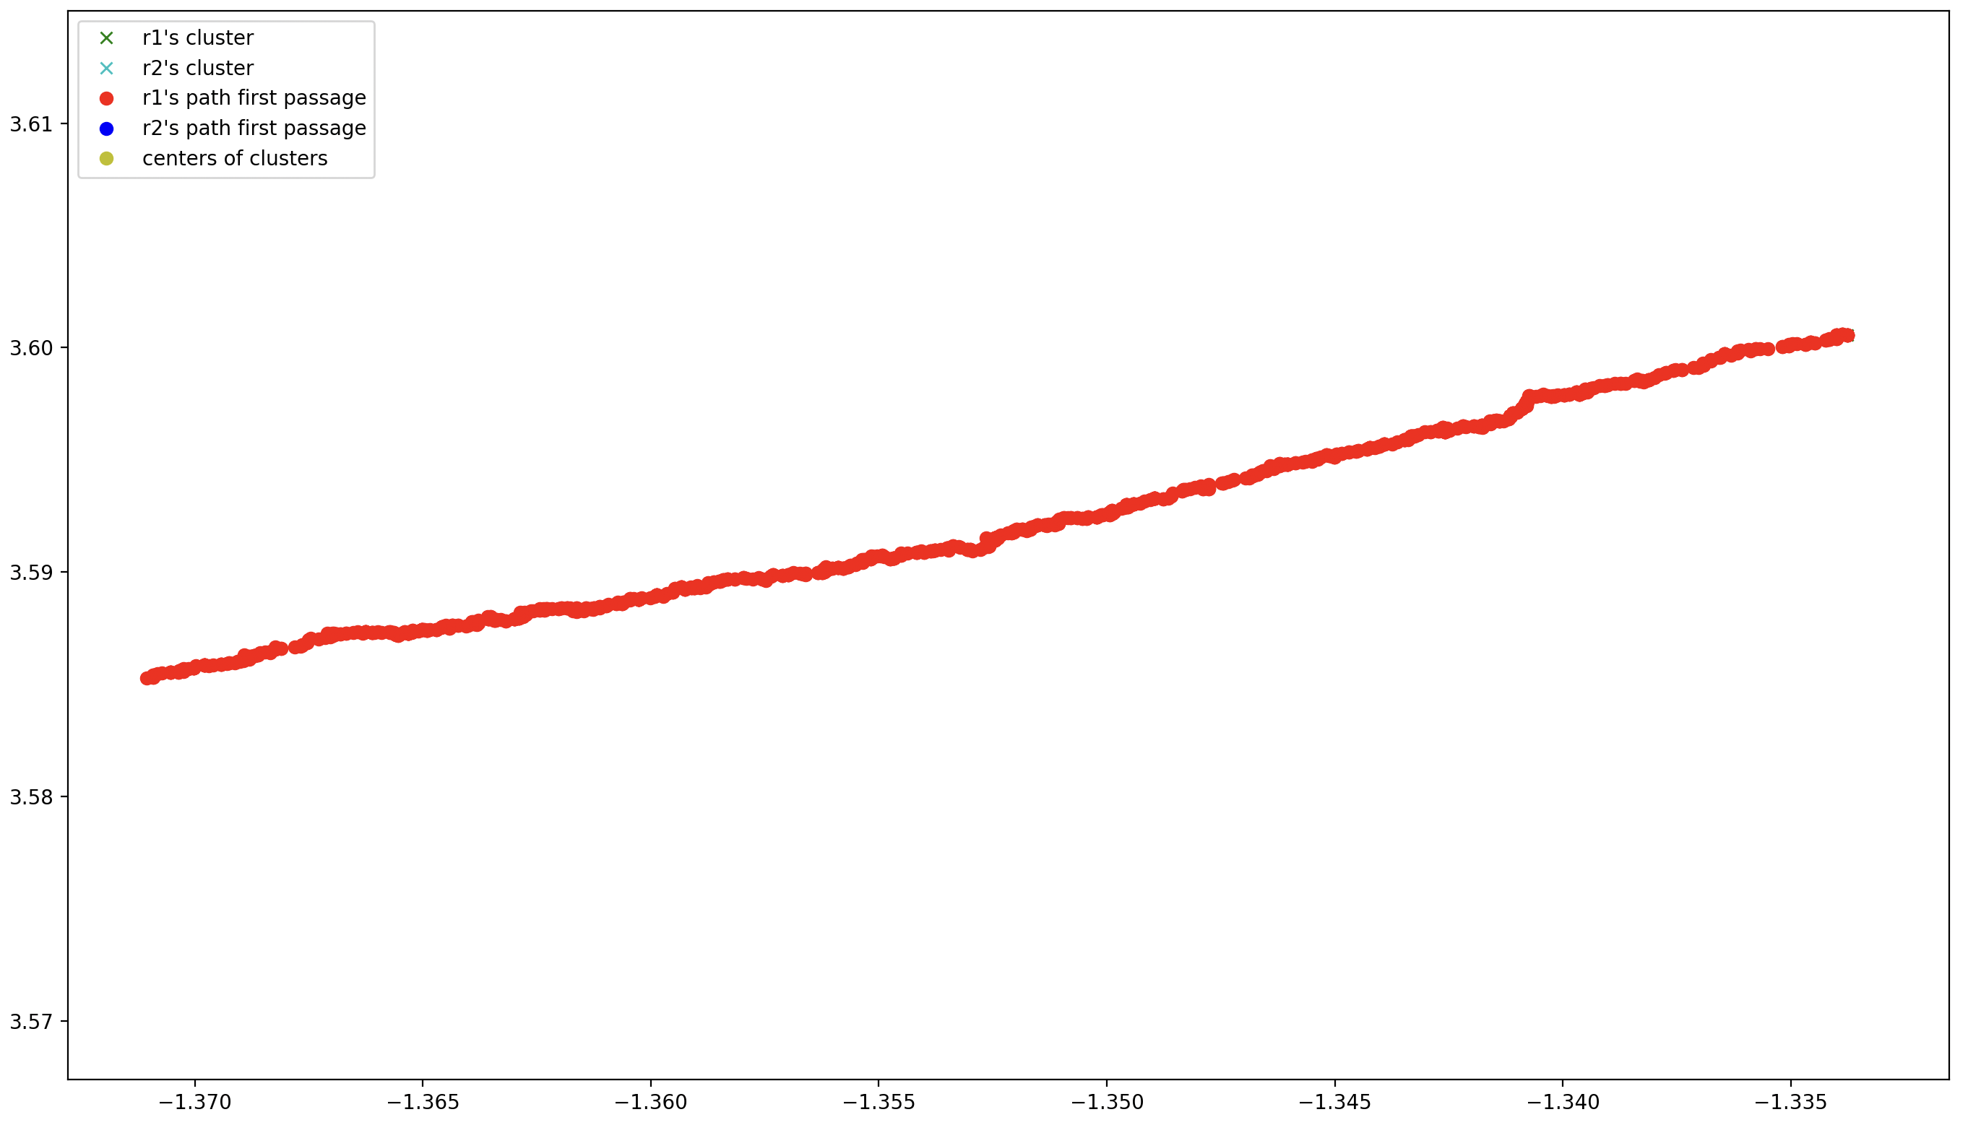Figure 5: zoomed in changes of r1's position during the first passage for a = 5 * 10E-5
(II) Changes at the end of each epoch
For a=10e-5 and 10 epochs:
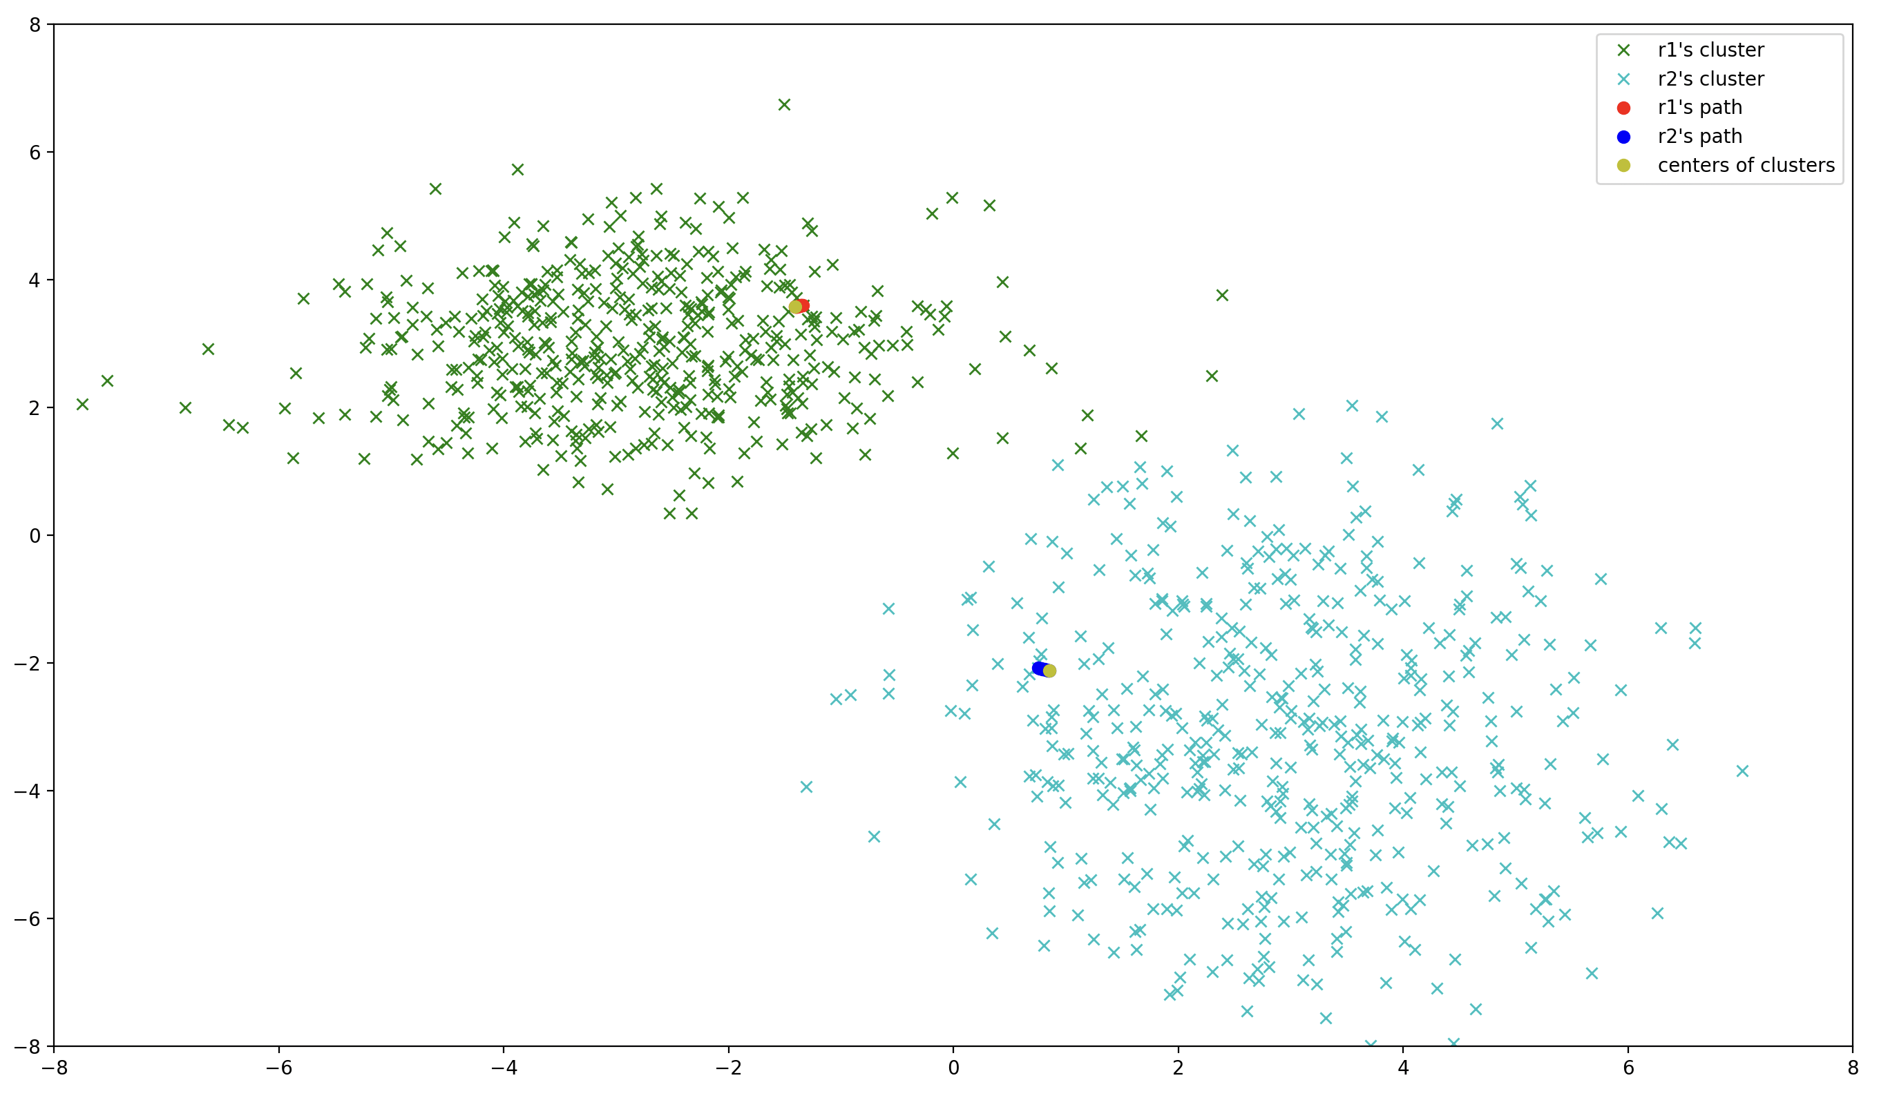Figure 6: changes of r1 and r2 positions in the 10 epochs with a = 10e-5

For a=10e-2 and 10 epochs:
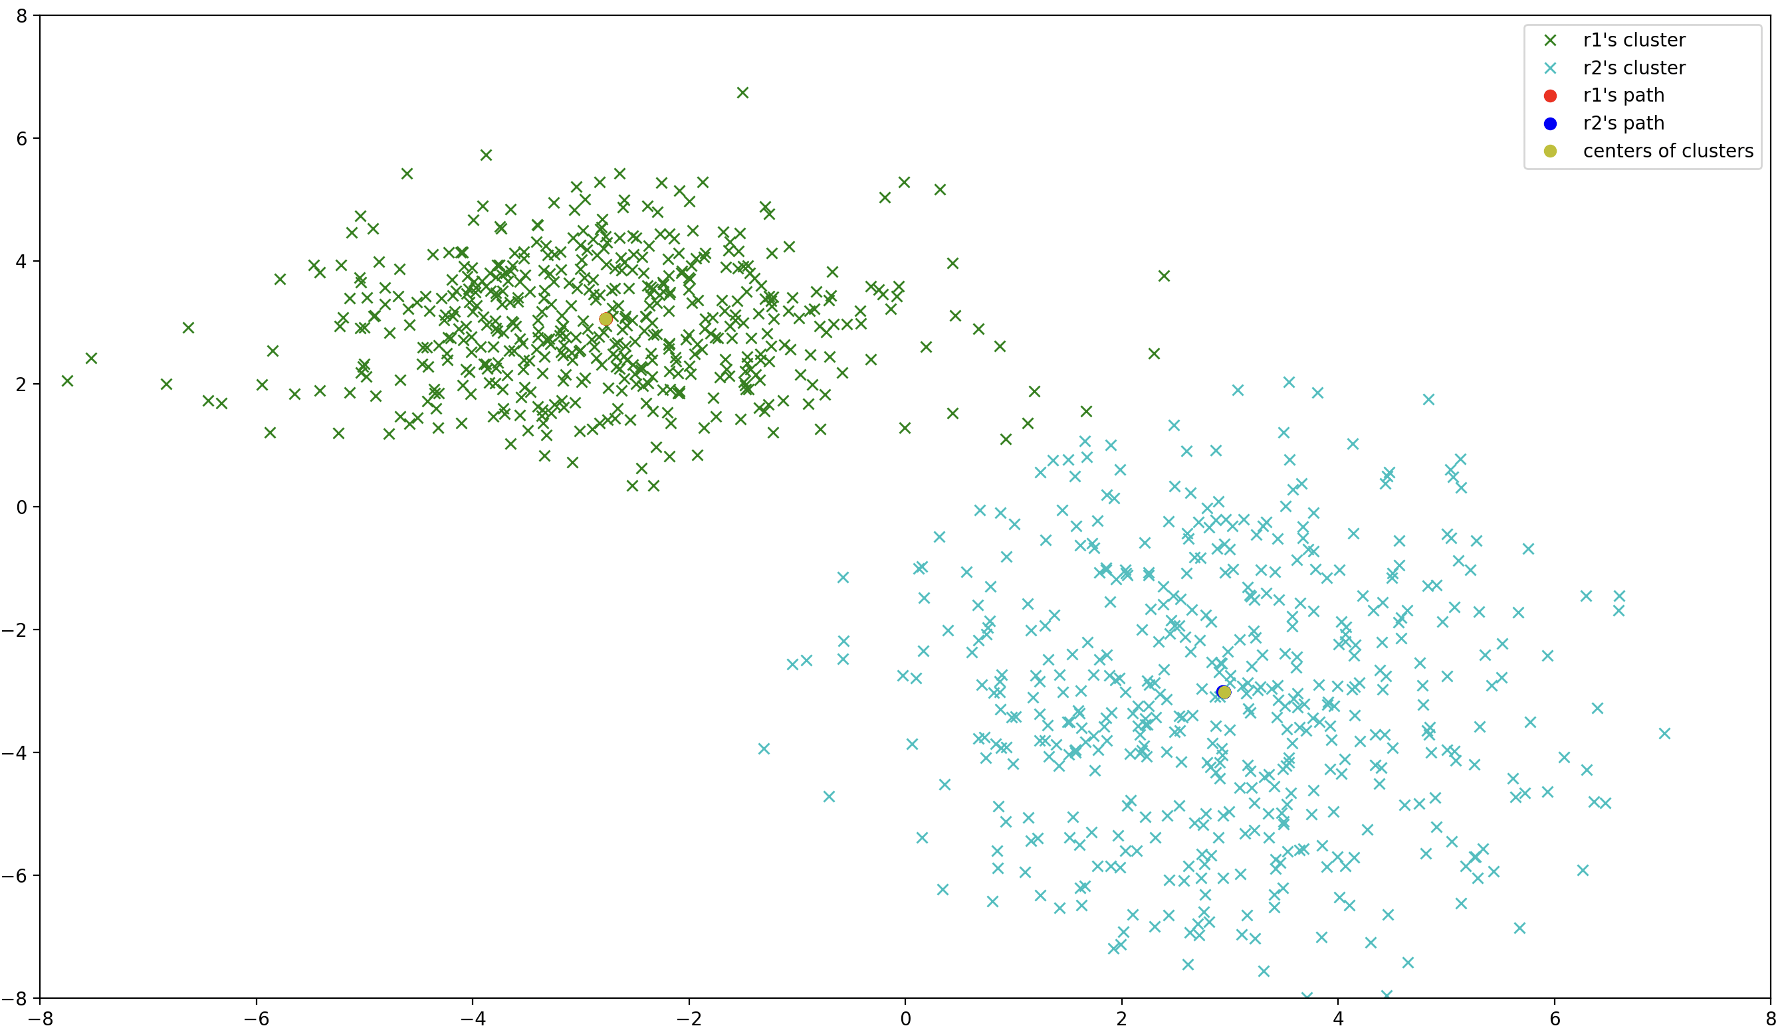Figure 7: changes of r1 and r2 positions in the 10 epochs with a = 10e-2
For a = 5 * 10E-5 and 100 epochs:
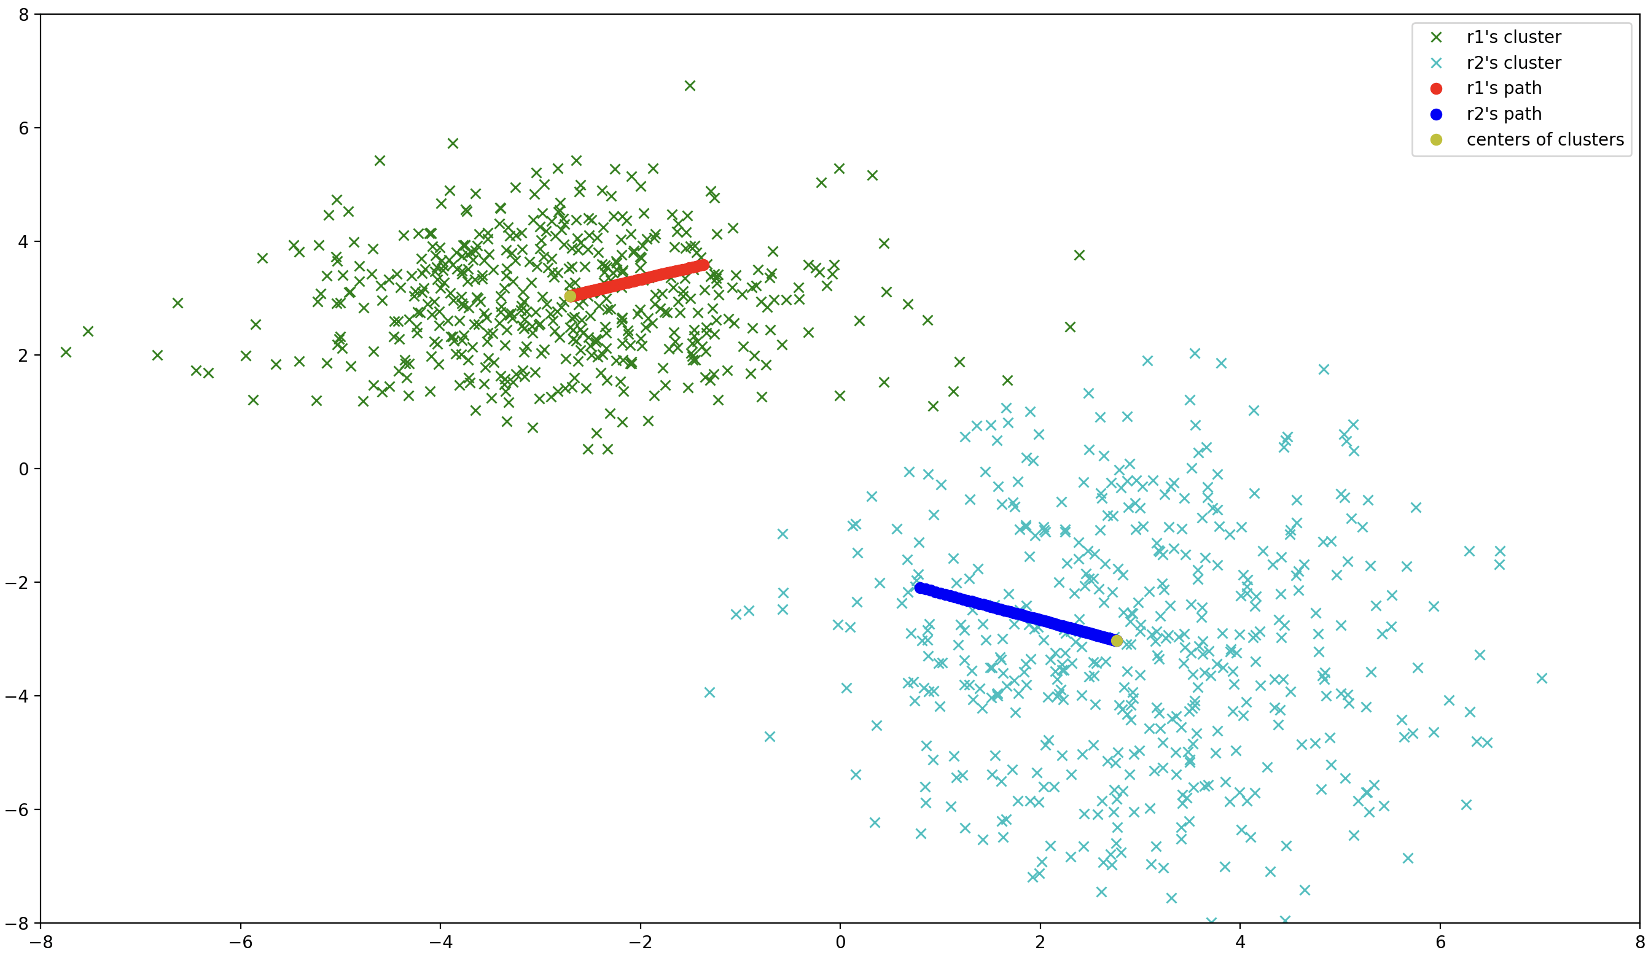Figure 8: changes of r1 and r2 positions in the 100 epochs with a = 5*10e-5

Conclusions:
For the first approach the rate of change of r1 and r2 are different. (see Figure 2 and 3) Compared to second approach where the changes to r1 and r2 are more uniform.
We also noticed that he higher the α value the more frantic the movement of the center points will be. Also in the case of α=10e-2 most of the changes to r values were performed in the first couple of epochs while the rest of the epochs were not changing them in any meaningful way.
In every case the r values seem to be attracted towards the mean values of our normal distributions. ((-3,3) and (3,-3)). While with α=10e-2, the r values overshoot, with smaller α and higher amount of epochs, r values get really close to the means.

4. Instead of changing the value of the representatives for each example, accumulate
the values of the difference (x − r) and change the value only when all examples have
been observed. Accumulate only for the closest representative in each iteration.
5. Plot the consecutive positions of r1 and r2 and compare with the plot in exercise 1.
What do you observe?

Second approach:
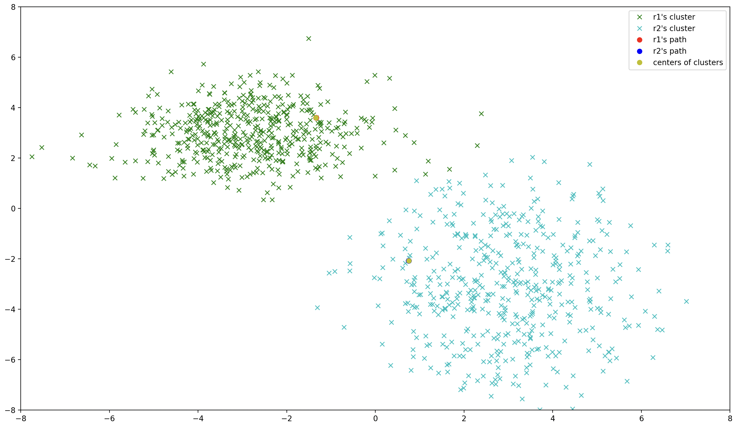Figure 9: Second accumulative approach with a=5*10e-5 in 100 epochs
Comparing to the first approach with the same input properties, the second approach seems to be slower at converging, but after adjusting the α value:
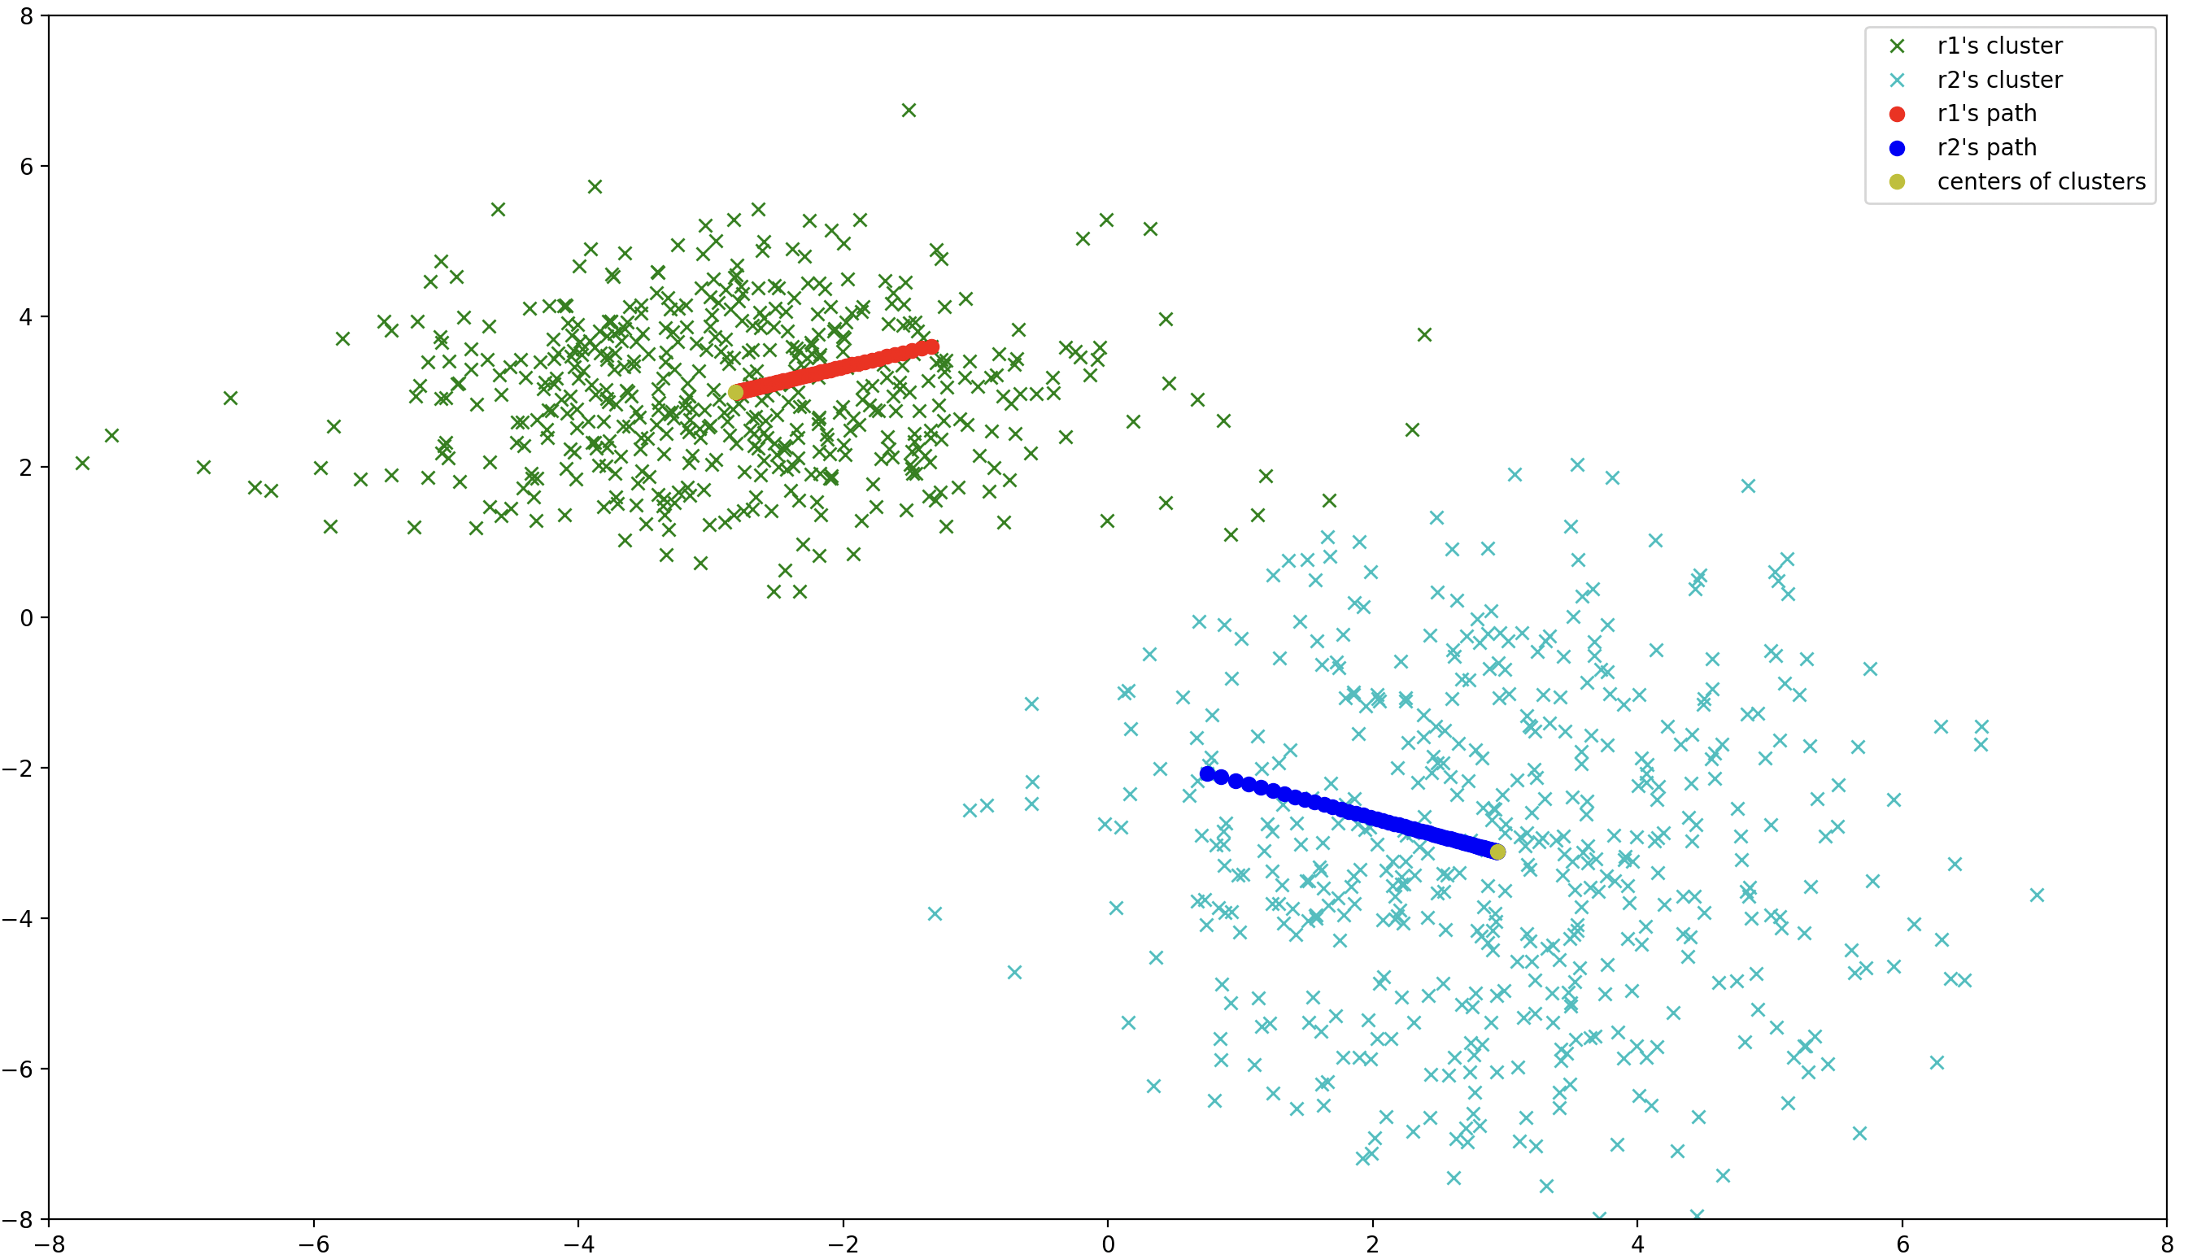Figure 10: Second accumulative approach with a=5*10e-2 in 100 epochs

we get a much better result. Compared to previous approach, (Figure 6, the most similar properties) the changes to path look almost identical, but if we increase value of α:
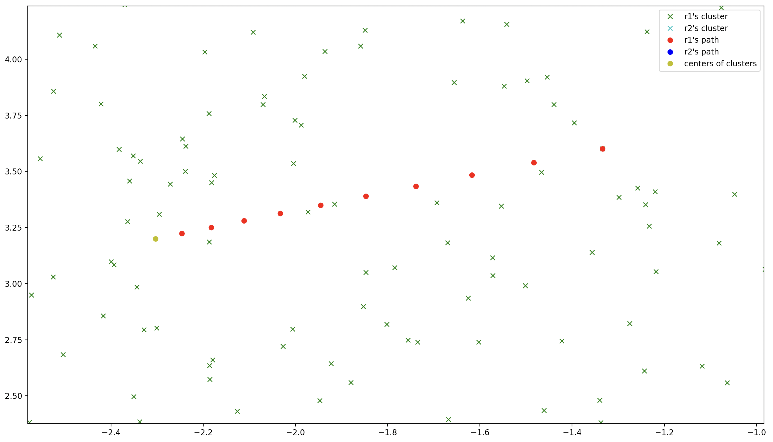Figure 11: Second accumulative approach with a=1 in 10 epochs, zoomed in changes of r1

so for the second approach, even if the α value is really big, the convergence seems to be stable. At least a lot more stable than in the first approach (see Figure 2) for large α values.

6. Plot with different colors:
• color 1 – points closer to r1 labeled 1;
• color 2 – points closer to r1 labeled 2;
• color 3 – points closer to r2 labeled 1;
• color 4 – points closer to r2 labeled 2.
What do you observe?
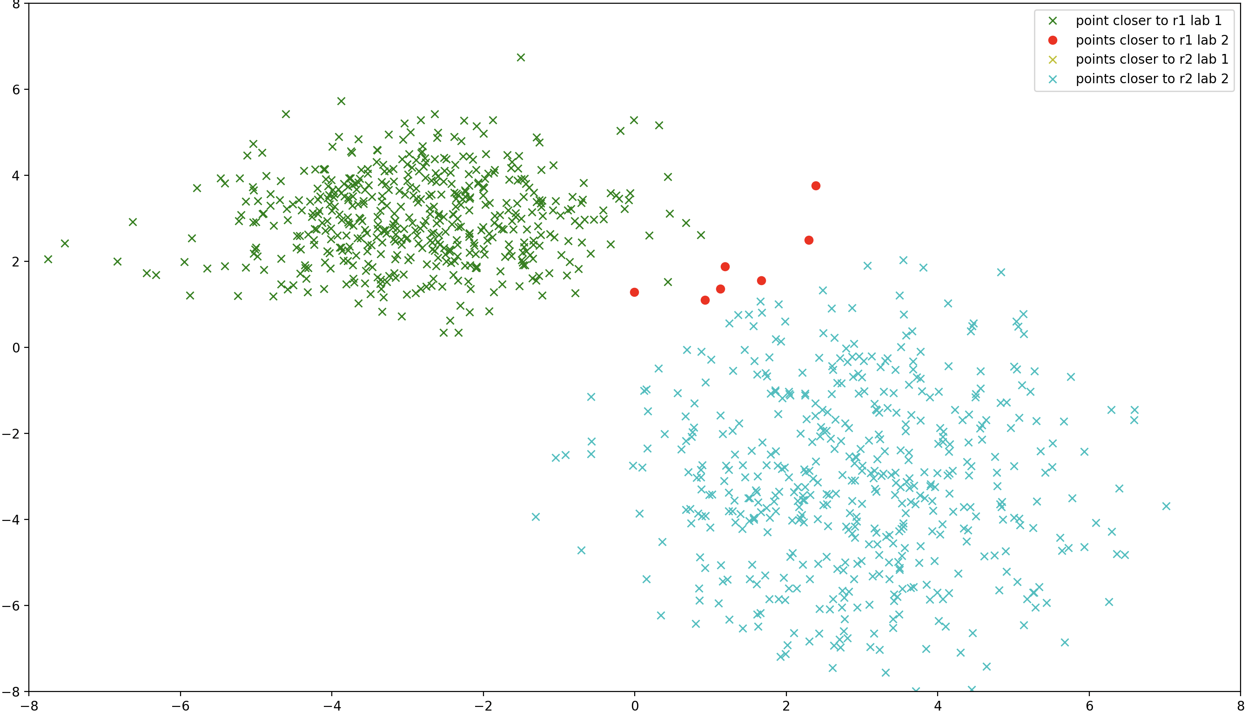Figure 12: points assigned to clusters r1, r2, for a = 5 * 10e-2 in 100 epochs
We observed that a couple of red points were wrongly assigned to r1, while they should have been assigned to r2. But in general most points are divided according to initial distribution.

7. Repeat the experiment 30 times and plot the final values of r1 and r2 over the dataset.
If necessary amplify the viewed area to see the points’ distributions.
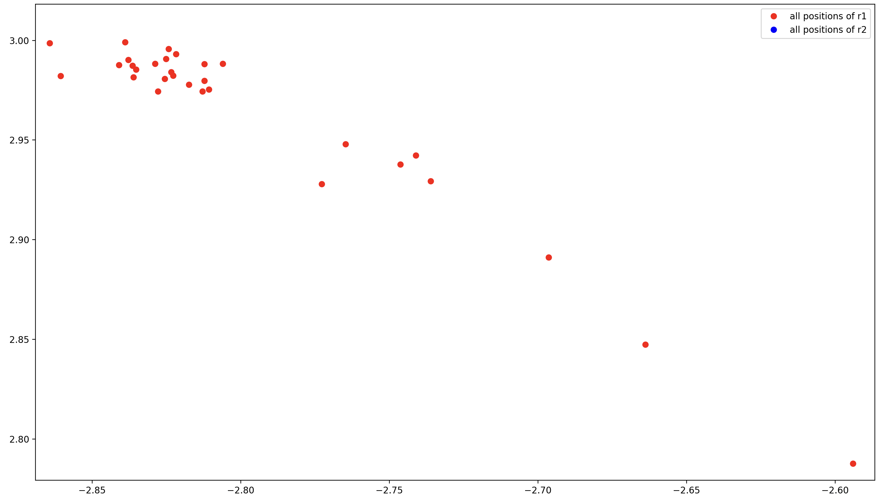Figure 13: distribution of r1 values over 30 experiments, with a = 5 * 10e-2 in 100 epochs
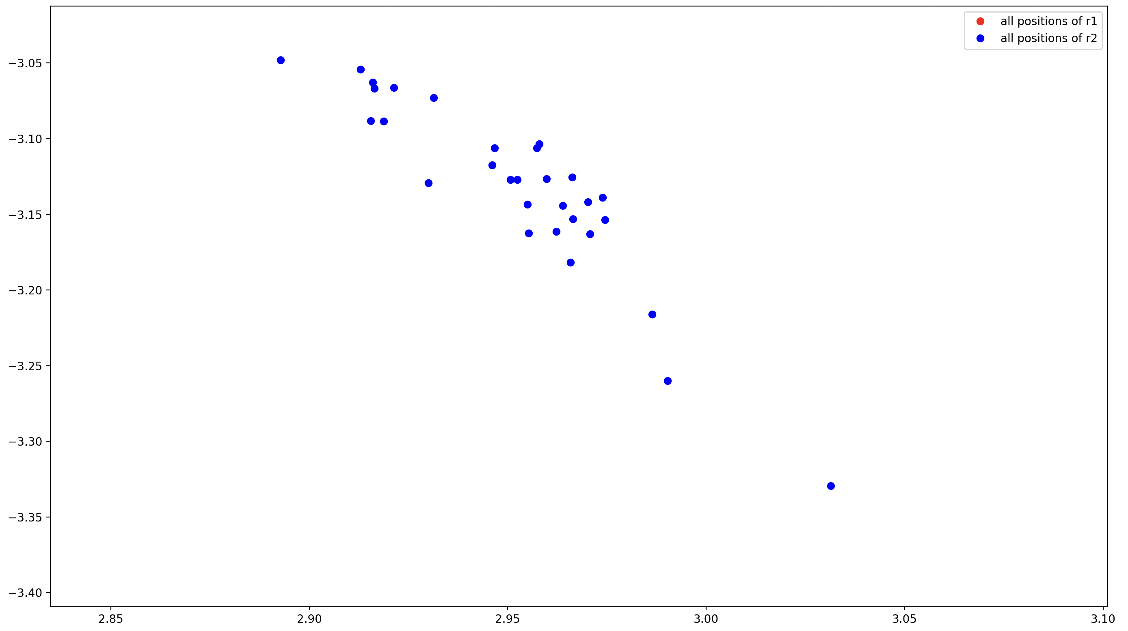Figure 14: distribution of r2 values over 30 experiments, with a = 5 * 10e-2 in 100 epochs

Exercise 2
Implement a simplified version of agglomerative hierarchical clustering, as proposed in the
following algorithm:
while there are more than two points do
Find the closest two points
Replace both points by their average
end while
Test it on sets of points similar to the ones of the last exercise.
Dataset:
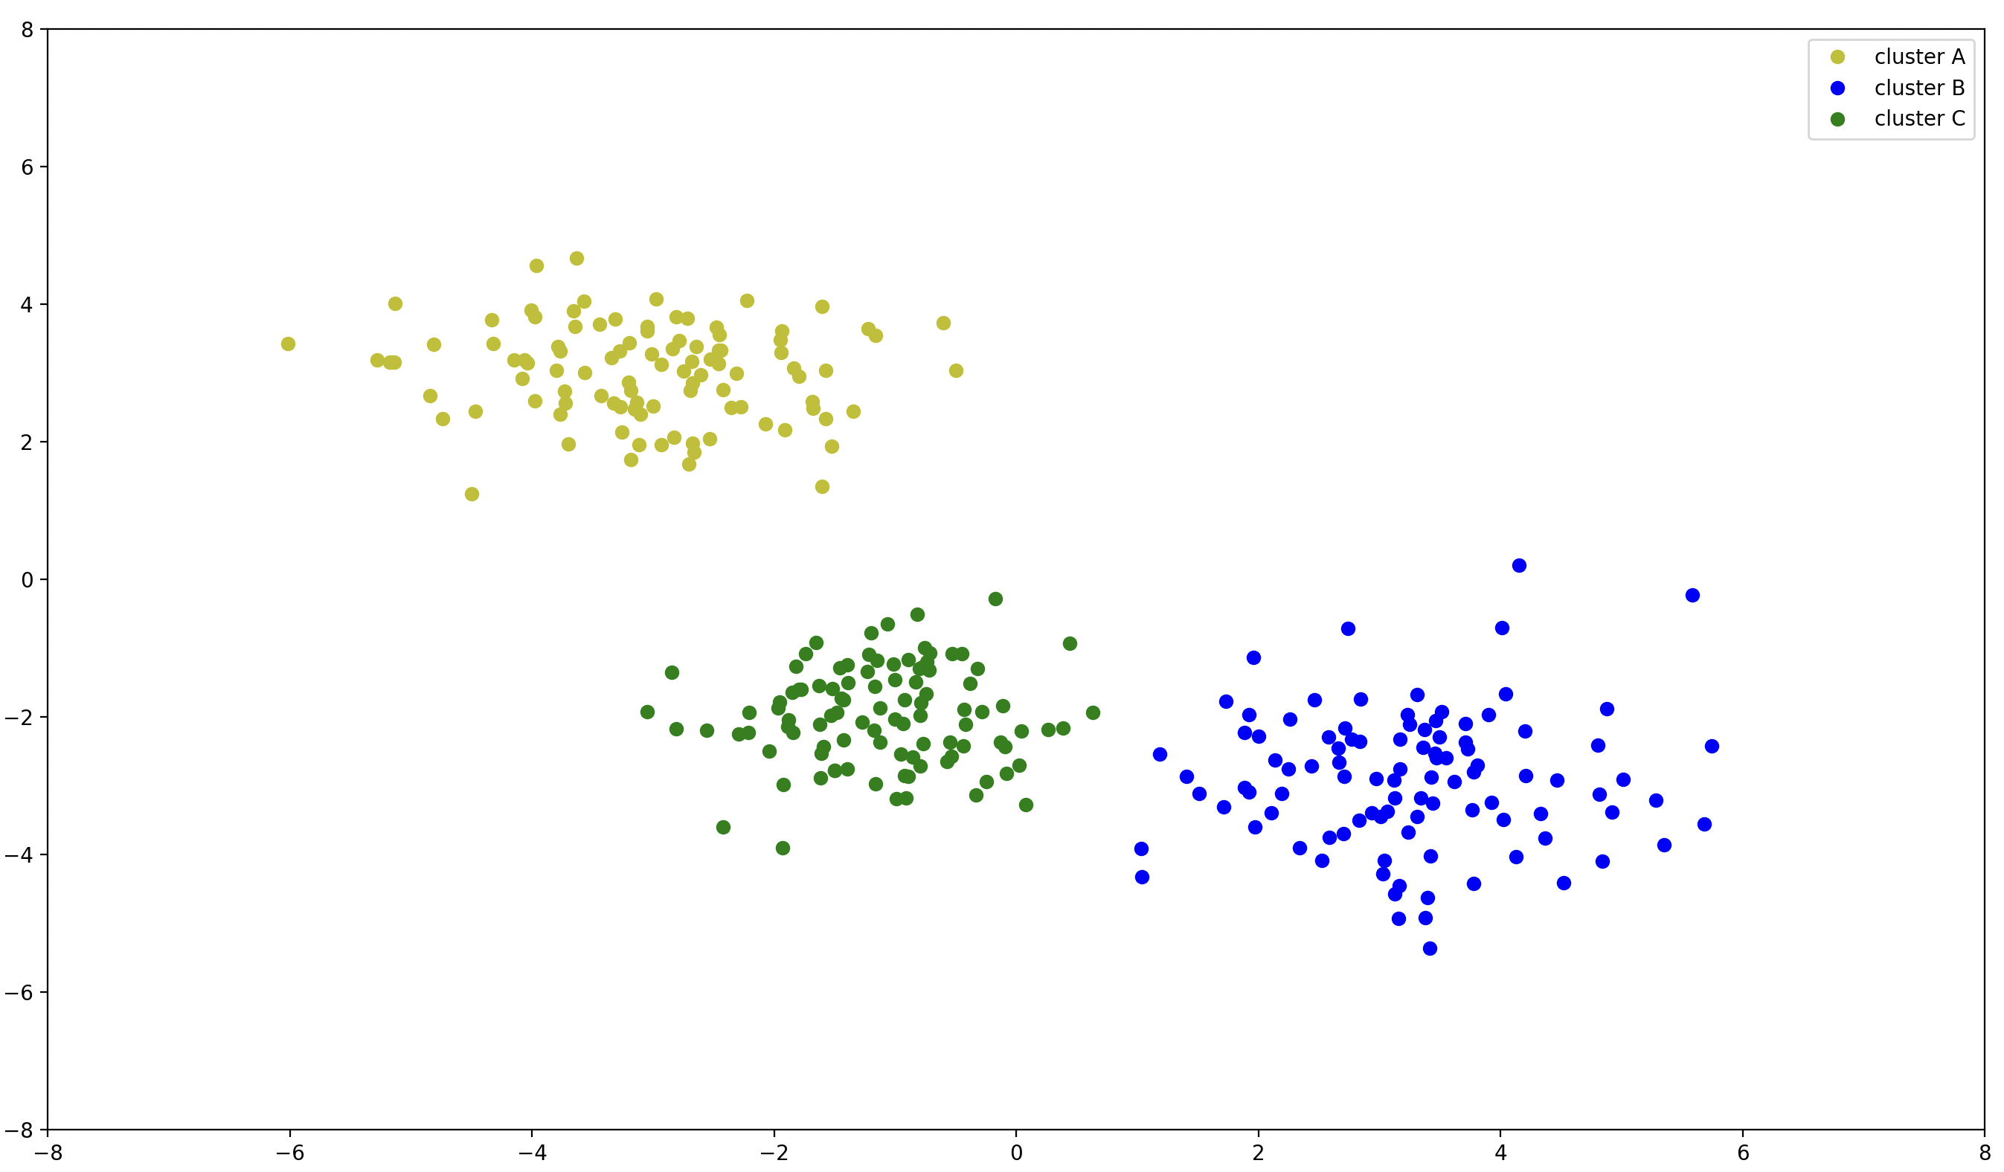Figure 15: dataset used during exercise 2. (note that because of big O complexity of aforementioned algorithm we had to reduce amount of points in the dataset to 300)
Visualization:
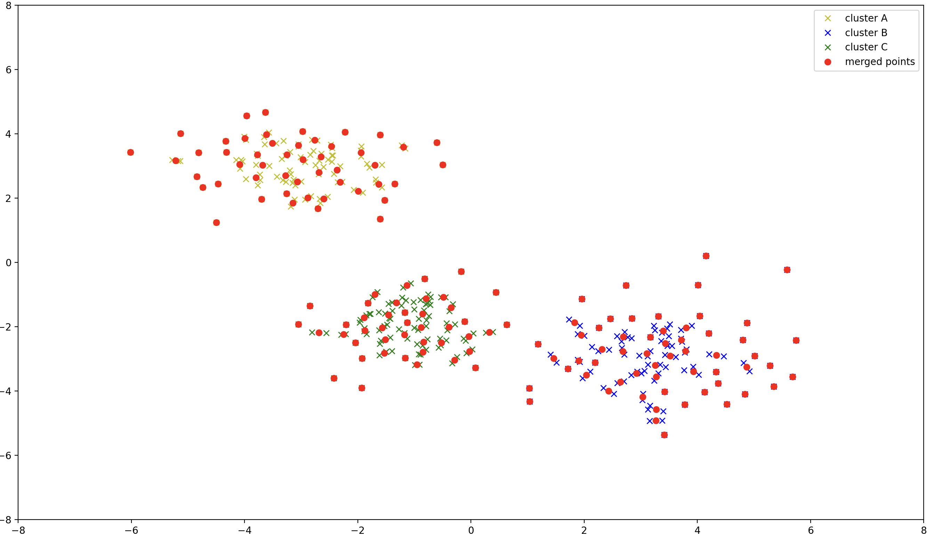

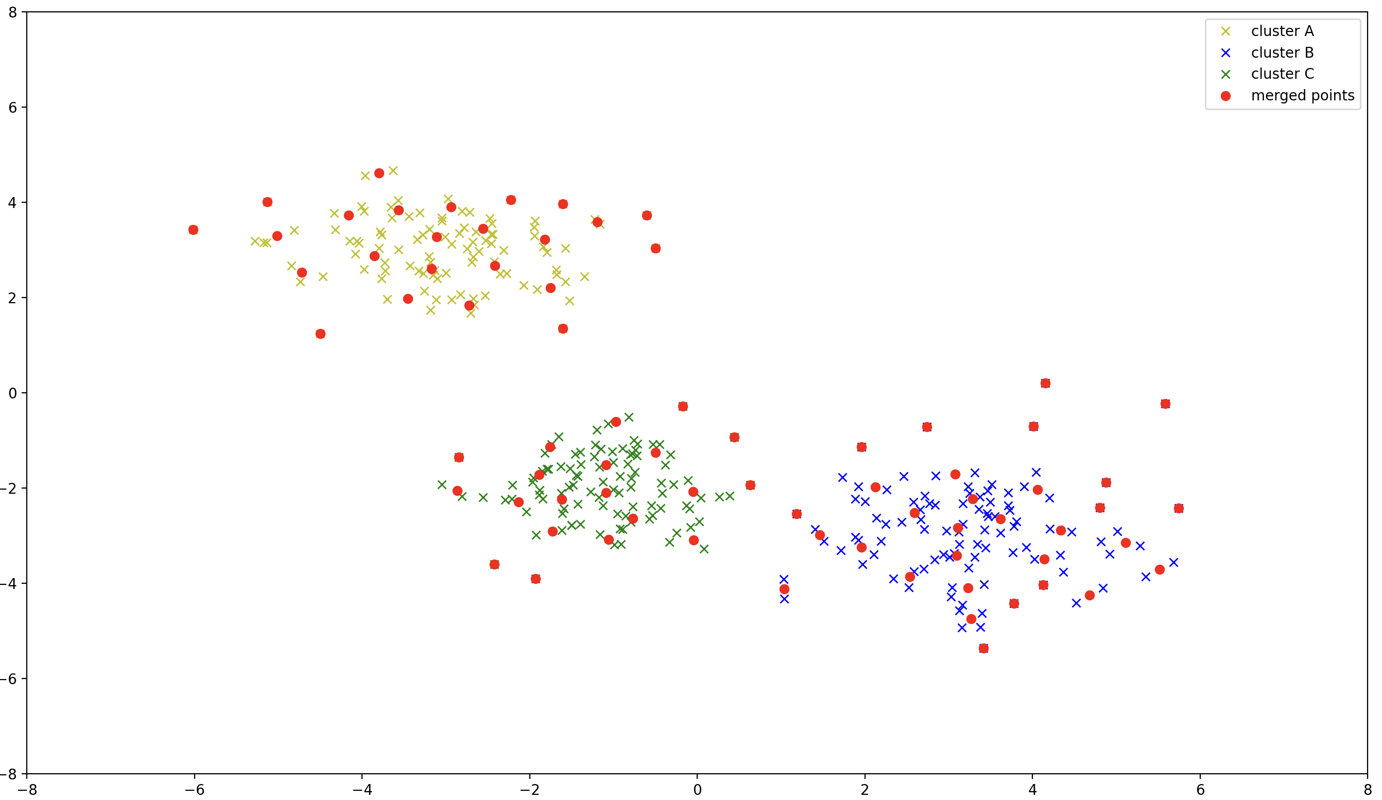
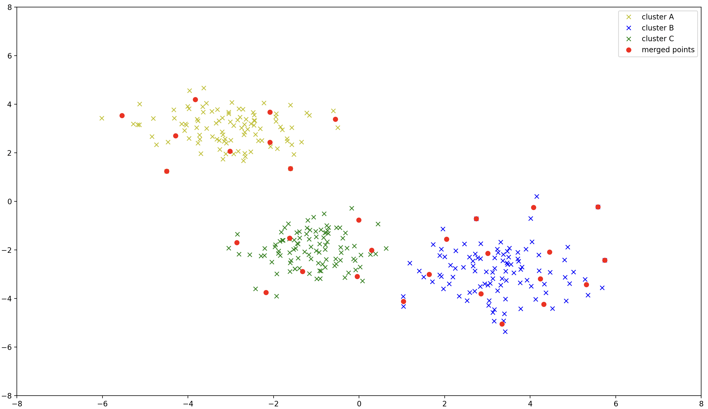

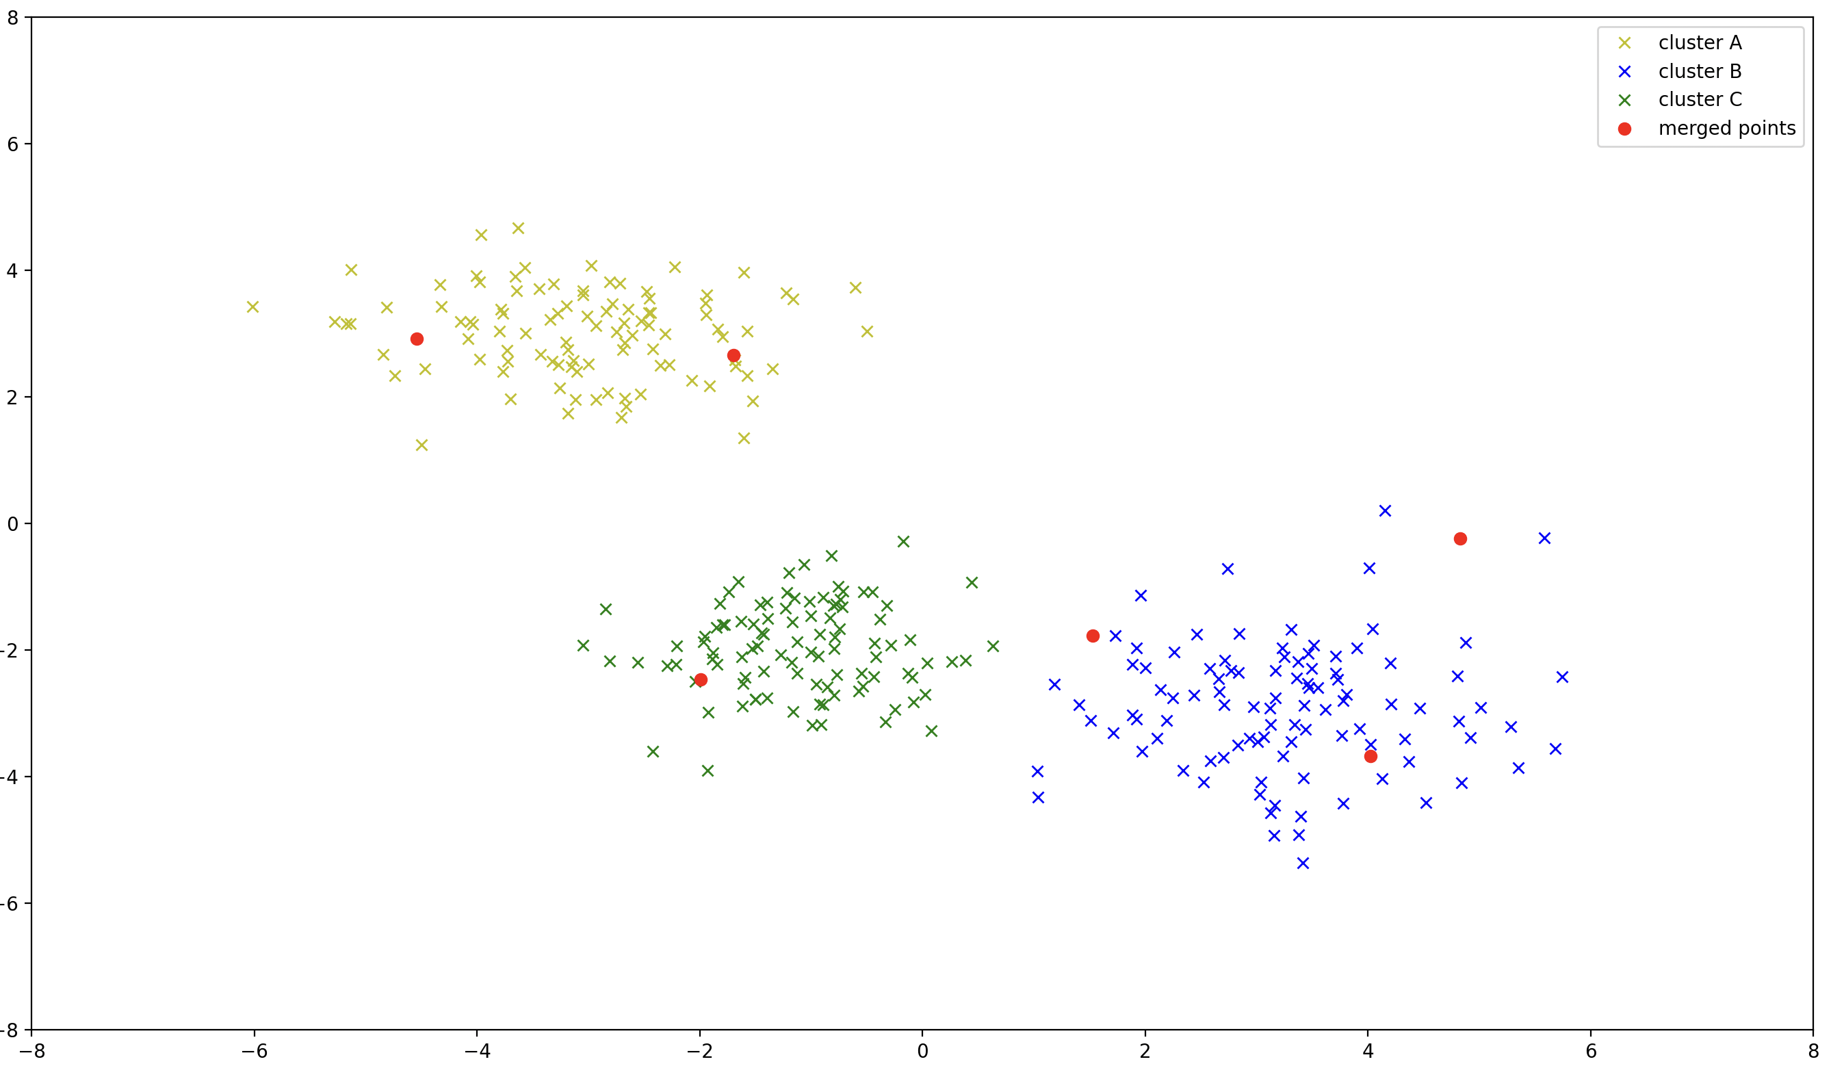
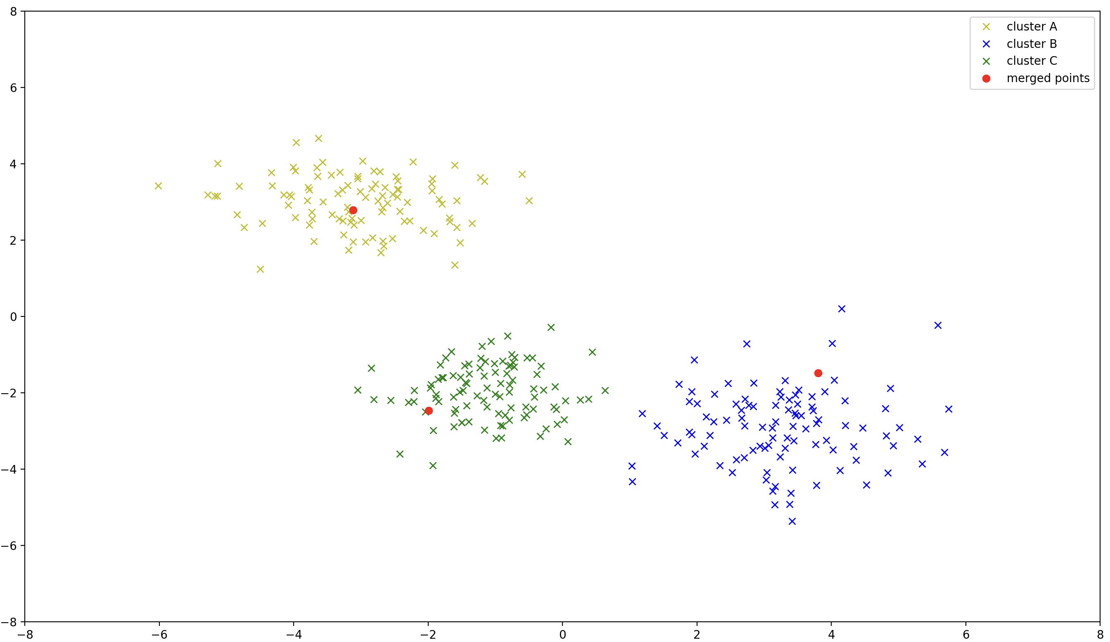Figure 16: Final result of agglomerative hierarchical clustering

