2/24/220

Blog Site

Challenge 1

- Have the home root redirect to the “home” ejs page.
- Have an h1 on this ejs page that says “Home”.
  - //Redirect home route to home
app.get("/", function(req, res) {
res.render("home");
});
      - Add <h1>Home<h1> to home ejs page.

Challenge 2

- Have the home starting content const appear on home route.
- Add ejs variable in a paragraph tag.

  - app.get("/", function(req,res) {
res.render("home", {
postContent: homeStartingContent
});
});
      - <h1>Home</h1>
      - <p><%= postContent %></p>

Challenge 3

- Using ejs include given header and footer to home page

<%- include("header"); -%>
</head>
<body>
<h1>Home</h1>
<p><%= postContent %></p>
</body>
<%- include("footer"); -%>

Challenge 4

- Create new folder called partials
- Move header and foot to partials folder.
- Change links on home.ejs to work with files in new location.

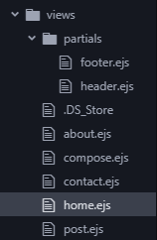

//Answer
<%- include("partials/header"); -%>
</head>
<body>
<h1>Home</h1>
<p><%= postContent %></p>
</body>
<%- include("partials/footer"); -%>

Challenge 5

- Add functionality to allow URL “localhost:3000/about” to redirect to about.ejs page.
- Apply same header and foot to about.ejs page.
- Apply above to contact page also.
- Have const for contactContact and aboutContent posted to corresponding ejs pages.

//About Route
app.get("/about", function(req,res) {  res.render("about", {  postContent: aboutContent  });  }); | <!DOCTYPE html>  <html lang="en" dir="ltr">  <head>  <meta charset="utf-8">  <title>About</title>  <%- include("partials/header"); -%>  </head>  <body>  <h1>About</h1>  <p><%= postContent %></p>  </body>  <%- include("partials/footer"); -%>  </html>
//Contact Route  app.get("/contact", function(req,res) {  res.render("contact", {  postContent: contactContent  });  }); | <html lang="en" dir="ltr">  <head>  <meta charset="utf-8">  <title>Contact</title>  <%- include("partials/header"); -%>  </head>  <body>  <h1>Contact</h1>  <p><%= postContent %></p>  </body>  <%- include("partials/footer"); -%>  </html>

Challenge 6

- Update code to link correct pages to nav bar options.

...

<div class="container">
<div class="navbar-header">
<p class="navbar-brand">DAILY JOURNAL</p>
</div>
<ul class="nav navbar-nav navbar-right">
<!-- 6 -->
<li id="home"><a href="/">HOME</a></li>
<li id="about"><a href="/about">ABOUT US</a></li>
<li id="contact"><a href="/contact">CONTACT US</a></li>
</ul>
</div>.
..
Challenge 7

- Update code to load compose from localhost:3000/compose
- have an h1 that says “compose”
- text input with a button labeled “publish” next to it.

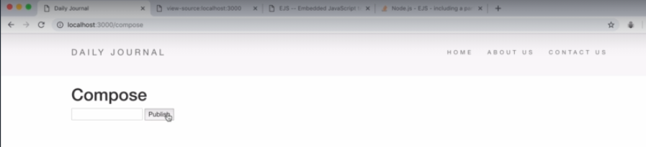
- Should look like this
  - Answer below

<%- include("partials/header"); -%>  </head>  <body>  <h1>Compose</h1>  <input type="text" name="" value="">  <button type="submit" name="button">Publish</button>  </body>  <%- include("partials/footer"); -%> | //Compose Route  app.get("/compose", function(req,res) {  res.render("compose");  });

Challenge 8

- Update code to console.log anything entered into text input after publish button is pressed.
  - Answer below
<form class="" action="/compose" method="post">  <input type="text" name="postTitle" value="">  <button type="submit" name="button">Publish</button>  </form> | app.post("/compose", function(req,res) {  console.log(req.body.postTitle);  });

Challenge 9

- Transform compost page.
  - Make it look like this.

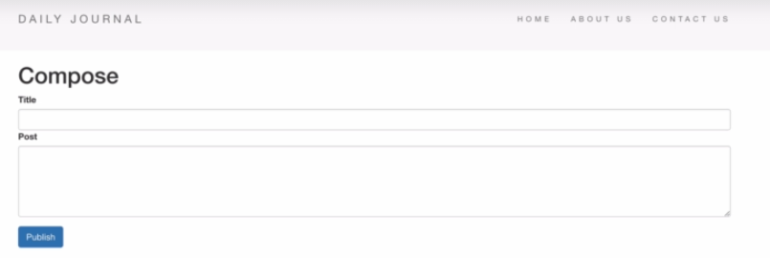

- Bootstrap enabled on both inputs. Title is single line
- Multiline textbox (add using HTML)
- Make publish button blue, and make it look like image above.
- Extra labels, extra textbox added using HTML, format form using bootstrap.
<form>
<div class="form-group">
<label>Title</label>
<input type="text" class="form-control" id="postTitle" value="">
</div>
<div class="form-group">
<label>Post</label>
<textarea name="postContent" class="form-control" rows="8" cols="80"></textarea>
</div>
<button type="submit" class="btn btn-primary">Publish</button>
</form>

Challenge 10

- Create a javascript object thats called “post”.
- Store post title as well as post body to this variable.
app.post("/compose", function(req,res) {
const post = {
title: req.body.postTitle,
content: req.body.postBody
};
});
Challenge 11

- Put newly created post object inside a global variable called posts
- We are gonna have an array that will store all of these new posts, but it will be a global variable.
- New empty array that is a global variable, then add new post object to array.
- At the end of route, redirect to root route.
- Inside root route we are going to log all of the posts inside posts array.
//Global Variable  var posts = [];  /Compose Post Route  app.post("/compose", function(req,res) {  const post = {  title: req.body.postTitle,  content: req.body.postBody  };  posts.push(post);  res.redirect("/");  }); | //Home Route  app.get("/", function(req,res) {  res.render("home", {startingContent: homeStartingContent});  console.log(posts);  });  //Add these to form on compose.ejs or post route doesn't get initiated  <form action="/compose" method="post">
Challenge 12

- Delete console log from home route on app.js
- Log the same information but from the home.ejs page.
<body>  <h1>Home</h1>  <p><%= startingContent %></p>  <% console.log(posts); %>  </body> | //Home Route  app.get("/", function(req,res) {  res.render("home", {  startingContent: homeStartingContent,  posts: posts  });  });
- Add posts: posts to app.js so home.ejs has access to posts array as well as objects inside.
- Add console.log to home.ejs and now that it has access to posts, it can log the objects inside.

Challenge 13
- Update code to console log each post title from compose page.
- First time prints first title, second time print first two titles, and third time prints all three post titles.
- Write a for loop inside ejs that loops through post array and consoles logs each of every title of posts.
- To test try at least 2 posts.
<body>
<h1>Home</h1>
<p><%= startingContent %></p>

<%for( var I = 0; I < posts.length; i++) { %>
<% console.log(post[i].title); %>
<% }); %>

</body>
Challenge 14
- Convert for loop to foreach loop.
<body>

<h1>Home</h1>
<p><%= startingContent %></p>

<% posts.forEach(function(post) { %>
<% console.log(post.title); %>
<% }); %>

</body>
Challenge 15
- Update code to add post title and content to home page as a new post.
- Have it display under starting content.
- Each additional post should be added to the home route.
<% posts.forEach(function(post){ %>

<h1> <%=post.title %> </h1>
<p> <%=post.content %> </p>

<% }); %>

