3/16/2020
API’s
Application Programming Interfaces

Lec 248

- API = Application Programming Interface.
  - An Application Programming Interface (API) is a set of commands, functions, protocols, and objects that programmers can use to create software or interact with an external system.

- Think of API’s like a restaurant. You can go eat there from an offered menu, but if you were to eat the ingredients in the kitchen used to make whats on the menu the restaurant is not going to be happy.
  - Business logic is closed off to user, although the output and info is available to the user and presented in similar fashion as a menu in a restaurant.\
  - A contract between data provider and developer.
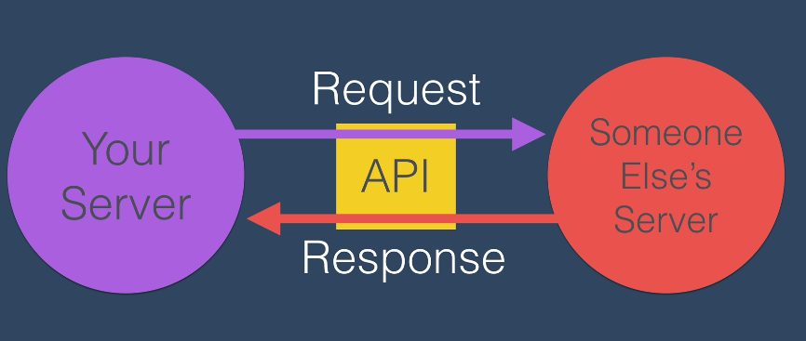
    - “These are all the things that developers can access, and these are the methods, the objects, the protocols to access them. We as the website that hosts the data, will try to not change any of these methods or functions without notifying you”.

Lec 249

