2/28/2020
Lecture 332
Databases explained: SQL vs. NOSQL
- SQL - Relational - Structured query language( Ex. MySQL, PostgreSQL).
  - Really good at establishing relationships between data.
  - Problematic “null” entries, say someone doesn't provide necessary information.


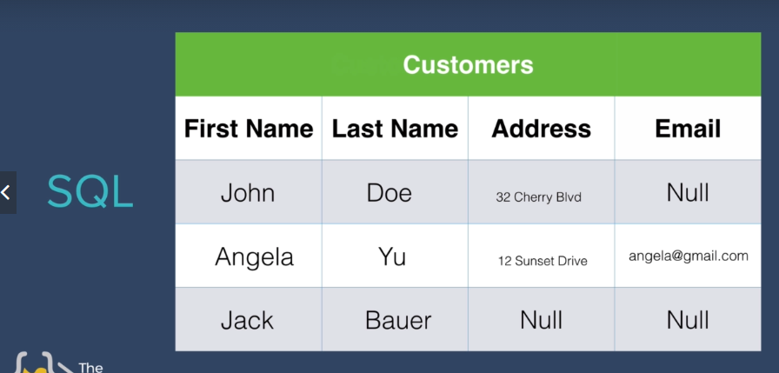

  - SQL tries to square off data and inserts “Null” in records that have not been filled.

- NoSQL – Non relational -Not only structured query language.(Ex. MongoDB, redis).
  - Same situation is not problematic in NoSQL.
    - Each object has key value pairs and differences in value does not disrupt data structure.
    - Remains structural while not being bound to a certain structure.
    - If there was an extra key value pair, it does not effect other objects like SQL. (adds null)
