Java Practice
5/10/2019

Java Notes
Section 1, Lecture 1
Introduction
- Learn various different Java concepts as well as OOP basics.
- Install IntelliJ
- Section 2, Lecture 2
- Install JDK from oracle website.

Section 3, Lecture 8
What is a String?
- String is an object typically respresenting sequence of characters.
- The java.lang.String class is used to create string object.
- String are always in double quotes.

Section 3, Lecture 9
Data types in java

- Java have basically eight primitive data types.
  - Byte – the byte data type is an 9-bit signed two’s complement integer. It has a minimum value of -128 and a maximum value of 127. The byte data type can be useful for saving memory in large arrays, where the memory savings actually matters.
  - Short – The short data type is a 16-bit signed two’s complement integer. It has a minimum value of -32,768 and a maximum value of 32,767. you can use a short to save memory in large arrays, in situations where the memory savings actually matter.
  - Int – 2-bit signed two’s complement integer, which has a minimum value of -2^31 and a maximum value of 2^31-1. Int data type is normally used in Java to support arithmetic operation for integers.
  - Long – The long data type is a 64-bit two’s complement integer. The signed long has a minimum value of -2^63 and a maximum value of 2^63-1. Use this data type when you need a range of values wider than those provided by int.
  - Float – Float data type is a single-precision 32-bit floating integer. As with the recommendations for byte and short, use float (instead of double) if you need to save memory in large arrays of floating point numbers.
  - Double – the double data type is a double-precision 64-bit floating point. For decimal values, this data type is generally the default choice.
  - Boolean – The boolean data type has only two possible values: true and false. Use this data type for simple flags that track true/false conditions.
  - Char – The char data type is a single 16-bit Unicode character. It has a minimum value of ‘\u0000’ (or 0) and a maximum value of ‘\uffff’. Char should be always in single quote.
Section 3, Lecture 10
Conditional execution If & else
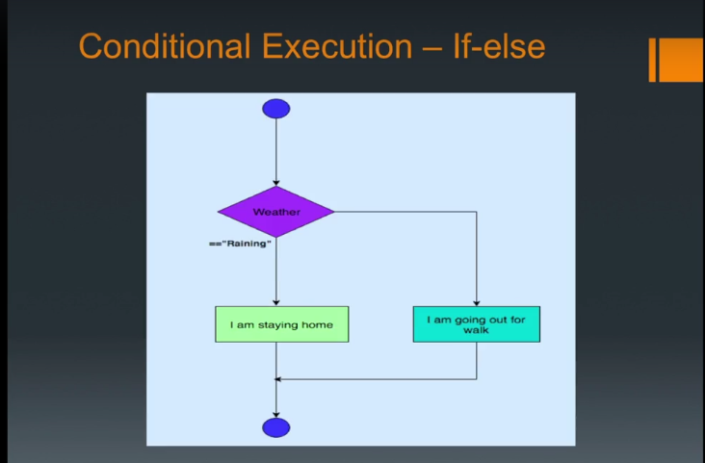

Section 3, Lecture 11
Conditional execution If, else if, and else
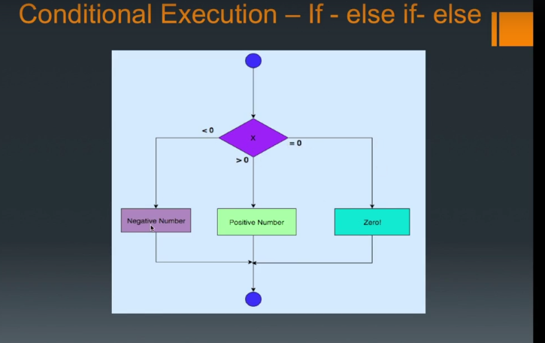

Section 3, Lecture 12
Conditional expressions OR, AND
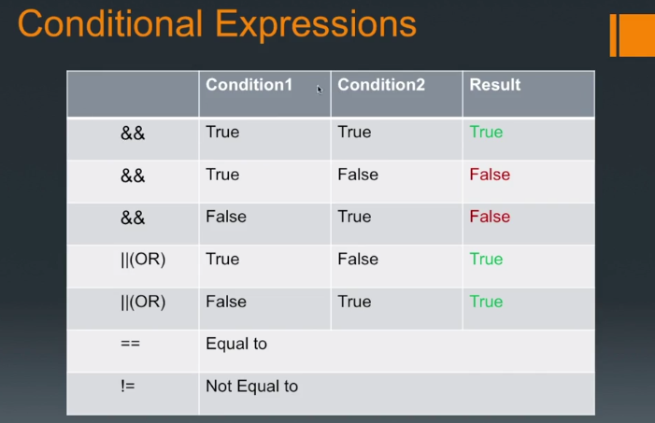

Section 3, Lecture 13
Switch
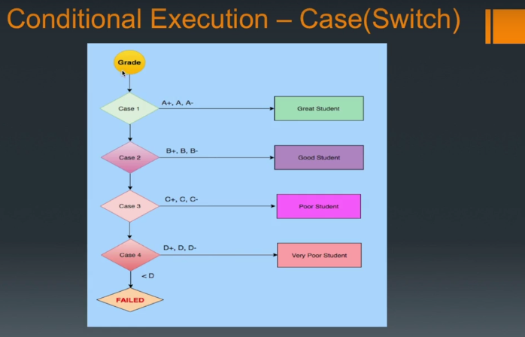
Section 3, Lecture 14
Arrays in Java
- Arrays are ordered, integer-indexed collections of any object.
- Arrays are always in curly brackers{}.
- Arrays indexing starts at 0 just like in C or Ruby
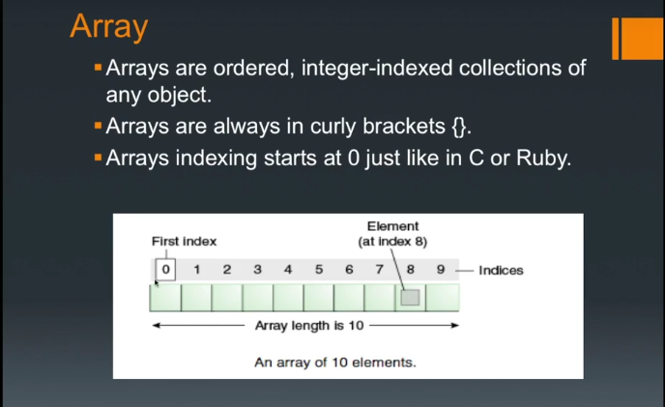

Section 3, Lecture 15
Looping in Java – For Loop
- A loop is a sequence of instructions that is continually repeated until a certain condition is reached.
- Looping is used to iterate over the range of numbers, text, array elements and so on.
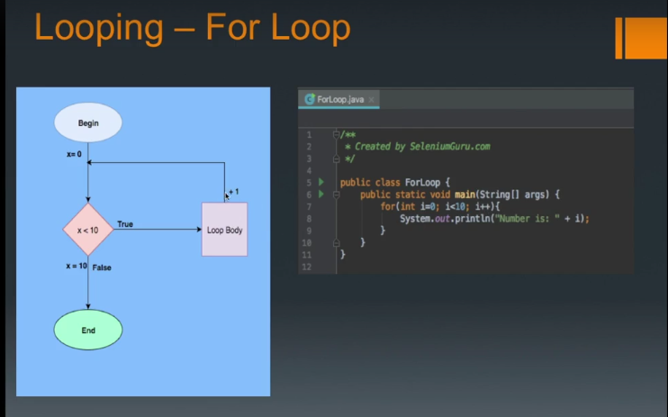

Section 3, Lecture 16
Looping in Java – While Loop
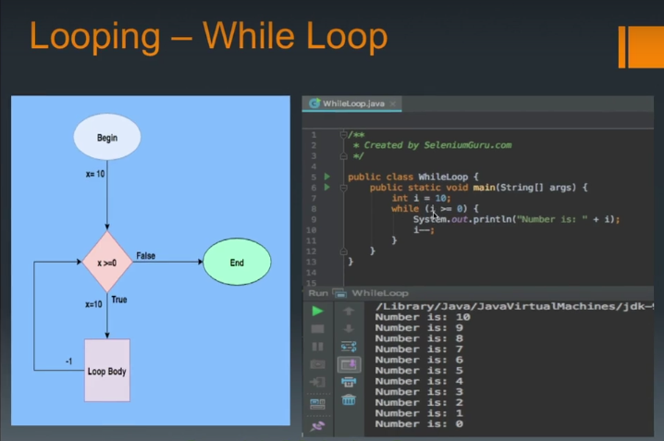

Section 3, Lecture 17
Looping in Java – Arrays – Part 1
- See arrays above (Lecture 14)

Section 3, Lecture 18
Looping in Java- Arrays- Part 2
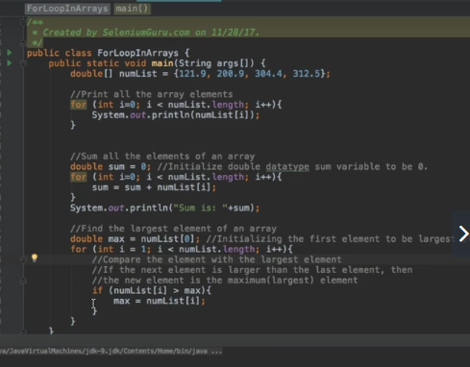

Section 3, Lecture 19
String Interpolation

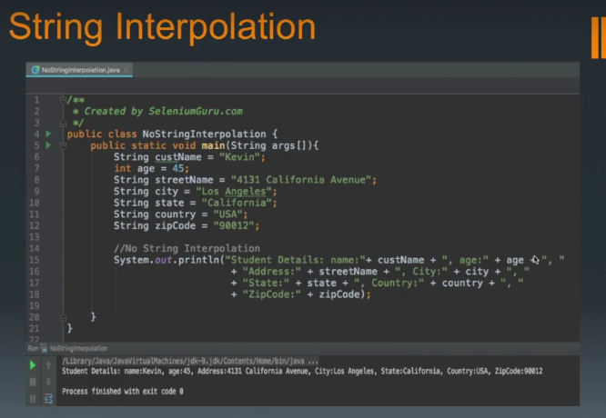
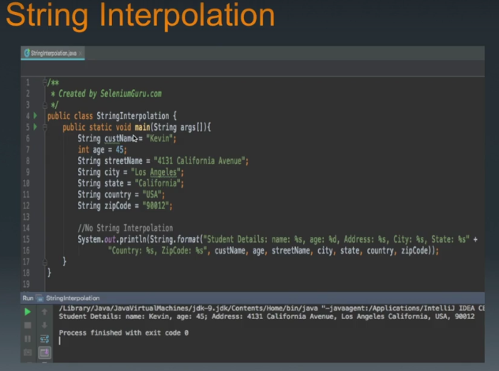

Section 3, Lecture 20
Java Methods Part 1
- Methods are collection of statements grouped together to perform an operation.
- Methods are used to bundle one or more repeatable statements into a single unit.
- Methods are very similar to functions in any other programming language.

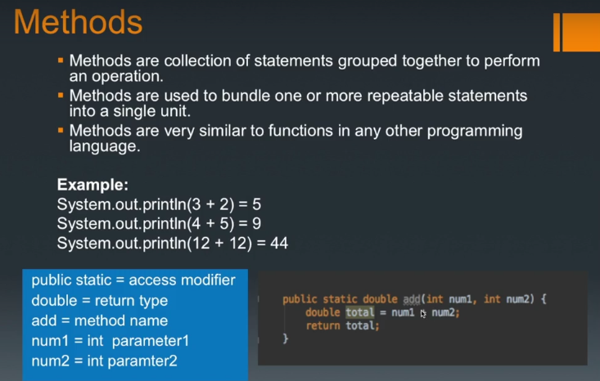
Section 3, Lecture 21
Java methods part 2
- See part 1

Section 3, Lecture 22
What are Java classes?
- Class is a specifiication or a blue print (set of instructions) of how to provide some service.
- Like Blueprint, class has some exact specifications.
- Many Objects can be created from the same class.
- Classes can contain methods, variables for an object.
- A class can have subclasses that can inherit all or some of the characteristics of the class.
- Subclasses can also define their own methods and variables that are not part of their superclass.
- Example:
  - Animal – Dog, Cat, giraffe, Monkey
  - Vehicle – Car, Bicycle, Motorbike, SUV
  - Ford – Focus, F-150, Mustang, explorer, Fiesta.
  - Dog – Corgi, German Shepard, Labrador.
  - Honda – Accord, Civic, Pilot, CR-V
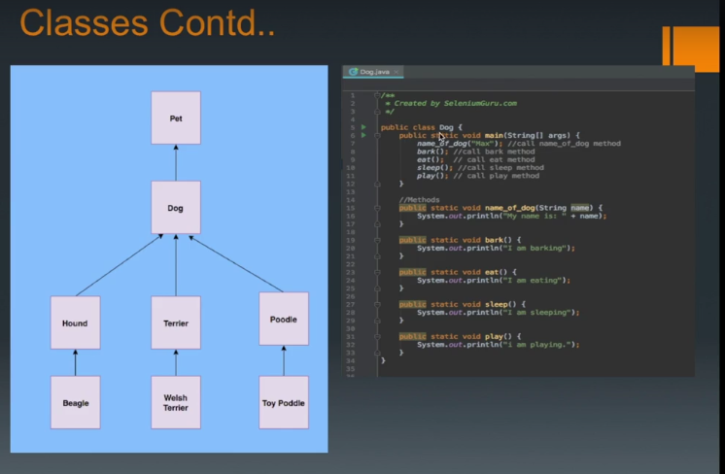

Section 3, Lecture 23
Types of Java Method – Static Methods
- Static Method- Methods that can be called and executed without creating an object or instantiation of the main class.
- Can be invoked directly via class name.
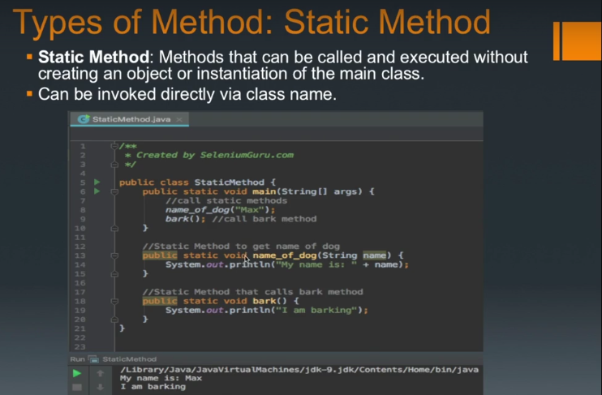

Section 3, Lecture 24
Types of Java Method – Instance Methods
- Instance method – Methods that are called after instantiation of class or object creation.
- It is the most commonly used method type.
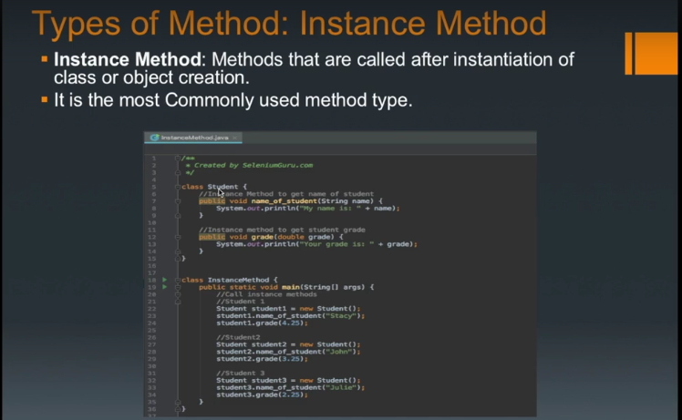

Section 3, Lecture 25
Types of Java Method – Constructor Method – Part 1
- Constructor Method – Default method of the class that will be run at the time when the object is created or instantiated.
- Constructor method is used to declare default behavior for all objects.
- Constructor name must be same as its class name.
- Constructor must have no explicit return type.
- There are two types of constructors:
  - Default constructor (no-arg constructor)
  - Parameterized constructor.
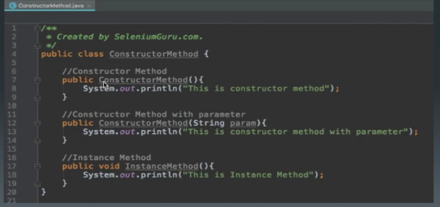
Section 3, Lecture 26
Types of Java Method – Constructor Method – Part 2
- See part 1.

Section 3, Lecture 27
Types of Method: Accessor Getter Method
- Accessor Method: Accessor Methods provide access to objects instance variables.
- Accessor Method is used to return the value of a private field. It follows a naming scheme prefixing the word “get” to the start of the method.
- Also called as “Getter” method is used to get the value from the private caraibles used in the object.

Types of Method: Setter Method
- Mutators Method: Accessor methods provide access to an object’s instance variables.
- A mutator method is used to set a value of a private field.
- It follows a naming scheme prefixing the word “set” to the start of the method name.

Section 3, lecture 28
Variables
- Variables are the memory locations which holds any data to be used by any program.
- Variable types – Local variables, instance variables, class variables, constants.
- Local variables – variables that are declared in methods, constructors, or blocks.
- Instance variables are declared in a class but outside a method, constructor or any block.
- Instance variables are created when an object is created with the use of keyword ‘new’ and destroyed when the object is destroyed.
- The instance variables are visible for all methods, constructors and block in the class. Normlly, it is recommended to make these variables private (access level).

Section 3, lecture 29
Class Variables
- Class variables also known as static variables are declared with the static keyword in a class, but outside a method, constructor or block.
- Static variables are rarely used other than being declared as constants. Constants are variables that are declared as public/private, final, and static. Constant variables never change from their initial value.
- Static variables are stored in the static memory. It is rare to use static variables other than declared final and used as either public or private constants.
- Static variables are created when the program starts and destroyed when the program stops
- Visibility is similar to instance variables. However, most static variables are declared public since they must be available for users of the class.
- Constants- Variables that are permanent/immutable. Always written in uppercase. Always denoted by final return type.

Section 3, Lecture 30
Packages
- A java package is a group of similar types of classes, interfaces, and sub-packages
- Package in java can be categorized in two form, built-in package and user-defined package.
- There are many built-in packages such as java, lang, awt, javax, swing, net, io, itul, sql etc.
- Advantage of Java Package – Java package is used to categorize the classes and interfaces so that they can be easily maintained. Java package provides access protection. Java package removes naming collision.

Section 3, Lecture 31
String Methods
- The java.lang.String class provides many useful methods to perform operations on sequence of char values.

- Common String Methods
- Length() - returns the length of string.
- Format(String s) – returns formatted string.
- substring(int index) – returns sub-string for given begin index.
- Substring (int beginIndex, int endIndex) - returns sub-string starting from begin index and end index.
- constains(Char c) – check the equality of string with object.
- equals(String) – check the equality of string with object.
- equalsIgnoreCase(String) – compares another string.
- IsEmpty() - checks if string is empty.
- concat(String s) – concatenates specified string.
- replace(Char a, Char b) – replaces all occurrences of specified char value.
- split(String regEx) – Returns split-ted string matching regex.
- toLowerCase() - returns string in lowercase.
- ToUpperCase() - returns string in uppercase.
- Trim() - removes beginning and ending spaces of this string.
- valueOf(int value) – converts given type into string.

Section 3, Lecture 32
Integer Methods

- Int is primitive type which stores the actual binary value for the integer you want to represent whereas Integer is a java class and variables of integer stores references to integer objects, just as with any other reference (object) type.
- Common Integer Methods
- intValue() - Returns integer value of integer class object.
- doubleValue() - Returns double value of integer.
- floatValue() - returns float value of integer.
- parseint() - returns integer value of String if applicable.
- compare(int d) – compares 0 if integer a and integer b is equal.

Section 3, Lecture 33
Regular expressions in Java
- Regular expression (regex or regexp for short) is a special text string for describing a search pattern
- Regex pattern are normally described inside the “\”.
Example- wildcard notations such as “\\*.txt” to find all text files in a file manager.

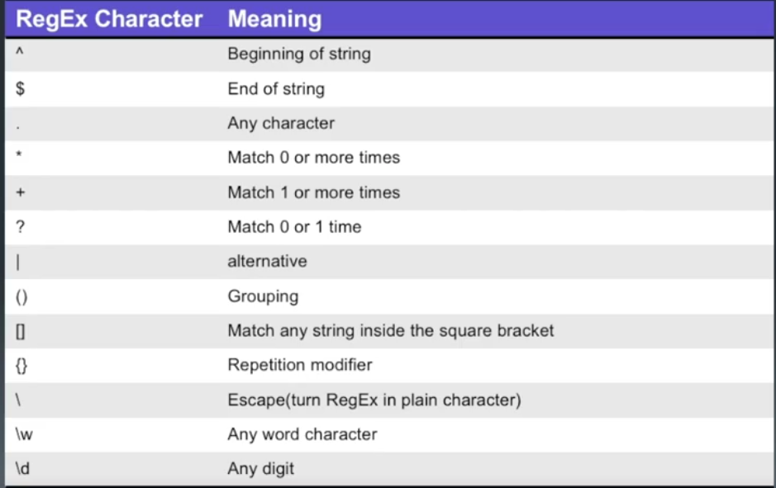
Section 4, Lecture 34
Java OOP – Encapsulation
- OOP- Programming language model organized around objects rather than “actions” and data rather than logic.
- Logical procedure that takes input data, processes it, and produces output data.
- In OOP, Everything is an object just like the real world.
- OOP Types
  - Encapsulation
  - Inheritance
  - Polymorphism
  - Overriding
  - Abstraction
  - Interfaces

Encapsulation
- Process of packing data and functions into a single component.
- Internal representation of an object hidden from outside.
- Variables of a class will be hidden from other classes, and can be accessed only through the methods of their current class.
- Can be used in order to prevent modification of variables from objects.
- To achieve encapsulation in Java
  - Declare the variables of class as private
  - Provide public getter and setter methods to modify and view variables
Section 4, Lecture 35+36
Java OOP – Inheritance
- Relation between two classes where a child class inherits all features of its parent class.
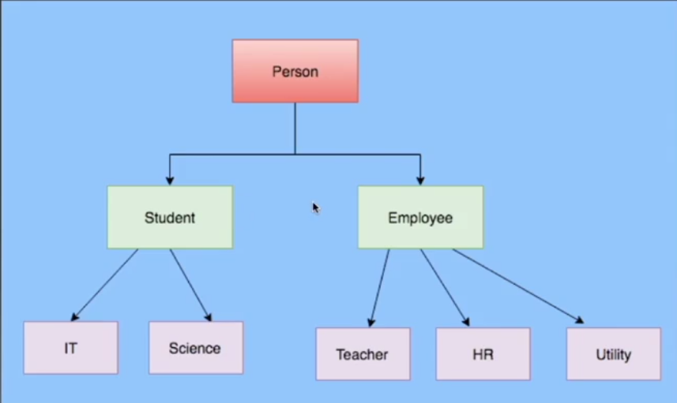
- Methods from the parent can be overridden in the child and new logic can be added.
Section 4, Lecture 37
Java OOP – Polymorphism
- Polymorphism derives from the Greek word “Poly” meaning much or many form or shape.
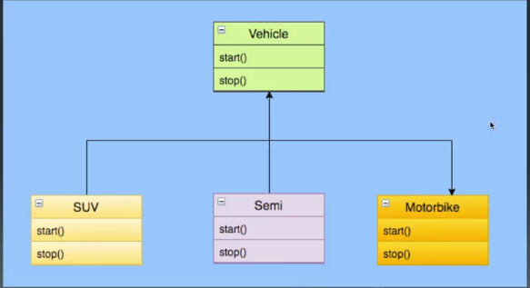
- Polymorphism in programming refers to the ability to use same methods in different ways for different objects or data types.

Section 4, Lecture 38
Java OOP – Overriding
- Overriding is the ability to define a behavior that is specific to the subclass type, which means a subclass can implement a parent class method based on its requirement.
- Overriding means to override the functionality of an existing method
- Overriding is normally done during inheritance where the parent class and sub class may have same method name and needs to be overridden based on the requirement.
Section 4, Lecture 39
Java OOP – Overloading
- Overloading is the ability to define a behavior that is specific to the subclass type, which means a subclass can implement a parent class method based on its requirement.
- Overloading allows different methods to have the same name, but different signature where signature can differ by number of input parameters or typr of input parameters or both.
- Overloading is normally done during inheritance where the parent class and sub class may have same method name but with different parameters or input type and needs to be overloaded based on the requirement.
- Main advantage of overloading is that you don't have to create multiple methods for the same functionality if the functionality requires different parameters or input types.
Section 4, Lecture 40
Java OOP – Abstraction
- Abstraction in java is process of hiding the implementation details from the user.
- Only functionality will be provided to the user.
- Example of abstraction is to pushing the button in your elevator. You do not need to know the details how it works but only need to know what button you need to press to go to your destination floor.
- Abstract class is a class that is declared abstract.
- Key features of Abstract methods
  - Abstract methods may or may not contain abstract methods (methods without body).
  - If you inherit an abstract class, you have to provide implementations to all abstract methods in it.
  - You have to inherit from another class if you want to use an abstract class and provide implementations

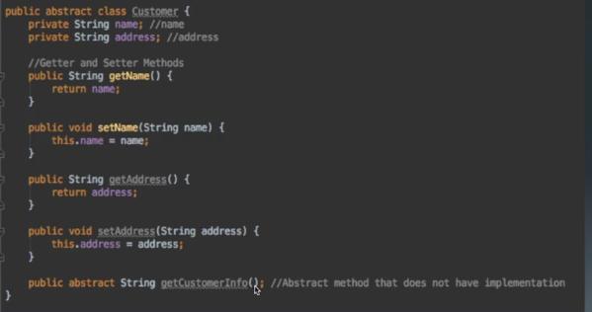

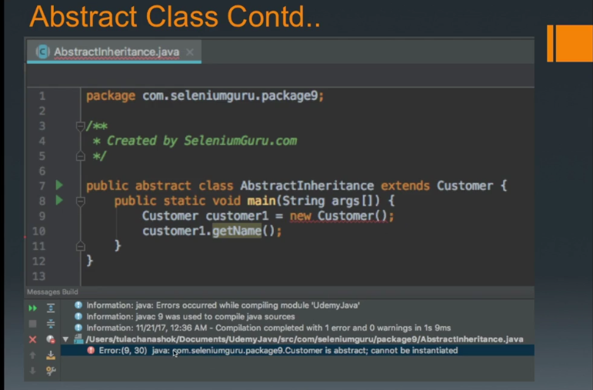
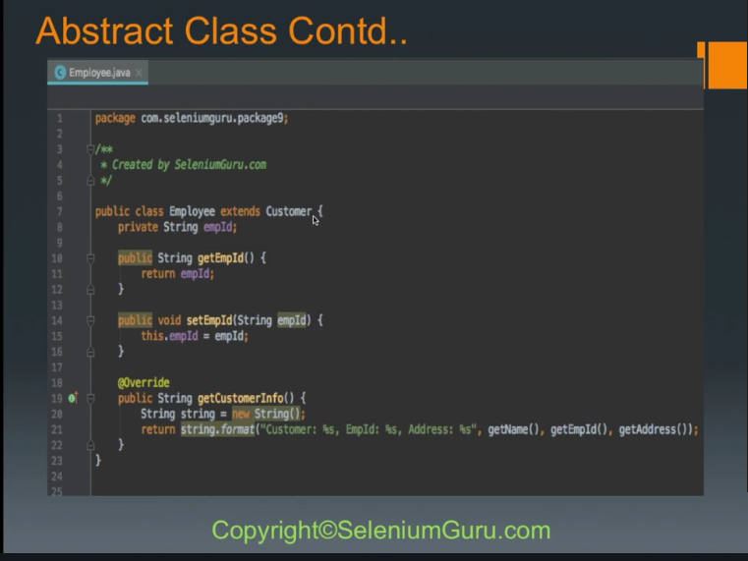
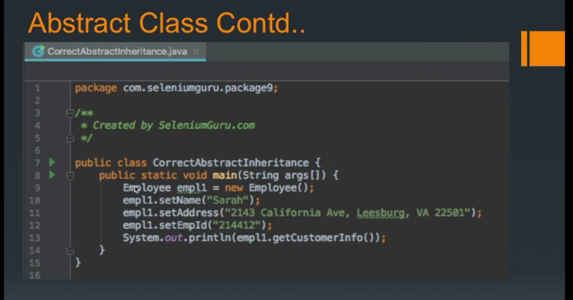
Section 4, Lecture 41
Java OOP – Interface
- Interface in Java is a reference type similar to a class but contain only signatures, default methods, static methods, and nested types without containing any implementation inside the body.
- Key features of Interfaces
  - All the methods inside the Interface is empty or does not have any implementation.
  - Interface cannot be instantiated just like abstract class.
  - Interface does not contain any constructors.
  - All methods inside the interface are abstract.
  - All the instance fields must be declared both static and final.
  - Interface cannot be extended by another class but rather be implemented by other classes.
  - All the methods inside the interface has to be used if implemented by other classes.
  - Interface is implicity abstract so there is no need to use the abstract keyword.
  - Interface has only abstract methods so no need to use abstract keyword for methods.
Section 4, Lecture 42
Java OOP – Array List
Collections
- A collection is a group of Individual objects represented as a single unit.
- Java provides Collection Framework which defines several classes and interfaces to represent a group of objects as a single unit.
- The Collection interface (java.util.Collection) and Map interface (java.util.Map) are two main root interfaces of Java collection classes.
- Collections provides consistent API as API has a set of interfaces like Collection, Set, List or Map.
- Collections reduce programming effort as it eliminates the headache of designing a collection.
- Increases speed and quality providing better performance.
List
- List is an ordered collection of objects in which duplicate values can be stored
- List allows positional access and insertion of elements. List is the child interface of collection.
- List is the child of interface of Collection.
- List Interface is implements by ArrayList, LinkedList, Vector and stack classes.

List a1 = new ArrayList(); //Create ArrayList
List a2 new LinkedList() //Create LinkedList
List a3 = new Vector();//Create Vector

ArrayList
- ArrayList uses a dynamic array for storing the elements.
- It inherits AbstractList class and implements List interface.
- ArrayList can contain duplicate elements.
- ArrayList maintains insertion order.
- Non-Generic array List can contain any type of objects.
- Generic ArrayList allows you to have one type of objects in the collection
- List elements can be traversed using iterator interface or by for each loop
ArrayList list1 = new ArrayList(); //Non generic Array List
ArrayList<String> list2 = new ArrayList<String>();//Generic ArrayList

Section 4, Lecture 43
Java OOP – Linked List
- LinkedList also inherits AbstractList class and implements Deque interface.
- LinkedList also can contain duplicate elements.
- LinkedList also maintains insertion order.
- LinkedList is slow compared to ArrayLit since it takes time to traverse the list.
LinkedList<String> linkedList1 = new LinkedList<String>();

Section 4, Lecture 44
Java OOP – Vector
- Vectors are dynamic arrays.
- Arrays once created, you cannot add or remove elements but Vector allows you to add or remove elements at run time.
- You can create vectors by importing java.util.Vector class and create an object from the Vector class.
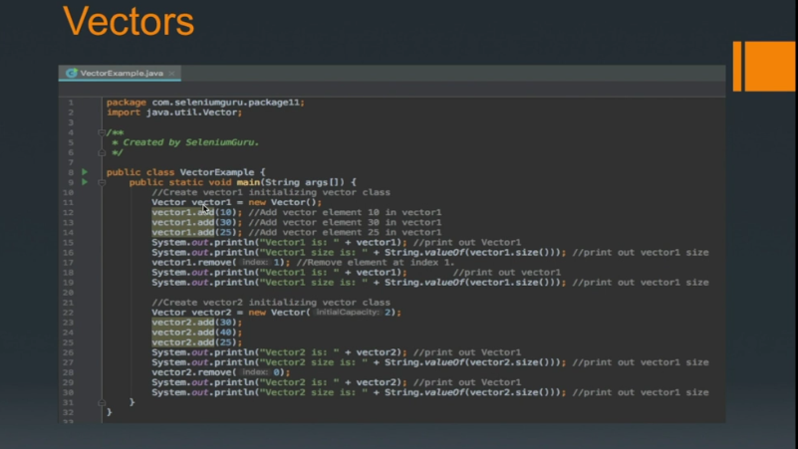
- You can create vector object with n number of elements and then add/remove elements onward.
Section 4, Lecture 45
Java Access Modifiers – Private
- Access modifiers in Java specifies accessibility of a date member, method, constructor, or class.
- There are four types of java access modifiers.
  - Default
  - private
  - protected
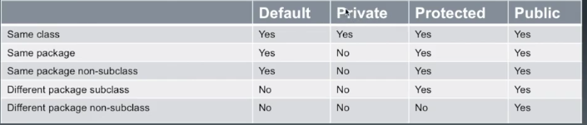
  - public
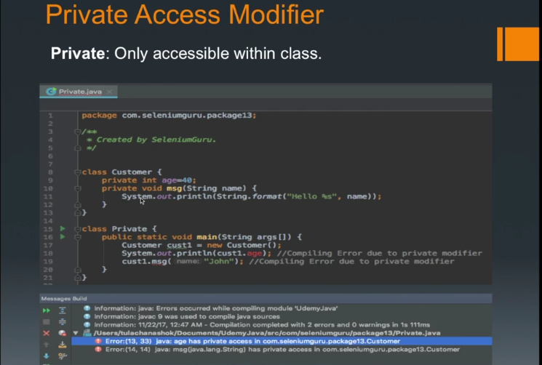

- Private: Only accessible within the class.

Section 4, Lecture 45
Java Access Modifiers – Default
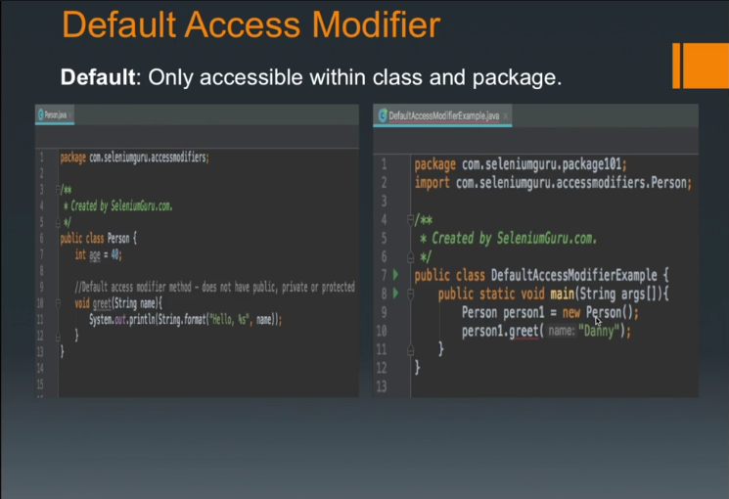
- Default: Only accessible within class and package.

Section 4, Lecture 46
Java Access Modifiers – Protected
- Protected: Accessible within package and outside the package but through inheritance only.
- The protected access modifier can be applied on the data member, method and constructor. It cant be applied on the class.

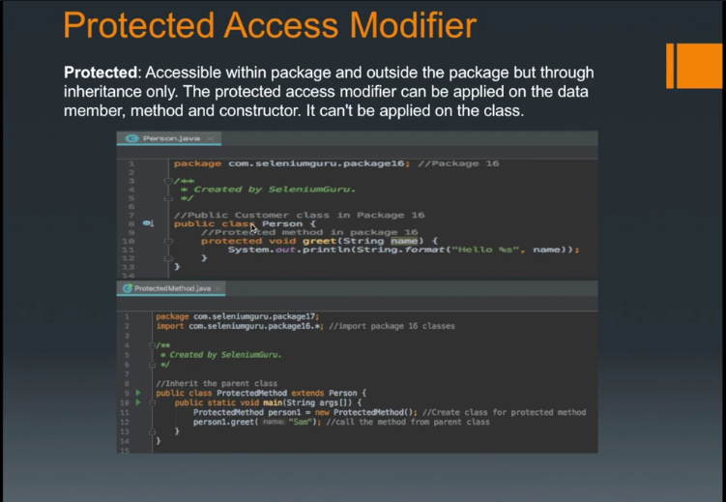

Section 4, Lecture 48,49
Java Access Modifiers – Public
- Public: Accessible everywhere. It has the widest scope among all modifiers.
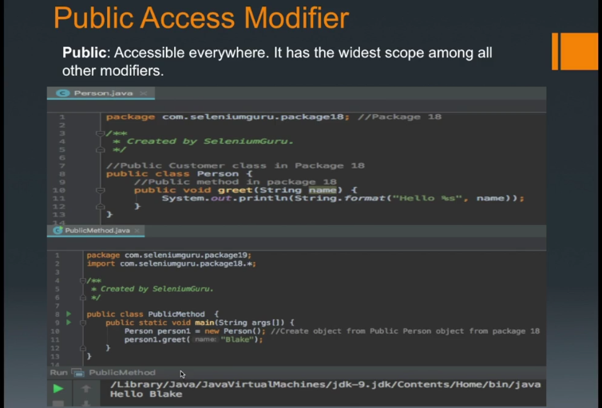

Section 4, Lecture 50
Java File IO Types – Byte Stream
- All I/O methods are derived from class java.io.
- File Input/Output in Java are performed using stream.
- A stream can be defined as a sequence of data. There are two kinds of streams-
  - InPutStream – Used to read data from a source.
  - OutPutStream – Used for writing data to a destination.
- There are various streams that can be used to do I/O functions in Java.
  - Byte Streams – Used to perform input and output of 8 bytes.
    - Mostly commonly used in FileRead and FileWriter class
  - Character Streams - Used to perform input and output of 16 bytes.
    - Mostly used in FileInputStream and FileOutputStream class.
  - Standard Streams – Standard stream to provide standard I/O where the user can take input from keyboard and produce output to computer screen.
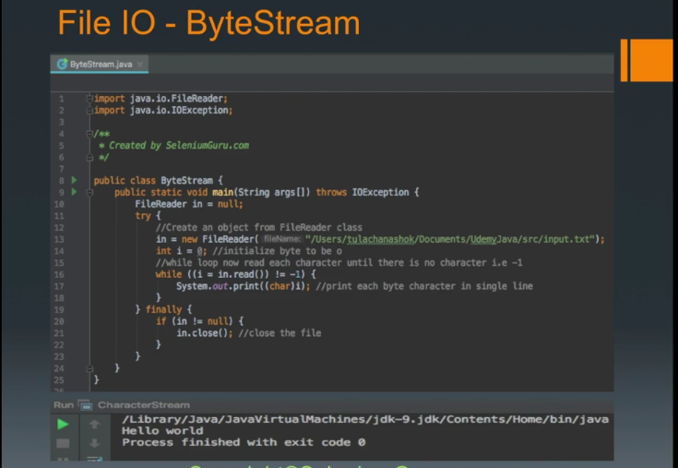
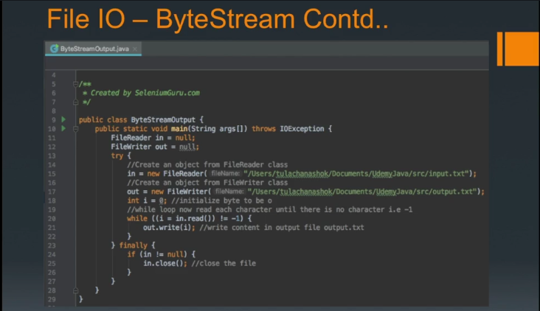
    - Commonly used in System.in, System.out and Systen.err.

Section 4, Lecture 51
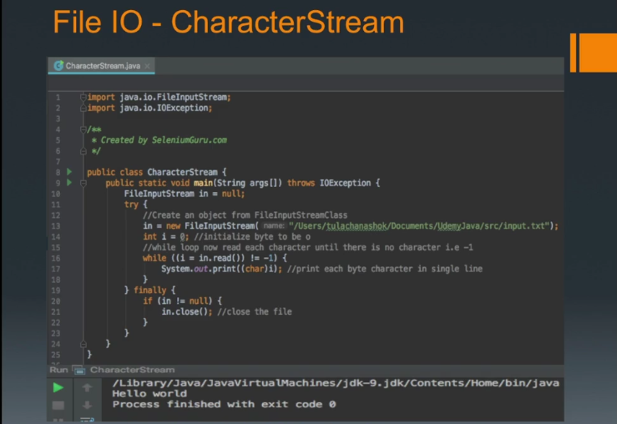
Java File IO Types – Character Stream

Section 5, Lecture 52
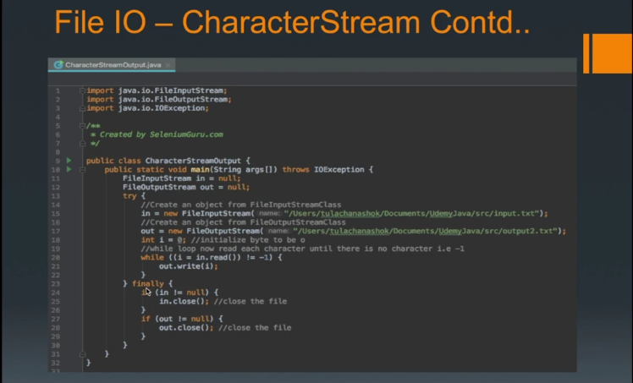
Intro to J Unit – Part 1
- Junit is a Testing Frankework for Java that helps us to perform unit tests for our java code that we have written.
- Junit uses annotations to identify methods that specify a test.
- Junit Test method are annotated by @test annotation.
- JUnit(4.3) uses following annotations.
  - Import org.junit.* - Imports all Junit classess.
  - @Test – Identifies a method as a test method.
  - @Before – Method executed before each test.
  - @After – Executed after each test.
  - @BeforeClass – Executed once, before start of all tests.
  - @AfterClass – Executed Once, after all tests have been finished
  - @ignore – Marks that test should be disabled
  - @Test(timeout=100) – Fails if the method takes longer than 100 milliseconds.
- Junit provides static methods to test for certain conditions with the Assert class.
- Assert statements typically start with assert.
- Assert statements compares the actual value returned by a test to the expected value and throws AssertionException if the comparison value.
- Assert uses the following methods.
  - Fail([message]) – fail the method
  - assertTrue(message, boolean) – Checks that the boolean condition is true.
  - assertFalse(message, boolean) – Checks that the boolean condition is false.
  - assertEquals([message], expected, actual) – Tests that two values are the same.
  - assertNull(message, object) – Check that the object is null.
  - assertnotNull([message], object) – Check that the object is not null.
Section 5, Lecture 53
Intro to J Unit – Part 2
Section 6, Lecture 54
Intro To Maven
- Apache Maven is a software project management and comprehension tool.
- It uses the concept of a project object model(POM), which can manage a project’s build, reporting and documentation from a central piece of information.
- Maven’s primary goal is to allow a developer to comprehend the complete state of a development effort in the shortest period of time.
- In order to attain this goal there are several areas of concern that Maven attempts to deal with:
  - Making the build process easy
  - Providing a uniform build system
  - Providing quality project information
  - Providing guidelines for best practices development
  - Allowing transparent migration to new features.

Section 6, Lecture 55-6
Maven Installation for Windows/Mac
- Download Maven build tool from https://maven.apache.org/download.cgi
- Unzip the maven and put it in Documents folder.
- Add the bin directory of the created directory apache-maven-<version> to the PATH environment variable.
- Open new command prompt and verify that the maven is installed using the command below
        - mvn -version
Section 6, Lecture 57
Maven Project Demo
Maven Commands
- clean: cleans up artifacts created by prior builds.
- Validate: validate the project is correct and all necessary information is available.
- Compile: compile the source code of the project
- test: test the compiled source code using a suitable unit testing framework. These tests should not require the code be packaged or deployed.
- Package: take the compiled code and package it in its distributable format, such as JAR.
- Integration-test: process and deploy the package if necessary into an environment where integration tests can be run.
- Verify: run any checks to verify the package is valid and meets quality criteria.
- Install: install the package into the local repository, for use as a dependency in other projects locally.
- Deploy: done in an integration or release environment, copies the final package to the remote repository for sharing with other developers and projects.
Section 7, Lecture 58
Conclusion -Helpful Resources
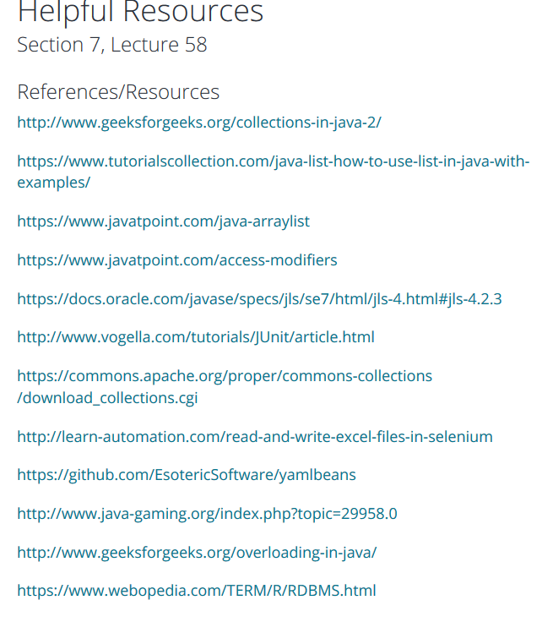

Section 7, Lecture 59
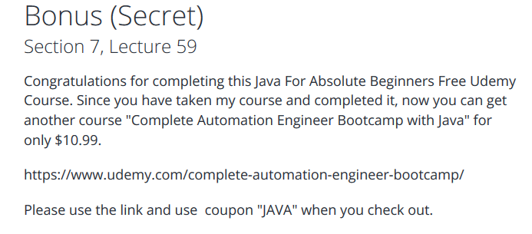
Bonus(Secret

