Eric Pineda
Comptia A+ Study guide

Comptia A+ Cert. 902
Section 1 Notes

Path of A PC Tech
- Whats is the CompTia A+
  - A+ is an industry certification that's administered by an organization called the Computing Technology Industry Association, better known as CompTIA.
  - The CompTIA A+ certification is actually two separate exams that you sit down and you take at a computer.
- How to Pass The A+ Exams
- So you go to a Pearson VUE testing center at a scheduled time.
- You sit down, you take one or both of the exams, and then you're A+ certified if you pass.
- Now, the exams themselves consist of multiple choice and performance-based questions. The multiple choice questions can be standard multiple choice questions or they could be multiple choice questions with schematics, diagrams to help you answer the question, or they could even be things like drag and drop. But, they're all multiple choice.
- Now, along with that, are performance-based questions. Performance-based questions actually make you do something, and you've got to work at a command line or you've got to click within Windows or something to actually get some kind of job done.
- Both of these tests will give you a maximum of 90 questions although it could be far fewer.

- What is on the A+ 220-901 Exam
  - Number one is hardware. Hardware is 34 percent of the exam.
  - Number two is networking at 21 percent of the exam.
  - Three is mobile devices at 17 percent of the exam
  - and number four, hardware and network troubleshooting, which is 28 percent of the exam.

- Why Get A+ certified
- Well, number one, there are over seven hundred different IT. certifications out there right now. So if somebody is coming into the IT. world, how do you pick, where do you, Where do you start, where do you go? Well the CompTIA A+ is considered by many to be the DE-facto entry level IT. certification out there.
- Number two, and this is important, is it that the CompTIA A+ acts as a beautiful launching pad towards more advanced certifications.

Section 2 Notes

Operational Procedures

- Professionalism
  - Don’t wear T-Shirt and Jeans on the job.
  - Wear a nice shirt with nice pants.
  - Brush or comb your Hair and be clean.

- Communication
  - Mikes Six Step System
    - Set the stage
      - Be on time and ask for permission to begin your work.
    - Be Attentive
      - Allow the customer to describe the problem.
      - Ask Open-Ended questions to narrow the scope of the problem.
      - Restate the issue or question to verify understanding.
      - Avoid distractions and personal interruptions.
      - Communicate timeline and expectations with the customer.
    - Be Polite
      - Be culturally sensitive.
      - Avoid technical jargon and slang.
    - Handle Problems
      - Maintain a positive attitude – Don’t argue with the customer.
      - Offer different repair options (If available)
    - Don’t Snoop
    - Finish The Job
  - Arrive at the job site on time and be attentive to the customers needs.
  - Be polite and avoid arguing with the customer.
  - Document the fix and follow up with the customer at a later date.

- Three Threats to your PC
  - EMI
    - Large Magnetic wave s in places they shouldn't be.
    - Can wipe data, but in most cases can continue to use the hardware.
  - Electro static discharge (ESD)
    - The tiniest charge can destroy a hard drive as well as other equipment.
    - Touch the case or power supply to ground yourself.
    - User a anti_ESD mat and wristbands.
    - Big risk when it comes to CPU and RAM. Other components are not as fragile to ESD.
    - Components come in anti-static bags. When transporting it is important you use an anti static bag.
    - Components also come with anti static foam.
  - Radio frequency interference (RFI) can disrupt wireless signals.
  - Electromagnetic interference (EMI) can damage data stored on a hard drive
  - Electrostatic discharge (ESD) can destroy PC components if you don’t use anti-static devices.

- Physical safety
  - Remove things like jewelry and ties before working on a PC.
  - Unplug the system unit or use the switch on the power supply.
  - Lift with your legs, not your back.
  - If you need help, ask somebody.
  - Don’t wear loose jewelery ot tires while working inside a PC.
  - Unplug the system unit before working inside the case.
  - Use proper lifting technique.
- Equipment Safety
  - Messy cables can also be a tripping hazard.
  - Take advantage of cable management – make things prettier.
  - Keep a fire extinguisher around.
    - Type A – Wood fires
    - Type B – Grease Fires
    - Type C - Electrical fires
    - Makes sure you have the right king of Fire extinguisher. (BC is shown, reccomended).
  - A #2 Phillips screwdriver is one of the most important PC repair tools. (Case, power supply, remove motherboards, etc.)
  - Need toolsets for different devices than desktops. Mobile devices, laptops etc.
  - WWW.IFIXIT.COM for info on a good kit.
  - Multi-meters or Voltmeters
    - Set voltage on multi meter
      - Red to Hot, Black to neutral – Should read 115-120 V in US.
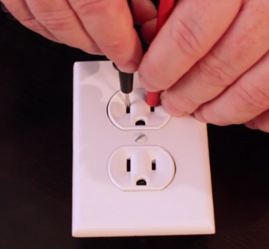

  - Red to Hot, Black to ground. - Should also read 115-120V in the US.

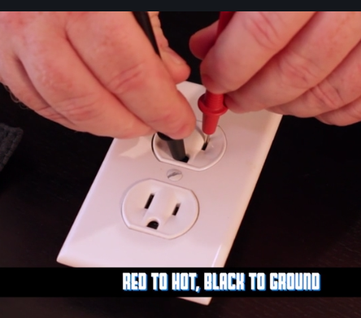

  - Red to Neutral, Black to ground. - If your doing this right, you should be getting 0 Volts.
    - You would be surprised how often people miswire things.

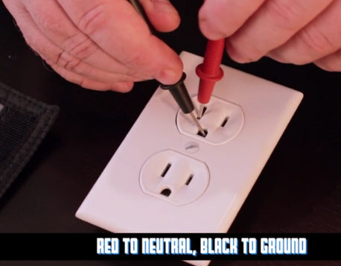

  - Follow all local government regulations.
  - Use proper cable management techniques to prevent hazards.
  - Use fire extinguishers and multi-meters to keep equipment safe.
  - Follow all local government regulations.

- Troubleshooting theory
  - Step 1 – identify the Problem.
  - Step 2 – Establish a theory of probable cause.
  - Step 3 – Test the theory to determine probably cause.
  - Step 4 – Establishing a plan of action.
  - Step 5 – Verifying full system functionality – If necessary apply preventive measures.
  - Step 6 – Document your findings
  - Troubleshooting technical problems is core to a tech’s job.
  - Listening to your users is a critical part of troubleshooting.
  - Remember the steps to Comptia’s troubleshooting process.
- Inside The PC
  - Every case opens in a different way, so you’ll need to read a manual or use trial and error to get one open.
  - The system unit contains a power supply, motherboard, CPU, RAM, and other components.
  - The system unit uses many types of cables to connect ports, switches, lights, and fans.

Section 3 Notes

The Visible Computer
- Touring Windows Vista
  - Windows vista uses the familiar desktop and start menu interface.
  - User account control was introduced with windows vista.
  - Comptia expects the control panel to be in classic view.

- Touring Windows 8 Part 1
  - CPU speed is measured in Hertz, or cycles per second.
  - The CPU speed is determined by the speed of the motherboard and the clock multiplier.
  - Multi-core processors include more than one CPU on a single physical chip.

- Touring windows 7 Part 2
  - Cache is used as very fast temporary storage on a CPU.
  - Modern CPU’s use one or two levels of cache.
  - The Level 1 Cache is the smallest and fastest cache;
  - The Level 3 Cache is the largest and slowest cache.\

- Touring Windows Part 3
  - All modern CPU’s can handle 64-Bit mode, but you need 64-Bit operating system to take advantage of it.
  - 64-Bit CPU’s enable you to use more than 4GB of RAM.
  - Use the system applet to check if your version of windows supports 64-Bit computing.

- Touring Windows 8
  - CPU extensions add functionality to a processor.
  - Virtualization support enables CPU’s to more efficiently run virtualized systems.
  - Integrated graphics processing units can replace dedicated video cards in many systems.

- Touring Windows 10
  - CPU sockets are zero insertion force to prevent damage to the fragile chips.
  - Intel CPU’s use LGA sockets, AMD CPU’s use PGA sockets.
  - There are many different sockets on the test, study the sockets covered.

- Touring OS X
  - Make sure you have a CPU that is compatible with your motherboard.
  - Follow the orientation notch on the processor to properly connect the CPU to the motherboard.
  - Read the manual to learn how to attach the cooling fan; They are all different.

- Touring Ubuntu Linux
  - Fans are used to cool CPU’s, cases, and other components.
  - You can either use the OEM fan that came with the device or replace it with a third-party fan.
  - Use a utility like speed-fan to control when your fans spin up and how fast they spin.
- Tech Paths
  - Passive liquid cooling runs hot fluid through a radiator to keep your CPU cool.
  - Active liquid cooling works like a refrigerator built into your case
  - Liquid cooling systems can be difficult to install, but they cool your PC more efficiently than standard fans.
Section 4 Notes

RAM
- RAM Sticks and Speeds
  - Determine capacity and speed. Easiest way is to look at the label.
  - Dual in-line memory module (DIMM).
  - DRAM (Dynamic Ram, first form of RAM)
    - SDRAM (Synchronus DRAM) were earlier, slower forms of RAM.
  - Modern RAM comes in DDR, DDR2, and DDR3 varieties.
  - DDR (Double Data Rate) -
    - Take Motherboard speed (100 MHz) Double it (200 MHz) times 8 (PC-1600)
  - DDR2 -240 Pin DIMM, notch in a slightly different place.
    - Motherboard speed (100MHz) double that (200Mhz) get ddr2 speed, double again (DDR2 400), to get pc speed multiple by 8 (PC2 3200)
  - DDR3
    - Also a 240 pin DIMM (same as DDR2) but different notch placement.
    - Quadruples the bus to achieve its speeds
    - Take motheboard speed (100MHz) multiples by 4 (400 MHz) to get DDR3 speed you double that (DDR3 800 MHz) multiply by 8 (PC3 6400).
  - To do anything on your pc, a program must be loaded into RAM.
  - DRAM and SDRAM were earlier, slwoer forms of RAM.
  - Modern RAM comes in DDR, DDR2, and DDR3 varieties.
- RAM Capacity
  - Make sure your motherboard can handle the amount of RAM you want to install.
  - RAM capacities are additive: If you install two 2-GB sticks, you have 4 GB of RAM.
  - Avoid mixing RAM sizes and speeds; it can cause stability issues.
- Virtual Memory
  - When your PC runs out of physical memory, It moves programs into a temporary memory space called virtual memory.
  - To control virtual memory from within windows, Go to control panel | System | Advanced )System settings) | Performance.
  - If your PC is using virtual memory too often, you should buy more RAM.

Section 5 Notes
Power Supplies

Choosing a power supply

- Before buying a power supply, make sure it will suit yourn needs.
- Find a power supply with a high efficiency rating.
- Mae sure you know the amount of power being output on each rail of a power supply

Power Protection

Section 6 Notes

Implementing Hard drives

Understanding partitioning

- MBR was the original PC partitioning system
- MBR is limited to four (2 TB) Primary partitions
- GPT is MBR’s replacement and supports much bigger, and many more partitions than MBR.

Basic Partitioning

- MBR Partition types: Primary and Extended
- Extended Partitions hold logical drives
- GPT allows volumes greater than 2TB and up to 128 volumes per disk.

Dynamic disks

- Volumes can shrink or extend within a disk on basic disks
- Spanning drives requires dynamic disks
- Spanning offers no fault tolerance.
File Systems

- Windows – FAT, FAT32, EXFAT, NTFS
- MAC – HFS
- Linux – EXT3, EXT4

Storage Spaces

- Storage pools – group of hard drives that share settings. RAID etc.
- Thin-Provisioning – virtualizes pool. Reports to the world it has 10TB of space even though it has 1.81. When you run out of space, storage spaces tells you to add more. From here all you do is add another drive to the pool and you can keep going.
- Proprietary to microsoft.

Section 7 Notes

Essential Peripherals

Configuring USB
- To See All of your USB Devices, Go to device Manager.
- From device manager, you can inspect each usb device and see more information
- You can check how much bandwidth and power each device uses.

Section 8 Notes

Building a PC

Media Sources
- Iso’s are block copy images.
- Iso’s can be used as backups or installation media
- Copy Iso’s to flash media for faster performance.

Windows Install Options

- Simple and unattended installation.
- Network installation.
- Image Deployment.

Windows Upgrade Paths

- D

Installing Windows

- R
Post-Installation Tasks

- H

Section 9 Notes

Windows Under the Hood
What is the registry
The Boot Process
Processes
Dealing with Processes
Services
Windows 8 Task Manager

Section 10 Notes

Users, Groups, and Permissions.

Introduction to Users and Groups
Creating Users in Windows vista/7
Managing Users in Windows 8 or 8.1
Sharing folders and files

Section 11 Notes

Maintaining and optimizing operating systems

The Zen of Computer Maintenance
Patch Management
Autostarting Programs in Windows
Meet the MMC
Installing and Uninstalling Programs - Windows
Windows System Restore
Windows Backup

Section 12 Notes

Windows Command Line Basics
Working with folders and Files
Fancy Copying
Working with Drives
Advanced Windows Command Line
Linux Command Line Basics
Working with Folders and Files in Linux
Linux File Permissions
Miscellaneous Linux Commands

Section 13 Notes

The Recovery Console
Windows Recovery Environment
Advanced Startup Options Part 1
Advanced Startup Options Part 2
Boot Problems
Event Viewer and Action Center
Application Troubleshooting
Kernel Panics

Section 14 Notes

Virtualization Basics
Your First Virtual Machine
Infrastructure as a Service laaS
Platform as a Service PaaS
Software as a Service SaaS
Cloud Owndership

Section 15 Notes
Internet Options
Proxy Servers
Troubleshooting Internet Connections

Section 16 Notes

Touring Android
Touring iOS
Touring Windows Mobile

Section 17 Notes
Cellular Configuration
Wireless mobile Connections – Part 1
Wireless Mobile Connections – Part 2
Mobile Devices and Email
Synchronization
Securing Android Devices
Securing iOS Devices

Section 18 Notes

Installing Local Printers
Installing Network Printers
Cloud Printing

Section 19 Notes

Physical Security
Passwords and Authentication
Protecting Against Snoops
Malware
Anti-malware Applications
Anti-Malware Practices
Hardware Firewalls
Software Firewalls
Software Firewalls
Data Destruction
Incident response

