Eric Pineda
Comptia A+ Study guide

Comptia A+ Cert. 901
Section 1 Notes

Path of A PC Tech
- Whats is the CompTia A+
  - A+ is an industry certification that's administered by an organization called the Computing Technology Industry Association, better known as CompTIA.
  - The CompTIA A+ certification is actually two separate exams that you sit down and you take at a computer.
- How to Pass The A+ Exams
- So you go to a Pearson VUE testing center at a scheduled time.
- You sit down, you take one or both of the exams, and then you're A+ certified if you pass.
- Now, the exams themselves consist of multiple choice and performance-based questions. The multiple choice questions can be standard multiple choice questions or they could be multiple choice questions with schematics, diagrams to help you answer the question, or they could even be things like drag and drop. But, they're all multiple choice.
- Now, along with that, are performance-based questions. Performance-based questions actually make you do something, and you've got to work at a command line or you've got to click within Windows or something to actually get some kind of job done.
- Both of these tests will give you a maximum of 90 questions although it could be far fewer.

- What is on the A+ 220-901 Exam
  - Number one is hardware. Hardware is 34 percent of the exam.
  - Number two is networking at 21 percent of the exam.
  - Three is mobile devices at 17 percent of the exam
  - and number four, hardware and network troubleshooting, which is 28 percent of the exam.

- Why Get A+ certified
- Well, number one, there are over seven hundred different IT. certifications out there right now. So if somebody is coming into the IT. world, how do you pick, where do you, Where do you start, where do you go? Well the CompTIA A+ is considered by many to be the DE-facto entry level IT. certification out there.
- Number two, and this is important, is it that the CompTIA A+ acts as a beautiful launching pad towards more advanced certifications.

Section 2 Notes

The Visible Computer
- How Computers Work
  - Stored data is loaded into ram so it can be worked on.
  - Users provide input that directs how the data should be processed.
  - The output is the processed data, Usually viewed on a monitor.

- Primary PC Components
  - The system unit provides processing and storage.
  - Common input devices include keyboards, mice, and scanners.
  - Common output devices include monitors, printers, and speakers.

- External Connections
  - Most modern peripherals use the universal serial bus (USB) port.
  - Other common connectors include eSata, DVI, HDMI, and audio connections.
  - Parallel, serial, and VGA ports are all considered legacy connectors.

- Inside The PC
  - Every case opens in a different way, so you’ll need to read a manual or use trial and error to get one open.
  - The system unit contains a power supply, motherboard, CPU, RAM, and other components.
  - The system unit uses many types of cables to connect ports, switches, lights, and fans.

Section 3 Notes

Microprocessors
- What is a CPU?
  - The central processing unit (CPU) is similar to a very fast calculator.
  - Intel and AMD processors power most of the computers used today.
  - Like a car, processors have a make and model that define its features.

- CPU Speeds and Cores
  - CPU speed is measured in Hertz, or cycles per second.
  - The CPU speed is determined by the speed of the motherboard and the clock multiplier.
  - Multi-core processors include more than one CPU on a single physical chip.

- CPU Caches
  - Cache is used as very fast temporary storage on a CPU.
  - Modern CPU’s use one or two levels of cache.
  - The Level 1 Cache is the smallest and fastest cache;
  - The Level 3 Cache is the largest and slowest cache.\

- 32-Bit vs. 64-Bit processing
  - All modern CPU’s can handle 64-Bit mode, but you need 64-Bit operating system to take advantage of it.
  - 64-Bit CPU’s enable you to use more than 4GB of RAM.
  - Use the system applet to check if your version of windows supports 64-Bit computing.

- CPU Extensions
  - CPU extensions add functionality to a processor.
  - Virtualization support enables CPU’s to more efficiently run virtualized systems.
  - Integrated graphics processing units can replace dedicated video cards in many systems.

- CPU Sockets
  - CPU sockets are zero insertion force to prevent damage to the fragile chips.
  - Intel CPU’s use LGA sockets, AMD CPU’s use PGA sockets.
  - There are many different sockets on the test, study the sockets covered.

- Installing a CPU
  - Make sure you have a CPU that is compatible with your motherboard.
  - Follow the orientation notch on the processor to properly connect the CPU to the motherboard.
  - Read the manual to learn how to attach the cooling fan; They are all different.

- Cooling your PC
  - Fans are used to cool CPU’s, cases, and other components.
  - You can either use the OEM fan that came with the device or replace it with a third-party fan.
  - Use a utility like speed-fan to control when your fans spin up and how fast they spin.
- Liquid Cooling
  - Passive liquid cooling runs hot fluid through a radiator to keep your CPU cool.
  - Active liquid cooling works like a refrigerator built into your case
  - Liquid cooling systems can be difficult to install, but they cool your PC more efficiently than standard fans.
Section 4 Notes

RAM
- RAM Sticks and Speeds
  - To do anything on your PC, A program must be loaded into RAM.
  - DRAM and SDRAM were earlier, slower forms of RAM.
  - Modern RAM comes in DDR, DDR2, and DDR3 varieties.
- RAM Capacity
  - Make sure your motherboard can handle the amount of RAM you want to install.
  - RAM capacities are additive: If you install two 2-GB sticks, you have 4 GB of RAM.
  - Avoid mixing RAM sizes and speeds; it can cause stability issues.
- Other types of RAM
  - RAMBUS RAM was the first double data rate RAM, but it wasn’t popular for very long.
  - ECC and parity RAM are special varieties of RAM often used in server machines to increase stability.
  - SODIMM RAM is used in laptop PCs and comes in several varieties can capacities.

- Installing RAM
  - Make sure your system can handle the memory you want to install.
  - Firmly snap the RAM into place; It should not wiggle or move once installed.
  - If the system doesn't boot, take the RAM out and try installing it again—You won’t hurt anything.
- Troubleshooting RAM
  - Use the system applet to check how much RAM windows can see you system.
  - Memtest86 and the windows memory diagnostic both test your RAM, looking for errors.
  - Don’t be afraid to experiment – Try replacing different sticks of RAM until you find the bad one.

Section 5 Notes
BIOS

What is the BIOS?

POST

- Once the Power Good Wire reaches a certain voltage, the CPU is started.
- CPU begins POST. Makes announcement for peripherals to say HERE! In a sense. It reports back errors if any are found. That what POST is all about.
- Takes place before anything is on the screen, also first thing that appears on the screen.
- Beep codes are low level and cant be shown on video because video hasn't been tested yet. Ex. Video card beeps, Ram Beeps.
- POST CARD – Power On Self Test Card. 2 hexadecimal read out error codes that vary from one BIOS maker to another.
- Beep Codes, POST cards, On screen stuff. Nothing on screen until video is tested. If Video card is malfunctioning it will resort to beep codes. POST cards can help in this situation.

Section 6 Notes

Motherboards

Form Factors

- Form Factors provide standards for PC components, such as size, shape, and connections.
- The first well-known form factor was the AT Form Factor
- The most commonly used form factor today is the ATX form factor

ATX and ITX Motherboards

- The ATX form factor is available in standard, mini ATX, MicroATX, and FlexATX sizes
- You won’t find any standard ITX motherboards, but you will see mini-ITX, Nano-ITX, and PICO-ITX
- Small form factors often have their own special kind of power supply.

Chip-sets

- The definition of north bridge is whoever is handling the memory controlling.
- Chip-sets collect motherboard functions that were once controlled by individual chips.
- The north-bridge was typically used for any function that required speed and a more direct connection to the CPU.
- The south-bridge was often used for slower or older functions that didn't require as much power.
The Expansion Bus

- PCI stands for Peripheral Component Interconnect. 32-Bits wide Running at 33 MHZ or 66MHZ.
- Mini-PCI (Expansion bus made to fit laptops) runs at 32-Bits wide at 33 MHZ.
- The next generation of buses are know as PCI Express (PCI-E).
- PCI Express (PCI-E) Uses serial communication as opposed to parallel communication.
- MINI-PCI-E – 52 pin connector supporting 2 lanes.
- PCI is 32 Bits wide and runs at 33 MHZ
- PCI-X is 64 Bits wide and runs at 133 MHZ
- To calculate the speed of a PCI-E slot use this formula (Speed = Lane Speed X Number Of Lanes)
- Both PCI and PCI-E have mini versions used in Laptops.

Touring The Motherboard

- There are a large number of components on a modern motherboard. Read the manual for the specifics of an individual board.
- Some key components on the board are the CPU socket, RAM slots, expansion slots, and the many connectors for peripherals.
Installing a Motherboard

- Make sure to test each of your components before screwing the motherboard into the case
- Use standouts and washers to safely securely install the motherboard.
- Remember to plug in all of the necessary power and front panel connectors.

Section 7 Notes

Power Supplies

Electricity Basics
- Volts X Amps = watts
- Direct Current (DC) = an electric current flowing in one direction only and substantially constant in value —abbreviation DC
- Alternating Current (AC) = an electric current that reverses its direction at regularly recurring intervals —abbreviation AC
- Think of electricity as flowing water, coming though wires instead of pipes.
- Direct current moves in one direction, while alternating current rapidly switches directions.

The Power Supply

- P1 Connector – 20 pin – 24 pin. Lower power board would use 20 instead of 24.
- Supplementary power connector – Usually 4 pin sometimes 8. Most motherboards work with 4. Some motherboards absolutely require a power supply with 8 pins.
- Sata Power Connectors - Used for sata hard drives and optical media.
- Mini Power Connector – Not used to much anymore. An example of using this is to power extra USB slots in the expansion bay
- Molex Power Connector – Mainly for fans, secondary supplementary power. Sata is more common for what this used to be used for now.
- The most important connectors are the P1 and supplementary power connectors
- PCI Express power connectors are often used with powerful video cards.
- Other common connectors include the Sata, Molex and mini power connectors.

Niche Power Supplies and Features

- Modular Power Supply- Has connections for all cables and you use what you need.
- Small Form Factor Power Supplies –Usually used for Mini-ATX, Flex ATX builds.
- Beyond wattage, power supplies have other features and qualities you should keep in mind.
- Modular power supplies enable you to pick and choose which power connections to use inside your case.
- Small form factor power supplies come in several varieties but all include the standard connectors.
Choosing a Power Supply

- Efficiency- Measured at a percentage. Good power supplies can be up to 90%. cheaper can be as low as 50%. Better power supplies tend to advertise their efficiency. Stay at least around 82-85%.
- Rails - Electrical circuitry that isolates different types of power outputs and that way one dosent get sacrificed to the other in order to do the best efficiency possible.
- Before buying a power supply, make sure it will suit your needs.
- Find a power supply with a high efficiency rating.
- Make sure you know the amount of power being output on each rail of a power supply.

Troubleshooting Power Supplies
- A voltmeter can show the voltages carried by each power connector.
- A voltage tester will light up green if it receives power.
- Don’t forget to make sure everything is plugged in.

Section 8 Notes

Hard Drives
- Sata 1 2003 -1.5 Gbits/s
- Sata 2 2004 - 3.0 Gbits/s (Enabled native command queuing)
- Sata 3 2009 – 6.0 Gbit/s
- Recognize the three types of Sata connectors
- Memorize the Sata version, speeds, and features
- Before installing an OS, check the bios setup and make sure that AHCI has been turned on to use newer Sata features.
Solid State Drives

- Non-Volatile memory host controller interface specification – NVMe
- An SSD looks just like a hard drive to the computer
- SATA/AHCI and PCIe/NVMe are the interfaces and protocols used by solid state drives.
- When buying an M.2 drive, read the box closely to verify if it needs Sata or NVMe.

Hard drive Overview

- Different mass storage devices store data differently.
- LBA hides different storage methods from the operating system.
- The file system translates from the operating system to mass storage.

RAID

- Random/Redundant array of independent Drives/Devices (RAID) Benefits: Speed, Data safety.
- Raid 0: Striping. Need at least 2 hard drives. Raid 0 Speeds things up but does not make data safe
- Raid 1:Mirroring. When saving it clones a piece of what its saving to each drive. Does not speed anything up. Actually slows things down. Have a complete perfect backup although it is slow. There are 2 types. Mirroring, and drive duplexing. 2 separate controllers each feeding a drive in the array
- Raid:0 = No safety, but with speed. Requires at least 2 drives.
- Raid 5: A little faster along with data security. Can lose 1 drive and use data from 2 other drive and recreate the failed drives data.
- Raid 10: Minimum of 4 drives. A stripe of mirrors. Can lose one drive on each mirror and still keep working. Downside, takes a lot of drives.
Raid 1: Safety, slower speed. Requires at least 2 drives. Regular raid 1, and duplexing.
- Raid arrays enable you to speed up data access, protect data, or both.
- The most common raid styles include 0, 1, 5, and 10.
- Raid 1 and Raid 0 requires two drives, Raid 5 requires three drives, and raid 10 requires four drives.
Hardware RAID

- Hardware RAID uses hardware built into a motherboard or an expansion card to build and manage the array
- When installing your drives, good labeling and notes will help you stay organized and avoid data loss
- The new RAID array will appear to windows as a single large drive.

Setting the Boot Order

- Depending on the situation, you may need to boot from a device other than the hard drive
- From the system setup, you can change the boot order to check optical drives, thumb drives, and so on.
- Many modern systems enable you to change the boot order outside the system setup.

Section 9 Notes

Implementing Hard Drives
- Decimal Prefixes
- Kilo (K) = 1000
- Mega (M) = 1000 K
- Giga (G) = 1000 M
- Tera (T) = 1000G
- Peta (P) = 1000 T
- Exa (E) = 1000 P

- ICE Binary Prefixes
- KIBI [KI] = 2^10 = 1024
- MEBI [MI] = 2^20 = 1024
- GIBI [GI] = 2^30 = 1024
- TEBI [TI] = 2^40 = 1024
- PEBI [PI] = 2^50 = 1024
- EXBI [EI] = 2^60 = 1024

- Prefixes are unique to every type of situation
- Binary prefixes are more accurate than decimal prefixes
- Be comfortable using the two different types of prefixes interchangeably.

Hardware Raid

- When implementing raid, you can choose between hardware and software raid.
- Hardware raid requires a dedicated hardware controller or a motherboard that supports raid.
- Software raid relies on windows to control the raid array.

Hard drive Troubleshooting

- Disk Cleanup – Eraser of unneeded files. Drives slow down when almost full
- Disk Defragment – With constant saving and deleting of files on various spaces are different times, defragmenting organizes it and bunches it up together in a sense.

- Read/Write failures -
- Error Checking Launched from Graphic Interface (Right click drive, Properties, Tools, check for errors.)
- CHKDSK Launched from Command Line
- CHKDSK /F finds and fixes file errors
- If it still constantly has errors the best course of action is to back up your data and get a new drive.
- IF your hard drive starts clicking and failing it is time to back up your data and get a new hard drive.

- Drive Not Ready Error
- Unrecognized drives usually happen during installation. Re installation is usually the next step.
- Check connections. Power, does your power cables have power etc.
- Check Bios. A good drive that is properly configured and plugged in will show up in your boot devices.
- Check Controller settings. AHCI instead of SATA settings for example.
- If BIOS sees it and windows doesn't (which is rare, windows has almost every driver built in.) Check out manufacturers website for specialized drivers that windows does not have.

- Operating System Not Found
- Remove any unbootable media. If a flash drive is connected with unbootable media and is trying to boot from it this can happen.
- Check boot order. Chance of random boot order change. Make sure everything is in the order it is supposed to be.
- If all else fails some file may have corrupted. Here you would use windows repair utilities. Windows is designed to rebuild all of its boot files and bring it back online.
- All else fails, backup is not possible. New hard drive is a must.

- Crash Screen
- Hard drives are probably the least of your concerns with these issues.
- Text on screen can give you clues or indicate that the problem is happening at a hard drive level (Ex. NTFS://files || FAT32://files etc.)
- CHKDSK, windows repair utility, Replace drive.

- S.M.A.R.T
- System Monitoring and Reporting Technology.
- The purpose of S.M.A.R.T is to create values that are built into a hard drive where if we reach a certain threshold value on these particular little issues, the drive can tell you it is having a problem. The point of this is to give the user a clue that a hard drive is going to die soon. There is no fixing in S.M.A.R.T, it is a predictor.
- Windows has no native S.M.A.R.T support.
- Some BIOS have built in S.M.A.R.T.
- As S.M.A.R.T errors climb, backup, and replace drive.

- Use the windows tools to check and report drive issues.
- Big problem? Replace and reinstall
- Back it up before you have a problem!

Section 10 Notes

Essential Peripherals
- CD Media
- The first compacts discs were designed for audio playback
- Early CDs had a maximum capacity of 650 megabytes; Later increased to 700 megabytes.
- Cd formats include CDDA, CD-ROM, CD-R, and CD-RW

- DVD Media
- Designed for video from the ground up. Had region codes (region 1 is the US, US DVD player is a region 1 player). Films are released in different places at different times, reason for region codes is to have some control over this.
- DVD come in speeds. DVD player has a read speed. DVD-R has a read speed and a write speed. DVD-RW has a read speed a write speed and a rewrite speed.
- DVD-R starts at 4.7gb, as we get into dual layer this grows.
- DVDS were originally designed for movie playback, and include region-locking to prevent discs from being played in other countries.
- DVD formats include DVD Video, DVD-ROM, DVD+/-R, DVD+/-RW, and DVD-RAM.
- DVDS can be single0 or dual-sided, single- or dual-layered, or any combination of the above.

- Blu-Ray Media
- The two most common formats have 25gb or 50gb(Single-layer vs Dual-layer).
- High-Bandwidth digital content protection (HDCP). Means in order to play a blu-ray you must have HDCP compliant equipment. If not, still plays but at low resolution.
- BLU-Ray Recordable (BD-R) uses udf format. BLU-Ray recordable/erasable (BD-RE).
- Blu-Ray discs were designed to playback high-defininition video content.
- Blu-Ray discs include HDCP, A content control system designed to prevent piracy
- Formats of Blu-Ray include BD video, BD-Rom, BD-R, and BD-RE

- Universal Serial Bus
- USB 1.0 -1.5MBPS and 12 MBPS
- USB 2.0 – 480 MBPS
- USB 3.0 – 5 GBPS
- Many different devices use usb to connect to a pc.
- Know the various speeds for USB 1.0, 2.0, and 3.0.
- Remember the different connectors, including A, B, B-Mini, B-Micro, and the USB 3.0 Connectors.

- USB
- USB 1.1 – 1.5, 12 MBIT/S -3M – Low speed USB, Full Speed USB.
- USB 2.0 – 480 MBIT/S -5M – High Speed USB
- USB 3.1 -5 and 10 GBIT/S -3M – Superspeed USB, Superspeed USB+
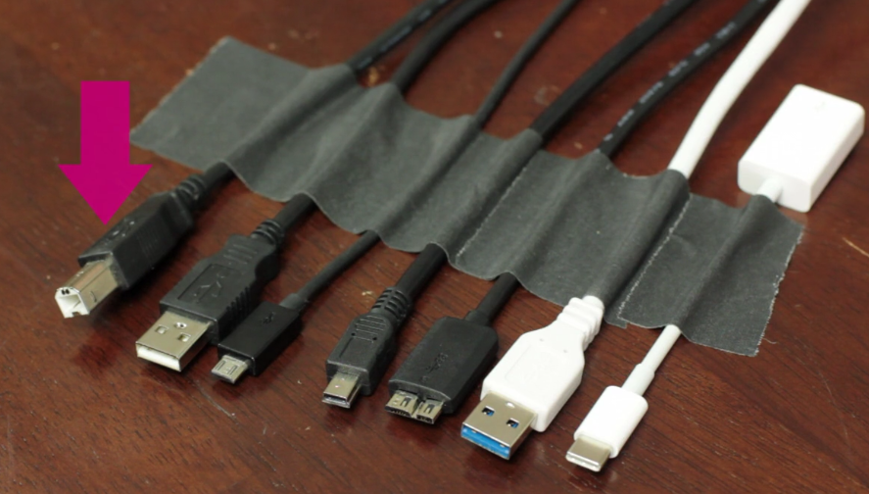

- Left To Right
- USB B(Full), USB A, USB B-Micro, USB B-Mini, USB 3.0 Micro-B,
- USB A 3.0, USB C.
- Black USB Port = 1.0/2.0 Speed.
- Blue USB Port = 3.0 Speed.
- Red USB Port = USB Power Delivery Specification
- Make sure to memorize the USB names and speeds.

- Flash Memory Overview
- Compact Flash (CF) – 1994, invented by sandisk. First widely used flash (Cameras etc.)
- Smart Media Card (SMC) – 1995, pushed by toshiba. Seen mainly in cameras.
- xD Picture Card – Popular flash media used in olympus and fujifilm cameras.
- Secure Digital (SD) – 1999 from panasonic. Took over as one of the most popular flash media formats. Computers, cameras, video recording equipment.
- MiniSD – Short reign, not to popular anymore.
- MicroSD – Most popular modern form of flash memory.

- FireWire and other Connectors
- there are 2 speeds of firewire
- Firewire 400 – 400 MBIT/s a second. 4- conductor and 6 – Connector firewire wire. 4.5 M
- Firewire 800 – 800 MBIT/s a second. 9- pin firewire 800 connector. 4.5 M
- Serial Ports
- Serial Connection -The oldest connection in the history of PC’s. First I/O.
- DB – 9 – 9 Pins, D Shape.
- YOST or Rollover cable – RJ45 on side, serial connection on other. Talks to router directly.
- Parallel Ports – Also an old I/O connection used on PC’s. DB – 25. to centronics connector. Mainly used for printer.
- Firewire comes in two speeds 400 and 800 MB/s.
- Serial ports are associated to a com port by the system
- Parallel ports were used almost exclusively for printers.

- Keyboards and Mice
- Mouse Keys – Use the numeric keypad to move the mouse around the screen.
- Sticky Keys – Press the keyboard shortcuts (such as CTRL + ALT + DEL) one key at a time.
- Toggle Keys – Hear a tone when you press CAPS LOCK, NUM LOCK or SCROLL LOCK.
- Filter Keys – Ignore or slow down brief or repeated keystrokes and adjust keyboard repeat rates.
- The keyboard and mouse are your primary input devices.
- You can configure the keyboard in the keyboard applet and the mouse in the mouse applet.
- Use mild detergent and a damp cloth to clean keyboards and mice.

- Other Input Devices
- Digitzer – tablet great for designing. Uses a stylus. USB.
- Barcode Scanner – Designed to read barcodes. Almost never need special driver. Default windows driver usually works fine since it is pretty much a keyboard.
- Game Controller – USB. Back then joysticks had their own port.
- A digitzing tablet enables somone to write or draw in special applications.
- A barcode scanner turns barcodes into a string of text
- A Game controller can enhance your gaming experience by giving you more control.\

- KVM Switches
- Keyboard-Video-Mouse Switch (KVM) – a way to take 1 keyboard, 1 video, and 1 mouse into multiple systems.
- A KVM enables you to connect multiple computers to a common set of peripherals
- Some KVMS are controlled by physical buttons, while others use hotkeys.
- You can connect more than just keyboards, monitors, and mice; Some kvm switches support sound and other devices.

- Cameras and Camcorders
- Digital Cameras – Usually uses USB, shows up as removable drive.
- Digital Camcorders – USB, HDMI.
- Most digital cameras connect to a PC via USB, though many also offer an HDMI port.
- Digital camcorders also have USB ports, but some include an additional firewire connection as well.
- Cameras and camcorders generally appear on your PC as an external drive.

- Webcams
- Webcams enable you to stream video over the internet, mostly for video chatting.
- Make sure you properly configure your software to use the camera.
- Each webcam also includes its own setup utility.

- installing PC expansion cards part 1
- Understand what new function does your computer need to perform.
- Research. Make sure you find the type of card to do the job you need it to do.
- Power. A lot of cards need their own power connectors. Can your PC make this work?
- Hardware/Software – some cards require certain operating systems and software.
- Physical installation – Make sure motherboard has the inputs for the desired card.
- Driver – make sure windows has a driver, if not, update it.
- Application – After the card is installed and the driver is running you would need an application to take advantage of it. Not much application when it comes to USB.
- Configuration – The type of configuration varies dramatically depending on the device itself.
- Have a reason to install a PC expansion card.
- Install the expansion cards correctly.
- Research and make sure it is the right card for you.

- Installing expansion cards part 2
- Research.
- Physical installation and drivers.
- Application and configuration.

Section 11 Notes

Building a PC
- The Right PC For You
- The right PC for you
- Thick Client- A moderate CPU, moderate amount of RAM, a single hard-drive, optical media, some connections in the front for USB/Audio, connections for video cards, etc.
- Can turn a thick client to a virtualization workstation simply by adding as much RAM as we can.
- When you dont need all the firepower of a thick client, a thin client is what you would need. Often very small devices, these have the minimum hardware requirements for its operating system.
- Graphics/CAD/CAM workstation - Needs high end graphics card, lots of RAM, lots of CPU power, and Wacam tablet etc.
- Audio/Video Editing workstation – Add more higher end sound equipment, an d a couple of monitors.
- Gaming PC – Powerful graphics card, usually running 2 identical ones is a good idea. SLI for nvidia card, crossfire for AMD cards.
- Home Server PC – Stores videos, music etc. Needs lots of storage that responds quickly. Lot of hard-drives for RAID 5 array.
- Home Theater PC (HTPC) – HTPC case, as well as speakers and TV.
- Make sure you know the components for each type of PC.
- Every type of PC is based on the standard thick client.
- When you build a PC, keep your client’s needs in mind.

Section 12 Notes

Display Technologies
- How Monitors work
- Monitors are made up of tiny elements called pixels.
- Red, Green, and Blue pixels mix to form the colors of a monitors
- LCD Monitors use CCFL or LED backlights to light the pixels.

- Plasma and DLP displays
- Light Emitting Diode (LED)-Have longer life than CCFLS. Brighter image.Pretty much a LCD that uses LEDS as back lights instead of CCFLS.
- Plasma – Blacker black. Screen burn in before. Has been gone for years. Nature of tiny lights, screendoor effect. Also uses more power. Prettier image at the cost of other stuff.
- LED Monitors are just LCD monitors with an LED backlight instead of a CCFL Backlight.
- Plasman displays are made up of tiny, electrically-charged elements of gas.
- DLP shines an image onto an array of mirrors to create a display.

- VGA and DVI
- VGA -Video Graphics Adapter – Analog connector. Had to be connected to a Ramdac?. Designed to work with CRTs. Needed digital connection for new flat screen LCD/LEDs.
- DVI – Digital Visual Interface
- DVI-I – (DVI Digital and Analog) Single Link.
- DVI-D (DVI Digital) Single Link.
- DVI – A (DVI Analog).
- VGA is an analog connection, and DVI is a (Primarily) digital conenction.
- DVI is available as DVI-I, DVI-A, and DVI-D.
- Avoid using VGA-To-DVI converters.

- Other Video Connections
- Other Video connections include composite, component, S-Video, Displayport, and HDMI.
- Most High-Definition components use HDMI.
- You can also send video out over ethernet.

- Graphics Cards
- You install a graphics card just like any other expansion card.
- Most graphics cards use chipsets by AMD or NVIDIA
- Use the utilities included with your graphics card to get the best picture.

- Projectors
- Lumens – Brightness projector can fire out to the screen.
- Throw – How far a projector can “throw” the image. Set distance between projector and monitor.
- The brightness of a projector is measure in lumens.
- The size of a projectors display relative to its distance from the screen is called the throw
- Make sure you know how to properly configure a projector in windows.

- Using Multiple Monitors
- You can attach a second monitor to your PC if your graphics card supports it.
- The second display can either extend or mirror the first display.
- You can “Reposition” the monitors in windows to match how they are physically arranged.

- Troubleshooting Video
- VGA Mode/Low resolution mode - If you have a driver problem and no way around it is found, windows boots into what can be compared to as safe mode for video. Allows user to access settings and potentially find a solution.
- You accidentally set your resolution wrong
- Your video driver is not acting correctly.

- No Image On Screen
- Check Connections
- Video cards can push a video mode that your monitor cant handle.

- Overheat/Shutdown
- Video card getting too hot.
- Check for any dirt in your system.
- Make sure to leave enough room for your video card to breathe.

- Dead Pixels
- Its not getting any signal at all. Not getting color, but stuck in a certain color.
- Replace your monitor.

- Artifacts
- Check your connections.
- Your video driver cant handle the task at hand.
- Overheating video card
- Video RAM. Video ram on video card can go bad and manifest itself as artifacts.
- There is nothing wrong. Depending on how someone compresses something this can happen.

- Color Patterns Incorrect
- Check you on-screen display settings.
- Check your connections. One pin not connected perfectly can cause this.

- Dim Image and Flickering Image
- Check brightness on your monitor.
- Check if you need to replace CCFLS, LEDS, or the inverter. Most likely replace monitor.
- Nowdays flickering is cause by connections.

- Distorted Image and Distorted Geometry
- Overscan – Sometimes screen makes the image bigger than the display itself. Check onscreen display for overscan setting.
- Projectors – Pin cushioning, side of images go in or out. Keystoning, weird trapezoid shape. Projectors can be modified to fix distortions.

- Burn In
- Old fashioned issue. Image is permanently burned into screen.
- With today's technology this has generally disappeared.
- Transient Image Persistence (Image Sticking) – modern day burn in. Repairable if you know what to do. Try to run something to “unstick” those pixels.

- Oversized Images and Icons
- The computer has booted itself into VGA mode, or drivers are acting up.
- Windows settings -Medium/large Icons
- Custom DPI Setting – 100%-300%

- Plugged in, Turned on, and good connections.
- Check drivers and settings.
- Use on-screen display settings.

Section 13 Notes

Essentials of Networking

- Introduction to Networking
  - A web browser is a web client.
  - Servers provide access to the data.
  - Clients use some kind of network connection to access data on the server.
  - Clients and servers aren’t hardware—They’re software.
- Moving Data Over a Networking
  - MAC address – Media Access Control address.
  - Data is sent across a network in discrete pieces called frames.
  - Hubs and switches are devices that connect multiple devices so they can send and receive data over a network.
  - Every network device has a unique identifier called a MAC address.
- Structured Cabling
  - Structured cabling uses wall outlets and patch panels to protect and organize your network equipment.
  - Patch cables connect your PC to the wall outlet
  - Most patch panels are stored in equipment or telecommunication rooms.
- Patch Cables
  - UTP – Unshielded twisted pair (Ethernet)
  - CAT3 – 10MBs Ethernet network.
  - CAT5 – 100MBs Ethernet network.
  - CAT6 – 10Gbs Ethernet network, short distance.
  - CAT6A – 100 Meter distance.
  - TIA/EIA 568 A and B -
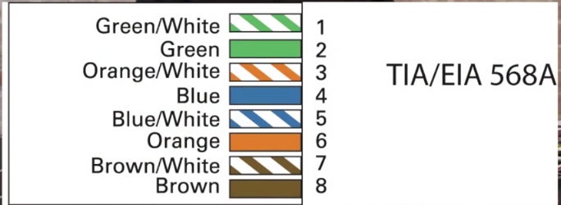
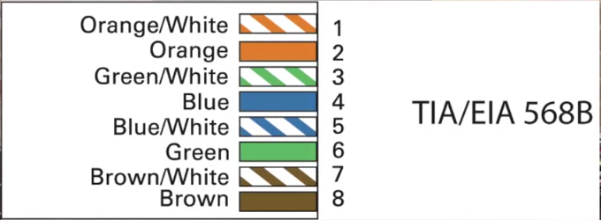
  - PVC – No fire rating at all.
  - RISER – Better than PVC but not as good as plenum.
  - PLENUM – Best fire protection you can get. Standard for horizontal run.
  - Know the difference between CAT 5 and CAT 6.
  - Use a crimper to attach the Ethernet connector.
  - Plenum cabling is used to prevent noxious fumes from burning cable.
- Fiber Optic and Coaxial Cables
  - Fiber optic cables support very long lengths. 40 KM is not uncommon.
  - Fiber optic cables are immune to electromagnetic interference.
  - Fiber optic makes use of 2 types of light
    - Laser diodes generate laser light.
    - Legs generate visible and infrared light.
  - Single mode cable uses laser light. Designed for it specifically.
  - Multi-Mode cable (More common, cheaper, slower) uses (regular light, LEDS) visible and infrared light.
  - When working with fiber optics there is always two cables. One for sending, one for receiving.
  - Duplex cable- two cables fused together.

  - There are hundreds of different fiber optic cables. Luckily the comptia a+ only covers 3.
    - ST Cable (Stick and Twist) – Round connector, one of the oldest connectors around.
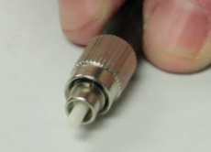

    - SC Cable (Stick and Click) – Square connector.
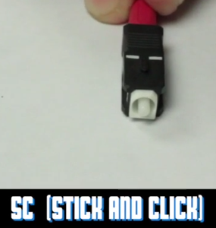

    - LC Cable(Local connector) – Duplex cable, smaller takes up less space.
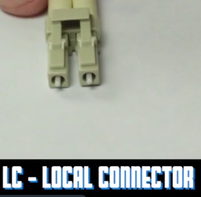

- Coaxial Cable
  - More than one connection that shares an axis.
  - Has at least 2 conductors.
  - RG = Radio Grade.
  - RG-6 -Used to connect cable to cable modem.
  - RG-59 – used to connect old cable TV boxes.
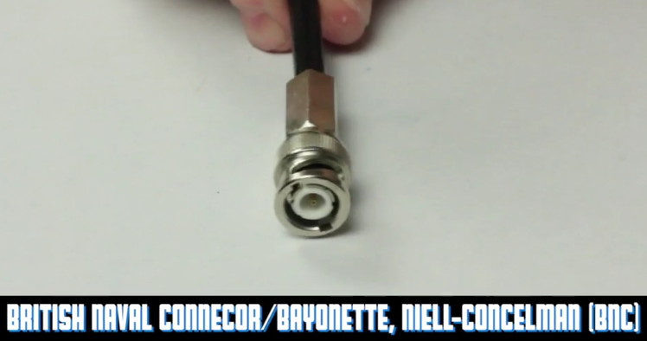

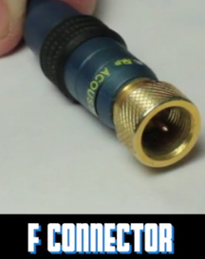

  - Know the benefits of Fiber Optic Cable, Fiber optic cable and connector types.
  - Know Coaxial cables and connectors.
- Networking Tools
  - Cable Tester – Tests continuity and wire mapping simultaneously.
  - Micro Scanner - Tests everything at the same time. Continuity and wire mapping. More sophiscated ones include TDR system.
    - Uses TDR (Time Domain Reflectomter) to tell you the cable length.
    - Tone Generators - Doesn't fix anything but helps you find stuff.
      - If you have a bundle of cables and are looking for one particular cable you can plug in one end of the cable to the micro-scanner and use the tone probe to listen and find this particular cable.
      - Tone Probe – Listens for tones generated by tone generator.
- A cable tester ensures that a cable is functioning and has been wired properly.
- The more money you spend on a cable tester, the more features it will have.
- Use a tone generator and tone probe to locate cables.
Section 14 Notes

Local Area Networking
- Introduction to TCP/IP
  - LAN(Local Area Network) – A number of computers that are physically connected to each other via a switch and are all part of the same broadcast domain.
  - Routers don’t care about MAC address they only care about logical addresses.
  - (TCP/IP) - Transmission Control Protocol/Internet Protocol
    - Started with 3 dots since it was thought you would never be further than 3 routers away from the top of the internet. IP part of TCP has replacements in modern times as a result.
    - IP address consists of 4 values (1-254 with three dots in between ie.192.168.0.9)
  - A small group of physically close computers is known as a local area network.
  - IP addresses are logical addresses, as opposed to MAC addresses, which are physical.
  - IP address notation includes four sets of numbers [1-254], each seperated by a dot.
- Network IDs and Subnet Mask
  - Node addresses cannot be all 0’s or all 255’s.
  - Set a Static IP Address – Provide IP addresses, subnet mask, and default gateway.
  - Default Gateway – Local Area Network connection on router.
    - By convention, default gateways get node addresses of .1 (Or .1.1 or .1.1.1)
  - Within a network ID every computer has the same subnet mask.
  - IPConfig shows IP address, subnet mask, and default gateway.
  - Set a static IP address – Provide IP address, subnet mask, and default gateway.
  - Node address must have the three values first.
- Dynamic IP Addressing
  - DHCP – Dynamic Host Configuration Protocol.
  - “Obtain an IP address Automatically” causes windows to call out for a DHCP server.
  - APIPA – Automatic Private Internet Protocol Addressing. Always begins with 169.254
  - IPConfig /Renew causes your IP address to reset.
  - IPConfig /Release causes your machine to forget its IP address.
  - Rogue DHCP server hands out unauthorized IP adderesses.
  - Use alternate configuration tab to set fail-over behavior if no DHCP server is available.
    - Fail-over options are to use APIPA or static IP address settings.
  - Use your DHCP server, Know your network ID.
  - IPConfig / Renew and /Release can help manually get an IP address.
- NAT
  - NAT – Network Address Translation (NAT)
  - Routers use NAT to share a single IP address with multiple systems.
  - NAT rewrites the private IP address of the client as the public IP address of the router.
  - The same is done in reverse with the return packet.
- Special IP Addresses
  - Broadcast address is 255.255.255.255. Every computer on LAN is going to listen and take in whatever that packet is.
  - LoopBack is 127.0.0.1 – LocalHost is the same as 127.0.0.1
  - APIPA is 169.254.X.X
  - Private IP Addresses- there are 3 types
    - Anything that starts with a 10. Ex. 10.14.22.34
    - Any IP address that goes from 172.16 to 172.31. Ex. 172.16.0.1 , 172.31.255.254 ,
172.26.100.10.
    - 192.168.X – Most famous type of private IP addresses.
  - LoopBack 127.0.0.1
  - 3 private address ranges: 10.node.node.node, 172.16.node.node – 172.31.node.node, 192.168.X.node.
  - Broadcast address is 255.255.255.255.
- PING and IPConfig
  - Ping can perform IP address to name translation.
  - IPConfig/All shows most IP configuration information
  - IPConfig/FlushDNS clears the DNS cache
  - Ping/T Causes continuous pings
- TCP, UDP and ICMP
  - TCP Runs over IP
    - TCP – Transmission Control Protocol
    - TCP is connection oriented – TCP negotiates to create a connection between client and server.
  - UDP – User datagram protocol. Not connection oriented, connection-less so they say.
    - Datagram means unacknowledged.
    - DHCP Uses UDP.
  - ICMP – Internet Control Message Protocol – connection less but only one packet.
    - ICMP is used by Ping.
- TCP is a connection oriented protocol.
- UDP is a connection-less oriented protocol.
- ICMP is the maintenance protocol for an IP Network.

- Port Numbers
  - A value through (0-65535) that is part of every TCP or UDP packet. Every TCP or UDP packet has 2 port numbers. The first port number is used by the receiving system to determine the program that needs to receive this data. The 2nd one works like a return address that the receiving system uses when it responds.
  - Every web server on earth is designed to listen on port 80.
  - The powers of the internet have set up the first 1024 port numbers as well known port numbers. Here is a list of port number you have to memorize for the a+
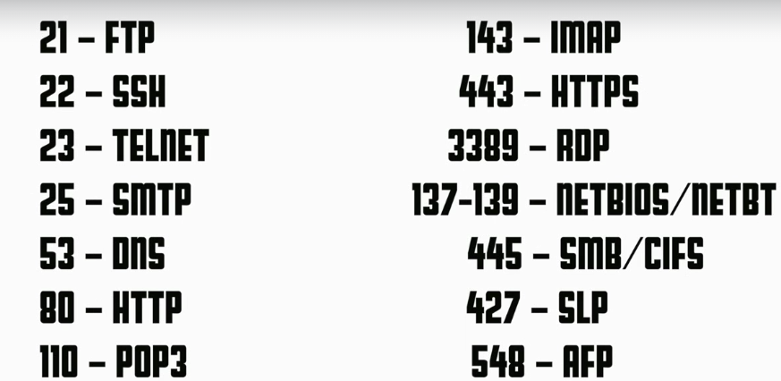
  - Whats important right now is to understand that every-time two devices connect there are two port numbers associated with that individual connection.
  - Port numbers range from 0 – 655535
  - Every TCP and UDP packet has two port numbers.
  - The first 1024 ports are called “Well-Known” ports.

- Working with Connections
  - Netstat shows connections to and from your computer.
  - Netstat gives us a quick way to see what connections are currently on this particular system.
    - Netstat -n shows network statistics numerically
      - Common for webpages to go from established to time wait. They make a connection, hand the page to the client, go into time wait and actually close.
  - Netstat -A shows all network statistics.
    - Shows everything that is going on whether it is an active connection or its listening, whatever it is you will see it.
    - One of the challenges wit netstat is its a cmd tool and you have to retype it to refresh.
  - TCPVIEW
    - TCPVIEW shows network connection information in graphical format.
    - Allows us to know who is connecting on my computer at any given moment.
- It is important to keep track of sessions.
- Netstat is built into windows
- TCPVIEW is a graphical and a quick download from microsoft.
- Understanding DNS
  - Domain Name System (DNS) – A bunch of computers that's job is resolve IP addresses based off fully qualified domain names (FQDN). Take these FQDN’s and find out what the IP addresses are then hand them to the computer.
  - Contact list on a mobile phone works the same way as DNS servers to IP addresses.
  - WWW.TOTALSEM.COM
  - Host---Secondary----Top Level Domain
  - Typing IPConfig/all will show DNS server information.
  - Dns servers go up and down all the time. Try Googles DNS Server: 8.8.8.8 – super powerful DNS server that works for just about anybody, often faster than ISP’s dns server.
- DNS resolves FQDNS to IP addresses
- www.totalsem.com is an example of a FQDN
- .com and .edu are examples of top-level domains (TLDS).
- Dealing with DNS
  - Google’s public DNS Servers 8.8.8.8, 8.8.4.4
  - Use IPConfig / all from command line to see the IP Address of your DNS Server.
  - If you ever run into a situation where someone needs to know the ip address of your dns server make sure to run IPConfig / all.
  - How do you know if DNS is down? Usually when you can’t get on the internet(really you are on the internet but the DNS is down!)
    - Ultimate test – Use ping to test internet connections and DNS.
      - Even if you ping by a FQDN it responded back with an IP address. If your DNS server is truly down that wont happen.
      - If you can access something by its IP address but not by its FQDN the DNS server is down, or your disconnected from it.
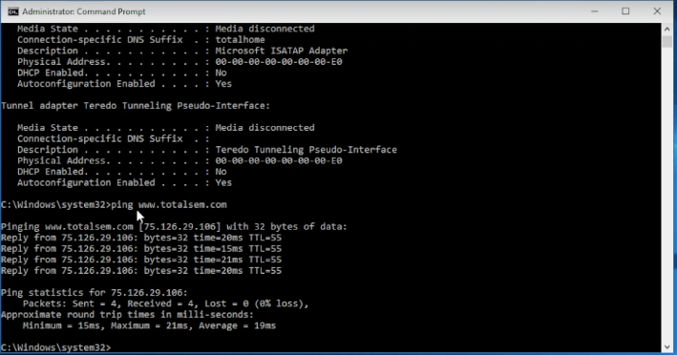

  - nslookup tests DNS server functionality.
  - Use nslookup for name to address translation.
    - Quick and dirty way to see what DNS server you are using right now, also a qay to query a DNS server to see if it is up and running.
- Googles public DNS servers are 8.8.8.8, 8.8.4.4
- Use Ipconfig and ping to quickly test DNS
- nslookup is a command line tool to quickly look up DNS entries.
- Windows Naming
  - Know the difference between work group and a domain.
    - When you install windows initially you 1. give your computer a name, 2. you give it the type of network its in (Work-group or domain).
    - Computers in the same work group are called peers, all connected to same switch. When they boot up they broadcast their names and all computers on the network “write these names down” in-case they need to talk to each other and then they can instantly see each other within the group.
- In a domain you are installing another computer. Not a regular computer, this runs Windows server.
  - Server is different than home editions. For example, windows server has a built in DHCP server, as well as a DNS server. Features you would not see on home versions.
- Home editions of windows cannot join domains.
- Windows clients default to workgroup connection
- All major operating systems support samba
- Remote desktop is used to talk to your servers.
- NET Command
- When you type Net it will give you an idea of what you can do.
  - Net View
    - running net view by itself is a great way to make a quick and dirty look of what computers can the system see within the workgroup its in.
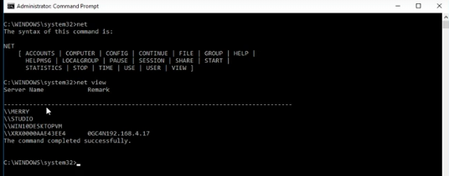

- Net User – Answers the question, who am I right now in terms of the network.
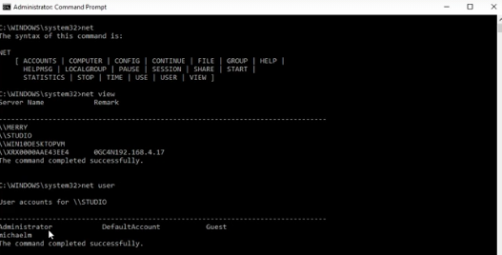
- Net view \\specificComputer – shows actual shares from particular system.
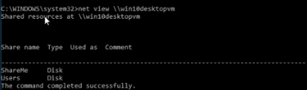

- Net Use – used to map a drive – assigning a drive letter to a shared folder.
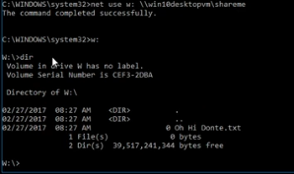

- Net Share – lets you choose a file to share to the workgroup?

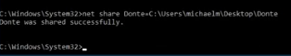

- Net accounts – handy way to get an idea of what type of settings you have for all your accounts.

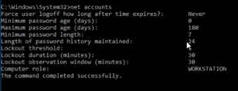

- Net Start/stop – a bit dated (can run services.msc instead to start and stop services). Shows all services that are network based and you can use Net Stop to stop any particular service.
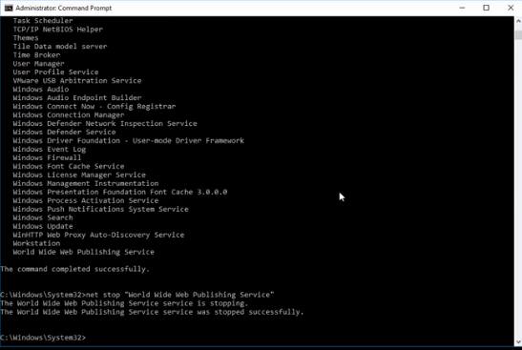

- The net command is a very old command that helps you manage your network.
- The net command has many different options to manage and manipulate your network (Net use, Net share, etc.).
- The net view command shows everything that is on the network.
- NETDOM Command
  - Domain – A group of computers that are under the administration of one or more windows server systems. These server systems run Windows Server. In order for your computer to join a domain you actually have to go over to the server and type in certain commands.
  - Domain is a group of computers under a windows server.
  - Netdom add can add new systems to a domain.
  - Netdom remove can remove any system on that domain.
- Windows Name Resolution
  - Netbios- ports 137,138,139
  - Around the time vista came out-Link Local Multi-Cast Name Resolution (LLMNR) – Runs on udp port 53,54 – vastly improved name resolving service, much better than net bios.
  - Win 10 pro uses both Netbios and LLMNR
  - Win Home uses only LLMNR
  - NBTSTAT – cmd prompt tool
  - Every windows system has a registered name. Make sure your system knows who it is. Best way to to this is use nbtstat -n.
  - nbtstat – r = Clears remote cache table
  - nbstat – RR = all registered information rebroadcasted and reestablished.
  - Keep in mind nbstat is a netbios tool, dosent work to well with LLMNR but you can find yourself turning to it to make quick fixes when you cant find your computer on your network.
  - The netbios protocol creates and manages connections based on names of computers within a LAN.
  - The link-local multicast name resolution (LLMNR) allows for name resolution for hosts on the same local network.
  - The nbtstat diagnostic command can be useful, but has some issues with LLMNR.
- Routers
  - Routers by definition interconnect broadcast domains.
  - Each network card inside the router has an IP address.
  - The connection that connects to the internet is the WAN. The rest are LAN.
  - The routing tables lists the instructions used by the router to send packets out.
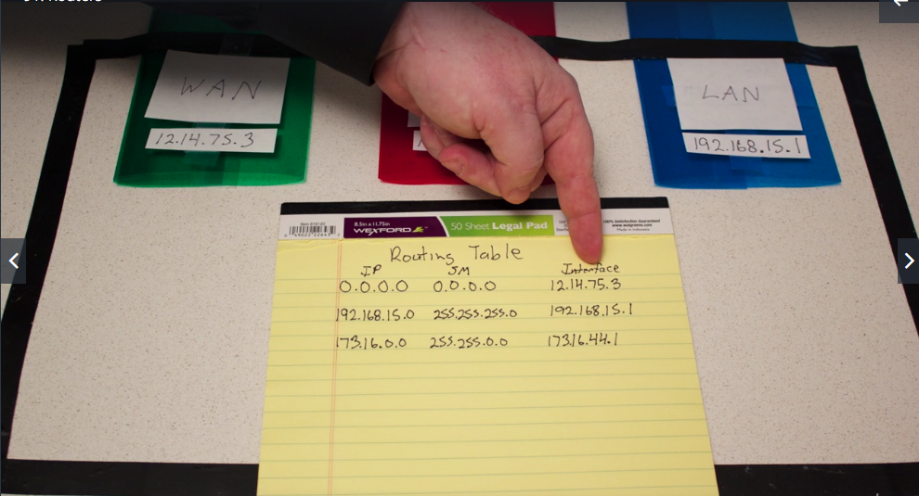

  - Routers don't care where packers come from, they only care about where packets go
  - Routers use routing tables to decide where to send each packet.
  - All broadcasts are eliminated.
- Configuring Routers
  - SOHO routers = (Small Office / Home Office).
  - PPPoE – Is essentially a tool set that allows internet providers to make you login before they give you the internet. If you have a ISP who actual needs you to login you select PPPoE and fill in the username and password section on the router setting page.
  - Almost all SOHO routers are configured through a web browser
  - Change all default passwords and IP addresses.
  - Document EVERYTHING!
- Advanced Router Configuration
  - 3 very specific things done on SOHO routers
    - Port forwarding
      - Port-forwarding opens one or more ports to internet requests.
      - Happens when you have something inside your network that you want to access.
    - Port triggering
      - Similar to port forwarding, but its not permanent. Has to be started by someone inside your network.
    - Quality of Service
      - The ability to slow down traffic that is less important and to allow traffic that is important through when the bandwidth is really heavy.
      - Tool you would use when you have an issue with things slowing you down. If things aren’t slowing you down you wouldn't need QoS.
      - Typically used for VoIP (giving it highest priority to avoid choppy voice) and game servers.
- DMZ – Demilitarized zone – Anything that comes in from the internet, send it to one particular system.
- Port forwarding opens one or more ports permanently.
- Port triggering opens one or more ports temporarily.
- Quality of service allocates bandwidth by port number.

Section 15 Notes
Wireless Networking

- Wireless Network Hardware
  - 802.11 standard been around for over 15 years.
    - To create a 802.11 network you are gonna need a couple items
      - Wireless NIC.
      - Wireless access point. - Only has one ethernet port in the back. Bridge between wireless and Ethernet network.
      - SOHO routers have multiple ethernet ports usually but also have several things built in (switch + wireless access point a the same time).
  - In order to set up a wireless network you have two choices, Ad-Hoc VS. Infrastructure mode.
  - To connect to a wireless network, your pc needs a wireless NIC.
  - You also need a wireless access point to which PCS can connect.
  - Many wireless access points are packaged with switches and routers.
- WI-FI standards
  - 802.11 – came out in 1997 and has become the standard.
    - 802.11 A
      - Came out at roughly the same time as 802.11 B.
      - Ran on the 5 GHz ISM band – 54 mb/s.
      - Less popular because technical issues when it came out, secondly B had a much wider range. B can serve a lot more people cause of its range.
    - 802.11 B
      - First big (arguably) popular 802.11 standard.
      - Ran at 2.4 GHz ISM band – 11 mb/s (gotten a lot faster).
    - 802.11 G
      - Took all the goodness of A and B and put it all in one standard.
      - 2.4GHz band – 54 mb/s a second.
      - Backward compatible with 802.11 B .
      - Radios in wireless access point of 802.11 A run at a different band so there is no compatability.
    - 802.11 N
      - Ran on 2.4 Ghz and 5 Ghz – 600 mb/s
      - Introduced MIMO: Multiple Input, Multiple output.
      - 5 GHz is for native 802.11 N features.
      - 2.4 Ghz is for backward compatibility with 802.11 B and G.
    - 802.11 AC
      - Runs exclusively at 5GHz band. - 1 GB/s.
      - Up to 8 Streams with MIMO.
      - MU-MIMO supports up to 4 clients at once.
- For a 802.11 A B and G you have one antenna that send and one that receives. 802.11 N started to change things.
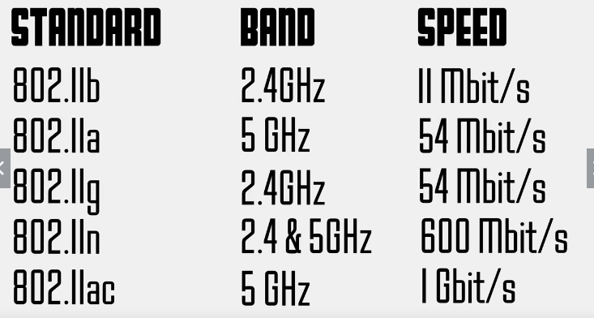

- Basic WAP Setup
  - SSID – Service Set Identifier – Names your wireless connection.
  - Set Channel – Auto or Manual Selection.
    - Can use a site survey. (Wifi Analyzer – Give an idea of what wireless networks are in your area right now.)
- Wireless Encryption
  - WEP, WPA, WPA-2 Personal (best).
  - Make sure you know the strengths and weaknesses of each wireless encryption standard.
  - WEP is insecure – DON’T USE IT.
  - WPA2 is the strongest Wi-Fi encryption. USE IT!
  - If you put a wrong password and cant get on the internet you are probably an a ipipa address (169.254)
- Wireless Problem Scenarios
  - Interference is a common issue. If your expected speed is 65mbps and your getting 11mbps you might be having a interference issue.
  - Use windows utility to check wireless speeds.
  - Changes made to WAP settings will no longer match client profiles. Forgetting and reconnecting to the network will renew the client profile.
  - Interference can disrupt or slow wireless connections.
  - Sources of interference can include other WAPS wireless mice and keyboards, and even microwaves.
  - Remove sources of interference or change the WAP’s frequency to avoid interference.
- Connecting to a WI-FI network
  - Wi-Fi Protected Setup – WPS
  - From windows, you can easily view all nearby wireless networks
  - Make sure you know the SSID and password for the network you want to connect to.
  - Using WPS to connect to a Wi-Fi network with a single button sounds great—But don’t use it!

- Troubleshoot Wireless Connections
  - Make sure your antenna are positioned to avoid interference.
  - Check the settings in your way configuration to ensure you are not on the wrong channel.
  - Use mac filtering to keep outsiders off your wireless network.

- Bluetooth
  - Profiles – Has to have the ability to need certain functions or provide certain functions.
    - Ex. Bluetooth headset provides speaker and microphone so it connects to a phone, your phone would like to use the microphone and speaker so there is a particular profile that handles that.
    - Personal Area Network (PAN) – Where two devices can share data among themselves
    - Connect iphone in mini-cooper, uses Telephone and Audio functions (2 profiles used here).

- Pairing
  - Class 1 = 100M
  - Class 2 = 10M
  - Class 3 = 1M
- Bluetooth is great for short-term connections with headsets and cars.
- There are multiple Bluetooth profiles that control how the connection works
- make sure you know the three classes of Bluetooth.

Section 16 Notes

The Internet

- Internet Tiers
  - There are 2 tiers of companies that provide internet to the united states.
    - Tier 1 – Companies that run by period agreements. Most of everything that is the internet is tier 1.
    - Tier 2 – Has some amount of period agreement but has to pay the tier ones to connect to them.
    - Tier 3 - Not paying for their own big lines for the most part they are paying tier 1 or tier 2 companies for access to the internet. Ex. Comcost Corp (provide internet for millions of US customers.
  - Tier 1 providers control the biggest and highest level internet connections.
  - Tier 2 providers connect to tier 1 providers.
  - Tier 3 providers are often internet service providers for consumers.
- Dial-up Connections
  - Dial-up connections are, by todays standards, incredibly slow.
  - You can configure your modem, including setting your ISP’s phone number, from within windows.
  - ISDN can transfer data twice as fast as a traditional dial-up connection.
- Broadband Connections
  - DSL – Digital Subscriber Line.
  - PPPoE – Point-to-point protocol over ethernet
  - Cable – Coaxial cable with F-type connecter.
    - Great way to move data. For this reason cable companies have been using it for many many years.
    - Shared network. Everyone from your neighborhood plugs in to the same “hub”.
  - Fiber optic – Essentially high speed DSL.
    - Usually comes with a TV service as well. Very competitive with the businesses using cable connections still.
  - DSL is the slowest broadband connection and connects to a phone line.
  - Cable is the fastest broadband connection and uses coaxial cable.
  - Fiber optic is the fastest broadband connection and uses fiber-optic cabling.
- Wireless Internet Connections
  - Cellular WAN
    - When originally designed they were not designed for data at all, they were analog devices designed to voice.
    - Now they have moved into the world of moving data as well as voice, there have been a huge number of technologies now (ex. GSM, LTE etc).
    - GSM popular form of what we call 3G.
    - LTE popular form of what we call 4G.
    - Long-Term Evolution (LTE) VS Worldwide interoperabilty for microwave access (WiMax)
  - 802.11
    - Most people think of a WAP in a home office but companies such as t-mobile and ATT provide commercial hotspots in airports for example.(Number of different access points with one logon).
  - Metropolitan Area Network (MAN)
  - Satellite – Companies have antennas/dish running coaxials to a “box” then to rj-45.
    - Lots of latency, stops and skips. But Satellite is reliable.
- LTE is the primary 4G protocol for cellular internet connections.
- Metropolitan area networks are usually built from 802.11 hotspots.
- Satellite internet connections are relatively slow, but available from any place with a clear view of the sky.
- Internet Applications
  - TCP vs UDP
    - TCP – The reason they call TCP/IP that is because TCP is the primary heavy lifting most of the time protocol we go to for moving data between two computers.
      - When you want super reliable data, TCP is the way to go.
      - 95+% run TCP, connection oriented and they make sure the devices are talking to each other.
    - UDP – More simplistic. Used when your not so worried about the data.
      - In a UDP situation the client will simply shoot the data over to the server and whether the server is ready or not it will get it.
      - Used in situations fir example utilities and stuff we absolutely guarantee we know the servers are up and running.
      - UDP is connection less. Only used in situation for a very small number of utillities where you want to just send the data, UDP is a lot faster than TCP and that is a huge advantage.
- A TCP connection ensures that the sender and receiver are connected.
- UDP Connections do not check for a receiver; They send data either way.
- Internet applications use ports to ensure that data is sent and received properly.
- Telnet and SSH
  - Telnet- Basically a remote terminal emulator that lets you get to somebody else’s command line.
    - Telnet comes with windows (comes with pretty much any client).
    - Telnet servers require usernames and passwords.
    - Allows you to remotely connect to someone else’s command prompt.
    - Telnet uses Port 23.
    - Telnet is completely unsecured, unencrypted. If you were sat at the other computer you can see login credentials in the clear.

  - SSH- More secure.
    - Secure Shell (SSH) Putty is a very flexible terminal emulator program.
    - Client for all kinds of remote connectivity.
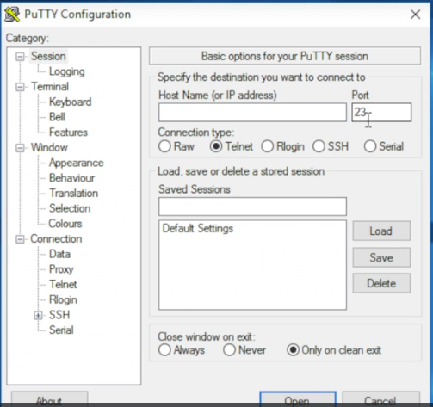

    - SSH – Port 22 + Encrypted.\
    - Doesn't look any different from telnet, but all data is encrypted and receiving end has a decrypter. Anyone sniffing around isn't able to see what your doing.
    - Telnet is an unsecured remote connection utility that uses port 23.
    - SSH is a secure terminal emulator that encrypts data.
    - SSH uses port 22.

- HTTP
  - HTTP
    - Uses Port 80
  - HTTP(S)
    - HTTP(S) – Hypertext Transfer Protocol (Secure)
    - Uses Port 443
- NetStat
  - Netstat -n – Turns everything to numbers
  - Netstat -n -a – Turns everything into numbers, than also shows every connection that is on the computer including listening ports.
- HTTP: Port 80 | HTTPS: Port 443
- HTTP is not secure | HTTPS is secure
- Use netstat to check for port 80 and port 443 traffic.
- E-mail
  - Simple mail transfer protocol (SMTP); Port 25
  - Post office Protocol 3 (PoP3); Port 110
  - Internet Message Access Protocol (IMAP); Port 143
- FTP
- File Transfer Protocol (FTP); Port 20 and 21
- Secure FTP (SFTP); Port 22
- Using an FTP client like filezilla can make FTP transfers a lot easier to manage.
- Remote Desktop Connections
  - Telnet- Basically a remote terminal emulator that lets you get to somebody else’s command line.
    - Telnet uses port 23.
  - Secure Shell (SSH); Port 22
    - Telnet and Secure Shell do not let you see the desktop of the computer you are accessing remotely only the command line.
  - Remote Desktop Protocol (RDP); Port 3389
    - Windows comes with this.
    - Pressing the windows key and typing “NSTSC” brings up the remote desktop connection client.

- File Sharing
  - Netbios over IP aka Netbios/NetBT
    - Had some big limitations and years ago it was dumped.
  - Common Internet File System (CIFS).
    - Even though it is on the A+ it is considered an obsolete term.
  - Term used today is Server Message Block (SMB)
    - Port 445 SMB
  - A Useful tool is TCPView from Sysinternals.
    - Can do the same thing through the netstat command but this is much more user friendly.
  - Ports 137-139 CIFS/Netbios over IP
    - Old school netbios over IP port numbers.
    - If you want to share folders and files on a windows system you need these ports.
    - Ports 137-139 and port 445 are need to do what you want to do (share folders and files.)
    - Port 548 Apple Filing Protocol (AFP)
    - Linux emulates SMB with Samba.
  - Nebios Over IP/CIFS – Ports 137-139
  - SMB – Port 445
  - AFP – Port 548

Section 17 Notes
Portable Computing

- Laptop Types
  - Standard Laptop
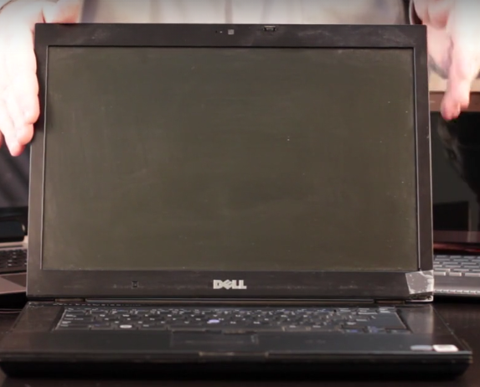

    - Going to be having somewhere in the area of about half a gig to one gigabyte of ram.
    - It's going to be running some form of mobile Intel processor.
    - It will have a two and a half inch drive.
    - It will have optical media but the important thing here to appreciate is that this is just running regular Windows there is nothing special about it.
    - It might be 32 bit Windows it might be 64 bit but it's just running Windows and that is a regular good ole laptop.
  - Desktop Replacement
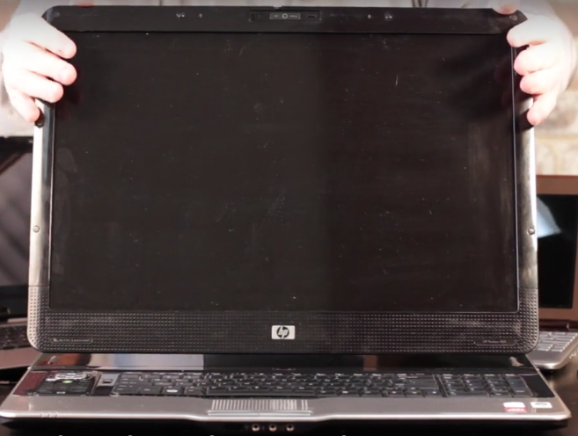

    - A desktop replacement is going to boast a really big screen. Usually in the area of up to 21 inches.
    - A desktop replacement is going to have tons of RAM. It could have 4, 8, 16 gigabytes of RAM in it. It's going to be running the highest end of Windows possible it's always going to be 64 bit, full size keyboard, two big hard drives a lot of times usually two sets of optical media.
    - This is the no compromise type of system for basically somebody who wants to bring everything with them.

  - NetBook

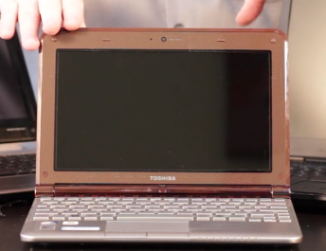

    - Netbooks are distinct from other types of laptops and that a lot of times they don't run a typical Intel or AMD processor, a lot of times they'll run an Intel Atom type processor. These are 32 bit processors they run great There's nothing wrong with them.
    - They usually have very small amounts of RAM in a lot of cases they don't even have hard drives they'll just use SD cards or solid state drives for their storage needs. The other thing to keep in mind is that they tend to run very low end version of Windows like Windows starter and stuff like that
    - For the A-plus exams make sure you know low end version of Windows but reality of lot of these guys run Linux.
  - UltraBook
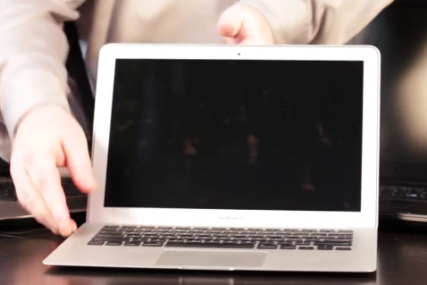

    - He (MacBook Air) was the inspiration for a series of windows based laptops known as UltraBooks
    - Ultra books are distinct in a number of ways that shares with this guy right here. First of all they're extremely thin and extremely light. By definition all of their storage is going to be solid state.
    - They lack optical media but they're going to have plenty of RAM a big screen and a nice CPU to back it all up with. So what it sacrifice is in storage it makes up for in big screens nice firepower and lots of RAM.
  - Tablet PC
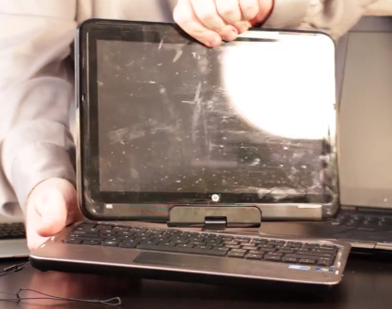

    - But what we're talking about tablet PC we are covering a very specific objective on the comp to the A-plus exams that talks about this type of fellow in particular.
    - These actually predate what we called tablets now and they're distinct in that in some way they can be treated as a tablet without a big keyboard. The important thing to distinguish these is that these will always use a stylus.
    - Now this guy's running just a regular version of Windows 7. But the big differences is that Windows 7 has a lot of features that make a tablet PC aware. So what I want to do is take a minute and let's take a look at some of the Windows 7 tablet features
    - When you have a real tablet PC you get some control panel options that you wouldn't normally see. In windows 7 it's called pen and touch and in Windows Vista it's called Pen and input devices but it still works the same way either way.

  - Make sure you know the many types of laptops
  - Some laptops can replace while others are weaker but much more portable.
  - Don't confuse tablet PCs with other tablets; They’re entirely different.

- Laptop Expand-ability
  - Mini- PCIE

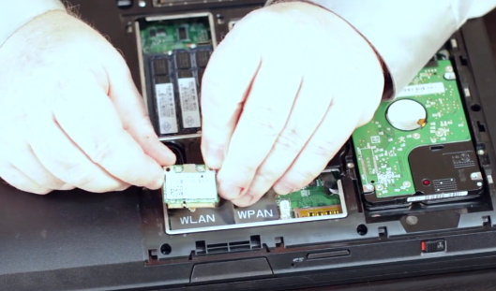

    - Wireless NIC often connected here.
    - Sectioned off by WLan and WPan. Can connect into either one but it is labeled to be better organized.

  - Docking Station
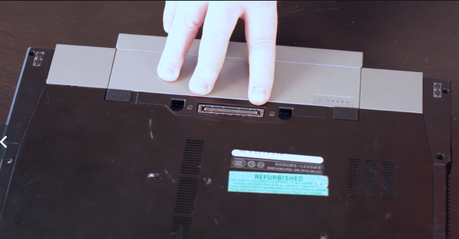

    - So it's a full blown docking station but I have to have a proprietary connector so if I want to add even more expand-ability I can buy a Dell docking station for certain Dell laptops and I get a lot more extra connectors.
    - Keep in mind docking stations are proprietary to particular makes and models of laptops.
  - PCMCIA
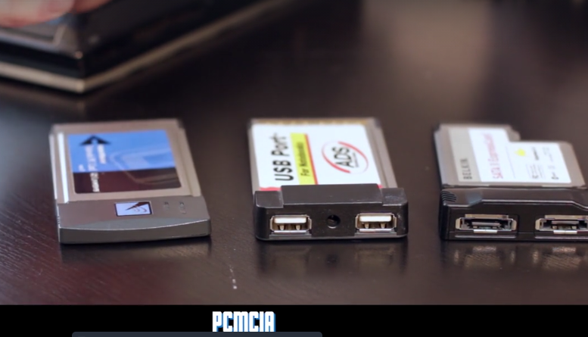

    - 16 bit type connector.
    - Same width, thickness varies. Type 1 being the skinniest, type 3 the thickest.

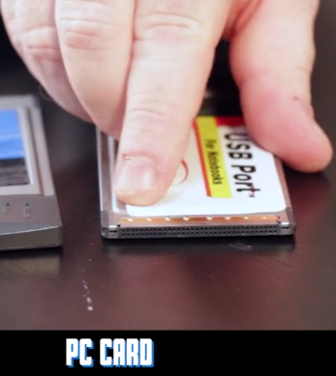

    - A few years later PC card was released, distinct metal at ends, 32 bit connector.
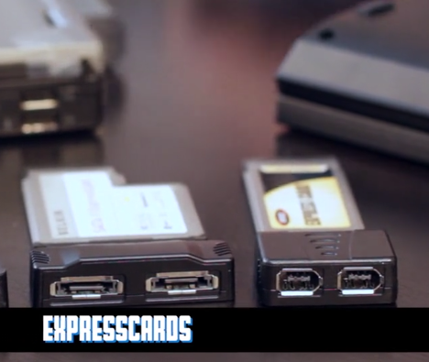

    - ExpressCards - come in 34MM and 54MM widths. Not interchangable with PCMCIA/PC card.
  - There are often spaces inside your laptop for more RAM, Hard drives, optical drives, and more.
  - The earliest expansion cards for laptops were PCMCIA, and PC cards.
  - More modren expansion cards include expresscard, although even it may be on its way out.

- Touring a Laptop
  - Light Crystal Display (LCD)
    - Tn or IPS.
      - TN – Oldest of first generation of LCD.
      - IPS – Better contrast, and range of view. Generally prefered
  - Organic light emitting diode (OLED)
    - Instead of CCFL, uses LED. LED uses less power, can be brighter and have much longer life.
  - Both have a backlight, could be Cold Cathode Fluorescent Light (CCFL)
  - Screen backlighting – LED and CCFL
  - Monitors – TN and IPS
  - Laptop Upgrades – RAM, drives, CPU, Motherboard, peripherals
- Laptop Ports
  - SD Card Reader
  - USB-3
  - VGA
  - Ethernet
  - HDMI
  - Mini-Display Port-forwarding
  - eSata
  - Display Port
  - Adapters exist to adapt most ports
    - Macbook Air
      - Thunderbolt Connector
  - Recognize Laptop Ports
  - Know their function
  - USB dongles for everyone!
- Proper Laptop Disassembly
  - When opening a laptop, make sure to keep track of all the little pieces you remove.
  - Draw a sketch or take a picture so you remember where everything goes.
  - Use the documentation provided by the manufacturer.
- Power Management
  - ACPI – Advanced Configuration and Power Interface (ACPI)
    - ACPI On – Everything is Running
    - ACPI Sleep – Keeps RAM powered and shuts off all other systems.
    - ACPI Hibernate – Saves RAM to disk then powers everything off.
    - ACPI Hybrid – Saves RAM to disk but keeps RAM powered for rapid boot.
  - Windows Power Plans
    - Balanced
      - Automatically balances performance with energy consumption on capable hardware.
    - High Performance
      - Favors performance, but may use more energy.
    - Power Saver
      - Saves energy by reducing your computers performance where possible.
  - Power Options
    - Generally bios power settings are ignored by operating system.
    - Hybrid sleep defaults to disabled on laptops.
    - Hybrid sleep defaults to enabled on desktops.
      - The reason for this is because when your on the go and throwing around a laptop (closing screen to shut off, shaking in a laptop/book-bag, etc.) having a hard drive begin operating at that point in time to make a copy of RAM can cause damage to it and is a bad idea. Desktops would not have this problem.
    - APM and ACPI
    - Sleep VS Hibernate VS Hybrid
    - Wake on LAN and other BIOS controller triggers.
- Troubleshooting Laptops
  - Use compressed air to clean out keyboards
  - Be careful not to break any fragile cables when removing a keyboard.
  - When removing a keyboard, try not to bump or dislodge the monitor connection.

Section 18 Notes

Understanding Mobile Devices

- What is a Mobile device?
  - Portables and hybrids run desktop operating systems
  - Mobile devices run OSS designed for touch screens.
  - Mobile devices are packed with sensors.
  - Some mobile device sub-classes: Smartphone, phablet, tablet, wearables, and dedicated.
- Wired Mobile Connections
  - Data connectors like micro-usb, lighting, and type-c.
  - Power connectors, which are often the same as datas.
  - Media connectors such as Audio and Hdmi.

Section 19 Notes

Printers and multi-function Devices

- Printer Technologies
  - Impact printers use tiny pins to press an ink ribbon against paper.
  - Ink-jet printers use tiny jets to shoot ink onto paper
  - Laser printers use a laser to transfer and fuse toner to paper.

- Printer Connections
  - Parallel and Centronics
    - Centronics – old D shaped 30 pin connector (First printer, 30 years ago, used this.
    - Parallel – 25 pin DB connector.
    - When connecting to a printer its either USB (preferable) or a Parallel/centronics connector.
- Ethernet Connection
  - Network printers don't need to be connected to a computer. Only a connection to the network.
  - Works as DHCP client, picks up a DHCP address and anyone on the network is able to locate them.
- Print Server

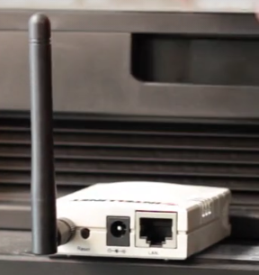

  - Can connect Ethernet to server, and printer by USB on the other side. Give network capabilities to printer who does not have them by default.
  - Wired/wireless network. Configuration options, can be set up as DHCP or find the SSID for the wireless.
- Local printer connections include USB and parallel/centronics
- network printer connections include Ethernet and wireless
- You can also attach a print server to connect USB printers to a network.
- Maintaining Impact Printers
  - Print Head – Has pins inside of it that are being pushed by actuators. Holds an ink ribbon.
  - Make sure the platen is correctly aligned.
  - If you get spotty prints, clean the print head.
  - If you use compressed air to clean your printer, take it outside first.
- Maintaining Ink-jet printers
  - Open the front or top panel of the printer to replace the ink cartridge.
  - Use the supplied software to clean and align printheads.
  - Make sure to run the inkjet printer often to avoid clogged ink.
- Maintaining Laser Printers
  - Maintenance kits – Something that is passed out by the manufacturer to keep your system up and running.
  - Laser printers put out a lot of O-zone. That is why laser printers have some sort of O-zone filter.
    - If you don't have one, o-zone tends to tear up plastics and rubbers and all kinds of stuff like that, so you want to have a good functioning o-zone filter.
    - Clues that let you know that you have a bad o-zone filter is constant papers jams and if one of your old take-up rollers are as hard as a rock.
- Use the laser printing process to track down problems.
- Maintenance kits can be used regularly to refresh certain parts inside the laser printers.
- For best results, use good paper.
- Troubleshoot Print Jobs
  - Print Spooler – Shows all print jobs currently in queue for that printer.
  - Print Management – Give you an idea of what is on your system as well as other systems right now.
  - The print spooler manages all current print jobs.
  - Clear unwanted print jobs from the print spooler to avoid waiting for the printout you want.
  - Print management tracks your printers and printer drivers.

CCNA BootCamp Notes
Section 2
The OSI Model
- L7-Application, L6-Presentation, L5-Session, L4-Transport, L3-Network, L2-Data Link, L1-Physical.
- Application Layer
  - Ensuring the remote communications partner or partner-to-be is available. Remember, it takes two to tango and two to network.
  - Ensuring the endpoints of any communication agree on basic rules, including data integrity, privacy, and the presence of absence of error recovery features. (More on that later).
- Presentation
  - The presentation layer answers one basic question. “How should this data be presented?”.
  - If you have ever opened a PDF with a non-PDF-friendly app, you were likely presented with page after page of unreadable characters. That’s a presentation later isssue!
  - Data encryption takes place at L6.
- Session
  - Layer 5, the Session layer, serves as the manager of the overall data transfer process. L5 handles the creation, maintenance, and teardown of the communications channel(the session) that exists between our two communicators.
- Transport
  - Things start to get interesting at Layer 4, the transport layer. The main purpose of L4is to establish a logical end-to-end connection between two systems. That’s obviously important, but it’s not the only L4 action. The Transmission Control Protocol (TCP) and the User Datagram Protocol (UDP) are doing some important work at this layer.
- Networking
  - We network admins really start getting involved with things at Layer 3, the network layer, because that’s where you’ll find these beauties:
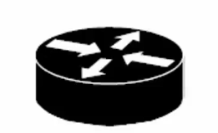

  - That’s the universal symbol for a router, and L3 is where routers do their job. Basically, the router’s job is to answer two questions:
    - What valid paths exist from here to where we need to go – our destination?
    - Of those valid paths, which is the best path to use to get there?
- Data Link
  - At the data link layer we’ll run into another very common network device…

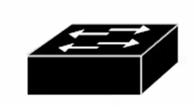

  - This is the universal symbol for a switch, our main L2 device. Switches use Media Access Control addresses (MAC addresses) to get their job done. MAC addresses are often referred to by four other names, all of which you need to be familiar with.
    - Layer 2 address/ L2 Address, referring to the layer at which the address is used.
    - Hardware address, used because the MAC address is physically written into the hardware.
    - Burned-In Address (BIA), because the address is burned into the hardware.
    - Physical address, because the address physically exists.
  - Watch that last one, “Physical addresses”. They dont run at the physical layer, the bottomost layer of the OSI model. They run at L2. But speaking of the physical layer…
    - No matter how complex our networks are or become, in the end, it’s all about secnding ones and zeroes across the physical layer.
    - Anything dealing with a network cable or the standards in use – including the pins, connectors, and electric current used – is running at the physical layer.
- The documents, photos, videos, and everything else our end users send has to be converted to that string of ones and zeroes. As data flows down the OSI model, the data is gradually converted to smaller and smaller units, until we get to the only data the physical layer can handle.
- Application / Presentation / Session layers: These layers don’t have an associated unit. “Data is Data”.
- Transport layer: Segments
- Network Layer: Packets
- Data Link Layer: Frames
- Physical: bits (Ones and Zeros)
- As data heads down the OSI model, each layer except the Physical layer adds a header that will be removed by the same layer at the other end of the session.
- These headers are layer-specific. For example, the presentation layer at the receving end cares only about the header attached by the presentation layer at the remote end of the session and so forth.
- The combination of data and a layer-specific header is called a Protocol Data Unit (PDU), and they’re usually referred to by the layer number (L7 PDU, L6 PDU, etc.).
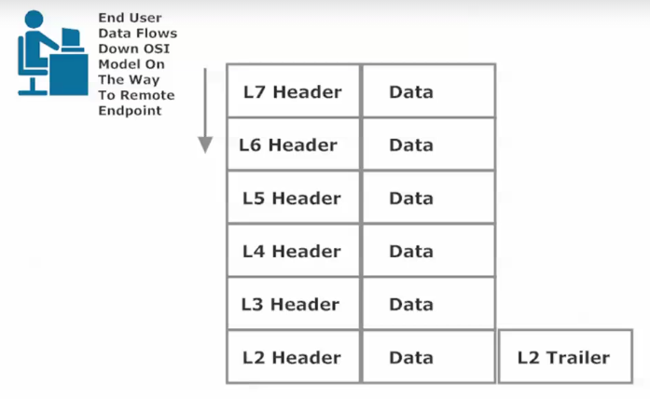
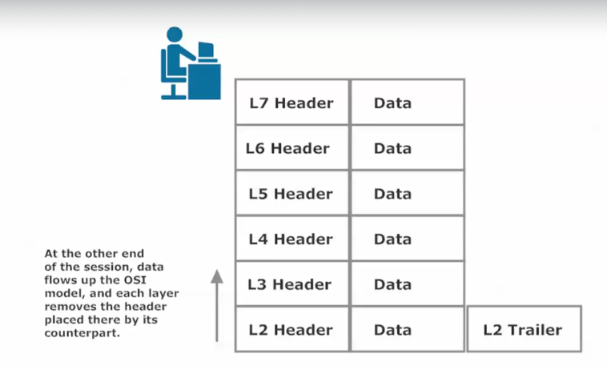

TCP/IP
- The TCP/IP Networking Model
- This model originally had four layers, and the bottom layer caused a lot of anixety among CCNA candidates, since that layer was actually known by three different names – and the name you saw depeneded on the book you were reading.
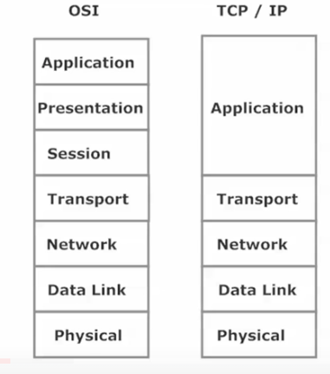
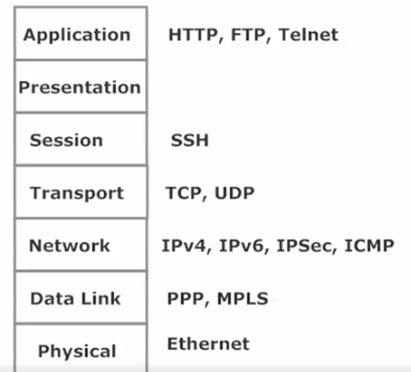
- Not only has this model evolved into a five-layer model, but the bottom layer is now known by one simple name. Let’s have a look at all five layers and how it maps to the OSI model.

