User manual for TranslateX

Copyright

This user guide is protected by the Copyright Act. Changes to the contents, or partial copying of the contents, may not be made without permission from the copyright holder.

The user's guide may be freely distributed in its entirety, either digitally or in printed format, to all TranslateX users.

Table of Contents

What is TranslateX? 3

Installation process 4

Using TranlsateX 14

Create a new project 14

Managing project 22

**A project in the EPiServer Open Source Initiative**

This documentation describes a module or product within the EPiServer Open Source Initiative. By using Open Source, you get control of the code and you can also adjust and improve features and functions to better fit your needs. The module/product is free of cost and has no Software Agreement connected to it.

You can use this Open Source project to help you in your upcoming project, to faster and with less effort, create a solution of your needs. Though, even if it might contain a pre-built module and even include an installer, it is still an Open Source project, not a commercial module and it is up to you to maintain the code.

This Open Source project is meant to be used within an EPiServer project. It is delivered with source code which means that you have a possibility to add or adjust features but also fix possible bugs within the project. Changes you make are also possible to add back to the project and by doing this, improving the product even more, so that other people or within the community can gain from the work.

The documentation is one part of this Open Source project. It describes how to use the module and might also describe system architecture and parts of the API. Using the module within a project, you should expect to add more information to the documentation to create a useful documentation for your users. Within the code it might also be documentation, helping you to understand and work with the code as a developer.

 The project is created in English and the user interface is also supporting English. If using other languages, you might need to translate texts, and in some cases also add language support to the module.

The Open Source Project is tested before the first release but it has not gone through such thorough tests as the Commercial products from EPiServer AB have done. It is up to you and your project group to decide if further tests should be made.

EPiServer AB does not give formal support to the project but it is possible to add comments and questions within the project repository that other community members might answer to. It is also possible to contact EPiServer Expert Services for more assistance.

To evaluate this module, install it in a test environment (if a pre-compiled module is included). To start using this project, set it up in your developer environment, compile it and test it. From now on, it is up to you to fully use all the possibilities within this Open Source project.

# TranslateX

## What is TranslateX?

The purpose of the module is to streamline the tasks of translating content for sites that uses professional translation services like Lionbridge, Translations.com or other translation agencies with technical integration abilities.

In short, the TranslateX Module is a plug-in to EPiServer Edit mode, allowing editors to create translation projects that will be sent to their preferred translation agency. A project can consist of one or more pages and uploaded files that belong to those pages.

The translation agency will receive the content in a non-EPiServer specific format, ready for translation. When the agency is done translating the content, it will be made available to the EPiServer site and a notification is sent to the project owner.

Translated content can then be imported as new language versions, ready for inspection or published directly by the project owner.

Translation projects are assembled and sent by the EPiServer scheduler, EPiServer scheduler checks project status.

The architecture for the TranslateX module has been crafted to be provider independent, meaning it can work against different translation agencies. The plug-in and UI concepts in EPiServer should be the same independent of the company doing the actual translations, but depending on the translation company’s available services and capabilities, there will be some variations on available features.

Each translation company will need its own connector in the EPiServer Translation module, and depending on what existing services are available from the company, some development might be needed by the translation company.

## Installation process

Double click to start msi installation file:

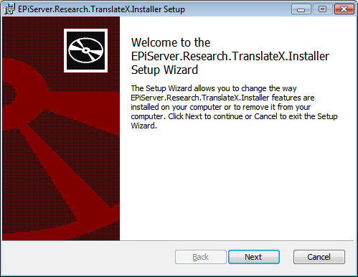

Accept the license agreement:

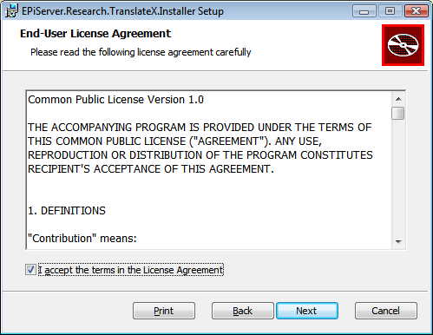

Choose the “Complete” installation alternative:

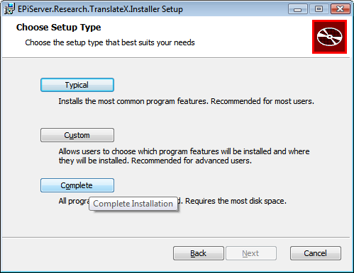

Click on “Install”:

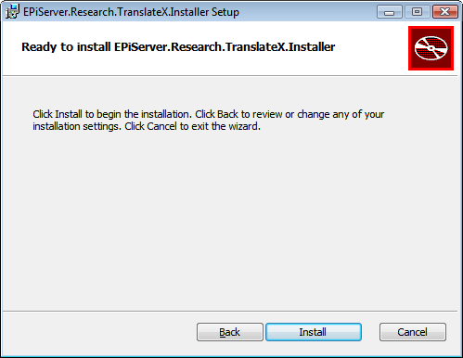

And installation will start:

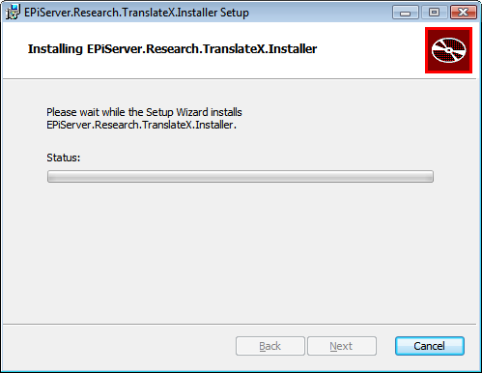

Click on “Finish” and now installation is done.

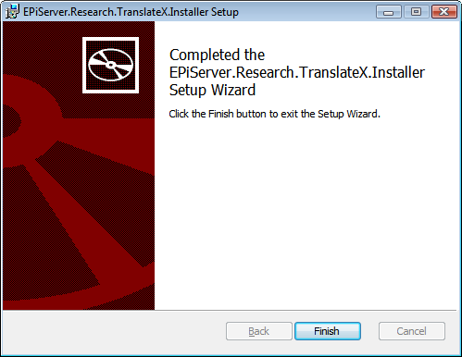

Start “EPiServer Deployment Center” and expand the version tree and choose “Install EPiServer.Research.TranslateX.Installer”:

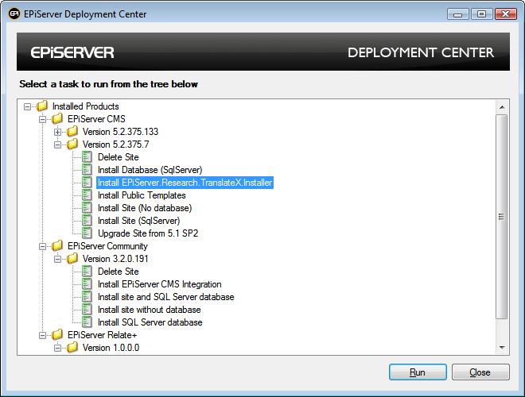

You get a prompt as this. Choose “Run once” or “Always run”.

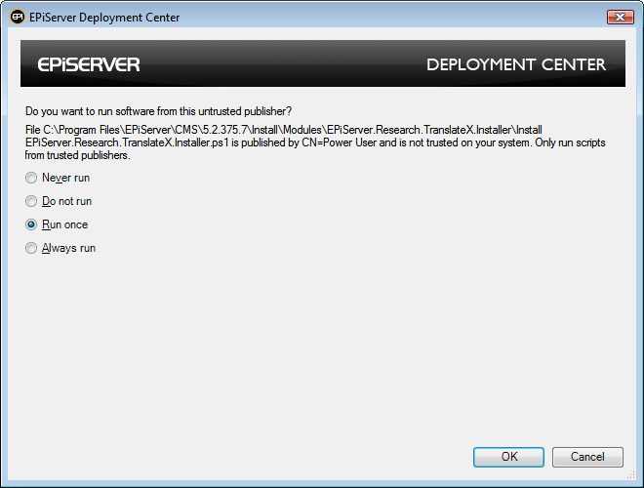

And now choose the site you want install TranslateX to:

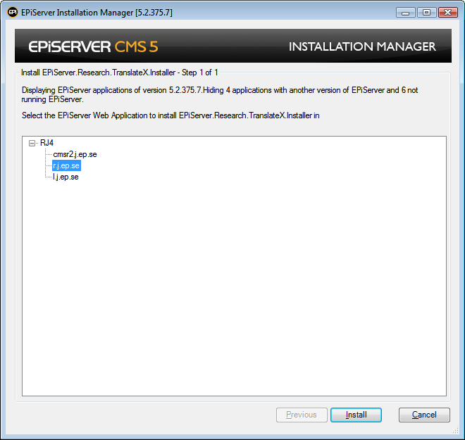

Installation will be finished.

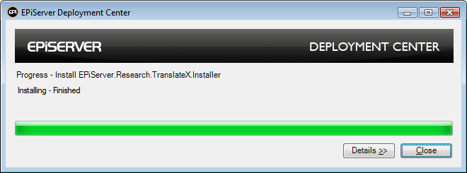

If you are going to use Lionbridge or other external translation agency you will need account information from your preferred translation agency before you can start use TranslateX module. More information about that can be found at: <https://www.coderesort.com/p/epicode/wiki/TranslateX>

## Using TranlsateX

### Create a new project

To start translation you need create a new translation project.

Select a page and switch to the right language version that needs to be translated in EPiServer Edit mode, click the Translation tab and click on “New project” button:

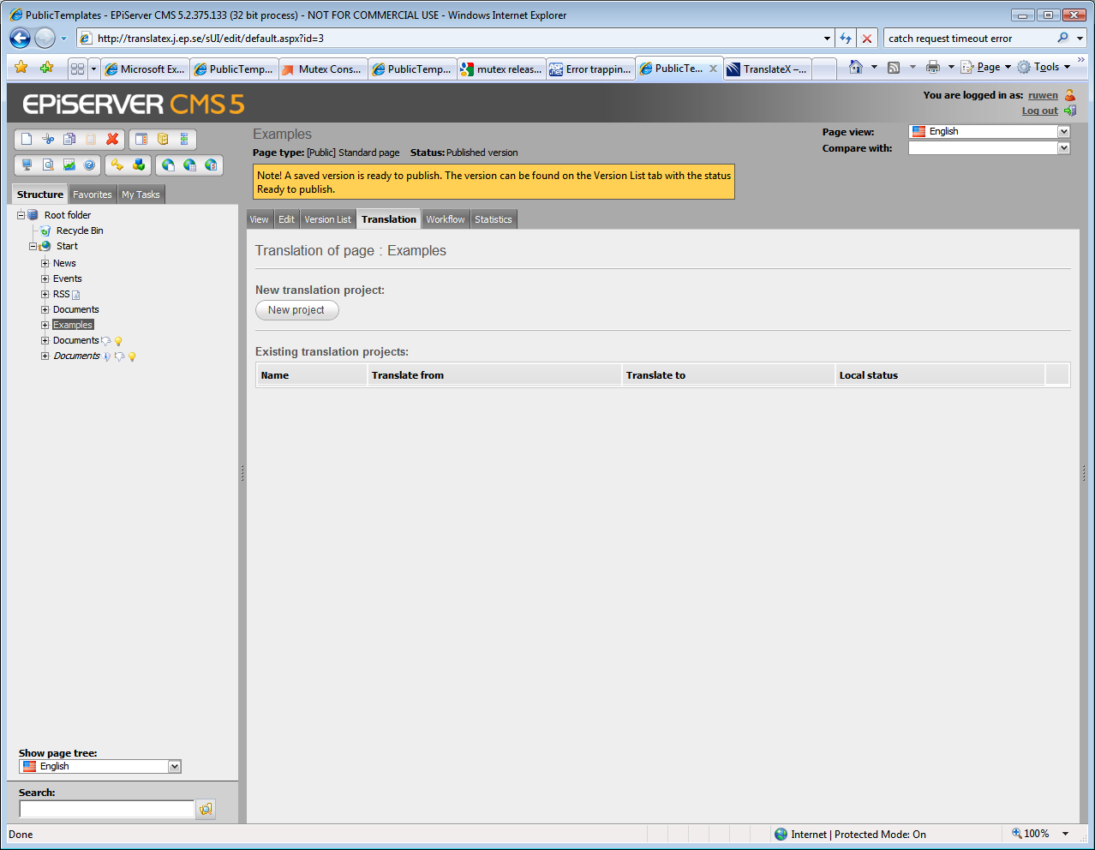

You can give project a name in this step. It will also show which language version you did select. Wizard will list all other languages that site has enabled (which you can find in admin-mode). You can choose to translate the child pages:

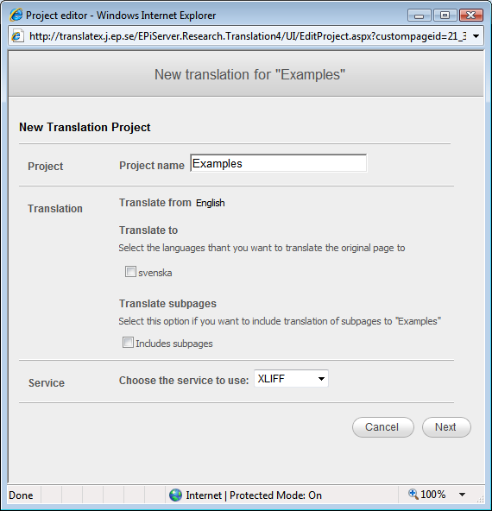

Next step is to choose pages you want to translate:

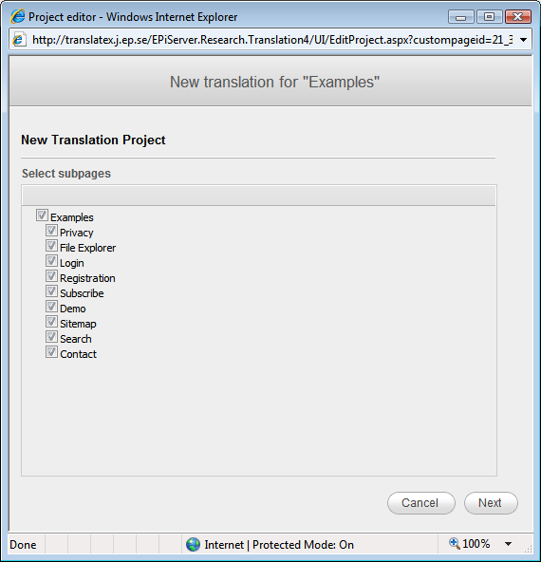

Choose files to include in pages:

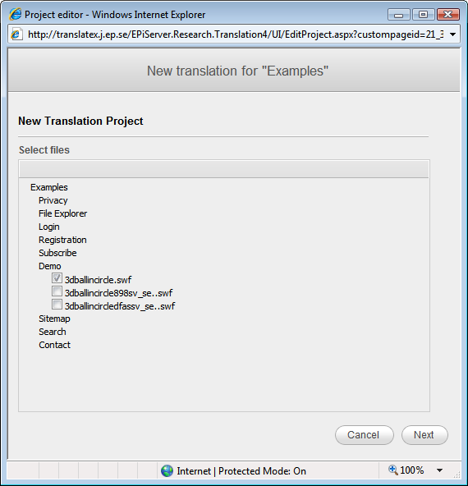

For different translation agency there will be different steps. Here is one example that shows that Lionbridge translation agency need some extra information before submit to their translation service.

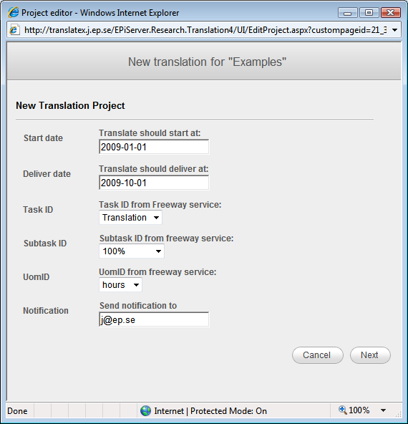

Here is another example on extra information that needs when a user use XLIFF service. To use the XLIFF service you need have a valid smtp setting in your web.config.

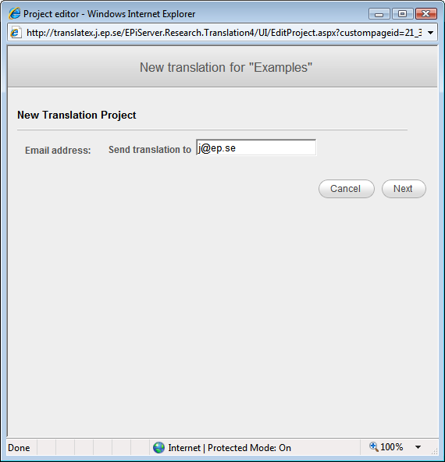

When all settings are done a summary page will show up. Click “Finish” to create the project on server.

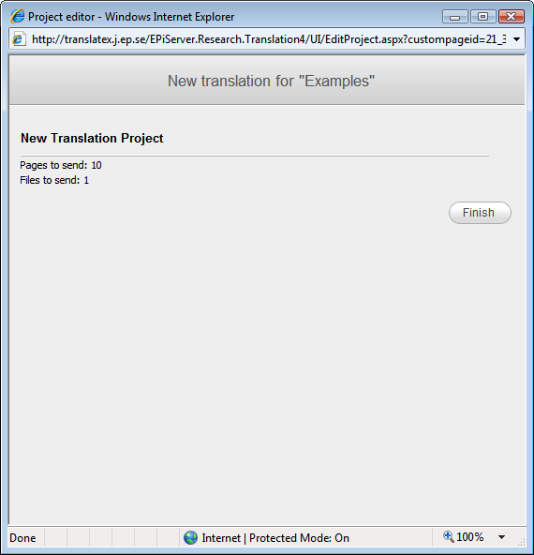

Now a translation project is created. You can click “Close window”

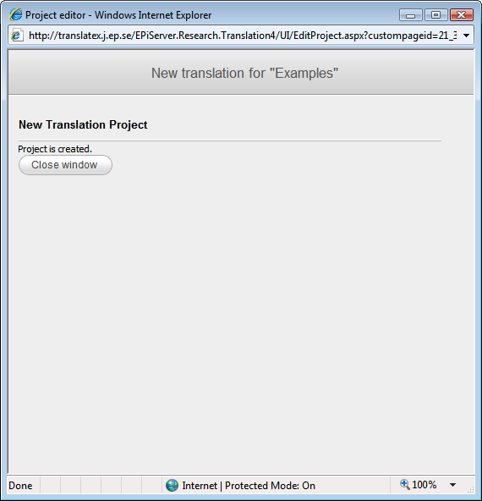

### Managing project

You can see all projects in a separate tab in edit mode:

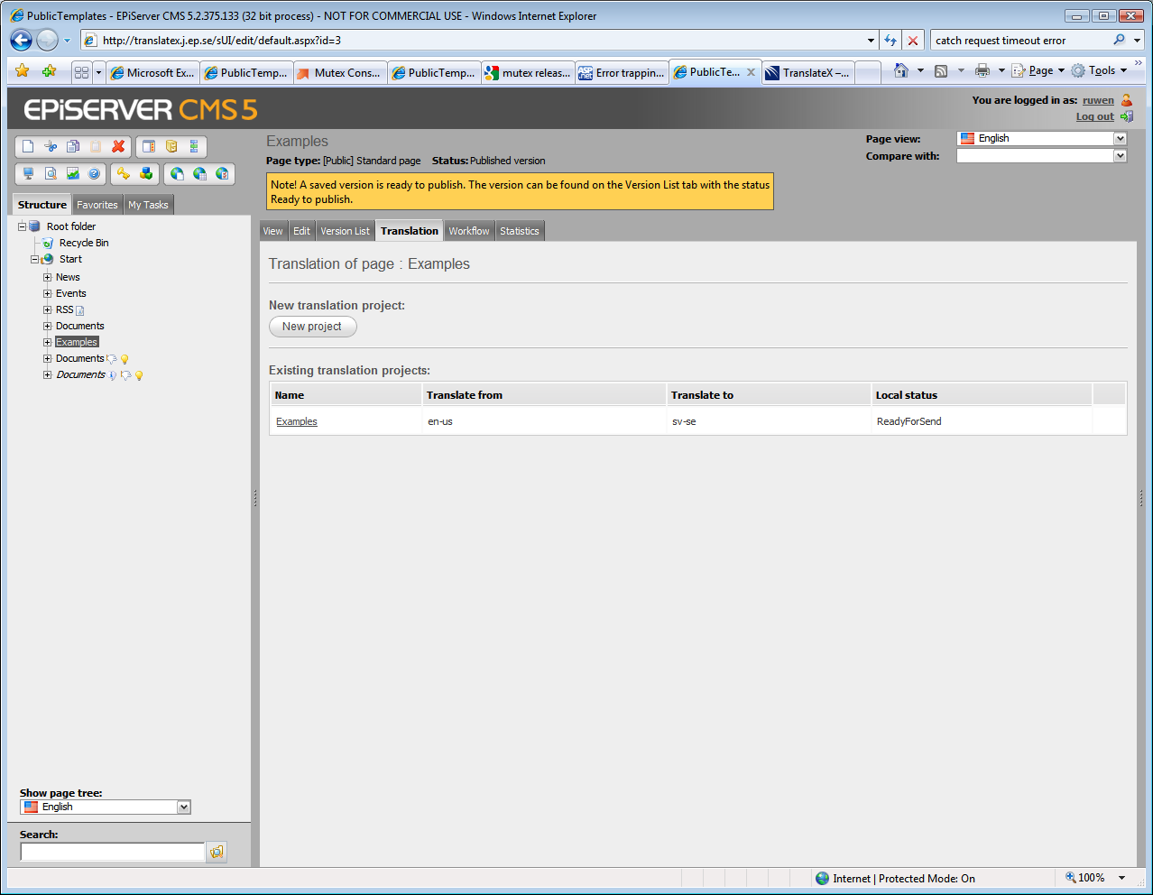

The scheduled task will see that there is a project ready for sending to the translation agency, and will assemble the content in a format that the translation agency can work with. The package is sent to the translation agency for translation.

When a project has been translated by the agency its status will change and is marked as ready for importing. An “Import” button is show behind the project on the project status page. At the same time, the project owner is notified by email that the project has been translated.

The project owner can choose to import pages as new language versions on the existing pages (the preferred option) or an entirely new node (which means a new content structure will be created.)

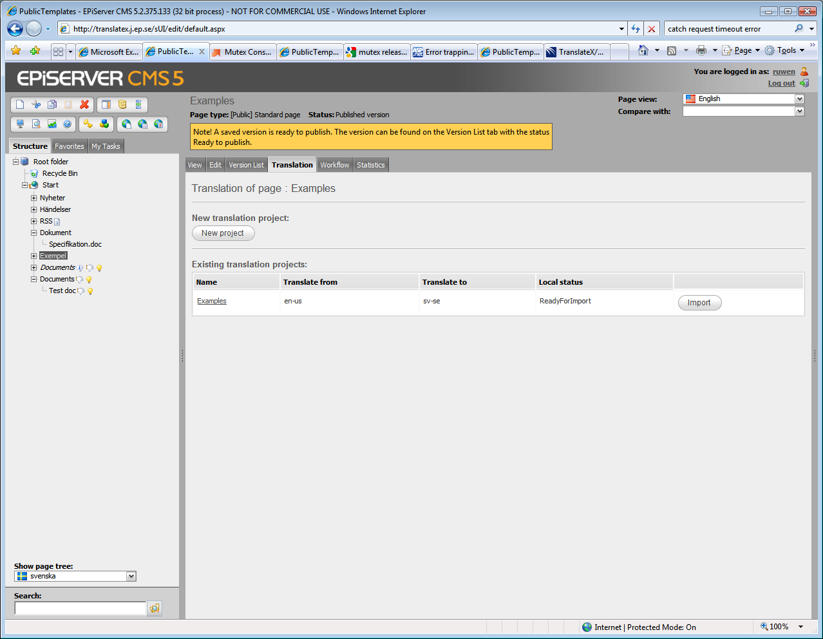

Clicking the import button shows this dialog:

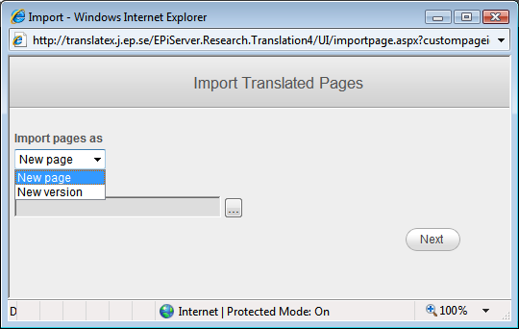

You can check in the content (ready to publish) or publish it directly:

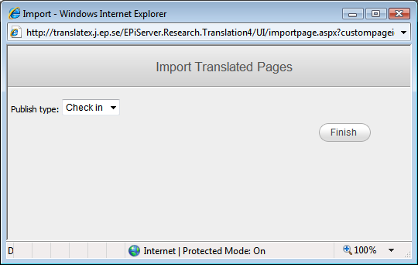

If you choose to Check in the project, you can inspect the pages before they are published and do any last minute changes before publishing. If you publish the pages directly, they will be immediately available.

After this step page(s) and file(s) will be published in EPiServer.