2021

Created by Epitaph

-1 Sanity Software Solutions

Rhode Islands Bulk Message Sender



Contents

FOREWORD AND DISCLAIMER 1

Introduction 2

Before you Begin 2

Installing the Tool 2

Creating a Template 3

Creating CSV Data file 4

Using the Tool with the Template and CSV Data File 6

# FOREWORD AND DISCLAIMER

This tool was designed in response to some random discussion in a Discord community that I’m in. The results are the fruits of me being hacked up on caffeine and insanity at 3 AM in the morning. As such, it is highly temperamental and may blow off one of your limbs or maim you permanently for life. I am not responsible for any mishaps, opening gateways to other hellish dimensions or the unsealing of ancient chaotic evil deities that may happen when you use this tool.

It is best that you make a sacrifice to the machine gods involving lots of goats and initiate protocols Alpha-Z-420-69 in the event that a containment breach occurs. You may also wish to have a loved one nearby to throw at the threat in the event of a containment breach occurring. There is also an easter egg for those who are willing to look and know where to look but I’ll leave that to you :D.

# Introduction

This document outlines basic usage for the Rhodes Islands Bulk Message Sender. Details on how to install, setup templates and use the tools are listed and described within this document.

# Before you Begin

In order to use this tool, you will need to have the following:

* Outlook Version 2013 and above
* Installation Admin privileges
* .NET Framework 4.8 Runtime installed - [Link](https://dotnet.microsoft.com/download/dotnet-framework/net48)

# Installing the Tool

To install the tool:

1. Download the .zip file containing the binaries/release.
2. Extract it to a temporary location of choice.

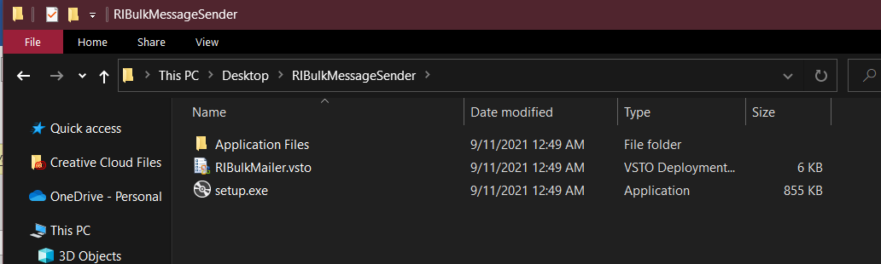

1. Run setup.exe, press install to proceed.

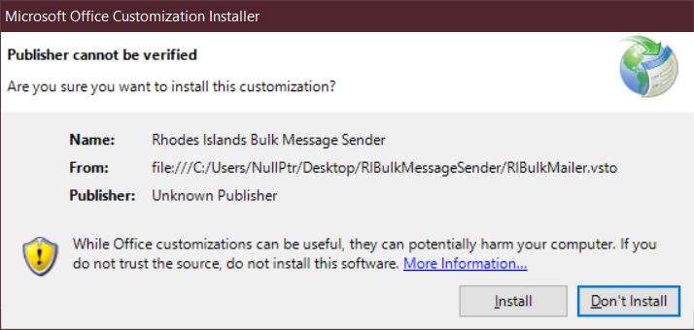

Wait for it to finish.

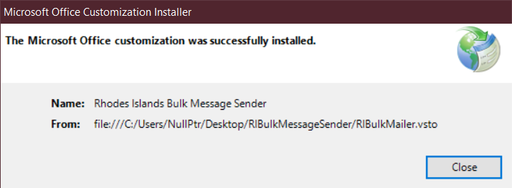

1. Open Outlook and look for the tab.

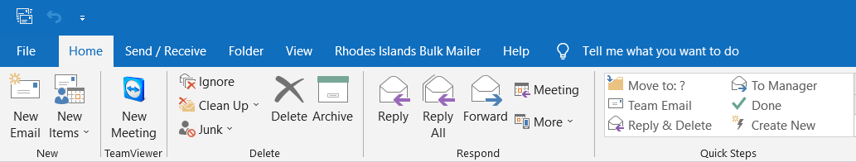

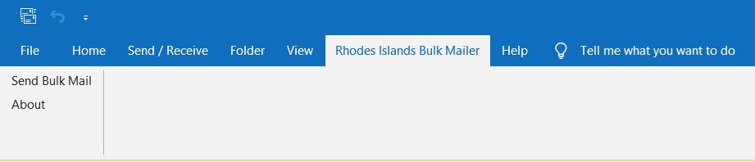

The tool should now be installed and ready for use.

# Creating a Template

1. Create a new email message. For any fields you wish to insert in bulk from the CSV, use the format {{FieldNameHere}} as an example shown below to insert place holders of your:

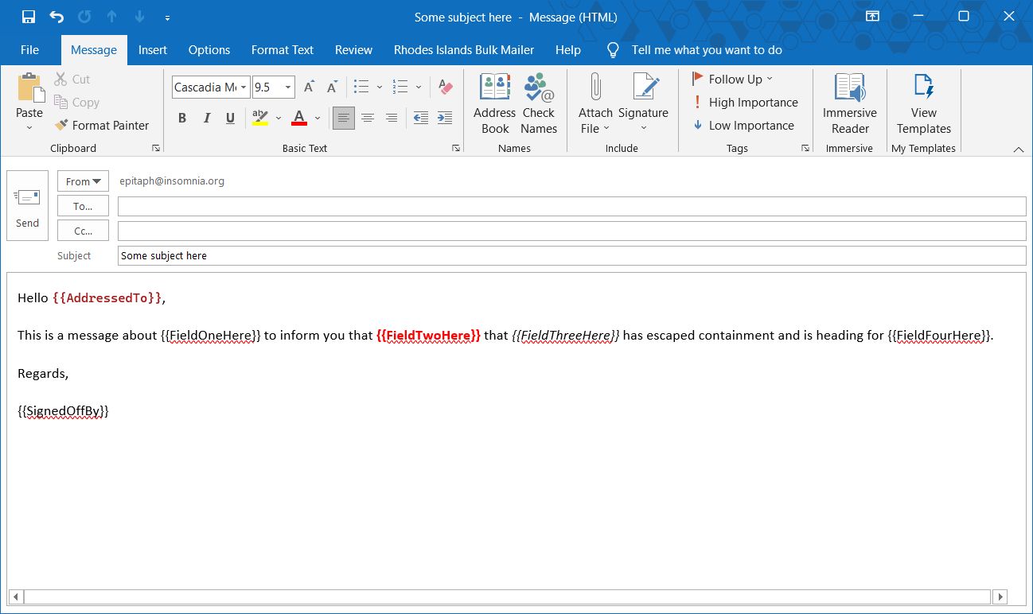

**Hint:**

* The placeholders must be consistent in formatting **i.e. every single element starting from the {{ to the }} bracket delimiters must be of the same formatting. This is** **to maintain consistent HTML representation which the tool relies on in order to find the place holders.**
* You can use colours and basic formatting to customize the appearance placeholder fields. These will retain their formatting on being replaced but make sure to follow the first note in regards to consistent formatting.

1. Once you have finished, go to **File > Save As** and save it as a .msg file to a location of choice.

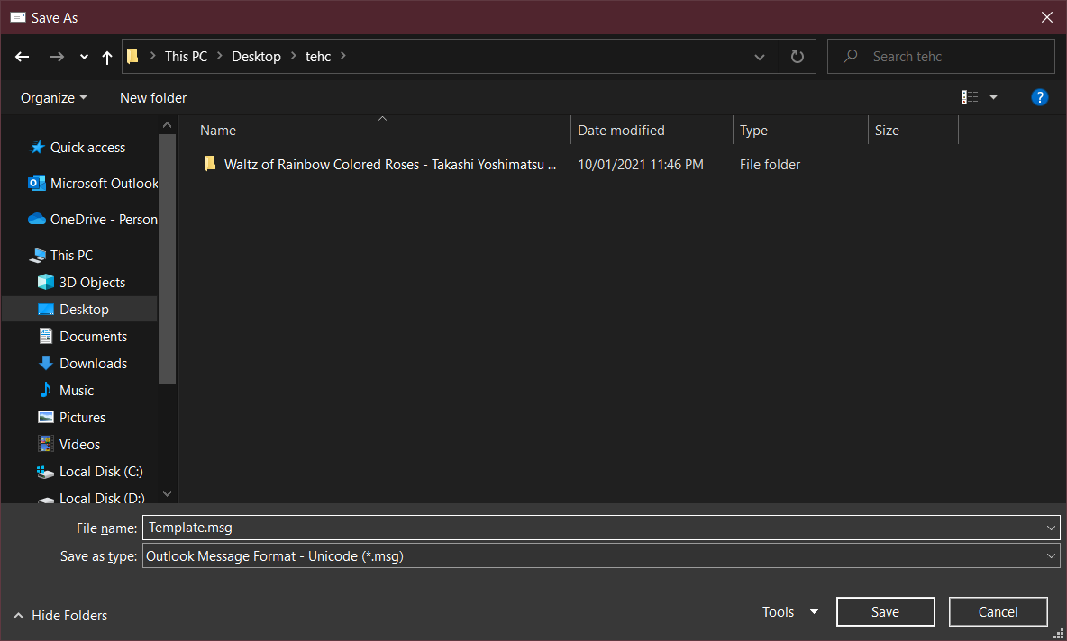

# Creating CSV Data file

To have the tool populate the email fields for you, you will need to create a corresponding CSV file containing columns and rows with your data. In order to do this:

1. Open up Excel or a spreadsheet program of your choice. This document will use Excel as an example as it’s generally the most used.

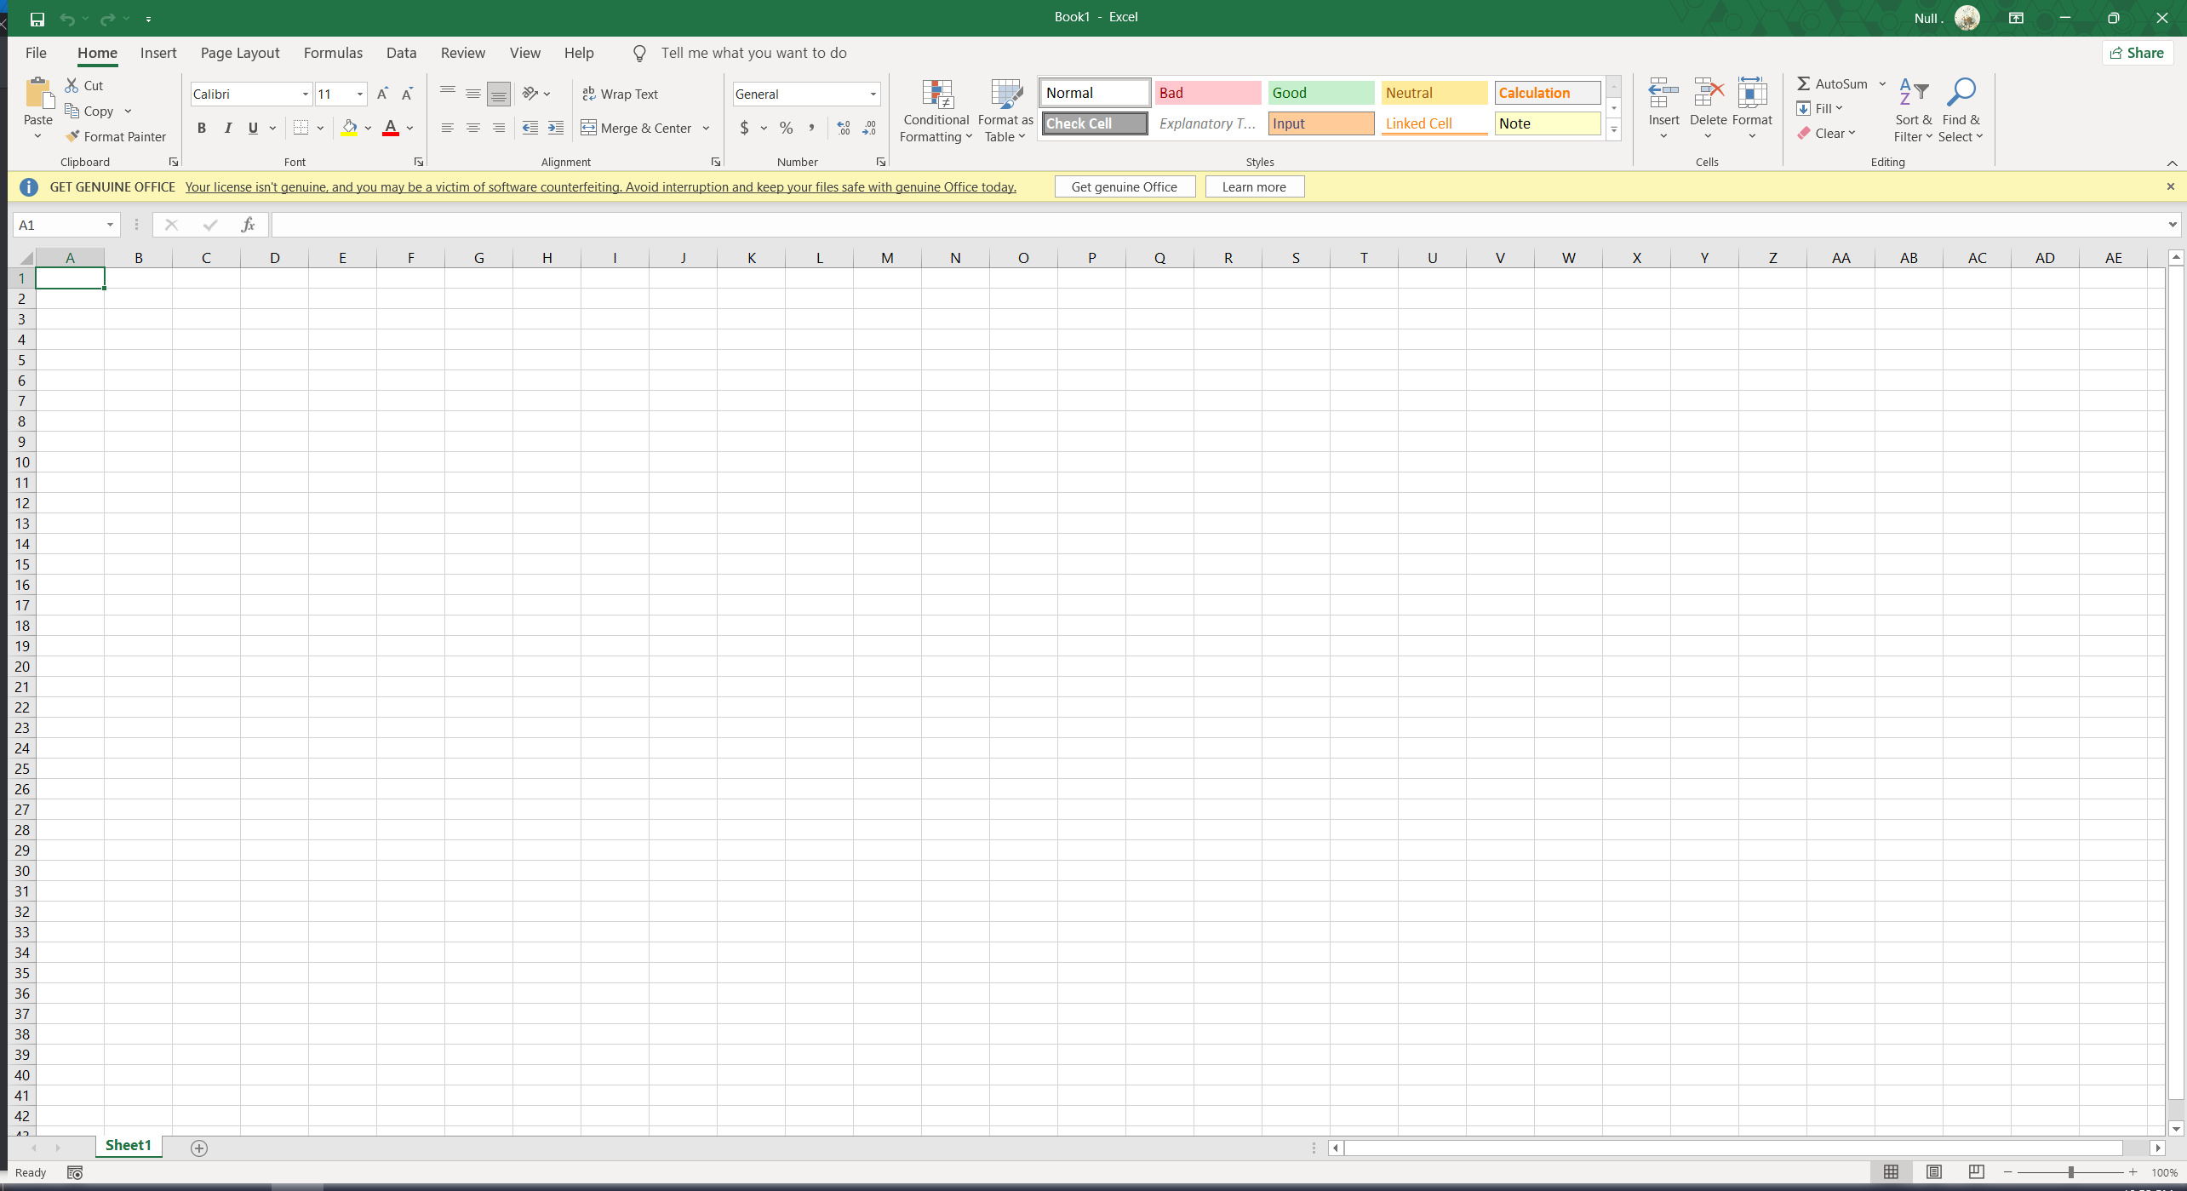

1. For the first two columns, insert **Email** and **AddressedTo** as shown below. These two columns are important and will define who each email should be addressed and sent to.

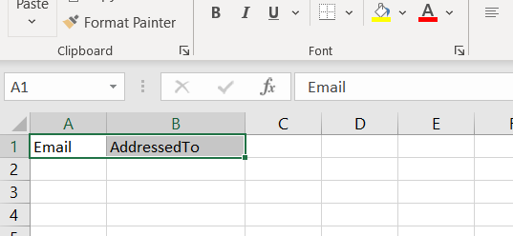

1. After these two columns, for each field you want to insert into your email, create a column. This will use the image within the first section as an example.

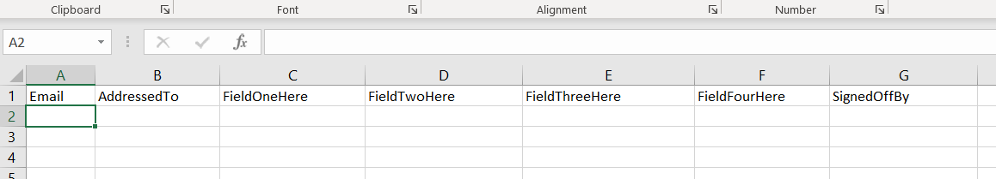

1. Now for each row, insert the corresponding values of whom you want to send the email and personalize it to/for.

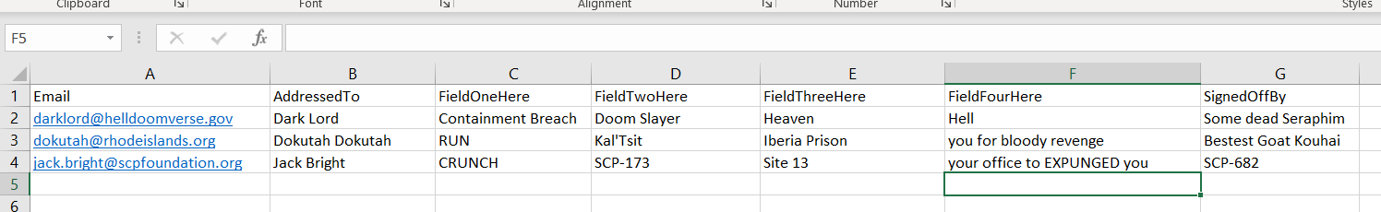

1. Once you’re happy with the contents, save it as a CSV. It should resemble something like below once you do.



# Using the Tool with the Template and CSV Data File

1. Select the account you want to send the emails from.

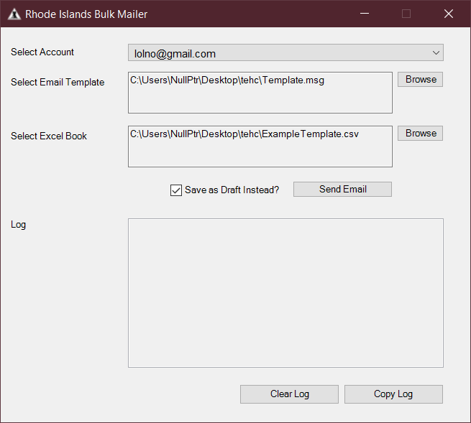

1. Select the .msg template that was created earlier.
2. Select the .csv file containing the values for the placeholders in the .msg template
3. Check or uncheck the Checkbox to either send all emails without preview, or to generate a series of draft emails you want to preview.



1. Press Send Email. Confirm whether you want to proceed or not with an action of consigning and condemning a thousand souls to their demise.

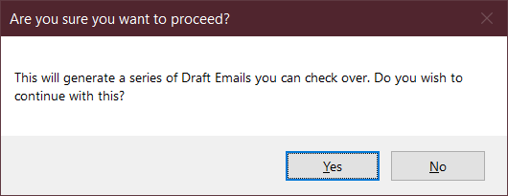

The results should be displayed within the log output for your checking and diagnostics.

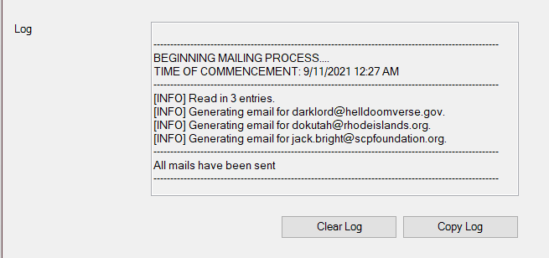

You can find the generated draft emails under a loaded PST within outlook as shown below.

