Python

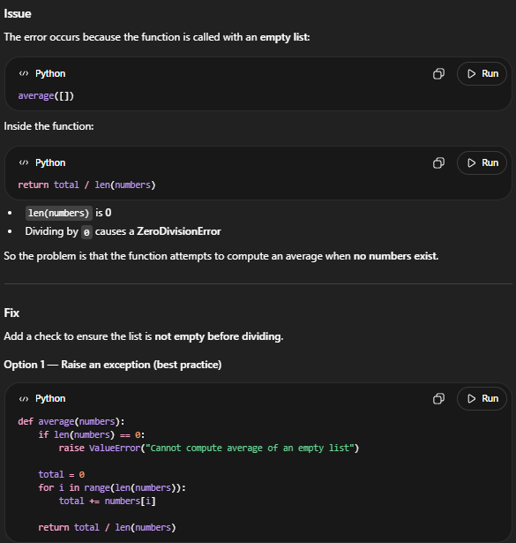
I am creating a python function that takes the average of a list of numbers input into the parameter. When I run my existing code:
def average(numbers):
total = 0
for i in range(len(numbers)):
total += numbers[i]
return total / len(numbers)

average([])

I get this error:
Traceback (most recent call last):
File "<stdin>", line 1, in <module>
File "<stdin>", line 5, in average
ZeroDivisionError: division by zero

What is the issue and how do I fix it?

The LLM had correctly identified that the issue was calling the code with an empty array and as a result was dividing by 0. The model gave a fixed code that checks the size of the array before dividing by its length to make sure a divide by 0 error does not arise.
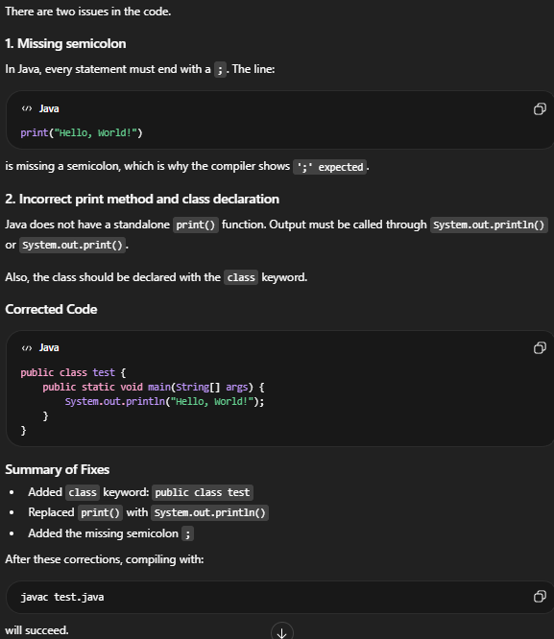

Java

I am writing a basic piece of code in Java. Here is the current code:
public test {
public static void main(String[] args) {
print("Hello, World!")
}
}

However, when I try to compile it, I get this error:
aryan@Yoga-9i:~/Java$ nano test.java
aryan@Yoga-9i:~/Java$ javac test.java
test.java:3: error: ';' expected
print("Hello, World!")
^
1 error
Where is the error and how would I fix it?

The code, even though the compile error only showed the single syntax issue with the missing semicolon, contained 2 errors combined with the incorrect print statement. The program was able to properly highlight both of these issues then recommend a fixed version of the code that had both the semicolon and the correct print statement. Running this code would give a correct result.

SQL

I am trying to make a SQL query that obtains the Id and name of every employee that had joined in the year 2025. The employees table contains every employee's employee id, name, age, department, address, phone number, salary, and join date. Here is the current query:
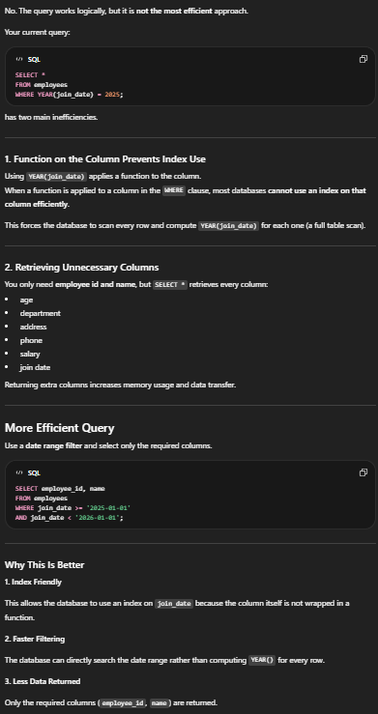
SELECT *
FROM employees
WHERE YEAR(join_date) = 2025;

Is this the most efficient method to derive that information?

The LLM correctly identified the two inefficiencies that are present in the SQL code. It was able to recognize that the query would benefit from using the specific column names instead of doing SELECT * and that the WHERE clause is not the best in searching since it checks every row unnecessarily. The LLM outputted a fixed SQL query that altered these parts to make the code more efficient.

