Subtask 1
Encoder-Only Transformers for Relational Reasoning
Array Element Ranking · Learning Phase Task 1

1. Problem Statement
- Given a sequence of 10 integers, predict the rank of each element (0 = smallest, 9 = largest).
- Example: [45, 12, 99, 31] → ranks [2, 0, 3, 1]
- This is a global relational reasoning task — the rank of any element cannot be determined without seeing the entire sequence.

2. Dataset
- 10,000 synthetic sequences, values in range 0–999, sequence length = 10.
- Split: 70% train (7,000) / 15% validation (1,500) / 15% test (1,500).
- Validation used during training to monitor generalization; test set untouched until final evaluation.

3. Methodology
- Framed as token classification: each position in the sequence independently predicts its own rank.
- Output shape: (batch, 10 classes, 10 positions). Loss: CrossEntropyLoss over all positions simultaneously.
- Three architectures compared: MLP, RNN, and a Transformer Encoder.
- Optimizer: Adam, lr=0.001, 20 epochs for all baselines. Transformer depth experiments used same settings.

4. Architectures

MLP
- Linear(10→128) → ReLU → Linear(128→128) → ReLU → Linear(128→100), reshaped to (batch, 10, 10).
- Sees all 10 values at once as a flat vector — no explicit mechanism to compare individual pairs.

RNN
- nn.RNN, input_size=1, hidden_dim=128, num_layers=2
- Each element fed in as a scalar; hidden state at each step projected to 10 class scores.
- The RNN processes tokens sequentially, meaning when predicting the rank of element at position 0, it has not yet seen elements 1–9. This fundamental left-to-right limitation makes it poorly suited for ranking, which requires global context.

Transformer Encoder (Manual Implementation)
- The implementation includes the following components:
- Multi-Head Self-Attention: Q, K, V projection matrices (W_q, W_k, W_v, W_o), manual attention score computation, scaling by sqrt(d_head), softmax, and weighted value aggregation.
- Bidirectional attention: No causal mask applied, so every token attends to every other token in both directions.
- Positional Encoding: A learned nn.Embedding(10, d_model) added to token representations.
- Feed-Forward Network: Linear(d_model→dim_feedforward), ReLU, Linear(dim_feedforward→d_model) applied per token.
- Residual connections and Layer Normalization after both attention and feed-forward sub-layers.
- Classification head: Linear(d_model→10) producing rank logits per token.
- Default hyperparameters: d_model=64, nhead=4, num_layers=2, dim_feedforward=128.

5. Numerical Representation

Sequence-wise Normalization
- For each sequence: x = (x − mean(x)) / (std(x) + 1e-8).
- Converts absolute values to relative differences within the sequence.
Why this matters: ranking depends only on relative order, not absolute magnitude. Normalization aligns the input representation with this invariance. Without it, raw values in 0–999 cause attention scores to grow too large, softmax collapses to near-uniform distributions, and the model cannot learn (loss stays at ln(10) ≈ 2.3).

6. Results

6.1 Model Comparison

Model | Token Acc. | Exact Seq. Acc. | Notes
MLP | 43.8% | 0.0% | No pairwise comparison mechanism
RNN | 30.4% | 0.0% | Sequential — cannot see full context per step
Transformer (2L) | 82.5% | 61.3% | Self-attention enables global comparison

Key observation: Exact sequence accuracy is the more revealing metric. MLP and RNN both score 0% — they never get all 10 ranks correct simultaneously despite partial token-level success. The Transformer gets the full sequence right 61% of the time.
Why RNN < MLP:
- The hidden state is a fixed-size vector (128 dims in our case). At each step it has to compress everything it has seen so far into that same 128-dim vector. By the time it reaches position 9, that vector is trying to represent the relationships between all 9 prior values simultaneously.
- When it's at position 0 producing a rank prediction, it has seen exactly one value. It has zero information about positions 1–9

6.2 Ablation Studies

A. Sequence Normalization
- With normalization: 82.5% accuracy.
- Without normalization: ~14% accuracy, loss stuck at 2.3 throughout training.
Inference: Normalization is not just a training aid — it’s a fundamental representation choice. Ranking is invariant under monotonic transformations of input values; normalization exploits this directly.

B. Positional Encoding
- With positional encoding: 82.5% accuracy.
- Without positional encoding: ~18% accuracy.
Inference: This was surprising. Ranking is theoretically position-invariant — the rank of a number doesn’t depend on where it sits in the sequence. So positional encoding should be irrelevant.
Before training starts, all token representations look nearly identical — they're all just a single float projected through the same Linear(1, 64) layer. With no positional encoding, token 3 and token 7 produce almost the same vector. The attention mechanism has no way to tell them apart, so it ends up attending to everything equally and learning slowly.
Positional encoding adds a unique vector to each position, so even before any real learning happens, token 3 and token 7 are distinguishable. This gives the model a starting point to build meaningful attention patterns from.

C. Encoder Depth

Layers | Test Acc. | Convergence | Observation
1 | 67.7% | Slow, plateaus | One attention pass not enough to resolve all rankings
2 | 97.1% | Fast, stable | Best result overall
4 (first) | ~16% | Explodes at epoch 19 | Gradient explosion destroys learned weights
4 (later) | 98% | Just slight increase at 9 but recovered at 10

4-layer instability — then and now:
- First run (no clipping): loss spiked to 2.3 at epoch 19, val acc dropped to 10%, test accuracy 16% — model completely collapsed and never recovered.
- Second run (no clipping): loss spiked to 0.45 at epoch 9, recovered by epoch 10, final test accuracy 98%.
- Same architecture, same settings — different outcome purely because the explosion happened to be smaller the second time.
- The reason is that gradient explosions are somewhat random in when and how hard they hit — they depend on which batch of data is seen at that step and the exact weight configuration at that moment. A large explosion overwrites learned weights beyond recovery; a smaller one just disturbs them temporarily.
- This is exactly why gradient clipping is necessary — without it you're relying on luck. Clipping caps the gradient magnitude before the update step, so no single batch can cause a large enough weight change to destroy what the model has learned, regardless of how unlucky the batch is.

Inference: Two layers is the sweet spot for this task — depth adds expressiveness but also instability. The 4-layer gradient explosion is a direct consequence of gradients multiplying through more layers during backprop. The 2-layer model at 97.1% was a better result than the initial 82.5%, suggesting that training stability matters as much as architecture choice.

7. Attention Visualization

Averaged Heatmap
- Extracted from model.layers[0].attention(x), averaged across all 4 heads.
- Row i = how token i distributes attention across all other tokens (each row sums to 1).
- Tokens disproportionately attend to extreme values (largest and smallest) — the most informative anchors for determining rank.
- Attention matrix is asymmetric: small-valued tokens attend strongly to large-valued tokens to establish their low rank, while large-valued tokens attend more broadly.
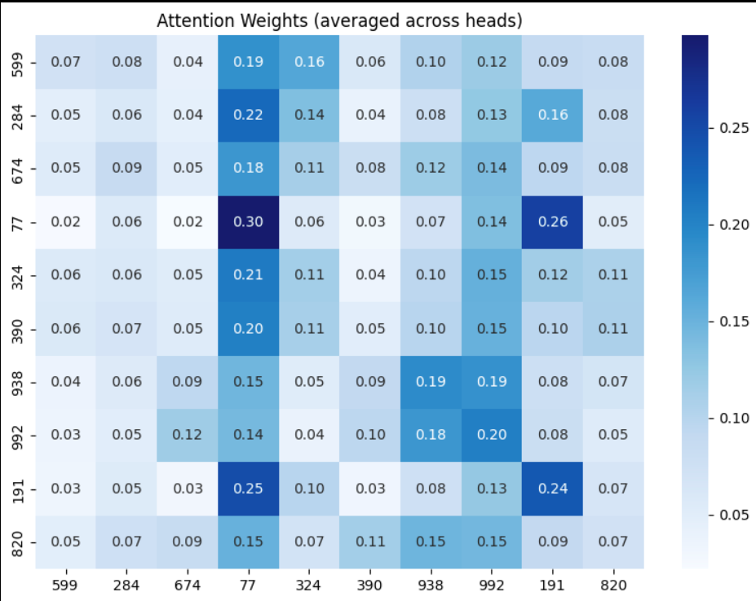

Per-Head Specialization
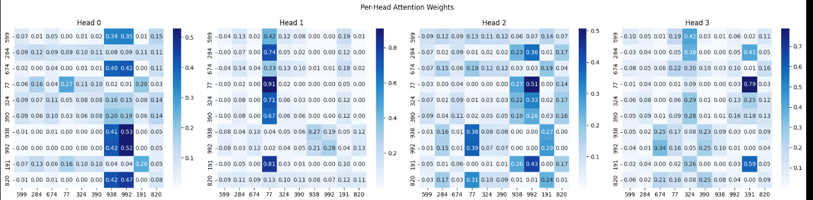

Key observations from the attention patterns:
- Tokens tend to pay disproportionate attention to extreme values (the largest and smallest numbers in the sequence), which are the most informative anchors for determining relative rank.
- The attention matrix is asymmetric — token i attending to token j is not the same as token j attending to token i. Small-valued tokens attend strongly to large-valued tokens to establish their low rank, while large-valued tokens attend more uniformly.
- Attention patterns become more structured after training — early in training, attention is nearly uniform; after convergence, clear patterns emerge reflecting pairwise comparisons.

Inference: The heads aren’t redundant — they appear to capture different aspects of the comparison problem in parallel. This is consistent with the design intent of multi-head attention, and visible in the heatmaps as qualitatively different weight distributions across heads.

8. Out-of-Distribution Testing

Input | Transformer | MLP | RNN
[1, 2, 3, …, 10] (ascending, in-range) | Good | Partial | Poor
[1000, 900, …, 100] (descending, large) | Partial | Partial | Poor
[1000, 1, 0, 100000, …] (extreme range) | Fails | Fails | Fails
[5, 5, 5, …, 5] (all identical) | Correct | Random | Random

- All-same sequence: after normalization this becomes near-zero everywhere. The Transformer correctly outputs rank 0 for all positions. MLP and RNN produce random outputs — they rely on value differences to make decisions.
- Extreme range [0, 100000]: all three models fail. Values far outside the 0–999 training distribution produce extreme z-scores after normalization that the model has never encountered.
Inference: The Transformer generalizes better on in-distribution OOD sequences because attention computes relative comparisons, which are more robust to mild distribution shift than fixed linear projections. But all models break on extreme inputs — this is a fundamental data-driven limitation, not an architectural one.

9. Conclusions

Why Transformers Work Here
- Ranking requires every element to be compared against every other element. Self-attention computes Q·Kᵀ which is literally a pairwise similarity computation across all token pairs in a single forward pass.
- MLP has global input but no comparison mechanism. RNN has sequential processing that prevents full global context. Transformer is the only architecture structurally aligned with the task.

Most Important Findings
- Sequence-wise normalization was the most critical design decision — more impactful than architecture depth or head count.
- Exact sequence accuracy is a more honest metric than token accuracy for this task — MLP/RNN differences from Transformer are invisible at token level but stark at sequence level.
- Deeper networks need gradient clipping. Without it, 4-layer training collapses.
- Positional encoding matters even for position-invariant tasks, likely as a symmetry-breaking mechanism during early training.

Limitations
- All models fixed to sequence length 10. MLP cannot be extended without retraining. Transformer could support variable length with sinusoidal (non-learned) positional encodings.
- OOD generalization beyond training range is poor — training with diverse value ranges or purely rank-based inputs would help.

LLM Usage
AI was used as a learning aid throughout this implementation. Specifically:

- It was used to understand what must be the shapes of the matrices and how should they be squeezed , unsqueezed and transposed etc for the implementation
- it was used for the heat map code
- it was used to derive inferences from the experiment
- it was used for debugging wherever required
- it was used for some pytorch codes (and some others where I did not know about the function to be used )
- it was used to create a base report from where later the changes were made
- it was used to understand why we need a validation and test data differently
- it was used to understand what batch_size is optimal for training and why

