**Mandatory Assignment: Airline System**

**Vision:**

To create an airline system (a website) in which customers can browse flights, order tickets and cancel tickets. Employees of the airline company will have restricted access (possibly an internal network) to manage planes, classify and reclassify flights and finally schedule and reschedule flights.

**Use cases:**

**Actor: Employee**

Add Planes to Service

Making the airline system able to add planes to service.

Remove Planes from Service

Making the airline system able to remove planes from service.

Classify Flights

Making the airline system able to classify flights.

Reclassify Flights

Making the airline system able to reclassify flights.

Schedule Flight

Making the airline system able to schedule flights.

Reschedule Flight

Making the airline system able to reschedule flights.

**Actor: Customer**

Query Flight Schedule

Making customers able to browse the flight schedule

Order Economy Ticket

Customer wants to order and buy an economy ticket

Order Coach Ticket

Customer wants to order and buy a coach ticket

Order First Class Ticket

Customer wants to order and buy a first class ticket.

Cancel Economy Ticket

Customer wants to cancel and refund an economy ticket.

Cancel Coach Ticket

Customer wants to cancel and refund a coach ticket.

Cancel First Class Ticket

Customer wants to cancel and refund a first class ticket.

**Brief use cases**

Add Planes to Service

Employee opens the internal network and selects the manage planes option. Employee then selects the “Add planes to service” option. The system demands the registration number of the plane(s) and lastly a password required to terminate the action. Employee dials in the needed information and the system executes the request and prints out “Plane (regi. nr. x) is now added to register”.

Remove Planes for Service

Employee opens the internal network and selects the manage planes option. Employee then selects the “remove planes from service” option. The system demands the registration number of the plane(s) and lastly a password required to terminate the action. Employee dials in the needed information and the system executes the request and prints out “Plane (regi. nr. x) is now removed from service”.

Classify Flights

Employee opens the internal network and selects the “Classify flights” option. Employee is then presented with a diagram showing destinations in the top array and planes in service in the left array. The employee can then mark which of the planes there will be going to which destinations.

Reclassify Flights

Employee opens the internal network and selects the “Classify flights” option. Employee is then presented with a diagram showing destinations in the top array and planes in service in the left array. Employee then selects the “Reclassify flights” option. Employee may now edit the flights already classified.

Schedule Flight

Employee opens the internal network and selects the “Flight schedule management” option. Employee then selects “Schedule flights” option which opens up the list of each of the planes currently in service. The employee schedules the desired flight and click the “Save” button. The system asks for a password to terminate the action. Employee dials in the password, the system saves the changes and prints out “Flights successfully scheduled”.

Reschedule Flight

Employee opens the internal network and selects the “Flight schedule management” option. Employee then selects “Reschedule flights” option which opens up the schedule for each of the planes currently in service, and enables editing. The employee reschedules the desired flight and click the “Save changes” button. The system asks for a password to terminate the action. Employee dials in the password, the system saves the changes and prints out “Flights successfully rescheduled”.

Query Flight Schedule

Customer opens the airlines website. Customer select the “available destination” option. The System will show the customer a list of all the airline destinations.

Order Ticket

Customer opens the airlines website. Customer selects the desired flight and then the “Order ticket” option. Customer will enter the desired date of departure. The system will ask the Customer what kind of ticket he/she wants to buy whereafter the customer selects the desired ticket version. The system will ask for selection of desired payment option and payment info which the customer replies to.The customer will receive a receipt from the system and the message “Ticket for (x destination) successfully ordered”.

Cancel Coach Ticket

Customer opens the airlines website. Customer selects “cancel ticket” option. The System will ask the Customer for a ticket number. Customer enter the ticket number.

the system ask for confirmation in the form of a “are you sure you want to cancel this ticket? yes/no” box. the ticket is now canceled and the system will inform the Customer that the money will be refunded within 5-10 weekdays.

**Fully Dressed Use case: Cancel Economy Ticket**

Primary Actor:

Customer

Stakeholders and Interests:

*Customer:* Wants to easily cancel his/her economy ticket without problems and receive a refund if possible.

Preconditions:

The customer has bought an economy ticket successfully and received a ticket number.

Success Guarantee:

The economy ticket is, if two weeks before the departure date, successfully canceled and refunded. If not two weeks before the ticket is only cancelled.

Main Success Scenario:

1. Customer opens the Airline Website
2. Customer selects “Cancel ticket” option
3. The system asks for the ticket number and the customer then dial it in.
4. The system shows a box with the text “are you sure you want to cancel this ticket? yes/no”.
5. The user clicks “yes” and the system shows the text “Ticket successfully cancelled”. Depending whether the ticket is cancelled two weeks before departure, the ticket is fully refunded (if two weeks before departure)

Extensions:

1a. The website is down

1. The customer contacts the airline company by phone and informs about the issue
2. The company initiates a restoration of the website

2a. Customer cannot find the “Cancel ticket” option

1. The customer clicks the very visible “help” option or contacts “Customer support”
2. the customer either contacts an employee or browses “help” until he/she has found the “Cancel ticket option.

2b. The “Cancel ticket” button doesn’t work.

1. The customer contacts customer support and informs about the problem.
2. Customer support employees fixes the problem, and the button is once again available.

3a. The customer dials in the wrong ticket number

1. The system informs that it “Could not find ticket number” and deletes the previous dialed in number from the customer
2. 1 is repeated until the customer dials in the correct number.

4a. The system doesn’t show the confirmation box

1. The customer contacts customer support and informs about the problem.
2. Customer support employees fixes the problem, and the box pops up again as expected.

5a. The “Yes” and “No function doesn’t work properly.

1. The customer contacts customer support and informs about the problem.
2. Customer support employees fixes the problem, and the customer can now use the buttons freely again.

5b. The ticket is not refunded correctly.

1. The customer can complain to the company and explain the case.
2. Employee and customer can discuss whether the refund request was fair (the ticket was cancelled two weeks before departure) or a hoax to cheat the system (the ticket was not cancelled two weeks before departure)

Special Requirements:

* 99% of the customers must be available to cancel their economy ticket without any need of help from customer support
* The fraud-rate of people trying to get non-endorsed refunds must be at a maximum of 1%
* It must require only 2 minutes of time at max to cancel an economy ticket
* The website must be operable 24/7 and have an uptime of 99.5%
* If the website is down, it can only take 30 minutes at max before it is operable again.

Frequency of Occurrence:

The system must be available around the clock.

**Use case diagram**

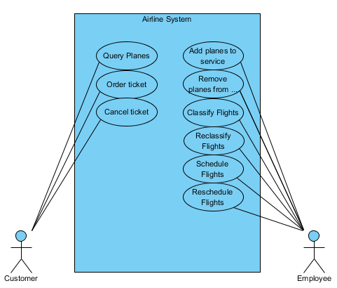

Domain Model

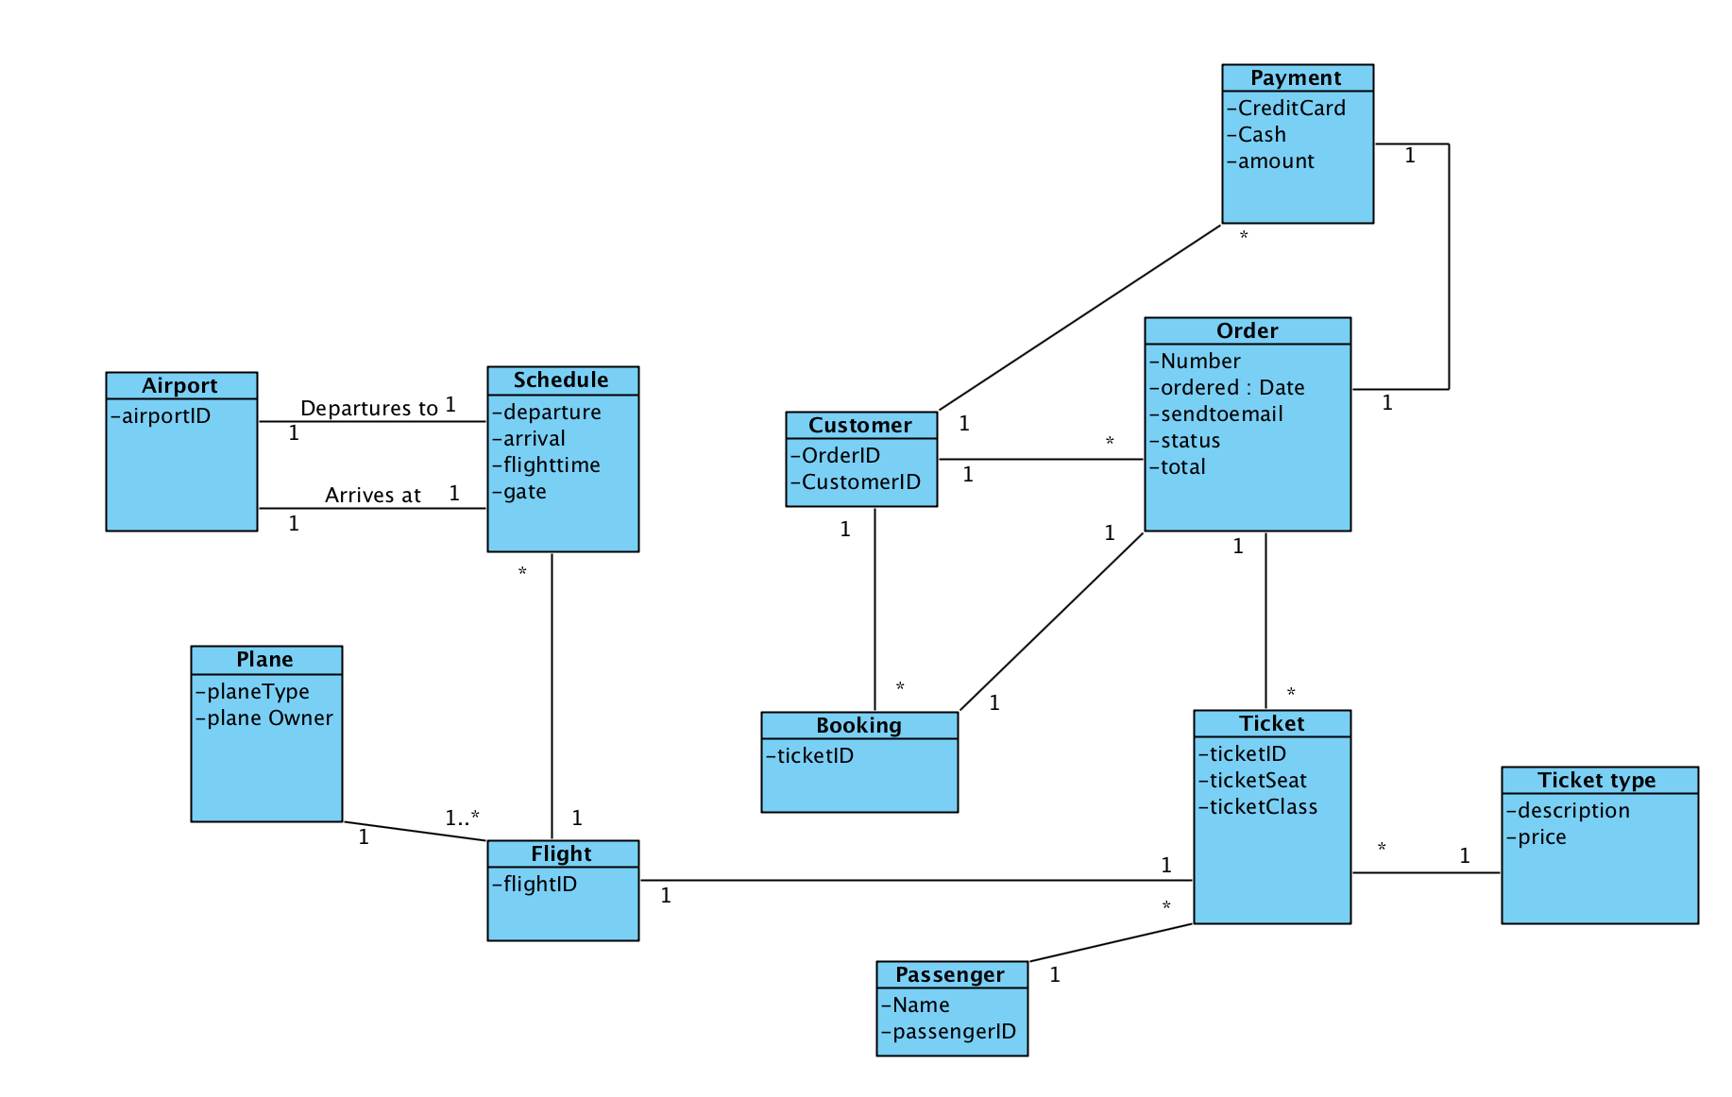

System Sequence Diagram

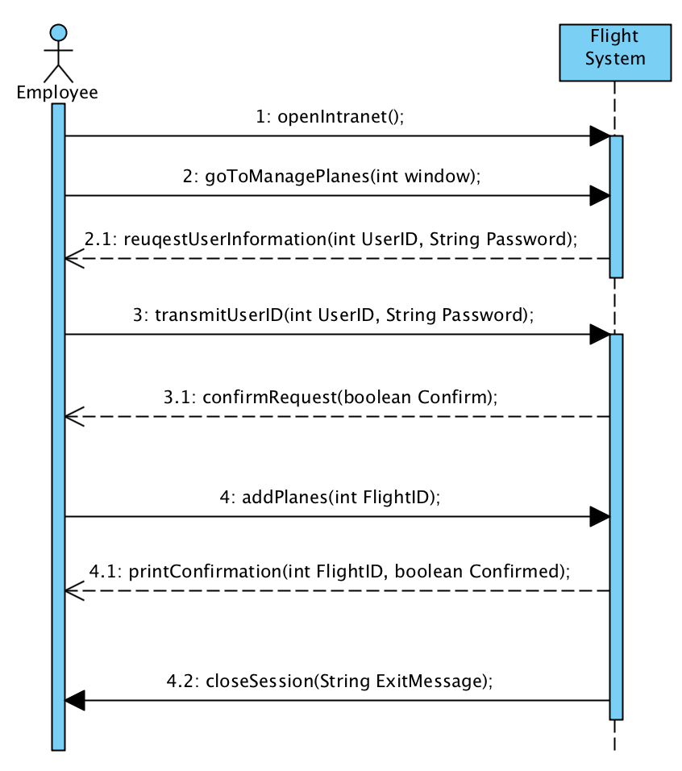

Documentation:

During the first SWD Project, we (Jonas Tvede Henriksen, Frederik Blixt and Fredrik Bjoerklund) have cooperated in finishing the assignment. Jonas & Frederik Blixt have focused on the Use Case scenarios(Briefs, Fully Dressed Use Case, and Use Case Diagram), Fredrik Bjoerklunds focus was primarily directed towards the Domain Model and System Sequence Diagram. Working on the assignment has been a joy and learning experience. We've had few bumps, so overall we had a sense of being well prepared for the task at hand. The finished paper supersedes our preliminary expectations, so we hope that you will be as satisfied as we are. We're looking forward to further criticisms so that we may improve ourselves.