SCHOOL OF COMPUTER SCIENCE AND ARTIFICIAL INTELLIGENCE |  |  |  |  | DEPARTMENT OF COMPUTER SCIENCE ENGINEERING
Program Name: B. Tech |  |  |  | Assignment Type: Lab |  |  | Academic Year:2025-2026
Course Coordinator Name |  |  |  | Venkataramana Veeramsetty
Instructor(s) Name |  |  |  | Dr. V. Venkataramana (Co-ordinator)  Dr. T. Sampath Kumar  Dr. Pramoda Patro  Dr. Brij Kishor Tiwari  Dr.J.Ravichander  Dr. Mohammand Ali Shaik  Dr. Anirodh Kumar  Mr. S.Naresh Kumar  Dr. RAJESH VELPULA  Mr. Kundhan Kumar  Ms. Ch.Rajitha  Mr. M Prakash  Mr. B.Raju  Intern 1 (Dharma teja)  Intern 2 (Sai Prasad)  Intern 3 (Sowmya)  NS_2 ( Mounika)
Course Code |  |  | 24CS002PC215 | Course Title |  | AI Assisted Coding
Year/Sem |  |  | II/I | Regulation |  | R24
Date and Day  of Assignment |  |  | Week6 - Thursday | Time(s)
Duration |  |  | 2 Hours | Applicable to  Batches
AssignmentNumber:12.1(Present assignment number)/24(Total number of assignments)
 | Q.No. | Question |  |  |  |  |  | Expected Time  to complete
 | 1 | Lab 12: Algorithms with AI Assistance – Sorting, Searching, and Optimizing Algorithms  Lab Objectives:  - Apply AI-assisted programming to implement and optimize sorting and searching algorithms.  - Compare different algorithms in terms of efficiency and use cases.  - Understand how AI tools can suggest optimized code and complexity improvements.  Task 1: Implementing Bubble Sort with AI Comments  - Task: Write a Python implementation of Bubble Sort.  - Instructions:  - Students implement Bubble Sort normally.  - Ask AI to generate inline comments explaining key logic (like swapping, passes, and termination).  - Request AI to provide time complexity analysis.  - Expected Output:  - A Bubble Sort implementation with AI-generated explanatory comments and complexity analysis.  Prompt:  Write a python code to implement bubble sort  Output:  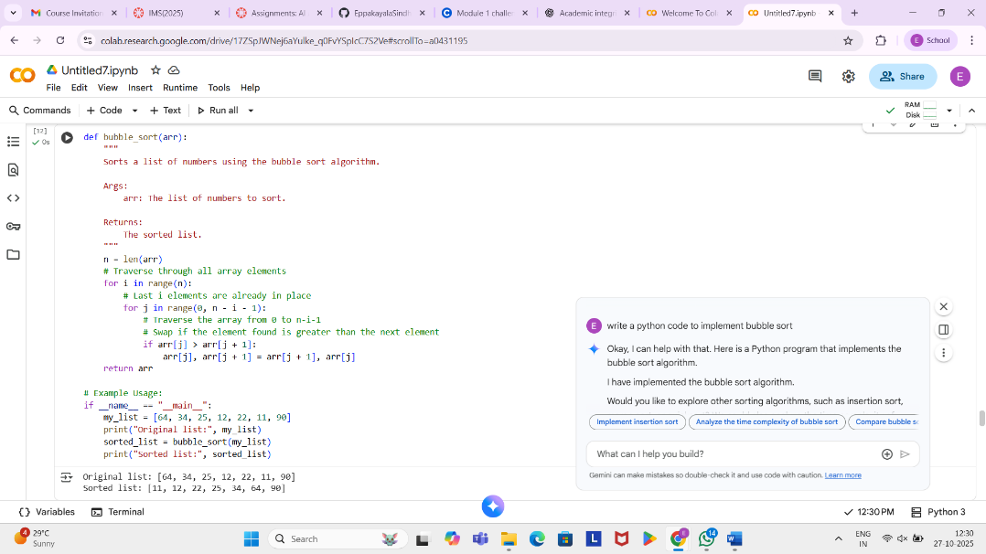  Prompt:  generate inline comments explaining key logic (like swapping, passes, and termination) and provide time complexity analysis  Output:  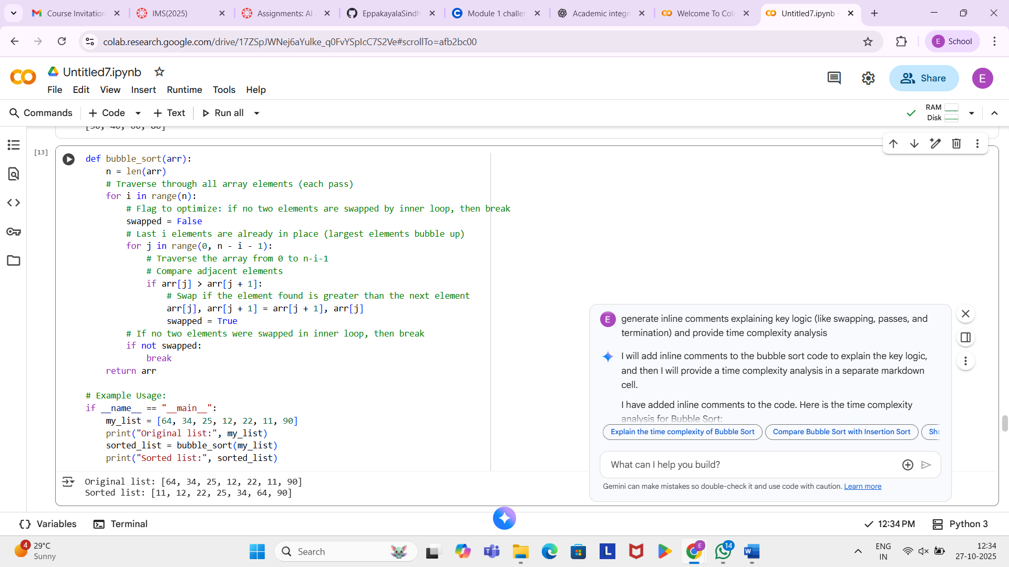  Task 2: Optimizing Bubble Sort → Insertion Sort  - Task: Provide Bubble Sort code to AI and ask it to suggest a more efficient algorithm for partially sorted arrays.  - Instructions:  - Students implement Bubble Sort first.  - Ask AI to suggest an alternative (Insertion Sort).  - Compare performance on nearly sorted input.  - Expected Output:  - Two codes (Bubble Sort + Insertion Sort).  - AI explanation of why Insertion Sort is more efficient for partially sorted data.  Prompt:  suggest me an alternative (Insertion Sort).  Output:  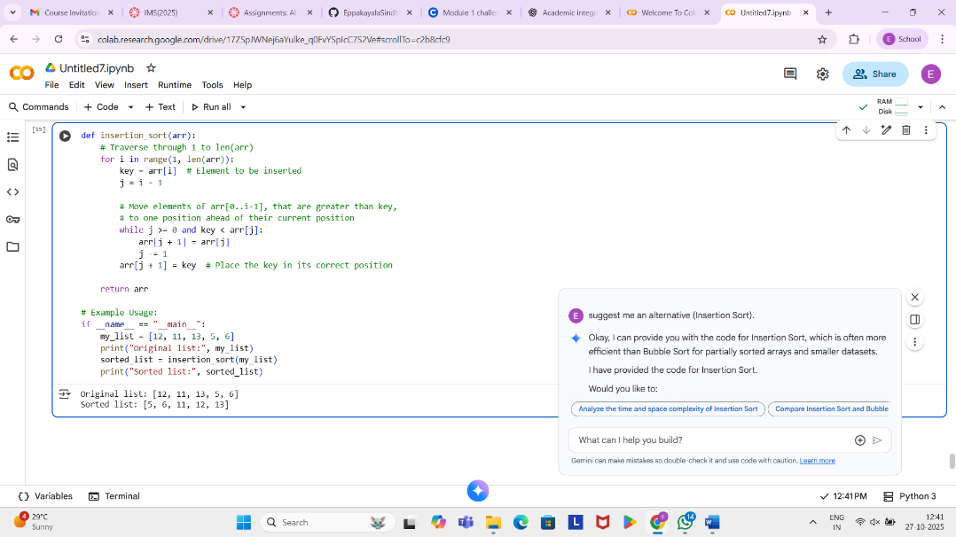  Prompt:  explanation of why Insertion Sort is more efficient for partially sorted data.  Output:  Insertion Sort is generally more efficient than Bubble Sort for partially sorted data because of how each algorithm handles elements that are already close to their sorted positions.  - Bubble Sort: In Bubble Sort, even if an array is mostly sorted, each element still needs to be compared with its adjacent element in every pass. This means that even elements that are already in their correct place (or close to it) are repeatedly compared and potentially swapped, leading to unnecessary operations. The O(n^2) complexity in the worst and average cases doesn't change significantly for partially sorted data.  - Insertion Sort: Insertion Sort builds the final sorted array one item at a time. When it encounters an element that is already in its correct position or only slightly out of place in a partially sorted array, the inner while loop (which shifts elements) will run fewer times. In the best case (an already sorted array), the inner loop doesn't run at all for each element, resulting in an O(n) time complexity. For partially sorted data, the number of shifts is significantly reduced compared to the comparisons and potential swaps in Bubble Sort, making it more efficient.  Task 3: Binary Search vs Linear Search  - Task: Implement both Linear Search and Binary Search.  - Instructions:  - Use AI to generate docstrings and performance notes.  - Test both algorithms on sorted and unsorted data.  - Ask AI to explain when Binary Search is preferable.  - Expected Output:  - Two implementations with docstrings.  - A student observation table comparing performance (Linear vs Binary Search).  Prompt:  generate docstrings and performance notes.  Output:  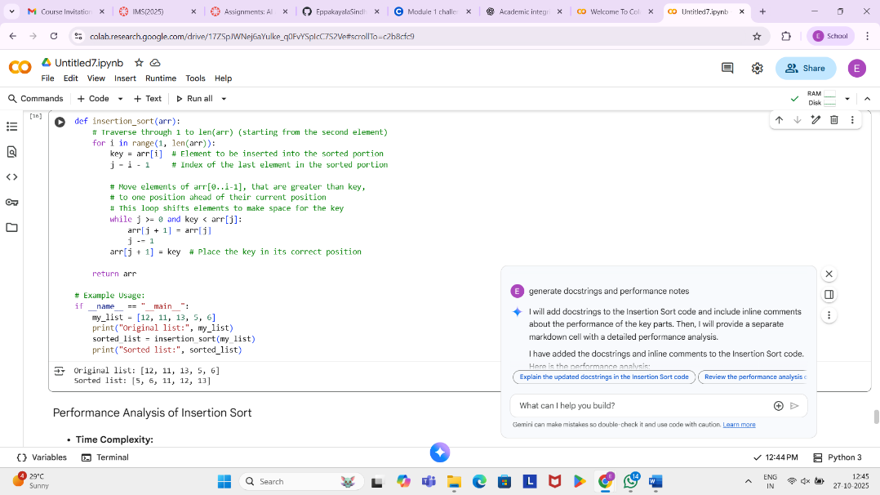  Prompt:  observation table comparing performance (Linear vs Binary Search).  Output:  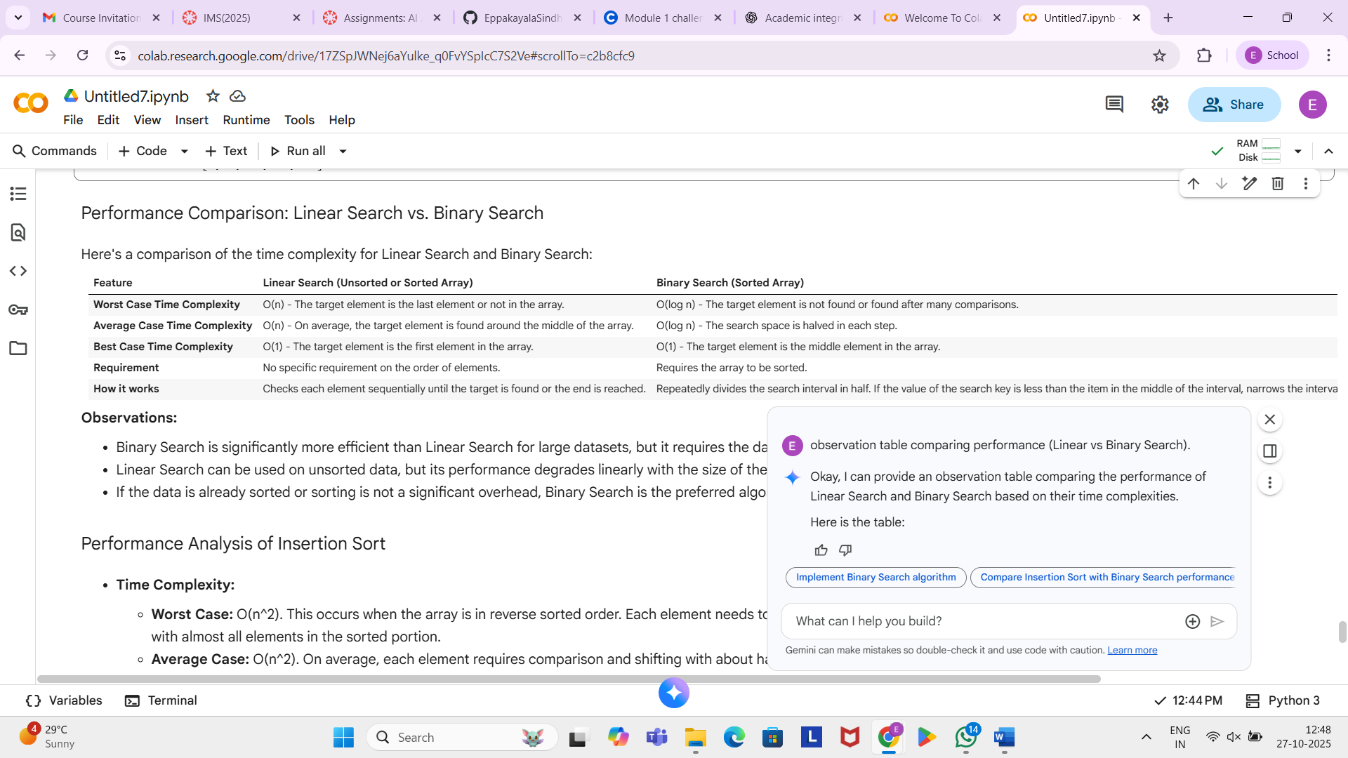 |  |  |  |  |  | Week6 - Thursday
Task 4: Quick Sort and Merge Sort Comparison
- Task: Implement Quick Sort and Merge Sort using recursion.
- Instructions:
  - Provide AI with partially completed functions for recursion.
  - Ask AI to complete the missing logic and add docstrings.
  - Compare both algorithms on random, sorted, and reverse-sorted lists.
- Expected Output:
  - Working Quick Sort and Merge Sort implementations.
  - AI-generated explanation of average, best, and worst-case complexities.
Prompt:
Compare both algorithms on random, sorted, and reverse-sorted lists.

Output:
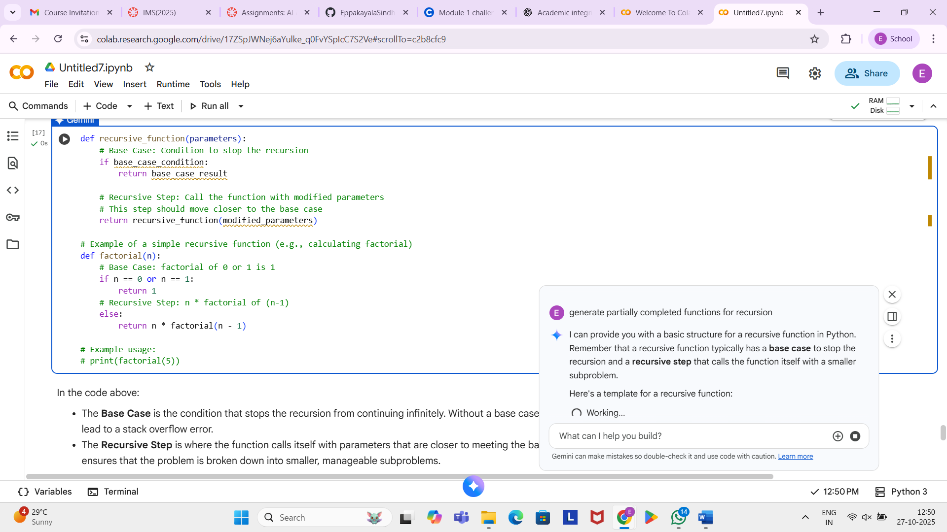

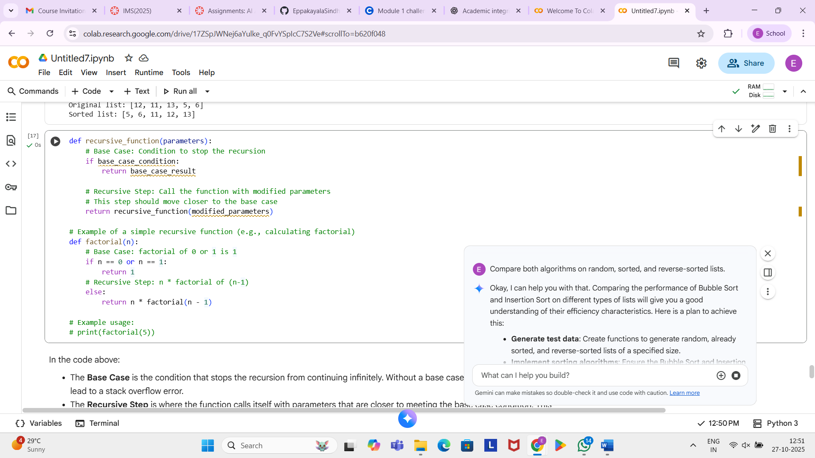
Task 5: AI-Suggested Algorithm Optimization
- Task: Give AI a naive algorithm (e.g., O(n²) duplicate search).
- Instructions:
  - Students write a brute force duplicate-finder.
  - Ask AI to optimize it (e.g., by using sets/dictionaries with O(n) time).
  - Compare execution times with large input sizes.
- Expected Output:
  - Two versions of the same algorithm (brute force + optimized).
  - AI explanation of how complexity was improved.

Prompt:
write a brute force duplicate-finder.

Output:
