SCHOOL OF COMPUTER SCIENCE AND ARTIFICIAL INTELLIGENCE |  |  |  |  | DEPARTMENT OF COMPUTER SCIENCE ENGINEERING
ProgramName:B. Tech |  |  |  | Assignment Type: Lab |  |  | AcademicYear:2025-2026
CourseCoordinatorName |  |  |  | Venkataramana Veeramsetty
Instructor(s)Name |  |  |  | Dr. V. Venkataramana (Co-ordinator)  Dr. T. Sampath Kumar  Dr. Pramoda Patro  Dr. Brij Kishor Tiwari  Dr.J.Ravichander  Dr. Mohammand Ali Shaik  Dr. Anirodh Kumar  Mr. S.Naresh Kumar  Dr. RAJESH VELPULA  Mr. Kundhan Kumar  Ms. Ch.Rajitha  Mr. M Prakash  Mr. B.Raju  Intern 1 (Dharma teja)  Intern 2 (Sai Prasad)  Intern 3 (Sowmya)  NS_2 ( Mounika)
CourseCode |  |  | 24CS002PC215 | CourseTitle |  | AI Assisted Coding
Year/Sem |  |  | II/I | Regulation |  | R24
Date and Day  of Assignment |  |  | Week4 - Tuesday | Time(s)
Duration |  |  | 2 Hours | Applicableto  Batches
AssignmentNumber:8.2(Present assignment number)/24(Total number of assignments)
 | Q.No. | Question |  |  |  |  |  | ExpectedTime  to complete
 | 1 | Lab 8: Test-Driven Development with AI – Generating and Working with Test Cases  Lab Objectives:  - To introduce students to test-driven development (TDD) using AI code generation tools.  - To enable the generation of test cases before writing code implementations.  - To reinforce the importance of testing, validation, and error handling.  - To encourage writing clean and reliable code based on AI-generated test expectations.  Lab Outcomes (LOs):  After completing this lab, students will be able to:  - Use AI tools to write test cases for Python functions and classes.  - Implement functions based on test cases in a test-first development style.  - Use unittest or pytest to validate code correctness.  - Analyze the completeness and coverage of AI-generated tests.  - Compare AI-generated and manually written test cases for quality and logic  Task Description#1  Use AI to generate test cases for a function is_prime(n) and then implement the function.  Requirements:  - Only integers > 1 can be prime.  Check edge cases: 0, 1, 2, negative numbers, and large primes.  Expected Output#1:  Prompt:  Generate a python code for the function is_prime(n)  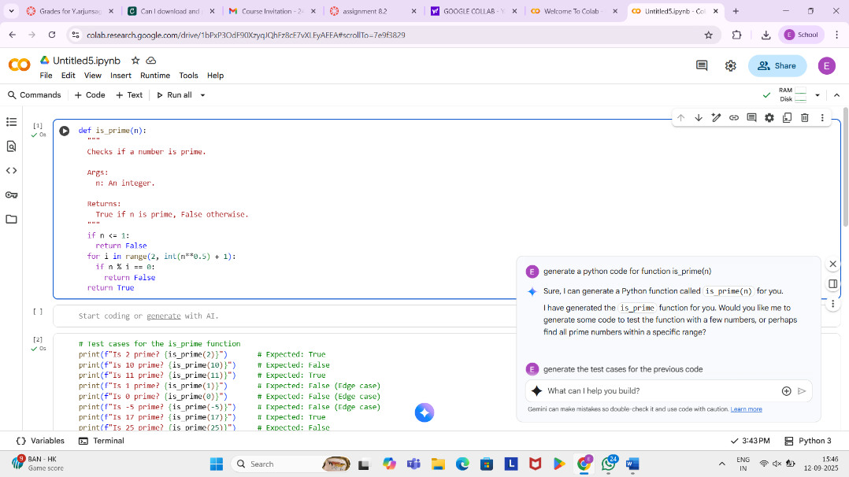  Prompt:  Generate the test cases for the previous code  - Test case for a function is_prime(n) generated by AI  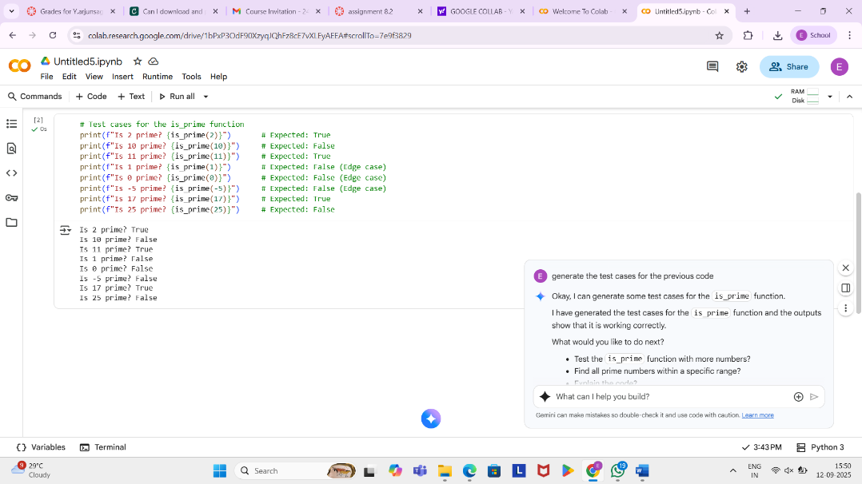  Comments:  - I have generated the is_prime function for you. Would you like me to generate some code to test the function with a few numbers, or perhaps  - I have generated the test cases for the is_prime function and the outputs show that it is working correctly.  Task Description#2 (Loops)  - Ask AI to generate test cases for celsius_to_fahrenheit(c) and fahrenheit_to_celsius(f).  Requirements  - Validate known pairs: 0°C = 32°F, 100°C = 212°F.  - Include decimals and invalid inputs like strings or None  Expected Output#2  Dual conversion functions with complete test coverage and safe type handling  Prompt:  generate a python code to change celsius_to_fahrenheit(c) and fahrenheit_to_celsius(f) requirements are : • Validate known pairs: 0°C = 32°F, 100°C = 212°F. • Include decimals and invalid inputs like strings or None  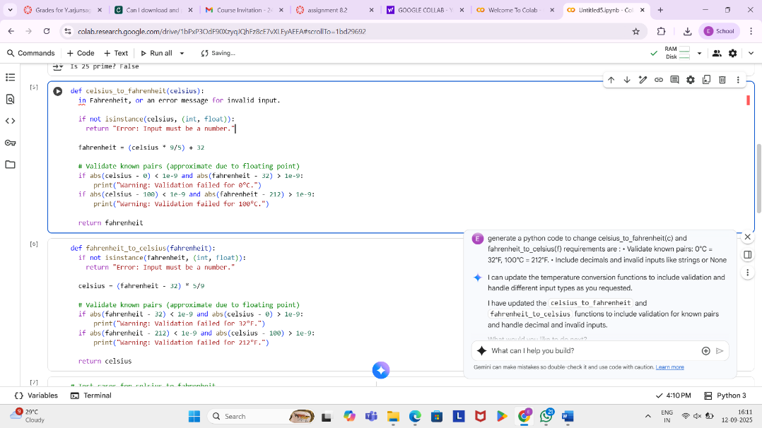  Prompt:  give some test case for the previous program  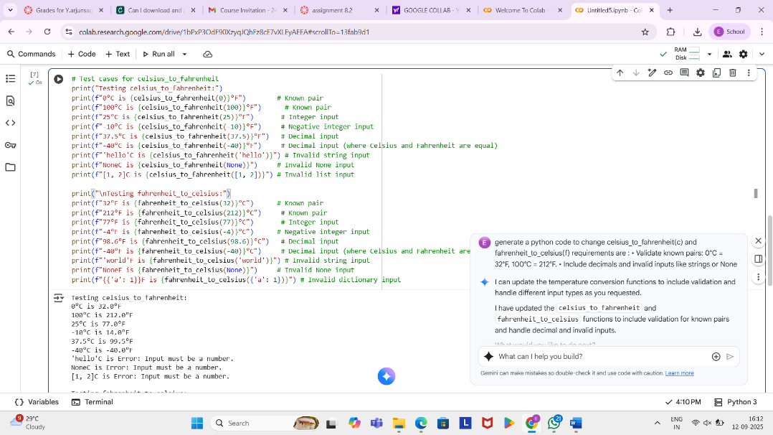  Comments:  - I have generated the celsius_to_fahrenheit and fahrenheit_to_celsius functions for you. Would you like to test these functions with some values  - I can update the temperature conversion functions to include validation and handle different input types as you requested.  - I have updated the celsius_to_fahrenheit and fahrenheit_to_celsius functions to include validation for known pairs and handle decimal and invalid inputs.  Task Description#3  Use AI to write test cases for a function count_words(text) that returns the number of words in a sentence.  Requirement  Handle normal text, multiple spaces, punctuation, and empty strings.  Expected Output#3  Accurate word count with robust test case validation.  Prompt:  write a python function count_words(text) that returns the number of words in a sentence.  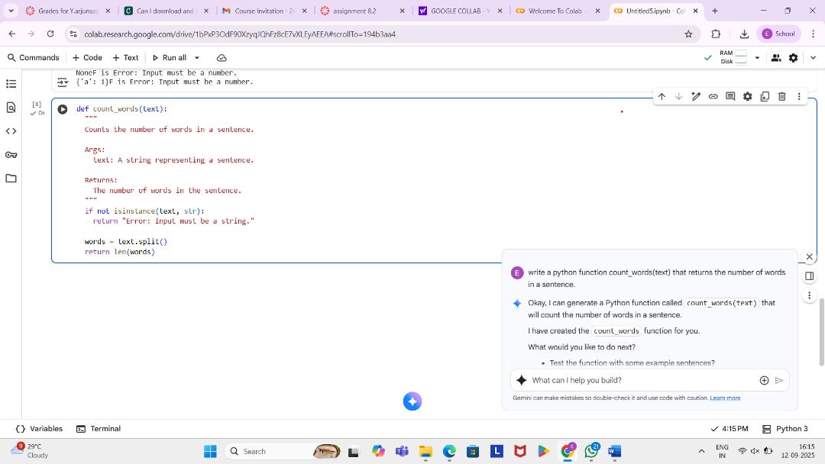  Prompt:  give me some test case  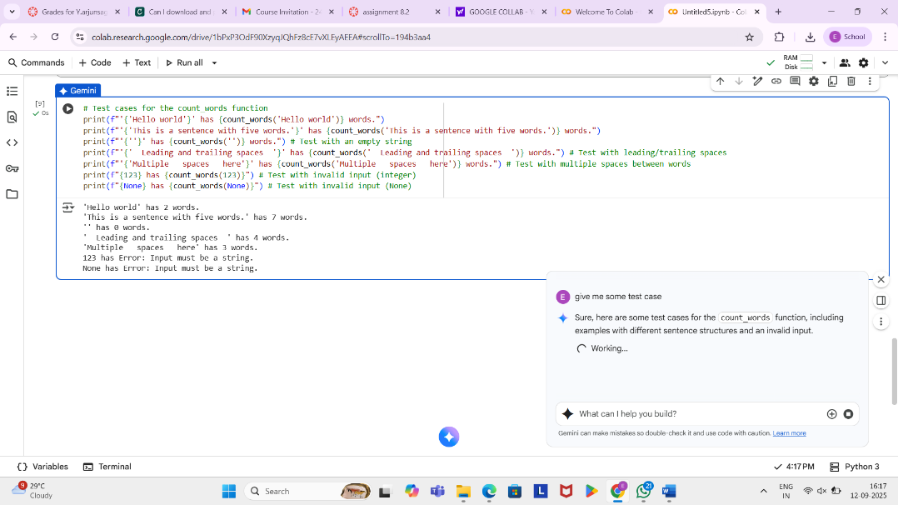  Comments:  - I can provide some test cases for the updated temperature conversion functions, including examples with valid numbers (integers and decimals) and invalid inputs.  - The test cases for both celsius_to_fahrenheit and fahrenheit_to_celsius have been executed, and the output demonstrates that the functions handle both valid numerical inputs (integers and decimals) and invalid inputs (strings, None, lists, and dictionaries) correctly by returning the specified error message.  Task Description#4  - Generate test cases for a BankAccount class with:  Methods:  deposit(amount)  withdraw(amount)  check_balance()  Requirements:  - Negative deposits/withdrawals should raise an error.  - Cannot withdraw more than balance.  Expected Output#4  - AI-generated test suite with a robust class that handles all test cases.  Prompt:  generate python code for BankAccount class with: Methods: deposit(amount) withdraw(amount) check_balance() Requirements: • Negative deposits/withdrawals should raise an error. • Cannot withdraw more than balance  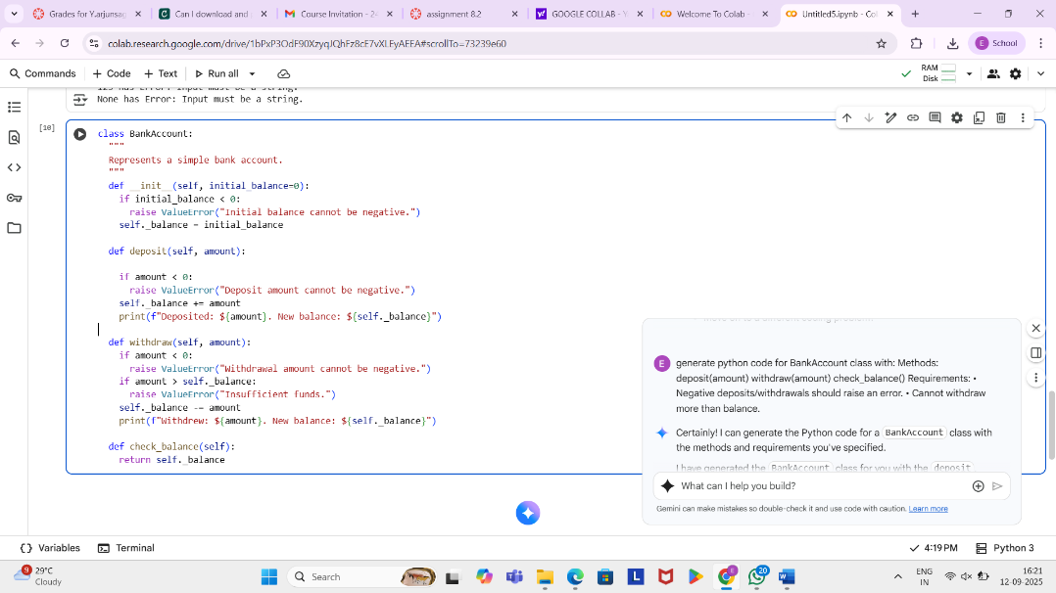  Prompt:  Give some test cases for previous code  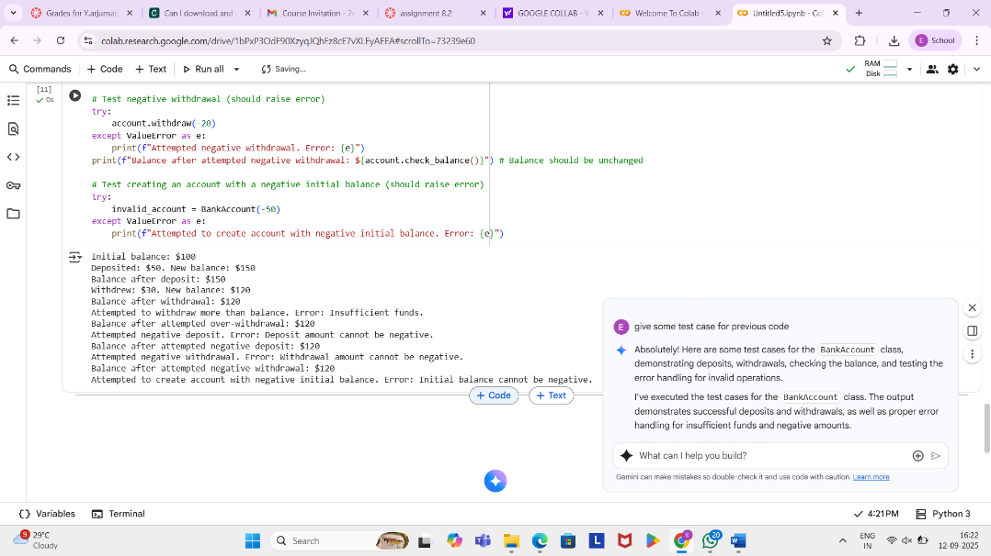  Comments:  - I can generate the Python code for a BankAccount class with the methods and requirements you've specified.  - I have generated the BankAccount class for you with the deposit, withdraw, and check_balance methods, including the requested error handling for negative amounts and insufficient funds.  Task Description#5  Generate test cases for  Examples:  121 → True  123 → False  0, negative numbers → handled gracefully  Expected Output#5  - Number-based palindrome checker function validated against test cases.  Prompt:  Write a python function is_number_palindrome(num), which checks if an integer reads the same backward.  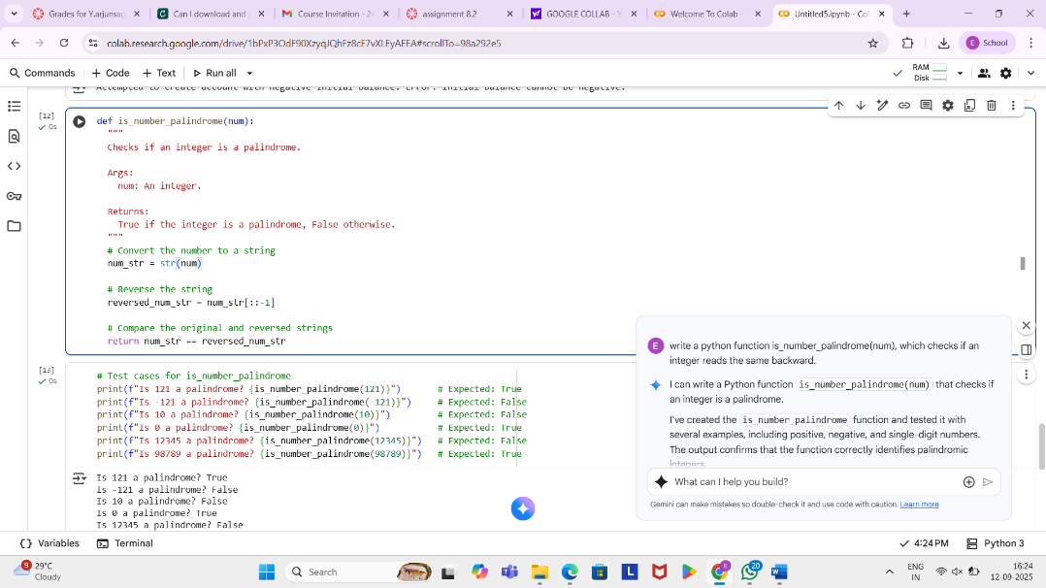  Prompt:  Give some test case for previous code  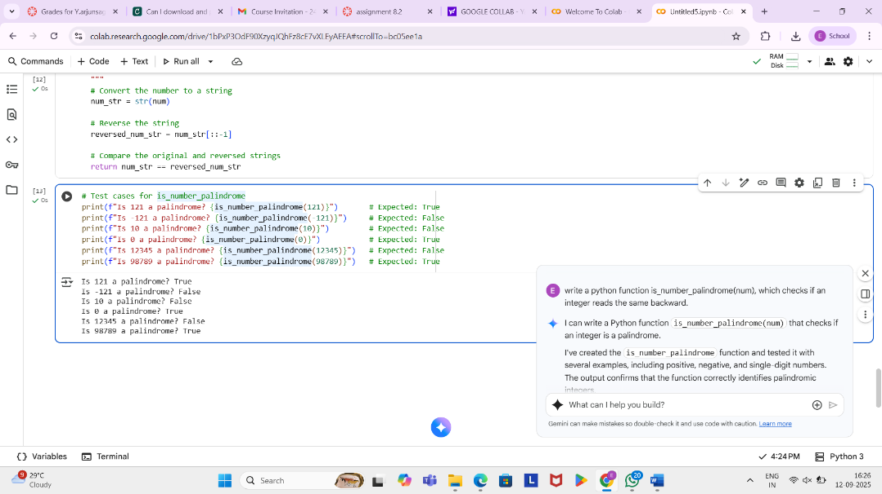  Comments:  - I can write a Python function is_number_palindrome(num) that checks if an integer is a palindrome.  - I've created the is_number_palindrome function and tested it with several examples, including positive, negative, and single-digit numbers. The output confirms that the function correctly identifies palindromic integers.  Note: Report should be submitted a word document for all tasks in a single document with prompts, comments & code explanation, and output and if required, screenshots  Evaluation Criteria:  Criteria Max Marks  Task #1 0.5  Task #2 0.5  Task #3 0.5  Task #4 0.5  Task #5 0.5  Total 2.5 Marks |  |  |  |  |  | Week4 - Wednesday

