2026
Siemens AG
Corporate Technology
Author: Andreas Zirkler, Manuel Eppler


TSN Application Center
Test App Description
Version 1.0
Table of Content
1. Scope and Introduction 3
2. Compilation 3
2.1. Old version 3
2.2. New version 3
2.2.1. Sudo user and ssh key 4
2.2.2. get git repository 4
2.2.3. Get new Linux kernel 4
2.2.4. get required packages and build app 4
3. Usage 5
3.1. Mode of operation 6
3.2. Optional parameters to configure app behavior 7
3.3. Optional parameters to configure traffic specification 11
3.4. Compiler switches 14
4. Setting up Grafana output 15
4.1. InfluxDB 15
4.2. Grafana 16
4.3. Error messages 20

Scope and Introduction
The TSN Test Application is developed in the Siemens Innofonds Project “TSN Application Center”. It was inspired by intel's "sample app taprio" and might still contain snippets of this code. Also Siemens’ “TSN Stack” and LNI test application have been used as a starting point for the application.

Compilation / Installation
If all requirements are fulfilled, you can easily compile the TSN test app using this script from the root directory of the repository:
./build_with_static_lib.sh
The new version of the app has several dependencies. The following chapters describe the steps to get it running on a newly installed Linux PC, preferably with debian bookworm.
Note: the bpftool library needs root privileges to be used, because it might change network settings and bypass the linux network stack. Thus, depending on the privileges management, it might be necessary to to run the aforementioned script with root privileges. You can identify this issue if bpftool is not found while it is installed in the latest version:
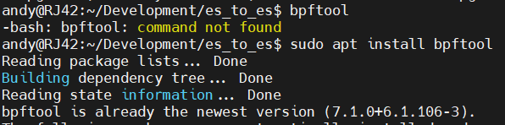

Sudo user and ssh key
su -
apt-get install sudo -y
usermod -aG sudo <username>
su <username>
sudo apt install git
ssh-keygen -t ed25519 -C "<hostname>"
- Copy the private key to your GitHub profile

Get git repository
sudo apt install git
mkdir Development
cd Development/
git clone https://github.com/EpplerM/TSN-Test-App.git
cd TSN-Test-App/

Get new Linux kernel
In case compilation fails, you might require a later Linux kernel. We recommend at least 6.1.x. To update:
sudo nano /etc/apt/sources.list
- Add the version you need, e.g.
deb http://deb.debian.org/debian bookworm main
sudo apt update
- Note: if you get error messages like “E: Release file for … is not valid yet”, check your system time.
apt-cache search linux-image
- Select the Kernel you like, e.g. linux-image-6.1.0-7-rt-amd64
sudo apt install linux-image-6.1.0-7-rt-amd64
sudo reboot

get required packages and build app
The required packages are listed in the file install_dependencies.sh in the root folder of the git repository. You might check the packages mentioned in there or simply run the script to install all necessary dependencies.

Usage
The app is started with the command
sudo ./tsn_test_app
from the directory the app is stored. Sudo privileges are required to put the ethernet interface into promiscuous mode. A set of parameters is used to configure the behavior of the app. All parameters are case sensitive. The first parameter must be the one determining the mode of operation, see chapter 3.1. All other parameters are optional and can be used in random order. See chapter 3.2 for parameters changing app behavior, chapter 3.3 for parameters changing the traffic specification.
Note that the application relies on synchronization of end stations. It is recommended to use ptp4l and phc2sys. You might check the synchronization state using sudo pmc -u -b 0 'GET TIME_STATUS_NP'
A summary of the test result is always given at the end of the test, see Figure 1. Noticeable values are hightligted in red. Additional output can be switched on and off with the verbose option (-v) and UPDATE_INTERVAL, see chapter 3.2 and .
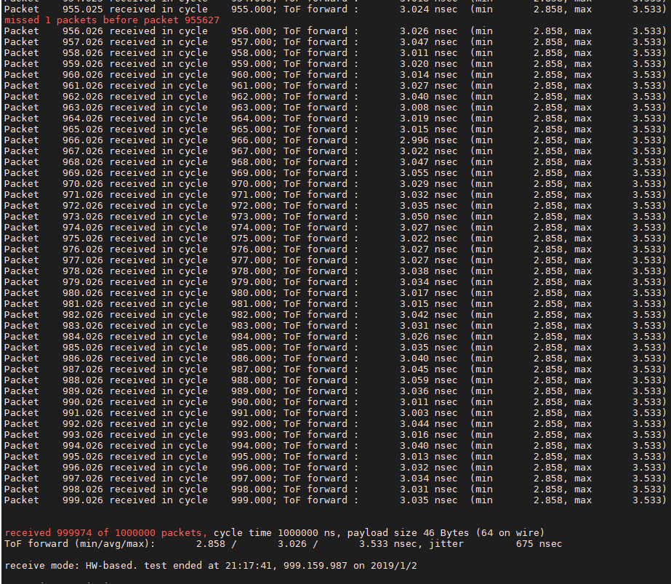
Figure 1: summary at end of test at receiver’s side
Whenever errors are shown at the reciever’s side, e.g. lost packets as in Figure 1, it is recommended to check for corresponding error messages at the sender, e.g. due to misconfiguration of queuing disciplines as shown in Figure 2.

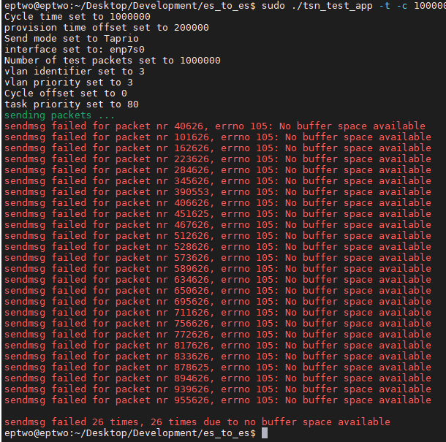
…

Figure 2: summary at end of test at sender’s side

Mode of operation
Possible options are (exclusive or):
-l listener. In this mode, the app is waiting for packets from a sender and computing the end-to-end delay and jitter. No packets are sent. Whenever a listener receives a reset packet it resets all statistic counters. After the last test packet was received, the listener app prints the statistic values. In infinite mode (option -I, see below) it is immediately ready for a new test, otherwise it terminates.
-t talker. In this mode, the app immediately starts to send packets according to the traffic specification defined by the parameters described in the following sections. Note that before the first test packet is sent a reset packet is sent. The reset packet is sent with low priority (VLAN priority 0) and outside of the schedule. It is meant to inform the listener about the start of a new test. The execution of the app terminates after the specified number of test packets was sent.
-tl initiating talker and listener. In this mode, the app immediately starts to send packets according to the traffic specification defined by the parameters described in the following sections, exactly as in mode t. Additionally, it is waiting for packets from a sender and computing the end-to-end delay and jitter as in mode l. After the specified number of test packets was sent and the last test packet was received and the statistic values where printed accordingly the execution of the app terminates.
-lt listener and responding talker. In this mode, the app is waiting for packets from a sender and computing the end-to-end delay and jitter as in mode l. Additionally, it starts to send packets according to the traffic specification defined by the parameters described in the following sections, as in mode t. In contrast to mode t is does NOT start to send packets immediately, but after it received the first test packet from a talker. After the last test packet was received, the listener app prints the statistic values. In infinite mode (option -I, see below) it is ready for a new test as soon as the specified number of test packets was sent, otherwise it terminates.
-A agent mode. The app starts idle and waits for a test client to connect on port 65000. The mode of operation can be selected via test client. Log information will be sent to test client. All parameters to configure app behavior can be used in agent mode and might be overwritten by test client. The app can be terminated via <ctrl-C> or via test client.
Test packets sent from talker are based on a Layer 2 Ethernet frame of minimum 64 bytes including MAC header (18 bytes) and payload (minimum 46 bytes), see Figure 3. By default, the destination MAC address is set to the locally administered multicast address 03:7A:CE:01:02:03. The payload starting at byte 19 contains alternating the total packet count and the cycle time of the running test (bytes 19-22) followed by the packet number (bytes 23-26) and the the sending time stamp (bytes 27-34). In case of a bi-directed test, the listener-talker endpoint transfers additionally the sending and receive time stamps of the previously received packet (bytes 35-50). According to requested packet size, remaining bytes are set to hex 42.
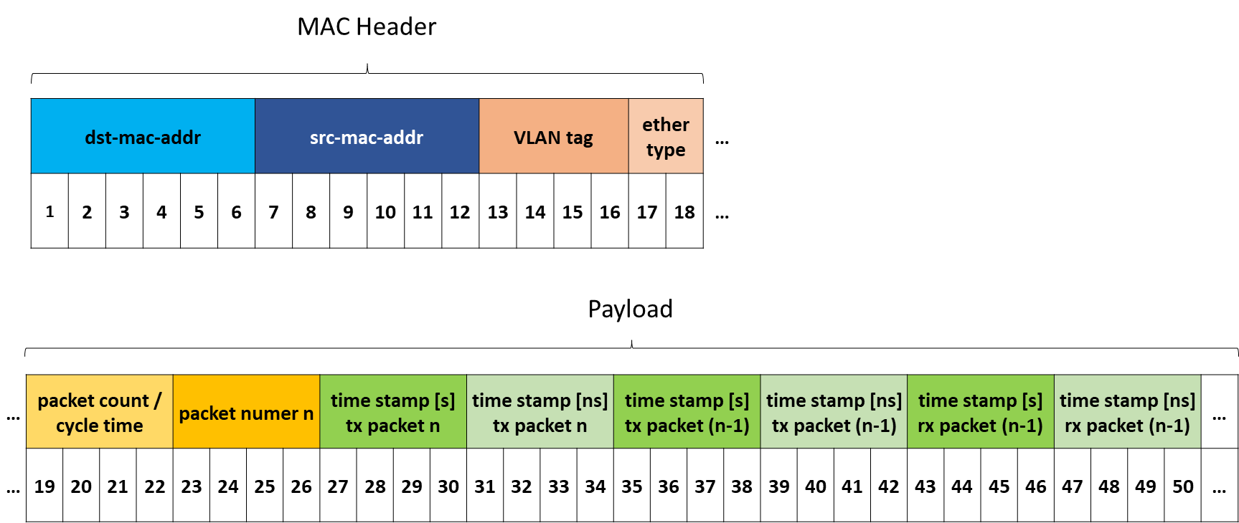
Figure 3: byte configuration of test packet

Optional parameters to configure app behavior
-I switches to infinite mode. Only useful for listeners and listeners with responding talkers, will be ignored for talkers and initiating talkers with listeners. In infinite mode, listeners and listeners with responding talker are ready for a new test directly after a test has finished, otherwise the execution of a listening app terminates after a test. In infinite mode, use <ctrl-C> to terminate the app.
-i selects the interface used for sending and receiving packets. If parameter -I is not used, the default value enp7s0 is used as interface. The app will crash, if the specified interface does not exist.
-p changes provision time. Only useful for talkers, initiating talkers with listeners and and listeners with responding talkers, will be ignored for pure listeners. The value is specified in nanoseconds, default is 200’000ns. Provision time is the time offset a packet to be sent is provided to the communication stack, i.e. the send() function is called, ahead of the planned send time. Refer to Figure 4 for better understanding.
-s selects the mode how send time stamps for sent packets are generated. Only useful for talkers, initiating talkers with listeners and and listeners with responding talkers, will be ignored for pure listeners. Must be followed by one of the following options:
- AL: the point in time when the Application Layer, i.e. the app, calls the send() function is written into the origin time stamp value of the sent packet. That means, that the time the SW and HW stack takes to send the packet out from the interface is taken into account when end-to-end delay is computed. High Jitter is to be expected as a SW-stack is included in the measured delay.
- HW: the planed send time is written into the origin time stamp value of the sent packet. That means, that only the real transportation time on the network is taken into account when end-to-end delay is computed. Note that a mechanism to enforce the planned send time, e.g. a taprio qdisc or a TAS shaper in a bridged end station, shall be used.
- ETF: same as HW, but additionally writes the send time to the auxiliary information of the packet header, which is needed for using the ETF (earliest transmission time first) feature, which is also activated by this option. Note that SCM_TXTIME is a long long integer, thus this feature will fail on machines not supporting 64 bit variables, e.g. the Fraunhofer IPMS board. Code snippets:
  - Activate TX-time option:
setsockopt(sockfd, SOL_SOCKET, SO_TXTIME, &sk_txtime;
  - Then write send time in auxiliary data:
cmsgcmsg_type = SCM_TXTIME;
*((_u64 *) CMSG_DATA(cmsg)) = send_time;
-r selects the mode how receive time stamps for received packets are generated. Must be followed by one of the following options:
- AL: the point in time when the application layer has received a packet from the recvmsg() function is taken into account when end-to-end delay is computed. High Jitter is to be expected as a SW-stack is included in the measured delay. This option can be an alternative to SW and HW, if adequate driver- and HW-support is not available, or might be used to measure network stack delay and jitter.
- SW: the SW-based time stamp, which has been generated when the network interface driver has received the packet, is taken into account when end-to-end delay is computed. Note that this option requires adequate NIC driver support. This option is only an alternative to HW, if adequate HW-support is not available.
- HW: the HW-based time stamp, which has been generated when the network interface has received the packet, is taken into account when end-to-end delay is computed. Note that this option requires adequate HW-support.
-E this option changes the way the app is synchronized to the network. In default mode, PTP4Linux is used to synchronize the network interface to the network, PHC2SYS is used to synchronize the Linux system clock to the network interface. The app then simply uses the Linux system clock to achieve timing information. If option -E selected, the app directly accesses the clock of the network interface card to achieve timing information. PHC2SYS is not required in this case, better timing precision is thus to be expected. Note that a Siemens-proprietary kernel patch is required to use this option, however this patch is planned to be published.
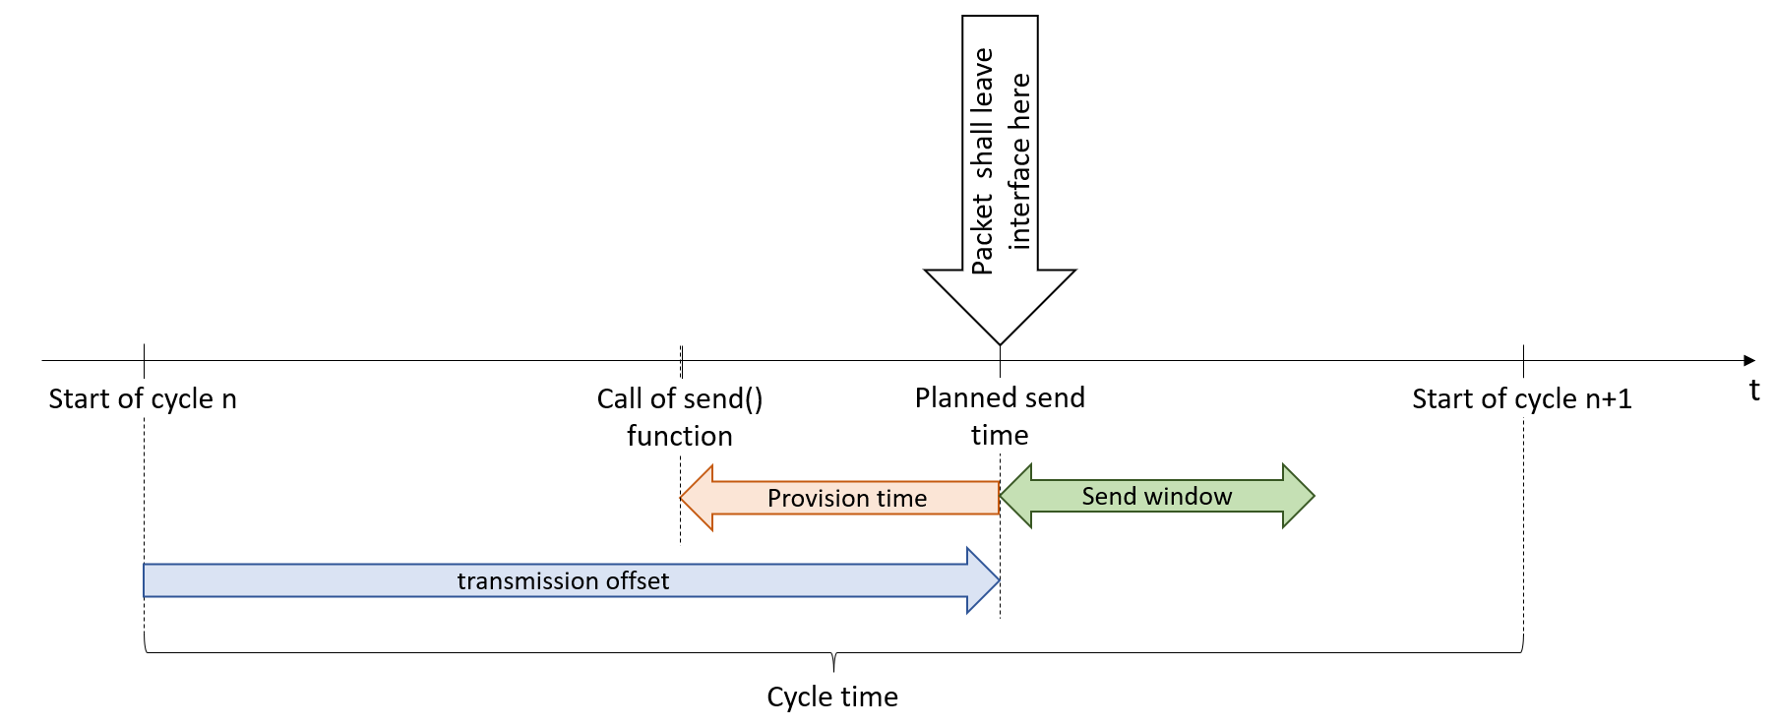
Figure 4: frame send timing
-v activates a couple of verbose output, which is useful for debugging or timing analysis. You might want to not use it to achieve shorter cycle times. To ease reading when sender and receiver are running in parallel, sender output is in green color. Given additional output is:
- Task priority, Current time and wakeup time before test start
- Send time for every sent packet (see Figure 5)
- Provision time for every sent packet, if PROVISIONTIME is defined additionally (see Figure 5)
- Receive time, origin time and computed delay for every received packet (see Figure 6)
- Warnings about excessive delay for every packet received with ten times more delay than the previous average
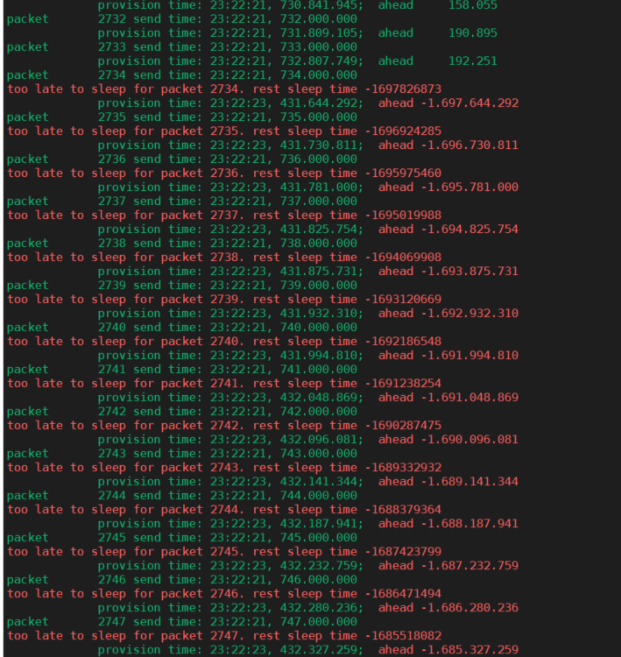
Figure 5: verbose output at sender
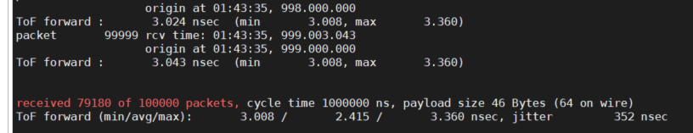
Figure 6: verbose output at receiver
--round-trip can only be used for listening talkers (--tl). It will compute the sum of forward- and backward-delay and provide it on the command line output (and the file output in combination with -F). Note that the residence time in the talking listener, i.e. the time the opposite node takes to respond to the packet, is not contained in the round trip delay value, only the pure forward and backward communication delay!
--reply-mode is meant to imitate the behavior of a request-respone communication pattern, e.g. TCP. It can only be used for talking listeners (--lt). Normally, a talking listener starts to send packets after it has received the first test packet from the listening talker and then continues to send a packet every cycle time. With --reply-mode activated, it abstains from sending a packet, if it did not receive a packet since it did send a packet in the last cycle. With this, it behaves like it would “reply” to the packets received from the listening talker. --reply-mode takes a parameter, the so-called reply-retry value. With this parameter set to 0, the talking listener will never send a packet as long as it does not receive packets. With a value x > 0, it will send a packet after x consecutive cycles not receiving a packet.
Note: depending on the network delay, jitter and synchronization accuracy, it might happen that some packets are not sent, because a packet from the listening talker was not received on time. It is recommended to increase the cycle time in this case.
--recovery_period specifies the number of packets which must be received, before a stream is considered to have recovered from an interruption. The test app will note the number of missed packets on the command line and the report file (refer to --report) during the running test and will note the longest consecutive number of missed packets in the statistics at the end of the test and the report file. By default, one single packet is sufficient to divide a period of interruption in two, i.e. the default recovery period is 1. For example, if 100 packets are missed, then 1 is received, and then 150 are missed, the longest consecutive number of missed packets would be 150. If, as another example, the recovery period is set to 10, the consecutive reception of 10 packets is required to divide a period of interruption in two. With a recovery period of 10, if 100 packets are missed, then 9 are received, and then 150 are missed, the longest consecutive number of missed packets mentioned in the statistics would be 259 packets.
-F activates output of packet number and time of flight for all packets received at a listener to a file. In –tl mode, the round trip delay will be written to the file additionally. Unlike --report, the file output does not contain information about test app and test traffic configuration. The file will be stored in a sub-folder called logs in the folder the app was started in. The filename is automatically generated to <hostname>_<interface>_<date>__<time>.csv.
--verbose-file is similar to -F, but writes the send timestamp for every received packet additionally. In combination with –round-trip it also writes the round trip delay, but you need to use –verbose-file on both ends to get the send time stamp for both directions.
--report enables the generation of a test report file. This file contains the configuration of the test app and the test traffic specification as well as errors and warnings occurred during the test and statistics at the end of the test. Unlike file output (-F), the report does not contain delay values for every single packet. The file will be stored in a sub-folder called reports in the folder the app was started in. The filename is generated to <hostname>_<interface>_<date>__<time>.csv.
-- testcase allows the user to specify a testcase name for a test. --testcase automatically enables the report file output (refer to --report). The specified testcase name will be noted in the report file and prepended to the report file name.
-q Quiet mode, no warnings about excessive delay values of received packets are printed, neither to standard output nor to the report file. Useful in environments with weak or no synchronization.
--qq Very quiet mode, no warnings about excessive delay values of received packets, missed or duplicate packets, or broken connections to a test client are given, neither to standard output nor to the report file.
-Q configures the priority value used for the Linux socket used for sending the packets:
setsockopt(sockfd, SOL_SOCKET, SO_PRIORITY, &priority, sizeof(priority));
This is used for the assignment to the according output queue based on the tc map. Refer to config_talker.sh for details. Default value is 5. Will be ignored for pure listeners
-S, -R and -C set task priority for send and receive task as well as CPU affinity for the whole app to the desired value. By default, task priority and CPU affinity are left with the system default, as manipulating task priority doesn’t work on all systems. If one or more of the options -S, -R or -C are used, the other options are set to the default values given below.
Warning: setting task priorities to too high values and/or choosing a CPU needed e.g. for ssh remote control, you might lock out yourself from the device, particularly when accessing it from remote.
-S sets task priority for the send task. The default value, which is only applied if -R or -C are used, is 80.
-R sets task priority for the receive task. The default value, which is only applied if -S or -C are used, is 80.
-C sets CPU affinity. CPUs are counted starting from zero. The default value, which is only applied if -S or -R are used, is 2, meaning the third CPU core is used.
--timeout defines the time (in seconds) after which a listener will give up waiting for further packets after a reset packet or the latest test packet was received. When the timeout expires, the listener will quit or get ready for the next test in infinite mode. Default is 1 second.
--grafana opens a direct socket communication to an influxDB and writes measured delay values to this database. See chapter for instructions to set up influxDB and Grafana. For short cycle times, most systems will get overloaded when writing values to influxDB every couple of microseconds. Therefore, the –grafana option takes a sampling period value. This means that only after the given number packets an update is written to the database. Not to lose relevant peaks, the minimum and maximum value of all packets received during the sampling period is provided. In listener mode, only for the forward delay, in listening talker mode for forward delay, backward delay and round-trip delay are provided. Additionally, forward and backward packet loss are provided in the format permill of lost packets over the last sampling period. We recommend combinations of cycle time and sampling period so that the update rate for Grafana does not exceed 10Hz.
Note: for short sampling periods, the packet loss value might appear to be wrong. However, if the sampling period is e.g. 10 packets, a single lost packet in this period means 100 ‰ packet loss.
--influx-server adjusts the IP address of the server hosting the influx DB which is used for the Grafana output. Default is 127.0.0.1, which equals localhost.
--influx-bucket adjusts the name of the bucket in influx DB which is used for the Grafana output. The default value is “DelayValues”. The bucket name should be adapted if multiple instances of the app feed data to the same influx DB.

Optional parameters to configure traffic specification
-c changes the cycle time. The value is given in nanoseconds, default is 1’000’000ns. Only useful for talkers, initiating talkers with listeners and and listeners with responding talkers, will be ignored for pure listeners.
-o changes the transmission offset. Only useful for talkers, initiating talkers with listeners and listeners with responding talkers, will be ignored for pure listeners. The value is given in nanoseconds, default is 100000ns. With the default option, the packets are sent 100000ns after the beginning of each cycle, see Figure 4. The given value must be greater or equal zero and shorter than cycle time.
-w causes the test app to send packets within a defined send window. Without -w option, or with -w 0, which is the default, the app sends packets as precisely as possible in the defined cycle, with the defined offset after cycle start time. With -w > 0, the packets are randomly spread over the defined window. E.g. with -o 100000 and -w 50000 the packets are sent in a window between 100 and 150µs after cycle start time. This feature is meant to test the different behavior of PSFP based on stream gates versus stream filters. Note that the packets are sent with the actual send time – including the “jitter” introduced by the -w option, as send timestamp, thus you will not measure additional jitter in the receiving listener, as long as there is no TAS-like feature active in between.
-m causes the app not to send m permill of the packets. The omitted packets are arbitrary selected by a random function.
-n changes number of test packets to be sent. Only useful for talkers, initiating talkers with listeners and listeners with responding talkers, will be ignored for pure listeners. Default is 100000. Use
-N for endless test. Only useful for talkers, initiating talkers with listeners and listeners with responding talkers, will be ignored for pure listeners. The sender will keep sending packets until <ctrl-c> is pressed.
-B Burst size. Only useful for talkers, initiating talkers with listeners and listeners with responding talkers. With this option, multiple packets, as many as specified by this option, are sent as dense as possible (see option -G) after each other. After one burst, the next burst will start with the next planned send time. Note that all packets of one burst will be handed over to the socket one after the other, virtually at once, which might result in a send buffer overflow, particularly when constrained hardware buffers are used.
-G Interframe gap for burst packets. Only useful in combination with option -B. By default, burst packets are attempted to be sent with the minimal interframe gap as specified in IEEE 802.3. Note that most PC-based end stations are not able to send packets with minimal interframe gap, in particular not for small packet sizes. In these cases, in particular in combination with mechanisms aiming on precise timing for sent packets – like ETF –, delay measurement might be corrupted, because burst packets are not managed to be sent at the planned point in time. As the orange graph in Figure 7 shows, packets within the burst might appear to suffer an increasingly higher delay than the first packet of each burst. In such a case, parameter -G should be used specify an interframe gap the NIC-PC-driver-combination in use can actually deliver, as done for the grey graph in Figure 7.
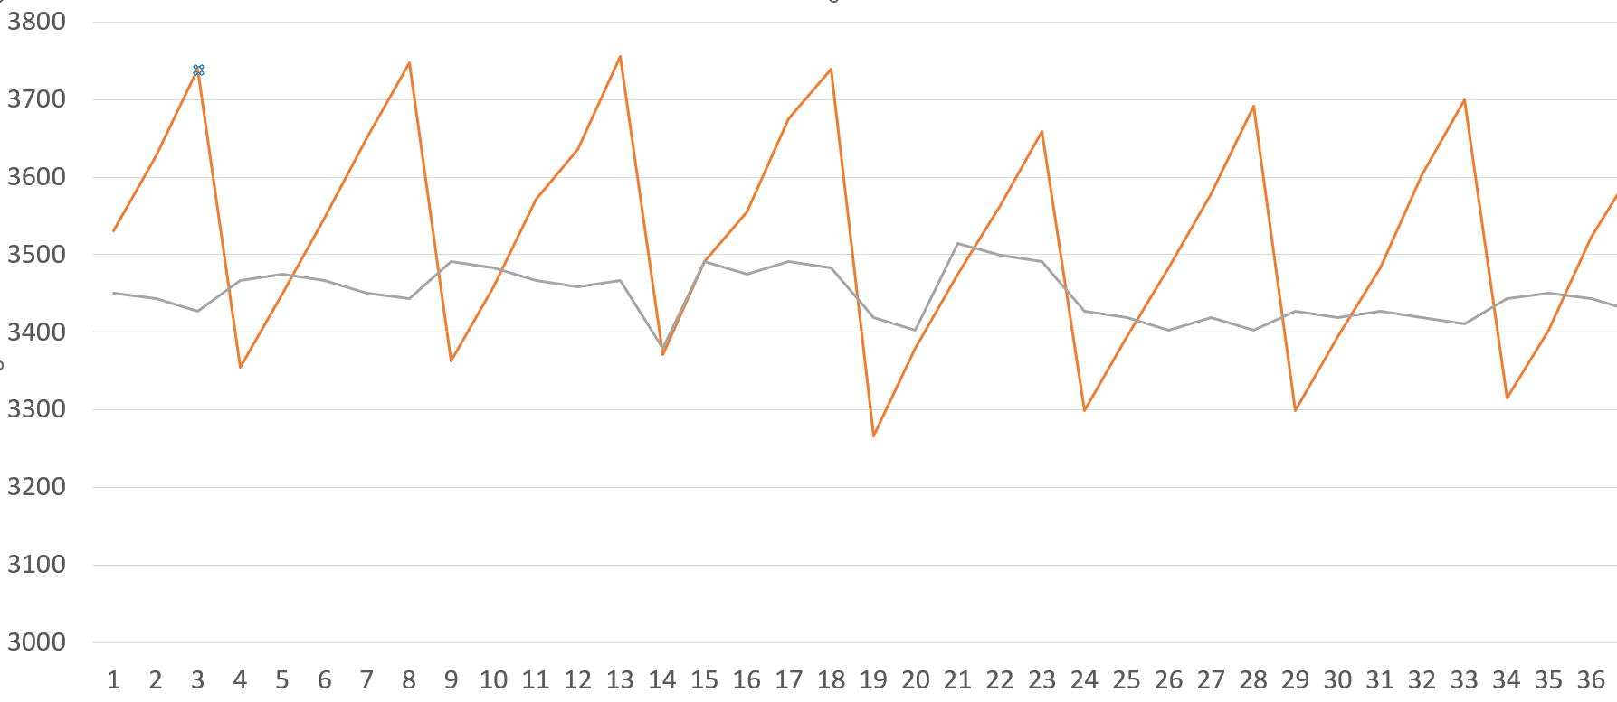
Figure 7: Corrupted delay measurement due to unreachable interframe gap
-P adjusts VLAN priority. Only useful for talkers, initiating talkers with listeners and listeners with responding talkers, as it just adds the VLAN priority to the VLAN tag in the sent packets. Default value is 5. Please note that the Linux-internal priority is adjusted with -Q.
-V adjusts VLAN identifier. Only useful for talkers, initiating talkers with listeners and listeners with responding talkers, as it just adds the VLAN identifier to the VLAN tag in the sent packets. Will be ignored for pure listeners, it does not filter packets with differing VLAN identifiers. Use a VLAN-aware interface (e.g. enp7s0.5 for VLAN 5 on interface enp7s0) and specify the according interface using the -i option to filter for packets from a specific VLAN. Default value is 5.
-d sets destination MAC address. Only useful for talkers, initiating talkers with listeners and listeners with responding talkers, will be ignored for pure listeners. Will always be used if specified. If not specified, responding talkers will respond to the MAC address test packets were received from. Talkers and initiating talkers with listeners will send to 03:7A:CE:01:02:03 as default, which is a locally administered multicast address (indicated by the leading 03). The address shall be given in format XX:XX:XX:XX:XX:XX.
-T is intended to generate test data, e.g. to train a network AI. This option requires an input file describing send windows and packet loss per period. The input file must be structured as follows:
<packetNumber> <sendWindow> <packetLoss>
<packetNumber> <sendWindow> <packetLoss>
…
<packetNumber> <sendWindow> <packetLoss>
where packetNumber is the number of the packet until which the sendWindow and packetLoss specified in the same line are valid. The first entry in the file is valid starting from packet 0. sendWindow defines the send window used in the specified period, see -w option. packetLoss is the percentage of missed packets in the defined window, see -m option. Please make sure, that the number of sent packets (option -n) matches the number of packets required to reach all specified periods.
-u Send UDP packets instead of Layer 2 packets. In combination with -u, -d accepts IP addresses as destination addresses.
Note: when the app is used with -u option it is using an inet socket instead of a raw socket. Thus, the full Linux ethernet stack is involved. This means, that real IP connectivity is required between the talker- and listener-interface. Using two interfaces in the same machine might cause issues.
Note: when the app is used with -u option it is using an inet socket instead of a raw socket. Thus, it cannot set the VLAN tags in the packets it sends. If a VLAN tag is required in the packets, which is typically the case e.g. to meet the right queue in the switches, you might want to manually add a VLAN port, e.g. for VLAN ID 42 on interface enp7s0:
sudo ip link add link enp7s0 name enp7s0.42 type vlan id 42
sudo ip link set up enp7s0.42
And map the priority, e.g. the default internal Linux priority (see option -Q) 5 to VLAN priority 5:
sudo ip link set enp7s0.42 type vlan id 42 egress-qos-map 5:5
Additionally, you need to provide add an IP address to the interface:
sudo ip addr add 192.168.178.34/32 dev enp7s0.42
Finally, use the VLAN interface to communicate over, e.g:
sudo ./tsn_test_app --lt -u -d 192.168.178.35 -i enp7s0.42
Please note that you have to provide the destination IP address on both --lt and --tl side for a bi-directional test. If you use a VLAN interface, it is required to use a VLAN interface on both talker and listener, otherwise you won’t receive any packets.
Note: to receive packets from the inet socket, the listener binds to a socket. By default, it binds to INADDR_ANY, i.e. IP address 0.0.0.0, port 7511, which means it will receive all packets delivered to the given interface. If you want to use multiple listener instances of the application receiving UDP packets on the same port, the second instance will fail because the address is already in use. To use multiple listener interfaces on the same port, you anyway need different VLAN interfaces to distinguish the streams, see above. You might want to use --bind-listener-ip to bind each listener instance to the IP address of its respective interface.
--ethertype changes the ethertype of sent packets. This might be useful using multiple instances of the test app in one layer 2 domain. Ethertype of talker and listener must match in order to receive packets.

Compiler switches
#define UPDATE_INTERVAL: if option verbose (-v, see chapter 3.2) is not set, the listener does not give any output per received packet. To get status information during a long-term test, a reduced output will be printed every UPDATE_INTERVAL packets. This output contains packet number, cycle number ToF for the current packet as well as min and max ToF. The difference between packet number and cycle number indicates lost packets, as every receiver cycle is triggered by a received packet. In Figure 8, for example, Packet number 995.025 has triggered cycle 995.000, meaning that 25 packets have been lost. The packet with number 955.626 was also lost, resulting in the error message and in packet 956.026 triggering cycle 256.000. The output in cycle 955.000 and 956.000 is given, because UPDATE_INTERVAL is set to 1000 in this example. A summary of the test result is always given at the end of the test, see Figure 1.

Figure 8: reduced sender output
#define PROVISIONTIME: if this compiler switch is defined, the provision time is double-checked before a packet is provided to the communication stack, i.e. before the send() function is called. If the computed provision time is earlier than the start of the previous cycle, an error message is given and the app is stopped. This might happen, if an excessive value for provision time is selected. If VERBOSE is defined additionally, provision time and the difference to the next send time is printed as « ahead » value for every packet to send.
#define CLASSIC_SLEEP: the send thread of the test app uses clock_nanosleep() to sleep until the next provision time, i.e. when it is required to provide the next packet to be sent. As this is not supported on all platforms, and yet unclear if it works with the -E option, defining CLASSIC_SLEEP switches back to nanosleep(), which might be a little less precise.
#define SOCE: The Linux version on the soc-e boards, and maybe some others, do not provide the libraries to compile the Taprio features. Thus, this compiler switch shall be defined to compile the app on the soc-e board.
#define DEBUG_RCV, DEBUG_SEND, DEBUG_STS and DEBUG enable some additional outputs for debug purposes.

Setting up Grafana output

InfluxDB
Follow the instructions given in this tutorial (https://docs.influxdata.com/influxdb/v2/install/) to install influxdb. You may install it on the same device where the listener, resp. the listening talker, will be located, or on any other device. In the latter case, you need to configure the server location using the command line option, e.g. --influx-server 192.168.179.1.

After the installation, the influxdb user interface should be available at http://localhost:8086/.
Afterwards, a bucket and an API token have to be created in the influxdb user interface. For this, follow the following steps
- Create a Username and Password of your choice
- Create an Organization called “TestApp”
- Create a Bucket called “DelayValues”. If you want to use one database for different instances of the test app, use different Bucket names. You can adapt the Bucket used by an app instance with --influx-bucket
- Activate a token (go to the APIToken menu, generate a new one and copy it to the clipboard)
- Create a file called “influxDBtoken.txt”, paste the API Token in it (single line, nothing else), and store in in the folder from which you will start the TSN test app.
After running the test app, you should see delay values in your bucket:
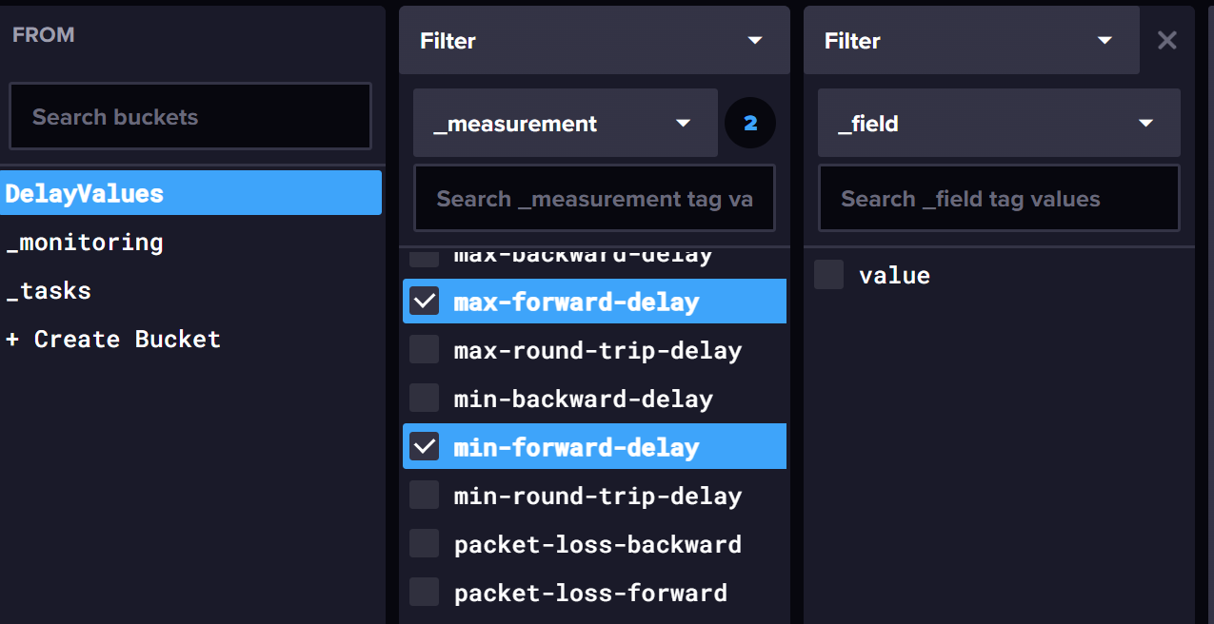
Figure 9: delay values visible in the DelayValues bucket in influxDB
And you should be able to see first data in the data explorer:
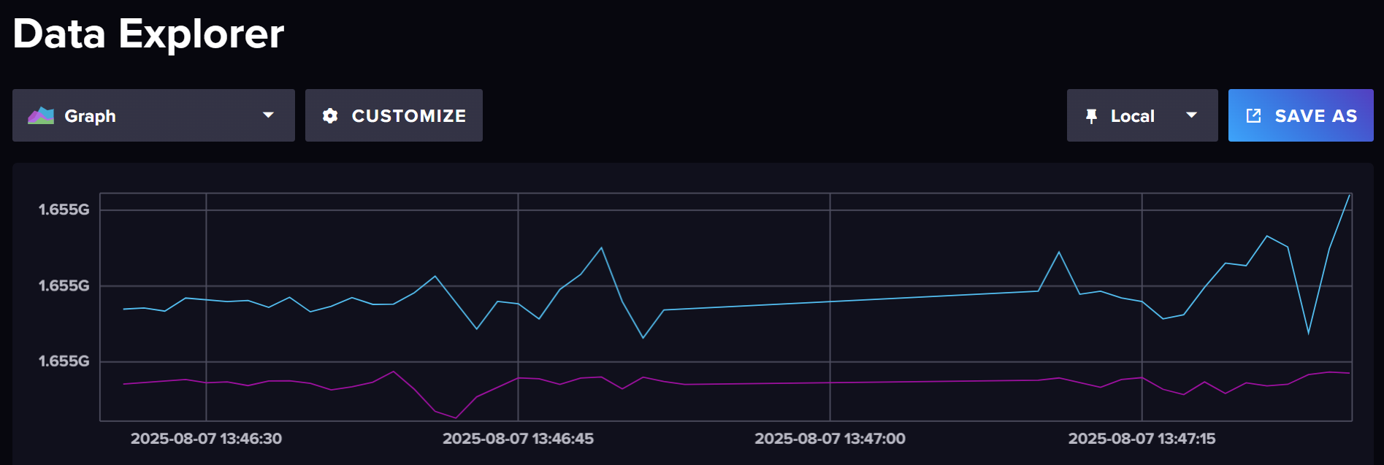
Figure 10: delay values visible in influxDB’s data explorer

Grafana
Follow the instructions here to install Grafana: https://grafana.com/docs/grafana/latest/setup-grafana/installation/debian/.
After installation, follow these steps:
- Start grafana
  - sudo systemctl start grafana-server.service
  - sudo systemctl status grafana-server.service
- add influxdb as a data source
  - Connections -> Data Source -> InfluxDB
  - Insert the URL of influxdb (http://localhost:8086)
  - Choose flux
  - Input the organization, bucket, etc. you have used in influxdb
  - Save and test connection
- add dashboard
  - you can create an own dashboard, or you might want to import the one delivered with the TSN Test App, see DelayMeasurement-grafana.json If you do so, you will need to adapt the data source settings:
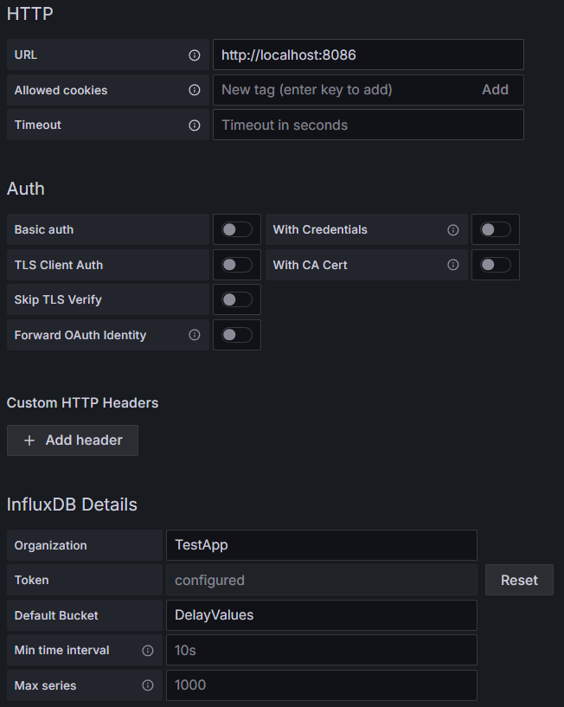
  - Save and Apply
- Change the minimum refresh interval of Grafana
  - By default, the minimum refresh interval for Grafana is 5s. If you want to change it, follow the steps described in the following discussion (https://community.grafana.com/t/how-to-change-refresh-rate-from-5s-to-1s/39008)
You are now ready to see the test app output directly in Grafana:
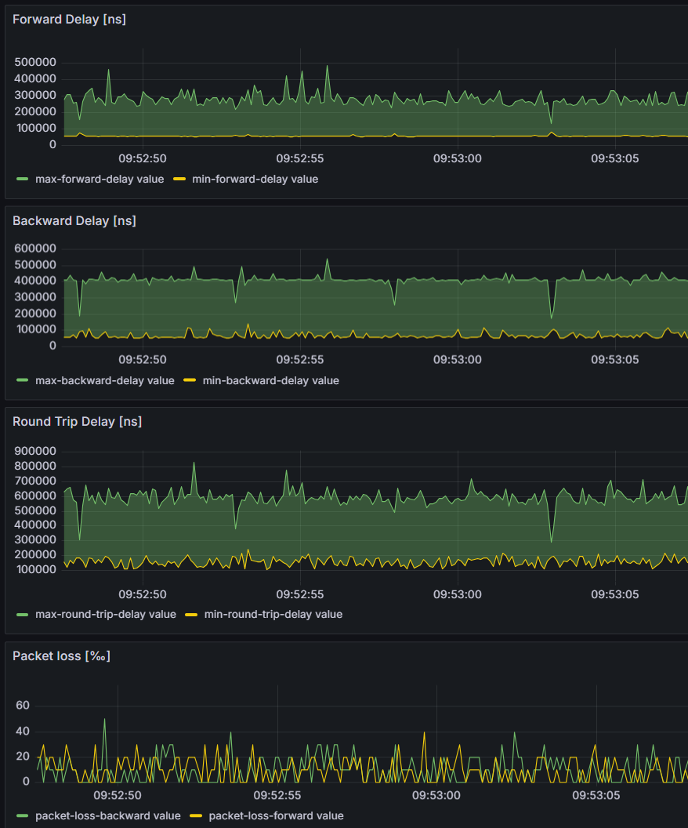
Figure 11: example Grafana output with a sampling period of 100
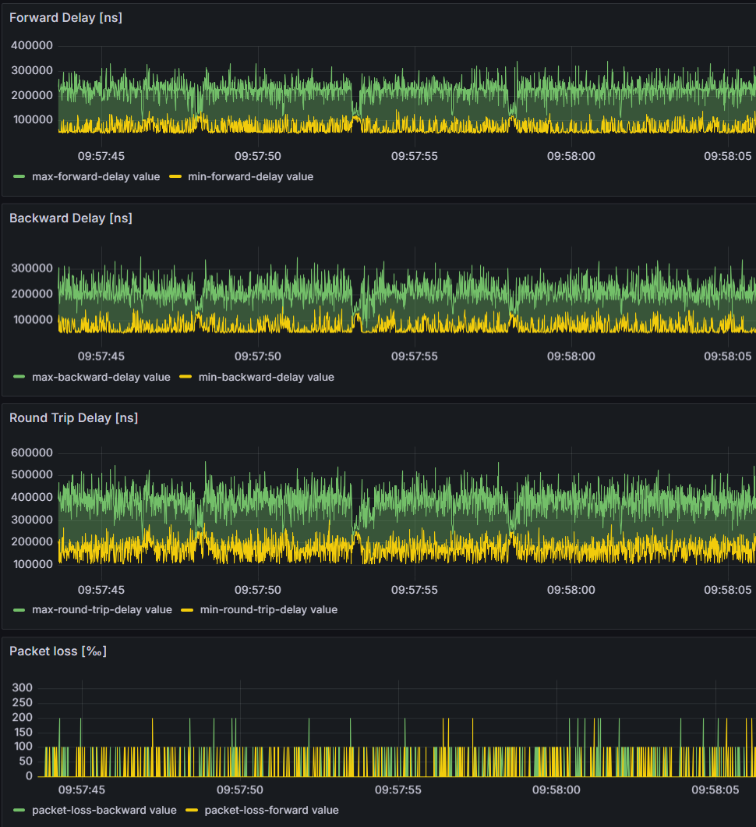
Figure 12: example Grafana output with a sampling period of 10

Error messages
Typical reasons for error messages from influxDB / Grafana:
- 204 No Content: This is not an error, it says that the reply from influxDB does not contain content, i.e. no error message – everything is fine.
- 401 Unauthorized: You are using an invalid access token for influxDB
- 404 Not Found: You are probably sending to a database or a bucket which doesn’t exist. Use sudo service influxdb status to get more information from influxDB.
- Connection to socket for grafana output failed: There is no server at the given IP address, or there is no influxDB listening on port 8086
- unable to create socket for grafana output: Invalid address/ Address not supported: The app cannot deal with the IP address you gave for the influxDB server. Maybe it’s misspelled? Please use 127.0.0.1 instead of localhost.

