**FTW**

**Design Document**

**Architecture/Design Document**

**Table of Contents**

1. **INTRODUCTION**
2. **SYSTEM BEHAVIOR**
3. **DESIGN PATTERN**

**3.1 Model View Controller**

**3.2 Detailed Class Design**

1. **TESTING**
2. **INSTRUCTIONS TO BUILD AND USE SOFTWARE**

**1 Introduction**

This document describes the architecture and design for the Calendar application which will allow users of all ages who want to use calendar app to view events or to keep track on daily/weekly/monthly events. Calendar application will allow users to add, update, delete, check time and color code events. Our application will send notification to remind users of their upcoming events.

The purpose of this document is to describe the architecture and design for UTD students.

Users - create events, start/end time, notify, view, color, remove events.

Developers - they want calendar application that will notify users of event

**2 System Behavior**

Here is the use case view of the calendar application and design. 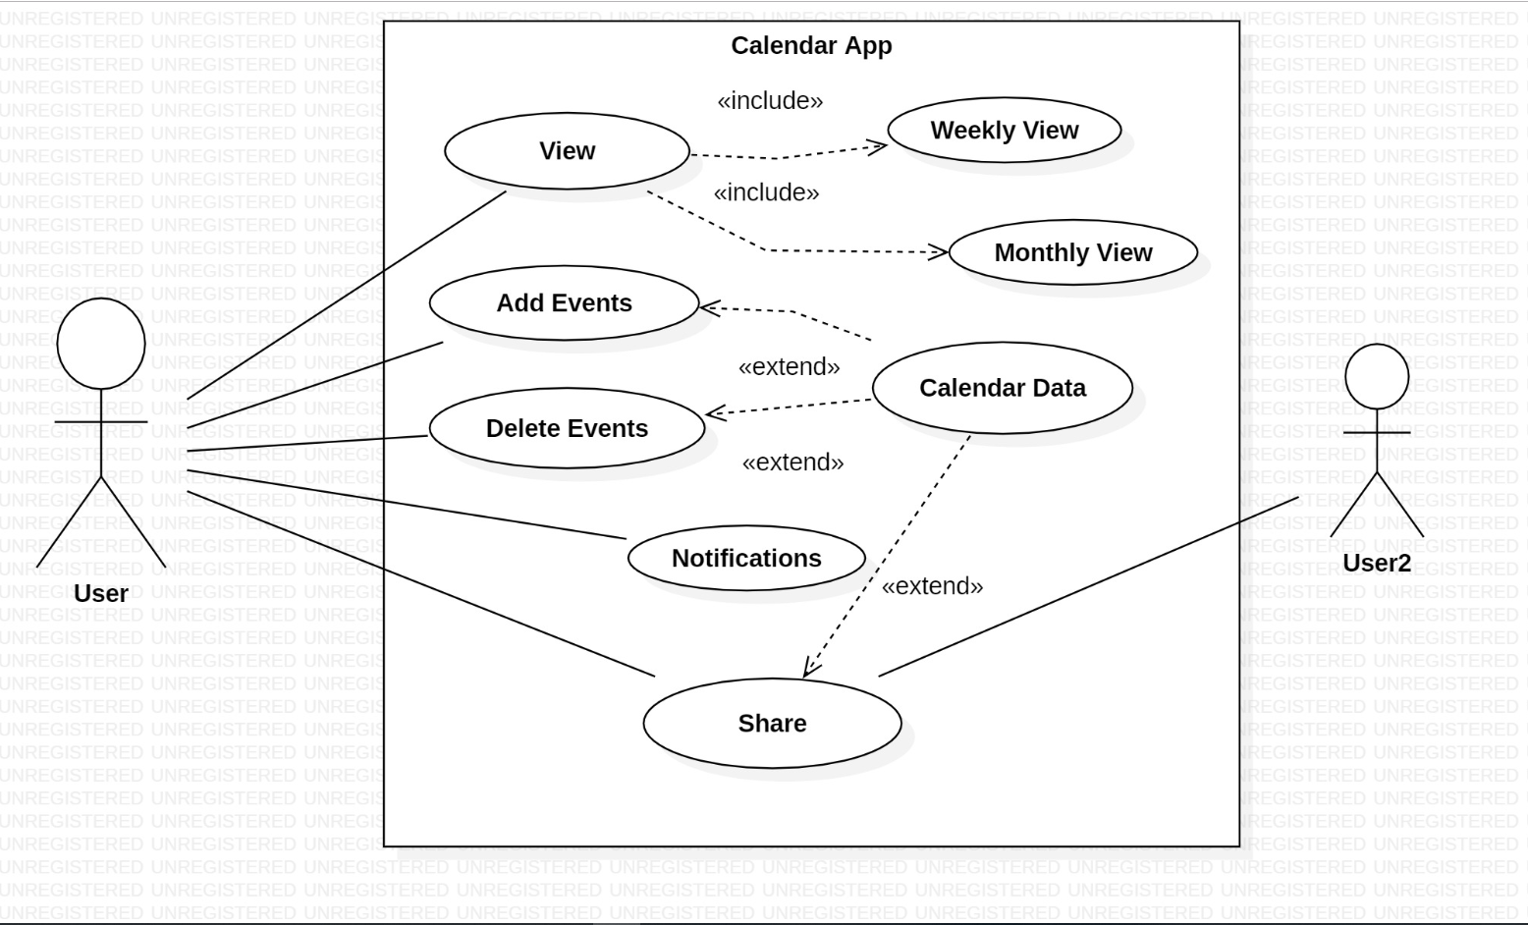

**3 Design Pattern**

**3.1 Model View Controller**

**3.2 Details Class Design**

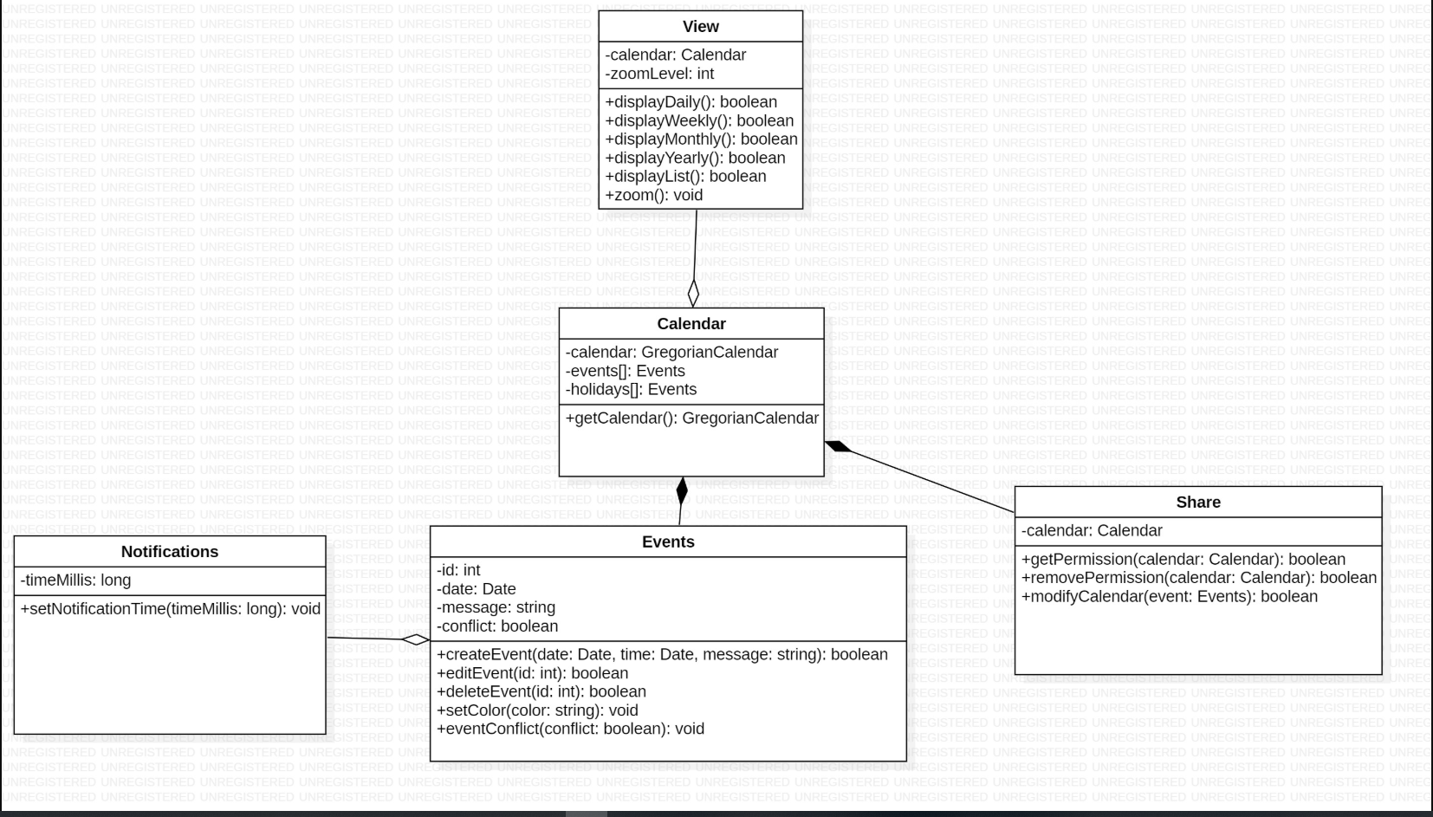

**4 Testing**

Gabriel Betancourt – event test

Kyle – database test

Emanuel –

Steven –

You can find the four-test case location of the code used in folder:

cs3354-FTW/Calendar_App/app/src/androidTest/java/com/ftw/calendar_app/EventJUnit.java