Trigger.

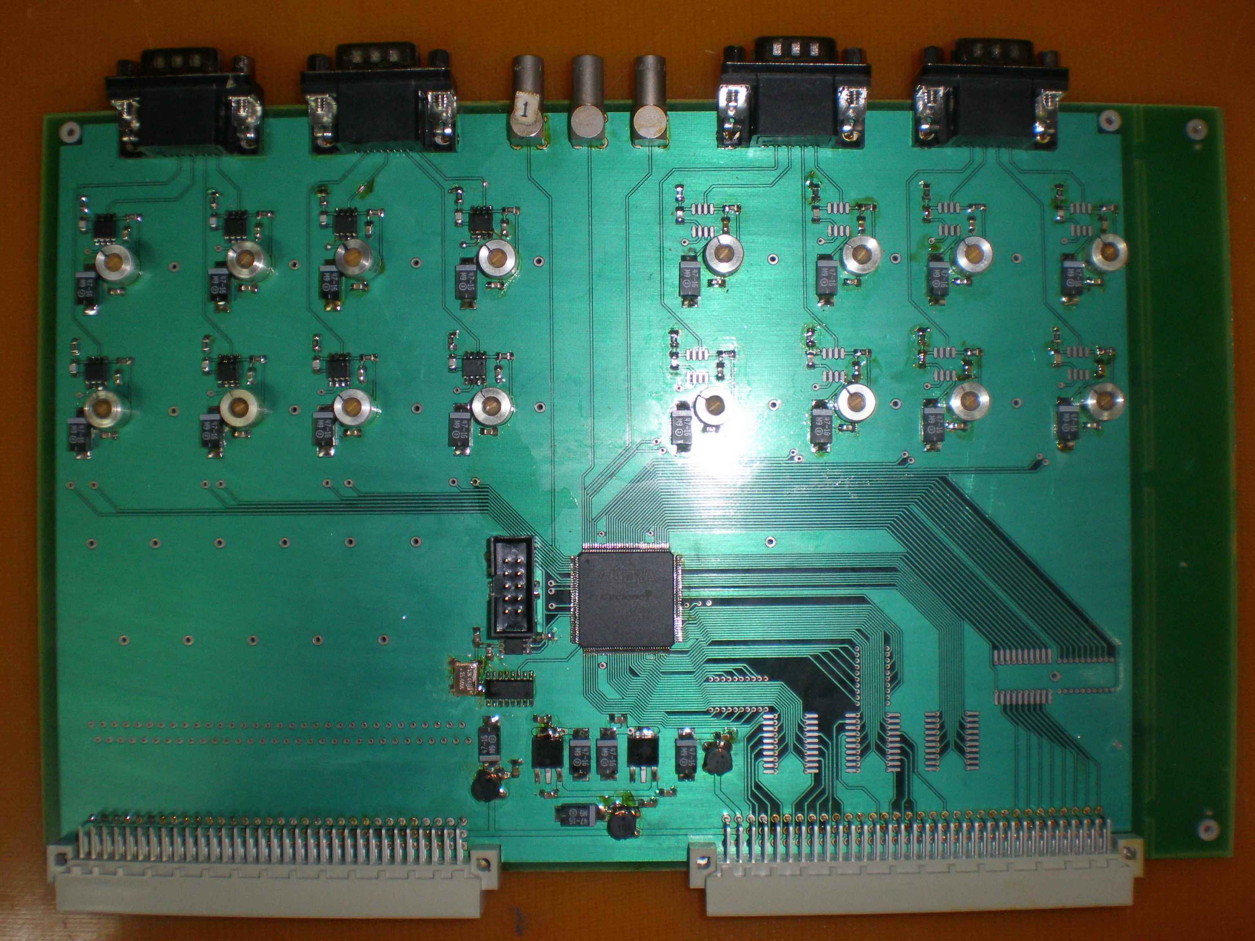

The board is made in the standard VME. It has 4 slots (DBR-9M) for the input signal from the signal converter board. And three LEMO connector for service signals (external frequency, the trigger signal, etc.).
It is assumed that the board will be controlled by crate controller. Board will have a set masks which will be selected by the user. In each event the board will be sent two words to the VME bus controller – number of the trigger groups and number of mask.

