C\C++双精度浮点型转整型时数据溢出x86与鲲鹏的差异

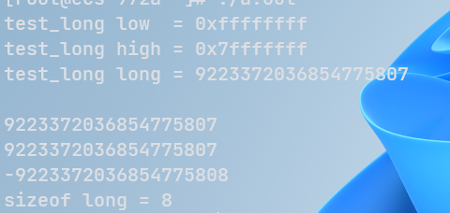

鲲鹏 编译双精度 test.c 并运行

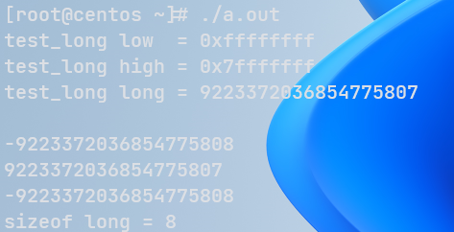

x86编译双精度test并运行

分析代码可知，x86环境下但long型数据发生溢出时数值会转化为最小的long数值，而鲲鹏则会保持最大的long数值。

查阅资料可知是由于两种CPU架构不同导致的

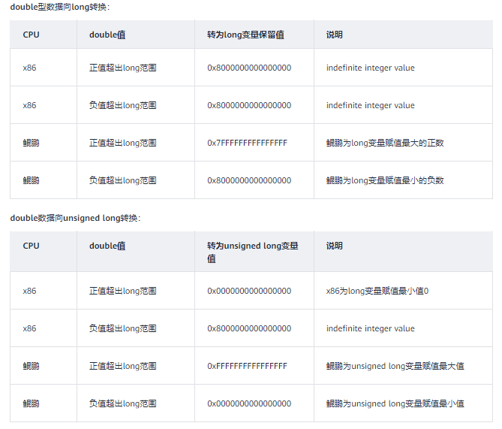

#include <stdio.h>

#include <limits.h>

int main(){

long test_long = (long)0x7ffffffffffffff;

printf("test_long low = 0x%x\n", test_long);

printf("test_long high = 0x%x\n", test_long>>32);

printf("test_long long = %ld\n", test_long);

long test_bb;

test_bb = (long) (test_long *(double) 10);

printf("\n");

printf("%ld",test_bb);

printf("\n");

printf("%ld", LONG_MAX);

printf("\n");

printf("%ld", LONG_MIN);

printf("\n");

printf("sizeof long = %ld\n", sizeof(long));

return 0;

}