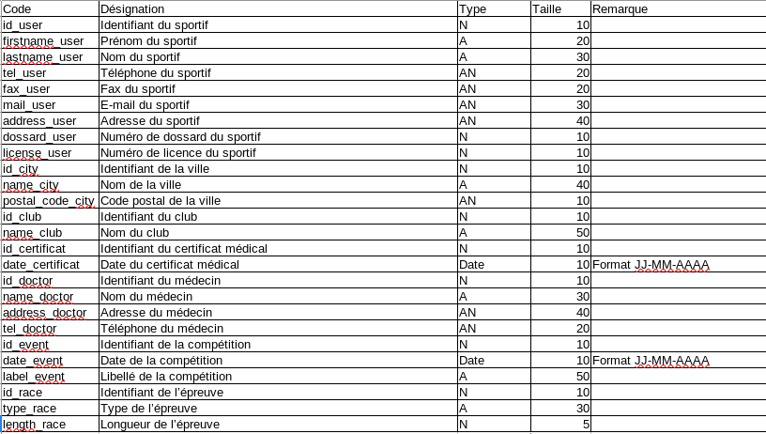
Dictionnaire de données :

MCD :

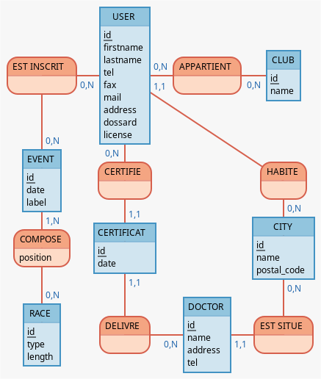

MLD :

User : id, firstname, lastname, tel, fax, mail, address, dossard, licence, city_id
Appartient : user_id, club_id
Club: id, name
City : id, name, postal_code
Certificat : id, date, user_id, doctor_id
Doctor : id, name, address, tel, city_id
Est inscrit : user_id, event_id
Event : id, date, label
Compose : event_id, race_id, position
Race : id, type, length

