**J1939-84™ Test Software Help File May 26, 2021**

1. About SAE J1939-84 Test Software[1]

SAE J1939-84 test software is implemented as an industry collaboration organized by ETI, Inc. The software implements a sequence of tests described in SAE J1939-84 section 6 to collect data required by 13 CCR 1971.1 (l)(1).. The software is implemented using a version of Java 11 that doesn’t require the payment of a license fee for Java 11. The Java runtime system is bundled with the released software to avoid any Java runtime compatibility problems. The software is distributed under an MIT license model by ETI, Inc.

The software requires a TMC RP1210C compatible adapter for CAN communications. A Windows10 PC with at least 500MB of available dynamic ram is recommended. The software was developed using NEXIQ link 2 adapters and accompanying TMC RP1210C driver software. Windows 7 is not supported.

The current software requires implanted faults to succeed. Future versions will permit users to accept fault implant failures and continue testing.

1. Adapter Selection and Missing Adapters

The software displays a list of RP1210C adapters installed on the PC. Select the desired adapter from the list shown. The baud-rate may be manually selected. 500k-baud should be used for MY2016+ engines. MY2013-16 engines should use 250k-baud.

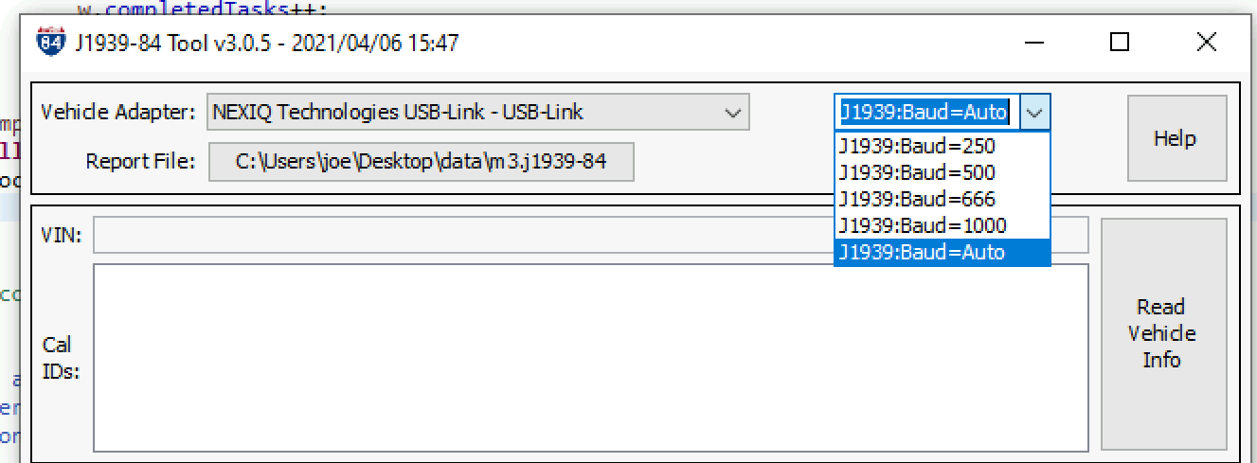

Figure 1 J1939-84 Adapter Selection

If the desired adapter is not seen in the selections display, the .ini file may be incorrect or missing from the expected directory, or the driver is not correctly installed. The user should consult the installation instructions for the CAN interface hardware and software. See section 6 to access raw data for queries and responses.

1. User Interface Features.

The SAE J1939 Software features a GUI user interface as shown in Figure 3. The interface is organized into panes and buttons which are described below. The adapter pane permits the selection of an RP1210C adapter in a drop box that populates the installed adapters. The vehicle information pane shows the VIN and CAL-IDs. A scrolling window at the bottom shows queries and responses.

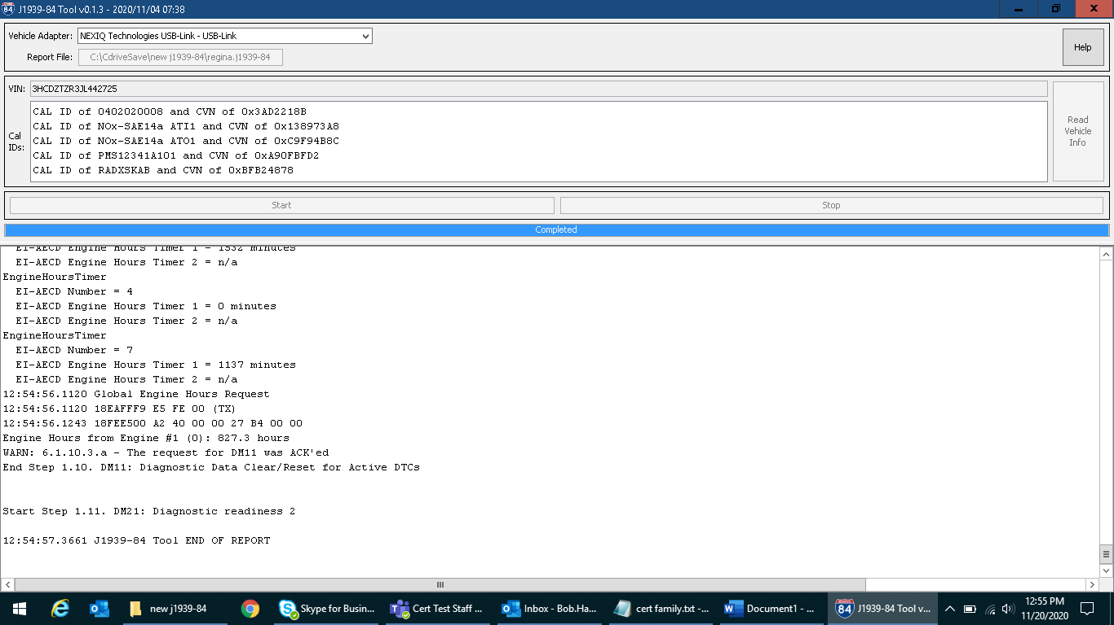

**Task Bar Tab**

Figure 3 J1939-84 GUI Interface

The file browser button launches the operating system’s file name and directory selection tool. The user may select any directory where he has write privileges. Local directories are recommended over directories hosted on remote servers.

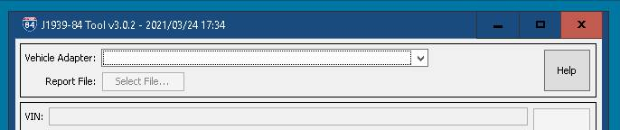

**File Browser Button**

**Adapter Dropdown Menu**

Figure 4 Adapter Pane and File Browser Button

The read vehicle info button populates the VIN and CAL-IDs from the vehicle. This activates the start button.

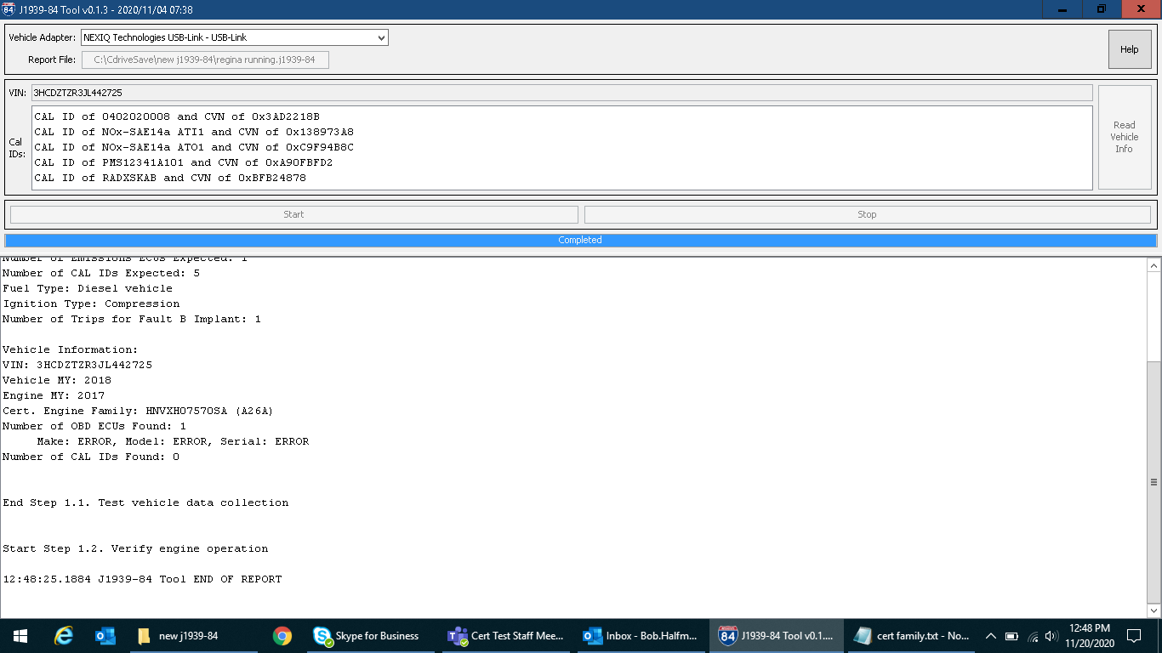

**Read Vehicle Info Button**

Figure 5 Read Vehicle Info Button



**Press Start to begin**

Figure 6 Start Button

Press start to begin the test. The blue bar below the start shows the test completion progress. Press Cancel to stop the test. When start is pressed a data collection dialog box is displayed.

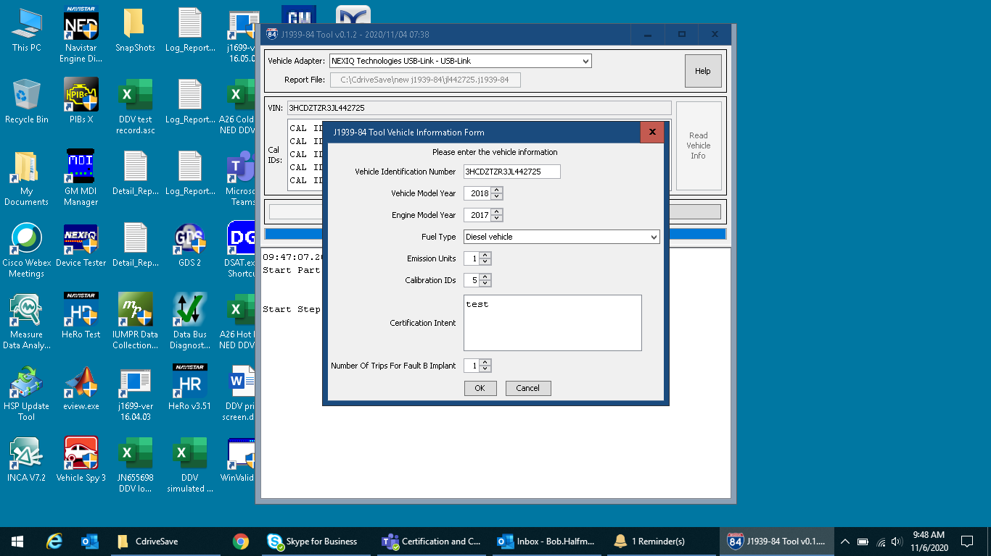

**Fault B Implant Cycle Count**

**User Notes**

**Powertrain Classification**

**VIN Query Response**

**OBD ECU and CAL-ID Counts**

**Model Year Data Entry**

Figure 7 Test Data Collection Dialog Box

Figure 6 shows the data collection dialog box. The VIN is populated from the vehicle. The engine model year and powertrain classification selections drive the alternation of queries and evaluation criteria. The number of CAL-IDs received from OBD ECUs must match the numbers entered. Set the number of Fault B implant trips to match the manufacturer’s instructions. A check box may also appear to permit users to ignore VIN errors for development tests.

Figure 7 shows the test progress bar and scrolling window where queries, responses and outcomes can be reviewed. The test progress bar shows the progress for individual tests. The scrolling window permits data review while tests are running.



**Test Progress Bar**

**Query Outcome Scrolling Window**

Figure 7 Log Review Pane and Test Progress Bar

1. Report Examples.

One report file with three sections is provided. The first section provides the number of failures, user data entries and vehicle information.

Summary of J1939-84 Tool Execution

J1939-84 Tool version 3.0.7 - 2021/04/12 08:26

Generated: 2021/04/12 14:19:47.8004

Log File Name: C:\CdriveSave\new j1939-84\v307 786b Link2.j1939-84

TEST SUMMARY REPORT

OUTCOME:

Failures:    10

Warnings:    29

Information: 0

Incomplete:  0

Timing:      2

Passes:      168

User Data Entry:

Engine Model Emissions Year: 2018

Number of Emissions ECUs Expected: 1

Number of CAL IDs Expected: 5

Fuel Type: Diesel vehicle

Ignition Type: Compression

Number of Trips for Fault B Implant: 1

Vehicle Information:

VIN: 3HSDZTZR0KN374359

Vehicle MY: 2019

Engine MY: 2018

Cert. Engine Family: 2018 cert year

Number of OBD ECUs Found: 1

    Make: INT  , Model: 7571031717, Serial: 124KM2Y4503688

Number of CAL IDs Found: 5

    DM19 from Engine #1 (0): [

      CAL ID of RADXSPAB and CVN of 0xA0D4A053

      CAL ID of NOx-SAE14a ATI1 and CVN of 0x138973A8

      CAL ID of NOx-SAE14a ATO1 and CVN of 0xC9F94B8C

      CAL ID of 0201010002 and CVN of 0x0033FFAC

      CAL ID of PMS12341A101 and CVN of 0xA90FBFD2

    ]

Addresses Claimed

   18EEFF00 [8] 00 00 40 05 00 00 00 00 Engine #1 (0)

   18EEFF03 [8] 00 00 40 02 00 03 00 00 Transmission #1 (3)

   18EEFF05 [8] 42 56 60 05 00 05 02 10 Shift Console - Primary (5)

   18EEFF0B [8] 00 00 40 0B 00 09 00 00 Brakes - System Controller (11)

   18EEFF0F [8] 00 00 40 05 00 0C 00 00 Retarder - Engine (15)

   18EEFF17 [8] 43 47 60 05 00 13 00 00 Instrument Cluster #1 (23)

   18EEFF19 [8] FF FF FF FF FF FF FF FF Passenger-Operator Climate Control #1 (25)

   18EEFF21 [8] 2B 00 60 05 00 1A 00 10 Body Controller (33)

   18EEFF37 [8] 0D 00 60 05 00 29 00 00 Lighting - Operator Controls (55)

   18EEFF3A [8] 10 00 15 00 00 00 00 00 Passenger-Operator Climate Control #2 (58)

   18EEFF4C [8] 38 32 A0 01 00 38 00 00 Communications Unit, Radio (76)

   18EEFF4C [8] 38 32 A0 01 00 38 00 00 Communications Unit, Radio (76)

   18EEFFEC [8] 03 18 66 05 00 81 00 10 Door Controller #1 (236)

   18EEFFED [8] 29 4C 60 05 08 81 00 10 Door Controller #2 (237)

The second section lists the outcome for each test.

J1939-84 Tool version 3.0.7 - 2021/04/12 08:26

Generated: 2021/04/12 14:19:47.8004

Log File Name: C:\CdriveSave\new j1939-84\v307 786b Link2.j1939-84

Part 1 - KOEO Data Collection..........................................(FAIL)

Test 1.1 - Test vehicle data collection................................(PASS)

Test 1.2 - Verify engine operation.....................................(PASS)

Test 1.3 - DM5: Diagnostic readiness 1.................................(PASS)

Test 1.4 - DM24: SPN support...........................................(PASS)

Test 1.5 - PGN 65260 VIN verification..................................(PASS)

Test 1.6 - DM56: Model year and certification engine family............(PASS)

Test 1.7 - DM19: Calibration information...............................(WARN)

Test 1.8 - DM20: Monitor Performance Ratio.............................(PASS)

Test 1.9 - Component ID: Make..........................................(PASS)

Test 1.10 - DM11: Diagnostic Data Clear/Reset for Active DTCs..........(WARN)

Test 1.11 - DM21: Diagnostic readiness 2...............................(PASS)

Test 1.12 - DM7/DM30: Command Non-continuously Monitored Test/Scaled...(FAIL)

…

Part 2 - Key On Engine Running Data Collection.........................(FAIL)

Test 2.1 - Verify engine running.......................................(PASS)

Test 2.2 - DM5: Diagnostic readiness 1.................................(WARN)

Test 2.3 - DM24: SPN support...........................................(PASS)

Test 2.4 - DM20: Monitor performance ratio.............................(PASS)

Test 2.5 - DM19: Calibration information...............................(PASS)

Test 2.6 - DM56: Model year and certification engine family............(PASS)

Test 2.7 - Component ID: Make..........................................(PASS)

Test 2.8 - DM26: Diagnostic readiness 3................................(PASS)

Test 2.9 - DM21: Diagnostic readiness 2................................(PASS)

Test 2.10 - DM7/DM30: Command Non-continuously Monitored Test/Scaled...(PASS)

Test 2.11 - DM27: All Pending DTCs.....................................(PASS)

Test 2.12 - DM29: Regulated DTC counts.................................(PASS)

Test 2.13 - DM31: DTC to Lamp Association..............................(PASS)

Test 2.14 - DM25: Expanded freeze frame................................(PASS)

Test 2.15 - DM33: Emission increasing AECD active time.................(PASS)

Test 2.16 - DM34: NTE status...........................................(PASS)

Test 2.17 - KOER Datastream verification...............................(FAIL)

Test 2.18 - Part 2 to Part 3 transition................................(PASS)

…

The third section provides the queries, responses and outcomes. Payload lengths are shown in brackets. Responses are completely decoded. Failure and warning messages follow responses.

Step 6.1.26.1.a - Reading bus for 20 seconds

PGN 61444 with Supported SPNs 190, 512, 513

13:22:58.6012 0CF00400 **[8]** FF 7D 7D 00 00 00 F0 7D

Found: Engine Speed from Engine #1 (0):

 SPN   899, Engine Torque Mode: 1111

 SPN  4154, Actual Engine - Percent Torque (Fractional): 1.875000 %

 SPN   512, Driver's Demand Engine - Percent Torque: 0.000000 %

 SPN   513, Actual Engine - Percent Torque: 0.000000 %

 SPN   190, Engine Speed: 0.000000 rpm

 SPN  1483, Source Address of Controlling Device for Engine Control: 0.000000 source address

 SPN  1675, Engine Starter Mode: 0000

 SPN  2432, Engine Demand - Percent Torque: 0.000000 %

PGN 61454 with Supported SPNs 3216, 3217

13:22:58.6431 18F00E00 [8] FF FA FE FA FF FF FF FF

Found: AFT 1 Intake Gas 1 from Engine #1 (0):

 SPN  3216, Engine Exhaust 1 NOx 1: 3012.750000 ppm

 SPN  3217, Engine Exhaust 1 Percent Oxygen 1: 21.026556 %

 SPN  3218, Engine Exhaust 1 Gas Sensor 1 Power In Range: 11

 SPN  3219, AFT 1 Intake Gas Sensor 1 at Temperature: 11

 SPN  3220, Engine Exhaust 1 NOx 1 Reading Stable: 11

 SPN  3221, AFT 1 Intake Wide-Range Percent Oxygen 1 Reading Stable: 11

 SPN  3222, AFT 1 Intake Gas Sensor 1 Heater Preliminary FMI: 31.000000

 SPN  3223, AFT 1 Intake Gas Sensor 1 Heater Control: 11

 SPN  3224, Engine Exhaust 1 NOx Sensor 1 Preliminary FMI: 31.000000

 SPN  5714, Engine Exhaust 1 NOx Sensor 1 Self-diagnosis Status: 111

 SPN  3225, AFT 1 Intake Oxygen  Sensor 1 Preliminary FMI: 31.000000

…

13:34:02.8964 Destination Specific DM29 Request to Engine #1 (0)

13:34:02.8985 18EA00F9 [3] 00 9E 00 (TX)

13:34:02.9054 189EF900 [8] 00 00 01 00 00 FF FF FF

DM29 from Engine #1 (0):

Emission-Related Pending DTC Count                               0

All Pending DTC Count                                            0

Emission-Related MIL-On DTC Count                                1

Emission-Related Previously MIL-On DTC Count                     0

Emission-Related Permanent DTC Count                             0

…

Failure and warning messages follow responses. Messages include an index number for the criterion. Message payload lengths are shown in brackets.

13:22:48.5036 Sending DM7 for DM30 to Engine #1 (0) for SPN 7330

13:22:48.5065 18E300F9 **[8]** F7 A2 1C 1F FF FF FF FF (TX)

13:22:48.6998 18A4F900 **[24]** F7 A2 1C 02 0C 00 00 00 01 00 00 00 F7 A2 1C 02 22 01 00 FB FF FF FF FF

DM30 from 0: [

 SPN 7330 FMI 2 (SLOT 12) Result: Test Passed. Min: 0, Value: 0, Max: 1 count

 SPN 7330 FMI 2 (SLOT 290) Result: Test Not Complete.

]

**FAIL:** ***6.1.12.2.a (A7.1.b)*** - Test result for SPN 7330 FMI 2 from Engine #1 (0) does not report the test result/min test limit/max test limit initialized properly

**WARN:** ***6.1.12.2.a (A7.2.b)*** - Engine #1 (0) returned duplicate test results for SPN 7330 FMI 2

1. Test Conditions and Test Coordination

See section 5 of SAE J1939-85 for the complete discussion of test conditions and coordination required to successfully collect data for 13 CCR 1971.1 (l)(1). The criteria are intended for stationary operation in vehicle manufacturers’ repair stalls. Extended hot or cold soaks at extreme temperatures before running the tests may impact results.

Engine manufacturers must define how to implant Fault A and Fault B as illustrated in SAE J1939-84 Figure 2, including identifying any equipment needed to implant the faults, the number of trips needed to detect each fault, and the amount of time needed to detect the fault at low idle engine speed.

1. Raw log review

The raw CAN bus messages are stored in temporary files throughout the running of an active J1939-84 test.  The raw log files are rewritten with each new run of the J1939-84 test.  These files can be used to help understand what other activity is taking place during the queries and responses. The files are in the local application data directory, defined by the %TEMP% environment variable.

Here is an example of the directory tree where the raw J1939-84 log files are stored.  C:\Users\u021755\AppData\Local\Temp

The files are named J1939_840.log and then increment up from there until the active J1939-84 test is complete.

J1939_840.log, J1939_841.log, ... J1939_8450.log

Below is a query and response from the output file:

09:38:52.3166 DS Request for PGN 65155 to Engine #1 (0) for SPNs 1417, 1418

09:38:52.3197 **18EA00F9** [3] 83 FE 00 (TX)

09:38:52.3242 **1CFE8300** [8] 2D 60 2D 60 FF FF FF FF

Ignition Timing 2 from Engine #1 (0):

 SPN  1417, Engine Cylinder 5 Ignition Timing: -7.648438 deg

 SPN  1418, Engine Cylinder 6 Ignition Timing: -7.648438 deg

 SPN  1419, Engine Cylinder 7 Ignition Timing: Not Available

 SPN  1420, Engine Cylinder 8 Ignition Timing: Not Available

The same query and response in the raw log file are shown below. The messages follow the log header.

2021-05-04 09:38:52.319 FINE   org.etools.j1939_84.bus.RP1210Bus lambda$decodeDataAndQueuePacket$4 09:38:52.3186 0CEF0B2A [8] 7E CD 0E 32 FF FA FF B9

2021-05-04 09:38:52.320 FINE   org.etools.j1939_84.bus.RP1210Bus lambda$decodeDataAndQueuePacket$4 09:38:52.3189 18F00E00 [8] FF FA FE FA FF FF FF FF

2021-05-04 09:38:52.320 FINE   org.etools.j1939_84.bus.RP1210Bus lambda$decodeDataAndQueuePacket$4 09:38:52.3192 18F00F00 [8] FF FA FF FF FF FF FF FF

2021-05-04 09:38:52.320 FINE   org.etools.j1939_84.bus.RP1210Bus lambda$decodeDataAndQueuePacket$4 09:38:52.3195 18FF1500 [8] FF FF FF FF FF FF 00 00

2021-05-04 09:38:52.321 FINE   org.etools.j1939_84.bus.RP1210Bus lambda$decodeDataAndQueuePacket$4 09:38:52.3200 18FC9600 [8] 7F 02 FF FF FF FF FF FF

2021-05-04 09:38:52.320 FINE   org.etools.j1939_84.bus.RP1210Bus lambda$decodeDataAndQueuePacket$4 09:38:52.3197 **18EA00F9 [3] 83 FE 00 (TX)**

2021-05-04 09:38:52.321 FINE   org.etools.j1939_84.bus.RP1210Bus lambda$decodeDataAndQueuePacket$4 09:38:52.3203 18EFFF00 [8] FF FF FF FF 10 00 1E 00

2021-05-04 09:38:52.321 FINE   org.etools.j1939_84.bus.RP1210Bus lambda$decodeDataAndQueuePacket$4 09:38:52.3206 0CF00A00 [8] FF FF 71 13 FF FF FF FF

2021-05-04 09:38:52.322 FINE   org.etools.j1939_84.bus.RP1210Bus lambda$decodeDataAndQueuePacket$4 09:38:52.3209 18FF52E8 [8] 00 00 00 80 00 00 00 C0

2021-05-04 09:38:52.322 FINE   org.etools.j1939_84.bus.RP1210Bus lambda$decodeDataAndQueuePacket$4 09:38:52.3211 10F01A00 [8] FF FF FF FF 4C 3B EC 13

2021-05-04 09:38:52.322 FINE   org.etools.j1939_84.bus.RP1210Bus lambda$decodeDataAndQueuePacket$4 09:38:52.3214 0CF02300 [8] 00 00 FF FF FF FF FF FF

2021-05-04 09:38:52.322 FINE   org.etools.j1939_84.bus.RP1210Bus lambda$decodeDataAndQueuePacket$4 09:38:52.3217 0CF00300 [8] D1 00 0D FF FF FF 90 FF

2021-05-04 09:38:52.323 FINE   org.etools.j1939_84.bus.RP1210Bus lambda$decodeDataAndQueuePacket$4 09:38:52.3220 10FCFD00 [8] FF FF FF FF 0F 37 FF FF

2021-05-04 09:38:52.323 FINE   org.etools.j1939_84.bus.RP1210Bus lambda$decodeDataAndQueuePacket$4 09:38:52.3223 18F0000F [8] 40 7D 7D FF 00 7D FF 7D

2021-05-04 09:38:52.323 FINE   org.etools.j1939_84.bus.RP1210Bus lambda$decodeDataAndQueuePacket$4 09:38:52.3226 18FEF200 [8] 2F 00 00 00 FF FF FF FF

2021-05-04 09:38:52.324 FINE   org.etools.j1939_84.bus.RP1210Bus lambda$decodeDataAndQueuePacket$4 09:38:52.3229 0C010300 [8] 00 00 00 00 00 00 00 00

2021-05-04 09:38:52.324 FINE   org.etools.j1939_84.bus.RP1210Bus lambda$decodeDataAndQueuePacket$4 09:38:52.3232 18FF53E8 [8] 80 00 00 00 00 00 00 E0

2021-05-04 09:38:52.324 FINE   org.etools.j1939_84.bus.RP1210Bus lambda$decodeDataAndQueuePacket$4 09:38:52.3235 1CEBFFE8 [8] 05 FF FF FF FF FF FF FF

2021-05-04 09:38:52.325 FINE   org.etools.j1939_84.bus.RP1210Bus lambda$decodeDataAndQueuePacket$4 09:38:52.3245 0CF00200 [8] FF 00 00 FF FF FF FF FF

2021-05-04 09:38:52.325 FINE   org.etools.j1939_84.bus.RP1210Bus lambda$decodeDataAndQueuePacket$4 09:38:52.3242 **1CFE8300 [8] 2D 60 2D 60 FF FF FF FF**

2021-05-04 09:38:52.325 FINE   org.etools.j1939_84.bus.RP1210Bus lambda$decodeDataAndQueuePacket$4 09:38:52.3248 0CF00400 [8] F0 7D 84 9C 12 00 F0 84

2021-05-04 09:38:52.326 FINE   org.etools.j1939_84.bus.RP1210Bus lambda$decodeDataAndQueuePacket$4 09:38:52.3253 18FF54E8 [8] 00 00 00 80 00 00 00 C0

2021-05-04 09:38:52.327 FINE   org.etools.j1939_84.bus.RP1210Bus lambda$decodeDataAndQueuePacket$4 09:38:52.3271 08FE6E0B [8] 00 00 00 00 00 00 00 00

2021-05-04 09:38:52.328 FINE   org.etools.j1939_84.bus.RP1210Bus lambda$decodeDataAndQueuePacket$4 09:38:52.3274 18FF55E8 [8] F1 FF FF FF FF FF FF FF

2021-05-04 09:38:52.328 FINE   org.etools.j1939_84.bus.RP1210Bus lambda$decodeDataAndQueuePacket$4 09:38:52.3277 18F0090B [8] D3 83 60 83 7D 4F 7B 7D

2021-05-04 09:38:52.329 FINE   org.etools.j1939_84.bus.RP1210Bus lambda$decodeDataAndQueuePacket$4 09:38:52.3280 0CF00203 [8] 00 00 00 FF F7 F7 11 03

2021-05-04 09:38:52.329 FINE   org.etools.j1939_84.bus.RP1210Bus lambda$decodeDataAndQueuePacket$4 09:38:52.3283 0CF00C03 [8] DB 03 A2 12 FF FF FF FF

2021-05-04 09:38:52.329 FINE   org.etools.j1939_84.bus.RP1210Bus lambda$decodeDataAndQueuePacket$4 09:38:52.3286 18EA00F9 [3] DC FE 00 (TX)

2021-05-04 09:38:52.329 FINE   org.etools.j1939_84.bus.RP1210Bus lambda$decodeDataAndQueuePacket$4 09:38:52.3292 18FF56E8 [8] 00 00 00 00 CB C0 00 E0

2021-05-04 09:38:52.331 FINE   org.etools.j1939_84.bus.RP1210Bus lambda$decodeDataAndQueuePacket$4 09:38:52.3312 18FF57E8 [8] 00 C8 00 FF FF FF FF FF

2021-05-04 09:38:52.333 FINE   org.etools.j1939_84.bus.RP1210Bus lambda$decodeDataAndQueuePacket$4 09:38:52.3332 18FF58E8 [8] 00 00 00 00 54 CF 00 E0

2021-05-04 09:38:52.334 FINE   org.etools.j1939_84.bus.RP1210Bus lambda$decodeDataAndQueuePacket$4 09:38:52.3335 18FE5BE8 [8] 43 FF FF FC FC FF 01 FF

# # #

1. J1939-84 is a trademark of SAE International.