SMARTREVIEW QR
System Design Document
Dynamic Review QR Subscription & Printed Card Platform
Core design principle
Print once. Manage the destination online. Keep the same QR when links change or a subscription is renewed.

Document type | Proposed system design
Source basis | SmartReview QR Software Requirements Specification (SRS)
Version | 1.0
Status | Architecture and UX baseline for implementation

Document Purpose
This document translates the approved SmartReview QR requirements into an implementation-oriented system design. It defines the structural architecture, domain boundaries, state model, data ownership, interfaces, UX system, security controls, integration contracts, operational behavior, and test strategy needed to build the proposed platform. It is intentionally designed for a production-capable MVP without forcing unnecessary microservices or infrastructure complexity.
Design stance
Build the smallest reliable system that can sell, activate, route, renew, analyze, and fulfill a dynamic QR service. The public QR route is the critical path; subscription truth is centralized; receipts are evidence rather than unquestioned payment truth; external providers are adapters; and the physical card workflow remains separately entitled.

1. System Context
SmartReview QR is a multi-tenant SaaS platform for businesses that want a single printed QR code to route customers to an online review or feedback destination. The printed QR contains a platform-controlled URL. The platform evaluates the QR and subscription state at scan time and either redirects the customer to the configured destination or presents a controlled inactive/suspended page.
Actor | Primary goals | Key interactions
Business owner / client | Create and manage a review QR, maintain branding, renew service, view scans, order cards | Onboarding, dashboard, QR management, billing, card order, support
Customer / scanner | Quickly reach the review destination | Scan QR -> controlled redirect -> third-party review page
Administrator / operations | Operate the service and protect revenue | Receipts, subscriptions, QR moderation, plans, orders, support, reports
Payment provider | Confirm an online payment when enabled | Checkout + signed webhook events
AI/OCR provider | Assist with receipt extraction and anomaly detection | Structured extraction request/response
Printer / delivery partner | Fulfill physical QR materials | Design file + order details + status updates

2. Design Goals & Constraints
- Activation should be understandable within minutes for a non-technical business owner.
- The QR image must remain stable when the destination link changes or service is renewed.
- Public scan resolution must be lightweight, fast, and isolated from dashboard rendering.
- Client records must be strongly tenant-scoped; UI hiding is never treated as authorization.
- Manual receipt verification is the launch payment workflow; gateway integrations are future adapters.
- AI is optional. The platform must function correctly when local LM Studio or any cloud AI provider is unavailable.
- Physical print fulfillment must be an entitlement/workflow separate from digital QR routing.
- Analytics should provide operational insight without trying to identify individual scanners.
- The UI must be warm, trustworthy, minimal, and strongly aligned to the requested brand palette.

3. Architecture Overview
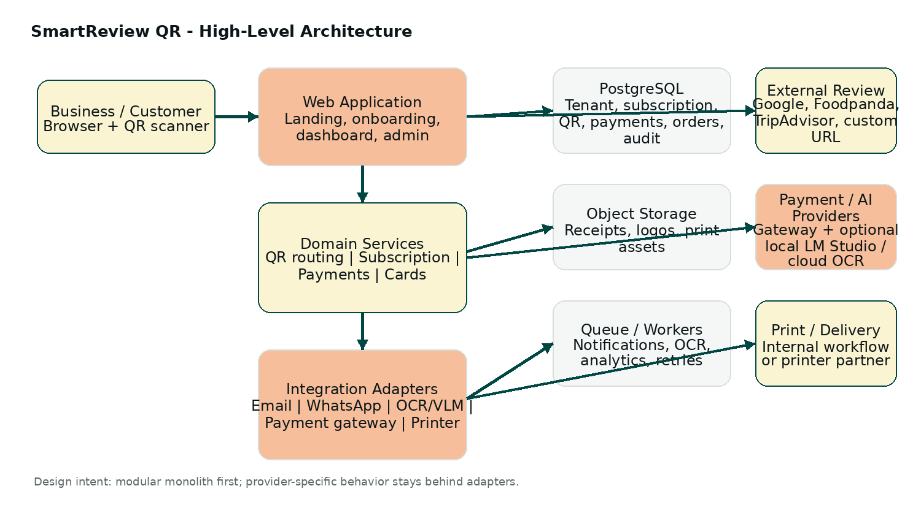
The recommended implementation is a modular monolith: one deployable application initially, with explicit domain modules and provider adapters. This avoids distributed-system overhead while keeping seams for future extraction into separate services if scale or team structure justifies it.

3.1 Logical Modules
Module | Responsibilities | Owns / protects
Identity & Access | Authentication, sessions, role checks, MFA for admins | Users, sessions, permissions
Tenant & Business | Businesses, locations, brand profile, timezone | Tenant ownership and business profile
Review Destinations | Platform type, URL validation, destination settings | Destination configuration
QR Service | Short-code creation, QR image generation, lifecycle | QR identity and operational state
Routing Service | Effective-state resolution and temporary redirect | Public scan behavior
Subscription & Plans | Plans, entitlement rules, expiry, grace, renewal | Subscription truth
Payment Evidence | Receipt uploads, extraction, verification, crediting | Payment/receipt workflow
Analytics | Scan events, funnel events, aggregates | Operational metrics
Design & Fulfillment | Templates, assets, card orders, print status | Physical product lifecycle
Notification Service | Expiry reminders, approval notices, order updates | Message templates/history
Support & Audit | Support tickets, operational timeline, audit logs | Administrative traceability
Integration Adapters | Gateways, OCR/VLM, email, WhatsApp, printer APIs | Provider credentials and external IDs

3.2 Runtime / Deployment View
- Web application: serves marketing pages, authenticated UI, admin UI, API endpoints, and the public QR route.
- PostgreSQL: authoritative transactional store for tenants, subscriptions, QR configuration, payments, orders, and audit state.
- Private object storage: receipts, logos, generated print assets, and exported files.
- Background workers / queue: notifications, receipt AI/OCR, analytics aggregation, provider retries, exports, and cleanup.
- Optional cache: used only where safe; it must never pin an outdated subscription routing decision for the public QR path.
- External providers: payment gateway, email, WhatsApp, OCR/VLM, geolocation enrichment, printer/delivery partner. All are accessed via adapters.

4. Core Domain Design
The key architectural improvement is to separate operational control from commercial entitlement. A QR code can be enabled operationally while its subscription is expired, and a paid QR can still be suspended. The public route therefore computes one effective routing outcome from multiple domain facts rather than trusting a single status flag.
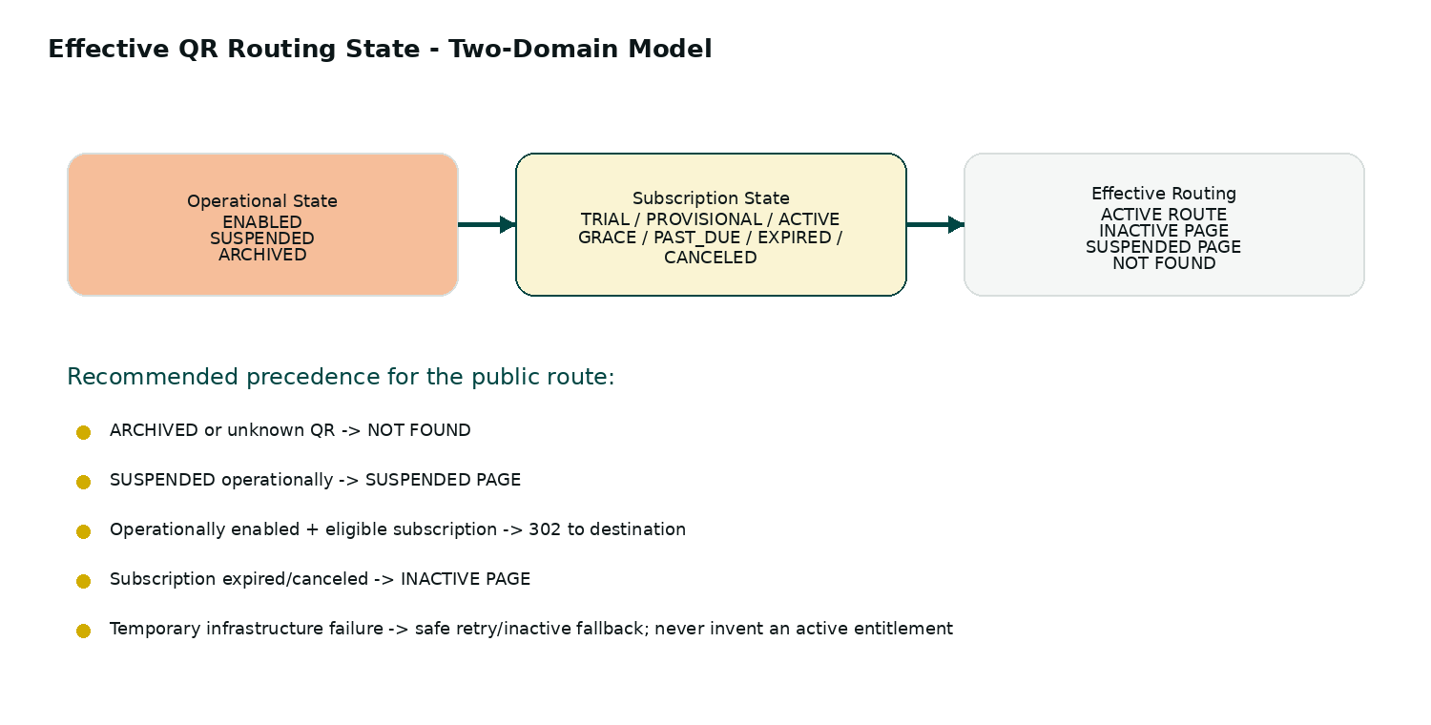

4.1 Core Entities
Entity | Purpose | Important design rules
Account / Tenant | Commercial boundary for one client | Every client-owned record has an ownership path to the tenant
User | Login identity and role membership | Admin role is separate from client role; sessions are revocable
Business | Brand and operational profile | Timezone and locale are stored here or at location level
Location | Optional branch/outlet boundary | MVP may expose one default location while data model stays multi-location ready
Review Destination | Target URL + provider metadata | Validate format; do not claim third-party availability forever
QR Code | Stable public identity + QR image metadata | short_code is globally unique and non-predictable
Subscription | Time-based entitlement | Current period, grace, provisional window, status, and plan version are authoritative
Plan | Pricing + entitlements | Historical plan snapshots are preserved when prices change
Payment Intent | Commercial request to pay | Connects plan, tenant, expected amount, and reference
Receipt | Uploaded payment evidence | Private storage, hash/fingerprint, extraction results, review state
Payment | Credited financial record | Idempotent reference/transaction identifiers
Scan Event | One QR scan observation | Minimal analytics fields with retention policy
Design | Brand/template configuration | Separate customer preview from printer-facing output
Card Order | Physical fulfillment workflow | Never automatically create print jobs from unapproved payment evidence
Notification | Outbound message record | Template/version + delivery status for debugging
Audit Event | Administrative trace | Actor, target, action, reason, before/after summary, timestamp

4.2 Data Ownership & Integrity
- Global uniqueness: QR short codes, external payment event IDs, and other provider event keys.
- Idempotency keys: payment approval, webhook processing, subscription extension, notification enqueueing, and card fulfillment jobs.
- Financial/audit records should be archived rather than hard-deleted.
- Every client-facing read and write is tenant-scoped server-side.
- External provider IDs are stored separately from internal primary keys.
- Historical plan price/entitlement snapshots prevent later plan edits from rewriting past commercial records.

5. Dynamic QR Design

5.1 Public QR Contract
Every printed QR resolves through a platform route such as https://yourdomain.com/q/AB12CD34. The short code contains no tenant ID, subscription ID, payment information, or personal data. The QR route is designed as a high-priority infrastructure path and should not depend on loading the authenticated dashboard UI.
Runtime rule set:
- Unknown or archived QR -> not-found response.
- Operationally suspended QR -> suspended response.
- Operationally enabled + eligible trial/provisional/active/grace policy -> HTTP 302 to current destination.
- Operationally enabled + expired/canceled subscription -> inactive/renewal page.
- Logging and analytics failure must not block a valid redirect.
- Internal dependency failure must never accidentally extend or invent entitlement.

5.2 QR Resolution Sequence
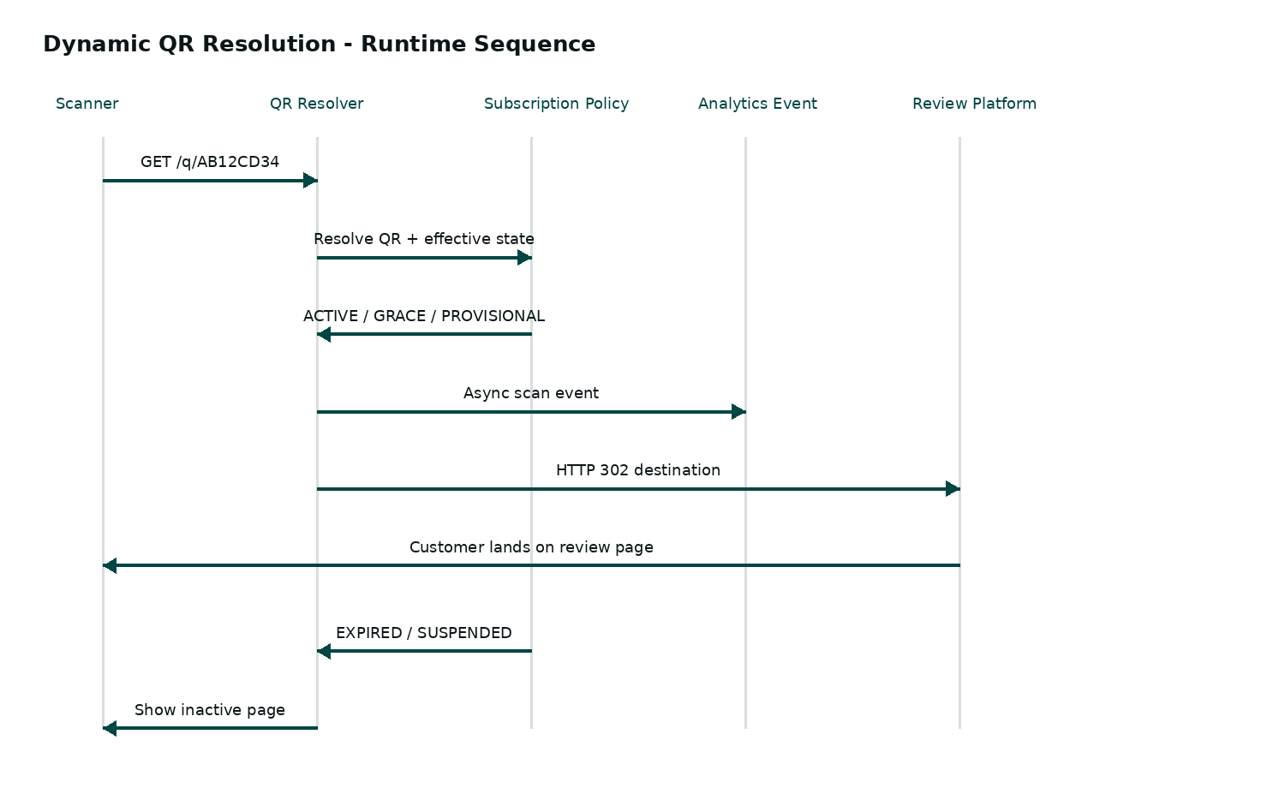

5.3 Redirect Safety
- Use a temporary redirect such as HTTP 302; avoid 301 for subscription-controlled destinations.
- Prevent intermediary/proxy caches from pinning an outdated destination decision.
- Validate and normalize destination URLs before storing them.
- Keep the resolver response path lightweight enough to tolerate scan bursts.
- Use asynchronous scan event emission where practical.
- Provide safe internal pages for expired, suspended, unknown, and temporarily unavailable states.

6. Subscription & Entitlement Design
Subscription state is time-based entitlement; QR operational state is operational control. The effective routing decision combines them. Dates are stored in UTC and displayed in the business or location timezone.
State | Meaning | Routing behavior
TRIAL | Free configured access before payment | Route while within trial and operationally enabled
PROVISIONAL | Temporary access following receipt submission under policy | Route during provisional window while evidence is under review
ACTIVE | Paid, valid entitlement | Route
GRACE | Expired period but grace policy still allows access | Route + warn client
PAST_DUE | Payment expected but not yet resolved | Policy-defined; usually provisional or inactive
EXPIRED | Entitlement ended and grace closed | Inactive page
CANCELED | Commercial access intentionally ended | Inactive page unless policy grants residual access
SUSPENDED (operational) | QR/account deliberately disabled | Suspended page regardless of payment state

6.1 Renewal Calculation
- Active renewal extends from the existing period end rather than resetting from payment time.
- Expired renewal starts from the effective renewal date unless an explicit admin backdating rule applies.
- Grace does not create a new entitlement period; it is an access policy over an ended period.
- Receipt approval can credit once only. Repeated clicks or retries must have no additional financial effect.
- Plan price and duration are snapshotted into the transaction/renewal record.

7. Payment & Receipt Verification Design
Manual payment receipts are the launch path. The system should improve speed for the client without treating OCR or AI as unquestionable proof. A receipt creates evidence and, where configured, provisional access; authoritative credit still requires the system policy and/or admin verification.
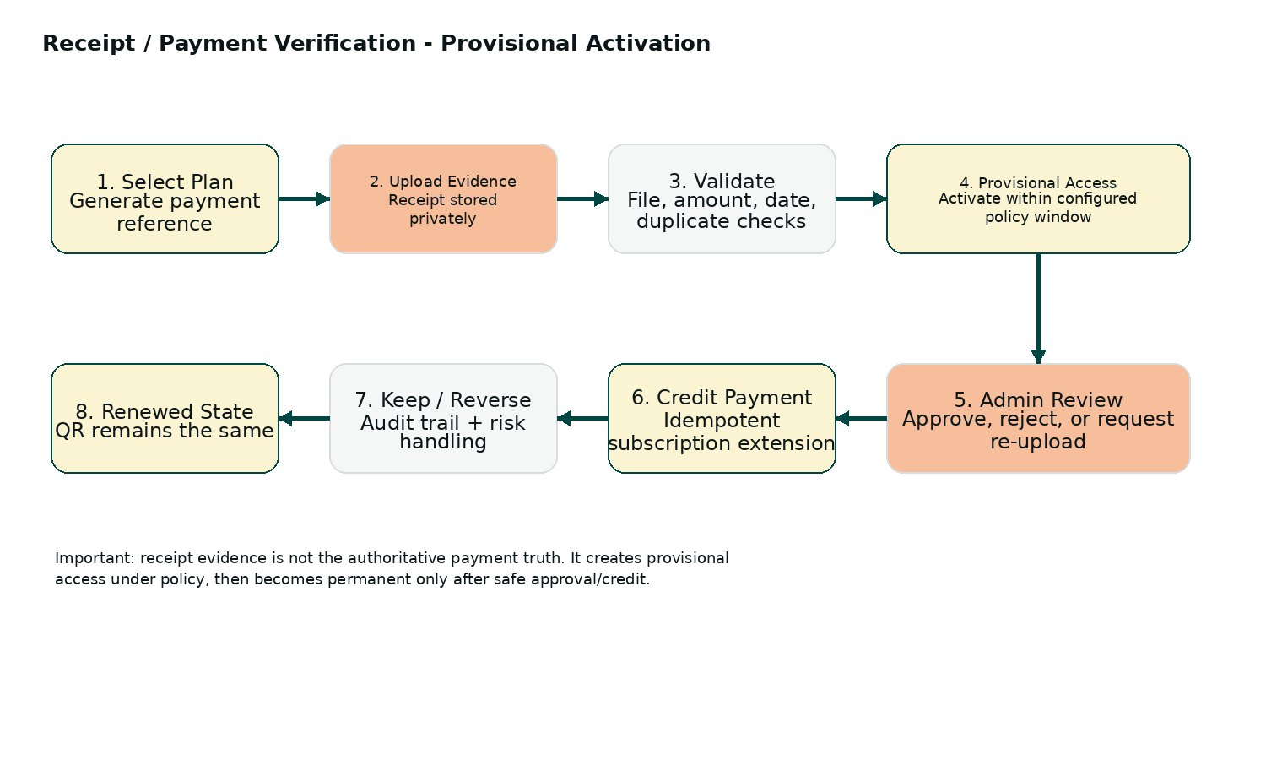

7.1 Receipt Pipeline
1. Create payment intent with selected plan, expected amount, currency, and a unique payment reference.
2. Accept a private receipt upload with MIME/signature/size validation and tenant-scoped storage.
3. Compute cryptographic hash and perceptual fingerprint to detect reuse.
4. Run optional OCR/VLM extraction asynchronously.
5. Apply deterministic validation rules: amount, currency, date window, transaction/reference uniqueness, generated reference where available, image readability.
6. Create provisional access when enabled by policy; record start/end and reason.
7. Route ambiguous or suspicious cases to the admin review queue.
8. Approve, reject, or request re-upload; approval is idempotent and atomically credits the subscription.
9. Notify the client and append an audit timeline event.

7.2 Admin Receipt Review UI
The review screen should display the original receipt evidence beside extracted fields and rule results. The admin must be able to see what the system detected, what rule failed, and what decision has already been made without navigating across multiple pages.
- Expected amount vs detected amount
- Payment date
- Transaction/reference identifier
- Generated payment reference
- Duplicate/fingerprint warning
- AI/OCR provider and model metadata
- Risk/confidence explanation
- Previous submissions from the same account
- Approval/rejection/request-reupload controls
- Reason and audit history

8. Optional AI / LM Studio Design
AI is an enhancement layer, not a dependency for core routing or billing. The integration uses a provider abstraction so local LM Studio, a cloud VLM/OCR service, or a deterministic OCR engine can be swapped without rewriting payment or subscription logic.
AI task | Input | Output | Failure behavior
Receipt extraction | Receipt image | Structured amount/date/reference/name fields | Fall back to manual review
Readability assessment | Receipt image | Readable / unclear + confidence | Keep in review queue
Anomaly assistance | Extracted fields + policy context | Flags only; no direct credit | Admin review
Duplicate assistance | Current receipt + fingerprints/history | Similarity signal | Use deterministic hash/fingerprint as stronger control
Structured explanation | Rule results + model output | Human-readable reasons | Show rule failures without AI dependency

8.1 LM Studio Configuration
- Provider type: LM Studio / cloud / local OCR / disabled.
- Base URL and optional authentication stored server-side.
- Model discovery and selected active model.
- Task-specific model assignment for extraction vs anomaly assistance.
- Timeout, retry count, max tokens, temperature where supported.
- Health check and test extraction from admin settings.
- Fallback provider when local model is unavailable.
- Persist provider/model/prompt-template version alongside every AI-assisted review.
AI safety boundary
The original receipt remains the evidence. AI output is advisory/structured extraction. The application validates model output against a schema before any field is accepted into a rule engine; no raw free-form model response should directly mutate subscription state.

9. Business / Client UX Architecture
The client experience should revolve around one question: “Is my QR currently working, and what do I need to do next?” The dashboard therefore prioritizes operational status and renewal over dense analytics.

9.1 Primary Navigation
Navigation item | Primary purpose | Default priority
Overview | Status, expiry, scan snapshot, recent activity | Highest
My QR Codes | Create/edit/test/download/manage QR destinations | Highest
Subscription | Plan, expiry, renewal, receipt/payment history | Highest
Design & Cards | Customize QR/card assets and place orders | Medium
Analytics | Scans, trends, device/location aggregates, routing health | Medium
Notifications | Message preferences and history | Low
Support | FAQ, contact, tickets, payment/printing help | Medium
Settings | Business profile, users/team later, timezone, AI optional settings where authorized | Low

9.2 Onboarding Wizard
1. Create account
2. Add business name and essential profile details
3. Choose review platform / custom URL and paste link
4. Validate destination and preview QR
5. Select plan and see exact entitlement
6. Pay or upload receipt
7. Show activation state and unlock download/order actions according to entitlement
Activation UX rule
Never hide why an action is unavailable. Show the required next step directly: “Upload receipt”, “Awaiting review”, “Renew”, “Complete business profile”, or “Download unlocked”.

10. UI Design System
Visual direction: warm, trustworthy, modern, and lightweight. It should feel like a practical growth tool for local businesses rather than a generic finance SaaS or consumer QR generator.

10.1 Brand Tokens
Token | Hex | Usage | Guidance
Ink / Primary Text | #0C1618 | Headings, primary text, icons on light surfaces | Default text color; strong contrast
Deep Teal | #004643 | Primary buttons, active navigation, links, QR status highlights | Primary brand action color
Cream | #FAF4D3 | Page backgrounds, hero surfaces, gentle panels | Large-area warm background
Gold | #D1AC00 | Accent, plan emphasis, progress, small highlights | Use sparingly; avoid small gold text on cream
Peach | #F6BE9A | Promotional cards, soft warnings, design accents | Secondary accent, not sole status signal

10.2 Semantic Status Design
- Active: Deep Teal + check icon + “Active”.
- Provisional: Gold accent + clock icon + “Under verification - QR temporarily active”.
- Grace: Peach/Gold + warning icon + explicit expiry date.
- Expired: neutral/danger treatment + “Inactive - Renew to reactivate”.
- Suspended: danger-neutral treatment + “Temporarily unavailable”.
- Status must always include text and icon; color alone is insufficient.

10.3 Component Language
Component | Design behavior
Primary button | Deep Teal filled, strong label, 10-12 px radius, visible focus ring
Secondary button | Teal outline or neutral fill; used for Test QR / Preview / Back
Accent action | Gold used for plan emphasis or “recommended” treatment, not destructive action
Cards | Soft 12-16 px radius, restrained shadow, generous internal spacing
Status chip | Icon + text, rounded pill, compact but readable
Tables | Sticky header for long admin queues; zebra striping only as subtle aid
Forms | Single-column on mobile; inline help under complex fields
Modal / Drawer | Prefer side drawer for admin review; modal only for focused confirmation
Empty state | Explain what to do next and provide one primary CTA
Toast | Use only for immediate confirmation; persistent errors live near the affected control

10.4 Client Dashboard Wireframe
Desktop: left sidebar + compact top business header + main content grid. Mobile: bottom navigation or compact menu + stacked status cards. The first viewport should show the QR health state, expiry date, renewal action, and QR preview.
Area | Content
Header | Business name, account menu, notification indicator, support shortcut
Hero status card | Active / Provisional / Grace / Expired / Suspended + expiry + next action
QR card | Preview, Test QR, Download, Copy dynamic link
Scan card | Total scans + 7/30 day trend + routing health
Subscription card | Current plan, price, period, renewal/receipt state
Physical card card | Order status and “Order cards” when entitled
Recent activity | Last scans, payment updates, admin messages
Support card | WhatsApp/email/FAQ entry

10.5 Public Scan Pages
Page | Purpose | Design behavior
Active redirect | Get customer to destination | Normally no intermediate UI; 302 redirect
Inactive / expired | Explain service state cleanly | Simple page, no technical details, optional “Contact business”
Suspended | QR temporarily unavailable | Neutral language; never expose internal moderation details
Not found | Unknown/archived code | Generic recovery page + home/support
Temporary error | Platform dependency issue | Brief retry-safe message; never claim the business is inactive unless state is authoritative

11. Design & Printed Card System
The design system should treat the QR itself as the stable functional artifact and the printed medium as a separately managed presentation layer. A card may change without changing the QR identity.

11.1 Template System
- Minimal White: cream/white surface, dark QR, logo, short CTA.
- Restaurant Dark: deep ink/teal base with high-contrast QR treatment.
- Modern Accent: cream surface with gold/peach accent elements.
- Corporate Clean: teal-led layout with restrained gold accent.
- Every template must preserve a quiet zone and sufficient contrast around the QR.

11.2 Design Editor Scope
The MVP should not attempt to become a full Canva-like editor. Provide controlled choices: template, logo, business name, CTA text, accent color, QR container style, and preview. Admin printer configuration controls bleed/trim rather than exposing print-production complexity to clients.

11.3 Scannability Gate
- Run a QR decode test against the rendered export before allowing a print-ready asset.
- Keep the quiet zone clear.
- Do not overlap logos or decorative elements with critical QR modules.
- Generate high-resolution raster and vector output where practical.
- Show a printer-safe preview separate from the marketing preview.
- Block production status until final design/payment entitlements are satisfied.

12. Admin / Operations Experience
The admin interface is queue-oriented. It should optimize for decision speed, traceability, and safe manual operations rather than visual marketing polish.
Screen | Key elements
Operations overview | Active/provisional QR count, expiring subscriptions, pending receipts, open card orders, alerts
Receipt queue | Filters by status/risk/date/plan; sort by age; bulk-safe assignment
Receipt detail drawer | Evidence, extraction, rule checks, history, action controls
Subscriptions | Search client/QR, state timeline, extend/grant trial/suspend actions with reasons
QR moderation | Search short code, business, destination; suspend/restore/archive
Plans | Plan versions, price, duration, grace, provisional policy, print entitlements
Card orders | Design approval, production, shipment status, delivery notes
Support | Ticket queue + conversation + account timeline
Audit log | Immutable-style operational history with actor/action/target/time
Integrations | Provider settings, health checks, API/webhook status, AI/LM Studio configuration

13. Analytics & Event Architecture
Analytics is built from explicit events rather than ad-hoc counters scattered through the codebase. The event record should identify tenant, entity, event type, timestamp, and minimal context. Raw scan data has a controlled retention period.
Event family | Examples | Use
Acquisition | landing_view, pricing_view | Marketing funnel
Activation | signup_completed, business_created, destination_saved, qr_created | Onboarding funnel
Billing | plan_selected, payment_started, receipt_uploaded, receipt_approved, subscription_renewed | Commercial funnel
QR | qr_tested, scan_received, routing_failed | Operational health
Fulfillment | card_order_created, design_approved, shipped | Physical product funnel
Support | ticket_created, ticket_resolved | Service quality

13.1 Client Analytics
- Total scans
- Scans today / week / month
- Scan trend
- Approximate country/city where available
- Device category
- Top scan periods
- QR-to-destination routing health
- Recent activity
Privacy rule
Analytics should answer “how is this QR performing?” rather than “who scanned this QR?” Exact location and personal identity should not be inferred from coarse IP-derived data.

14. Notifications & Retention Design
Notifications should be event-driven and template-versioned. The platform should provide automatic expiry reminders without creating unnecessary message noise.
Trigger | Suggested timing | CTA
Expiry upcoming | 14, 7, 3, 1 days before expiry | Renew subscription
Expired | On expiry | Reactivate QR
Receipt submitted | Immediately | View verification status
Receipt approved | Immediately | Download QR / continue
Receipt rejected | Immediately | Review reason / re-upload
Card order update | At status changes | Track order / contact support
Destination health issue | When detectable | Fix review link

15. Security & Privacy Architecture

15.1 Authentication & Authorization
- Use vetted password hashing and secure session handling through the selected auth framework.
- Protect cookie-based sessions with appropriate secure, same-site, and CSRF controls.
- Enforce tenant authorization in service/data access layers.
- Admin MFA is a production requirement target.
- Rate-limit login, signup, receipt upload, and suspicious QR abuse patterns.
- Secrets and provider credentials stay server-side in environment/secret management.

15.2 File Security
- Accept only configured MIME types and reasonable file sizes.
- Validate actual file signatures rather than trusting extensions.
- Use private object storage and signed URLs for controlled access.
- Generate safe filenames and tenant-scoped storage paths.
- Use malware scanning where the infrastructure supports it.
- Never expose one tenant’s receipts or assets through guessable URLs.

15.3 Abuse / Fraud Controls
- Receipt hash and perceptual-image duplicate checks.
- Unique transaction/reference identifiers where available.
- Plan/amount mismatch and stale-date checks.
- Repeated receipt submission throttling.
- Risk flags are evidence for human review, not an opaque autonomous credit authority.
- Every manual extension, reversal, suspension, or approval records actor + reason + timestamp.

16. Reliability & Observability
- Health endpoints for web, database, queue, object storage, and external integrations.
- Structured logs with correlation/request IDs for public QR and admin operations.
- Alert on QR resolver error rate, queue backlog, receipt-processing failures, webhook failures, and notification failures.
- Backups for transactional data with a tested restore process.
- Graceful degradation: analytics can fail without blocking QR redirect; AI can fail without blocking manual review; printer integrations can fail without corrupting subscription state.
- Use retries with exponential backoff and bounded attempts for external integrations.
- Circuit-breaker or temporary-disable behavior for unhealthy providers.

17. Background Jobs & Scheduled Work
Job | Purpose | Safety
Expire subscriptions | Transition derived/operational views or prepare reminders | Idempotent; state transition checked against current record
Expiry reminders | Send scheduled notices | Unique message key per tenant/period/channel
Receipt AI extraction | Asynchronous model/OCR processing | Retry-safe; structured output validation
Scan aggregation | Build daily/monthly summaries | Re-runnable from event log
Webhook retry | Retry failed provider event handling | Idempotent provider event ID
Asset generation | Create print files / exports | Unique job key to avoid duplicates
Retention cleanup | Remove/archive aged scan/support data | Policy-controlled and auditable

18. API Design
APIs are organized by domain rather than a flat collection of implementation-specific endpoints. The exact URI naming may change, but the separation below should remain.
API group | Representative operations | Rules
Public | Resolve QR, inactive page, suspended page, optional demo | No authentication; minimal dependencies; abuse controls
Auth | Signup, login, logout, password reset, session | Secure session lifecycle
Tenant/Business | Get/update business, locations | Tenant scoped
Destination | Create/update/test review destination | URL validation + health checks
QR | Create/list/get/update/archive/test/download | Short code immutable after issuance
Plans/Subscription | List plans, start purchase, renew, view history | Central entitlement logic
Receipt/Payment | Upload receipt, status, history, payment intent | Private files + idempotent credit
Analytics | Scan summaries, trends, routing health | Aggregate/read-only views for client
Design/Card | Assets, templates, previews, card orders | Separate print entitlements
Admin | Queues, manual decisions, plan management, exports | Strong RBAC + audit
Integrations | Health checks/configuration | Credentials never returned to browser

19. Integration Contracts
- Payment: provider event signature verification, provider event ID idempotency, external transaction ID storage.
- OCR/VLM: JSON schema output, explicit timeout, retry/fallback strategy, provider/model metadata.
- Email/WhatsApp: message template ID/version, delivery status, retry policy.
- Printer: design file reference, order state, production approval gate, shipment reference.
- Review destinations: URL validation and optional lightweight health check; platform availability is never guaranteed by the application.
- All adapter calls have clear timeouts and error mapping; provider errors must not be allowed to corrupt internal commercial state.

20. Edge Cases & Failure Handling
Scenario | Expected behavior
QR scanned immediately after expiry | Use server-side authoritative effective state; never rely on client cache
QR destination changed | Same QR short code continues; next scan uses new destination
Renewal submitted before current period ends | Extend from current period end
Renewal submitted after expiry | Start from effective renewal time unless backdating is configured
Same receipt uploaded twice | Fingerprint/transaction checks + idempotent credit
Admin clicks approve twice | Second action is a safe no-op
Payment webhook delivered twice | Provider event ID prevents duplicate processing
Receipt image is unreadable | Keep provisional/review policy, request re-upload
AI provider is down | Continue deterministic checks/manual review
Analytics service is down | Redirect still succeeds
Destination URL becomes invalid | Show controlled destination-error behavior; do not manufacture a new link
Account suspended while subscription is active | Suspension takes precedence for routing
Card order canceled after payment | Keep financial record; update fulfillment/audit state separately
Client tries to access another tenant asset | Return authorization failure; never leak existence or file metadata

21. Testing & Quality Strategy

21.1 Test Layers
- Unit tests: subscription dates, grace/provisional rules, state precedence, URL validation, idempotency keys.
- Integration tests: database + object storage + queues + receipt pipeline + notifications + webhook handlers.
- End-to-end: signup -> business -> destination -> QR -> payment/receipt -> provisional/approval -> scan -> renewal -> expiry.
- Security tests: tenant isolation, authorization bypass, file upload abuse, rate limits, admin permissions.
- Performance: public QR resolver under burst scan load and queue/event ingestion.
- Visual regression: landing, onboarding, dashboard, QR manager, receipt review, expired page, mobile layouts.
- Print/scannability tests: real QR decode from generated print assets at intended card size.

21.2 High-Risk Acceptance Tests
Acceptance scenario | Pass condition
Dynamic QR survives destination change | Printed QR image stays identical; next scan reaches new destination
Expired subscription | QR does not route to review destination after grace
Renewal after expiry | Existing QR becomes routable without regenerating QR
Active renewal | Extension begins at prior period end
Duplicate receipt | No second credit/extension is created
Provisional activation | Client gets access according to configured temporary window while admin review remains pending
Cross-tenant access attempt | Request is denied without exposing target record
AI outage | Receipt upload and manual verification remain functional
Analytics outage | Valid active QR still redirects successfully
Print safety | Generated QR decodes and passes configured contrast/quiet-zone check

22. Deployment & Environments
Environment | Purpose | Data policy
Local development | Feature implementation, LM Studio testing, fake payment/receipt fixtures | Synthetic/test data only
Staging | Integrated QA, webhook and email sandboxing, pilot validation | Non-production or masked data
Production | Real client subscriptions, receipts, scans, orders | Backups, monitoring, retention policies, secure secrets

22.1 Configuration Groups
- Application: domain, environment, timezone defaults, session settings.
- Database/storage: connection strings and bucket settings.
- QR: route domain, redirect policy, retention settings.
- Billing: manual payment instructions, plans, currencies, provider credentials.
- AI: LM Studio base URL/model/fallback/provider controls.
- Notifications: email/WhatsApp provider settings and templates.
- Printing: card products, dimensions, bleed/trim, printer workflow.
- Security: rate limits, MFA, allowed file types, retention windows.

23. Recommended Implementation Sequence
The system should be implemented in vertical slices so every phase produces a testable business outcome rather than a large batch of disconnected UI.
Phase | Deliverable
1. Foundation | Auth, tenant isolation, business profile, shared UI tokens, database migrations, audit base
2. QR Core | Destination management, short-code generation, QR image, public resolver, inactive/suspended pages
3. Subscription | Plans, entitlement engine, expiry/grace/provisional states, renewal calculations
4. Payment Evidence | Payment intent, receipt upload, duplicate checks, admin review, idempotent credit
5. Client UX | Onboarding, dashboard, QR manager, subscription pages, notifications
6. Analytics | Scan events, funnel events, client metrics, routing health
7. Design/Card | Templates, scannability checks, print asset export, card orders
8. AI Assist | LM Studio/cloud adapter, receipt extraction, confidence/risk assistance
9. Operational hardening | Monitoring, backups, rate limits, security testing, visual regression, pilot readiness

24. Recommended Enhancements Beyond the Initial SRS
The following are design-level enhancements that fit the product and can be introduced without changing the core business concept:
- QR health monitoring: periodically verify destination URL reachability and alert the client when a saved destination appears broken.
- Graceful destination fallback: configurable last-known-good destination only where business policy explicitly permits it.
- Activation checklist: show a small progress checklist until the client has a valid destination, active entitlement, tested QR, and optional print order.
- QR test mode: a client-facing “Test QR” view that confirms the route and displays the resolved destination without requiring a physical scan.
- Entitlement matrix: separate subscription features from physical product entitlements to support clean plan evolution.
- Agency/team-ready tenant model: retain tenant boundaries so multi-user/agency functionality can be added later without reworking ownership.
- Feature flags: enable card ordering, AI assistance, new templates, and payment gateways per tenant/plan during rollout.
- Admin impersonation with audit trail: support teams can inspect a client session safely without revealing credentials or bypassing audit controls.
- Backup destination or feedback form: optional custom fallback for businesses that want a first-party feedback path without changing the QR.
- QR export pack: bundle PNG/SVG/print-ready outputs with version metadata so clients know which design is current.
- Operational timeline: one chronological feed combining subscription, receipt, QR, order, and support events for both client support and admin debugging.

25. Design Definition of Done
- The modular domain boundaries are represented in code and not only in documentation.
- The public QR route is independent of dashboard rendering and remains fast under scan load.
- Operational QR state and subscription entitlement are separate sources of truth.
- Receipt approval, renewal, and webhook processing are idempotent.
- Provisional access follows an explicit policy window and is visible in both client and admin UI.
- Tenant isolation is tested with negative authorization scenarios.
- LM Studio integration can be disabled without breaking the core payment or QR workflow.
- All critical admin actions create auditable records.
- Landing, client dashboard, public scan pages, and admin review screens share the same design token system.
- QR exports pass scannability checks before print production.
- Backups and restore have been exercised in a non-production environment.
- Critical user journeys are covered by automated tests and manual pilot checks.

26. Final Design Summary
The proposed SmartReview QR platform should be built as a domain-driven modular monolith centered on a small set of strong invariants: the printed QR identity never needs to change; the destination is mutable; subscription entitlement is centralized; operational suspension overrides commercial entitlement; receipts are evidence and can provide provisional access under policy; actual credit is idempotent; analytics and AI are asynchronous enhancements; physical print is a separate entitlement; and every tenant/admin action is auditable.
The interface should visually communicate the same model: deep teal for action and trust, cream for warmth, gold for controlled emphasis, peach for secondary accents, and dark ink for readable structure. A client should be able to understand QR state, expiry, and the next action at a glance, while the admin interface should make verification and operational decisions fast and traceable.
Core implementation invariant
A QR scan must resolve from authoritative server-side state. Never let a stale browser/proxy cache or a duplicated “active” flag decide whether a subscription-controlled QR is usable.

Appendix A - Suggested UI Screen Inventory
Area | Screens
Marketing | Home, Pricing, How it Works, FAQ, Contact/Support, Demo QR
Authentication | Sign up, Log in, Forgot Password, Reset Password, Verification
Onboarding | Business profile, Review link, QR preview, Plan selection, Payment/receipt, Activation result
Client | Overview, QR list/detail, QR editor, Subscription, Payment/receipt history, Analytics, Design templates, Card orders, Notifications, Support, Settings
Admin | Operations dashboard, Clients, QR codes, Receipts, Receipt review, Subscriptions, Plans, Payments, Card orders, Templates, Support, Reports, Audit log, Integration settings, AI/LM Studio settings

Appendix B - Suggested Status Copy
State | Client-facing copy
Active | Your QR is active and ready to receive scans.
Provisional | Your QR is temporarily active while your payment is being verified.
Grace | Your QR is still active during the grace period. Renew to keep it active.
Expired | Your QR service is inactive. Renew your subscription to reactivate the same QR.
Suspended | This QR is temporarily unavailable. Contact support if you need help.
Not found | This QR code could not be found or is no longer available.

