**PROJECT REPORT**

TOPIC: **TRANSACTION MANAGEMENT SYSTEM USING PL/SQL**

**Name: ANKIT KUMAR**

**Roll no.: 101804042**

**Degree: B.E. (ELECTRICAL)**

**TRANSACTION MANAGEMENT SYSTEM USING PL/SQL**

**IMPLEMENTATION:**

This project solely focuses on Transaction Management of the customer’s bank account. Firstly, the table containing the customer’s details like account number, account name, account balance, account branch, account city is created. Then the details of 10 customers have been inserted in the table. After this the PL/SQL code for the updation of balance (withdraw, deposit) for the customers has been written.

**SOFTWARE USED:** Live SQL

**CODE:**

**--creating table (database object)**

create table bank_account(

account_no char(10),

account_name char(15),

account_balance number(15),

account_branch char(15),

account_city char(15));

--**inserting customer details**

insert into bank_account values('A10713698', 'Kunal sharma', 350000, 'Mayapuri', 'Delhi');

insert into bank_account values('A10713701', 'arindma', 670000, 'preet vihar', 'Delhi');

insert into bank_account values('A10713705', 'ujwal dua', 980000, 'swesh colony', 'gurgaon');

insert into bank_account values('A10713711', 'Kaviraj', 785000, 'rk residency', 'noida');

insert into bank_account values('A10714102', 'jaspreet', 1420000, 'juju colony', 'Jaipur');

insert into bank_account values('A10714106', 'Arav sinha', 458000, 'Midhapur', 'Jodhpur');

insert into bank_account values('A10714109', 'vatsalya', 950000, 'sun park', 'Mohali');

insert into bank_account values('A10714117', 'sidanshu', 1780000, 'jouri park', 'Chandigarh');

insert into bank_account values('A10714125', 'Kajal vij', 254000, 'andheri', 'Mumbai');

insert into bank_account values('A10714129', 'Kustabhshu', 3000000, 'powai', 'Mumbai');

select * from bank_account;

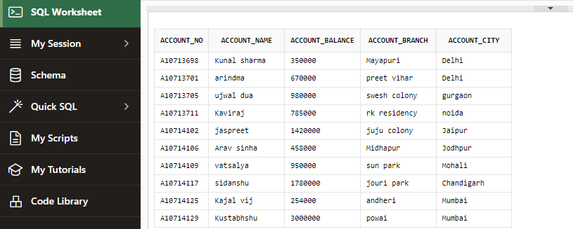

**--PL/SQL CODE:**

DECLARE

personalact_no bank_account.account_no%type;

xact_balance bank_account.account_balance%type;

options number(1);

deposit number(10);

withdrawal number(10);

BEGIN

personalact_no:=&Enter_Account_Number;

options:=&1Deposit_2Withdrawal_3Balance;

select account_balance into xact_balance from bank_account where account_no=personalact_no ;

IF( options = 1 ) THEN

deposit:=&Enter_Deposit_Amount;

update bank_account set account_balance=account_balance+deposit where account_no=personalact_no ;

xact_balance :=xact_balance+deposit;

dbms_output.put_line('Rs. '||deposit||' has been creadited in your account');

dbms_output.put_line('Your final balance is Rs. '||xact_balance );

ELSIF( options = 2 ) THEN

withdrawal:=&Enter_Withdrawal_Amount;

IF ( withdrawal<=xact_balance ) THEN

update bank_account set account_balance=account_balance-withdrawal where account_no=personalact_no ;

xact_balance:=xact_balance-withdrawal;

dbms_output.put_line('Rs. '||withdrawal||' has been debited in your account');

dbms_output.put_line('Your final balance is Rs.'||xact_balance );

ELSE

dbms_output.put_line('Your withdrawal amount is greater than balance');

dbms_output.put_line('Your transaction failed');

dbms_output.put_line('Your final balance is Rs.'||xact_balance );

END IF;

ELSE dbms_output.put_line('Your balance is Rs. '||xact_balance );

END IF;

END;

**OUTPUT:**

1. For account number='A10713698' , options:=1, deposit:=5000

Updated table:

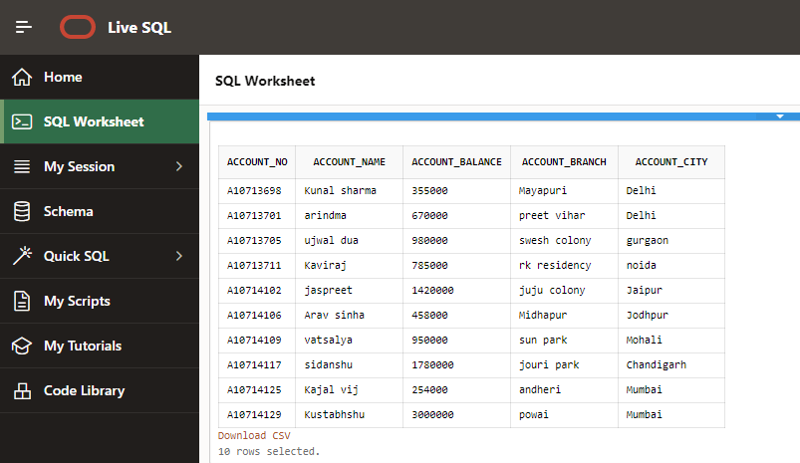

1. For account number= 'A10714117' , options:=2, withdrawal:=3000

Updated table:

