***SAS ON-DEMAND***

**Step1:**

Click on the below link to register in the On-demand portal.

<https://odamid.oda.sas.com/SASLogon/login?service=https%3A%2F%2Fodamid.oda.sas.com%2FSASODAControlCenter%2Fj_spring_cas_security_check>

**Step2:**

Click on the ‘Not registered or cannot sign in’ link.

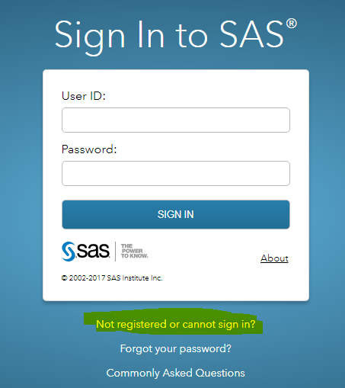

**Step3:**

On the below link click ‘Don’t have a SAS Profile’

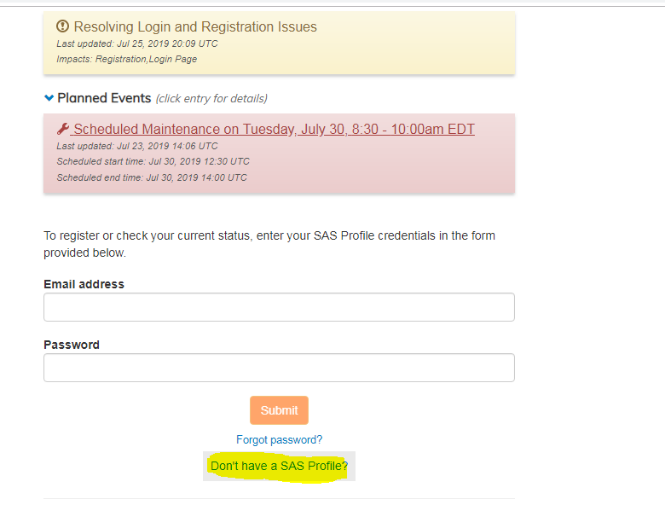

**Step4:**

Below popup will open select ‘Create Profile’ from this.

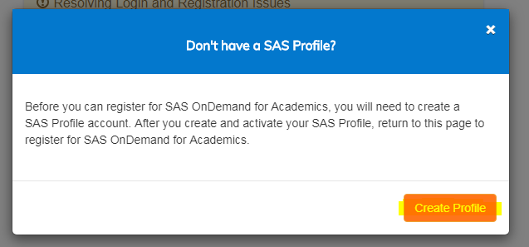

**Step5:**

Fill all the details on the below page,

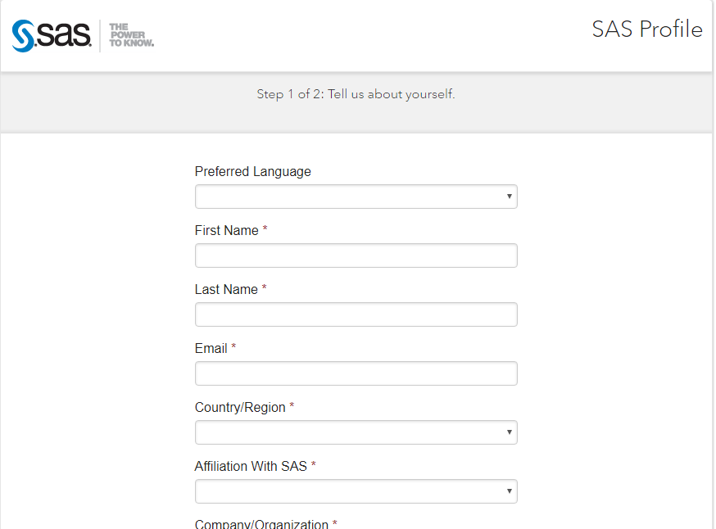

**Step6:**

Please find sample on how to fill the page,

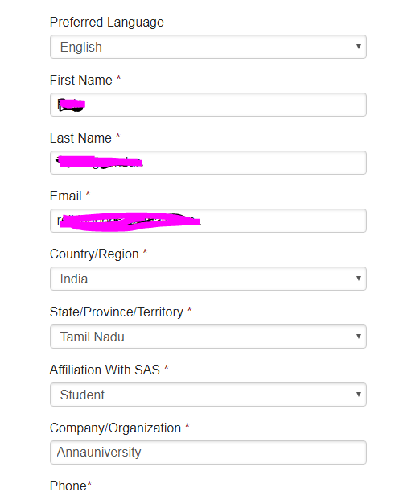

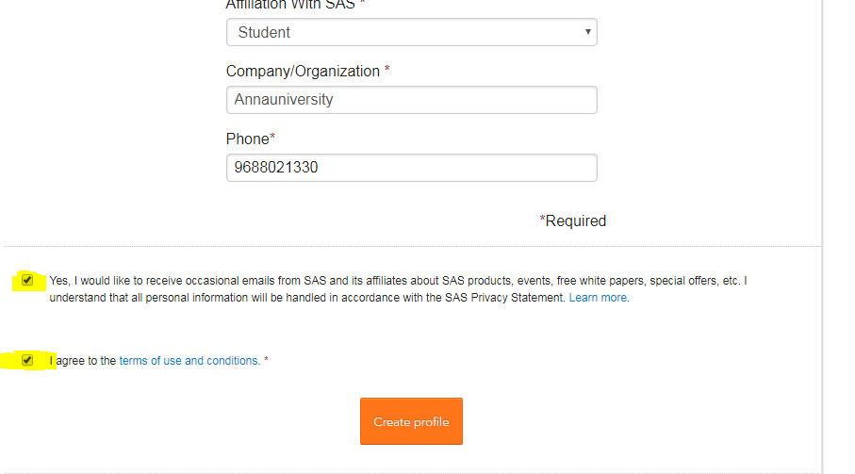

**Step7:**

After clicking on then ‘Create profile’ you will get the below popup stating the profile has been created. After this please login into your mail and click the link on that mail to verify your email.

Once you are done with this it take one day to activate your account.

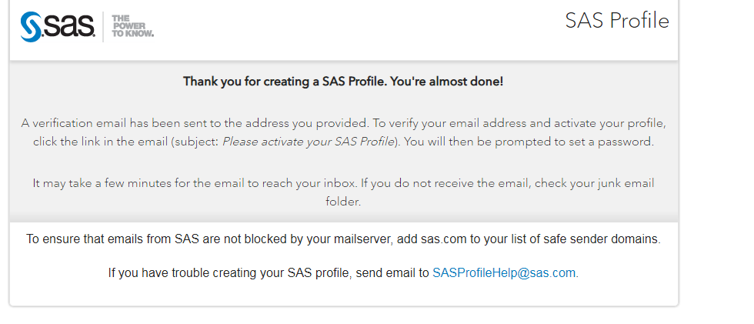

**Step8:**

After your account is activate click on the below link and try logging using your email_id and password.

<https://odamid.oda.sas.com/SASLogon/login?service=https%3A%2F%2Fodamid.oda.sas.com%2FSASODAControlCenter%2Fj_spring_cas_security_check>

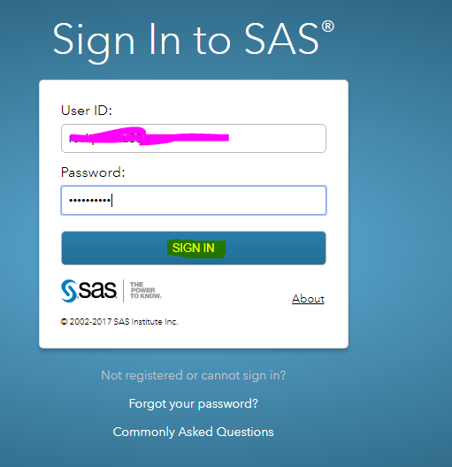

**Step9:**

After login go to the bottom of the page and click the highlighted one ‘SAS Studio’

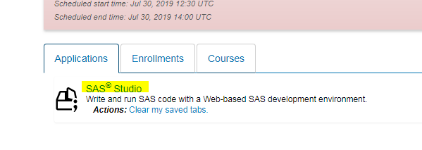

**Step10:**

It will show the initializing in separate window.

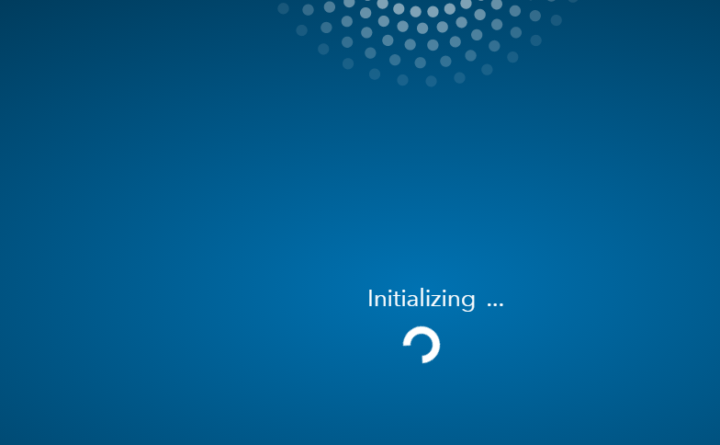

**Step11:**

Here you go for the SAS Editor page.

