NAT Gateway For Private Subnet Internet Access

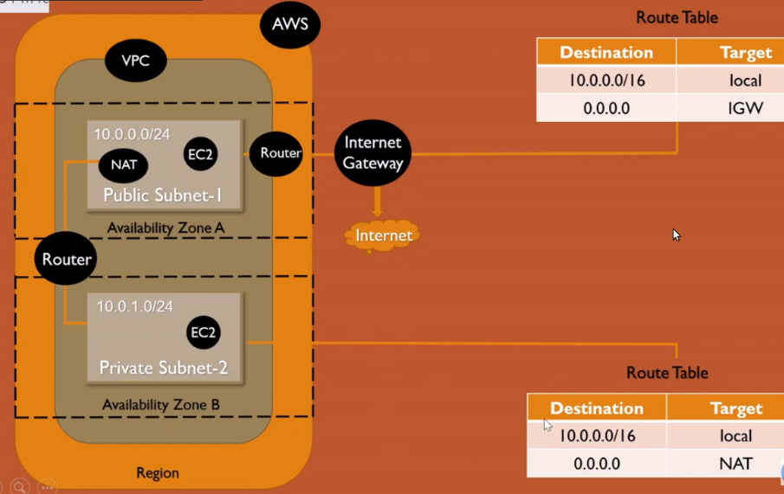

Login to AWS console -----> Go to services choose -----> VPC

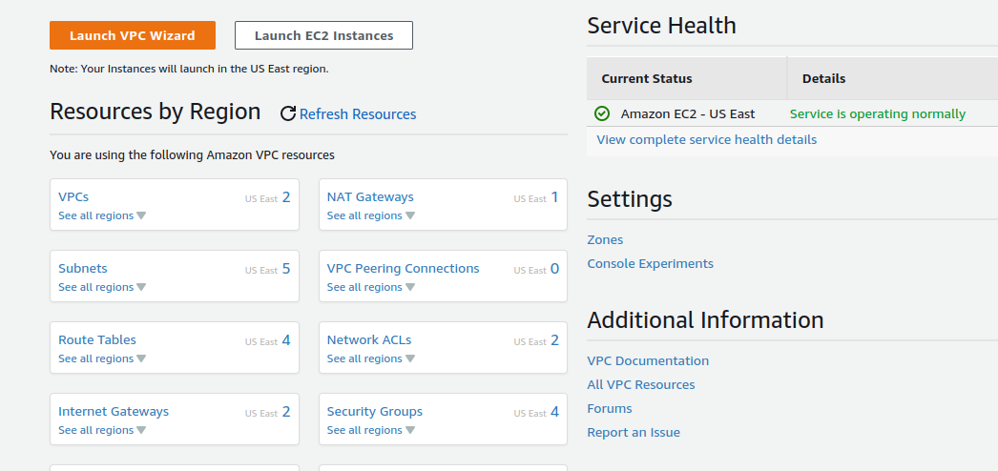

Choose VPC’s -----> Click on create VPC
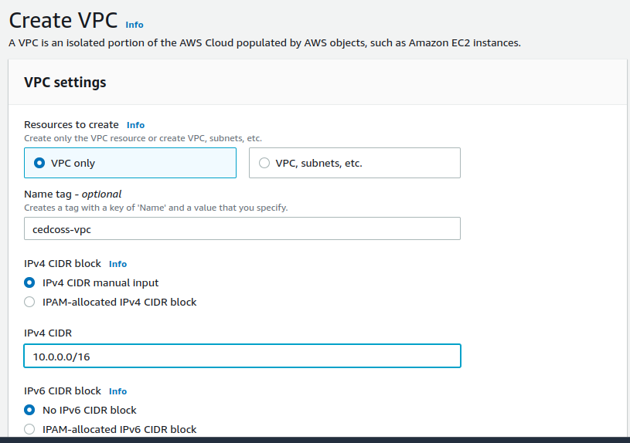
Click create VPC button.

Back to VPC’s dashboard -----> Click on Subnet -----> Choose create Subnet

Select your VPC ID & scroll down --> Create your Subnet Name ---> Create CIDR Block .

“Here we are create two subnet one public and one private subnet”

Public Subnet :

“A subnet that's associated with a route table that has a route to an internet gateway”

Private subnet :
“back-end servers that don't need to accept incoming traffic from the internet and therefore do not have public IP addresses”
Public Subnet
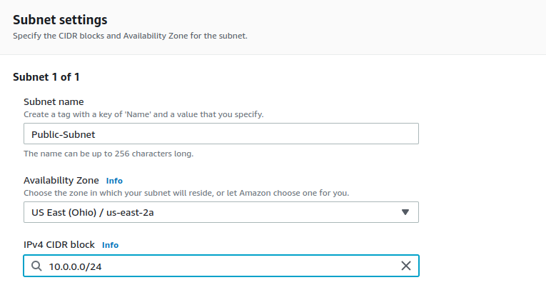
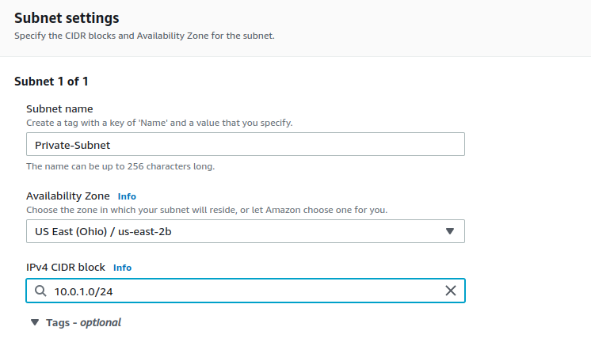
Private Subnet

Click on Create Subnet -----> Back to VPC’s Dasboard ----> Click on Internet Gateway (IGW) ----> here you have default IGW (ignore them) ---> Just Choose create Internet Gateway

Internet Gateway :
“A network "node" that connects two different networks that use different protocols (rules) for communicating”

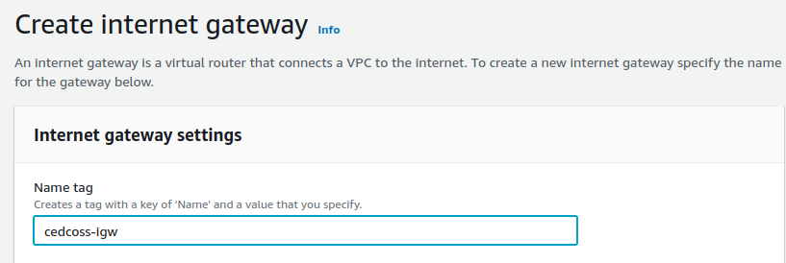

Create you Internet Gateway Name ----> Back to Internet Gateway dashboard

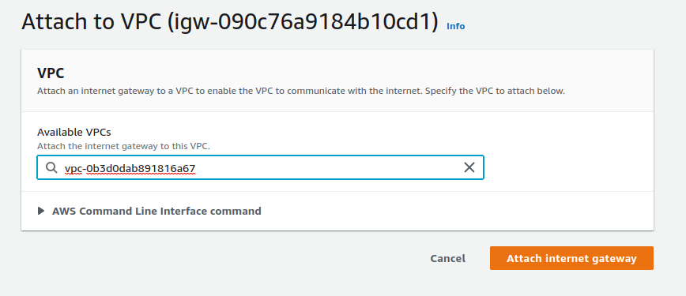

You have a notification ‘Attach to VPC’ Choose your VPC.

Back to VPC’s dashboard click on Route Table ---> Choose create Route Table

create two Route Table :

1 : Public Route Table
2 : Private route Table

Route Table :

“Each subnet in your VPC must be associated with a route table, which controls the routing for the subnet (subnet route table). A subnet can be explicitly associated with custom route table”
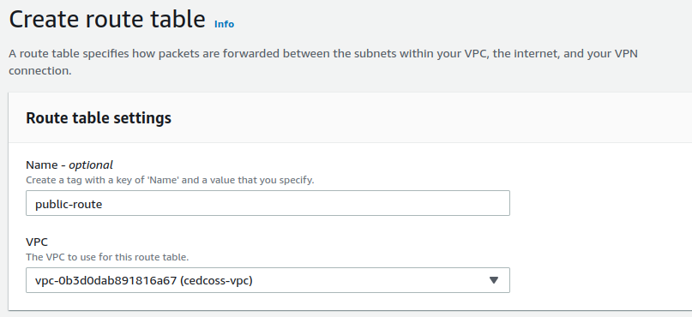
“Contains a set of rules, called routes, that are used to determine where network traffic from your subnet or gateway is directed”

“A subnet can only be associated with one route table at a time, but you can associate multiple subnets with the same subnet route table”

Go inside of route table ---> click on route ---> Edite route
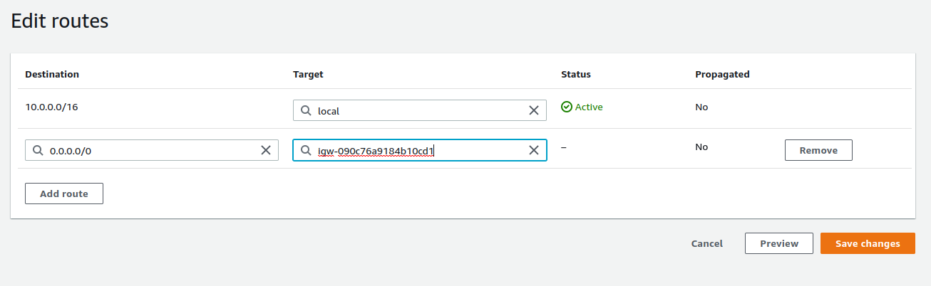
click on Save change.

Back to Route table ---> choose create route table “Private Route Table”
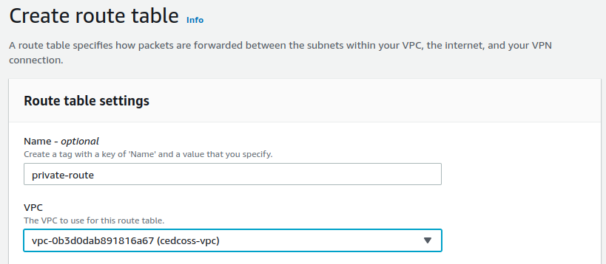

Back to route table dashboard click on Public Route Table go inside it --- > click on Subnet association ---> edite subnet association ---> select public subnet & -->
save changes.

