Real Time Data Streaming System with AWS Kinesis, Lambda Functions and a S3 Bucket

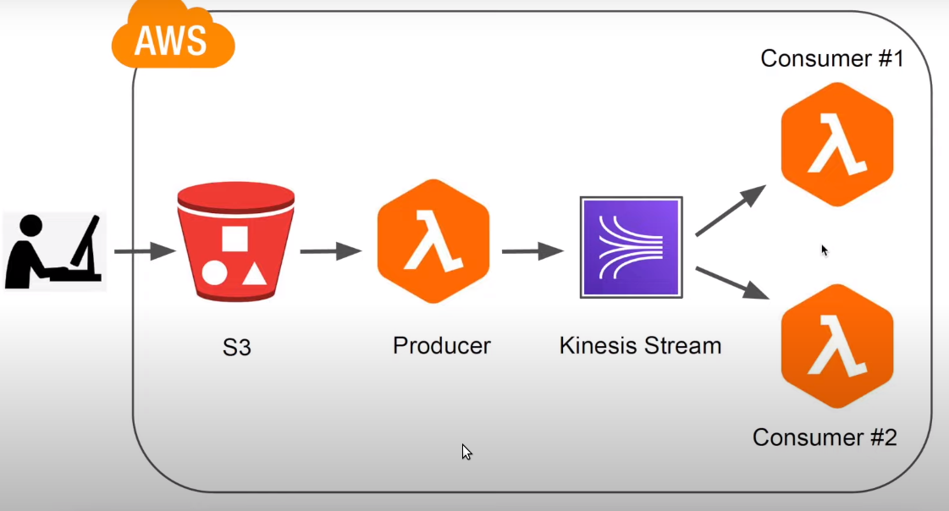
Whenever you upload a file to our S3 Bucket its going to a trigger a Lambda function which is a Data Producer that reads the file content to from the S3 Bucket & push the data to Kinesis & now we have two consumers that comsume the data from the stream and they can do diffrent things with it for example, consumer no 1 can read the data & then send an email to all the clients with the information or you can just publish your data to social media plateform and then consumer no 2 can just save the data to a database.

Go to ----> AWS console ----> choose IAM ----> click on role.

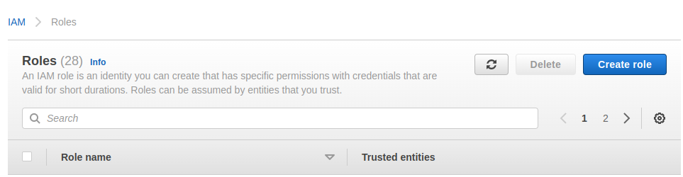

Select ---> Lambda click on next
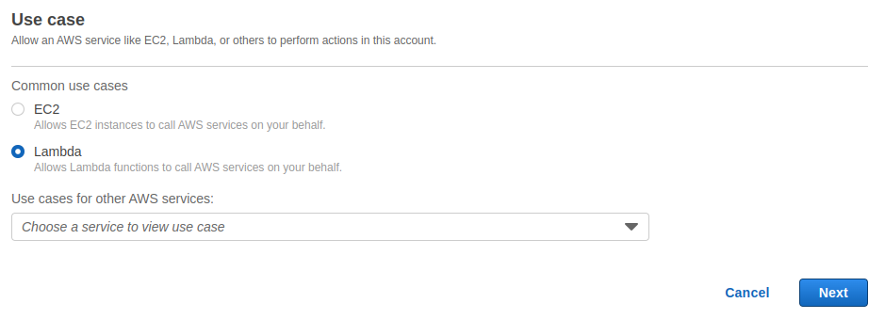
Create 3 plicy
1 : AmazonKinesisFullAccess
2 : AmazonS3FullAccess
3 : CloudWatchFullAccess

Enter the role name -----> click on next.

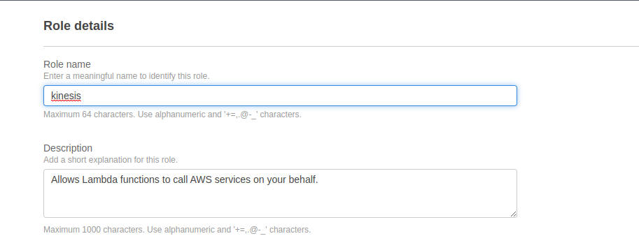
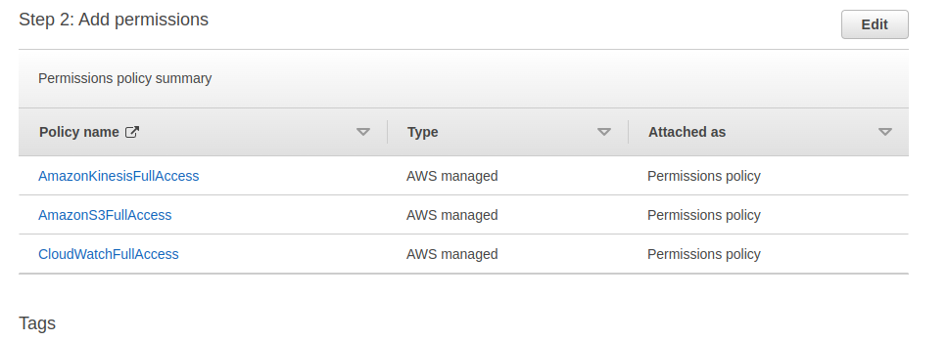

Go to AWS console select Lambda
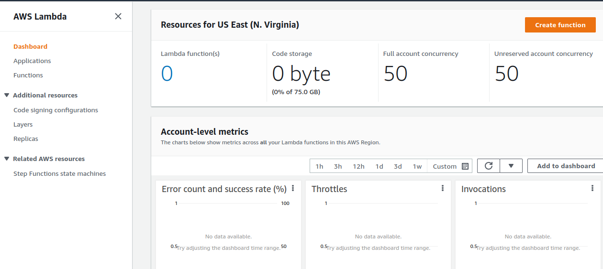
Click on create function ‘name producer’
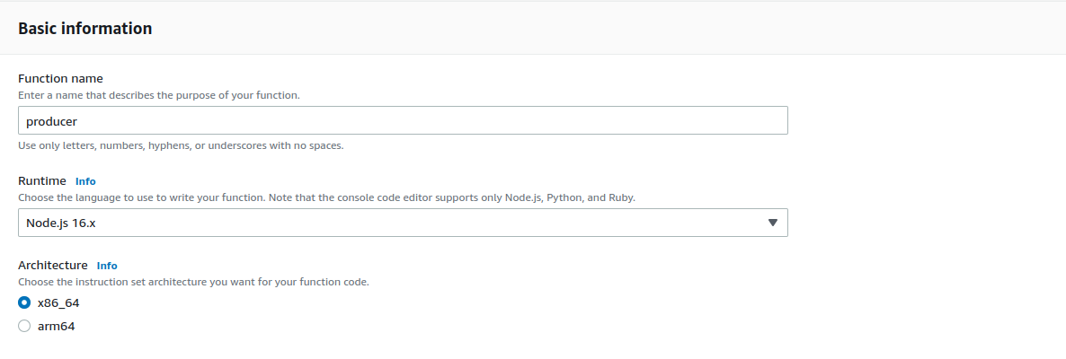
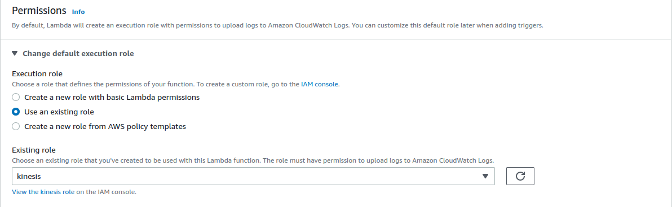

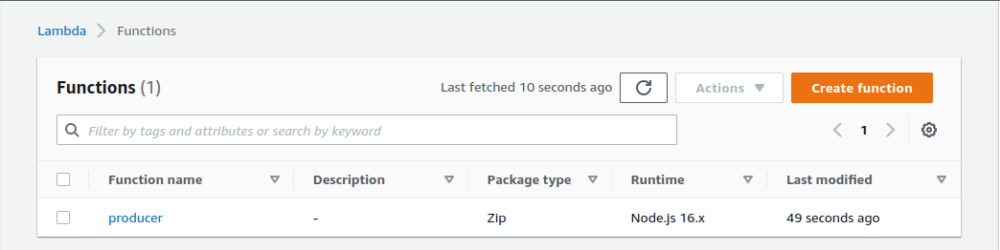
click on create another function ‘name consmer 1’

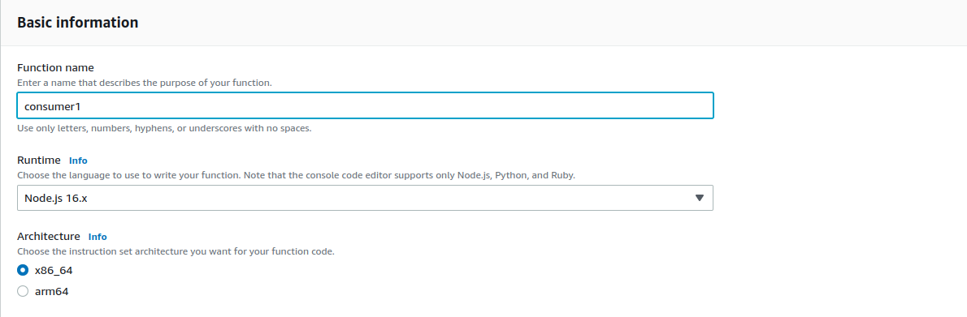
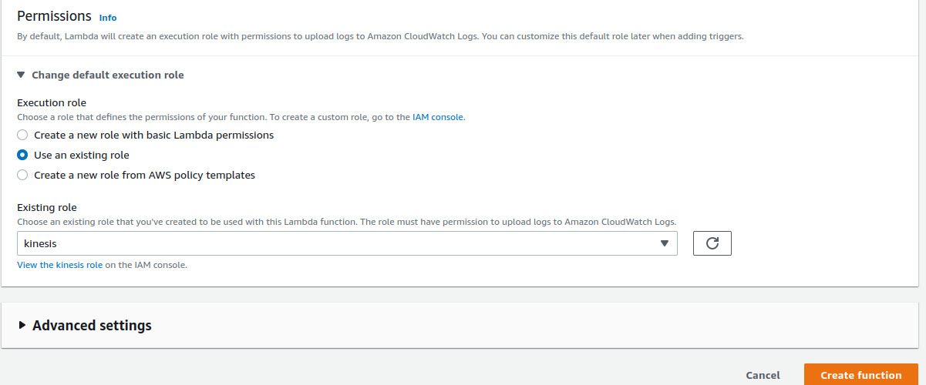

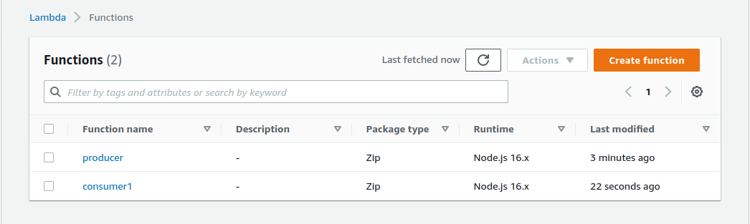
Create consumer 2 ----> click on create function.

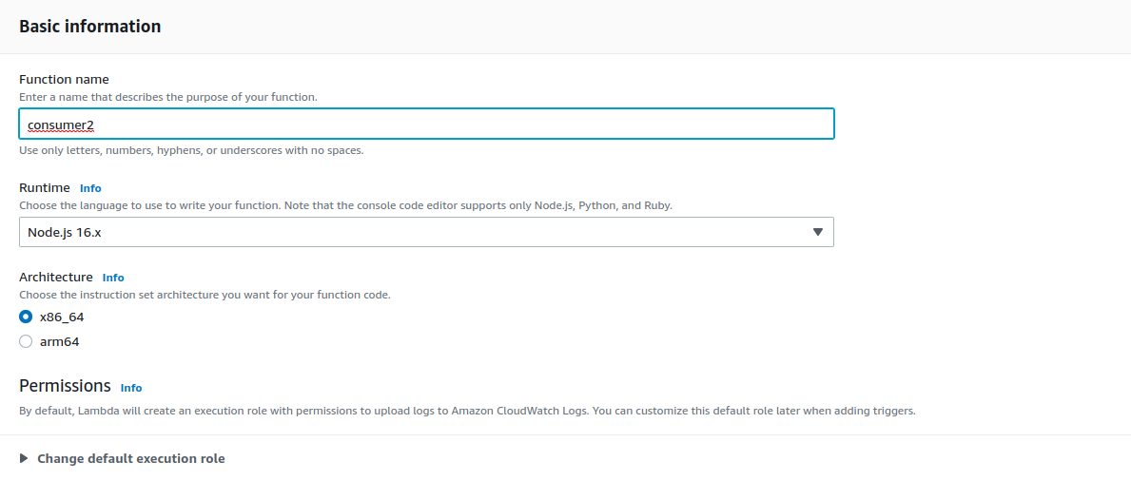
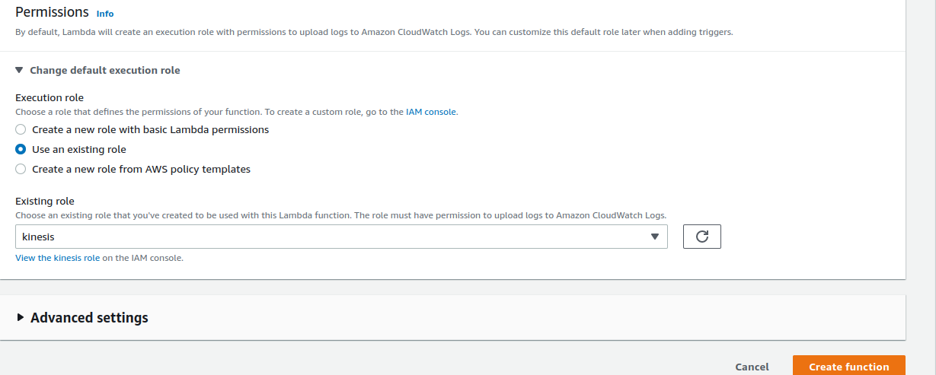

Now go to S3 bucket & create a bucket.

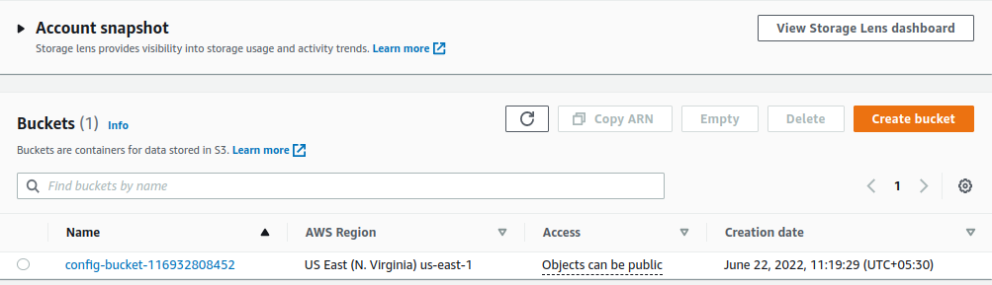
click on create bucket ----->

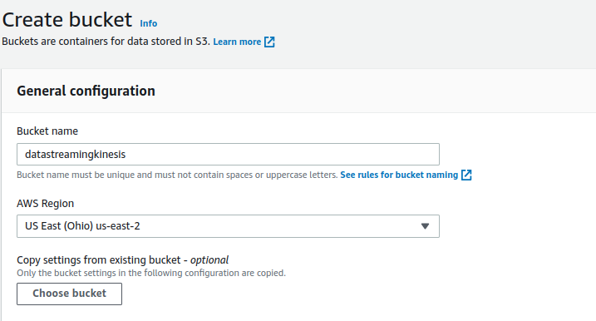

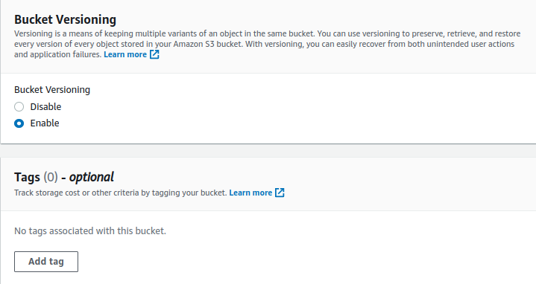

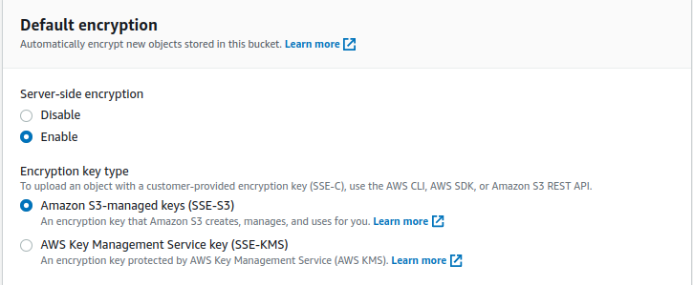
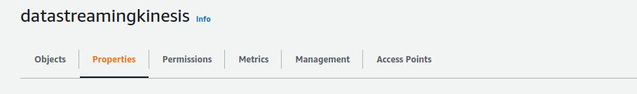

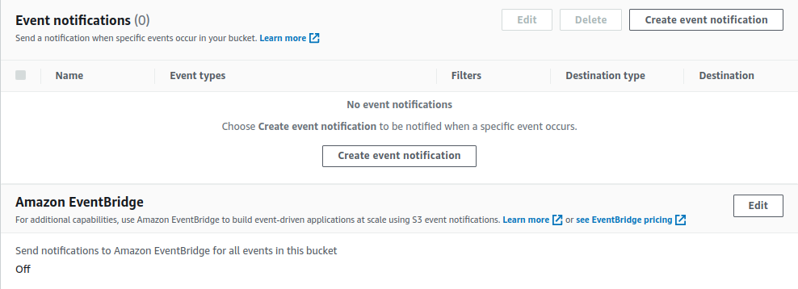
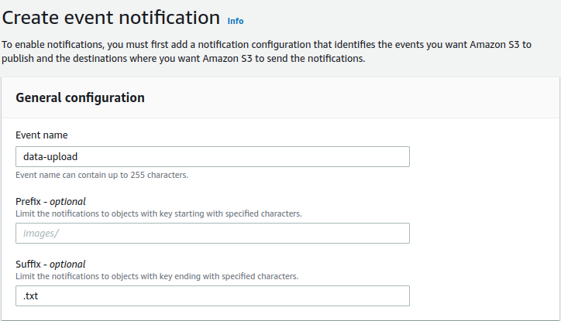
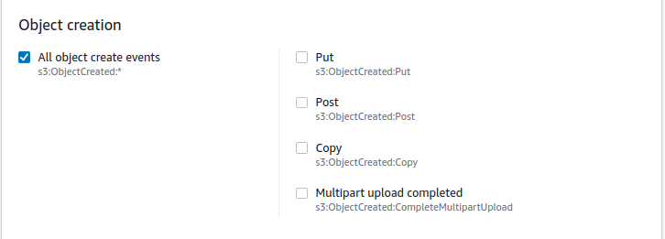

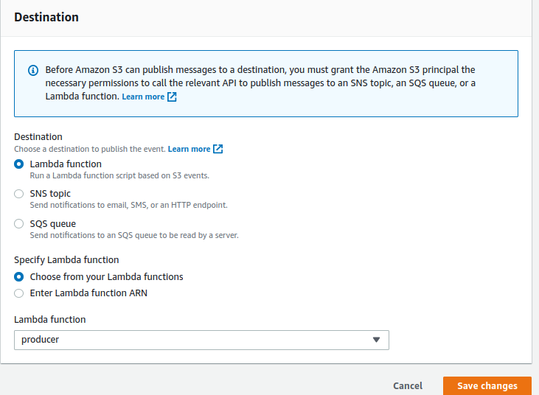
Go to Kinesis dashboard ----> select Kinesis data streams

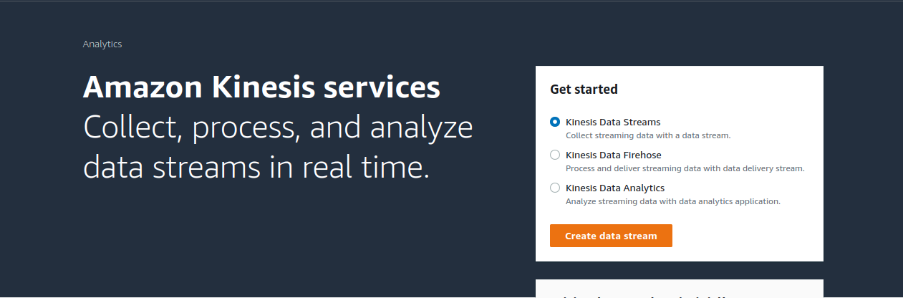

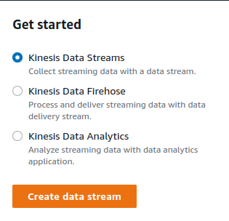
click on create data stream.

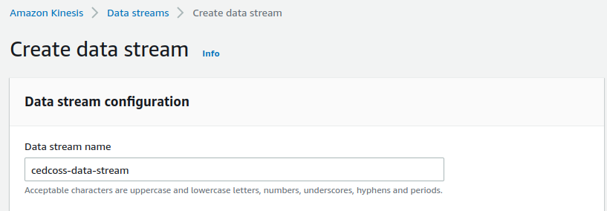
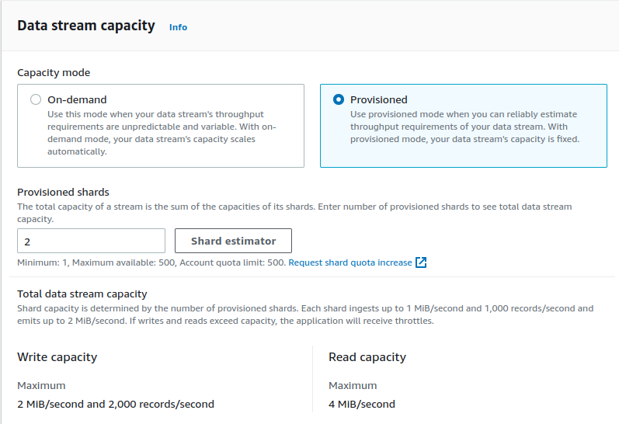
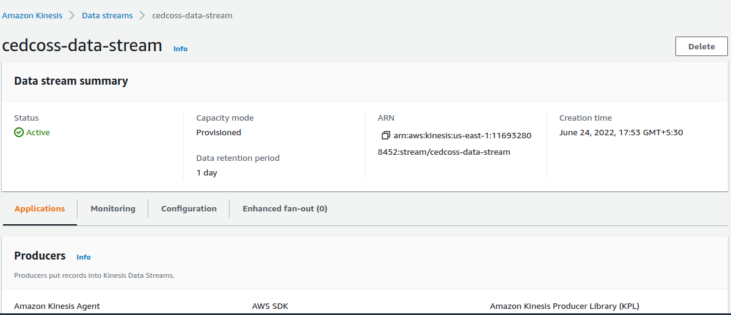

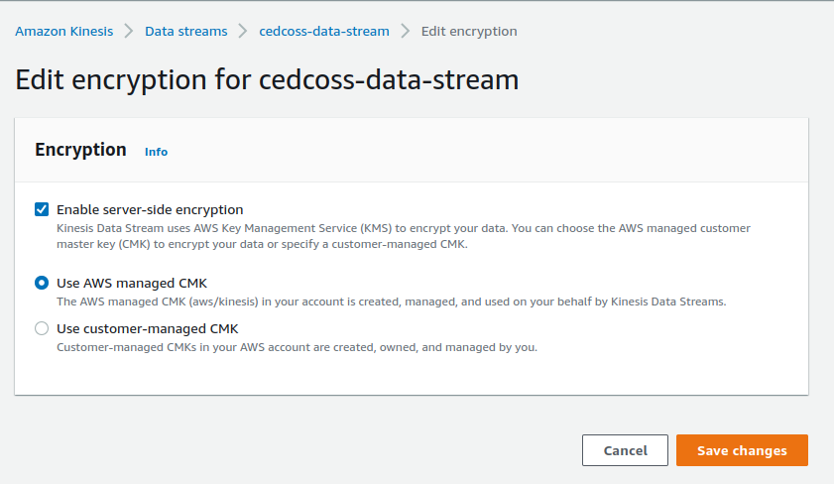
Now click on function & choose producer.

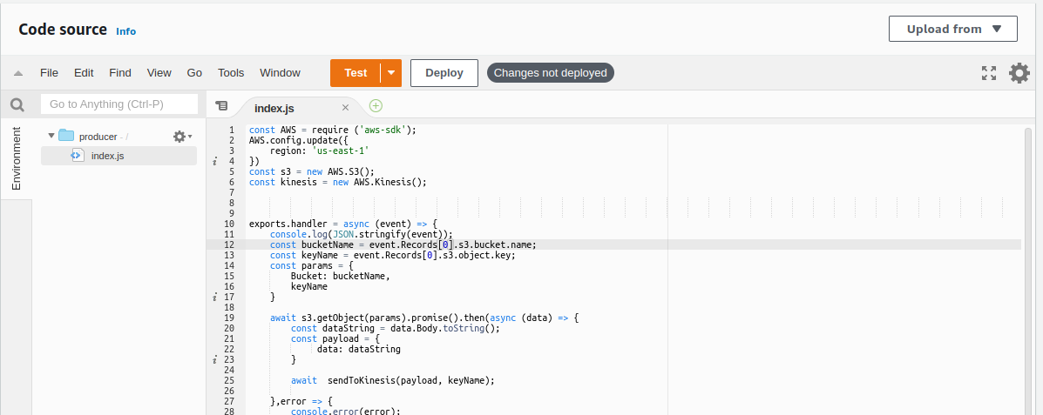
JavaScript code for producer

const AWS = require ('aws-sdk');
AWS.config.update({
region: 'us-east-1'
})
const s3 = new AWS.S3();
const kinesis = new AWS.Kinesis();

exports.handler = async (event) => {
console.log(JSON.stringify(event));
const bucketName = event.Records[0].s3.bucket.name;
const keyName = event.Records[0].s3.object.key;
const params = {
Bucket: bucketName,
keyName
}

await s3.getObject(params).promise().then(async (data) => {
const dataString = data.Body.toString();
const payload = {
data: dataString
}

await sendToKinesis(payload, keyName);

},error => {
console.error(error);
} )

};
async function sendToKinesis(payload, partitionKey){
const params = {
Data: JSON.stringify(payload),
PartitionKey: partitionKey,
StreamName: 'cedcoss-data-stream'
}
await kinesis.putRecords(params).then(response =>{
console.log(response);

}, error => {
console.error(error)

})
}

Click on Deploy.

Now go to consumer1 ----> click on index.js

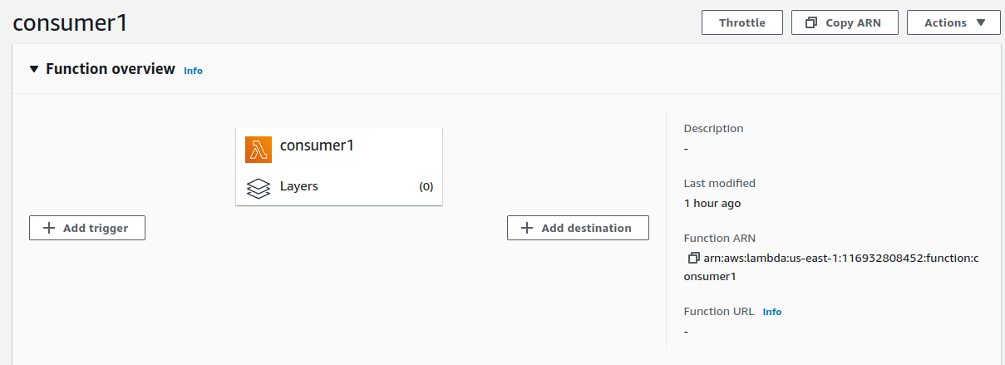
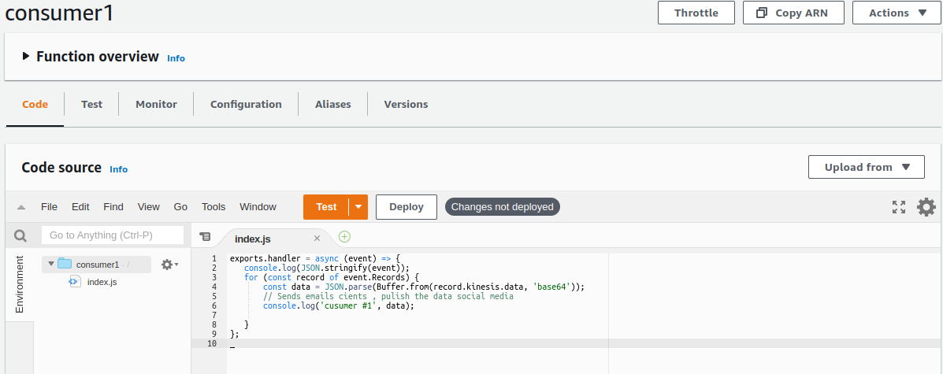

Consumer1 index.js script :

exports.handler = async (event) => {
console.log(JSON.stringify(event));
for (const record of event.Records) {
const data = JSON.parse(Buffer.from(record.kinesis.data, 'base64'));
// Sends emails cients , pulish the data social media
console.log('cusumer #1', data);

}
};

Now click on Deploy ----> Now go to Consumer2 do the same.

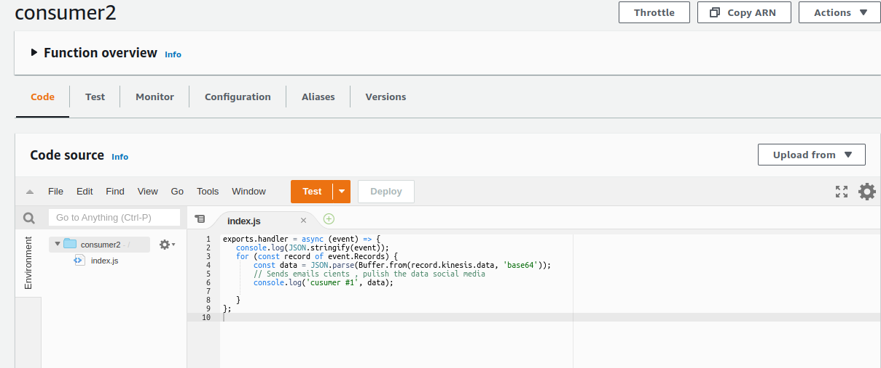

Consumer2 index.js script :

exports.handler = async (event) => {
console.log(JSON.stringify(event));
for (const record of event.Records) {
const data = JSON.parse(Buffer.from(record.kinesis.data, 'base64'));
// Sends emails cients , pulish the data social media
console.log('cusumer #1', data);

}
};

Click on Deploy. ---> Go back to consumer1 & ---> click on Add trigger

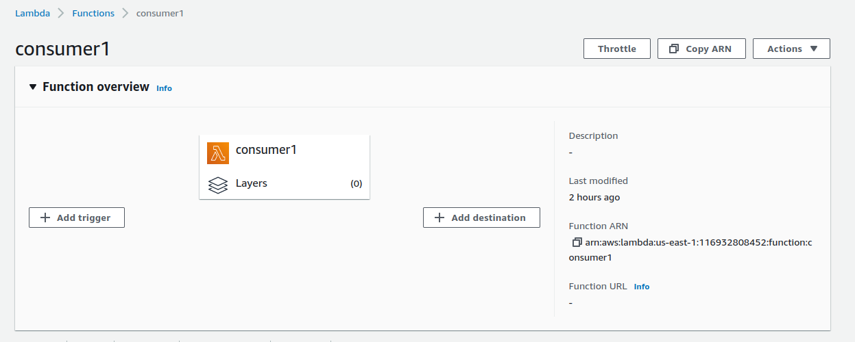

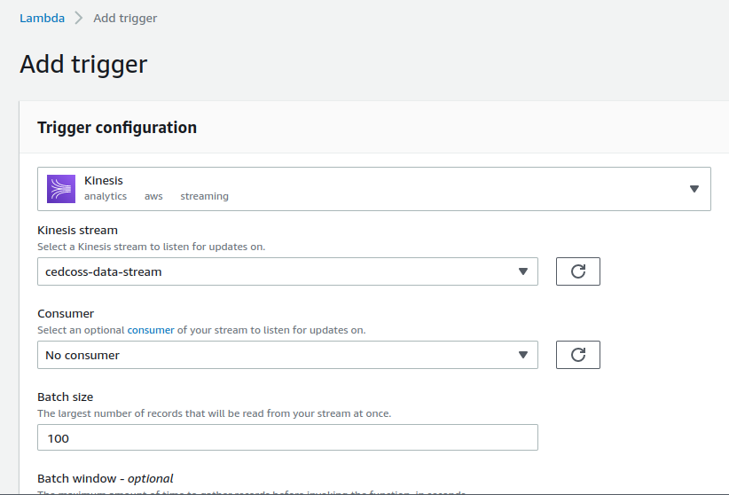

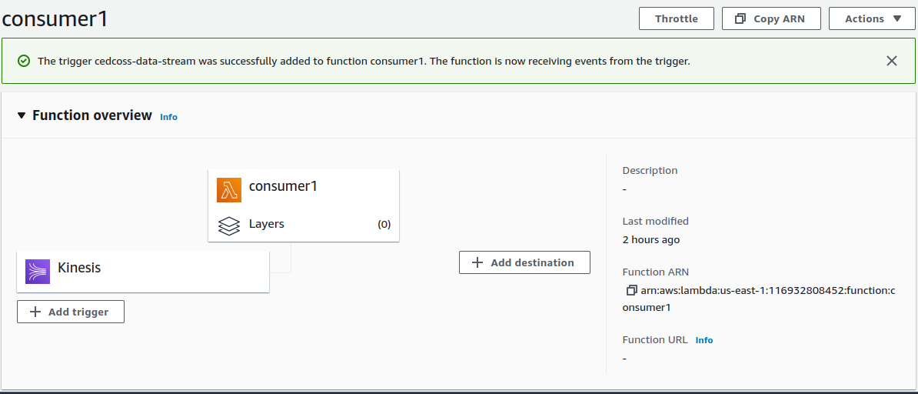
Go back to Lambda dashboard -----> click on consumer2

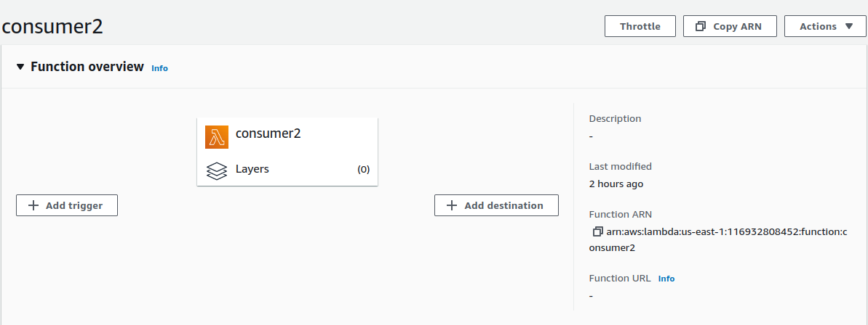
click on Add trigger ----> select Kinesis as we do our privious step with consumer1.

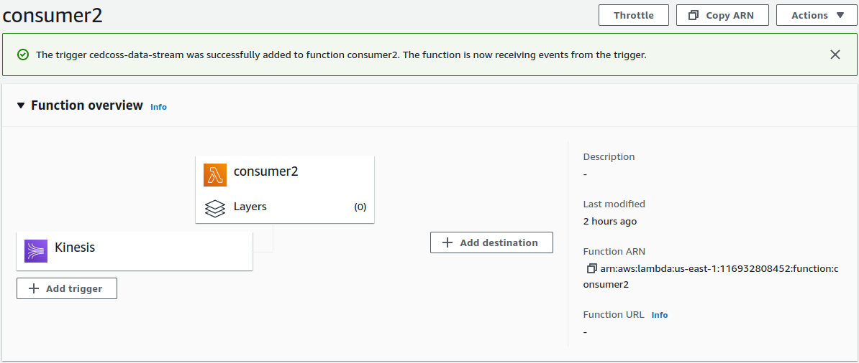

Okay, so now we have to create .txt file -----> upload it on S3 bucket.

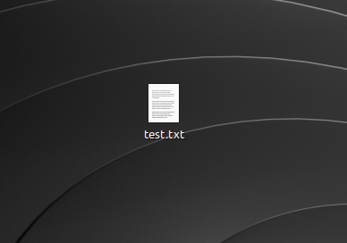

Go to S3 bucket ----> click on upload.

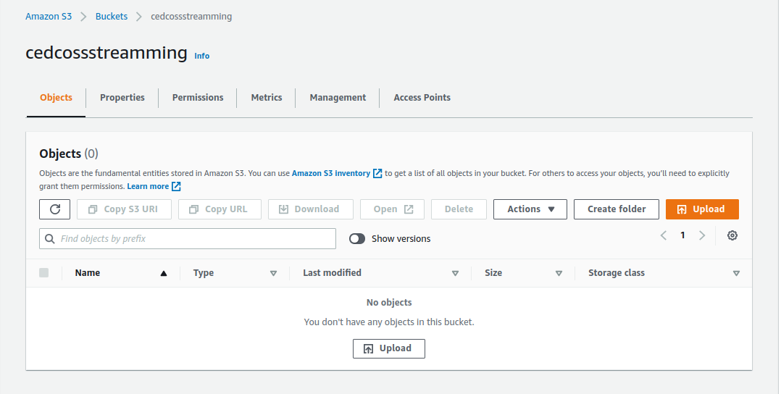
Now add file ---> click on upload file.
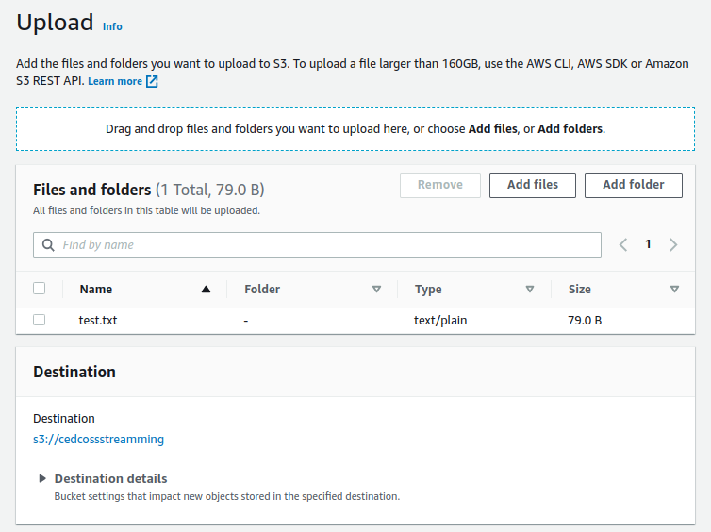

Go back to Lambda & choose ---> Producer -----> click on monitor.

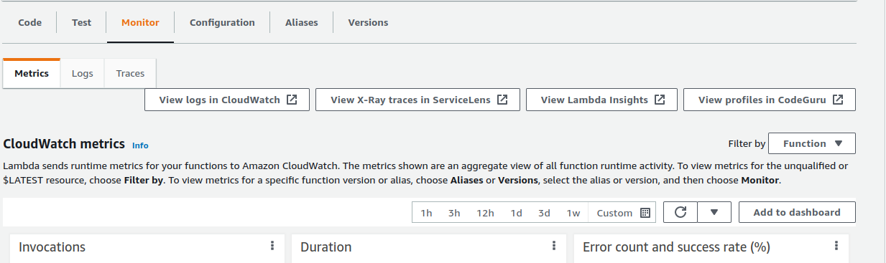

click on ------> View log in CloudWatch.

Back to ‘Producer’ /aws/lambda/producer/ ---> click on ‘Log Streams’

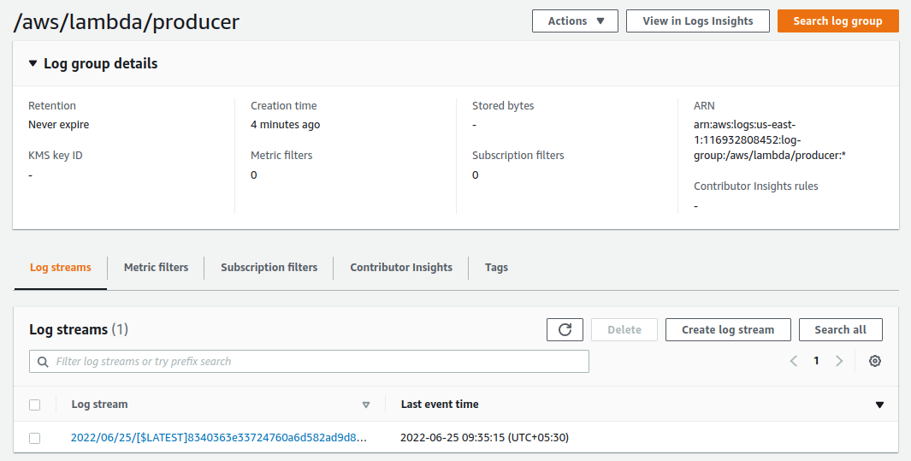

Here you can can see your log streams.

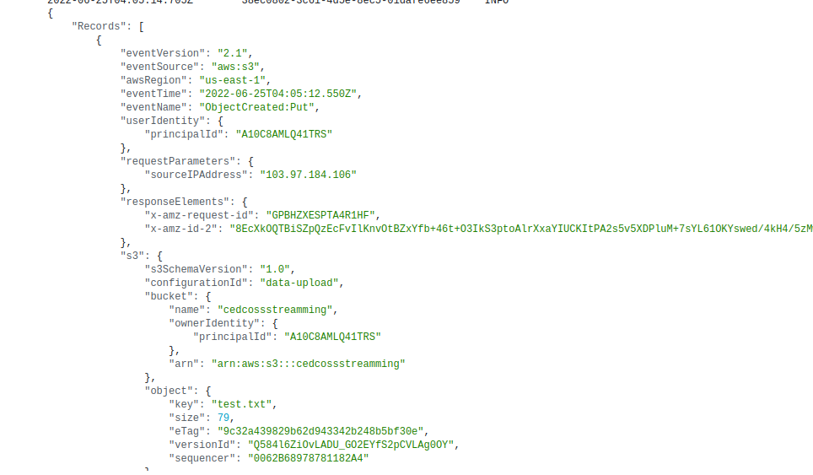

Done!

