**AWS EC2 Image Builder**

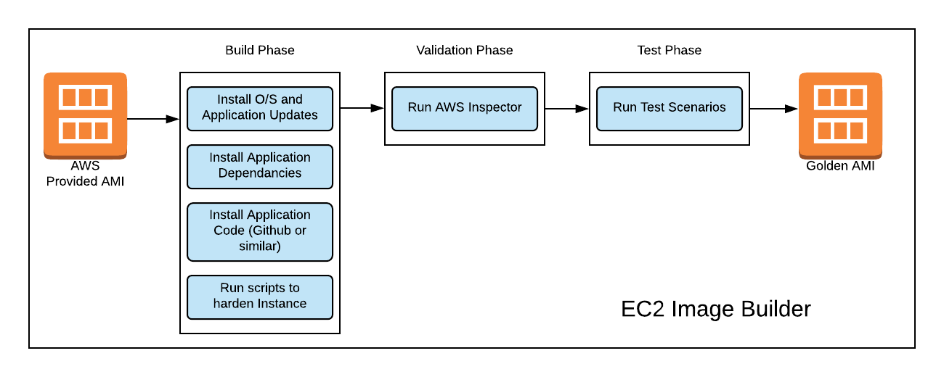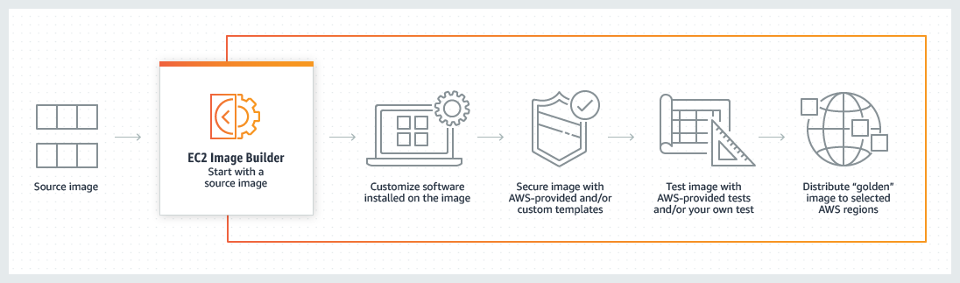

**Manual AMI Creation**

Launch EC2 instances (from existing AMI image) --- > t2.micro (X86)

Add some user data or configure it depends onyour requirements

- Create an image

- Create another EC2 instance from new image to verify

**EC2 Instance Image Builder**

Now to have to automate these steps

Building Testing Distributing AMI

we will spin EC2 instance (using already created image)

Go to AWS console search EC2 Image Builder ----> Choose image builder.

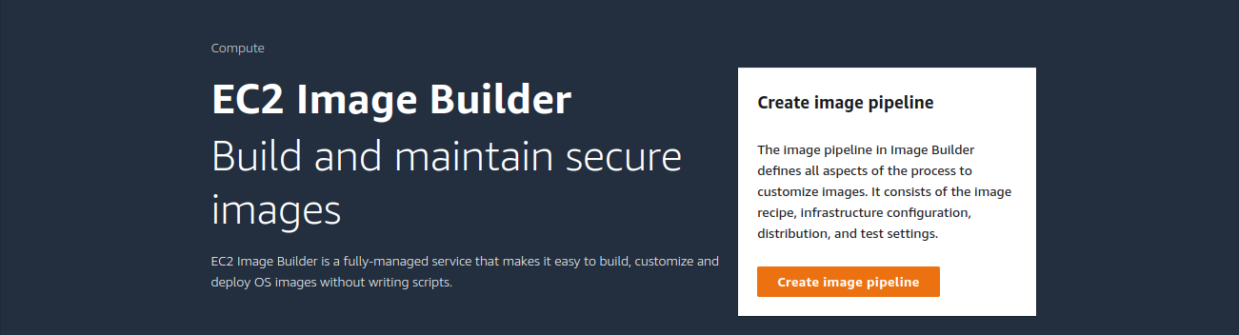

1 : Click on create image pipeline, Specify pipeline details.

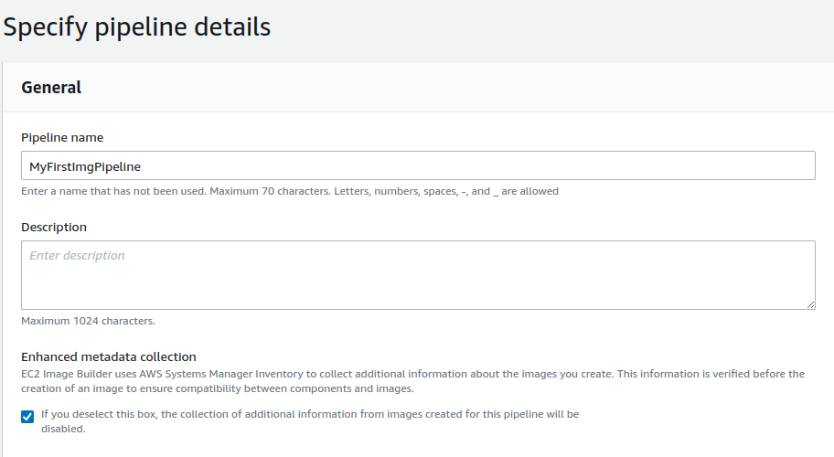

Now choose the Build Schedule, in my case am using manual build schedule.

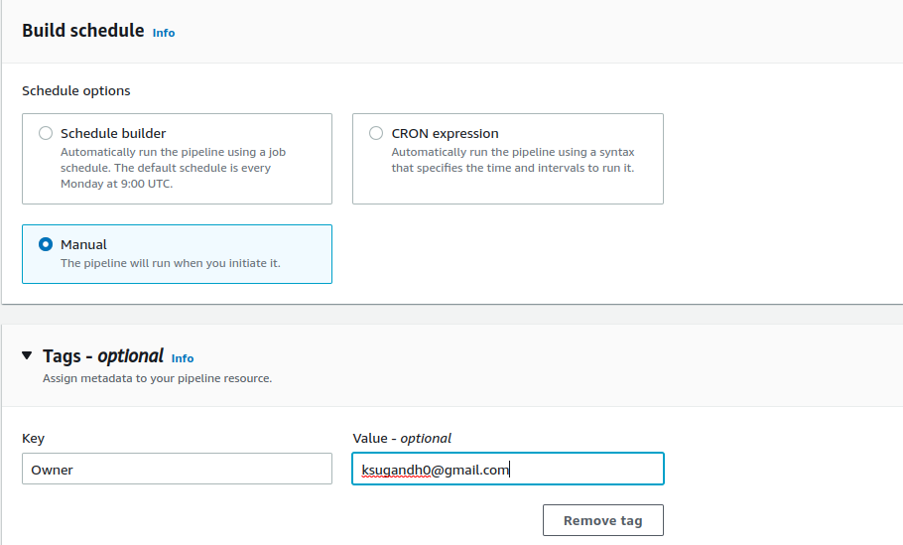

2 : Choose recipe we have two here : use existing recipe & create new recipe.

I am creating first time so I choose ‘create a new recipe’

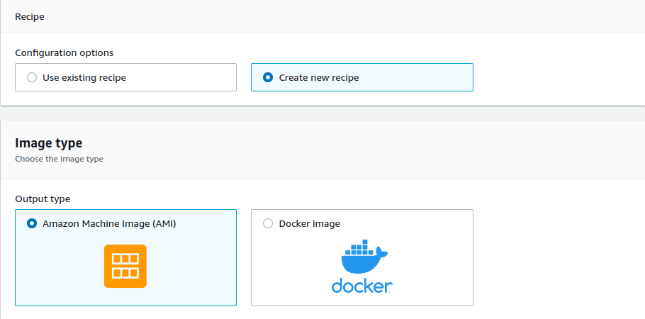

Fill the metadata of recipe like name & version

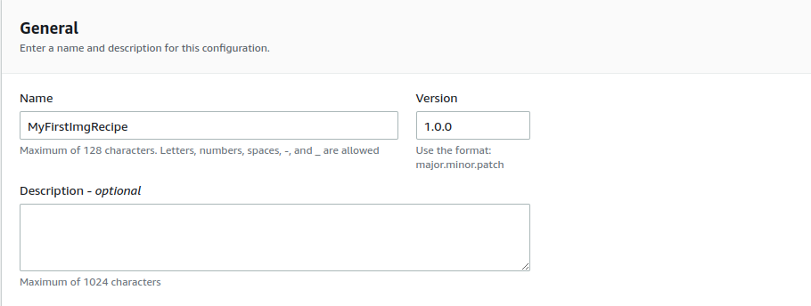

Now you can select the base image from a list of Image Builder managed images or Amazon Machine Images (AMI’s) that your account has access to or import a virtual image Select Image.

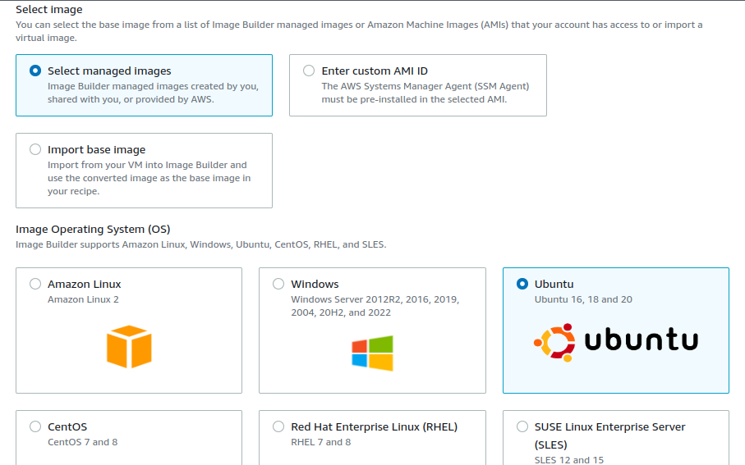

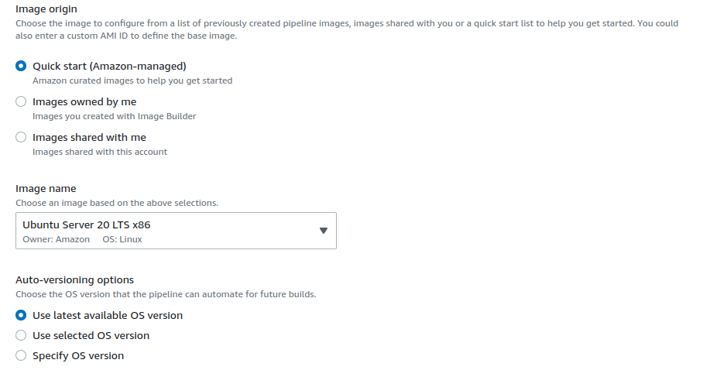

Select build component as required,

In my case iam choose amazon-corretto-11 & aws-cli-version-2-linux

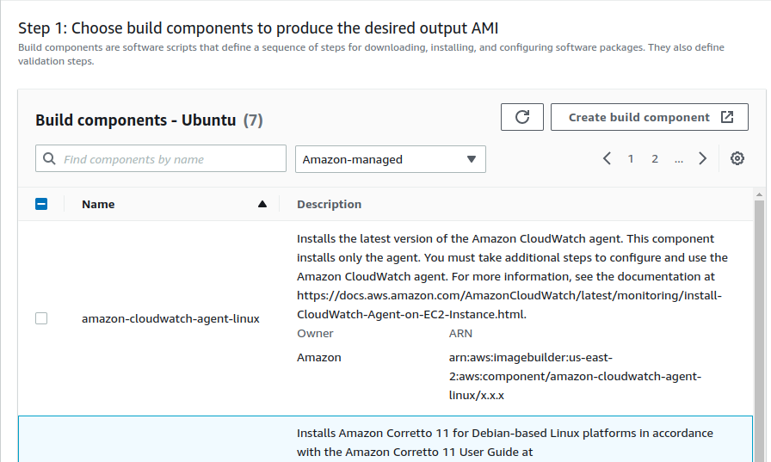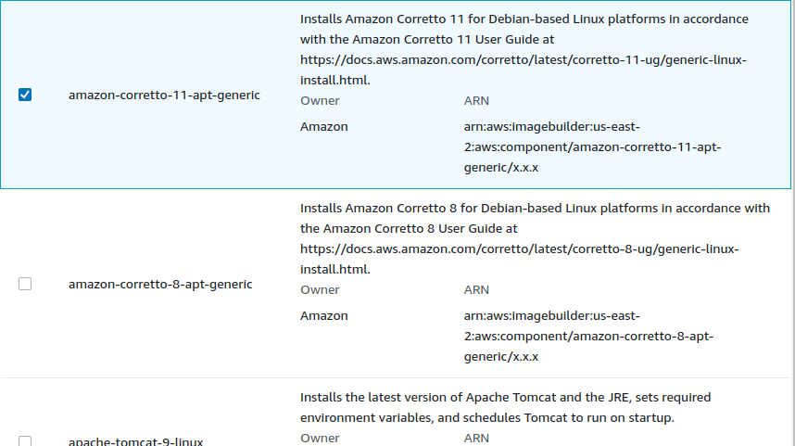

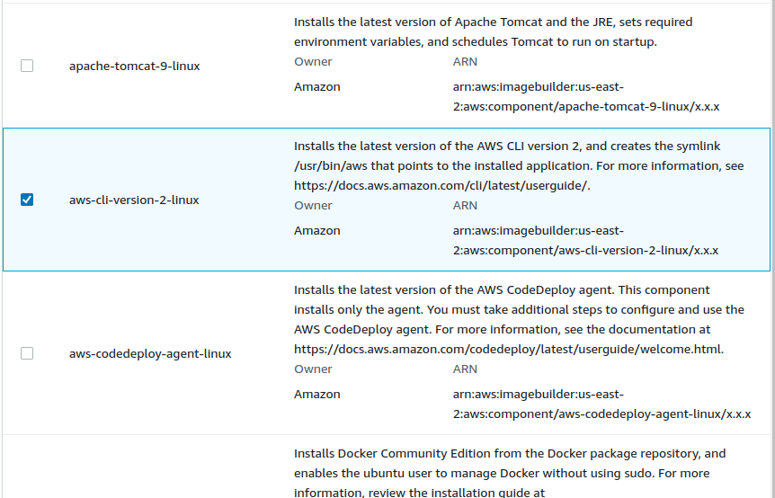

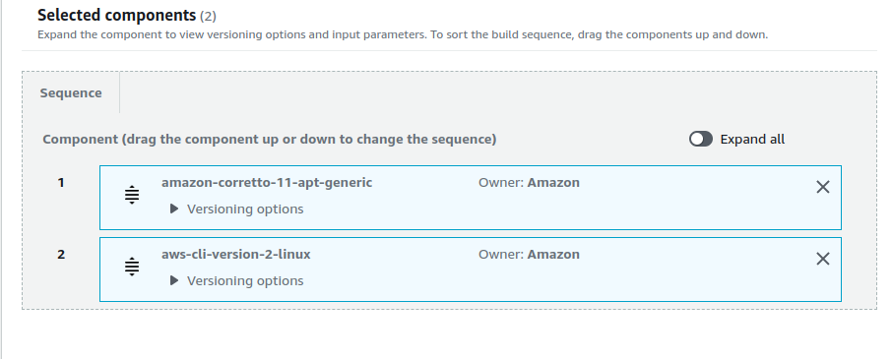 Here choosed component list.

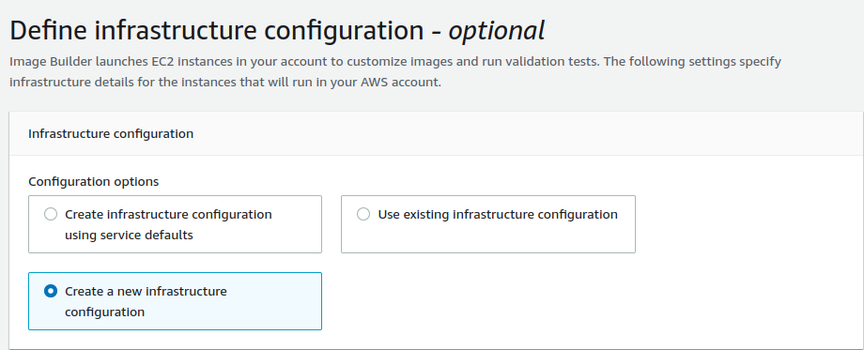Here we have to define infrastructure configuration. We have option here to choose the configuration option.

Now we have to configure IAM Role to create a IAM role on EC2

- EC2InstanceProfileForImageBuilder

- EC2InstanceProfileForImageBuilderECRContainerBuilds

- AmazonSSMManagedInstanceCore

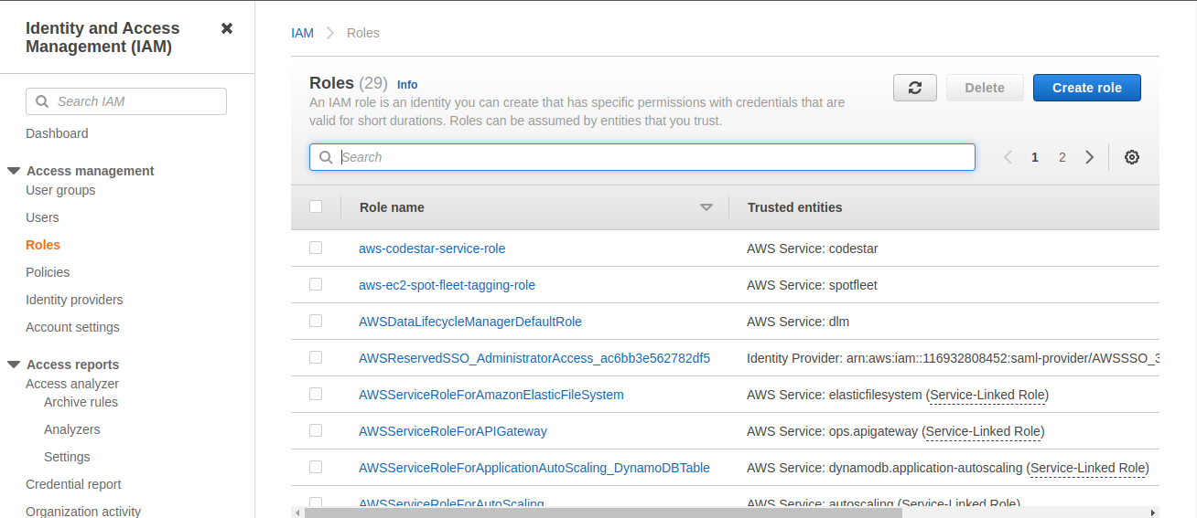

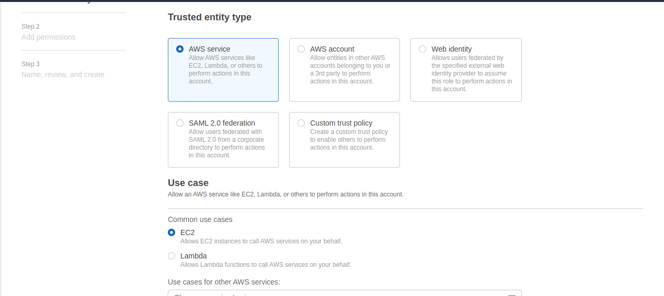Select AWS services & in use cases select EC2

Write IAM role name

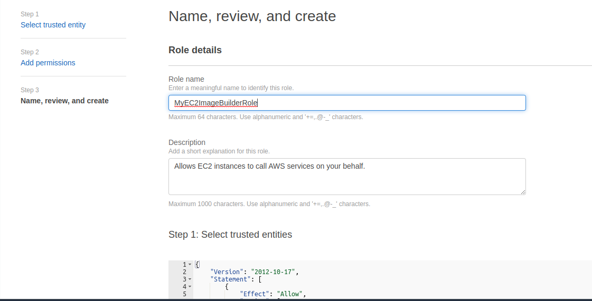

Here the 3 policy which we create under IAM

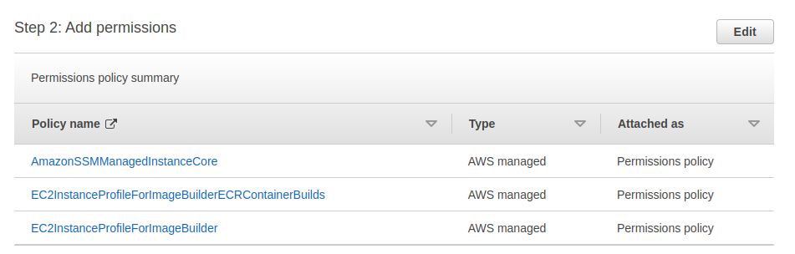

Click on create.

Now back to EC2 Image Builder & proceed the next step under IAM role select

newly create IAM role.

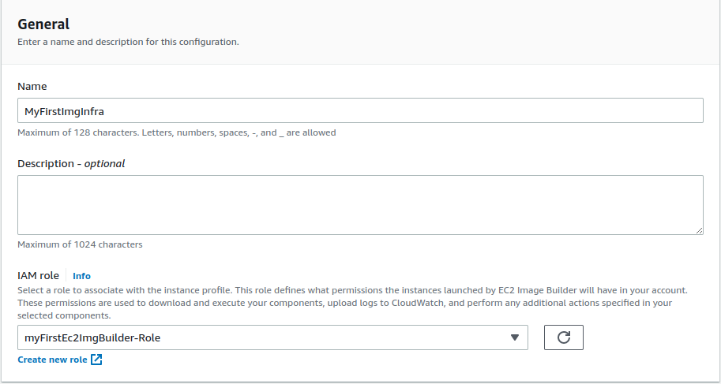

Select instance type

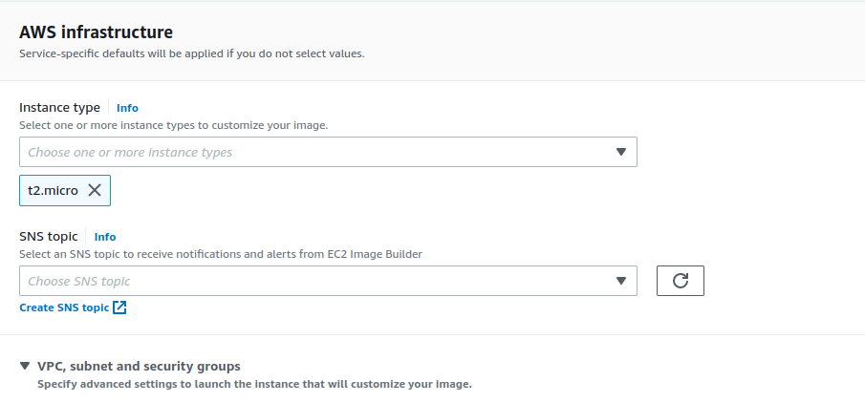

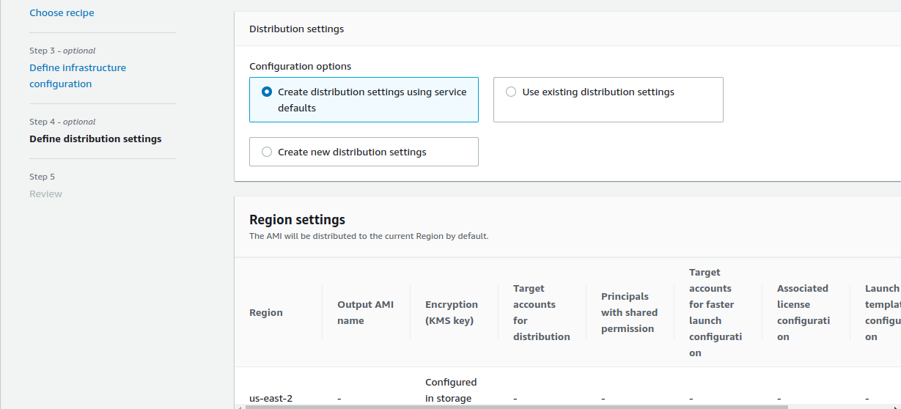

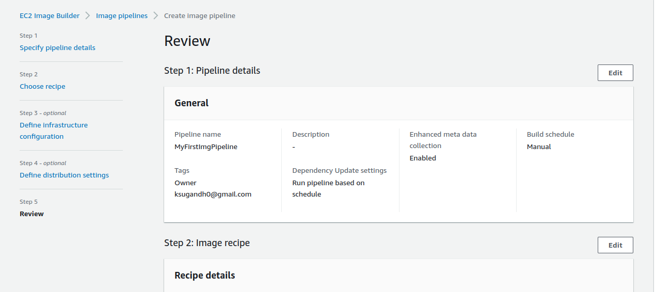Review the configuration & click one create pipeline

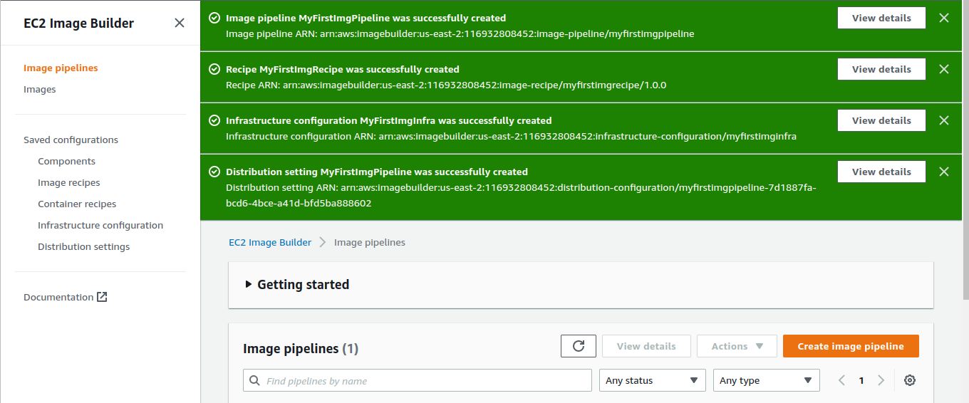

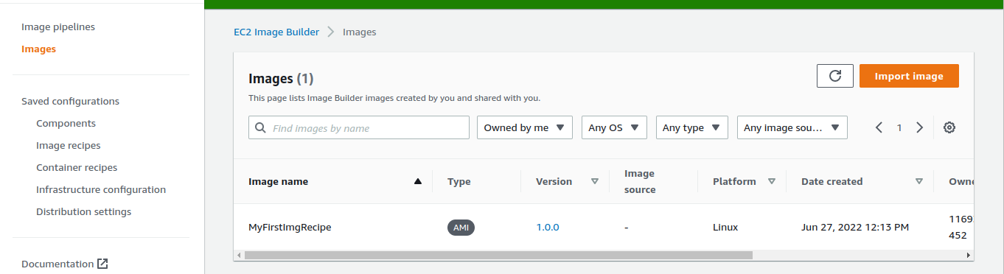Back to EC2 Image Builder dashboard click on images here you can see your newly created image cl

Click on 1.0.0 (version) here you see status Building ‘Pipeline’

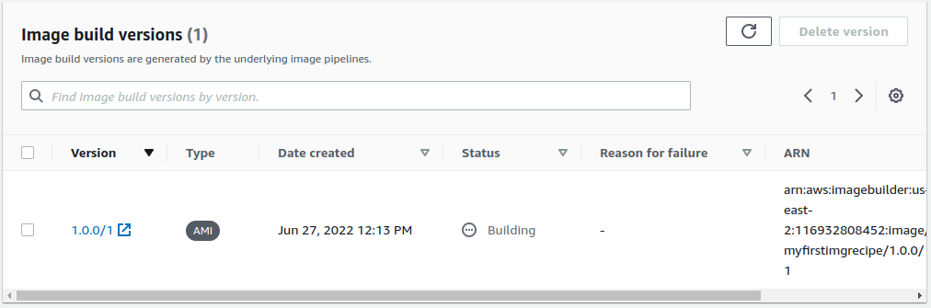

Now go to EC2 dashboard ------> click on running instances

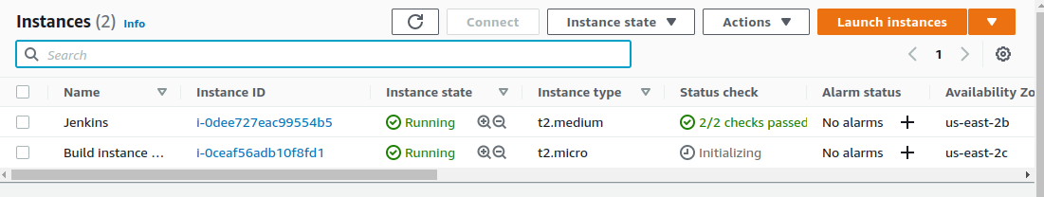

Here see a instance that name is Build Instace its automatically generated

wait untill its state should stop & terminate

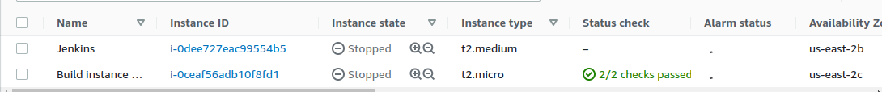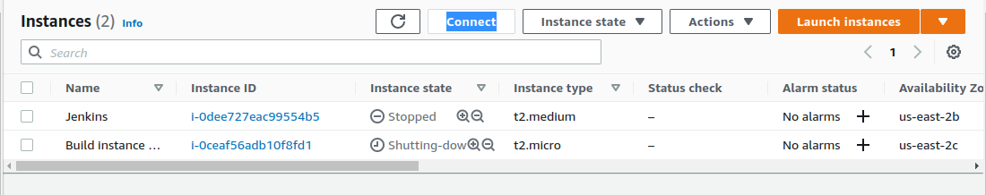

After terminated this **Build Instances** see automatically next step install come up **‘Test Phase’**

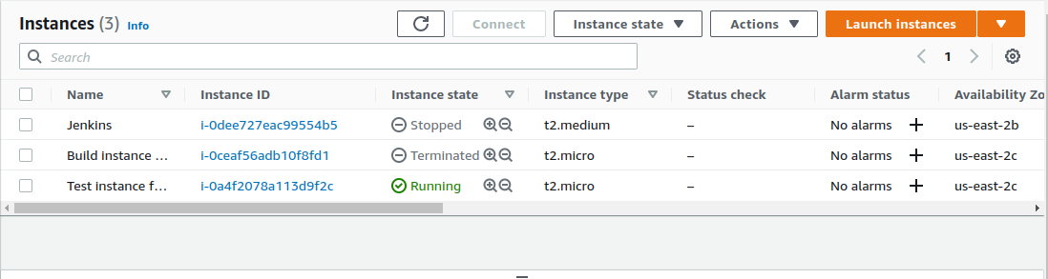

Now go to EC2 Image Builder ----> Images ----> MyFirstRecipe ----> Version

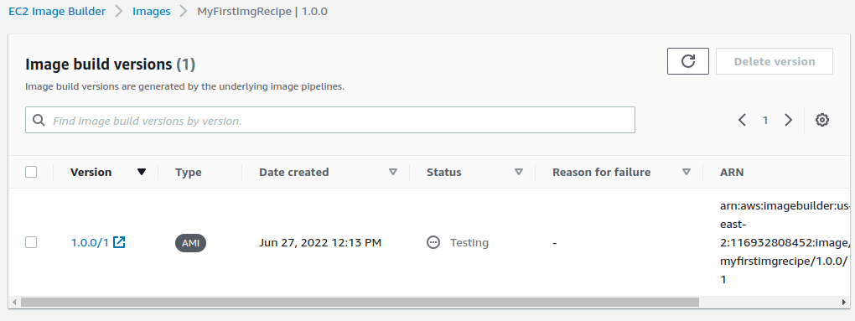

Here we after terminating our Build Instance automatically pipeline genrate Testing phase.

Now go back to EC2 instance & here our Testing Instance stoped & termminated.

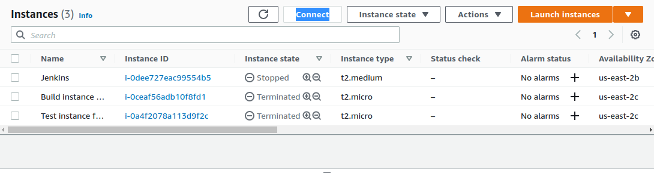

\

Now go back EC2 Image Builder ----> Images ----> MyFirstRecipe ----> Version

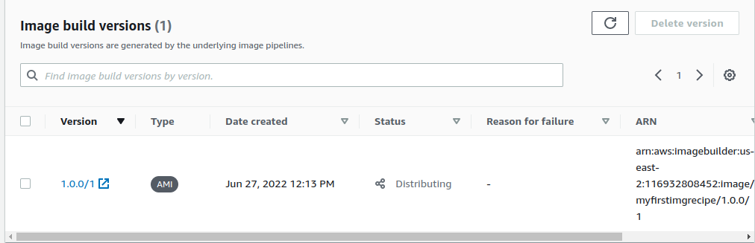

Here we shown in status another step of pipeline is come up ‘Distributing’

wait a while untill Intregrating pipeline step come up

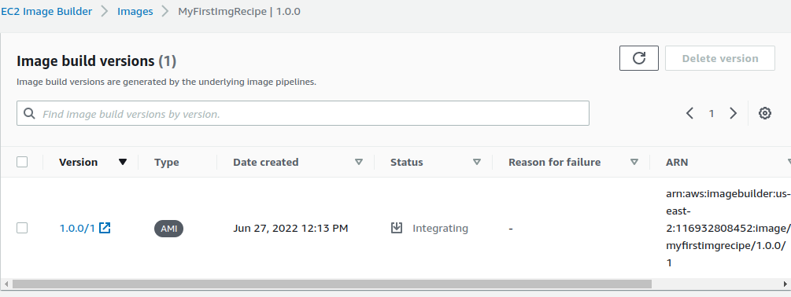

Now our pipeline status shown ‘Intregrating’, wait a while it will come up the pipeline stage ‘Avaiable’

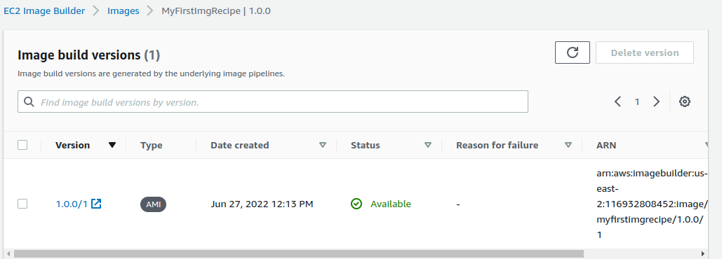

Now go to EC2 dashboard -----> Under ----> Images -----> Select AMI’s.

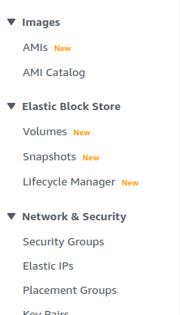

Here your AMI is ready to launch.

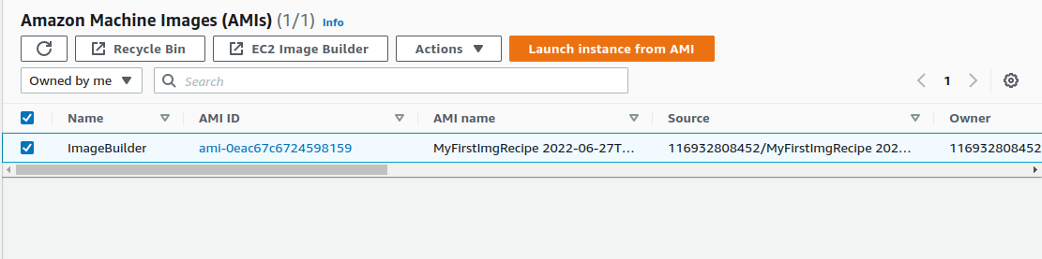

Go to EC2 Instances ---> Click on launch instances.

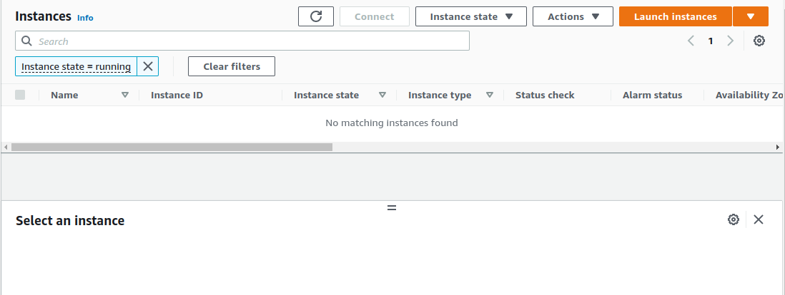

Choose AMI ---> click on My AMI & select newly created AMI (MyFirstImgRecipe) select & next

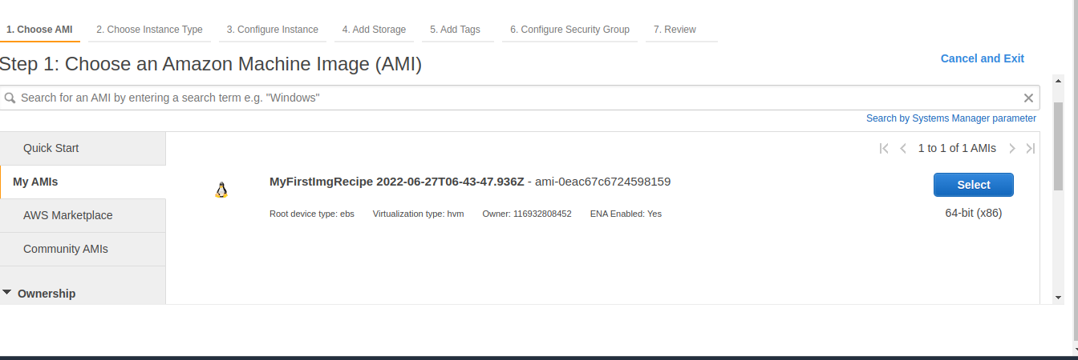

Complete all the steps of launching EC2 instance.

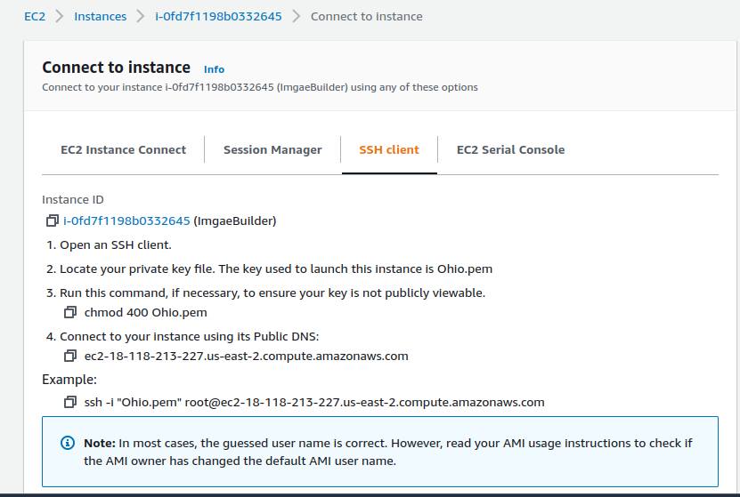

Take SSH connection to your terminal & check whether those things we configure build component that are installed or not.

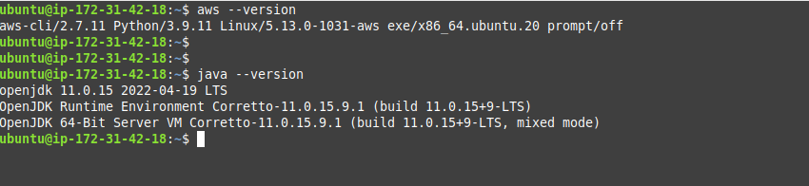

Done!